Booking a Trip (Air, Car, and Hotel) in Concur as a Travel Arranger

This guide will show you, step-by-step, how to make an air, car, and hotel reservation on Concur for another employee. Important Note: You must be given permission to book for the employee or be set up as a self-assigning travel arranger for the department.
1. After registering for Concur, log in with your work email address and password.
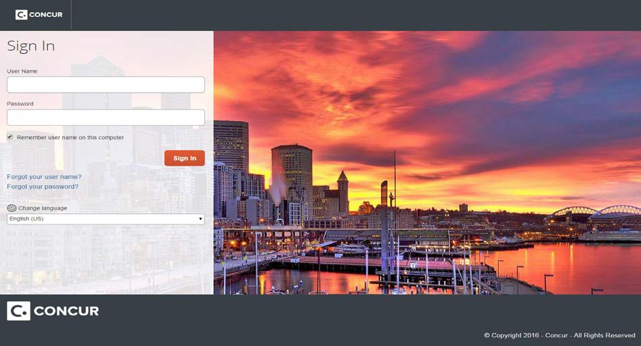

2. On the Concur home page, look to the Profile section on the upper right side of the page. Click on “Profile.”
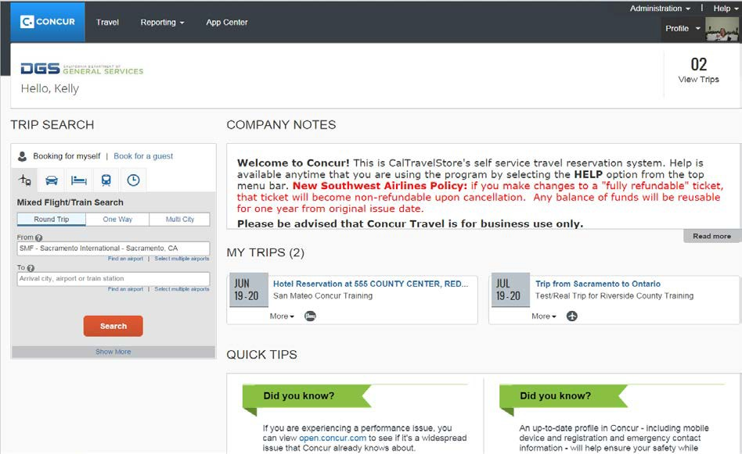

3. In the “Acting as Other User field,” find the traveler you want to book travel for. Remember, you must be added as an Assistant/Travel Arranger in that traveler’s Concur profile. If you are assigned as an Assistant/Travel Arranger to less than 10 travelers, you will see a drop-down list. If you arrange travel for more than ten people, you can start typing in the traveler’s name and they should appear.
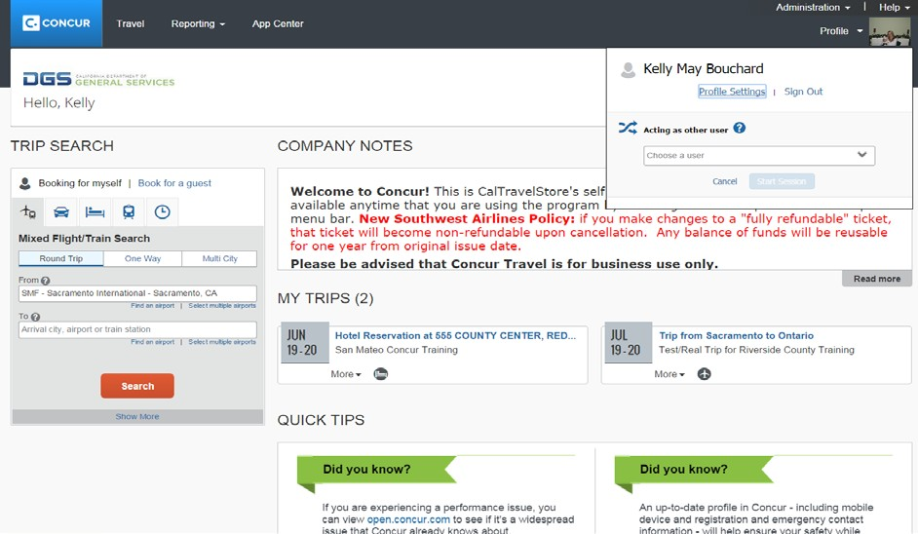

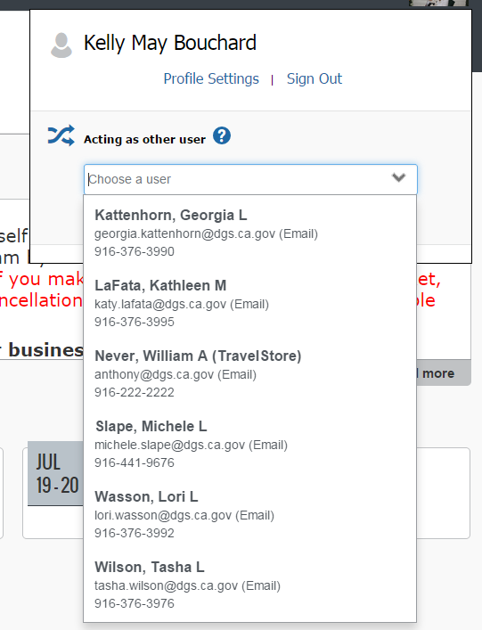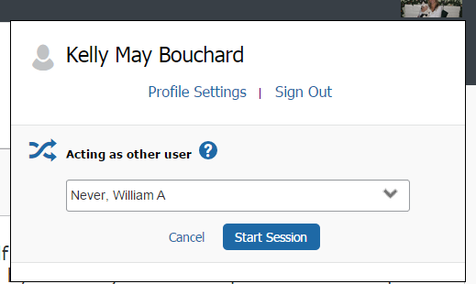
4. Select the traveler’s name, and then click “Start Session.”

5. Concur will switch the view and take you into the traveler’s profile as an Assistant/Travel Arranger. You will notice the green “Acting As” in the upper right-hand side of the page, with the traveler’s name you will be booking travel for.
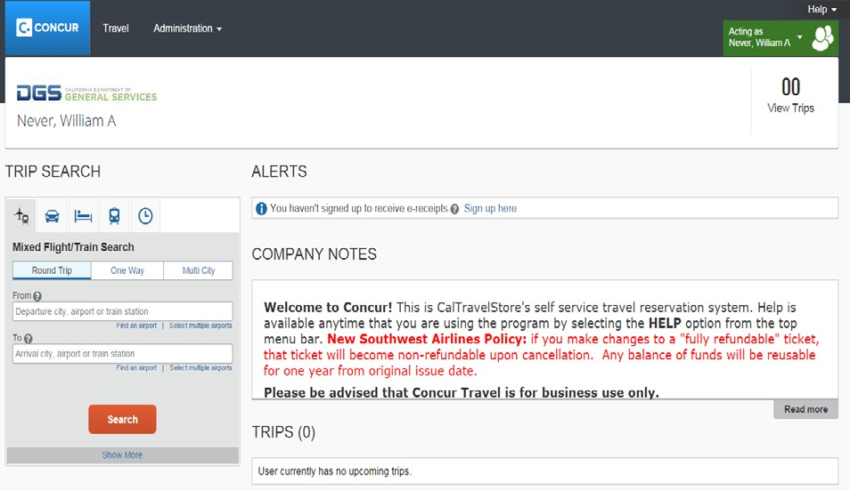

6. Use the Trip Search section on the left side of the page to start the booking process. Concur should be used to book airfare, rail, rental cars, and hotels for your official government business travel (personal travel is prohibited).
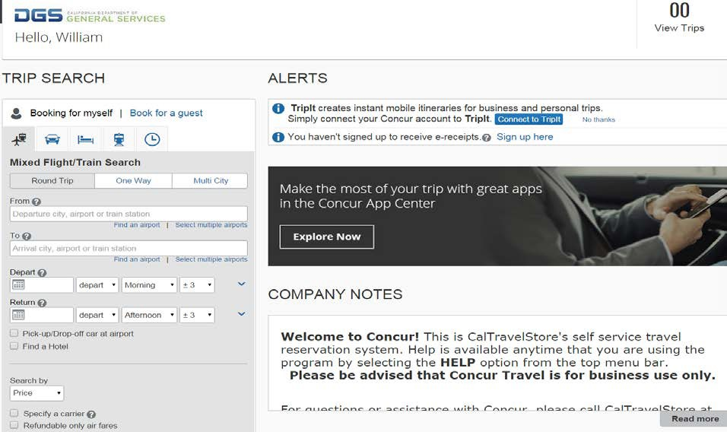

You can book airfare, rental car, and hotel during the same search. To only book one detail of the trip – such as airfare – use the corresponding tabs along the top of the Trip Search.
7. Select one of the following types of flight options: Round Trip, One Way, Multi- Segment.

8. In the Departure City and Arrival City fields, enter the cities for your travel. When you type in a city, airport name, or airport code, it will automatically search for a match.
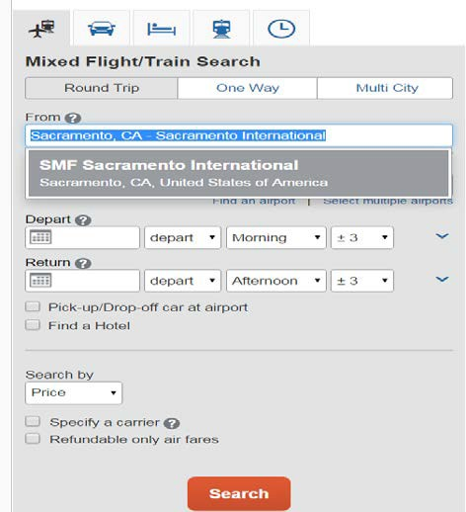

9. Click in the Departure and Return date fields, then select the appropriate dates from the calendar. Also, select the appropriate departure and return times. The system will search before and after the times you select based on the +/- number of hours selected in the dropdown boxes.
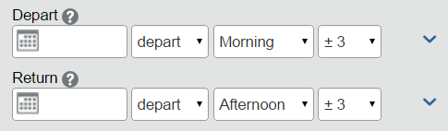

10. Click the arrow to the right of the time window to see a graphical display of flights available for the routing and date you have selected. This allows you to adjust your search criteria, if necessary.
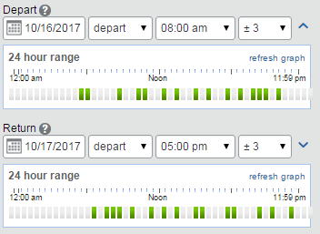

11. To book a rental car during this search, select the “Pick-up/Drop-off car at airport” checkbox.

12. To book a hotel stay during this search, select the “Find a Hotel” checkbox. You can choose to search for the hotel by Airport, Address, Company Location, or Reference Point/Zip Code (a city or neighborhood). You can also expand your search by changing the number of miles in the distance box.
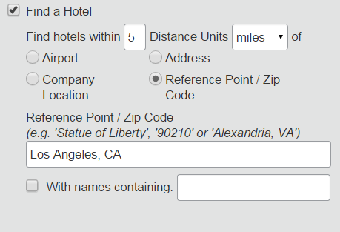

13. In the “Search by” section, select how you first wish to review the airfare results either by Price or by Schedule. We recommend you search by Price. Then Click the “Search” button.
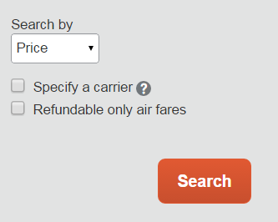

Reserving a Flight…

14. A grid (matrix) summarizing your airfare search results will appear at the top of the page, with your search results appearing below. Make sure you factor in baggage fees if you are preparing a cost estimate.

The “Preferred” verbiage indicates that this is a preferred State of California contracted vendor.
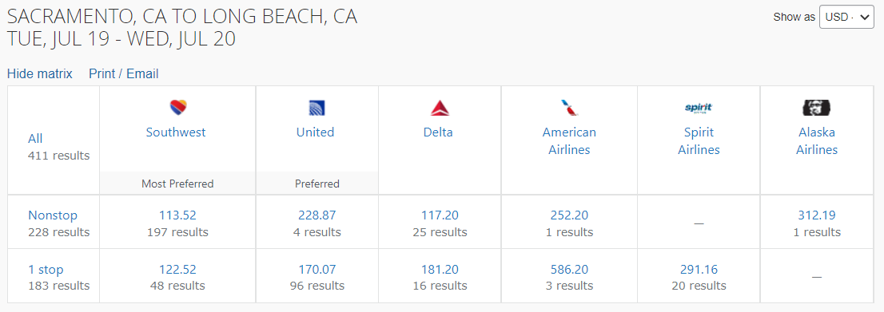

15. To filter your results, select a column, row, or cell from the matrix. For example, to view only the nonstop flights click the “Nonstop” cell. To view only Southwest flights, click the “Southwest” cell.

An additional, higher value airfare will be presented allowing you to compare fares and benefits, side by side, and select the airfare that best suits your travel needs. The airfare comparisons are by individual carrier, not a comparison between different carriers that might be cheaper.
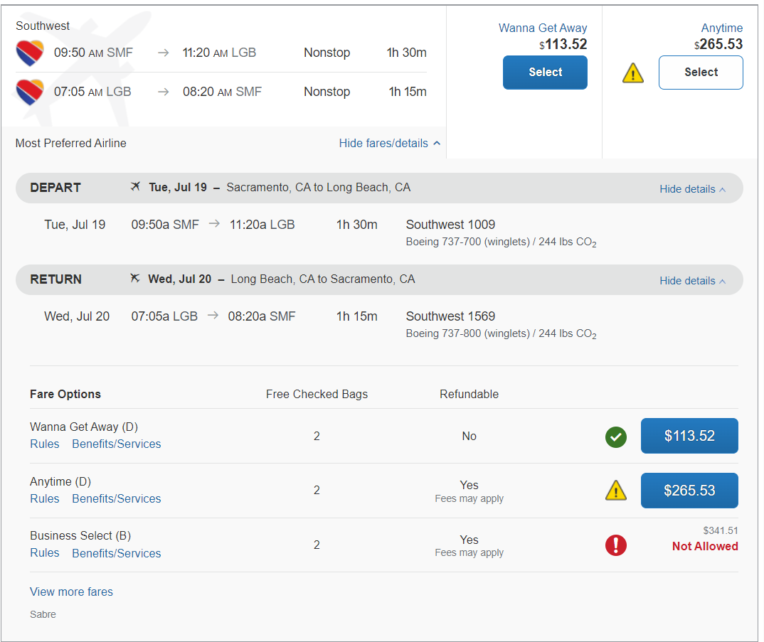

The “Wanna Get Away” fares are non-refundable but reusable. The “Anytime” fares are refundable unless you make a change then the ticket will become non- refundable, and the “Business Select” fares are considered first class or premium types of fares. These “Business Select” fares may be grayed-out on your site prohibiting you from purchasing them if this is your department policy. If you have additional questions about your department policy, please refer to your department travel coordinator.

16. If you need to change your flight search, or filter your results, you can do so by using the filters and/or toggle bars on the left side of the screen.
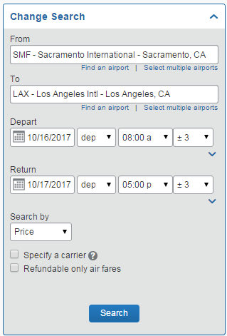

17. Please note that on the left-hand side of the screen is a trip summary that is geared to assist you in following the necessary steps when booking your trip.
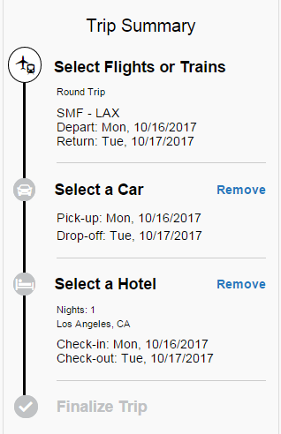

18. Once you are ready to make your selection, select the blue price button.
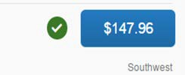

19. Once you have booked your flight you will be brought to a confirmation screen. This will allow you to confirm that you selected the right flight, confirm that you are booking for the right person, select your seat (if an option for your flight), review charges, review and accept the restrictions and rules, and book the flight. There will be a screen similar to this after each step in booking the trip.
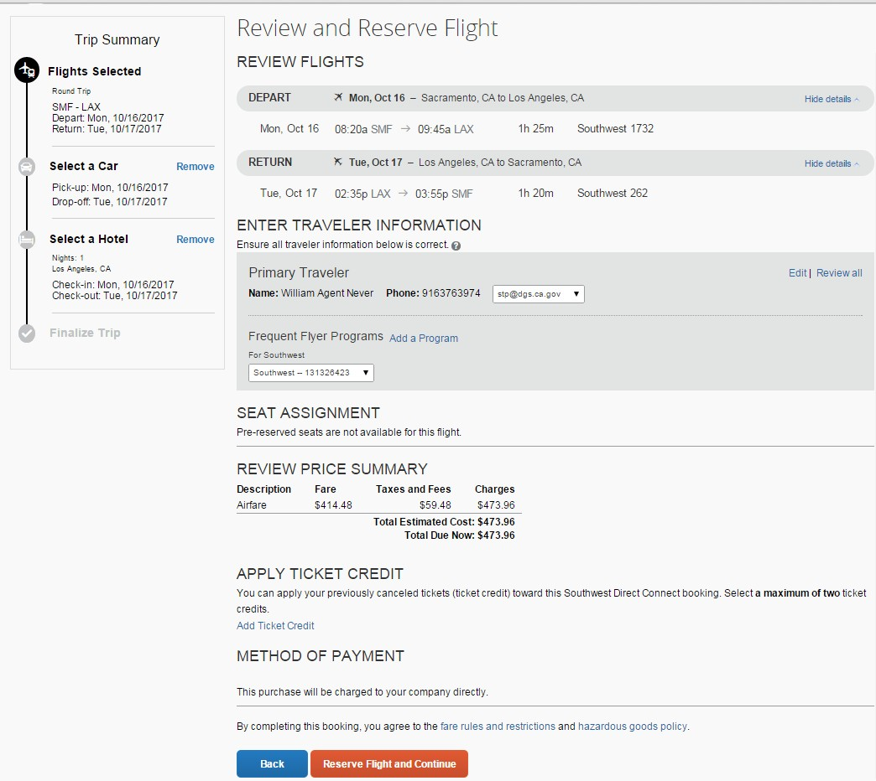

In the flight reservation screen, you can select your seat assignment, if necessary. Simply click on the button that says, “Select Seats.” This will bring up a seat map of the plane.

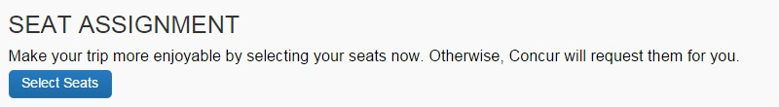
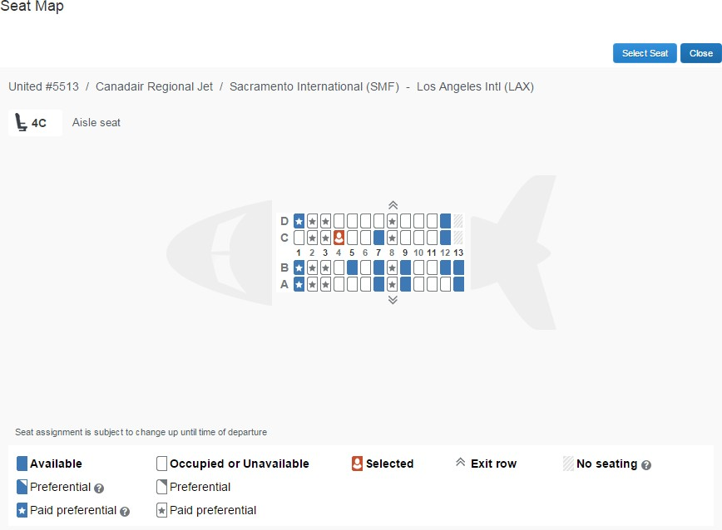

20. Select a seat by clicking on the available blue seat location. Once selected it will turn orange. Confirm your seat selection by clicking the “Select Seat” button. Then click “Close.”

21. After reviewing the confirmation page, click “Reserve Flight and Continue.” There will be a similar screen to this after each step in the booking process.

Reserving a Rental Car…

22. Next, you will see your rental car search results, if you checked the Pick-up/Drop- off Car at Airport checkbox.

23. Similar to the flight search, a matrix summarizing your search results will appear at the top of the page. If you follow the State of California car rental policy, compact and intermediate are the required car rental classes. Renting a vehicle larger than the intermediate size requires the car rental justification form.
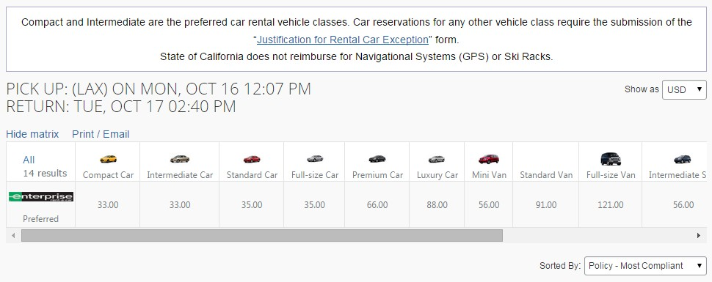

24. To filter your results, select a column, row, or cell from the matrix.

25. You can find rental location, hours, and contact information by clicking on the “Location Details” link.
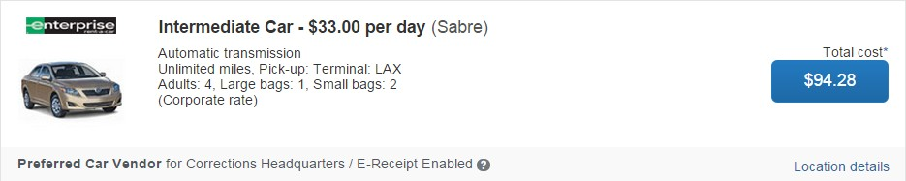

26. Select your appropriate rental car by clicking the blue price button.

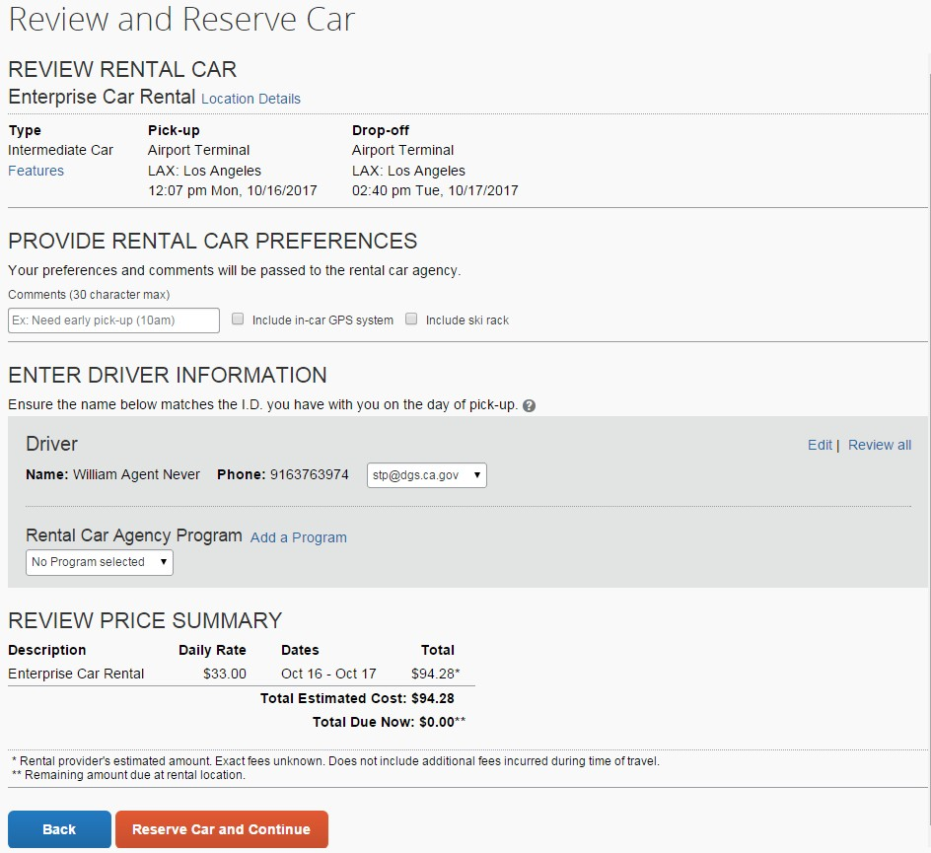

27. Again, you will be brought to a review screen to review and confirm the car rental details. Then click “Reserve Car and Continue.”

Reserving a Hotel Room…

28.If, when entering your search criteria, you checked the “Find a Hotel” checkbox:

You will see your hotel search results. A map will display your first twenty-five search results in relation to the location you selected/entered as part of your search criteria.

If you follow the State of California short-term lodging reimbursement rates, you can find these rates by clicking the link at the top of the page. As an optional user (non-state entity), your short-term lodging reimbursement rates/travel policy may differ.

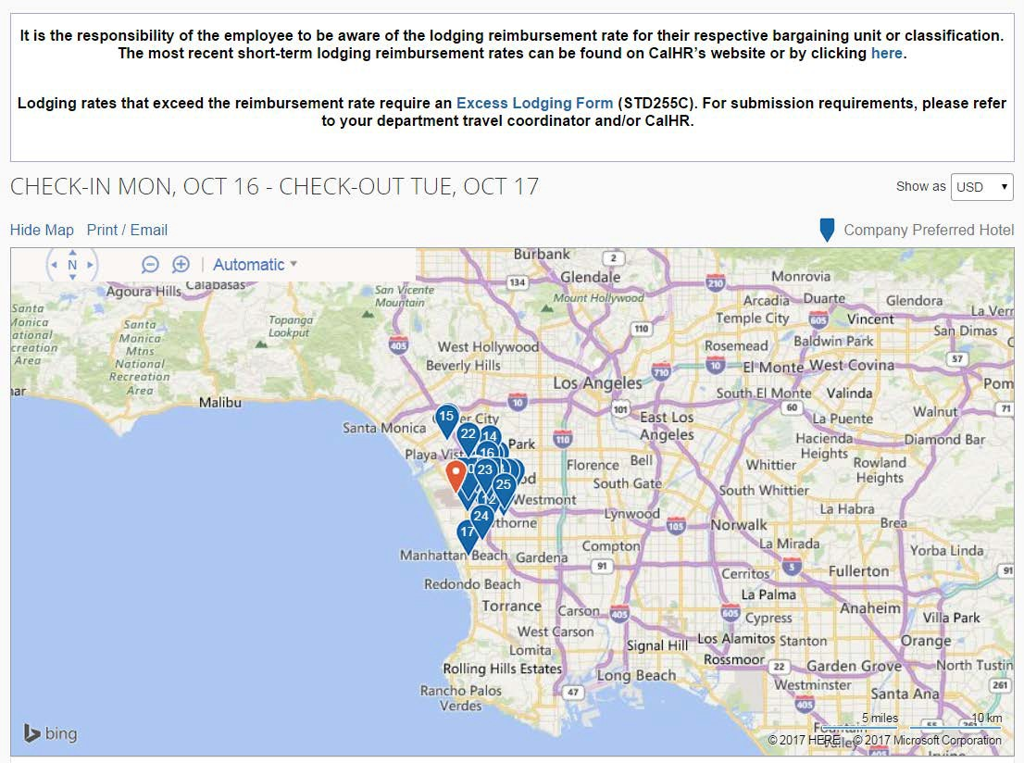29. You can sort the list of hotels by Preference, Price, Rating, Policy, and Distance. The default is set to display the hotels from the lowest price to the highest price. You can also search for specific hotels using the “Hotel Name Search” field.

Please note that the rating system is a Northstar Travel Rating for hotels. The rating system is not based on traveler reviews (location, customer service, cleanliness, etc.). We recommend still using traveler review websites such as, TripAdvisor or Yelp, for hotel reviews.
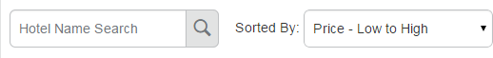

30. If needed, you may use the options on the left side of your screen to filter your results further, such as by Hotel Chain or by Hotel Amenities.
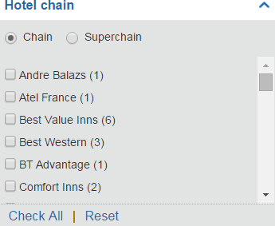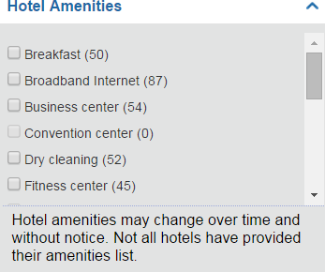

31. Scroll through the page to view all the hotels. To view more hotel selections, click the “Next” button on the bottom of the screen.
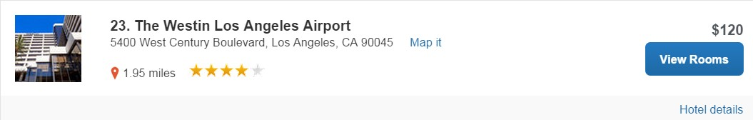

32. Click on “Hotel details” for information on the hotel, such as, directions, attractions, amenities, cancellation policy, and all the information you would normally find on the hotel’s website. You can also click on the image to view images of the hotel or virtual tours, if available.
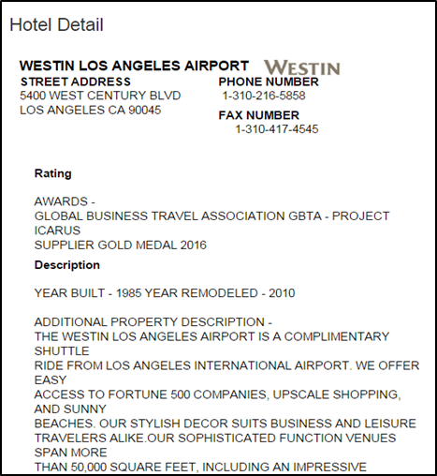

33. Click the “Views Rooms” button for a specific hotel to find more detailed information, including room types and room rates.
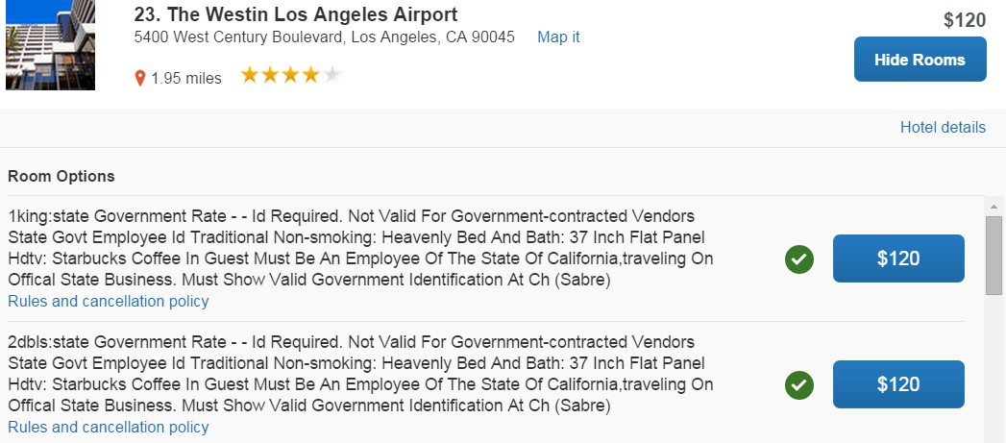

34. When you are ready to reserve a hotel room, click the blue price button for the appropriate hotel and rate. You will need a credit card to reserve the hotel.
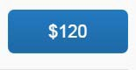

35. Review the hotel information on the “Review and Reserve Hotel” page and check the box to agree to the “Accept Rate Details/Cancellation Policy” box at the bottom of the page. Then click “Reserve Hotel and Continue.”
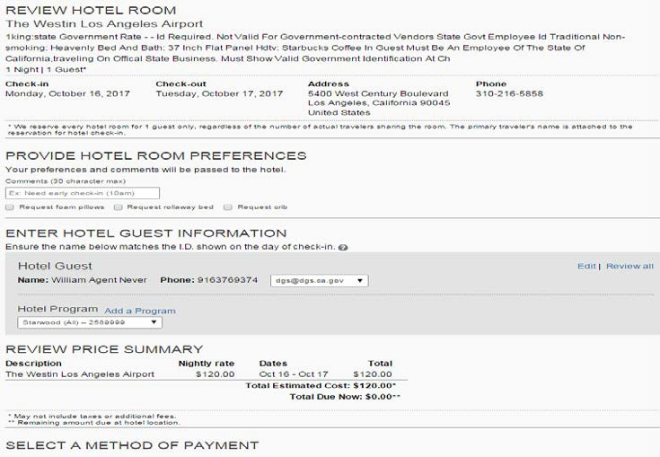

Completing Your Reservation…

36. Review the details of the reservation on the Travel Details page. If necessary, change any element of your trip by clicking the appropriate change/cancel link along the right side of your screen, or use the icons at the top of the Trip Overview to add to your itinerary. Remember, any non-Southwest airline changes other than cancellations must be called into the travel agency once your reservation has been confirmed and ticketed. When ready, scroll to the bottom of the page and click “Next.”
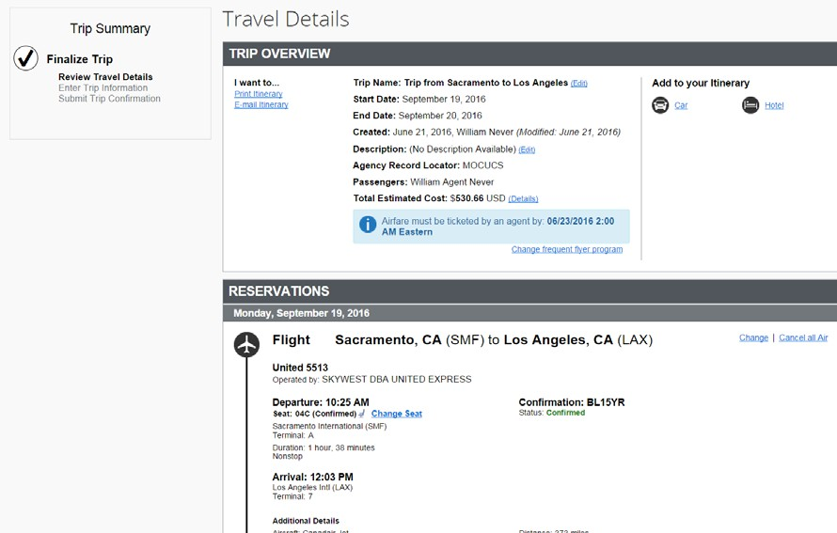

37. On the Trip Booking Information page, enter the trip information in the Trip Name and Trip Description fields. As a travel arranger, both you and the traveler will receive a copy of the travel itinerary.
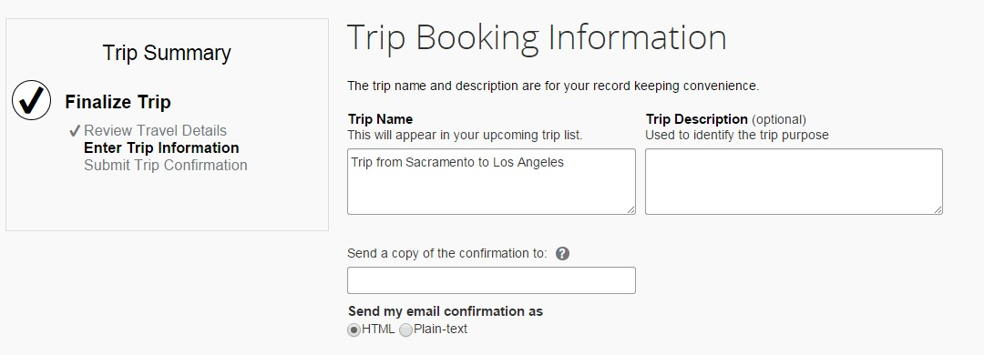

38. If your site is customized to capture department accounting or billing codes, you will enter the appropriate codes here, for example, index, PCA, billing code, Fi$Cal number, etc.
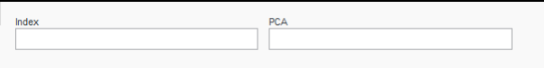

39. Click the “Next” button to proceed to submitting your trip.
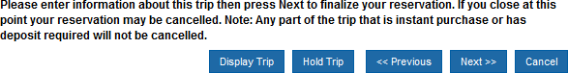

40. Your itinerary appears again, with the trip information just entered, for final review. Click “Purchase Ticket,” at the bottom of the page, to finalize your trip.

41. Once you click Purchase Ticket, your itinerary will appear one last time, now with a blue “Finished!” message in the upper left corner.

42. Make sure you always scroll to the bottom of the page clicking Next, Next, Next until you have received the “Finished!” message.
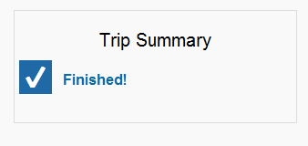

43. Once you return to the Travel Center or the home page of Concur, you may click on the green “Acting As” in the upper right-hand corner.

If you are done booking travel for others, select the blue “Done Acting for Others” button. Or, if you wish to book for additional travelers, select their name in the “Choose a user” field, click “Start Session,” and repeat steps 6-42.
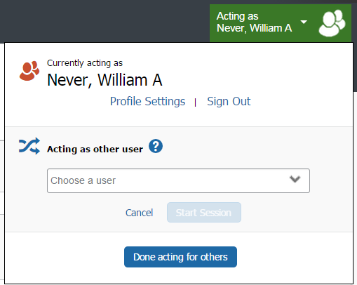

Important Changes to Airline Reservations
Effective October 4, 2021, flight changes/exchanges for all carriers in Concur are limited to one (1) instance. Additional flight changes/exchange must be called into CalTravelStore.
Effective October 4, 2021, unused funds/credits for all carriers are display-only and can only be applied by calling CalTravelStore.
If you have additional questions on how to book travel for others, please contact your department travel coordinator, or the Statewide Travel Program at (916) 376-3974 or via STP email (statewidetravelprogram@dgs.ca.gov).

