Introduction

This user guide is intended to assist the travel administrator(s) manage the users/travelers for CalTravelStore’s online booking tool, Concur.

- How to Create/Add a New User in Concur (Pages 1-4)
- How to Delete a User in Concur (Page 4)

How to Create/Add a New User in Concur

All users of the online booking tool may only have one profile. Duplicate profiles will cause errors in the booking process.

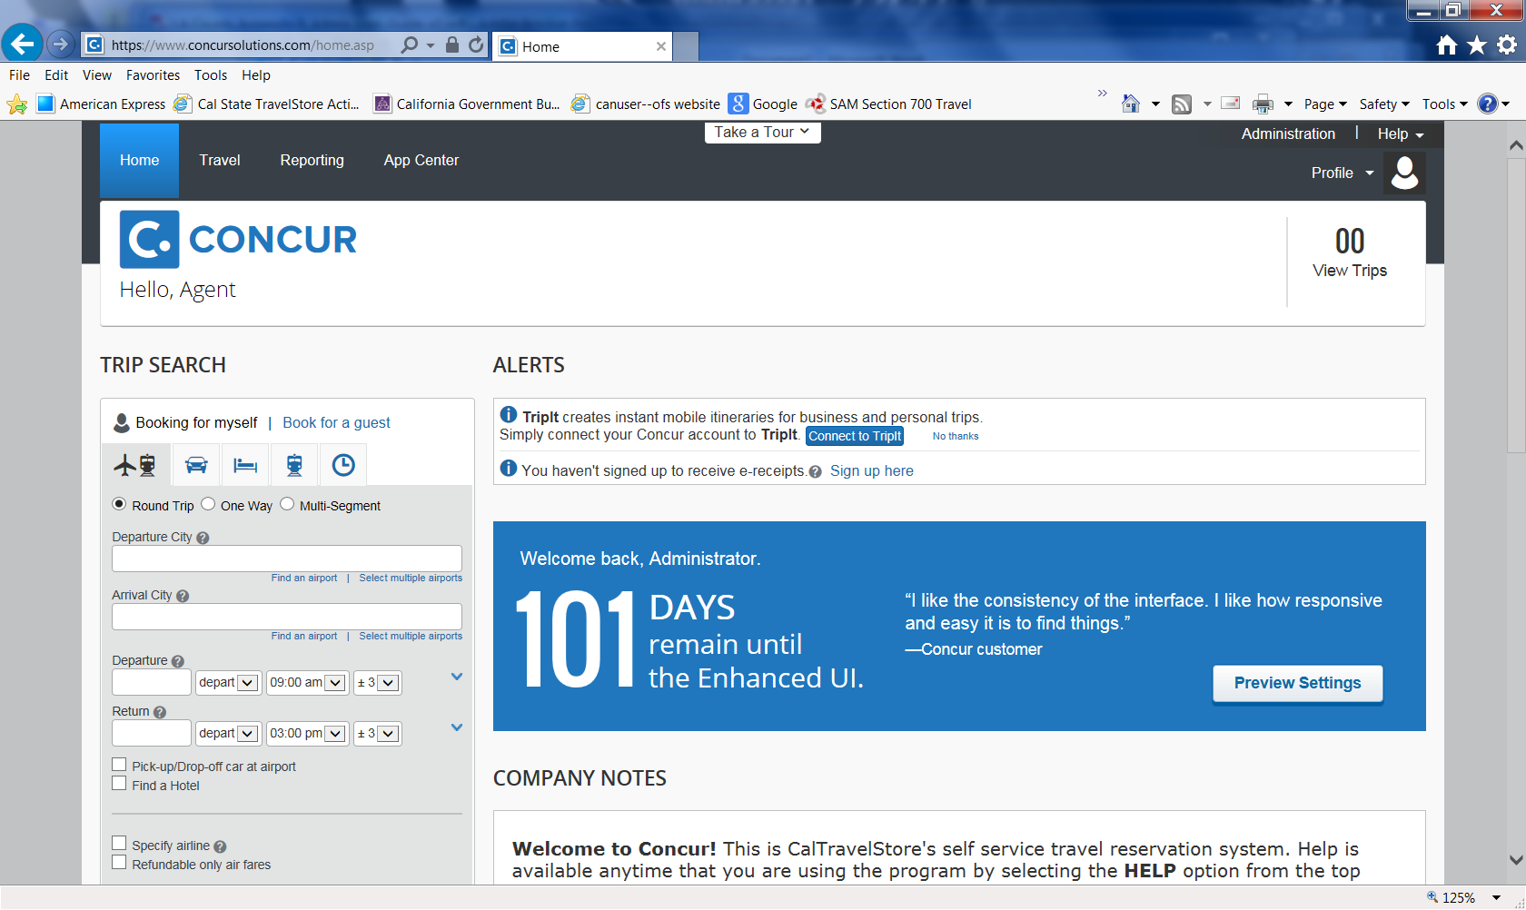
Cl
Click Administration or Company Administration

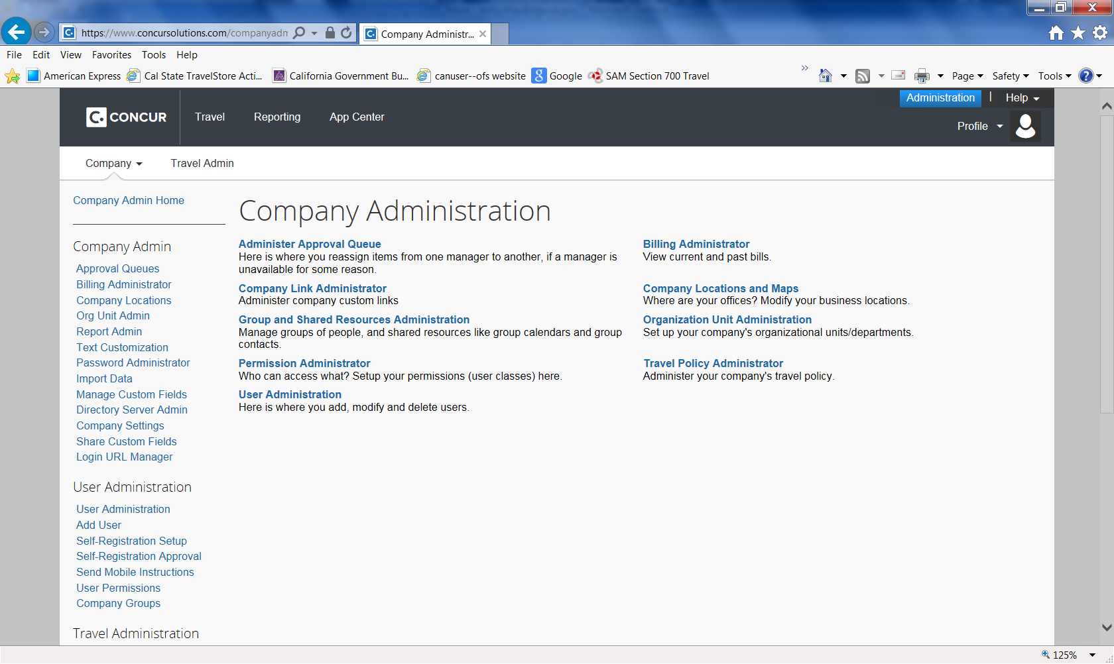

Click User Administration

Important Tip to avoid creating a duplicate user profile:
- Enter the users last name in the Search Text box, be sure to select ‘All’ under the User Status, Click Search
- Look for the users name on the listing below
- If the name does not appear – Add the new user
- If the name does appear, check the status of the user by clicking on their name
o If active, do not create a new user profile. Provide them with their login and password information (you need to reset their password to a default i.e. changeme1)
o If deactivated, contact DGS Statewide Travel Program at (916) 376-3974

- Select ‘Add new User’.
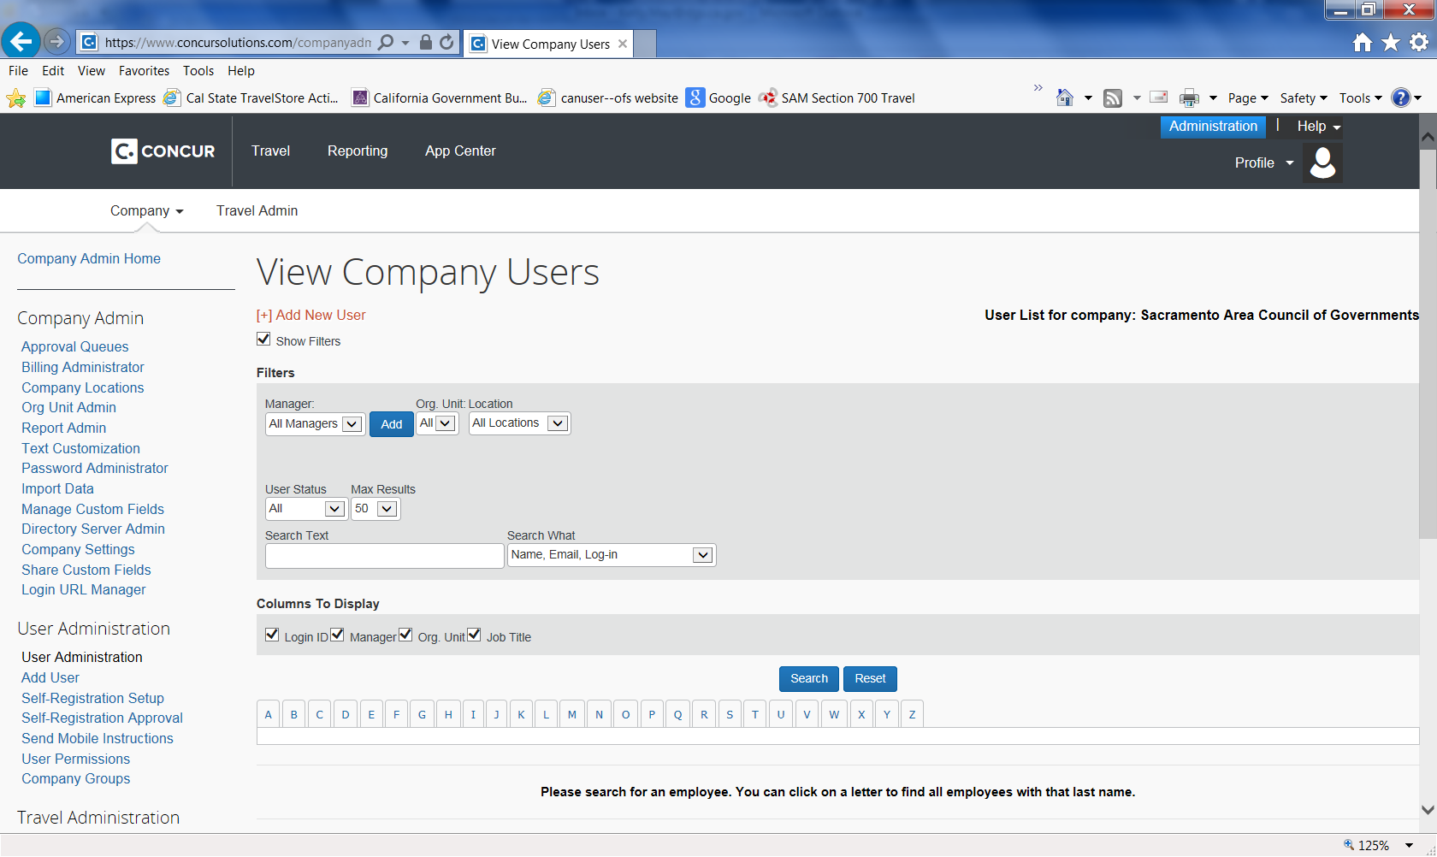
Click Add New User

- Enter the required information to add a new user as shown below:
  - CTE Login Name (must contain the ‘@’ symbol and is usually the user’s email address).
  - Enter the user’s temporary Password and then verify it in the Verify Password field (the password can be changed at any time after the first login).
  - Enter the appropriate information in the user’s First Name, Middle Name, and Last Name fields (must be the user’s legal name, and will be printed on any tickets they purchase through the system).
  - Enter the user’s email address in the Email Address field. NOTE: If you do not want the user/traveler to receive any email confirmations/traveler itineraries, enter in the travel arranger’s email address here.

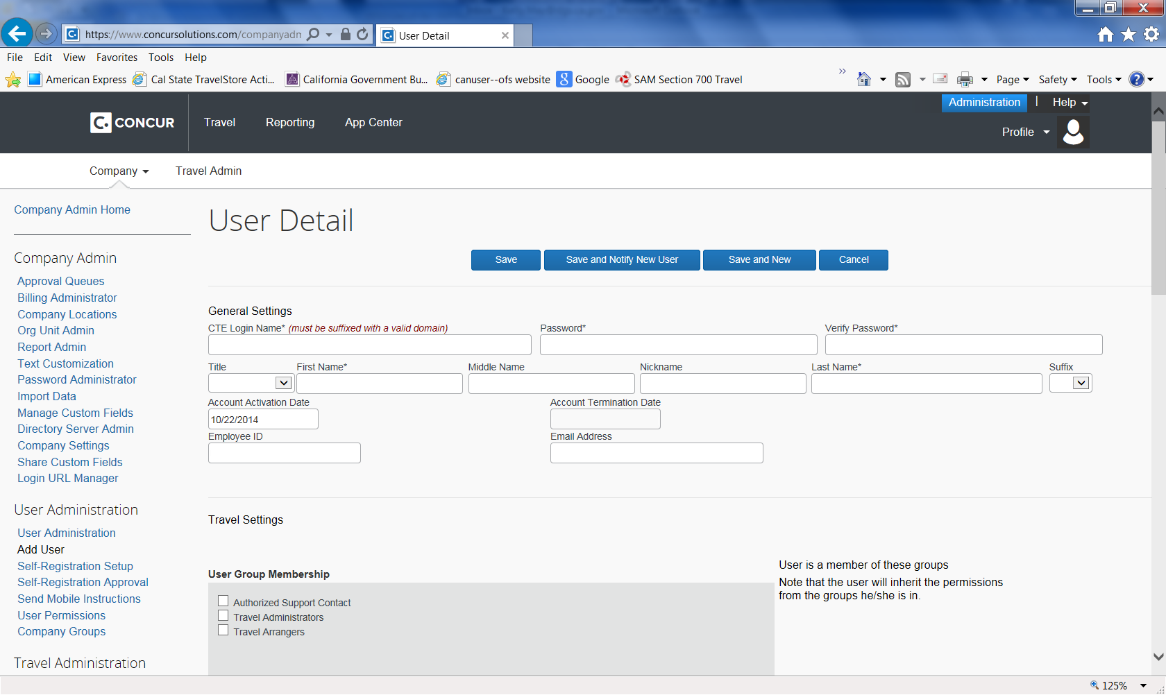
- Once you have entered the required information, you can click Save or Save and Notify New User.
  - ‘Save’ will save the profile. The traveler will not receive any email notification that a profile has been established for them. The traveler will not have access to Concur unless the temporary password has been provided to him/her.
  - ‘Save and Notify New User’ will send the traveler an email notification alerting them that a profile has been created, with a link to reset their password and access to log into Concur. Below is an example of the ‘Save and Notify New User’ function.
- Anytime a traveler needs to change or update their password, they can do so by clicking on Profile Settings, and then Change Password.
Click Change Password

Before you use Concur to book travel for the first time, update your profile and/or your traveler’s profile. You must save your profile and enter in all of the required fields before you first attempt to book a trip.

How to Delete a User in Concur

- Select User Administration. On the User Administration screen, search for the employee that needs to be deactivated.
- When the employee record is returned, click the employee’s name (it will be a hyperlink).
- In the CTE Login Name field, add .del or .old after the login name. This allows the proper login name to be used on another Concur site, if needed.
- In the Account Termination Date field, click the calendar icon.
- Use the calendar to select the date you want to the profile to be deactivated.
- Click Save.

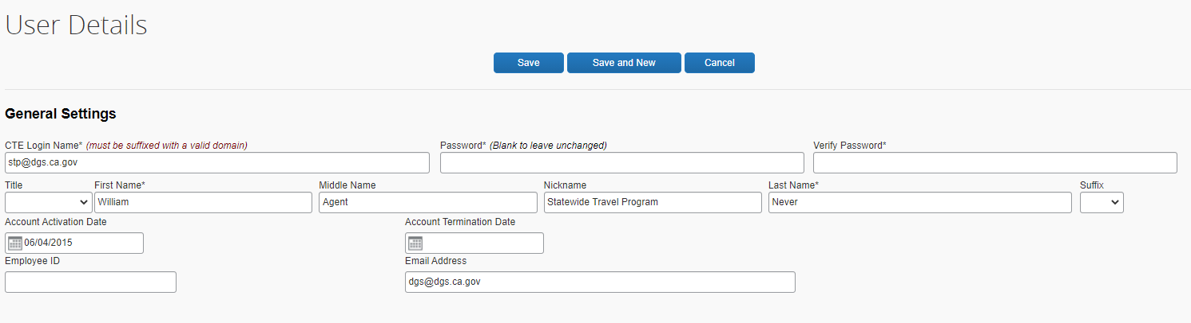
Select the date you want the profile to be deactivated

If you have additional questions about adding users to Concur or creating Concur profiles, please contact the DGS Statewide Travel Program main line at statewidetravelprogram@dgs.ca.gov or CalTravelStore at (877) 454-8785.

