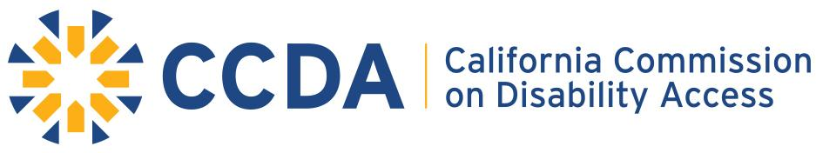
400 R Street, Sacramento, CA 95811 ~ direct 916-319-9974 ~ www.ccda.ca.gov

Draft ADA Community Dialogue/Listening Forum Sessions
In FY 18-19 CCDA will being the Outreach efforts within the Restaurant Industry.

General Overview
Focus Topics for the ADA Community Dialogue/Listening Forum Sessions
At all outreach events CCDA will provide attendees, through a facilitator lead panel presentation of SME and diverse businesses round table, engagement for an opportunity to interact on the listed topics:
- CASp Awareness
- ADA Funding Awareness
- Access Laws and Local Ordinances (Local ordinances of their region/city)
- Disability Awareness

Sample Format of Outreach Event
Morning Session: Listening Forum
Afternoon Session: Incubator Session and Interactive Activity of Reviewing the ADA Access Toolkit

