
Updated Resources for Business on CCDA Website
Home > California Commission on Disability Access > News >Valuation Threshold Updated for 2020
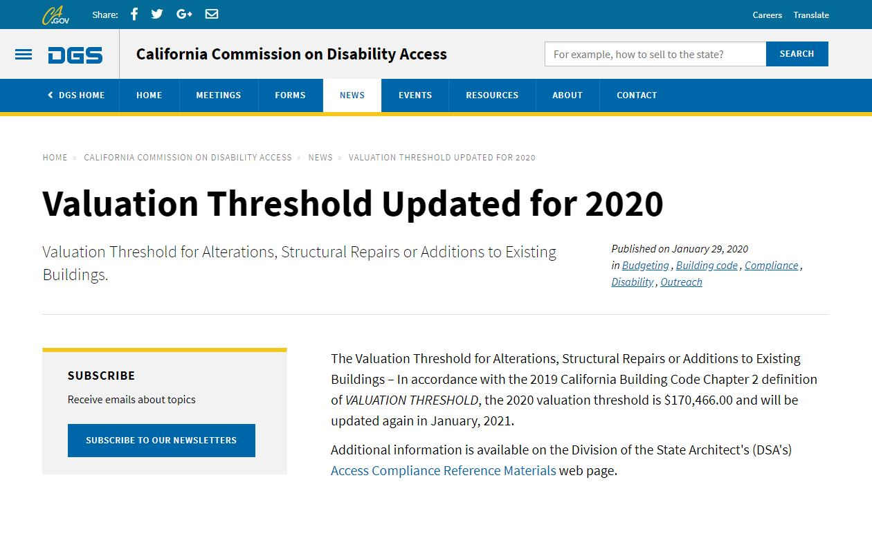
Home > California Commission on Disability Access > Resources > Disability Access Compliance Resources
