Third-Party Environmental Certifications by Category
Category | Commodity | Certifications
Building & Maintenance | Furniture | 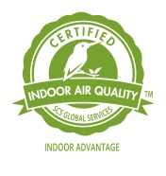SCS Indoor Advantage Gold, Office Furniture  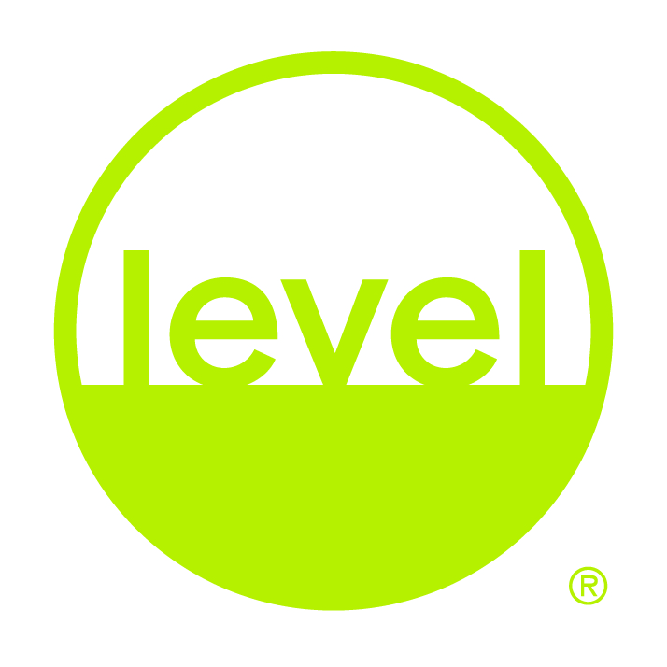BIFMA, level  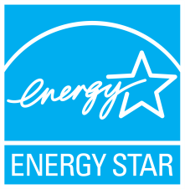ENERGY STAR
Building & Maintenance | Lamps | ENERGY STAR
Building & Maintenance | Indoor Paint | 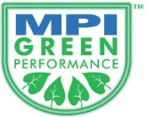 Master Painters Institute  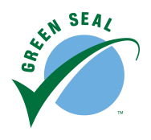 Green Seal
Building & Maintenance | Recycled Latex Exterior Paint | Master Painters Institute  Green Seal
Cleaning Supplies | Chemical Cleaners | Green Seal  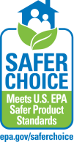 Safer Choice  EcoLogo UL
Food Supplies | Disposable Food Supplies | Green Seal  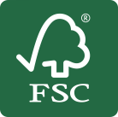 Forest Stewardship Council (FSC)  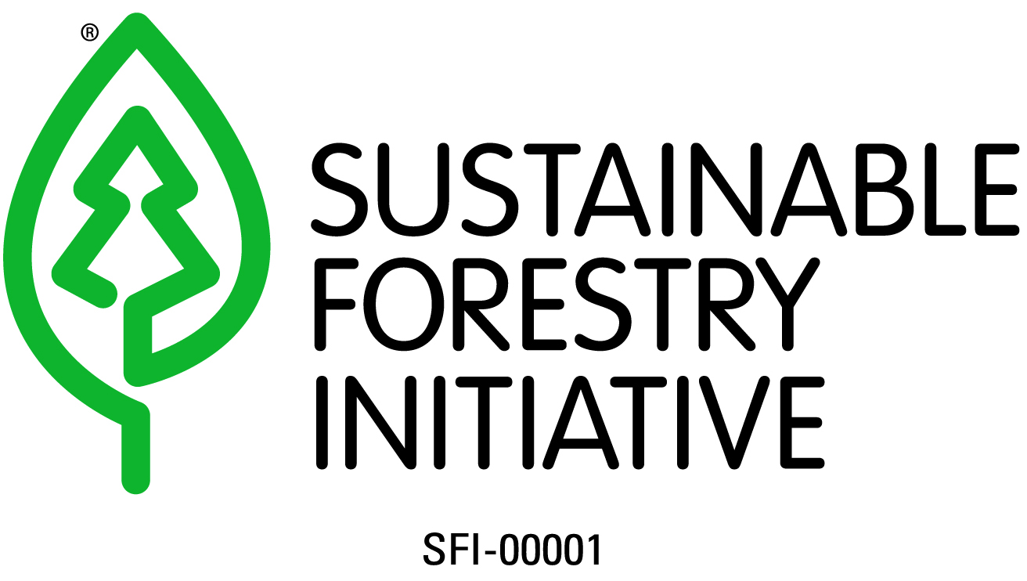 Sustainable Forestry Initiative (SFI)  Totally Chlorine Free (TCF)  Processed Chlorine Free (PCF)
Office Equipment | Entry & Mid-Level Data Storage | EU RoHS Compliant
Office Equipment | Enterprise Servers | EU RoHS Compliant
Office Equipment | Office Desk Lamps | ENERGY STAR
Office Equipment | Desktops, Laptops, Monitors |  EPEAT  ENERGY STAR  EU RoHS Compliant
Office Equipment | PC Servers | EU RoHS Compliant
Office Equipment | Printers & Multifunctional Devices | EPEAT  ENERGY STAR  EU RoHS Compliant  EcoLogo UL
Office Equipment | Televisions | EPEAT  ENERGY STAR
Paper Products | Grocery Paper Bags | Forest Stewardship Council (FSC)  Sustainable Forestry Initiative (SFI)
Paper Products | Newsprint | Forest Stewardship Council (FSC)  Sustainable Forestry Initiative (SFI)
Paper Products | Carbonless Rolls | Forest Stewardship Council (FSC)  Sustainable Forestry Initiative (SFI)
Paper Products | Printing & Writing Paper | Forest Stewardship Council (FSC)  Sustainable Forestry Initiative (SFI)
Paper Products | Recycled Bond Cut Stock | Forest Stewardship Council (FSC) Sustainable Forestry Initiative (SFI)
Paper Products | Continuous Feed Roll Stock | Forest Stewardship Council (FSC)  Sustainable Forestry Initiative (SFI)
Paper Products | Gloss, Matte Roll Stock and Recycled Gloss Sheets | Forest Stewardship Council (FSC)  Sustainable Forestry Initiative (SFI)
Paper Products | Recycled Paper Envelopes | Forest Stewardship Council (FSC)  Sustainable Forestry Initiative (SFI)
Paper Products | Janitorial Paper Products | Green Seal  EcoLogo UL

