**State Facility Drought Actions Matrix Instructions**

**Background**

Governor Brown’s [drought](http://gov.ca.gov/news.php?id=18368) proclamation charged the Department of General Services (DGS) with taking a leadership role to ensure that every effort is being made to conserve water across all state facilities.

To implement this directive, DGS surveyed all departments in February 2014 for information about what actions were being taken to conserve water at their respective facilities. That survey yielded more than 1,100 responses from 36 state departments and 35 district agricultural associations.

Now, DGS has converted these action plans into an online [reporting database](http://droughtactions.dgs.ca.gov/apex/f?p=101:101) to track their progress for the balance of the drought crisis.

**Checking Your Entries, Adding New Entries**

With this new tool in place, as well as some additional criteria now added for each entry, each department needs to check its submissions for accuracy and also insert any additional actions it has identified since the matrix was first distributed in February.

It is vital that departments verify the accuracy of actions included in the reporting database as this information will be distributed to the Drought Task Force and the governor’s office to be used for high-level decision making.

**Guidelines for Submissions**

* Departments should only submit actions that began after Governor Brown declared the drought state of emergency on January 17, 2014.
* So that DGS can capture which actions can be accomplished using existing resources, as well as what would be possible if additional funding were allotted, a field has been added asking whether the proposed action can be accomplished within existing funds. Additional information is available in the section below titled “Understanding the Fields.”

**Logging In**

To access the database, go to: [droughtactions.dgs.ca.gov](http://droughtactions.dgs.ca.gov/apex/f?p=101:101)

The first screen you will see is a login page:

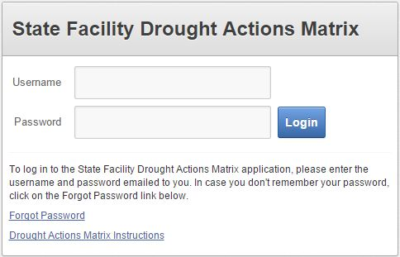

The database is password-protected and each department will receive login credentials via email from DGS. For convenience and simplicity, your organization has been provided with a single account to the Drought Actions application. It is intended to be shared amongst content managers for your organization. As this single account will be representative of your organization, using a vetting process for managing submitted content and users is highly recommended.

Please be advised that it is best to institute your own controls for access to this account. Individuals with access to this account will have the ability to make additions, changes and deletions to the State Facility Drought Actions Matrix. Controlling access to your shared account will ensure that the integrity of your organization’s contribution to this project remains intact.

The matrix is designed so that each department can edit its own submissions, but not those of other departments. However, you will have the ability to view other departments’ submissions for reference purposes.

If you have not yet received your login credential or are otherwise having trouble, please contact the DGS Office of Sustainability at [Sustainability@dgs.ca.gov](mailto:Sustainability@dgs.ca.gov).

**Using the Database Tool**

* The first data displayed upon login may not be your department’s data. If this is the case, search for your department by name or acronym using the Search field in the upper left corner:

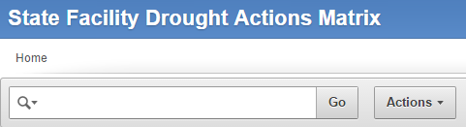

Please note that department names in the Facility Drought Actions Matrix are consistent with those listed at <http://ca.gov/Apps/Agencies.aspx>.

• To edit or update your entries, click on the “pencil tool” on the left side of the page.

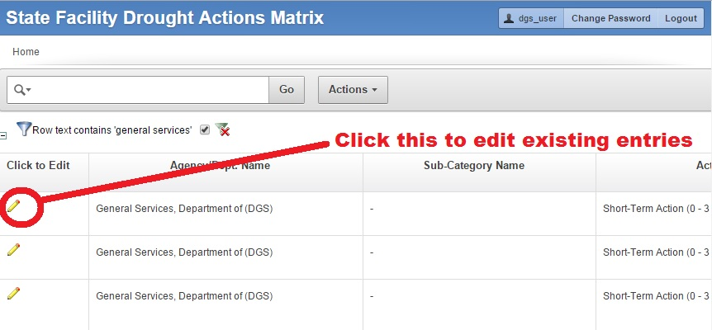

• To add a new entry click the blue “Create” button in the upper-right corner.

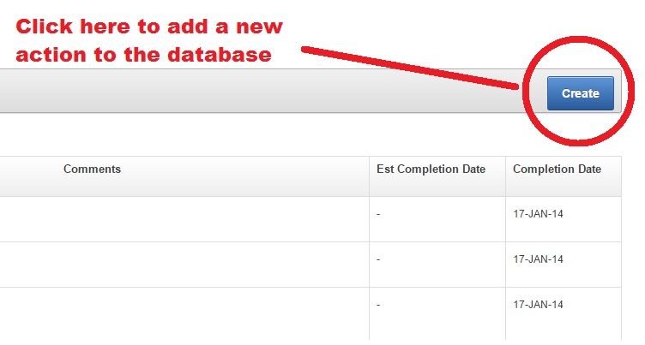

* Then fill out the data fields that are relevant for your action. Detailed information on the data fields is provided at the end of this document.

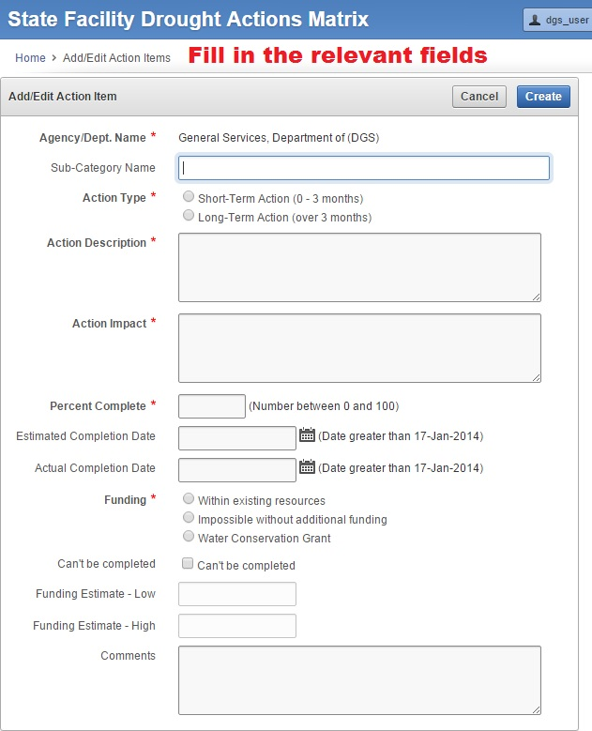

**Database Capabilities: Searching, Sorting and Running Reports**

The State Facility Drought Actions Matrix tool includes a number of useful functions, including sorting and running reports, which can be accessed by clicking the “Actions” button to the right of the search box.

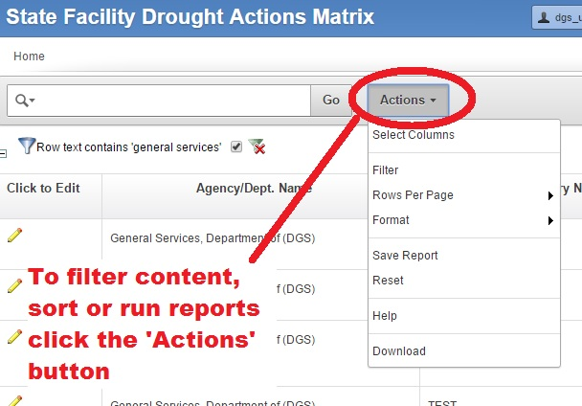

**Understanding the Fields**

Clicking on the title of a field will provide a brief description. When you create a new entry, fields marked with a red asterisk are required. You are strongly encouraged to complete optional fields, as feasible.

**Agency/Dept. Name**

Name of entity entering the action item. This field will be automatically completed based on the login you used to enter the State Facility Drought Actions Matrix.

**Sub-Category Name**

This field is optional. If the data originally provided by your agency/department was broken into sub-categories, the sub-category is indicated in this field. For example, the Department of State Hospitals (DSH) has a sub-category for “DSH – Napa.” Another example, the Department of General Services has a sub-category for “DGS – RESD” (RESD = Real Estate Services Division). Sub-categories can be added when new entries are created or when existing entries are modified.

**Action Type**

When creating a new entry, please select the appropriate Action Type. As indicated, Short-Term Actions are those that can be completed within 0-3 months. Long-Term Actions are those that will take over 3 months to complete.

If an action has both short- and long-term components, please enter the information as separate Action Items. For example, if your department plans to inventory fixtures and replace those that are leaking, you may enter a Short-Term Action (0-3 months) as “Inventory Fixtures” and a Long-Term Action (3-24 months) as “Replace Leaking Fixtures.”

**Action Description**

Please enter a brief description of the specific Action Item. Entries are limited to 500 characters, including spaces.

**Action Impact**

Please enter a brief description of less obvious, positive and/or negative impacts that may result from implementation of the identified Action Item. Entries are limited to 500 characters, including spaces.

**Percent Complete**

Please enter the current Percent Complete (0 – 100) for the Action Item. A Percent Complete of “0” indicates that implementation of the Action Item has not yet begun. A Percent Complete between “1” and “99” indicates that implementation of the Action Item is currently underway. A Percent Complete of “100” indicates that the Action Item is complete.

**Estimated Completion Date**

For Action Items with a Percent Complete between 0 and 99, please enter an Estimated Completion Date.

**Actual Completion Date**

For Action Items with a Percent Complete of 100, please enter an Actual Completion Date. If the Actual Completion Date is not known, please enter your best guess approximated Actual Completion Date.

The Actual Completion Date must be no later than the date of entry, and cannot be earlier than January 17, 2014 (the date of Governor Brown’s Drought Proclamation). If the Action Item you are attempting to enter was completed prior to January 17, 2014, please do not enter it in this database.

Please update this field with the correct date. Note: If the Action Item you are attempting to update was completed prior to January 17, 2014, please delete the Action Item from this database.

**Can’t Be Completed**

For Action Items with a Percent Complete of 0 and “Impossible without additional funding,” please select this option. If Action Item can’t be completed and or started, please select this option. Reasons why Action Item can’t be completed should be placed in the Comments column.

**Funding**

For new entries, please select whether the Action Item can be completed within existing resources, or if implementation of the Action Item will be impossible without additional funding. Please give careful consideration to your selection and do not select “Impossible without additional funding” unless the Action Item will not be implemented if no additional funding resources are identified.

If components of the Action Item can be implemented within existing resources, but other components will require additional funding, please enter the information as separate Action Items. For example, if your department plans to inventory landscape irrigation within existing resources, but replacing leaking systems will require additional funding, you may enter “Inventory Landscape Irrigation” as an Action Item to be implemented within existing resources, and “Replace Leaking Irrigation Systems” as a separate Action Item that is impossible to implement without additional funding.

For existing Action Item entries, please review and correct (if necessary) the default Funding selection. “Within existing resources” was selected as the default if your department did not specify a cost estimate for the Action Item. “Impossible without additional funding” was selected as the default if your department provided a cost estimate for the Action Item. It is critical that you ensure the correct Funding selection is made.

If Action Item was funded by the Water Conservation Grant, you must select “Water Conservation Grant.” This would indicate which action item is funded by the Water Conservation Grant.”

**Funding Estimate - Low**

If you indicated that the Action Item is impossible without additional funding, please enter a numerical, whole dollar value for the lower-range estimate of funds needed for implementation of the Action Item. If you are unsure of the funding amount required, please enter your best estimate. If you cannot estimate the funding amount, please leave the field blank and explain in the Comments field.

If you indicated that the Action Item can be implemented within existing resources, you will not be able to enter a Funds Estimate. It is not necessary to provide the cost of the Action Item if it can be implemented within existing resources.

**Funding Estimate - High**

If you indicated that the Action Item is impossible without additional funding, please enter a numerical, whole dollar value for the higher-range estimate of funds needed for implementation of the Action Item. If you have an exact funding estimate and do not need to provide a funding estimate range, please enter the same dollar value for “Funding Estimate - Low” and “Funding Estimate - High.” If you are unsure of the funding amount required, please enter your best estimate. If you cannot ballpark the funding estimate, please leave the field blank and explain in the Comments field.

If you indicated that the Action Item can be implemented within existing resources, you will not be able to enter a Funds Estimate. It is not necessary to provide the cost of the Action Item if it can be implemented within existing resources.

**Comments**

This field is optional. Please provide any additional information related to the Action Item, if needed. Entries are limited to 500 characters, including spaces.

*Please direct any questions or feedback on the State Facility Drought Actions Matrix to* [*Sustainability@dgs.ca.gov*](mailto:Sustainability@dgs.ca.gov)*.*