Revisions to SAM sections are provided after the summary table below, and are indicated with the “track changes” display through the revised text on all revised SAM pages. Highlighted content indicates newly added information to the SAM chapter. “Track Changes” are not inserted for format changes.
** Follow the link to the revised SAM Chapter **

CHAPTER/ SECTION | SUMMARY
Subject Index
Subject Index | Reintroduction of the SAM Subject Index.
Chapter 1
Section 0020 | Added SAM Subject Index to revision process: corrected typo; clarified hyperlink review.
Section 0030 | Update of SAM Author contact information for sections 30, 700-750, 753-780, 1600, 3500-3515, 3522.1-3590.5, 3600, and 5200.
Chapter 1330
Section 1330 | Added references and links to TOC.
Chapter 2800
Section 2810 | Updated to remove approval requirement as per MM16-06
Chapter 4100
Chapter 4100 Index | Added new section 4120.8
Section 4120.8 | New: abbreviated fleet acquisition process per Management Memo 17-02.
Chapter 4900
Section 4983 | Per TL 17-06, policy was updated to incorporate lessons learned from Cloud implementation.
Section 4983.1 | Per TL 17-06, section was updated to provide additional direction and information for all Agencies/state entities on cloud computing requirements including:  - Agencies/state entities are required to evaluate and use Infrastructure as a Service (IaaS) and Platform as a Service (PaaS) for all new technology, expansion or refresh initiatives.  - Agencies/state entities must acquire all IaaS and PaaS solutions through the California Department of Technology (CDT).  - Agencies/state entities must utilize the Department of General Services’ Cloud Computing Services Special Provisions when procuring commercial and/or government cloud services (SAM Section 4983.1).
Chapter 6800
Section 6806 | Modified wording to clarify that a program or activity should generally follow that classification’s expenditure rules for character of appropriations.

Chapter 7900
Section 7977  Illustration 2 | Updated Illustration 2.
Chapter 8400
Section 8452 | Revised to clarify information on the Plan of Financial Adjustment (PFA) process and add reference to section 8452.1. Deleted reference to section 8715. Minor edits.
Section 8452.1 | Minor edits
Section 8452.2 | Revised to clarify Finance’s review process for a PFA and minor edits.
Chapter 8700
Index and Section 8715 | Deleted section due to obsolete information on journal entries.

SAM—INTRODUCTION

SAM PUBLICATIONS AND CONTACTS
(R(Cevoinsetindu0e9d/)2016)
REVISING SAM 0020 (Cont. 1)
(Revised 09/2017)

Completing Revisions/Reviews to SAM
When it has been determined that revisions or reviews to the SAM are necessary, the following steps should be taken by the SAM Author and Coordinator to complete revisions/reviews:
Who | Step | Action(s) Taken
SAM Author | 1 | Receives working Word Version for SAM Chapter/Section(s) to be revised/reviewed from SAM Coordinator.
 | 2 | Reviews SAM Chapter/Section(s)  - If it is determined that content is current and still in practice, go to 2a
 | 2a | Gives authorization (via email) to SAM Coordinator to change reviewed date to current date. No further action required.
 | 3 | Revises SAM Chapter/Section(s) and completes the Revision Package sent from the SAM Coordinator (via email).  - Revision Package consists of the following:  - Author Revisions (Clean and Track Changes)  - Revision Summary (Two column table)  - Author Checklist (Form GS 237 authorization)  - Subject Index Changes (If necessary)
SAM Coordinator | 4 | Submits the Completed Revision Package to SAM Coordinator via email.
 | 5 | Receives Completed Revision Package and incorporates the Author Revisions into the Author Revision-Website Version.
 | 6 | Reviews cross-references in revised SAM material with Management Memorandums (MMs), Budget Letters (BLs), Technology Letters (TLs), and other mentioned agencies, departments, and sections to ensure accuracy and validity.
 | 7 | Sends Author-Draft Revision-Website Version back to SAM Author for Final Author Review

Rev. 435

(Continued)

SAM Sectin 30 – SAM Author Changes

0001-0030  Introduction | General Services, Office of Strategic Planning, Policy & Research (OSPPR) | State Administrative Manual (SAM)  & Management Memos  (MM) | Emin Nabiyev emin.nabiyev@dgs.ca.gov 916-376-5062
Jason Tyburczy Jason.tyburczy@dgs.ca.go v

916-376-5069

1600  Records Management | California Secretary of State (SOS) | www.sos.ca.gov | Rebecca Wendt Rebecca.wendt@sos.ca.gov 916-651-8420
Jenny Chakonova Jenny.chakonova@sos.ca.gov
Dennis Supachana dennis.supachana@sos.ca.gov 916-653-4329
Sydney Bailey Sydney.bailey@sos.ca.gov
Andrew Hyslop andrew.hyslop@sos.ca.gov 916-651-1368

(Continued)

SAM PUBLICATIONS AND CONTACTS
(Revised 09/2016)

SAM—INTRODUCTION

0030 (Cont. 2)

CHAPTER/ SECTIONS | DEPT. | RESOURCES | CONTACT INFORMATION
500-580  Advertising | General Services,  Office of State Publishing (OSP) | www.dgs.ca.gov/osp | Danielle Mahood Danielle.mahood@dgs.ca.gov 916-323-0309
 |  |  | Robin Erskine Robin.erskine@dgs.ca.gov 916-323-4301
700-750  753-780  Travel | California Department of Human Resources (CalHR) | www.calhr.ca.gov | Ray AsbellTheresa Reid Ray.asbell@calhr.ca.gov theresa.reid@calhr.ca.go
751-752  Travel | General Services, Risk & Insurance Mgmt.  (ORIM) | www.dgs.ca.gov/orim | Isabel Cortez-Raj Isabel.cortez@dgs.ca.gov 916-376-5297
900-911  Grants | Governor’s Office Planning & Research | www.gov.ca.gov | Scott Morgan Scott.morgan@opr.ca.gov 916-322-2318
912  Federal Grants | Finance,  Budget Operations Support | www.dof.ca.gov | 916-322-5540  foinbox@dof.ca.gov
1100-1107  Statewide Planning | Governor’s Office Planning and Research | www.gov.ca.gov | Scott Morgan Scott.morgan@opr.ca.gov 916-322-2318
1200-1233  Contracts | General Services, Legal Services (OLS) | www.dgs.ca.gov/ols | Richard Goldberg Richard.Goldberg@dgs.ca.gov 916-376-5108
1300  Real Estate Services Division (RESD) | General Services,  Real Estate Services Division (RESD) | www.dgs.ca.gov/resd | James Beck James.beck@dgs.ca.gov 916-375-4154
 |  |  | Karena Benskin Karena.benskin@dgs.ca.gov 916-375-4326

Rev. 4395

SAM - DGS FACILITIES MANAGEMENT DIVISION

Chapter 1330 INDEX

PROGRAM SUMMARY, RESOURCES, AND CONTACTS | 1330
Cost Of Services | 1330.1
Building Alterations | 1330.2
Use Of Buildings Outside Regular Working Hours | 1330.3
Parking In Loading Dock Areas Of State Buildings | 1330.4
Smoking In State Buildings | 1330.5
Office Plants | 1330.6
Display Of Art, Posters, And Notices In State Buildings | 1330.7
Purchase And Display Of Flags At State Buildings | 1330.8

Additional Building References
Standard Operating Procedures for Energy Management in State Buildings | 1805.3
State Buildings and Grounds Maintenance and Operation | 1821

SAM – PUBLISHING/PRINTING

HOW TO ORDER OSP SERVICES 2810
(Reviewed 12/2013)

Ordering Form. The requisitioning of printing and mailing is initiated by the use of a Printing/Support Service Order form, STD. 67. Facsimile or Internet transmissions are acceptable. The reverse side of STD. 67 provides instructions on how to complete the form. The STD 67 must have the name or signature of the person authorizing the expenditure. Effective February 11, 2010, no work will be initiated, no documents will be reviewed, and no contracts will be approved by the Department of General Services (DGS) that would result in the expenditure of funds unless the certification by the Agency’s Secretary or Department’s Director, or their designees, that the purchase is vital and mission critical for the agency or department making the purchase. For additional information, call (916) 322-1031.

Estimates. Upon request, OSP will provide cost estimates based upon the information available for budgeting or other purposes. Firm prices will be made only when all information and specifications are complete, or materials for printing or reproduction have been examined. All estimates and firm prices are valid for thirty calendar days.
OSP is subject to yearly rate changes.

Scheduling. The Printing Operations Unit will assist in working out non-standard schedules that are reasonable and attainable. Dependent upon material and labor resources available, a satisfactory solution or alternative may be worked out.

This chapter discusses the operational policies of all aspects of transportation services. This includes state-owned or operated mobile equipment, commercial vehicle rentals, airline transportation, parking and commuter services.

INTRODUCTION AND GARAGE OPERATIONS | 4100
MAINTENANCE | 4101
NO SMOKING IN STATE VEHICLES | 4102
MODIFICATIONS | 4103
IDENTIFICATION | 4104
UTILIZATION | 4105
PASSENGER MOBILE EQUIPMENT USAGE REPORT | 4106
TRAVEL LOGS | 4107
FUEL CARD MANAGEMENT | 4108
GENERAL SERVICES CHARGE CARD | 4108.1
HOME STORAGE | 4109
MOBILE EQUIPMENT PURCHASES | 4110
DISPOSITION | 4111
REUTILIZATION OR TRANSFER | 4112
INSPECTION SERVICES | 4113
ANNUAL INVENTORY OF MOBILE EQUIPMENT | 4114
REPAIRS AT COMMERCIAL/STATE FACILITIES | 4115
ACCIDENT REPAIRS | 4116

STATEWIDE TRAVEL MANAGEMENT PROGRAMS | 4117
AIRLINES | 4117.1
CAR RENTALS | 4117.2
TRAVEL AGENCIES | 4117.3
TRAVEL PAYMENT SYSTEM | 4117.4
PARKING AND COMMUTE SERVICES | 4118
ACQUISITION OF VEHICLES | 4120
FLEET ASSET REPORTING | 4120.1
PURCHASE ORDER STD. 65 & PURCHASE ESTIMATE STD. 66, 66A | 4120.2
FLEET ASSET APPROVAL EXPIRATION | 4120.3
ADDENDUMS | 4120.4
LEASES/RENTALS | 4120.5
TEMPORARY LEASES OF PASSENGER VEHICLES | 4120.6
SUBSTITUTIONS | 4120.7
ABBREVIATED FAP PROCESS FOR NON-LIGHT DUTY FLEET ASSETS | 4120.8
EXECUTIVE ORDER B-16-12 ZERO EMISSION PURCHASING MANDATE | 4121
DONATIONS AND GIFT OF FLEET ASSETS | 4123
VEHICLE INSPECTIONS | 4124
REPLACEMENT SCHEDULE CRITERIA | 4126

(New 083/2017)

Replacement mobile equipment and vehicles (fleet assets), excluding aircraft, having a gross vehicle weight rating (GVWR) of 8,501 pounds or more, may be processed through an abbreviated Fleet Acquisition Plan (FAP) process. This abbreviated process replaces the traditional FAP Memo narrative with a shortened approval form and authorizes approval of eligible fleet asset acquisition requests by the Chief of the Department of General Services (DGS), Office of Fleet and Asset Management (OFAM) or by the Deputy Director of the DGS Intgeragency Support Division, as applicable. All requested fleet assets must still meet all applicable fleet policies and requirements.

To use the abbreviated FAP process agencies will need to submit a complete FAP in the same manner they do now; combined with both light-duty asset (assets having a GVWR of 8,500 pounds or lower) and additional fleet asset requests. OFAM will identify the assets that meet the abbreviated process criteria, and will separate them out onto their own abbreviated FAP.

In addition, state agencies shall certify on the Fleet Acquisition Certification, in accordance with State Administrative Manual Section 4120, that a utilization analysis was conducted on all fleet assets that are like-type to those being processed through the abbreviated process, and that no assets could be redirected to meet that replacement fleet asset need. The utilization analysis shall be conducted and retained according to the following criteria:

- Utilization analyses shall be conducted using the provided Fleet Utilization Analysis Template, and shall contain, at minimum, the following information:

  - Each like type fleet asset included in the analysis with asset make and model, model year, equipment number and VIN
  - Annual mileage or hours, as applicable
  - Annual days used
  - The applicable minimum annual utilization standard, as listed by department on the Fleet Utilization Analysis Template, and days used for each vehicle type
  - Each asset clearly marked with which standard it meets
  - Justifications detailing why underutilized assets are not available to be redirected and what measures the department is taking to ensure best fleet management practices are implemented to increase utilization of the fleet asset
  - The 12 month timeframe the utilization analysis covered, which shall be based on either the prior 12 months, or the previous calendar year

- A copy of the utilization analysis shall be retained by the conducting agency for a period of three years.

- OFAM may, at any time, request a copy of the utilization analysis completed for a specified FAP.
- State agencies not in compliance with the required utilization analysis standards and document retention requirements, may have their eligibility for the abbreviated FAP process revoked.

Fleet assets eligible to be processed through the abbreviated process are subject to the FAP due dates and timeframes noted in SAM Section 4127.

INTRODUCTION 4983
(Revised 6/201578/2017)

In recent years, Cloud Computing is has emerged as an effective important solutionmethod for the cost effectivesecure, agile and reliable delivery of IT services. Cloud Computing will play a major role in improving the delivery of government services in the State of California. Cloud computing enables business programs to enhance service delivery while ensuring the underlying technologies are transparent, ubiquitous, and interchangeable.

To harness the benefits of cCloud cComputing, the State of California has adopted this Cloud Computing Policy. Agencies/state entities shall adopt a “Cloud First” policy. This policy is intended to accelerate the pace at which the Agencies/state entities will realize the benefits of cloud computing while adequately addressing relevant statutory and policy requirements associated with State IT systems, including information security and risk management, privacy, legal issues, and other applicable requirements. As such, Agencies/state entities must evaluate Cloud Computing as an alternative for all reportable and non-reportable IT projects. Whenever feasible, Agencies/state entities must utilize cloud services provided by the Office of Technology Services (OTech). If required services are not available through OTech, Agencies/state entities must utilize other commercially available Software as a Service (SaaS), Platform as a Service (PaaS), or Infrastructure as a Service (IaaS) cloud service models when feasible and cost effective. Additionally, Agencies/state entities must utilize the Department of General Services’ Cloud Computing Services Special Provisions when procuring commercial cloud services.

POLICY 4983.1
(Reviewed Revised 7/20176/2015)

As part of the Cloud ComputingFirst policy, each Agency/state entity shall:
- Evaluate Evaluate, in consultation with their IT organization secure cloud computing alternatives for all IT projects and infrastructure initiatives (e.g., storage, servers, and Wide Area Network equipment).solution options for all new reportable and non-reportable IT projects.
- Use a cloud service model, i.e., Cloud Software as a Service (SaaS), Cloud Platform as a Service (PaaS), or Cloud Infrastructure as a Service (IaaS), for all new reportable and non-reportable IT projects whenever a feasible and cost effective solution is available. that meets the Agency/state entity requirements, and provides the required level of security, performance and availability, and isThe use of cloud services must be consistent with the factors described in SAM 4981.1.
- Use IaaS or PaaS solutions for new, expansion or refresh initiatives. cloud services provided through the Office of Technology Services (OTech) as the first choice cloud computing solution for all new IT projects. If required services are not available through OTech, use other commercially available SaaS, PaaS or IaaS solutions.
- Use IaaS and PaaS solutions provided through the California Department of Technology (CDT). Requests shall be submitted to CDT through a Remedy Service Request. If using a commercially available SaaS service model, utilize it for commodity applications such as office productivity tools, virtual desktop, customer relationship management, human resources management, finance, project management, open data, and inventory management (refer to National Institute of Standards and Technology (NIST) Special Publication 800-146 for candidate SaaS application classes). Use a PaaS or an IaaS service model for all other application categories when feasible.
- If required IaaS or PaaS solutions are not available through CDT, CDT will partner with the Department of General Services (DGS) to determine the best procurement method. Classify the data managed by the applications that utilize cloud service models in accordance with SAM 5305.5.
- Use SaaS solutions provided through CDT, e.g., all office productivity software (including email*), or through DGS’ Software Licensing Program (SLP), when implementing commercial and/or government SaaS cloud computing solutions.

*Per Chapter 404, Statutes of 2010 (Assembly Bill 2408), all Agencies/state entities within the executive branch that are under the direct authority of the Governor must consolidate to the state’s share e-mail solution. Ensure compliance with the security provisions of the SAM (Chapters 5100 and 5300)

and the SIMM (Sections 58C, 58D, 66B, 5305A, 5310A and B, 5325A and B, 5330A, B and C, 5340A, B and C, 5360B).

6.7. If
required SaaS solutions are not provided through CDT, Agencies/state entities may acquire other commercial and/or government SaaS solutions.Based on data classification pursuant to SAM 5305.5, ensure compliance with relevant security provisions including those in the California Information Practices Act (Civil Code Section 1798 et seq.), Internal Revenue Service (IRS) Publication 1075, Social Security Administration (SSA) Electronic Information Exchange Security Requirements, Payment Card Industry Data Security Standard (PCI DSS) including the PCI DSS Cloud Computing Guidelines, Health Insurance Portability and Accountability Act (HIPAA) Security Rule, Health Information Technology for Economic and Clinical Health (HITECH) Act, and Criminal Justice Information Services (CJIS) Security Policy.

(Continued)

(Continued)
POLICY 4983.1 (Cont. 1)
(Revised 6/2015)

7.8. If
an Agency/state entity determines that the use of a cloud service solution is not feasible, or the required solution is not provided through CDT, they shall submit an exemption request to CDT for approval. The Cloud Computing Exemption Process is defined in Statewide Information Management Manual (SIMM) 18.Ensure appropriate level of compliance with the Federal Risk and Authorization Management Program (FedRAMP) certification for all IT projects using commercial cloud solutions where federal funding is involved.
8.9. C
lassify the data managed by the applications that utilize cloud service models in accordance with SAM 5305.5.Ensure that the commercial cloud service provider’s Standards for Attestation Engagements No. 16 Service Organization Control (SOC) 2 Type II report along with the cloud service provider’s plan to correct any negative findings is available to the Agency/state entity.
9.10. E
nsure compliance with the security provisions of the SAM (Chapters 5100 and 5300) and the SIMM (Sections 58C, 58D, 66B, 5305A, 5310A and B, 5325A and B, 5330A, B and C, 5340A, B and C, 5360B). that the confidential, sensitive or personal information is encrypted in accordance with SAM 5350.1 and SIMM 5305-A, and at the necessary level of encryption for the data classification pursuant to SAM 5305.5.
10.11. B
ased on data classification pursuant to SAM 5305.5, eEnsure compliance with relevant security provisions including those in the California Information Practices Act (Civil Code Section 1798 et seq.), Internal Revenue Service (IRS) Publication 1075, Social Security Administration (SSA) Electronic Information Exchange Security Requirements, Payment Card Industry Data Security Standard (PCI DSS) including the PCI DSS Cloud Computing Guidelines, Health Insurance Portability and Accountability Act (HIPAA) Security Rule, Health Information Technology for Economic and Clinical Health (HITECH) Act, and Criminal Justice Information Services (CJIS) Security Policy. that written agreements with cloud service providers address SAM 5305.8 provisions, and SaaS service agreements include the Department of General Services’ Cloud Computing Services Special Provisions.
11.12. E
nsure that the commercial and/or government cloud service provider’s Standards for Attestation Engagements No.16 Service Organization Control (SOC) 2 Type II report along with the cloud service provider’s plan to correct any negative findings is available to the Agency/state entity.physical location of the data center

where the data is stored is within the continental United States, and remote access to data from outside the continental United States is prohibited unless approved in advance by the State Chief Information Security Officer.
12.13. E
nsure that all confidential, sensitive or personal information is encrypted in accordance with SAM 5350.1 and SIMM 5305-A, and at the necessary level of encryption for the data classification pursuant to SAM 5305.5.Maintain an exit strategy for IT projects that utilize a commercially available SaaS service model. The exit strategy includes the Agency’s/state entity’s ability to export data in pre- defined formats and maintaining, when needed, a current backup of the data in the Tier III-equivalent data center facility designated to the Agency/state entity by SAM 4982.1 and unrelated to the cloud provider.
- Ensure cloud service agreements include all of the DGS’ Cloud Computing Services Special Provisions, and all written agreements with cloud service providers address SAM 5305.8 provisions. Maintain an effective incident response and mitigation capability for security and privacy incidents in accordance with SAM 5340. Report suspected and actual security incidents in accordance with the criteria and procedures set forth in SIMM 5340-A and other applicable laws and regulations.
- Ensure that the physical location of the data center, where the data is stored, is within the continental United States, and remote access to data from outside the continental United States is prohibited unless approved in advance by the State Chief Information Security Officer.
- Maintain an exit strategy for IT solutions that utilizes a commercial and/or government cloud service. The exit strategy must include the Agency’s/state entity’s ability to export data in pre-defined formats and maintain, when needed, a current backup of the data in the Agency/state entity’s designated Tier III- equivalent data center facility. Designated data center facilities must be unrelated to the cloud provider; data center assignments are described in SAM 4982.1
- Maintain an effective incident response and mitigation capability for security and privacy incidents in accordance with SAM 5340. Report suspected and actual security incidents in accordance with the criteria and procedures set forth in SIMM 5340-A and other applicable laws and regulations.

CAPITAL OUTLAY VERSUS STATE OPERATIONS AND
LOCAL ASSISTANCE 6806
(Revised 5/199889/2017)
The state appropriates funds in three broad classifications—state operations (support), local assistance, and capital outlay—referred to as the character of appropriation.
Unless statutory language specifically allows otherwise, once budgeted as one of the three characters, a program or activity must should generally follow that classification’s expenditure rules.
Infrastructure management uses all three characters of appropriation, depending on the activity. The general rule is that the acquisition/creation/renovation of real assets is classified as capital outlay if the state holds ownership. Operation and maintenance of state real assets is classified as state operations. State-funded but locally-owned infrastructure is classified as local assistance.
Certain types of leasing activities—called capitalized leasing—which are funded as state operations can also result in a capital acquisition. As used in this chapter, the term capitalized assets covers both traditional capital outlay as well as capitalized leasing. (Reminder: Capitalized assets are to be reported to the DGS Statewide Property Inventory [SPI] Unit for inclusion in the SPI.)
Exception to the prohibition against using support funds for capital outlay: Section 6.00 of the Budget Act provides a limited exception to the rule that support funds may not be used for capital outlay purposes. This section allows up to $35,000 of support funds to be encumbered for preliminary plans, working drawings, or construction of any project for the alteration of a state-owned facility (Section 6.00 does not apply to leased facilities). This amount may be exceeded only if:
- DOF determines the proposed alteration is critical and the use of a higher level of support funds is necessary; and
- The maximum cost of the project does not exceed $250,000.

DOF must notify the Legislature not less than 30 days in advance when approving more than $35,000 in support funding for a capital project. Section 6807 on minor capital outlay describes the approval process for projects of more than $35,000.
Guidelines for determining character of appropriation: The following discussion and table are intended as a guide to assist departments in determining whether an activity should be budgeted as capital outlay, support, or local assistance.

Capital outlay: Section 3.00 of the Budget Act defines capital outlay as “acquisition of land or other real property, major construction, improvements, equipment, designs, working plans, specifications, repairs, and equipment necessary in connection with a construction or improvement project” (emphasis added). Administratively, capital outlay is defined as:
- Any real property acquisition or new construction.

(Continued)

6806 (Cont. 1)
(Continued)

CAPITAL OUTLAY VERSUS STATE OPERATIONS AND LOCAL ASSISTANCE
(Revised 5/199889/2017)
- Any alteration, renovation, addition or betterment (including interior asbestos removal/remodeling) which extends the design life or alters/upgrades the function of a structure.
  - This does not include repairs and maintenance, which are intended to keep a facility functional at its designed level of services and life expectancy.

  - “Alteration” means any modification of existing space (buildings, structures or other facilities) that changes the use as to function, layout, capacity, or quality. Typical alterations include demolition of fixed partitions and/or construction of new fixed partitions or initial installation of carpeting and movable partitions. However, there are two instances in which alterations may be done with state operations funding:

    - In a leased space situation, the landlord generally makes the alterations and amortizes them through the lease. The lease, including increases for amortized alterations or lump-sum payment for alterations, is a state operations expense subject to the support budget review process; and

    - As noted in preceding text, Section 6.00 of the Budget Act allows the use of the support appropriation for alterations, within specified limits.

“Betterment” means any modification that increases the designed level of services or life expectancy of a facility or other state infrastructure (e.g. seismic improvements, upgrades, etc.).
- Fixed and movable equipment needed for initial occupancy of a new facility or space, but usually only if the new facility is not replacing an existing facility (see 6806 Illustration). Fixed equipment is referred to as Group 1 equipment, and movable equipment is referred to as Group 2 equipment (Section 6855).

(Continued)

(Revised 5/199889/2017)

- A lease-purchase (installment payment) agreement because equity is built as payments are made. Although the actual lease payments will be budgeted in state operations, the transaction is a capitalized assets acquisition.
All planned lease-purchases, whether authorized through the budget or special legislation, must be included in the department’s five-year capitalized assets plan. If the lease-purchase will be authorized through the Budget Act, a COBCP is required to verify economic benefits, whether or not there is a related support BCP for lease costs. (For lease-purchase agreements authorized through special legislation, DOF may require information similar in content to a COBCP at the proposed legislation stage.) These requirements apply to lease-purchases for state infrastructure financed through a joint powers authority, another level of government, or a private developer (Sections 6818 and 6820).
- Both the request for, and the exercise of, a purchase option. A lease with a purchase option gives the state the right, during the course of the lease, to purchase the asset for a predetermined price, if desired, which is a capital outlay acquisition. Adding a purchase option in a lease agreement is considered initiating a potential capital outlay acquisition. Although the lease payments prior to the exercise of the option are classified as state operations, the potential acquisition must be tracked as part of the department’s overall capitalized asset plan. Therefore, if authorization is sought through the Budget Act, anticipated purchase options and their exercise must both be presented for review as COBCPs, subject to dollar thresholds noted in Sections 6818 and 6820. Regardless of method of authorization, the planned use of purchase options must be included in the department’s five-year capitalized assets plan.
- Generally, the following are not considered as capital outlay: relocation (including temporary “swing space” while a project is under construction) and moving expenses, although DOF may authorize moving expenses as a capital outlay cost on an exception basis.

(Continued)

State operations: The following facility-related expenses are classified as state operations:
- Equipment not included in the complement necessary for initial operation of a new construction or renovation project.
- Movable equipment for new employees or new programs that are not part of a capital outlay project. (Such equipment is budgeted as an operating expense in the department’s support budget when the positions or programs are authorized.)
- Replacement equipment items (regardless of amount).

- Repair projects, including special repairs, not connected with a construction or improvement project. Examples of special repair projects include repainting, reroofing, electrical rewiring, plumbing repairs, dredging of river or stream beds to restore original flow capacity, replacing old equipment items, and road repairs. (Regardless of amount, “special repairs” are budgeted in the client department’s state operations appropriation.)
- Maintenance, including deferred maintenance. Maintenance is budgeted as “facilities operations” in the client department’s operating expense schedule.

- Relocation—including temporary “swing” space—and moving expenses, whether or not related to a capital outlay project. (However, DOF may authorize exceptions to this rule.)

- Lease or rental costs, and any associated budget requests. (However, as noted in the preceding text, capitalized leasing must be reflected in the five-year capitalized asset plan and COBCPs are required under specified conditions per Section 6818.)
- Generally NOT alterations in state-owned buildings, except as provided in Section
6.00 of the Budget (see preceding). In leased facilities, support funds may be used for alterations.
Local assistance is: The following infrastructure-related expense is classified as local assistance:

1. Grants to local agencies for the operation, maintenance, and acquisition or development of facilities or land, provided the local entity retains ownership after completion of the project.
(Continued)

ILLUSTRATION DISTINCTION BETWEEN CAPITAL OUTLAY AND STATE OPERATIONS
 | STATE OPERATIONS | CAPITAL OUTLAY
DESCRIPTION OF PROJECT 1/ | OPERATING EXPENSES AND EQUIPMENT | PROJECT LEVEL MINOR PROJECTS | PROJECT LEVEL MAJOR PROJECTS
Construction projects: New construction, alteration 2/ ,extension or betterment of existing structure.  (Construction projects include necessary Group I fixed equipment.) |  | If $250,000 or less and scheduled as minor projects in Budget Act3/ | In excess of  $250,000 3/
Repair and maintenance projects:  Repair and maintenance projects that continue the usability of a facility at its designed level of services | Irrespective of amount
Equipment (Group II, movable) projects (Section 6855):  - If related to a specific construction project.  - New equipment to meet program needs and not related to a construction project; replacement of existing equipment even though the new equipment is to be used in a new facility. | Irrespective of amount |  | Irrespective of amount or time of purchase
(Continued)

ILLUSTRATION DISTINCTION BETWEEN CAPITAL OUTLAY AND STATE OPERATIONS
 | STATE OPERATIONS | CAPITAL OUTLAY
DESCRIPTION OF PROJECT 1/ | OPERATING EXPENSES AND EQUIPMENT | PROJECT LEVEL MINOR PROJECTS | PROJECT LEVEL MAJOR PROJECTS
Purchase of land and/or facility/structure:  Including related costs such as condemnation and court costs, legal fees, and title reports etc. |  |  | Irrespective of amount
Capitalized leases of real property: All leases which build equity as payments are made. (Section 6818): ‘  - Lease-purchase  - A lease with purchase option agreement or amend an existing lease to add a purchase option  - Any other capitalized lease per Section 6818 | The lease payments are budgeted in support appropriation. Use a support BCP to request a budget increase. However, a coordinated capital outlay review is also required. |  | Transaction is reviewed for infrastructure cost/benefits because the property is acquired—or may be acquired—as a result of the lease. Submit a COBCP when requesting authority through the Budget Act, per Section 6818.
Operating leases of real property: Pure leases that do not build up equity as payments are made (Section 6876). | Irrespective of amount
(Continued)

ILLUSTRATION DISTINCTION BETWEEN CAPITAL OUTLAY AND STATE OPERATIONS
 | STATE OPERATIONS | CAPITAL OUTLAY
DESCRIPTION OF PROJECT 1/ | OPERATING EXPENSES AND EQUIPMENT | PROJECT LEVEL MINOR PROJECTS | PROJECT LEVEL MAJOR PROJECTS
Exercise of purchase option for currently rented or leased space (Section 6820) |  |  | Irrespective of amount
Relocation and moving costs  - Unrelated to a specific construction project.  - Related to a specific construction project. | Irrespective of amount Irrespective of amount 4/
Technical assistance/consultants This may include studies, master planning, feasibility studies, program management, and budget packages. | Depends on timing and nature/scope of activities. |  | Budget packages are generally capital outlay; other studies and assistance depend on timing and nature/scope of activities.

1/ State-funded but locally-owned infrastructure is classified as local assistance.
2/ Control Section 6.00 allows the use of limited support appropriations for the alterations of state-owned facility. 3/ See Public Contract Code Section 10108.5 for exceptions.
4/ DOF may authorize exceptions to this rule.

SAM⎯RECONCILIATIONS AND REPORTS
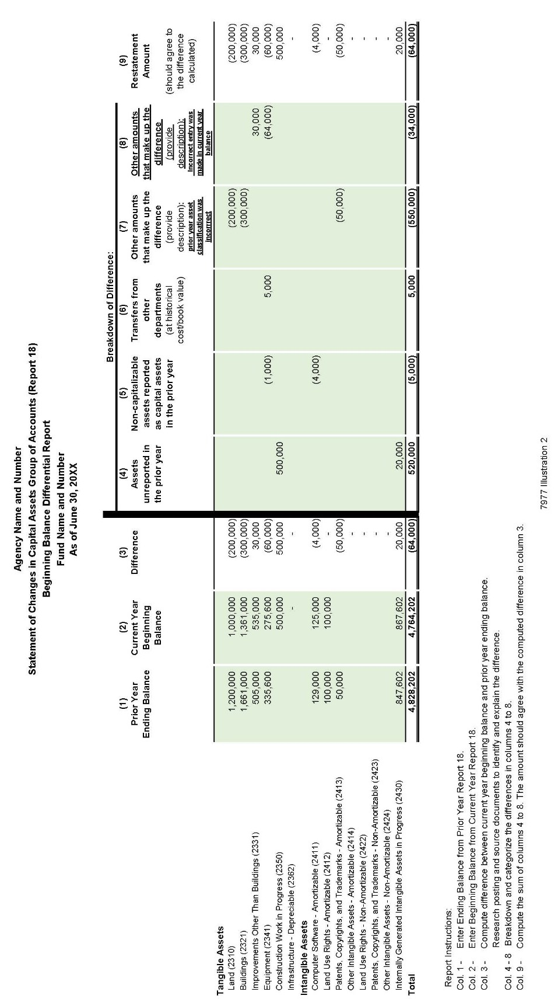

7977 Illustration 2

REV. 439

SAM - DISBURSEMENTS

PLANS OF FINANCIAL ADJUSTMENT 8452
(Revised 5/201589/2017)

A Plan of Financial Adjustment (PFA) is a plan proposed by a state department, approved by the Department of Finance (FINANCE) and the State Controller’s Office ( SCO), to allocate costs paid from one fund or appropriation to other funds or appropriations. For example, a department might pay all administrative costs out of its main fund and then transfer the applicable costs to the correct funds or appropriations for their share of the total costs paid The purpose of a PFA is to eliminate the use of multiple claim schedules for an invoice or payroll charge applicable to more than one fund or appropriation. . See SAM section 8452.1 for preparation of a PFA and section 8452.2 for approval of a PFA. If approved, the SCO transfers the funds as prescribed in the PFA. See SAM section 8452.2 for Approval of Plan of Financial Adjustment.
A PFA eliminates the use of multiple claim schedules for an invoice or payroll charge applicable to more than one fund or appropriation. Approved PFAs are used as the authority forto transfer of expenditures (financial adjustment) between appropriations of the same fund or between appropriations of different funds. GenerallyFor example, a department will record expenditures in their main fund throughout the month. At month end, the department will perform cost allocation/fund split and record the expenditures in the ultimate funds. The state department will provide SCO a written request called the Transaction Request, Form CA 504, which to transfers expenditures in accordance with the department’s approved PFA letter authority. The SCO will process the Transaction Request and notify departments byissue a Jjournal Eentry to the department for the financial adjustment. of the transfers. See SAM section 8715 for accounting treatment of PFAs.
PFAs will not be used to: provide working capital advances, overcome cash flow problems, or distort interest earnings between funds. Generally, financial adjustments are made on a monthly basis but could be more frequently if needed. Transfer of expenditures between funds will be made on an estimated basis when a material interest earnings loss will occur in the fund from which payments are made.
In accordance with law and principles of governmental accounting, departments are required to maintain separate accountability for each fund and/or appropriation covered by the PFA. All PFAs, expenditure transfers, and supporting documentation are subject to audit by the California State Auditor’s Office and SCO, Audits Division.

Rev. 430

PREPARATION OF PLAN OF FINANCIAL ADJUSTMENT 8452.1
(Revised 5/201598/2017)
Government Code (GC) section 11251 is the general statute that authorizes the use of a general PFA. Other sStatutes which authorize the use of a PFA for specific federal funds are:
Government CodeGC section 16365 for the Federal Trust Fund; Education Code section 12060 for the Vocational Education Federal Fund; and Health and Safety Code section 100390 for the Public Health Federal Fund.
The format for a general PFA is shown in Illustration 1 in SAM section 8452.1 and for the Federal Trust Fundfederal funds, Illustration 2. Each PFA must follow this format; however, statute references, funds, and appropriations will vary. If the PFA includes both general and Federal Trust Fundfederal fundss, follow SAM section 8452.1 Illustration 2 and include Government CodeGC section 11251 in the first paragraph 1. Each PFA requested under Government Code section 11251 will only need approval from the State Controller’s Office (SCO). SeeRefer to SAM section 8452.2 for Approval of Plan of Financial Adjustment.
The following items are to be included in a PFA:
- The first paragraph should include a request for approval of PFA, and a statement of the period of time for which PFA is to be effective. This period of time can be for a limited period (one, two, three years) or it can be continuous from year-to-year as shown in SAM section 8452.1 Illustration 1 indicates. (Departments should review their PFA each year and update as necessary. If and cancel thosethe PFAs which is are no longer needed, by nnotify theing SCO and Finance budget analyst. , in all cases, and Finance only for those requiring their approval).
- Identify the funds and/or appropriations covered by PFA. If PFA is to be continuous and one of the appropriations covered by the plan is appropriated yearly, care should be taken to identify the yearly appropriation and not the specific appropriation of a

particular year. For example, the ten11 digit item code (ex. 8860 _- 0001) numbers of a support appropriation should be used to identify a
001-

department's yearly support appropriation and not the year and chapter number of the current budget act. If the appropriation covered is made by other than budget act legislation, the year and chapter must be stated.
2.3. Also to be included is aA declaration by the department that a cost allocation plan will be used to allocate the costs covered by the PFA. A description of the cost allocation plan and the types of costs covered must be filed with the SCO. Those departments that have more than one PFA only need to file one cost allocation plan description unless a different plan is utilized for each different PFA. The description should include the type of costs being allocated and the methodology used to allocate the costs. Refer to SAM Chapter 9200 for guidelines on allocating costs. Although

these sections refer to allocating line-item costs to programs, the same principles apply to allocating shared costs between funds and/or appropriations.

Rev. 430

PREPARATION OF PLAN OF FINANCIAL ADJUSTMENT 8452.1 (Cont. 1)
(Revised 5/201598/2017)
costs to programs, the same principles apply to allocating shared costs between funds and/or appropriations.
  - The frequency of transfer requests between the funds and/or appropriations covered by the PFA must be included. Transfers must be made monthly should be on a monthly basis but can be more frequent if needed. and the period covered by the transfer must be clearly stated. For example, if an estimated transfer is submitted for July, it must indicate JULY ESTIMATES. When the estimate is cleared, the transfer request must indicate JULY ACTUAL.
Refer to SAM section 8452.2 for Approval of Plan of Financial Adjustment.
(Continued)

Rev. 430
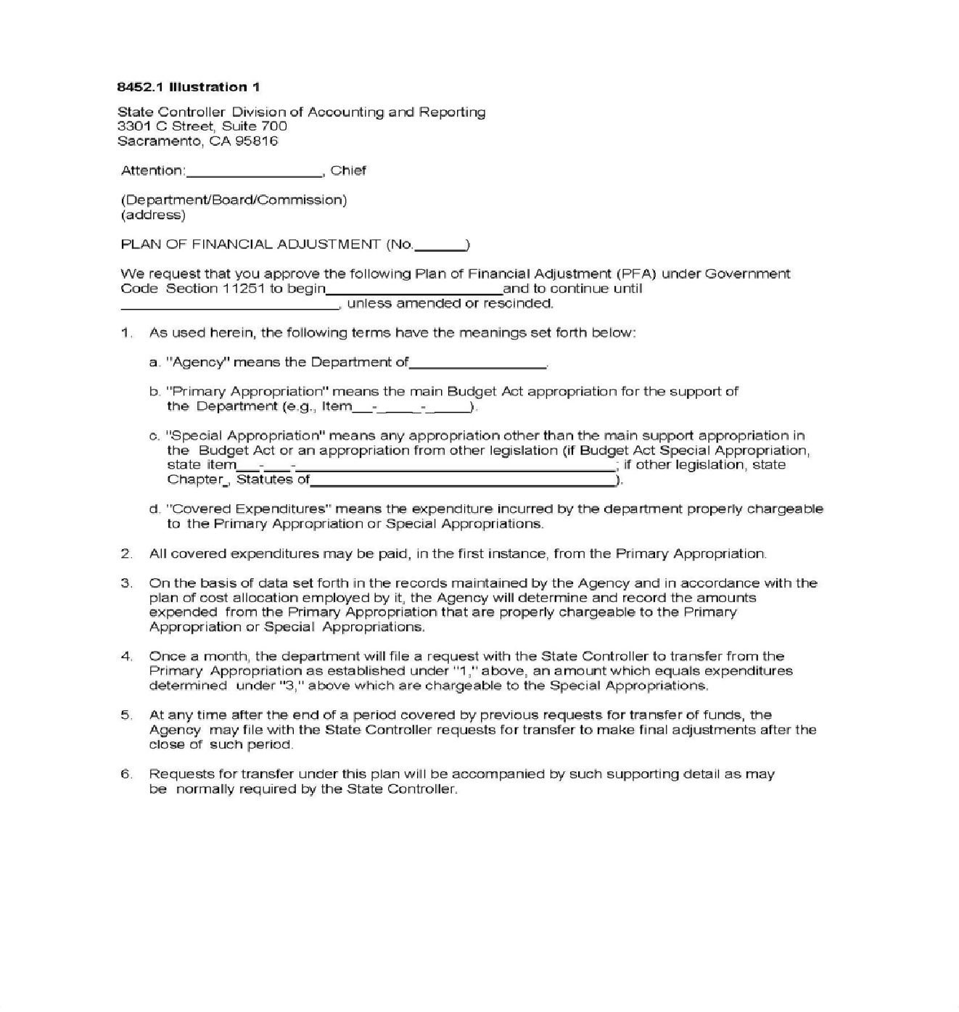

Rev. 430

(8452.1 Illustration 1, page 1)

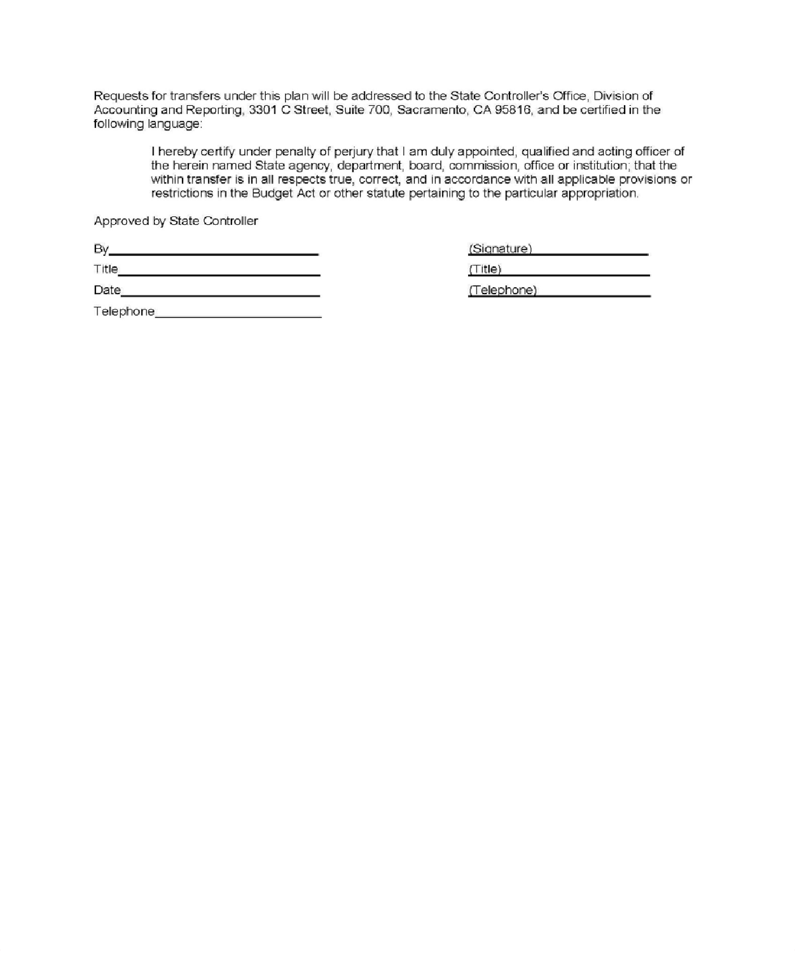

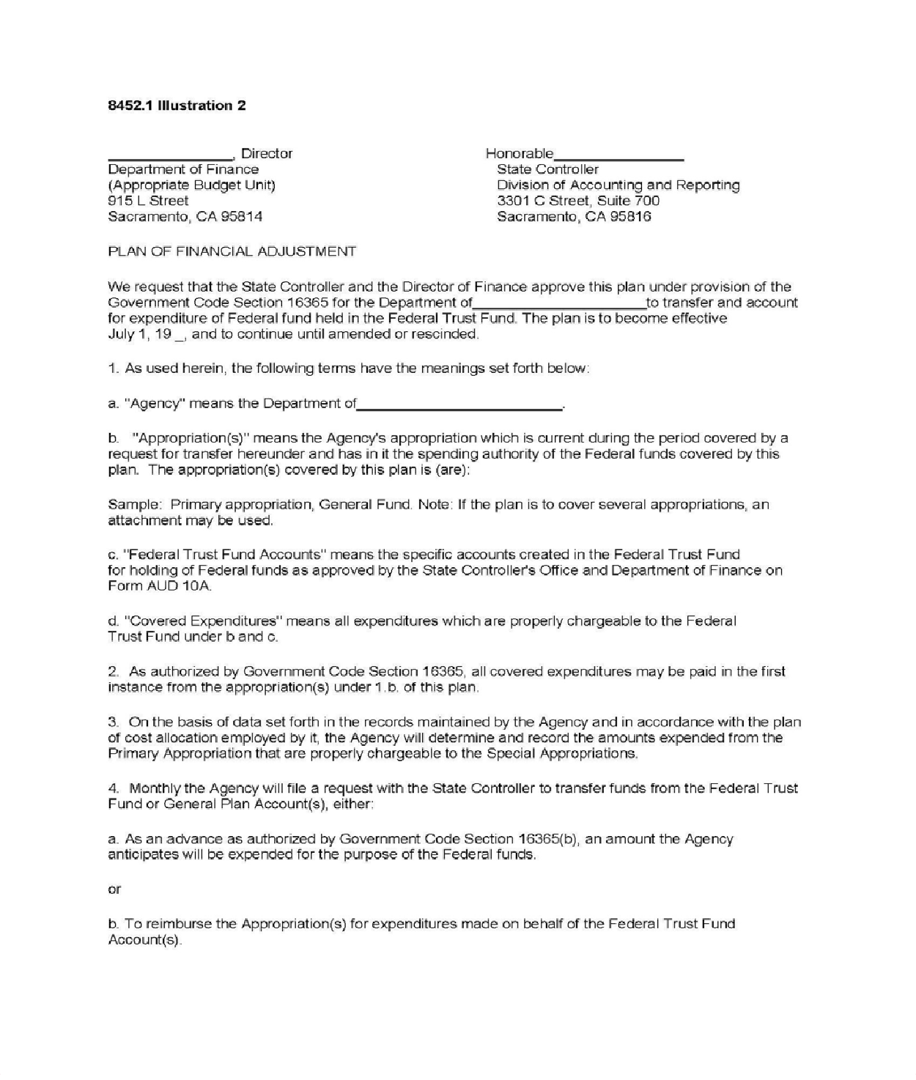

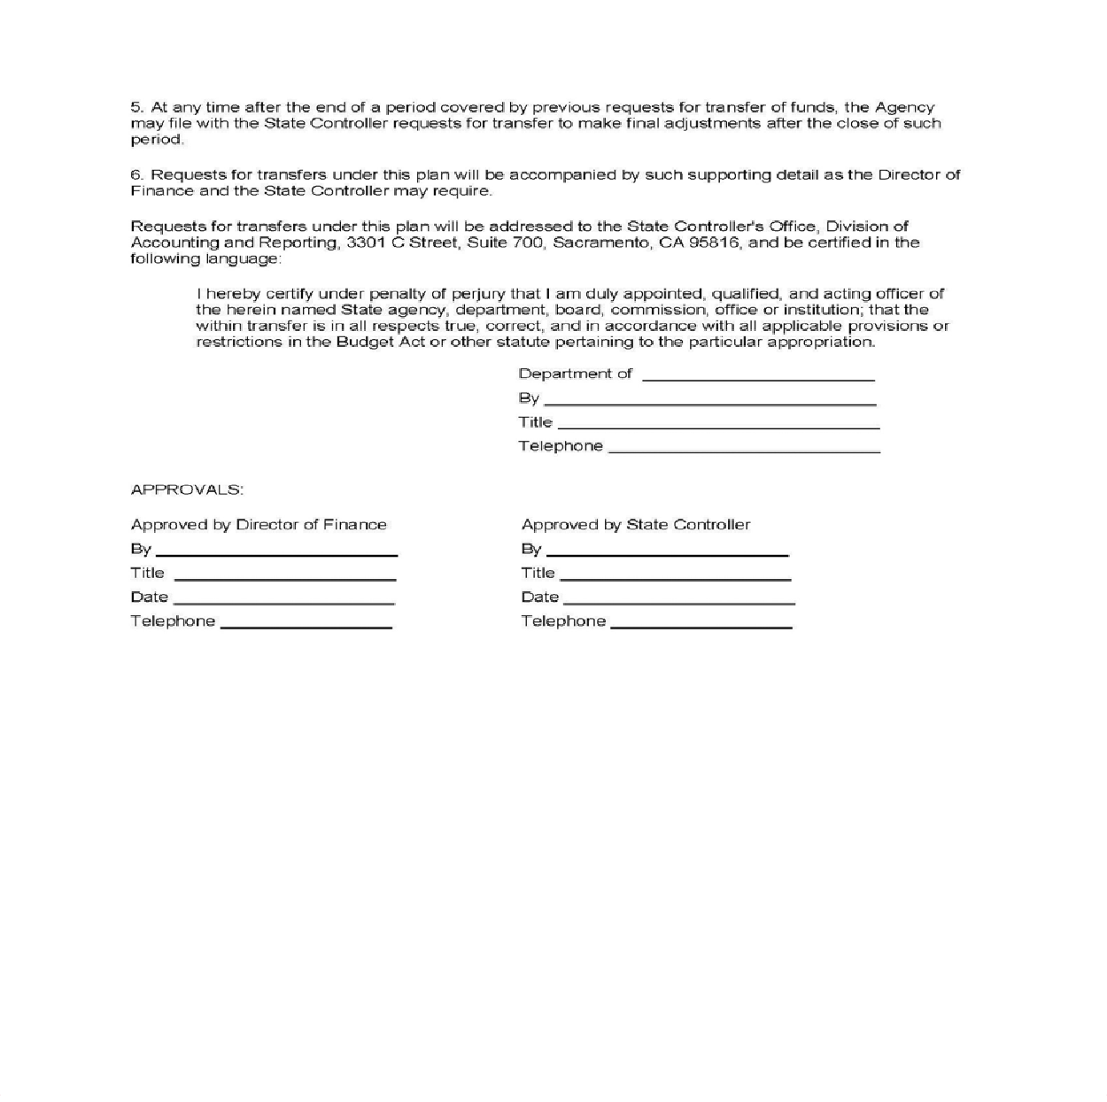

SAM - DISBURSEMENTS
APPROVAL OF PLAN OF FINANCIAL ADJUSTMENT 8452.2
(Revised 5/201598/2017)
Listed below are the types of Plan of Financial Adjustment (PFA) and the approval process:

General PFA
Government Code (GC) section 11251 authorizes the use of a general PFA. The following statutes authorize the use of PFAs and require approval by the Director of
Finance and the SCO: Government Code section 16365; Education Code section 12060; and the Health and Safety Code section 100390. Government Code section 11251 for general PFA requires only the approval of the SCO, after consultation with Finance. See SAM section 8452.1 for Preparation of Financial Adjustment.

Departments will submit the original proposed PFA to the SCO, Division of Accounting and Reporting. That office will review the proposed plan for proper format and confirm appropriations covered therein. The SCO will provide Finance’s budget analyst with a copy of the proposed plan for review and comment.

Federal PFA
The following statutes authorize the use of a PFA for these specific funds:
    - GC section 16365 – Federal Trust Fund
    - Education Code section 12060 – Vocational Education Federal Fund
    - Health and Safety Code section 100390 – Public Health Federal Fund

1. Proposed PFAs for Federal Trust Fund operations will be submitted directly to Finance's budget analyst for approval. Finance will then forward the Federal Trust Fund PFA to the SCO for final approval and distribution. If the proposed PFA includes both general and Federal Trust Funds, then submit directly to Finance.
2.

3. Upon approval, the SCO will return an approved copy of the PFA to the submitting department.
Combination (General and Federal) PFA
Authorizing statutes are provided above.

Approval Process
Departments will submit their original proposed PFA to the Finance budget analyst for review and approval. Finance will review the PFA to validate that the appropriation items are consistent with authorized legislation for expenditures (i.e., the Budget Act, special appropriations, and/or department’s legislative authority). If approved, Finance will forward the signed original PFA to SCO for final approval and distribution.

For all approved PFAs, the SCO will return an approved copy of the PFA to the submitting department and the Finance budget analyst.

Rev. 430

SAM—MISCELLANEOUS ACCOUNTING PROCEDURES

CHAPTER 8700 INDEX

General | 8700
Real Property Acquisition | 8705
Department of General Services | 8710
Record Credit Card | 8711.1
Billing Requirements | 8711.2
Verification Of Transportation Invoices | 8711.3
Tort Liability Payment Procedure | 8712
Plans Of Financial Adjustment | 8715
Sales Tax | 8720
Seller’s Permit | 8721
Non-Taxable Sales | 8722
Accounting For Sales Tax | 8725
Use Tax | 8730
Recording Data Used To Determine Consumer’s Use Tax | 8731
Payment Of Consumer Use Tax | 8732
Accounting For Use Tax | 8733
Application Of State-Administered Uniform Local Sales Taxes To State Agency Sales | 8734.1
Application Of State-Administered Uniform Local Use Taxes | 8734.3
Accounting And Reporting State-Administered Uniform Local Sales And Use Taxes | 8734.5
State-Administered District Transactions (Sales) And Use Taxes | 8735
Application Of State-Administered District Transactions (Sales) Tax To State Agency | 8735.1
(Continued)

