** Click on the Chapter Number to be taken to the actual SAM Chapter **

ITEM | SUMMARY
CHAPTER 1
Section 0025 | Changed Department of Personnel Administration to California Department of Human Resources (CalHR).  Added California Department of Technology (CTA).
CHAPTER 100
Section 190 | Several changes in the paragraph that follows bullet #7 under Employees. The suggested changes are meant to provide greater clarity with regard to the medical treatment of injured employees.
Section 191 | Employee Physical Exams: Changes in Paragraphs 4 to delete “State Personnel Board and replace it with “California Department of Human Resources” in the initial reference and “CalHR” replaces “SPB” in subsequent references. AB 1068; Jones-Sawyer (Chapter 427, Statutes of 2013) will take effect in January, 2014. This bill moves the responsibility for the Medical and Psychological Screening programs from SPB to CalHR as denoted in the Governor’s Reorganization Plan #1 for Human Resources functions.
 | Change in 5th paragraph reference to “DHS” to “DHCS” to reflect the correct acronym for the California Department of Health Care Services.
 | Change in paragraph 5 to update a reference to “DPA” – the Department of Personnel Administration, which has now been changed to CalHR through Governor Brown’s GRP 1 and AB 1062 which was the technical clean-up bill.
 | Remove 2nd and 3rd paragraphs. They are outdated.
 | Remove specific amount in statute which appears to be outdated information and is set in MOUs by DHCS.
Section 192 | Change in the last 3 paragraphs references to “DHS” to “DHCS” to reflect the correct acronym for the California Department of Health Care Services.
CHAPTER 700
Section 752 | Included additional language which was deleted from section 2580.2
CHAPTER 900
Section 900-910 | Reviewed
Section 911 | Minor additions and deletions to the grant process. No longer assign grant numbers for grant applications and only cover page required.
Section 912 | Reviewed and updated the Appendices A-D
CHAPTER 1300
Section 1328 | Revised Title Block to reflect current organization
 | Revised entire section to reflect current organization structure and program
Section 1328.1 | Revised Title Block to reflect current unit name
 | Revised entire section to reflect current organizational structure and program
Section 1328.12 | Revised entire section to reflect current organizational structure and program

ITEM | SUMMARY
CHAPTER 2400
Section 2400 A-1 thru A-3 | Added the current STD 268, 269 and 270
Section 2410 | Changed DPA to CalHR
Section 2420 | Incorporated verbiage pertaining to Peace Officers and Insurance Code section 557.5
Section 2430 | Added claim’s email address as another form of reporting, amended phone numbers, made grammatical error correction.
CHAPTER 2500
Section 2591 | Asbestos Notification to Employees - revised
CHAPTER 3500
Section 3500 | Revised Content
Section 3501-3502 | Deleted
Section 3504 | Deleted Sub Purchase Order
Section 3504.2 | Deleted section and added reference to SCM
Section 3506 | Deleted section and added reference to SCM
Section 3510 | Revised Content
Section 3520 | Replaced SAM section 4171-4175 with 4111 & 4112. Updated to include electronic submittal of STD 152.
Section 3520.2-3520.3 | Reviewed and updated form STD 152 & 158.
Section 3520.4-3520.9 | Reviewed and updated form STD 152.
Section 3521-3522.1 | Reviewed
Section 3533 | Redirected to PD website
Section 3566 | Redirected to SCM website
Section 3566.1 | Revised Content
Section 3570-3572 | Deleted
Section 3573, 3574.2,  3575-3575.1 | Removed Sub Purchase Order

ITEM | SUMMARY
CHAPTER 4700
Section 4700 | 1st paragraph: after “established in 1950” change to read:  to recognize employee contributions to State government.
 | Added new paragraph describing the Employee Suggestion Program.
 | 3rd paragraph (previously 2nd paragraph) removed words “also”, “performance resulting in “ and “improving”
 | 4th paragraph, reworded the Medal of Valor program so matches wording on Governor’s website, and capitalized State so to be consistent
 | Added new paragraph describing the 25 year service/retirement award
Section 4702 | Changed DPA to CalHR
 | Remove Government Code Section 19816 and added 19849.9
Section 4705 | Changed contact phone number from Kari’s number to mine.
 | Added web address directly linking reader to the MAP website
 | And added CalHR homepage web address
CHAPTER 7900
Section 7930 | Added submission of Dishonored Checks for Agency Accounts to STO on July 31.
Section 7951 | Updated list of required year-end reports as follows:  - Added new requirement of Report No. 6 for Non- Governmental Cost Funds.  - Removed distribution of Report No. 14 to Department of Finance, Fiscal Systems and Consulting Unit.
Section 7976 | Illustrations have been updated to remove SCO-MyCalPAYS statewide assessment and make minor edits.
CHAPTER 8400
Section 8426.1 | Added links to content for form STD. 435 and updated Illustrations
Section 8452.1 | Corrected Illustrations 1 & 2
Section 8453 | Corrected Duplication of Illustrations
CHAPTER 8600
Section 8643 | Corrected references to SAM Section 5300.  Corrected the dept. name of where the Security Incident Report must be submitted.

ITEM | SUMMARY
CHAPTER 8700
Section 8705 | Revised Real Property Acquisition Chapter
Section 8740 | Revised to update the state employee billing rates for 20141
Section 8753 | Revised for the following:  - California Technology Agency name change to California Department of Technology.  - CALSTARS function change from “Both” to “SWCAP Only”.  - Minor edits.
Section 8776.6 | Revised for the following:  - Adds language to allow departments the option of sending one collection letter for nonemployee accounts receivable  $25 and under  - Adds certification language requirements for departments to request approval to discharge amounts of $500 or less  - Minor edits
SUBJECT INDEX
Updated | Pages: 4, 6, 7, 11, 13-14, 16, 18

1 Section 8740 adheres to an annual update schedule outside of the regular quarterly SAM updates.

SAM - INTRODUCTION
MANAGEMENT MEMOS 0025
(Revised 3/14)
The Governor’s Office (GO), California Department of Technology (CalTech), Department of Finance (DOF), Department of General Services (DGS), and California Department of Human Resources (CalHR) issue SAM Management Memos to disseminate information directly related to SAM requiring immediate attention. A Management Memo is signed by the issuing departmental director. Generally, Management Memos expire within 12 months from the issue date. Management Memos are distributed to SAM subscribers and departmental headquarters offices. Active Management Memos may be accessed on the Internet at: http://www.dgs.ca.gov.
A department which wants to develop a Management Memo should contact the SAM Unit to ensure that the Management Memo process is the appropriate communications vehicle. The SAM Unit can consult in the Management Memo process and alternative processes.

Rev. 425 MARCH 2014

MEDICAL AND HOSPITAL SERVICES PROVIDED BY STATE INSTITUTIONS
(Revised 12/13) 0190

Extensive medical and hospital services should only be provided to the inmates, wards, patients, members or students for whom the State-operated medical facilities were established. This is because of physical and policy limitations.

Employees. Limited care and treatment of employee injuries and illness is permitted. In this case the medical staff, equipment, materials, and hospital services may be used. The illness or injury must be reported to arise out of and occur during the course of State employment. They also must be within the scope of the State's liability as defined by Workers' Compensation and Safety Laws. The following are considered to be reasonable services:

- First aid treatment.

- First medical treatment of a work injury.

- Diagnosis and prognosis of conditions connected with work.

- Arrangement for further treatment.

- Evaluation of the physical ability of an injured employee to return to work.
- Pre-employment and periodic physical exams for fitness and ability to safely perform arduous and hazardous tasks.
- Preventive measures such as chest x-rays, lab tests, immunization and other measures that will minimize hazards of exposure to contagious diseases while at work.

Medical treatment of industrial injuries should be limited to the initial visit and any follow-up visit that would be considered first aid. Additional visits should be handled according to the applicable workers compensation guidelines. In the case of an injury that will results in temporary disability or a permanent disability, or will require hospitalization, employees should be directed to an appropriate physician in accordance with applicable workers’ compensation guidelines. See SAM Sections 2581.4 through 2581.6 for procedures on reporting employee work injuries.

Visitors. First aid is the only medical service that should be given to visitors who become ill or are injured while on state property. Medical personnel must be certain that one of the following has occurred before the visitor is discharged:

- The visitor has been transferred to another physician.

- A friend or relative has accepted responsibility for further care.

- The visitor can properly take care of himself or herself if no further medical attention is needed.

(Continued)

MEDICAL AND HOSPITAL SERVICES PROVIDED BY STATE INSTITUTIONS
(Revised 12/13) 0190 (Cont. 1)

State agencies are responsible for carrying out the policies of this SAM Section.

When outside physicians or ambulances are called, it should be made clear to the visitor that the visitor, and not the state, is responsible for the costs of all medical care, treatment, and other provided services.

When the visitor alleges injury or was involved in an accident on state property, Accident Report form, STD. 268
must be filled out. See Appendix A-1. SAM Section 2460 explains the reporting procedures.

Records. Complete records must be kept of all first aid services rendered at state medical facilities. The records must fully identify:

- The person treated.
- The date of the injury or illness.
- The full diagnosis.
- The reason the treatment was needed; i.e., a description of the accident, etc.
- The services rendered, including drugs and supplies used.

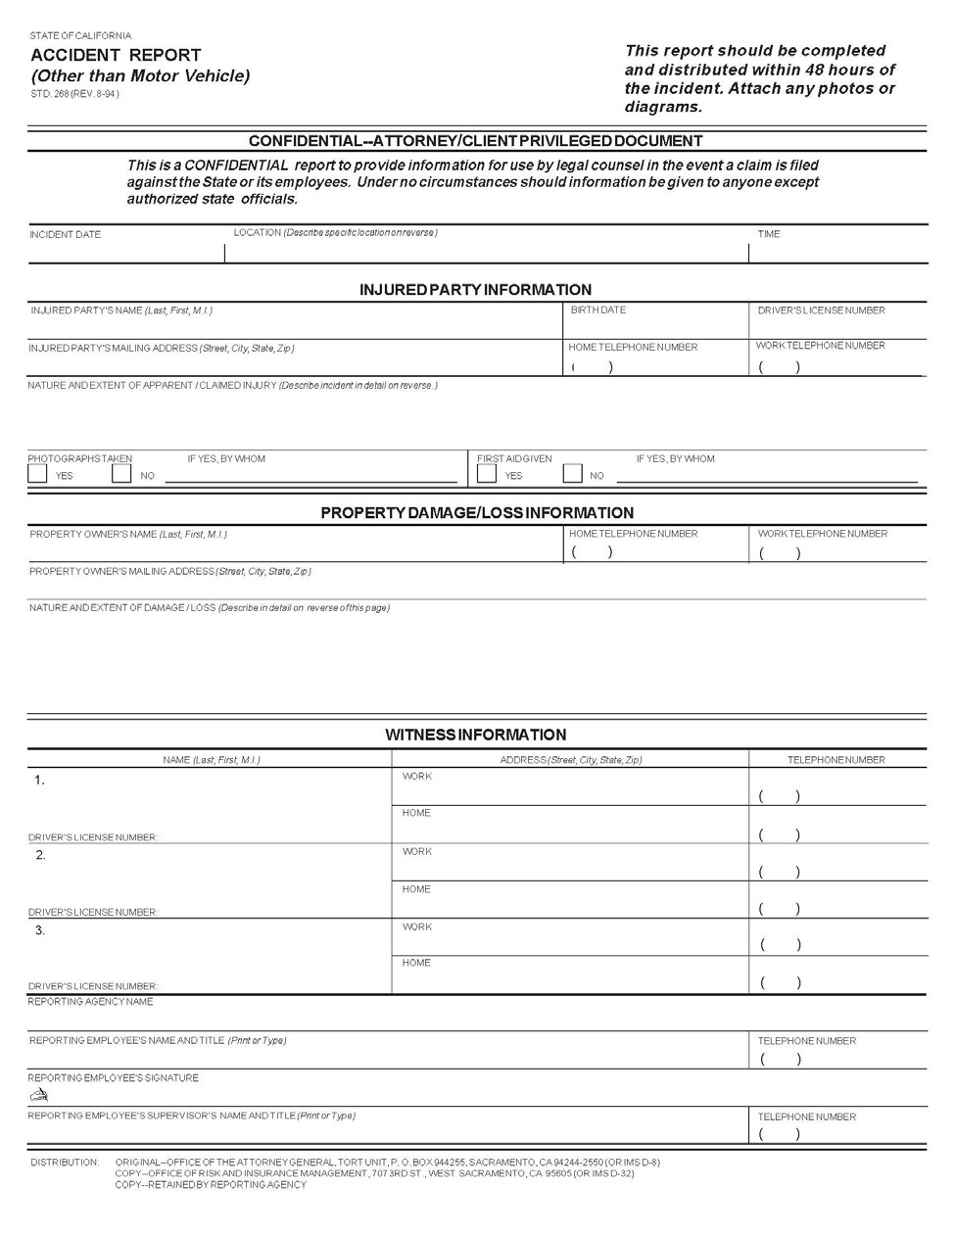

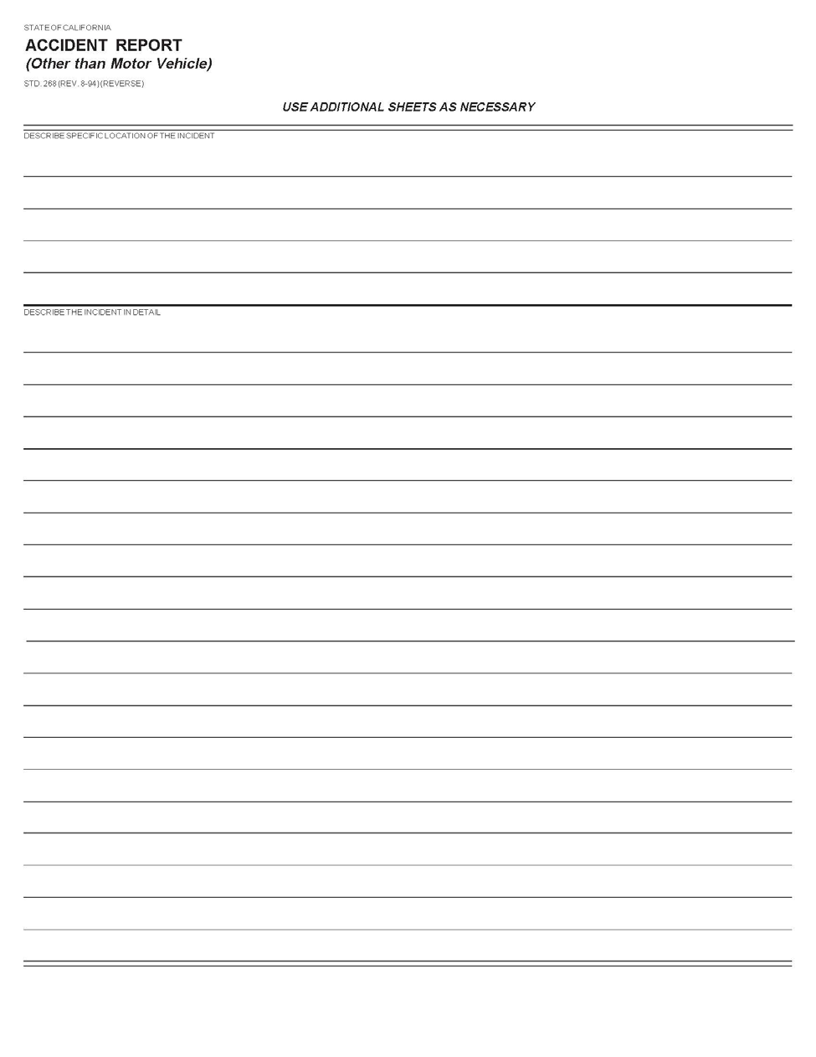

EMPLOYEE PHYSICAL EXAMS 0191
(Revised 3/14)
When physical examinations are required for pre-employment or as a condition of employment, the state will provide or pay for them. The applicant must pay for any more studies or exams beyond the approved level.
The California Department of Human Resources (CalHR) is responsible for ensuring the uniformity of health questionnaires and exam forms. CalHR’s Medical Officer must approve any job classification's requirement for all tests or procedures. The description of all special or extensive tests or procedures must also be approved by the Medical Officer.
The DHCS sets the dollar amount that the State will pay for all exams and related medical services. This amount may be changed by a Memoranda of Understanding applicable to rank and file employees or by CalHR regulations that apply to employees excluded from collective bargaining. The State will also pay for required diagnostic services or special tests when they are not commonly performed as part of the general physical exam. Reimbursement for physician services will be based on the proper unit value listed in the "1974 California Relative Value Studies".
A copy of the 1974 California Relative Value Studies is kept by the DHCS’s Rate Development Branch, (916) 657-1566 or CALNET 437-1566
FEE SCHEDULES, MEDICAL AND RELATED SERVICES 0192

(Revised 3/14)

Fee schedules. Fee schedules include, but are not necessarily limited to, the following:
- Medical.
- Dental.
- Optical.
- Hospital.
- Nursing home.
- Related services.
- Drugs.
- Medical appliances.

These fees are binding on the programs of all agencies except those financed under an insurance principle as in the case of the State Compensation Insurance Fund and the Disability Insurance Program.

DHCS has the primary responsibility for developing fee schedules for medical, dental, and related services. Policy related to priorities, expansion, or contraction of medical care programs is the responsibility of the program agency.

Sections of the schedules of maximum allowances for medical and related services are published and periodically revised by the DHCS. If you need a copy, contact the department.

Advisory Committees. Advisory Committees selected for the administrative and technical staffs of program agencies concerned with medical care will be established. These committees will be created as needed to advise DHCS on a particular problem or group of problems. They will serve until a solution for the problem or issue is developed.

SAM – TRAVEL GUIDE

DEFENSIVE DRIVER TRAINING 0752
(Revised 3/14)
The Department of General Services (DGS), Office of Risk and Insurance Management, approves and develops statewide driver training courses. All courses are conducted on a statewide basis. Charges for courses are listed in the General Services Price Book and Directory of Services. Course descriptions and scheduling information may be obtained by accessing the DGS Training Registration System website at https://www.training.dgs.ca.gov or contacting the Defensive Driver Training Coordinator, Office of Risk and Insurance Management, Department of General Services, 707 Third Street, First Floor, West Sacramento, CA 95605, Telephone (916) 376-5308.
Agencies shall compile and submit the Summary of State Miles Driven to the Office of Risk & Insurance Management. This annual report must be submitted by February 1 for the proceeding calendar year. For information forms and instructions, contact the Defensive Driver Training Program, Office of Risk & Insurance Managament, Department of General Services, 707 Third Street, First Floor, West Sacramento, CA 95605, Telephone (916) 376- 5308.

GENERAL 0900
(Reviewed 3/14)

Research of general public interest and benefit is a concern of state government and should be furthered, provided that such research does not unduly interfere with prescribed state programs and functions, and is in accord with the intent and desire of the State Legislature and state law. The following provisions relating to the acceptance and administration of public and private organization grants for research are not intended to interfere with or discourage the furtherance of desirable research. Neither are they intended to prohibit the incidental use of state equipment and facilities or otherwise discourage the personal study and development of state-employed scholars and professional personnel. These provisions are intended to establish uniform general principles concerning the administration of grant funds, reasonable use of state employees, and reasonable recovery of the state's expense in the performance of grant-funded projects.

Many private or public organizations grant funds to finance research and other projects which involve state employees, facilities, and operating costs. These projects are generally, but not necessarily always, of public interest and concern.

RESEARCH GRANTS ADMINISTERED BY STATE AGENCIES OR
AUXILIARY ORGANIZATIONS 0910
(Reviewed 3/14)

The Legislature has authorized and appropriated funds to some departments specifically to conduct research in connection with the department's authorized functions and programs. These departments administer grant funds through normal state financial procedures.

Many grants are made that involve state employees, facilities, and operating costs of state agencies and institutions that the Legislature has not specifically authorized for the performance of research and for which no appropriation of state funds have been made for this purpose. Often such grants are accepted and administered by "auxiliary" organizations and corporations formed by state employees of the agency or institution involved. The research is performed at the state institution or agency using state facilities and often by or under the direction of state employees. It is probable that many of these grants are awarded in recognition of the state facility and state employment of the personnel involved.

MANDATED STATE CLEARINGHOUSE’S ROLE 0911
(Revised 03/14)

- The State Clearinghouse (SCH) reviews applications for federally funded grants mandated by Executive Order (E.O.) 12372, Appendix I of the Catalog of Federal Domestic Assistance. Any state, independent, or local agency applying or planning to apply for federal funds should contact the SCH or consult OPR’s website (www.opr.ca.gov/s_federalgrantreview.php) to determine if that their Catalog of Federal Domestic Assistance Number (CFDA Number) is one of the grants subjected to state review. The SCH requires that a federal Standard Form 424 (the front application cover page) be submitted to SCH and their appropriate Area wide Clearinghouse at least 30 to 60 days prior to the final deadline set by the federal agency. The SCH does not set nor know the final deadlines for grants and will accept a federal Standard Form 424 at any time. The applicant is responsible for submitting their grant application in sufficient time to meet all deadlines. State agencies and departments who apply for federal funds are responsible for including a provision for recovery of indirect costs as described in Government Code sections 13332.01 and 13332.02 and reiterated in SAM section 8755.1.

- In addition, the SCH does not have information on federally funded grants. Information can be obtained by calling the federal agency funding the grant or by looking in the Catalog of Federal Domestic Assistance.

(Continued)

(Continued)

MANDATED STATE CLEARINGHOUSE’S ROLE 0911 (Cont. 1)
(Revised 03/14)

- The SCH will send a letter to the applicant at the end of the review period. If the SCH does not receive comments on a grant, the review will close 30 days after submittal. If comments are received, then the review period will close 60 days after submittal. All grant applications are sent out for review in the State Clearinghouse Newsletter. Federal agencies who require this letter will contact the SCH.

- The SCH does not deal with form CA-189, only the federal Standard Form 424 and those grants mandated for review by E.O. 12372.

- General Review. Once a federal Standard Form 424 (see Appendix C) has been submitted to the SCH and assigned a number, it is put out for review in the State Clearinghouse Newsletter. This newsletter is sent to all state agencies, area clearinghouses, local libraries, university libraries, and private citizens (at their request). The SCH requires that a federal Standard Form 424 (usually the front application cover page) be submitted at least 30 to 60 days prior to the final deadline set by the federal agency. If the SCH does not receive comments on a grant, the review will close 30 days after submittal. If comments are received, then the review period will close 60 days after submittal. All comments will be forwarded to the applicant.

- This review process is standard for all grants that are listed under E.O. 12372. A grant that does not fall under the E.O. 12372 should not be submitted to the SCH. Not all federally funded grants fall under E.O. 12372 for state review.

- This is the only role of the SCH in relation to federally funded grants. The SCH does not play a role in the review, awarding, or funding of state grants. Click here for a current copy of the State Clearinghouse Handbook.

FEDERAL GRANTS 0912
(Reviewed 3/14)

Review by Department of Finance (DOF)

Pursuant to the provisions of Government Code section 13326, advance approval for application to the federal government is delegated to agencies/departments, except requests for federal funds for the following:

- "New" activities not included in the budget,

- Activities which have been previously denied by the Administration or the Legislature, and

- Sensitive policy issues. The determination of a "sensitive policy" issue is at the discretion of the agency/department making the request for federal funds.

Budgeted Grant Requests

Requests for federal funds which can be anticipated should be included and justified as part of the departmental budget request. For budgeted grant requests, the applicant must file federal Standard Form 424 with the SCH prior to the publication of the Governor's Budget document for the fiscal year for which the grant is requested. The remittance advice for receipt of a budgeted grant request should cite the SCH identification number.

(Continued)

FEDERAL GRANTS 0912 (Cont. 1)
(Reviewed 3/14) Unbudgeted Grant Requests
Requests for federal grants that were not anticipated ("unbudgeted") must be forwarded to DOF if they meet any of the criteria specified above (Items 1, 2 and 3 - Review By DOF). For each grant request meeting this criteria, departments must submit a "Federal Grant Request" form DF-24. See Appendix D. Agency approval must be obtained prior to submission to DOF, except that departments which do not report to an agency secretary are to submit their requests directly to DOF. Forms must be submitted to DOF at least 10 working days prior to the federal deadline for application. Constitutional Officers, the University of California, and the California State University are not required to obtain DOF approval. Departments are also responsible for determining if any request for unanticipated federal funds meets the criteria for legislative notification set forth in Control Section 28.00 of the annual Budget Act. If requests meet the notification criteria, departments are also responsible for submitting the appropriate Section 28.00 materials to DOF along with the "Federal Grant Request" form DF-24.

After approval is received by DOF for an unbudgeted grant request, the applicant must also file federal Standard Form 424 with the SCH.

Employer/Taxpayer Identification Number for Grant Requests

The federal Standard Form 424 must include the Employer/Taxpayer Identification Number that was assigned to the department by the Internal Revenue Service (See also SAM section 8422.19).

State, Metropolitan, and Regional Clearinghouses

For a list of Areawide, Metropolitan, and Regional Clearinghouses, see Appendix B. The address and telephone number of the SCH is:
California State Clearinghouse Office of the Governor
Office of Planning and Research 1400 Tenth Street
Sacramento, California 95814

Telephone: (916) 445-0613

Page Appendix A
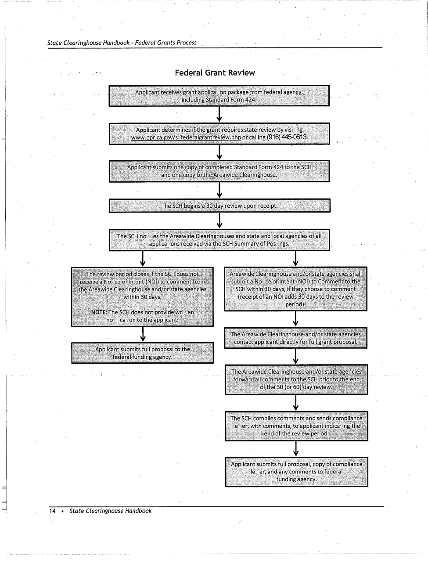

Page Appendix B
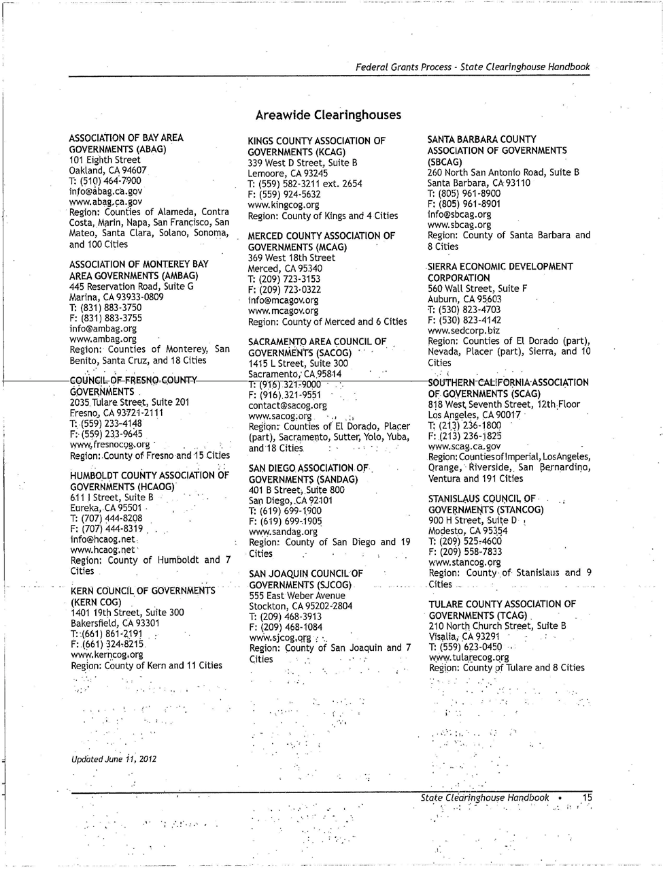

Page Appendix C
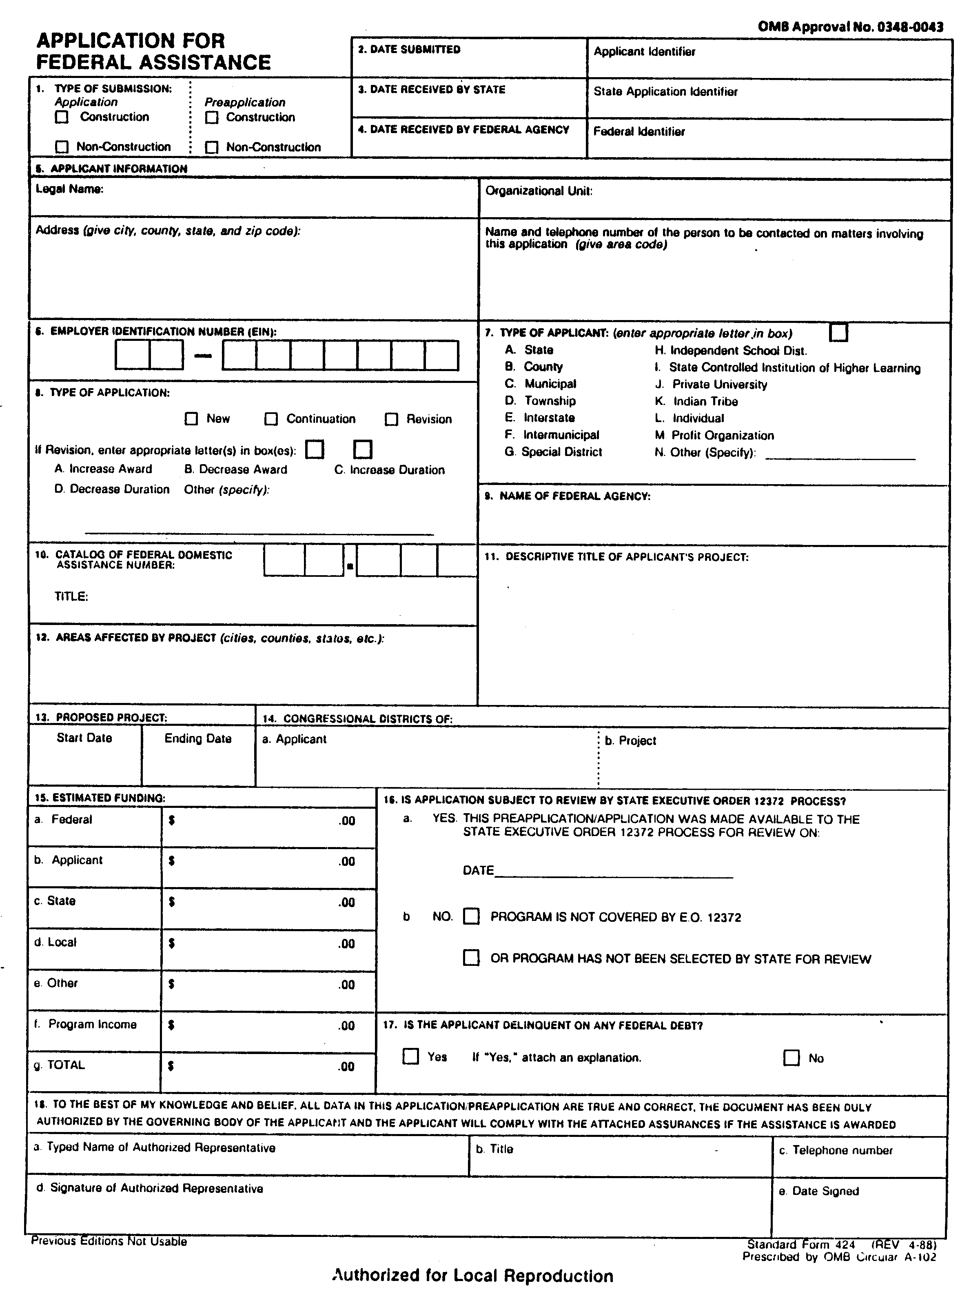

Page Appendix D
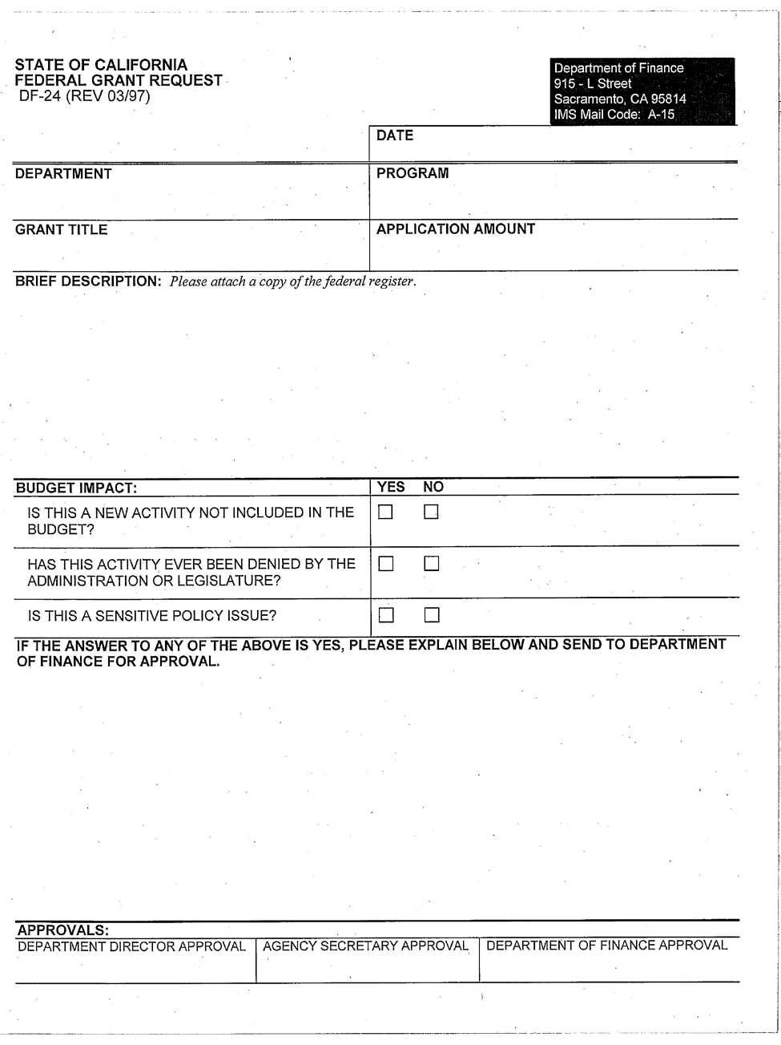

(Continued) Chapter 1300 INDEX (Cont. 2)

CONSTRUCTION SERVICES BRANCH
PROGRAM SUMMARY, RESOURCES, AND CONTACTS  Major Policies and Services  Available Services  Quality Assurance Inspection and Testing  Code Inspection to Ensure Compliance with Building Codes and Regulation Field Level Management of Construction  Change Order Estimating and Negotiation  After-Contract Guarantee Enforcement and Dispute Resolution Direct Construction Services  Administration of Construction Contracts | 1328
Construction Management and Inspection Unit | 1328.1
Direct Construction Unit | 1328.12
BUILDING AND PROPERTY MANAGEMENT BRANCH
PROGRAM SUMMARY, RESOURCES, AND CONTACTS | 1330
Cost Of Services | 1330.1
Building Alterations | 1330.2
Use Of Buildings Outside Regular Working Hours | 1330.3
Parking In Loading Dock Areas Of State Buildings | 1330.4
Smoking In State Buildings | 1330.5
Office Plants | 1330.6
Display Of Art, Posters, And Notices In State Buildings | 1330.7
Purchase And Display Of Flags At State Buildings | 1330.8
BUSINESS OPERATIONS, POLICY AND PLANNING BRANCH
PROGRAM SUMMARY, RESOURCES, AND CONTACTS | 1335
Statewide Real Property Inventory | 1335.1
APPENDICES
FORMS:
Public Works Project Authorization And Transfer Request (Resd Std. 22) | A-1
Request For Project Undertaking By State Agency (Resd Std. 23) | A-2

CONSTRUCTION SERVICES BRANCH
PROGRAM SUMMARY, RESOURCES, AND CONTACTS 1328
(Revised 3/14)
The Construction Services Branch (CSB) consists of two operational units. The Construction Management and Inspection Unit (CMIU), which provides construction management and contract document compliance inspection services for construction projects undertaken by the state.
The Direct Construction Unit (DCU) utilizes a combination of contracts and day labor under certain circumstances per Section 10122 of the Public Contract Code to directly accomplish construction projects.

MAJOR POLICIES AND SERVICES

- Available Services
  - Quality Assurance Inspection and Testing
  - Code Inspection to Ensure Compliance with Building Codes and Regulation
  - Field Level Management of Construction
  - Change Order Estimating and Negotiation
  - After-Contract Guarantee Enforcement and Dispute Resolution
  - Direct Construction Services
  - Administration of Construction Contracts

Contact information and additional program information on CSB’s services and operations may be accessed from our home page located at http://www.dgs.ca.gov/resd/Home/ConstructionServicesBranch.aspx.

CONSTRUCTION MANAGEMENT AND INSPECTION UNIT 1328.1
(Revised 3/14) Statutory Authority
Government Code Section 14951 states: “The State Architect has general charge, under the DGS, of the erection of all state buildings and shall have an inspector assigned to each building during its construction.” Responsibility for this inspection has been delegated to CSB by the State Architect.
The focus of the Construction Management and Inspection Unit (CMIU) is to ensure that state building and related facilities are constructed in accordance with approved design and contract documents, in compliance and applicable codes and regulations, and to the highest quality standards. The CMIU headquarters is located in Sacramento but area offices are strategically located throughout the state.
The CMIU offers the following services:

  - Quality assurance inspection and testing
  - Code inspection to ensure compliance with building codes and regulations
  - Construction management services
  - After-contract guarantee enforcement
  - After-contract dispute resolution

DIRECT CONSTRUCTION UNIT 1328.12
(Revised 3/14)
The Direct Construction Unit (DCU) is the state’s in-house construction contractor. It provides, for the use of all agencies, direct construction supervisors, casual trades craftspersons, and contracting available to provide direct construction services in case of emergency or when it has been determined to be in the best interest of the state to directly undertake the work per Public Contract Code Section 10122.

AIR TRAVEL INSURANCE 2410
(Revised 3/14)

State agencies may insure their officers and employees against injury or death from aircraft accidents while flying on state business in all but regularly scheduled passenger aircraft. See CalHR Rule 599.628(d) for qualifications. Agencies in need of this coverage should inform ORIM in writing the number of employee passengers and employee pilots separated between represented and nonrepresented employees

MOTOR VEHICLE LIABILITY SELF-INSURANCE PROGRAM 2420
(Revised 3/14)

The ORIM administers the State Motor Vehicle Liability Self-Insurance Program (VELSIP), which provides unlimited self-insured liability coverage for the state, agencies, and employees who operate covered self-propelled land vehicles on state business (California Vehicle Code Sections 17000 and 17001). Effective January 1, 2004, liability coverage is limited to $1 million per occurrence/accident when the state vehicle is operated by a non- salaried employee (i.e. student assistant, volunteer, etc.) on state business. The driver’s employing department/agency will be financially responsible for the payment of any claims, settlements, judgments or verdicts in excess of $1 million. With the exception of peace officers as defined in Insurance Code Section 557.5, the VELSIP provides excess liability coverage for state employees on state business while driving non-state vehicles, but only after the vehicle owner’s liability policy limits have been paid. The VELSIP does not provide coverage for injury to state employees nor for damage to state vehicles. Employee injuries are handled through Workers’ Compensation coverage. Damage to state vehicles are handled through the budget of the owning state agency.

MOTOR VEHICLE ACCIDENTS AND REPORTING 2430
(Revised 03/14)

If involved in a motor vehicle accident while on state business, state employee drivers must report the accident within 48 hours (regardless of the ownership of the vehicle) on a Vehicle Accident Report form, STD. 270, to the:
Office of Risk and Insurance Management (ORIM) 707 Third Street, First Floor
West Sacramento, CA 95605 P (916) 376-5300.
F (916) 376-5277
Claims@dgs.ca.gov

Should the accident result in bodily injury to anyone other than the state employee, the accident must be immediately reported to the ORIM by telephone or an advance faxed or email copy of STD. 270. On weekends, call (916) 376-5300, to leave a Voice Mail.
An Accident Identification card, STD. 269, should be carried in the glove compartment of all state vehicles. This card should be completed and the tear-off portion given to the other party. The card provides a convenient place to write down pertinent information while still at the accident scene. This information should be transferred to
the STD. 270 and sent to ORIM.

(Continued)

(Continued)

MOTOR VEHICLE ACCIDENTS AND REPORTING 2430 (Cont. 1)
(Revised 03/14)
For reporting purposes,

An accident is defined as one that involves a state-owned vehicle (or a non-state-owned vehicle operated by a state employee on state business) where there is damage caused to another person or property.
An incident involves only a state-owned vehicle where the damage, regardless of the amount, is limited just to the state vehicle which was stationary at the time the damage occurred. Incidents should not be reported to ORIM.

State employees should not discuss the accident with anyone other than the police, their supervisors, ORIM Claims Unit, or the independent adjusting company under contract with ORIM. If contacted by the other party, their attorney or insurance company, the state employee should refer the party or correspondence to ORIM Claims Unit. Under no circumstances should the state employee driver give either a written or recorded statement to the other party or their representatives.

If served with any post-accident legal papers, call ORIM Claims Unit immediately.

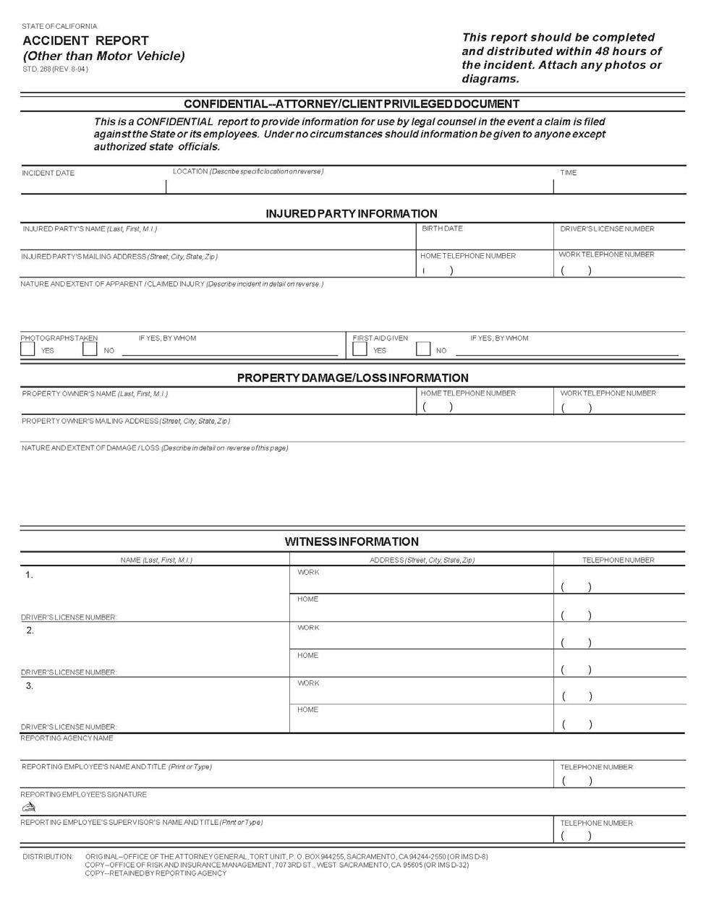

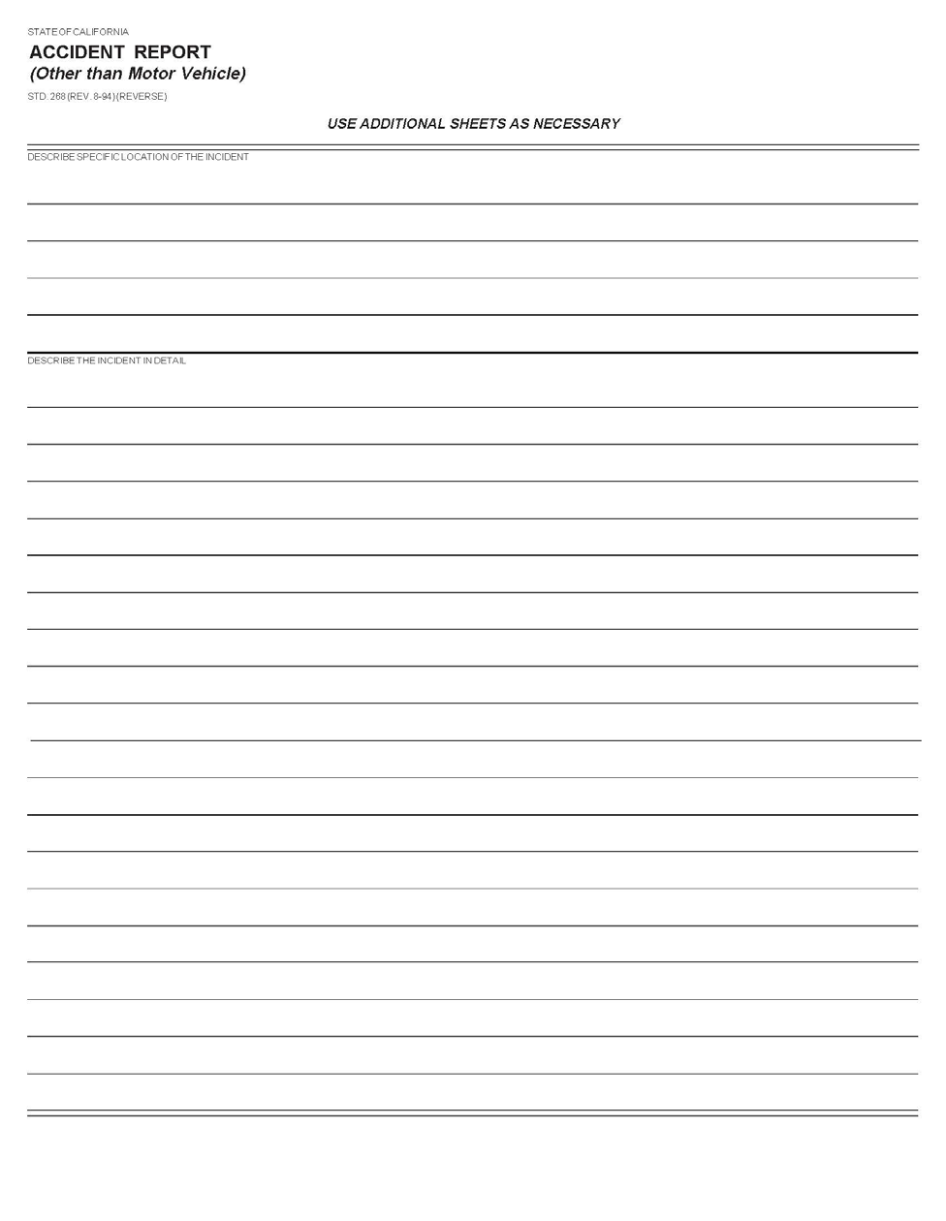

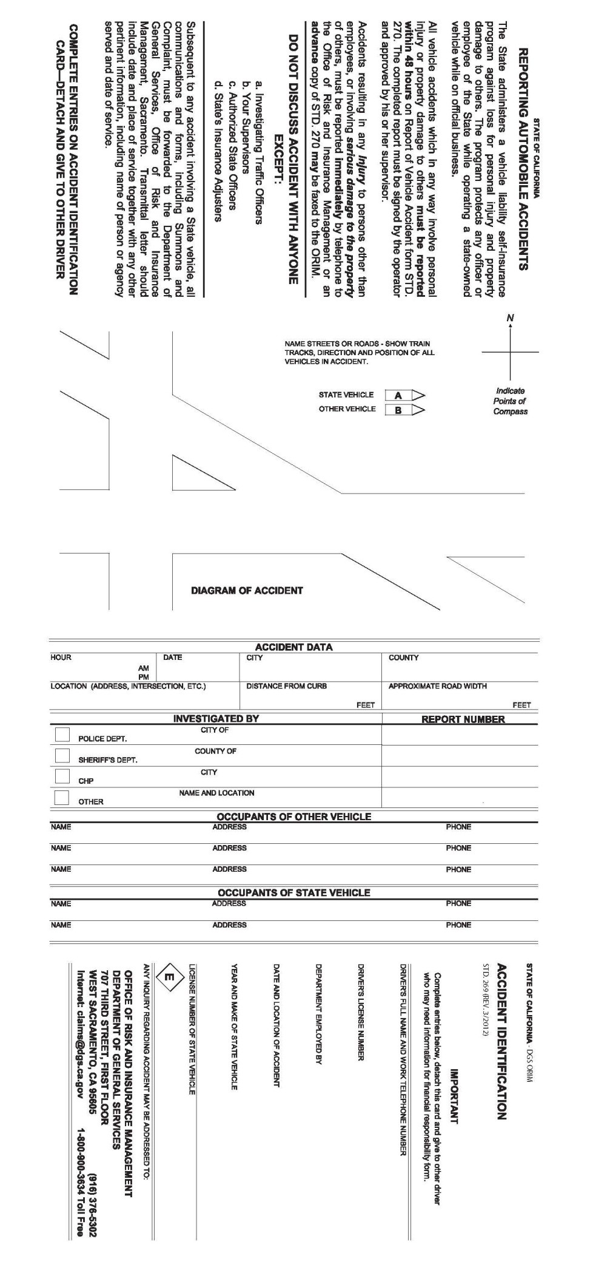

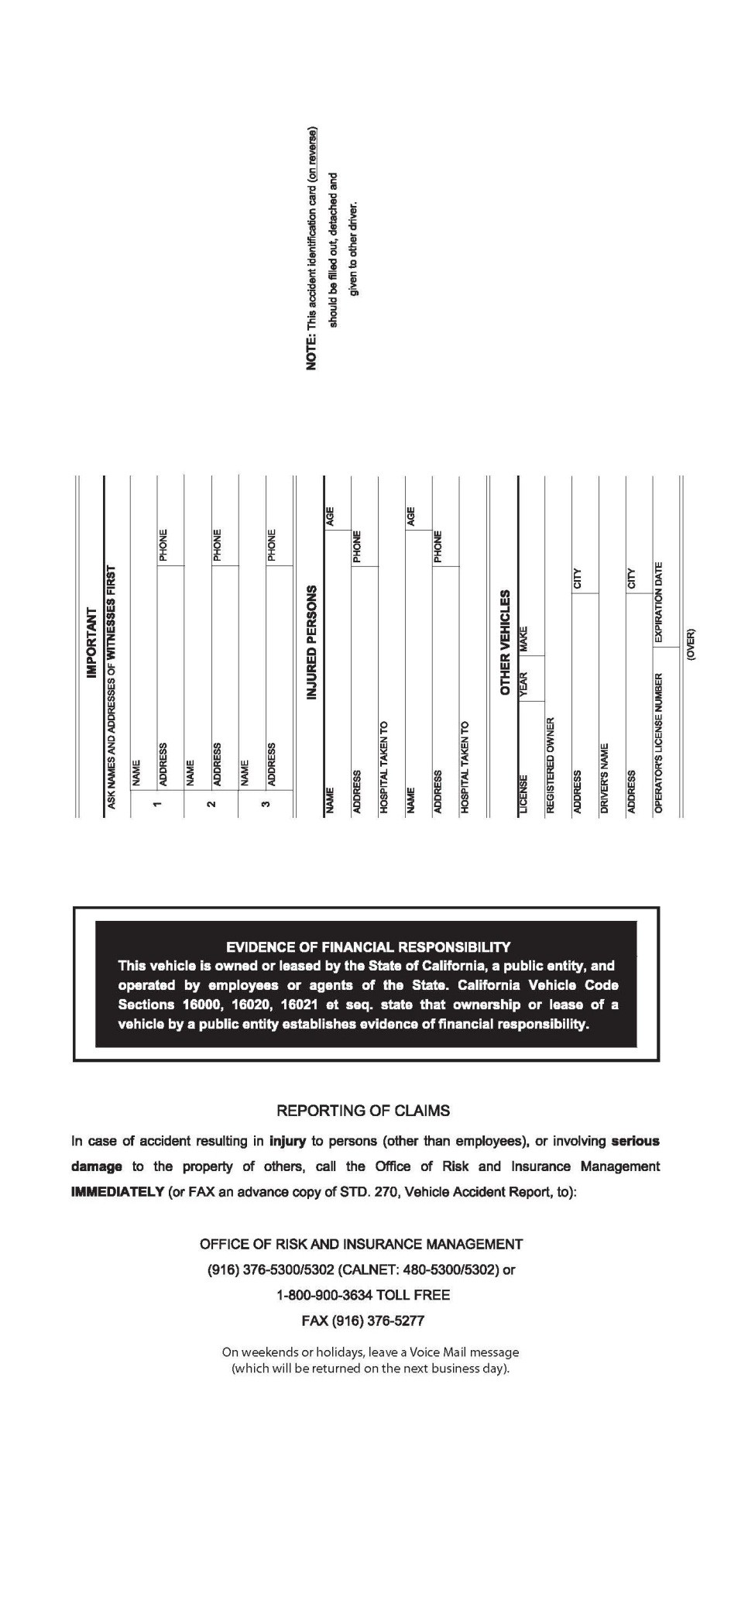

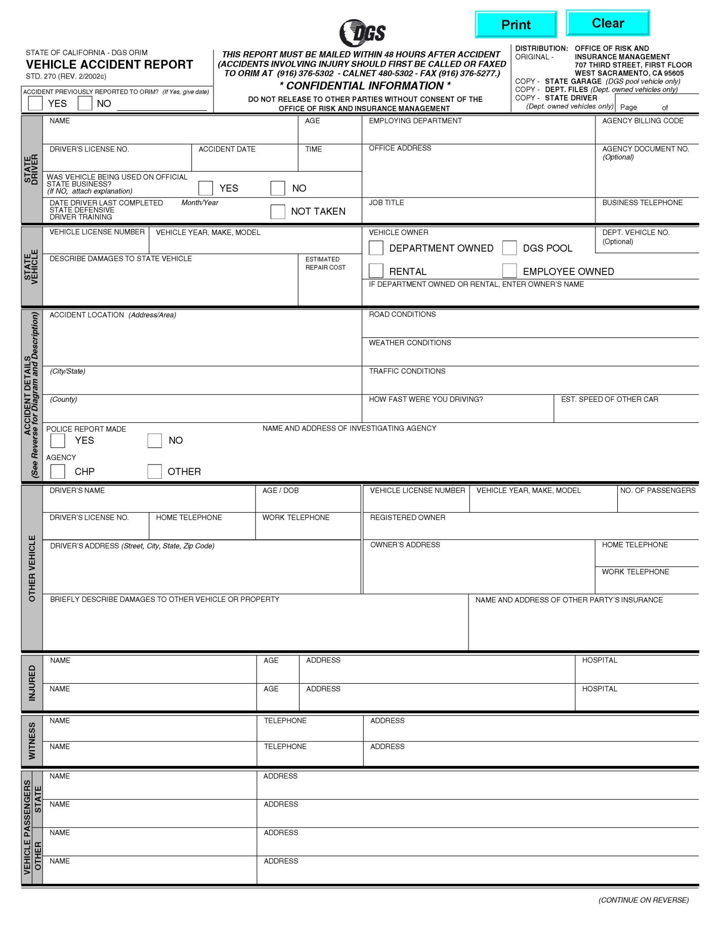

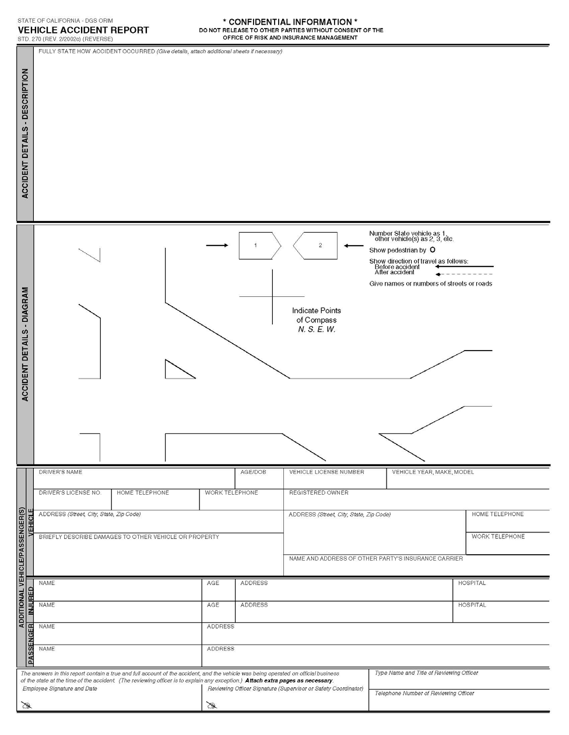

REPORTING REQUIREMENTS 2482
(Revised 3/14)

Property or money losses due to employee infidelity or dishonesty must be reported in writing to Department of Finance, Office of State Audits and Evaluations and the Bureau of State Audits. See SAM Section 20060.

SAM—WORKER'S COMPENSATION

ASBESTOS NOTIFICATION TO EMPLOYEES 2591
(Revised 3/14)

The purpose of this section is to help agencies, managers, and supervisors meet their responsibilities as employers.

State agencies needing information about the existence of asbestos in DGS buildings should contact the building manager. The Real Estate Services Division (RESD) will advise departments in leased space when they have knowledge of the presence of asbestos in the building.

Statutory Authority

Health and Safety Code Section 25915 et seq. mandates asbestos notification to employees.

Major Policies

State agencies that occupy buildings constructed prior to 1979, and know of the presence of asbestos materials in the building, are required to provide written notification to employees working in the building. Notices are required within 15 days of knowledge and shall then be made annually to all employees.

In agency-owned buildings, the agency is responsible for Asbestos Notification to Employees. It is suggested that the building manager be designated by the agency head to carry out this duty.

The state agency that operates or controls the building must deliver a copy of the notification to other departments with employees working in the building. New employees, agencies new to the building, or contractors shall be provided notice within 15 days of commencing work in the building.

Written notice shall include the following information:

- A description or list of the contents of any survey conducted to determine asbestos-related conditions within the building, and where and when the results of the survey are available.
- Specific locations identified by the survey or known to the agency where asbestos materials are present.
- General procedures and handling restrictions to minimize disturbance and exposure to asbestos. Indicate where information can be found when detailed handling instructions are necessary.
- Results of any bulk sampling analysis or air monitoring conducted for or by the agency, and information describing where the specific data are available.
- Potential health risks or impacts that may result from exposure to asbestos in the building.
If any construction, maintenance, or remodeling is conducted in an area of the building where there is the potential for employees to come into contact with, or to release or disturb, asbestos materials, the state agency, or agent of the owner responsible for the asbestos-related work will be required to post that area with a clear and conspicuous warning. See 2591 Illustration.

All existing asbestos survey and monitoring data, specific to the building, shall be made available to the employees or their representatives upon request. This information shall be kept within the building and be available at times convenient and accessible to employees, and their representatives, for review and photocopying.

GENERAL 3500
(Revised 3/14)

The Procurement Division, Department of General Services, is responsible for every purchase of non-IT supplies or equipment in excess of $100 and for contracts for purchases for every State agency with such exception as stated in Public Contract Code Sections 10295, 10298, 10430, and 12100.5.
The Procurement Division will also assist agencies in making determinations relative to the appropriate method of acquisition of their equipment needs. The office will also provide effective means of acquiring equipment whether the acquisition is to be made by purchase or through non-purchasing techniques.

COMPETITIVE PURCHASING 3503
(Revised 6/06)

The State is committed to a program of active competition in the purchase of personal property. Public Contract Code Section 10318 makes it illegal for any agency or employee to draft or cause to be drafted any specifications in such a manner as to limit the bidding directly or indirectly to any one specific concern, or any specific brand, product, thing, or service. It is the aim and desire of the Procurement Division, Department of General Services, to require that such competition be at all times by responsible suppliers, and the materials bought through such competition be properly suited to the job intended both as to price and quality.

Except for contracts and purchases for non-IT services and/or IT goods and services including telecommunication acquisitions which are processed according to the procedures set forth in SAM Chapter 1200 and SAM Chapter 5200, contracts and purchases in amounts exceeding $50,000 are normally made by sealed bid procedure. In emergency situations or other special circumstances, statutes may exempt purchases from the bid procedure. Sealed bids are opened and read at a specified time and are maintained on file (Public Contract Code Section 10301).

Where the dollar threshold involved is $50,000 and less, or where the competitive field is very limited, the Procurement Division will request informal quotations in lieu of using the more expensive formal method. Informal quotations will also be used to determine if previous prices are still in effect when dollar amounts are relatively small. Procurements valued $50,000 and less are considered informal and are to be conducted in accordance with the State Contracting Manual, Volume II, Purchasing Authority Manual (PAM) requirements for informal competitive non-IT goods procurements.

When the range of bids received is such that purchase is not in the best interests of the State, all bids will be rejected. When all bids are rejected, all bidders will be advised.

Also, all bids may be rejected when with the consideration of the surrounding circumstances it is determined that it would be in the State's best interest to do so.

PROHIBITED PRACTICES 3504
(Revised 3/14)

No State officer or employee will personally derive any benefit from use of facilities available to the State for the purchase of equipment, supplies, or commodities. Use of purchase orders or other State purchasing procedures to obtain property for personal use, or misrepresentations to vendors that personal purchases are for the State, for the purpose of obtaining price discounts not allowed on personal purchases, will expose officers or employees to prosecution under Penal Code provisions relating to embezzlement and theft.

PURCHASES FROM COMMUNITY-BASED REHABILITATION
OR SHELTERED WORKSHOPS 3504.2
(Revised 3/14)
See Chapter 2 of the State Contracting Manual, Volume 2 or Volume 3 for more information.

PURCHASES FROM PRISON INDUSTRY AUTHORITY 3505
(Revised 5/94)

In preparing purchase estimates, an agency will first consider if its needs can be met by Prison Industry Authority (PIA) commodities and services. Agencies are mandated by California Penal Code 2807 to purchase from and consult with PIA to develop new products and adapt existing products to meet their needs. They shall consult with PIA for commodities and services, or like commodities and services, even though not specified in the PIA catalog.

The Procurement Division, Department of General Services, will examine all submitted purchase estimates to determine whether PIA products would meet all reasonable requirements. If this appears to be the case, the Procurement Division will notify the ordering agency that the items should be purchased from PIA.

The Procurement Division will not purchase these items from commercial vendors without written authorization to do so from PIA. A waiver must be obtained from PIA prior to purchasing items from commercial vendors.

PURCHASING AUTHORITY 3506
(Revised 3/14)

The requirements for departments to obtain and maintain purchasing authority is contained in the State Contracting Manual (SCM). The SCM is available on the Internet at http://www.dgs.ca.gov/pd/Resources/publications.aspx.
Departments are held accountable for the procurement activities conducted under approved purchasing authority.

AUTHORIZATION OF AGREEMENTS 3507
(New 9/05)

  - State Departments – Authorized Signatures

    - Authority to sign purchase documents is limited to those executive officers who either have statutory authority or have been duly authorized in writing by one who has statutory authority.

    - Anyone who signs a purchase document should have knowledge in the procurement laws, policies and procurements pertaining to the goods or services being procured. If an individual with signature authority does not possess sufficient procurement knowledge and expertise, the individual should, prior to signing, have the purchase document reviewed by someone who possesses such knowledge and expertise.

    - Delegation of signature authority is a selective process and should be commensurate with experience with principles of sound contracting and procurement policies, demonstrated familiarity with the process of purchase document formation, execution, and administration, and completion of applicable training and/or certifications.

    - Each executive officer who has statutory authority to sign purchase documents shall ensure that his/her agency maintains a current written record of agency employees authorized to enter into and sign purchased documents on behalf of that agency. This written record shall be subject to DGS audit.
e, State Board’s and Commission’s purchase documents in excess of $5,000 must be accompanied by a copy of the resolution approving the execution of the purchase document, unless by statute the executive officer may sign the purchase document.

  - Local Governmental Entities – Authority
    - Purchase documents to be signed by a county, city, district, or other local public body must be authorized by a resolution, order, motion or ordinance for the purchase document. A copy of the authorization should be sent to DGS/OLS with the purchase document.

    - Where performance by the local governmental entity will be complete prior to any payment by the state a resolution is not needed.

PROCUREMENT SERVICES 3510
(Revised 3/14)

The Procurement Division, Department of General Services, can be of assistance to State agencies prior to requisition to determine possible supply sources, alternative product examinations, specification preparation, inspection and receiving practices, quality control, order follow-up and materials, expediting and the enforcement of the terms and conditions of purchase orders issued by the Procurement Division.

SPECIFICATIONS SECTION (Revised 10/74) 3510.1
The Specifications Section staff of the Office of Procurement, Department of General Services, can assist agency personnel in the preparation of the description and specifications of their purchase requirements before they are submitted on purchase estimates. Copies of standard specifications are available upon request; aid is available for developing descriptions of nonstandard commodities.

AGENCY RESPONSIBILITIES (Revised 9/91) 3510.2
Issuance of a purchase order by the Office of Procurement, Department of General Services is only one part of the buying process. The agency for whom the merchandise is purchased also has important functions to perform in this process.
Following are some of the responsibilities of receiving personnel:

- Receiving clerk must have a copy of order document to answer these questions:

  - Is delivery significantly late, unsatisfactory, or incomplete?

  - Does the item comply with the specifications and packaging requirements?

  - Are any inspection stamps or special labeling required and are they in evidence?

  - Has the shipment been inspected by the most qualified person available?

  - Have all the terms listed on the Purchase Order been met?

- Maintain copies of Purchase Orders on file when contractors have responsibilities into future fiscal years.

- Quality problems and questions should be directed to the Quality Control Section. See SAM Section 3510.3.
- Purchasing problems and questions should be directed to the Buyer whose name and phone number appear on every Contract and Purchase Order issued by the Office of Procurement.

QUALITY CONTROL SECTION (New 2/71) 3510.3
Quality Control assistance is available from the Office of Procurement, Department of General Services, for agencies throughout the State. The Quality Control Section should be contacted in the event:

- An agency has questions as to whether an item delivered against a purchase order meets specifications. (If necessary, Quality Control will arrange to inspect the item in question.)

- Equipment or supplies received and placed in services do not appear to be performing as expected or represented by the seller.

- You are receiving poor service, or experiencing other problems after items have been received.

FINANCIAL PROFILE REPORTS 3514
(Revised 12/03)

Agencies that require information on firms within the United States may obtain this data from the Procurement Division, Department of General Services, which has contracted for credit rating services. Use of the service for purposes other than as a check on firms to whom credit may be extended is not authorized. The service consists of two parts: (1) a reference book listing the general credit rating of virtually every firm in the United States; and (2) a special detailed, confidential business information report on specific firms. Reports on individual consumers may not be ordered.

Detailed reports contain a comprehensive statement of the background and financial status of the firms. Use of Procurement's reference book is free of charge. Upon written request, single reports may be purchased for a fee. The fee is updated annually; call the Procurement Division for the most current fee. Requests which require immediate information will be charged extra. All reports will be processed on the basis of single reports. All reports may be ordered from:

Department of General Services Procurement Division
707 Third Street, Second Floor West Sacramento, California 95605

MANUFACTURERS' WARRANTIES 3515
(Revised 12/03)

Many items of equipment purchased by State agencies carry a manufacturer's warranty of acceptable materials and workmanship. All agencies will register and maintain proper records of such warranties to ensure that defects covered by the warranty are repaired by the manufacturer.

The Procurement Division does not maintain any files or records of individual agencies' equipment warranties.

SURPLUS PROPERTY

DISPOSAL OF SURPLUS PERSONAL PROPERTY 3520

(Revised 3/14)
Prior to an agency’s disposal of any state-owned personal surplus property, other than vehicles and mobile equipment (See SAM Sections 4111 through 4112 for Disposition of Vehicles and Mobile Equipment), the agency must obtain approval from the State and Federal Property Reuse Program Office, Office of Fleet and Asset Management, Department of General Services.

(Continued)

(Continued)

DISPOSAL OF SURPLUS PERSONAL PROPERTY 3520 (Cont. 1)
(Revised 3/14)

The agency must submit to the State and Federal Property Reuse Program Office a Property Survey Report (STD. 152) requesting direction and approval prior to disposition of any state-owned personal surplus property, including general office furniture, regardless of the original acquisition value or if the property was recorded or capitalized for accounting purposes. The $5,000.00 unit acquisition cost requirement for capitalization does not apply to disposal actions. Final disposition, which includes sale, trade-in, discarding or turning the property over to the State and Federal Property Reuse Program Office, or discarding the property may not occur until the State and Federal Property Reuse Program Office approves the disposition.

To request approval, the agency must electronically submit the completed Property Survey Report (STD. 152), to the State and Federal Property Reuse Program Office in Sacramento. Agencies can access the online STD 152 at http://www.dgs.ca.gov/ofam/Programs/StSurplus/Reutilization/CSPS.aspx. This reporting requirement applies to all office furniture items, including (but not limited to) bookcases, cabinets, chairs, credenzas, desks, shelving, tables and similar items common to state offices.

The State and Federal Property Reuse Program Office facilitates and ensures recycling of used office furniture that is still sound and, therefore, reusable, thus contributing to reducing expenditures for new furniture and conserving the materials used in the manufacture of office furniture.

PROPERTY SURVEY BOARD 3520.2
(Revised 3/14)
Each agency will have a duly appointed Property Survey Board that is responsible for determining that, when disposing of surplus property, the decision to do so serves the bests interest of the state. To the extent possible, there will be a sufficient number of members on the Board to insure representation by both business management and program responsibilities. At least two Board members must approve all Property Survey Reports (STD. 152) and all Transfers of Location of Equipment (STD. 158).

PROPERTY SURVEY REPORTS 3520.3
(Revised 3/14)
When an agency proposes to dispose of state-owned, nonexpendable surplus property either by sale, by trade-in, or by turning it over to the State and Federal Property Reuse Program Office, or by discarding the property, the agency prepares a Property Survey Report (STD. 152) and submits it to the State and Federal Property Reuse Program Office for approval.
When an agency proposes to transfer such property to another agency or to a unit within the agency, the agency prepares a Transfer of Location of Equipment (STD. 158) and submits it to the State and Federal Property Reuse Program Office for approval. The agency may use an agency form in lieu of STD. 158 for intra-agency transfers between organizational units accounted for in the same general ledger account.
The agency retains the original copy of the approved STD. 152 or STD. 158, as applicable, in a suspense file, pending final disposition of the property. If the agency sells the property, the agency enters the dollar amount received from the sale and the receipt number on STD. 152, and disposes of the listed property without delay.
The requesting agency and the State and Federal Property Reuse Program Office retain copies of all STD. 152's and 158's in accordance with the general disposition schedule. See SAM Section 1611.

TRANSFER TO THE SURPLUS PROPERTY PROGRAM OFFICE 3520.4
(Revised 3/14)
When state-owned surplus personal property is not to be transferred within an agency, the agency submits a STD. 152 directly to the State and Federal Property Reuse Program Office.
The agency must provide adequate information in the "explanation" section of the STD. 152, and indicate the reason(s) for disposal of the property.
The agency must use a single STD. 152 only for similar items or items being surveyed for the same reason. The agency must use separate STD. 152s when surveying items for different reasons.

DONATION OF STATE PROPERTY 3520.5
(Revised 3/14)
When an agency proposes to transfer state-owned personal surplus property to a non-state entity, the agency prepares
a STD. 152 and submits it to the State and Federal Property Reuse Program Office for review and approval prior to final disposition. The recipient of the property must be on record with the State and Federal Property Reuse Program Office as an eligible done, thus indicating the recipient is eligible to receive such property.
NOTE: For vehicles and mobile equipment, submit proposals to the Department of General Services, Office of Fleet and Asset Management for review and approval.

SALE TO ANOTHER STATE AGENCY 3520.6
(Revised 3/14)
The same procedure is used as a transfer within an agency or department, except the selling agency must complete a Property Survey Report, STD. 152, and forward it to the Surplus Property Program Office before the sale takes place.

PUBLIC SALE 3520.7
(Revised 3/14)
An agency can offer state-owned personal surplus property for sale to the general public after the agency has offered the property for use within the agency and after submitting STD. 152 to the State and Federal Property Reuse Program Office for review and approval.

There are three methods an agency may use to dispose of state-owned personal surplus property through a public sale:
- Sealed bid;
- Auction;
- Fixed price (not recommended).

SEALED BIDS OR AUCTION SALES 3520.8
(Revised 3/14)
Typically the sealed bid method of public sale brings the highest cash return to the state. The agency must make a diligent effort to secure at least three competitive bids. If the agency cannot make three competitive bids, the agency employee who solicited the bids must prepare and sign a list of the firms or individuals contacted. The agency must attach the bid solicitation list and the bids received to the STD. 152.

When an agency elects to dispose of state-owned surplus personal property through a public sale by auction, the agency must publish information about the auction to all sectors of the community. Public notices include:
- Newspaper ads;
- Posting of notice of sale in public places;
- Mailings to interested businesses and individuals.
A fixed price sale requires the authorization of the Director of the Department of General Services.
Public sales should be announced a minimum of one week prior to the sale with newspaper ads running no less than three days. The bid opening date should allow ample time for advertising and inspection of the items by prospective bidders.

"Notice of Sale" flyers shall be made available on-site and should contain the following information:

- When and where the items offered for sale may be inspected.

- Bid opening date and time.

- Method of notification to successful bidders.

- Required method of payment and applicability of sales tax.

- Required time frame for successful bidders to pick up items.

- A "General Provisions" section should include an applicable statement similar to the following:

“Items are being sold as is and where is. Verification of the description and condition is the responsibility of the bidder. All sales are final. The State of California reserves the right to reject any or all bids, or to value any defects or irregularities therein. Minimum bid amounts, when indicated, shall be applicable.”

(Continued)

(Continued)

SEALED BIDS OR AUCTION SALES 3520.8 (Cont. 1)
(Reviewed 3/14)
“The State of California makes no warranty, either expressed or implied, as to the condition or completeness of the equipment being sold, nor does the equipment necessarily meet California Occupational Safety and Health Act Standard, Orders, or Regulations.”
After the successful bidder has paid for his/her items and presented his/her receipt, he/she shall be requested to sign an appropriate delivery receipt to signify that he/she has received the material. When scrap and junk is being sold, the person taking delivery shall either sign a delivery receipt or give the agency a receipt indicating the type and approximate quantity of material removed from the premises.

After the sale of material is completed, the amount of cash received shall be recorded on the approved copy of the Property Survey Report, which is retained by the organizational unit.

Whenever public sales are conducted, a system of checks and balances shall be used. This shall, at a minimum, consist of having separate persons handle the sale and the collection of funds.

State employees may participate in public sales providing they do so in the same manner as the general public. Employees may not use their position, office or prestige to their advantage when participating in sales of materials, nor may they participate on state time.

DISCARDED, SCRAPPED, RECYCLED, OR DISMANTLED FOR SALVAGE 3520.9
(Revised 3/14)
When an agency disposes of state-owned surplus personal property by means other than the sale of the property (i.e., salvaged, scrapped, discarded, “Recycled”, or hauled to a landfill) the agency’s responsible employee and unit supervisor shall certify in writing that the disposition has been accomplished. The certification may be made on the STD. 152, or attached and filed with the form. When the agency disposes of the property at a public landfill, the agency’s representative obtains the signature of the disposal site operator or attendant, indicating that the property listed was disposed of at the site. If the landfill is unattended, the agency’s responsible employee and the unit supervisor shall sign and certify that the disposition described was accomplished.
To the maximum extent possible, state agencies are required to recycle State owned surplus personal property with no useful life remaining. Agencies must dispose of irreparable and unusable electronic equipment (e-Waste) using the services of a State of California, Department of Toxic Substances Control authorized recycler.

DONATED FEDERAL SURPLUS PROPERTY 3521
(Reviewed 3/14)
State agencies are eligible to receive donated federal surplus property distributed by the Department of General Services, Office of Fleet and Asset Management, State and Federal Property Reuse Program Office. Substantial quantities of high- quality new and used surplus materials and equipment very frequently become available to State agencies from this source.
All agencies eligible to receive donated federal surplus property will make a maximum effort to acquire necessary materials and equipment through the Federal Surplus Property Program. The State and Federal Property Reuse Program Office assists agencies in securing federal surplus property through obtaining and circulating information as to available federal surplus property, and assisting agencies in placing requests for such items. Since desirable items are generally available for a very limited time, agencies should promptly respond to notices of available property.

INSPECTION OF USED FEDERAL SURPLUS PROPERTY 3521.1
(Reviewed 3/14)
The requesting agency inspects used federal surplus property before it is shipped to the agency. The Office of Fleet and Asset Management, Department of General Services, inspects used vehicles.

LOAN OF STATE SURPLUS PERSONAL PROPERTY 3522
(Reviewed 3/14)

The State and Federal Property Reuse Program Office, Office of Fleet and Asset Management, Department of General Services, maintains an inventory of office equipment such as computers, desks, chairs, tables, typewriters, and some office machines that are available to agencies on a short term, no-charge, loan basis.

Equipment may be obtained or reserved by contacting the State and Federal Property Reuse Program Office warehouse located at 1700 National Drive, Sacramento, CA 95834.

All types of surplus property equipment may be loaned at no charge for periods up to 30 days.

In emergency situations, agencies requiring long-term use of equipment for which they are unable to fund rental charges may request exceptions to the 30-day loan limit by submitting supporting information to the Manager, State and Federal Property Reuses Program Office, Office of Fleet and Asset Management. Also, if an agency delivers an approved purchase estimate to the State and Federal Property Reuse Program Office, surplus equipment may be loaned to the agency that originated the estimate pending receipt of the purchased equipment without regard to the 30-day limitation. Agencies are expected to provide transportation for loaned or rented equipment. At the request of renting or borrowing agencies, equipment can be shipped by freight collect, or by common carrier.

INTERDEPARTMENTAL EQUIPMENT RENTALS 3522.1
(Revised 3/14)
It is intended that agencies exchange available equipment and related services on a rental basis. In order to provide a simplified and uniform procedure for these transactions, departments will use an Interagency Service Agreement and Invoice (STD. 13A) to request the rental of available equipment, order supportive services, and provide the necessary documentation for billing purposes. Rental rates must include charges to recover all direct and indirect costs.
Complete information on interagency rental of mobile equipment, repair facilities, and mobile equipment repair services is included in the following publications:
- Statewide Mobile Equipment Inventory
- Repair Facilities Inventory and Location Catalog
These publications are available from the Chairman of the State Equipment Council, care of the Office of Fleet and Asset Management, Department of General Services, 802 Q Street, Sacramento, California 95814. The telephone number for the Office of Fleet and Asset Management is (916) 327-2086 or ATSS 467-2086.
The Interagency Service Agreement and Invoice (STD. 13A) may also be used in the interchange of equipment and related supportive services with city, county, or other local government units within the State.
SALE OR EXCHANGE OF PRODUCTS (See Government Code Section 11330–35.)

CONTRACTS 3530
(Revised 3/89)

Contract buying reduces the volume of repetitive work, permitting more care and consideration of the award of major purchases, thereby allowing each buyer to become more conversant with the material requirements of the operating departments. It permits a better scheduling of supplies, allowing the operating departments, particularly institutions, to better adjust their inventories. It also encourages better service on the part of vendors, because of the value of such statewide contracts.

As a result of an expanded and comprehensive standards program, it is possible to expand the term contract program since it can be predetermined what quality or specification of material will be accepted statewide.

Officers and employees purchasing contract items at retail prices will be personally liable for the difference between the retail and contract price except in verified emergencies which must be fully explained on the invoice covering the emergency.

To verify contract dollar volumes and to ensure accurate bid information is provided to all interested bidders, each agency using State Contractors must submit one copy of each contract order (STD. 65) To:

State Office of Procurement
P.O. Box 942804 Sacramento, CA 94204–0001

STATE PRICE SCHEDULES (REVISED 3/89) 3531
State Price Schedules are established to permit agencies to obtain volume pricing on noncompetitive items and to order directly from vendors. Unlike contracts, use of State Price Schedules is not mandatory. If an agency determines that another brand or type of item would meet their needs at a lower price, it may either make a delegated purchase or submit a purchase estimate to the Office of Procurement, depending on the dollar amount involved. Before making a delegated purchase, the agency must notify the Office of Procurement's Research and Analysis Section, in writing, of their intention to do so. The request will be considered approved unless the Office of Procurement notifies the requesting agency to the contrary within 48 hours (two working days) of receiving the request. If the agency submits a purchase estimate to the Office of Procurement, an explanation of the circumstances should be included.

MASTER SERVICE MAINTENANCE AND RENTAL AGREEMENTS (REVISED 9/91) 3532
Agreements negotiated by the Office of Procurement, Department of General Services, for the maintenance and rental of office machines are not mandatory for State agencies if they are able to secure better prices that may be due to their remote location or similar factor. Master Service Agreements issued by the Office of Procurement for photocopiers ensure that the guaranteed useful life of the equipment is adhered to, as contracted for in the original purchase order. Use of Master Rental Agreements for the rental of EDP equipment is subject to the provisions in SAM Section 5291. Terms and conditions of the agreement are included in the notice.

NOTICES OF CONTRACTS, STATE PRICE SCHEDULES AND MASTER SERVICE 3533 AGREEMENTS
(Revised 3/14)
The Procurement Division, DGS website (http://www.dgs.ca.gov/pd/home.aspx) contains listings of all statewide contracts, State Price Schedules, and Master Service Agreements. The website will show the method for placing orders, the price, the terms and conditions, etc.

DECREASE (REVISED 11/71) 3559.2
Request for Purchase Order or Estimate Change, STD. 96, may be used to decrease estimates in process if it is determined that the actual expenditure will be less than anticipated, and it is desired to reduce encumbrances to facilitate other use of funds.

PURCHASE ORDERS (REVISED 9/85) 3565
Purchases are authorized on the form Purchase Order, which is completed and sent to the vendor by the Office of Procurement, Department of General Services.

One purchase order will be issued for each vendor supplying items listed on a single purchase estimate. See SAM Section 3553.

PURCHASE ORDER CHANGES 3566
(Revised 3/14)

Information regarding purchase order changes can be found in the SCM. The SCM is available on the Internet at http://www.dgs.ca.gov/pd/Resources/publications.aspx.

WHEN REQUIRED 3566.1
(Revised 3/14)
Purchase order changes are required in the following instances:

  - Change in F.O.B. point
  - Change in terms if unfavorable to the State
  - Change in estimate number
  - Change in vendor's name (except simple spelling corrections)
  - Increase in Unit Price
  - Mathematical error over $10
  - Addition or cancellation of any item
  - Change in description specifications, scope of work or substitution of any material
  - Extension of time on "As Needed" or "As Required" order (such orders are written for units of material; "As Required" or "As Needed" for a period ending DATE).
  - Any overdraft of a purchase order except as permitted under subparagraph 3 in SAM Section 3566.2.

WHEN NOT REQUIRED (REVISED 9/91) 3566.2
Purchase order changes are not required when:

    - Price billed is less than purchase order.

    - Weight or quantity is less than purchase order and unit price as stated on the purchase order.

    - At the time of taking a final delivery, there is a balance in a purchase order, and the final delivery does not overrun the order by more than 10%. This would apply to such items as yardage, steel, lumber, rock, asphalt, products produced from roll paper stock; e.g., forms, cartons, etc., and other items when exact quantity is not known at the time the order is placed, including items that come in standard containers.

    - Delivery of items such as fresh vegetables varies from the weight, quantity or count specified, on the order (not to exceed plus or minus 10% of the value of the total order up to $1 million).

    - Order specifies certain sized containers and other containers which are acceptable are delivered, but total quantity and price are within the limits of the order.

    - Items are purchased by Procurement for resale and final delivery does not exceed the order value by more than 10%.

BLANKET PURCHASE ORDERS (REVISED 3/89) 3568
Blanket purchase orders issued without the taking of competitive bids and in which the products ordered and unit prices are not specified are strongly discouraged. Requests for blanket purchase orders must be accompanied by a statement explaining the nature of the probable emergency requiring the blanket purchase order, the probable effect on public health, welfare or safety caused by this emergency, and the reasons why other purchase methods will not meet the agency need.

Present policy all but excludes the use of blanket purchase orders. All such purchases will be made under a delegated purchase authority program which may be granted on an individual basis to agencies with approved Material Management Plans. Agencies must provide a justification of their need in order to receive the special purchase authority. All requests must be submitted to the Office of Procurement, Department of General Services. Details of information which must be included in such requests may be obtained from the Office of Procurement's Research and Analysis Section.

DISCOUNTS 3573
(Revised 3/14)

It is normal practice to extend both trade and cash discounts to the State.

TAXES

FEDERAL EXCISE TAX (REVISED 1/59) 3574.1
State purchases are normally exempt from Federal Excise Tax, but an Exemption Certificate, STD. 802, must be attached to the Sub-Purchase Order. See SAM Section 3585 for further detail.

SALES AND USE TAX 3574.2
(Revised 3/14)
In addition to the State sales tax, the State is subject to the Bradley-Burns Uniform Local Sales and Use Tax.

TRANSACTIONS (SALES) AND USE TAX (REVISED 12/90) 3574.3
In addition to the local sales and use tax described in SAM Section 3574.2, numerous counties have enacted ordinances establishing special taxing districts that impose one or two-and-one-half percent transactions and use taxes. The tax is imposed on the retailers and applies to sales to State agencies. State agencies taking deliveries of tangible personal property for use within the counties that have imposed these district taxes will pay this tax when such tax is added to the sales price by the retailers.

Effective January 1, 1988, sellers or lessors of vehicles, aircraft or undocumented vessels are required to collect the district tax imposed in the county of registration. If the tangible personal property is purchased in a county that does not have a district tax and is brought into a county that does impose a district tax the agency should report and pay the district use tax unless the property is a vehicle, vessel or aircraft and the tax has been collected by the seller.

This tax does not apply to contracts of sale for a fixed price agreed to and executed prior to the effective date of the district tax if neither party has the unconditional right to terminate the contract.

SALES AND USE TAX ON TRANSPORTATION CHARGES (RENUMBERED 8/70) 3574.5
California sales and use tax does not apply to separately-stated charges for transportation of property from the retailer's place of business or other point from which shipment is made directly to a place specified by the purchaser, except: (1) where the property is sold for a delivered price, or (2) where the property is delivered by facilities of the retailer.

The tax applies in the latter two circumstances unless the transportation occurs after title to property has passed to the purchaser and the charges for transportation are separately stated. In order to show that title passes prior to the transportation of goods, the intention of the parties in this regard must be expressed in some writing which constitutes a part of the contract of sale; otherwise, it will be assumed that title passes after the transportation is completed.

PERSONAL PROPERTY TAX EXEMPTION (NEW 8/76) 3574.6
The State is exempt from property taxation under California Constitution, Article XIII, Section 3(a). Any obligation for property tax on State leased equipment would exist, if at all, only as a result of an express provision of the lease agreement. If the lease obligation existed, payment would not be made directly to taxing authorities, but would be limited to reimbursing the lessor for actual tax payments which the lessor could prove had been made.

Provisions in a lease adding "applicable State and local taxes" to the monthly rental relate to sales and use taxes and do not encompass personal property tax. Any lease clause which requires the State to reimburse the lessor for personal property tax must be contained within the approved contract before the State would make any payments to reimburse the vendor for this tax. However, clauses requiring the State to reimburse for personal property tax should be avoided whenever possible.

If a copy of a personal property tax bill is received, the bill should be forwarded for payment to the lessor named in the bill by a letter per 3574.6 Illustration. No payment should be made by the State. If, after payment of the taxes, the lessor submits a properly documented claim for reimbursement and the lease so provides, the lessor can be reimbursed for the taxes applicable to the lease term.

In some instances, personal property tax bills will be received on equipment which was on lease but which was purchased by the State prior to the tax lien date of March 1st. In such a case, the property would be tax exempt and the bill should be returned to the taxing authority with a letter notifying it of the change in ownership. Such notice should include the date on which the State's purchase was made.

Questions regarding contracts or exemptions should be directed to the Department of General Services' Legal Office at (916) 445–4084 or ATSS 485–4084.

PROCEDURAL STEPS, PURCHASE ORDERS 3575
(Revised 3/14)

Copies of the Purchase Order, STD. 65, used for purchases under $100 are not required to be submitted to the Procurement Division, Department of General Services.

DEPARTMENTAL PROCEDURES 3575.1
(Revised 3/14)
Departments can issue more detailed instructions regarding purchase orders. While such instructions will be for information and guidance of departmental employees, it is recommended that they be issued after review of the SCM or consultation with the Procurement Division, Department of General Services. Copies of the instructions for delegated purchases must be on file with the Procurement Division.

SAM – MERIT AWARD PROGRAM

PROGRAM SUMMARY 4700
(Revised 3/14)

The Department of Human Resources (CalHR) is responsible for establishing policy and guidelines for the administration of the State Merit Award Program. The Merit Award Program was established in 1950, to recognize employee contributions to State government.

The Merit Award Program is responsible for the administration of the Employee Suggestion Program. This program rewards State employees for their innovative ideas which result in a direct benefit to the State’s operations.
Suggestions are categorized into three types: improved procedure, improved safety, and cost savings.

The Merit Award Program is responsible for the administration of the Superior Accomplishment and the Sustained Superior Accomplishment Awards. These awards are for an exceptional contribution to State government.

The Merit Award Program is responsible for the administration of the Governor's State Employee Medal of Valor Award Program. The Medal of Valor is the highest honor that the State bestows to its employees.

The Merit Award Program also administers the 25-Year Service and Retirement Awards recognizing State employees who have completed 25 years of State service, and retiring employees who have completed 25-years or more of State service.

STATUTORY AUTHORITY 4702
(Revised 3/14)

The Merit Award Program is authorized by Government Code Sections 19815.4 (d), 19823, and 19849.9. The law grants CalHR the authority to adopt rules and regulations governing the conduct of the Program. See CalHR Regulations, Article 4, Sections 599.655–599.664.

CONTACTS AND RESOURCES
(Revised 03/14) 4705

The Merit Award Program may be contacted at (916) 324-4660. The mailing address for the Merit Award Program is 1515 “S” Street, North Building, Suite 400, Sacramento, California 95811-7258.

The Merit Award Program website may be accessed at: http://www.calhr.ca.gov/state-hr- professionals/Pages/awards.aspx

CalHR’s website may be accessed at: http://www.calhr.ca.gov/Pages/home.aspx

Rev 425 MARCH 2014

CALENDAR OF REPORTS AND ACTIONS 7930
(Revised 3/14)

Departments must submit various financial reports and forms to control agencies and other departments. The following calendar will assist departments plan to meet reporting requirements. Reports listed in the calendar are limited to reports referenced in the SAM sections under the responsibility of Department of Finance (Finance), Fiscal Systems and Consulting Unit (FSCU) (SAM sections 7110-8535; 8538-8778; 8785-19464).

CALENDAR OF REPORTS AND ACTIONS

Due Date | Name of Report or Action | Department or Other Government Requiring Report | SAM  Section(s) Reference
January 31 | Nonresident Withholding Tax Statement, FTB Form 592-B | Franchise Tax Board (FTB) | 8422.196
February 1 | Bank Statements for Accounts Outside the State Treasury with Balances as of December 31 | State Treasurer’s Office (STO), Collateral Management Section | 19462,  19463
(non-CALSTARS  departments) First week of January 1/ February 28 2/ | Annual information returns (Form 1099) | 1/ FTB and 2/Internal Revenue Service | 8422.191
July 31 | Year-end financial reports (General Fund, Feeder Funds, and Economic Uncertainty Funds) | State Controller’s Office (SCO), Division of Accounting and Reporting (DAR) | 7952-7967  7976-7977  7979
July 31 | Dishonored Checks for Agency Accounts | STO | 8043
August 20 | Year-end financial reports (all other funds) excluding Report 13 | SCO, DAR | 7952-7967  7976-7977  7979
August 20 | Report 13, Report of Expenditures of Federal Funds | Finance, FSCU; SCO, DAR | 7974
August 20 | Report 14, Report of Accounts Outside the State Treasury, STD. 445 | STO, Collateral Management Section; SCO, DAR | 7975
August 20 | Bank Statements for Accounts Outside the State Treasury with Balances as of June 30 | STO, Collateral Management Section | 19462,  19463
August 20 | Report 19, Statement of Capital Assets Group of Accounts and Report 22, Statement of Contingent Liabilities | SCO, DAR | 7978, 7980

(Continued)

(Continued)

CALENDAR OF REPORTS AND ACTIONS 7930 (Cont. 1)
(Revised 3/14)

September 30 | Annual Late Payment Penalties Report on vendor payments for goods and services | General Services, Procurement Division | 8474.1
September 30 | Report of Office Revolving Fund Claims for Reimbursement | Finance, Office of State Audits and Evaluations (OSAE) | 8072
Before Nov. 1 | Report and remit certain abandoned personal property (on hand as of June 30) of escaped, discharged, or paroled inmates | SCO, DAR | 19425.2
Within 20 days of event | Submit Report of Independent Contractor(s) form, DE 542 | Employment Development Department | 8422.116
October 1 | Reporting Changes in Accruals- Subsequent Events | SCO, DAR | 7981
At the time of occurrence | Report of Cash Shortage | Finance, OSAE | 8072
At least annually | File Gasoline Tax Refund Claim, Form SCGR-1 | SCO, Tax Administration Section | 8745.3
At least annually | File sales and use tax returns | Board of Equalization | 8720, 8730
At least quarterly if taxes are withheld | Resident and Nonresident Withholding Statement, FTB Form 592 | FTB | 8422.196
 | Payment Voucher for Resident and Nonresident Withholding, FTB Form 592-V

IST OF YEAR-END REPORTS AND THEIR DISTRIBUTION 7951
(Revised 3/14)

The chart shown in the 7951 Illustration lists the required year-end reports, their distribution, and applicable SAM references.

Departments are required to submit one certification letter per fund. Each certification letter must have an original signature of authorization and include the certification statement shown below.

I certify (or declare) under penalty of perjury that the data on the attached statements is true and correct; and that I have not violated any of the provisions of Article 4, Chapter 1, Division 4, Title 1, Government Code (commencing with Section 1090).

Subscribed and executed this day of , 20 at , California.

Signature of Officer

Name and title of Officer

The certification letter must include:

- Date.

- Department name and organization number.

- Department mailing address and the name and e-mail addresses for the Department Director and Chief of Accounting.

- Fund name and number.

- A list of the reports submitted. If there is nothing to report, note this on the certification letter as “no activity to report”.

- Contact person, phone number, and e-mail address.

- Certification statement signed by the officer responsible for fiscal administration.

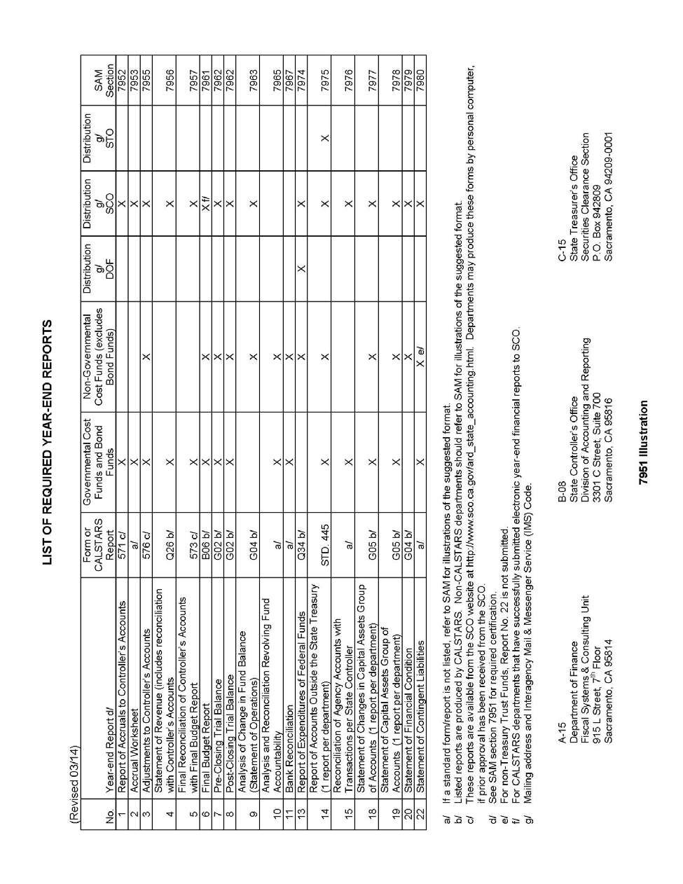

YEAR-END REPORT NO. 15, 7976
RECONCILIATION OF AGENCY ACCOUNTS WITH TRANSACTIONS PER STATE CONTROLLER
(Revised 3/14)

This report assures the accuracy and completeness of a department's revenue and expenditure accounts reported on its year-end reports. The Report No. 15 presents a reconciliation of a department's nominal accounts, the 8000 and 9000 series general ledger accounts with transactions per the State Controller as of June 30. The fund administrator will also record in their accounting system and include on the Report 15 certain statewide assessments charged to the fund. Submit this report with other year-end reports to the SCO.

A sample and instructions of how to complete Report No. 15, Reconciliation of Agency Accounts with Transactions per State Controller, is shown in the 7976 Illustration 1 and Illustration 2.

7976 Illustration 1 | (Revised 03/14)
 | Agency Name and Number |  |  |  |  |  |  |  |  |  |  |  |  |  |  | REPORT NO. 15
 | Fund Name and Number
 | REPORT NO. 15 RECONCILIATION OF AGENCY ACCOUNTS WITH TRANSACTIONS PER STATE CONTROLLER
 | FISCAL YEAR ENDING JUNE 30, 20XX
 |  |  |  | Reverse Prior Year (PY) |  |  | Apply Current Year (CY) |  |  | Transactions per Agency Accounts
 |  |  | (A) | (B) | (C) | (D) | (E) | (F) | (G) | (H) | (I) | (J) | (K) | (L) | (M) | (N) | (O) | (P)
 |  |  | Transactions per Controller | Adjustments to Controller's Accounts | Accruals | Corrections made  by Controller's | Adjustments to Controller's Accounts | Accruals | Total of  Columns (A)-(F) | Appropriation Expenditures (9000) | Reimburse- ments (8100) | Revenue (8000) | Refunds to Reverted Appropriations (9891) | Prior Year Appropriation Adjustments (9893) | Prior Year Revenue Adjustments (9892) | Operating Transfers In  (9811) | Operating Transfers Out (9812) | Statewide Assess- ments
 | Item 5555-0001-001 Chp 20/CY
 | State Ops FY /
 | 10 | A-Registrations | 24,675,103.72 |  |  |  |  | 12,410,445.43 | 37,085,549.15 | 37,085,549.15
 | 20 | B-Evaluations | 5,861,864.82 |  |  |  |  | 2,036,656.64 | 7,898,521.46 | 7,898,521.46
 | 30.01 C-Administration |  | 9,435,288.94 |  |  |  |  | 2,992,991.88 | 12,428,280.82 | 12,428,280.82
 | 30.02 D-Distributed Admin |  | -9,432,648.72 |  |  |  |  | -2,995,632.10 | -12,428,280.82 | -12,428,280.82
 | 99 | Clearing Account | 10,967,098.95 |  |  |  |  | -10,967,098.95 | 0.00 | 0.00
 | 90 | E-Rimbursements | -3,424,308.45 |  |  |  | -768,931.73 | -1,781,600.01 | -5,974,840.19 |  | -5,974,840.19
 | 97 | Revolving Fund Advance | 500,000.00 |  |  |  |  | -500,000.00 | 0.00
 | 98 | Advance to SRF | 300,000.00 |  |  |  |  | -300,000.00 | 0.00
 | Item 5555-0001-001 Chp 21/PY
 | State Ops FY /
 | 10 | A-Registrations | 4,084,368.09 |  | -5,245,872.25 |  |  | 1,235,550.21 | 74,046.05 |  |  |  |  | 74,046.05
 | 20 | B-Evaluations | 862,301.97 |  | -963,449.90 |  |  | 130,777.97 | 29,630.04 |  |  |  |  | 29,630.04
 | 30.01 C-Administration |  | 1,428,793.73 |  | -1,507,507.90 |  |  | 3,901.34 | -74,812.83 |  |  |  |  | -74,812.83
 | 30.02 D-Distributed Admin |  | -1,428,793.73 |  | 1,507,507.90 |  |  | -3,901.34 | 74,812.83 |  |  |  |  | 74,812.83
 | 99 | Clearing Account | -5,067,167.35 |  | 5,393,521.22 |  |  | -326,353.87 | 0.00 |  |  |  |  | 0.00
 | 90 | E-Rimbursements | -1,334,785.96 |  | 1,840,313.97 |  |  | -440,488.14 | 65,039.87 |  |  |  |  | 65,039.87
 | 97 | Revolving Fund Advance | -500,000.00 |  | 500,000.00 |  |  |  | 0.00
 | 98 | Advance to SRF | -200,000.00 |  | 200,000.00 |  |  |  | 0.00
 | Item 5555-0001-001 Chp 33/PPY
 | State Ops FY /
 | 10 | A-Registrations | 62,999.69 |  | -208,055.50 |  |  |  | -145,055.81 |  |  |  |  | -145,055.81
 | 20 | B-Evaluations | 5,831.61 |  | -22,117.68 |  |  |  | -16,286.07 |  |  |  |  | -16,286.07
 | 30.01 C-Administration |  | 39,004.69 |  | -28,835.57 |  |  |  | 10,169.12 |  |  |  |  | 10,169.12
 | 30.02 D-Distributed Admin |  | -39,004.69 |  | 28,835.57 |  |  |  | -10,169.12 |  |  |  |  | -10,169.12
 | 99 | Clearing Account | -172,766.73 |  | 172,766.73 |  |  |  | 0.00 |  |  |  |  | 0.00
 | 90 | E-Rimbursements | -190.88 |  | 48,261.48 |  |  |  | 48,070.60 |  |  |  |  | 48,070.60
 | Revenue - Current Year |  | -45,091.73 |  |  |  |  | -222.77 | -45,314.50 |  |  | -45,314.50
 | Refunds to Reverted Approp |  | -4,893.35 |  |  |  |  |  | -4,893.35 |  |  |  | -4,893.35
 | SCO – GAAP Assessments |  |  |  |  |  |  |  |  |  |  |  |  |  |  |  |  | 200.45
 | DOF – FSCU Assessments |  |  |  |  |  |  |  |  |  |  |  |  |  |  |  |  | 600.50
 | FI$Cal Assessments |  |  |  |  |  |  |  |  |  |  |  |  |  |  |  |  | 10,000.00
 | TOTAL |  | 36,573,004.62 | 0.00 | 1,715,368.07 | 0.00 | (768,931.73) | 1,495,026.29 | 39,014,467.25 | 44,984,070.61 | -5,974,840.19 | -45,314.50 | -4,893.35 | 55,444.68 | 0.00 | 0.00 | 0.00 | 10,800.95

SAM – RECONCILIATIONS AND REPORTS
(Revised 03/14)
Agency Name and Number Fund Name and Number
RECONCILIATION OF AGENCY ACCOUNTS WITH TRANSACTIONS PER STATE CONTROLLER
Fiscal Year Ending June 30, 20XX
Column | Description
A | Transactions Per Controller - Enter from the “Expend/Revenue” column of the Controller’s Agency Reconciliation Report at June 30, 20XX.  Enter the Revolving Fund Advance and Service Revolving Fund Advance from the “Advance” column of the Controller’s Agency Reconciliation Report.  Enter the amounts for the prior year advances from last year’s Report 15.
B | Reverse prior year Adjustments to Controller’s Accounts. Enter reversal of last year’s Report 15, Column E, Adjustments to Controller’s Accounts.
C | Reverse prior year Accruals. Enter reversal of last year’s Report 15, Column F, Accruals.
D | Reverse PY Corrections Made by Controller’s. Enter reversal of any prior year corrections made by SCO to Report No. 1, Report of Accruals to Controller’s Accounts and Report No. 3, Adjustments to Controller’s Accounts.
E | Current year Adjustments to Controller’s Accounts. Enter from Report No. 3, Adjustments to Controller’s Account.
F | Current year Accruals. Enter from Report No. 2, Accrual Worksheet. Use amounts from the last column of Report No. 2 titled “Net Total Accruals Per Agency” and use opposite sign.
G | The total of columns A through F must equal the total of columns H through O.
H - O | Columns H through O must agree with the corresponding nominal accounts, 8000 and 9000 series accounts, on the Pre-Closing Trial Balance, Report No. 7.  Use additional columns to identify other accounts as necessary. See 7962 Illustration 1 for detail.
P | Statewide Assessments include assessments for (1) SCO reporting for the Comprehensive Annual Report (GAAP reporting); (2) Finance, Fiscal Systems and Consulting Unit; and (3) Financial Information System for California.  The Fund Administrator will record and report Statewide Assessments. Obtain amounts from Controller’s Journal Entries for these assessments which will display the organization code of the department assessing the charge (e.g., 0840 for SCO, 8860 for Finance.) Do not include statewide assessments for charges recorded against your department’s organization code, as these types of assessments are charged to your department’s appropriations (e.g., Pro Rata.)  CALSTARS departments which submit manual year-end reports will report statewide assessments in Column P. The statewide assessments in Column P will be independent of other figures on Report 15. The total of Column H, Appropriation Expenditures must agree to total expenditures (GL 9000) on the Pre-Closing Trial Balance (Report No. 7). CALSTARS departments should refer to the CALSTARS Procedure Manual for detailed instructions on how to record the transactions.  Non-CALSTARS departments will report statewide assessments as expenditures in Column H, Appropriation Expenditures. Total appropriation expenditures on Report 15 must agree to total expenditures on Report 7, the Pre-Closing Trial Balance.

7976 Illustration 2

LOST OR DESTROYED WARRANTS 8426.1
(Revised 3/14)
Departments will use a Request for Duplicate Controller’s Warrant/Stop Payment form, STD. 435, to request a duplicate warrant to replace a lost or destroyed warrant. See 8426.1 Illustration. Departments will not issue an office revolving fund check to replace a lost or destroyed warrant except for a payroll warrant.
The STD. 435 is a three page form including:

Page 1 - The legal affidavit requesting a duplicate warrant. Page 2 - Instructions to the payee.
Page 3 - An optional agency notification of duplicate warrant issued and mailed.

The department that authorized the original warrant (authorizing department) will complete the top portion of the STD. 435. The pertinent data should be typed or legibly printed. If the information is not legible, SCO will return the form to the department.

The authorizing department will mail STD. 435 to the payee to complete the certification. The warrant payee will complete and mail STD. 435 to the SCO, Division of Administration and Disbursements.

The authorizing department may fax a STD. 435 to the payee with instructions that the payee complete the form in non-black, ball point ink. This is to ensure that the SCO receives STD. 435 with original signatures. If it cannot be ascertained whether an original signature is affixed to STD. 435, SCO will return the form to the authorizing department.

Upon receipt of the properly executed STD. 435, SCO will verify the status of the original warrant.

- If the warrant has been cashed, SCO will send a photocopy (front and back) with STD. 435 to the authorizing department.

- If the warrant is still outstanding, SCO will place a stop payment on the original warrant and issue a duplicate warrant within 7 working days. The duplicate warrant will be mailed directly to the payee.

If the authorizing department wants notification that the duplicate warrant was issued and mailed, the authorizing department must complete page 3 of STD. 435, Agency Acknowledgement of Issuance of Duplicate Warrant. The SCO will date stamp the acknowledgment when the duplicate warrant is issued and mailed to the payee and forward it to the authorizing department.

In cases of theft, the authorizing department will complete STD. 435 as instructed above. The authorizing department will mail or fax STD. 435 to the payee and fax a copy to SCO. A stop payment will be placed immediately to prevent redemption of the original warrant. It is incumbent upon the authorizing department to instruct the payee that if the original warrant is recovered, it is not to be cashed. The original warrant will not clear the banking system. Use this process only when the payee has reported theft of a warrant. Must call SCO at 916-445-3903 to place immediate stop and for fax number.

See Government Code Sections 17090–97 regarding lost or destroyed warrants.

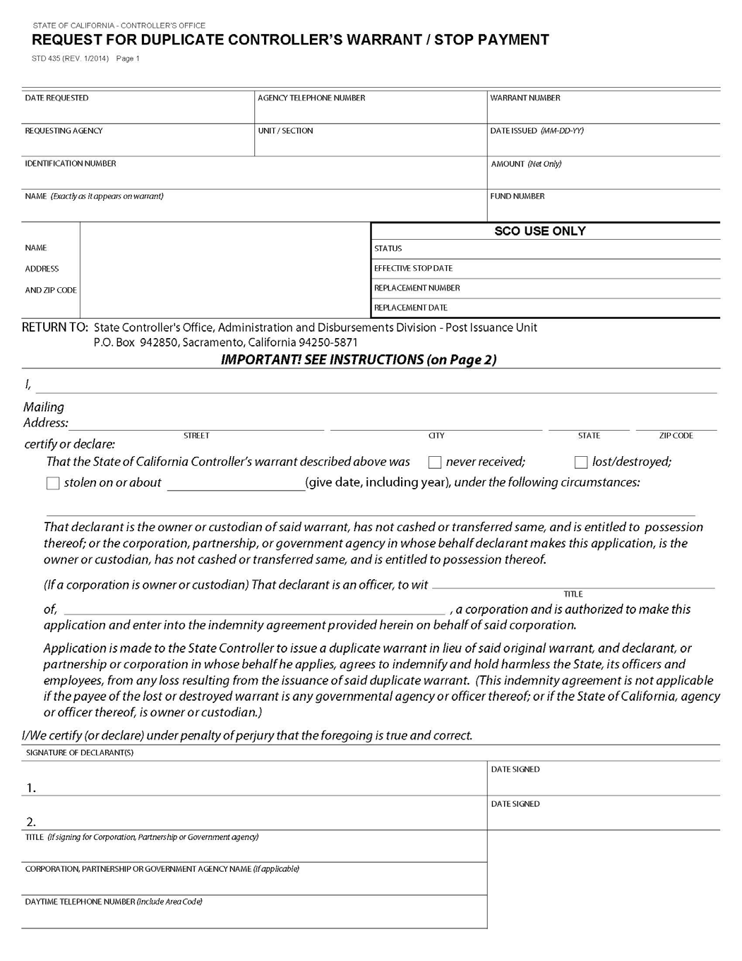

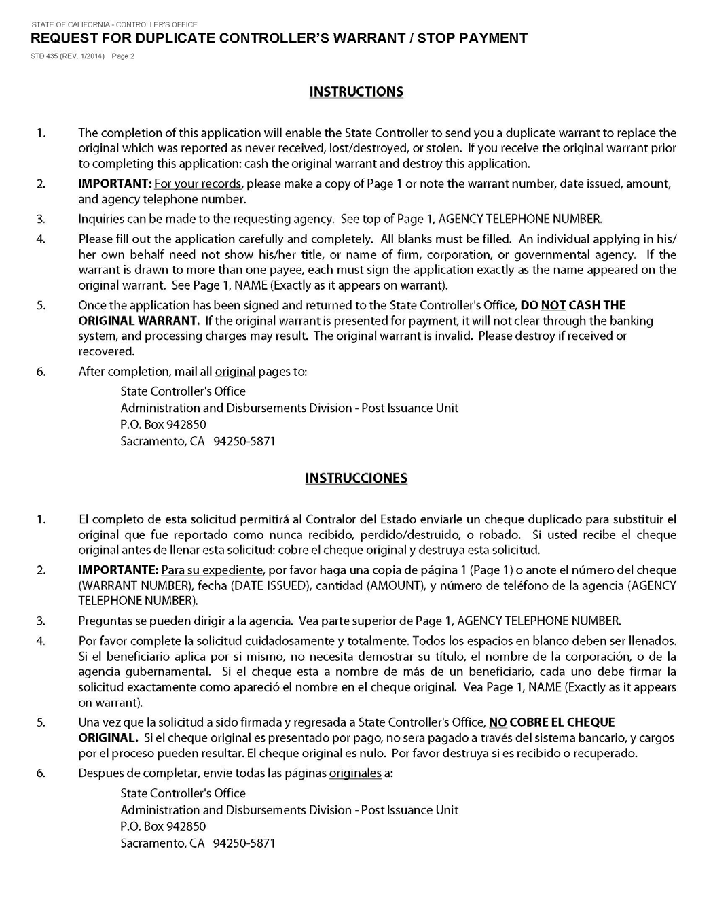

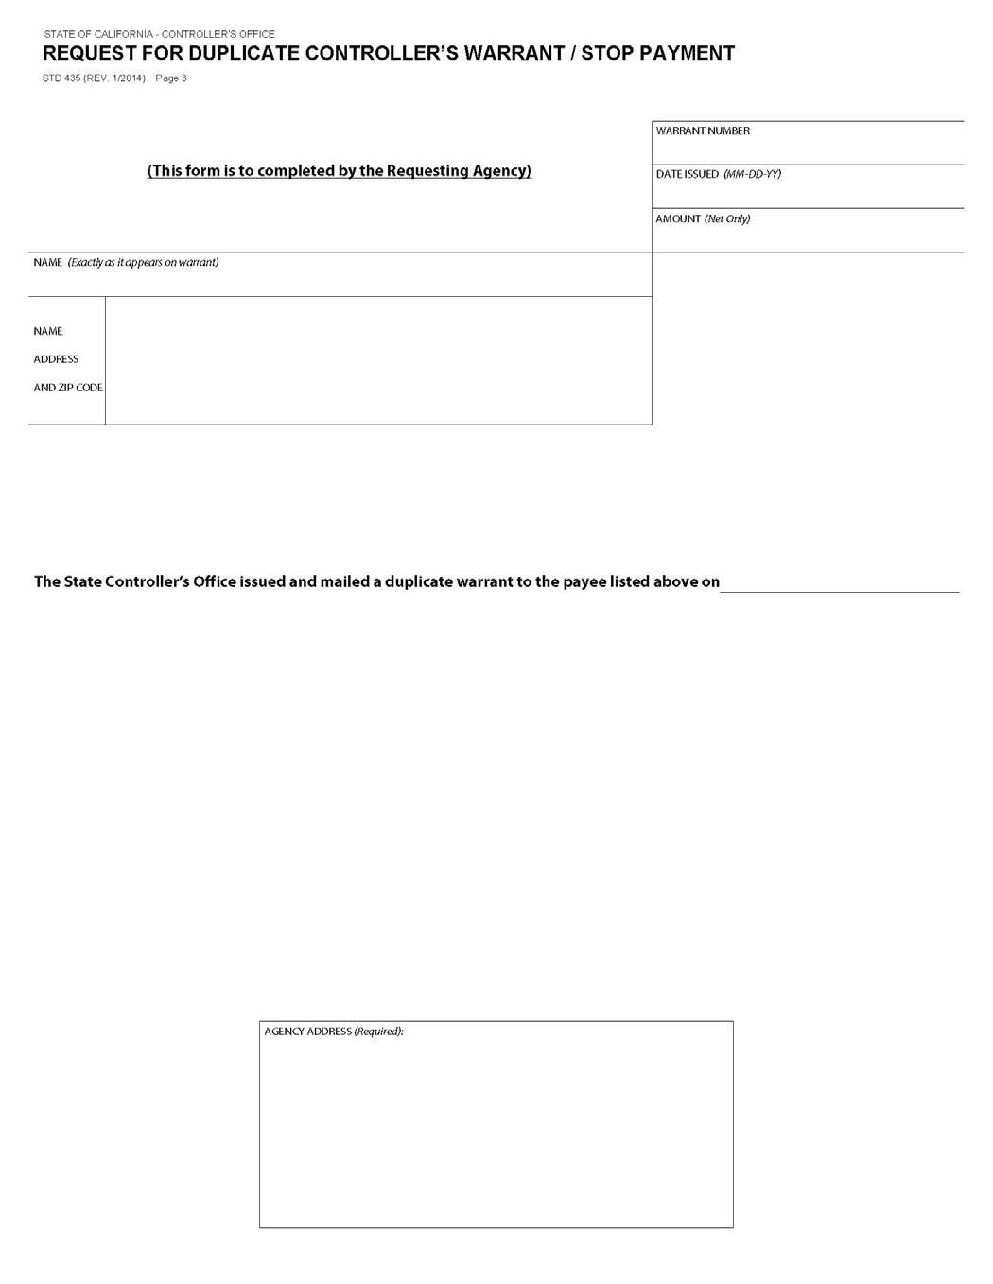

PREPARATION OF PLAN OF FINANCIAL ADJUSTMENT 8452.1
(Revised 3/14)
Government Code Section 11251 is the general statute that authorizes the use of a PFA. Other statutes which authorize the use of a PFA for specific funds are: Government Code Section 16365 for the Federal Trust Fund; Education Code Section 12060 for the Vocational Education Federal Fund; and Health and Safety Code Section 100390 for the Public Health Federal Fund.
The format to be used for a general PFA is contained in SAM Section 8452.1 Illustration 1; and for the Federal Trust Fund, SAM Section 8452.1 Illustration 2. Each PFA must follow this format. Of course, the statute references, funds, and appropriations will vary. Also, each PFA requested under Government Code Section 11251 should request approval only from the State Controller.
The following items are to be included in a PFA:

  - The first paragraph should include a request for approval of PFA, and a statement of the period of time for which PFA is to be effective. This period of time can be for a limited period (one, two, three years) or it can be continuous from year- to-year as SAM Section 8452.1 Illustration 1 indicates. Departments should review their PFA each year and cancel those PFA which are no longer needed by notifying SCO, in all cases, and DOF only for those requiring their approval.

  - Identify the funds and/or appropriations covered by PFA. If PFA is to be continuous and one of the appropriations covered by the plan is appropriated yearly, care should be taken to identify the yearly appropriation and not the specific appropriation of a particular year. For example, the ten digit item code ( - - ) numbers of a support appropriation should be used to identify a department's yearly support appropriation and not the year and chapter number of the current budget act. If the appropriation covered is made by other than budget act legislation, the year and chapter must be stated.

  - Also to be included is a declaration by the department that a cost allocation plan will be used to allocate the costs covered by the PFA. A description of the cost allocation plan and the types of costs covered must be filed with the State Controller. Those departments that have more than one PFA only need to file one cost allocation plan description unless a different plan is utilized for each different PFA. The description should include the type of costs being allocated and the methodology used to allocate the costs. Refer to SAM Section 9205 through 9228 for guidelines on allocating costs. Although these sections refer to allocating line-item costs to programs, the same principles apply to allocating shared costs between funds and/or appropriations.

  - The frequency of transfer requests between the funds and/or appropriations covered by PFA must be included. Transfers must be made monthly. The period covered by the transfer must be clearly stated. For example, if an estimated transfer is submitted for July, it must indicate JULY ESTIMATES. When the estimate is cleared, the transfer request must indicate JULY ACTUAL.

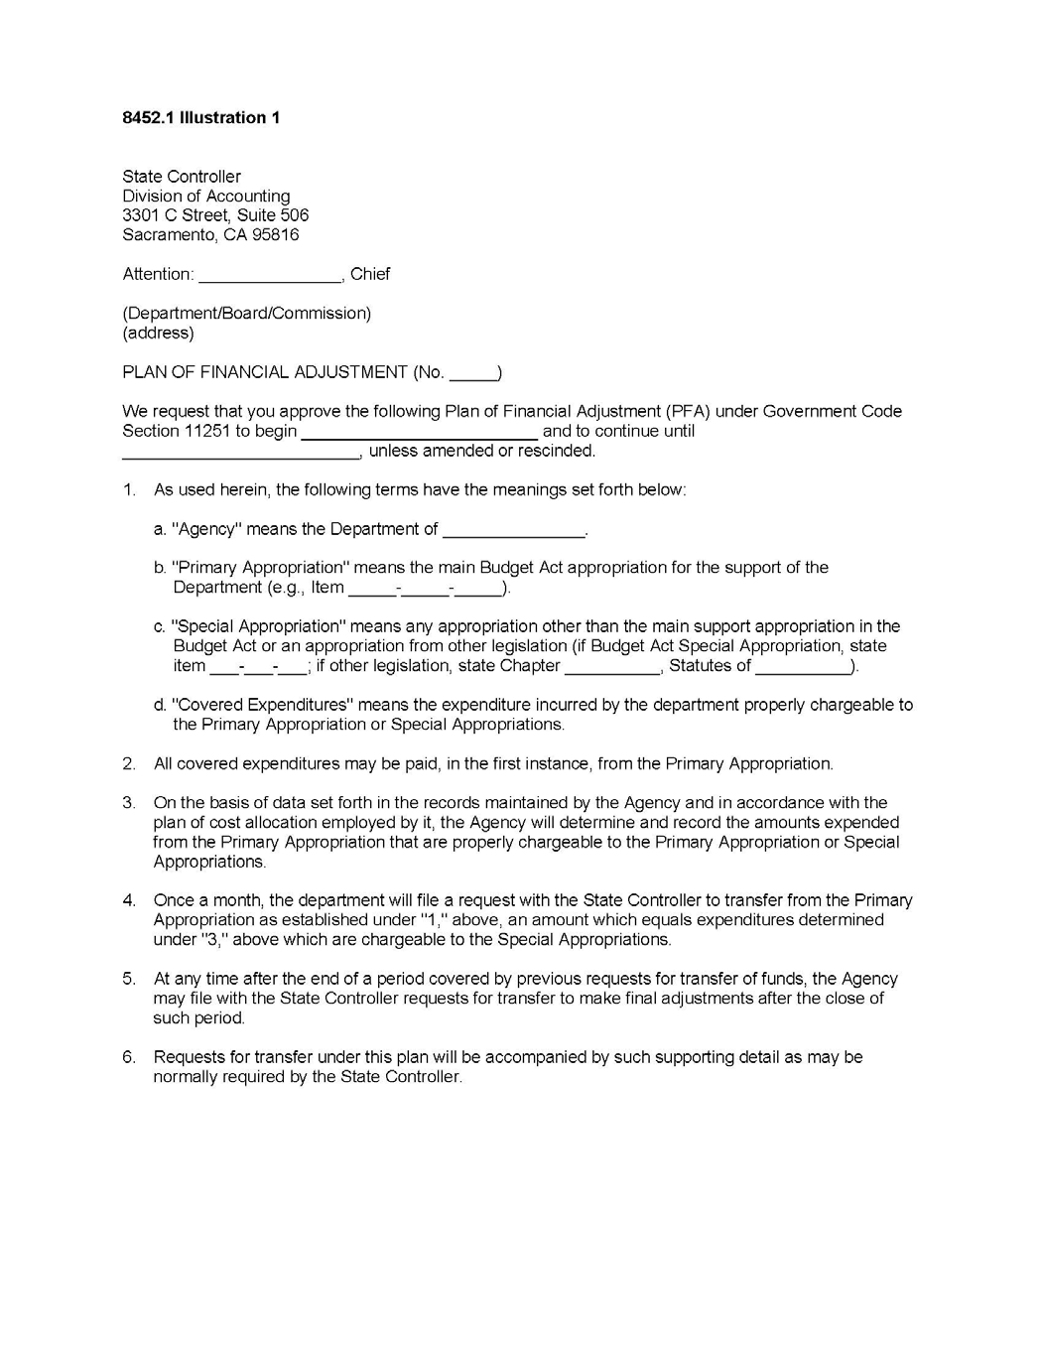

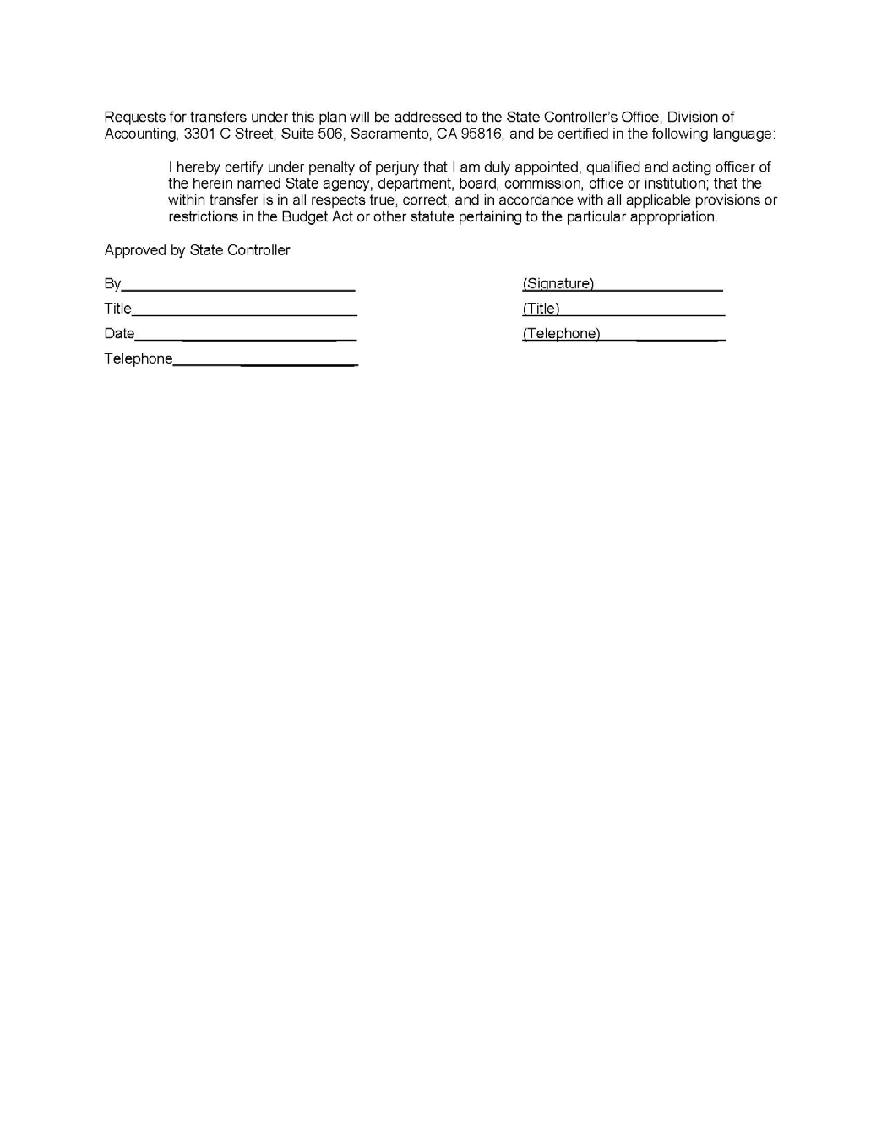

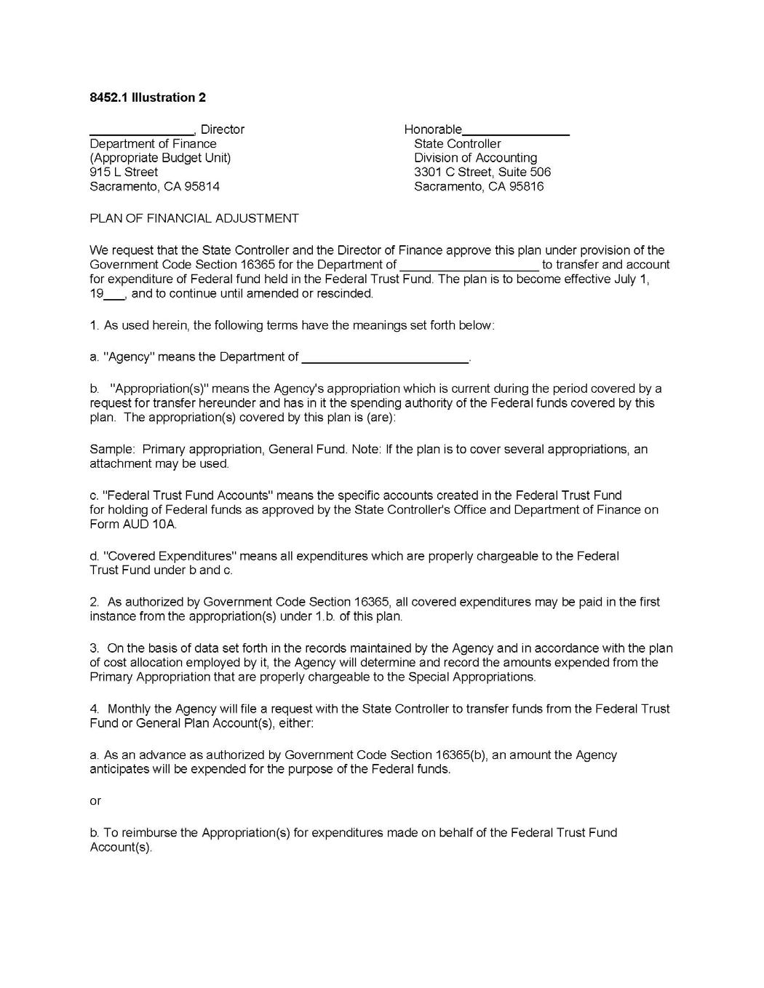

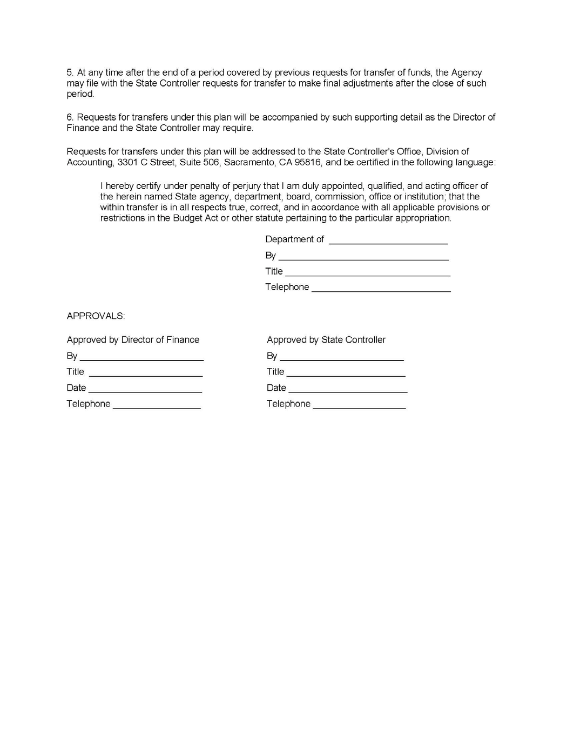

ADVANCE PAYMENTS FOR REIMBURSEMENT SERVICES CONTRACTS 8453
(Revised 3/14)

Charges for services to be performed by a state department may be paid in advance by the entity to receive such services. The department which performs the services will account for the payment as a reimbursement to their appropriation. Advance payments may be used to alleviate cash flow or collection problems. Terms of the advance payment must be specified in the reimbursement services contract.

Rev 425 MARCH 2014

SAM⎯PROPERTY ACCOUNTING

LOST, STOLEN, OR DESTROYED PROPERTY 8643
(Revised 3/14)

Whenever property is lost, stolen, or destroyed, departments will prepare a Property Survey Report form, STD. 152. The department will adjust its property accounting records and retain the Property Survey Report as documentation. The report will contain:

- A description of the events
- Precautions to be taken to prevent repeat situations
- A statement that the California Highway Patrol has been notified (Government Code Section 14613.7)

Losses of state property due to fraud or embezzlement will be reported to the Department of Finance (Finance), Office of State Audits and Evaluations and the California State Auditor’s Office. See SAM section 20080.
Employees will be charged with any loss and damages to state property due to their negligence or unauthorized use.

Department management must promptly investigate incidents involving loss, damage, or misuse of information assets. Departments shall immediately notify the California Highway Patrol upon discovery of all Information Technology security incidents and computer related crimes. See SAM Sections 5340.1 through 5340.4.

Each department having ownership responsibility for information must complete a Security Incident Report. The Security Incident Report, part of the State Information Management Manual, is available at http://www.cio.ca.gov/Government/IT_Policy/SIMM.html. The report must be submitted to the California Information Security Office within ten working days of the department’s becoming aware of an incident involving the theft of such information, including information stolen in conjunction with the theft of a computer or data storage device.

Rev. 425 MARCH 2014

GENERAL 8700
(Renumbered 2/65)

Some special problems arise that are common to several agencies but do not have general application which would warrant provisions therefore in the standard entries and General Ledger accounts. In order that procedures may be standardized among agencies having such special problems, instructions are included here. Instructions on special problems arising in a single agency or a few agencies are not included. Such procedures are transmitted to agencies concerned by memorandum.

REAL PROPERTY ACQUISITION 8705
(Revised 3/14)

In most cases laws authorizing the acquisition of real property provide that such acquisitions be subject to the provisions of the Property Acquisition Law. In recent years many appropriations for the acquisition of real property also provide for construction, improvements, and equipment.

To facilitate accounting for acquisitions of real property subject to the Property Acquisition Law, the following procedure is prescribed:

- The benefiting agency will record the entire amount of such appropriations in its allotment-expenditure accounts.
- The benefiting agency will submit a working budget to the Department of Finance for the entire amount appropriated.

- After approval by the Department of Finance, one copy of the working budget will be forwarded to the Accounting Section of the Department of General Services (DGS), where the amounts allotted for the acquisition of real property will be recorded.
- All claims for the acquisition of real property will be filed by the Accounting Section and accounted by that section as decreases in memorandum allotment accounts. In preparing these claims the Accounting Section will prepare an extra copy of the Claim Schedule, STD. 218, for the benefiting agency and will attach copies of all invoices. These copies of STD. 218 will be forwarded to the benefiting agencies after receipt by the Accounting Section of the Controller's Notice of Claim Paid, Form CO–I 02, and inclusive warrant numbers have been noted on the copy of STD. 218.
- Upon receipt of their copies of the Claim Schedule, STD. 218, the benefiting agencies shall record the expenditures in their accounts. Entries to the property accounts will be made at the same time and from the same source that expenditures are reflected in the accounts.

- The records maintained by the DGS will be memorandum records only. Expenditures from these appropriations will not be reflected in expenditure statements of the DGS.

- The benefiting agencies will be responsible for reconciling these appropriations with State Controller's Office accounts.

- State agencies that acquire real property are required to provide information to DGS for inclusion in the Statewide Property Inventory (SPI) and routing to the Secretary of State Archives to be in compliance with GC 11011.1-11011.21. For assistance in determining the appropriate documents to be submitted, contact RESD’s SPI Unit at SPIweb@dgs.ca.gov.

BILLING FOR SERVICES OF EMPLOYEES PAID ON MONTHLY BASIS 8740
(Revised 3/14)
Below is the formula for determining hourly rates when departments bill for services of employees paid on a monthly basis on or after January 1, 2014. The number of hours to be deducted for Saturdays, Sundays, holidays, and the state contribution for staff benefits are provided. Vacation, annual leave, personal leave program, sick leave, bereavement leave, informal time off, jury duty leave, military leave, furlough leave, and professional development leave will be compiled and averaged by the department for this computation.
This formula provides for billing only for hours actually worked. The formula does not include an amount for such costs as identifiable operating expenses incurred in rendering the service, charges for other than incidental use of equipment, overhead, and other costs. In addition, Workers’ Compensation, Industrial Disability, Unemployment Compensation, and Life Insurance benefits are not included in the formula since these expenses can vary substantially among departments. However, such costs should be included in billing for services in accordance with SAM sections
8752.1 and 8758.

HOURLY BILLING RATE CALCULATIONS
NDAR YEAR  ESS DEDUCTIONS  Saturdays | 365 days x 8 hours =  52 days x 8 hours = | 2920  416 hrs.
Sundays | 52 days x 8 hours = | 416 hrs.
Holidays | 12 days x 8 hours = | 96 hrs.
New Year’s Day | Labor Day
Martin Luther King Jr. Day | Veteran’s Day
President’s Day | Thanksgiving Day
Cesar Chavez Day | Day After Thanksgiving
Memorial Day | Christmas Day
Independence Day | Personal Holiday

CALE
hrs. L

Other Absences (averages):
Vacation/Annual Leave*
Personal Leave Program (PLP)*
Miscellaneous – Sick, Bereavement, Informal Time Off,
Jury Duty, Military, Furlough Off, Professional Development Leave*

Subtotal Vacation, PLP and Miscellaneous Absences
TOTAL DEDUCTIONS (include all amounts calculated under Deductions) TOTAL ACTUAL WORKING TIME PER YEAR (2920 hrs. less ―Total Deduction)

*Statewide data is not available. Each department, based on previous experience and expertise, must compile the information for Other Absences. Remember to calculate a separate average for each type of Other Absences (i.e. average vacation/annual leave, average PLP, and average miscellaneous absences).

STATE’S STAFF BENEFIT CONTRIBUTION PERCENTAGES
(Effective January 1, 2014)

Employee's Retirement | 21.20
OASDI | 6.20
Medicare | 1.45
Health, Vision, and Dental Benefits | 14.86
Total Percent | 43.711/
(Continued)

(Continued

BILLING FOR SERVICES OF EMPLOYEES PAID ON MONTHLY BASIS 8740 (Cont.1)
(Revised 3/14)

FORMULA FOR CALCULATING HOURLY BILLING RATE:

(Monthly Salary Rate x 1.4371) divided by
(“Total Actual Working Time per Year” divided by 12)

Note: Monthly Salary Rate should be adjusted as necessary to reflect (average) salary reductions for PLPs and furloughs.

Formula for calculating daily rate for 2,000 hours or less per year:
The number of working hours per month is not appropriate for employees not expected to work 2,000 hours per year, less vacation and sick leave. In such instances, an estimate of actual working time per month or year, considering average holiday, vacation, and sick leave should be used. For example, billing rates for academic year employees, such as college instructors, would be computed on the basis of the number of workdays in a year, less the average of sick leave usage. (Holidays and vacation are not considered in this instance since they are considered in determining the number of working days.)
Daily Rate = (Annual Salary Rate x 1.4371) divided by (Working Days per Year - Average Sick Leave Days Used per year)
Hourly Rate = Daily Rate divided by 8

1/Note: The 43.71 percent rate is applicable only to employees who are Miscellaneous Tier 1 members of the Public Employees' Retirement System. For those employees who are not Miscellaneous Tier 1 members, but who still belong to Social Security, their appropriate retirement contribution rate will be substituted for the 21.20 percent rate. Those employees who are not Miscellaneous Tier 1 members and who do not belong to Social Security will include their appropriate Medicare and retirement rates, and health, vision, and dental benefit rates. For example, the appropriate total rate for members of the Safety Retirement Category who do not belong to Social Security is 34.22 percent consisting of:
- 17.91 percent for retirement contributions from the appropriations of the employing departments
- 1.45 percent for Medicare
- 14.86 percent for health, vision, and dental benefits

This 34.22 percent figure will be used in lieu of the 43.71 percent figure shown above. State departments with employee members in different retirement categories may use a composite employer contribution rate, based on department experience. Also, any department may use other rates for OASDI, Medicare, and health, vision, and dental benefits if more accurate rates can be determined from the actual experience of their operations.

CENTRAL SERVICE COSTS 8753
(Revised 3/14)

Central service costs are those amounts expended by central service departments and the Legislature for overall administration of state government and for providing centralized services to state departments. These functions are necessary for state operations and are centralized to provide efficient and consistent statewide policy and services. Central service departments are:

California State Auditor’s Office | Legislative Counsel Bureau
California State Library | Legislature
California Department of Technology | Office of Administrative Law
Department of Finance Department of Human Resources Department of Justice  Financial Information System for California | Office of Planning and Research  Secretary of the California Health and Human Services Agency  State Controller’s Office
Governor’s Office  Health Benefits for Annuitants (Retired) Dental Benefits for Annuitants (Retired) | State Personnel Board State Treasurer’s Office
Central service costs are funded by the General Fund and the Central Service Cost Recovery Fund appropriations made to each central service department. The central services benefit most funds/departments. For equity, Government Code sections 11270–11277 and 22883 provide for the sharing of central service costs by funds other than the General Fund and the Central Service Cost Recovery Fund. This cost sharing process is titled formally as "General Administrative Costs" but is known more commonly as "Pro Rata." See explanation in SAM section 8754.

In addition to administering the Pro Rata central service costs sharing, the Department of Finance, Fiscal Systems and Consulting Unit (FSCU), prepares a Statewide Cost Allocation Plan (SWCAP) each year. SWCAP is a cost allocation plan which apportions federally allowable central service costs to departments. Therefore, differences exist in the central service costs contained in the two plans.

(Continued)

(Continued)

CENTRAL SERVICE COSTS 8753 (Cont. 1)
(Revised 3/14)

The central service functions included in Pro Rata and SWCAP are listed below:

Central Service Plans
Central Service Function | Pro Rata Only | SWCAP Only | Both
Department of Finance:
Audits |  |  | X
Budgets |  |  | X
California State Accounting and Reporting System (CALSTARS) |  | X
California Department of Technology |  |  | X
State Controller’s Office:
Accounting |  |  | X
Claim Audits |  |  | X
Payroll |  |  | X
General Disbursements |  |  | X
Field Audits |  |  | X
Personnel/Payroll Systems and Development |  |  | X
State Treasurer’s Office:
Investment | X
Banking |  |  | X
Cash Management and Trust Services |  |  | X
Financial Information System for California |  | X
State Personnel Board |  |  | X
Department of Human Resources |  |  | X
Office of Administrative Law |  |  | X
California State Library |  |  | X
Health Benefits for Annuitants (Retired) |  |  | X
Dental Benefits for Annuitants (Retired) |  |  | X
Secretary of the California Health and Human Services Agency |  |  | X
California State Auditor’s Office |  |  | X
Department of Justice |  | X
Legislature  Legislative Counsel Bureau Governor’s Office  Office of Planning and Research | X X X X
The costs of the above central services are apportioned on the basis of services provided. To do this, FSCU determines the most appropriate workload base for each central service. Actual workload units are accumulated for each department. Then, central service costs are apportioned to the departments/funds on the basis of these workload units.

NONEMPLOYEE ACCOUNTS RECEIVABLE 8776.6
(Revised 3/14)

Each department will develop collection procedures that will assure prompt follow-up on receivables. Departments will use the following procedures and guidelines for the collection of amounts owed to the state from nonemployees. These procedures are in accordance with the Accounts Receivable Management Act as provided in Government Code (GC) sections 16580-16586.

Locating Debtor
When the address of the debtor is unknown, departments shall attempt to obtain a current address. Departments may utilize Internet search engines and/or a data research service. Departments should perform a cost benefit analysis to determine if procuring services to locate debtors would be cost beneficial. Another alternative is to request the debtor’s address from the Department of Motor Vehicles by completing a Gov’t Agency Request for Driver License/Identification Record Information form, INF 254. In order to use this alternative, the date of birth or driver’s license/identification number of the debtor is required.

Collection Letters
Departments are advised to utilize collection practices that are cost effective and consistent with their program goals and legal authority. Three documented letters should be made to collect on nonemployee delinquent accounts. However, departments have the option of making one documented letter before proceeding to the discharge of accountability process for nonemployee accounts receivable of $25 and under. Refer to the Discharge of Accountability section below for further information regarding the discharge of accountability process.
For the collection letter process, the department will send a sequence of three collection letters at a minimum of 30 day intervals. If a reply or payment is not received within 30 days after sending the first letter, the department will send a second letter. This follow-up letter will reference the original request for payment letter and will be stated in a stronger tone. If a response is still not received from the debtor, a third letter will be sent 30 days later. This last letter will include references to prior letters and will state what further actions, including collection fees, may be taken in the collection process.

Collection Fee
GC section 16583.1 allows departments to charge a reasonable fee, not to exceed the actual costs incurred by the department, to recover the department’s collection costs on past due ARs.
If a department plans to recover costs pursuant to this section, departments should consider actual costs incurred, including, but not limited to, staff time to send out collection letters, postage, equipment costs, and contingency fees for private collectors.
Departments will record this fee as revenue, Source Code 162100, Delinquent Receivables – Cost Recoveries.

Collection Actions Review
If the three collection letters are unsuccessful, departments will prepare an analysis to determine what additional collection efforts should be made. The analysis should include a cost/benefit analysis of the collection actions listed below. Departments should initiate one or more of the following actions:
  - Offset Procedures—An offset, as the term indicates, is the interception and collection from amounts
owed by other state departments to the debtor. For more offset information, see SAM section 8790.

  - Court Settlements—There may be instances where it would be cost effective for departments to seek court judgments against debtors. Departments should consider the possibility of filing action in small claims courts. For larger sums, department counsel should be consulted for advice.

(Continued)

(Continued)

NONEMPLOYEE ACCOUNTS RECEIVABLE 8776.6 (Cont. 1)
(Revised 03/14)

  - Collection Agencies—Departments may consider contracting with another department that has a collection unit or with an outside collection agency.

The State Contracting Manual, the Public Contract Code section applicable to contracts for services, and GC
section 19130 should be consulted when a department is considering contracting with a collection agency. Any contract made with a collection agency must specify that all funds collected on behalf of a department will be remitted to that department. The collection agency can then be paid in one of several ways for its services - by a set fee per collection, on an hourly basis, or on a percentage basis, in arrears, based on services rendered.
Prior to assigning the debt to a collection agency, departments are required by law to notify the debtor in writing at the address of record that the alleged AR debt will be turned over for private collection unless the debt is paid or appealed within a specified time period.
  - Sale of ARs—Departments are authorized to sell ARs to private persons or entities. Departments will record the net income from the sale in their accounting records. Specific accounting entries for the sale of ARs are detailed in SAM section 10536, Standard Entry No. 36.

Prior to selling the debt, departments are required by law to notify the debtor in writing, at the address of
record, that the alleged AR debt will be turned over for private collection unless the debt is paid or appealed within a specified time period.
Departments will select the collection actions that are likely to generate the highest net income and do not compromise future state income collections. In addition, departments should consult with the Franchise Tax Board or any other state department that has successfully established an effective AR collection system to develop methods for improving their collection rate.

Discharge from Accountability

If all reasonable collection procedures do not result in payment, departments may request discharge from accountability of uncollectable amounts due from private entities. Departments will review their AR, no less than quarterly, to identify receivables for discharge. If departments have identified receivables for discharge, departments will file an Application for Discharge from Accountability form, STD. 27, with the SCO, Division of Accounting and Reporting. Applications for Discharge from Accountability of uncollectable amounts of more than
$10,000 will be filed separately from applications for amounts of $10,000 or less. The $10,000 amount applies to the total of all amounts owed by the debtor, not to each invoice. The application for discharge shall include:

- Statement of the nature of the amount due
- Name(s) of the person(s) liable
- Estimated cost of collection
- Any other fact(s) supporting the request, including offset attempts (See SAM section 8790)
- If the discharge from accountability is due to bankruptcy, the supporting documentation must include a copy of the court’s final discharge of the debtor and evidence that the specific department is included in the petition for bankruptcy.
- Signature, phone number, printed name, and title of person completing the STD. 27
- Signature, printed name, and title of manager authorizing the STD. 27
The individual authorizing the Application for Discharge from Accountability should be at a level at least equivalent to that of manager of the accounting office.

(Continued)

(Continued)

NONEMPLOYEE ACCOUNTS RECEIVABLE 8776.6 (Cont. 2)
(Revised 03/14)
For accounts receivable amounts of $500 or less, GC section 13943.2 provides that upon written authorization by the California Victim Compensation and Government Claims Board (VCGCB), state departments may refrain from collecting amounts of $500 or less. The $500 limitation applies to the total of all amounts owed by the debtor, not to each invoice.
Departments must request approval from the VCGCB for the authorization to discharge from accountability for collecting accounts receivable of $500 or less. When requesting approval from the VCGCB, departments must certify the following in their letter:
  - Attempts to collect these ARs are in accordance with SAM section 8776.6
  - Will discharge only those debts that have been determined uncollectible or it is not cost beneficial to continue pursuing collection
  - Understands the discharge from accountability does not release the debtor from the debt owed to the state

An example of what should be included in the request letter is available on the Accounts Receivable Toolkit at: http://www.dof.ca.gov/accounting/fscu/. Questions regarding this authorization should be directed to the
VCGCB, Government Claims Program, at (916) 491-3700 or toll free (800) 955-0045. Departments who do not obtain approval from the VCGCB shall apply for discharge from accountability with the SCO, as indicated above.

The California State Universities must refer to Education Code section 89750.5 for application limitations.

Petty Cash (See REVOLVING FUNDS (OFFICE))
Purchase Funds.......................................................8112–12.6
Purchases.........................................................................3580
Receipts 8020–23
Reconciliations................................................................8060
Recovery by Collection 8593.1
Recovery by Offset ..........................................................8790
Revolving Fund, Cash Book............................................8191
Separation of Duties ..................................8080–80.1, 8580.1
Shortages, Adjustment.........................................8072, 10509
Withdrawals 8040–48
CATALOGS AND PRICE LISTS
Material Services Section ................................................3542

CENTRAL STORES, OFFICE OF PROCUREMENT (See MATERIAL SERVICES)
CENTRALIZED PURCHASING, PURPOSE OF 3501–02
CENTRALIZED STATE TREASURY SYSTEM .........8001, 8890 CERTIFICATION
Lost or Destroyed Meal Tickets.....................................11027 CERTIFIED ACCESS SPECIALIST PROGRAM 1452.1
CHANGE FUNDS (See REVOLVING FUNDS (OFFICE)) CHARGE CARD (See CREDIT CARD)
CHARGES
Interagency Services........................................................8758
Living Quarters .............................................................11033 CHECKS (See WARRANTS)
CLAIM
Against an Employee 8790.7
Against the State .............................................................2461
Board of Control..............................................................8710
Capital Outlay Appropriations 8422.21
Claim Schedule
Consumer Use Tax Data.........................................8731
Disbursements 8422–27
Freight Bills...................................................3851–51.2
Processing Claims ..................................................8170
Real Property Acquisition.......................................8705
Refund Claims..............................................8240, 8424
Standard Entry No. 1 ............................................10501
Corrections (Form AUD–16) 8422.5
Damage to
Commercial Automobile 0758
Employee’s Personal Property ................................8423 Private Vehicle ..............0757, 2430–42.1, 8777.1–77.2 State Property, Third Party .....................................8778
Delinquent Invoices 8471.4-8471.5
Electronic Fund Transfer by DGS 8471.2
Purchase and Expense ...........................................8170, 8422
Claims for Refunds 11073.2
Gasoline Tax...............................................8745.1–45.4
Governmental Cost Funds ...................... 8240-41, 8424 Revolving Fund(s)
Advances ................................................................8595
Claims ....................................................................8170
Claims to Establish.................................................8425
Deficiencies ............................................................8072
Standard Entry No. 1 ............................................10501
Warrants 8422.25
Short or Damaged Shipments 3860–69
Tort Liability ...................................................................8712
Travel Expense Claim (See TRAVEL)
Use Tax ...........................................................................8730
Workers' Compensation (See INSURANCE)
CLASSIFICATION OF FUNDS................................... 7400 et seq. CLASSIFICATION OF INFORMATION ..................... 5300 et seq COMMERCIAL VEHICLES (See VEHICLE) COMMUNICATIONS (See TELECOMMUNICATIONS) COMPETITIVE BIDS (See BIDS, COMPETITIVE) COMPUTERS (See INFORMATION TECHNOLOGY)
CONDEMNATION DEPOSITS FUND
Interest Income 8284.2
Std. Entry No. 32 Interest Received...............................10532
CONFERENCE
Rooms, Use After Hours 1330.5
Travel to 0724
CONSTRUCTION 1300
Project Undertaking (RESD Form 23) 1300
Public Works Board Approvals ........................... 6700 et seq. Safety of Schools 1452.2
CONSTRUCTION MANAGEMENT AND QUALITY ASSURANCE MANUAL 1300
CONSTRUCTION REVIEW 1300
CONSTRUCTION SERVICES, OFFICE OF
Construction Management and Quality Assurance Manual 1300
Contacts 1300
Internet Location 1300
Phone Numbers 1300
Program Purpose 1300
Services 1300
Statutory Authority 1300
CONSULTANT SERVICES
Architectural 1452.2
Feasibility Studies & EDP Acquisition............................5202 CONTAINERS, RETURNABLE .............................................8765
CONTRACT(S)............................................................ 1200 et seq.
Advertising Space 0560
Approval General Services .....................................1215,1216
Authorization of Agreements 1208
Budgetary Approval ........................................................6530
Centralized Purchasing (See PURCHASES)
Contracts Register 1233
Exempted from General Svs. Approval 1215
Freight Shipments..................................................3802, 3885
General ................................................................ 1200 et seq.
General Svs. Approval Required 1216
Hazardous 1216
Information Security 5305.8
Information Technology
(See PROCUREMENT, Information Technology) Lease & Lease Purchase ........................................3700, 8632
Microfilm Services ................................................1216, 1652
Optical Disk Services ......................................................1652
Policy.....................................................................1200, 1205
Private Architect 1300
Project Undertaking (Form STD. 23) 1300
Public Works 0570
Rental 1216
State Contracting Manual 1205
CONTROLLER, STATE Accounts................................................................ 8800-8890
Adjustments to.................................................................7955
Fund Ledgers 8810–14
Numbering of Ledger Accounts..............................8814 DESTROYED, (See LOST, STOLEN, or DESTROYED)
DESTRUCTION OF PAPER WORK AND RECORDS (See RECORDS MANAGEMENT)

DIRECT CONSTRUCTION 1328.12
DIRECT DELIVERY, COMMODITIES ...............................10832 DISABILITY (See EMPLOYEE)
DISBURSEMENT VOUCHER (Form STD. 439) 8112.2
DISBURSEMENTS ......................................................8400 et seq. Claim Schedule (Form STD. 218) 8422.2
Electronic Fund Transfer by DGS 8471.2
General 8400.1
General Ledger Accounts ................................................7610
Reportable Payments .......................................8422.19 et seq. Payrolls..................................................................8421, 8451
Late Payment Penalties.........................................8474 et seq. DISCOUNTS .................................................................3573, 8113 DISCHARGE FROM ACCOUNTABILITY 8776.6
DISHONORED CHECKS
Income Adjustment, Examples 8290.9
Redeposit Charge ...................................................8043–43.2
Standard Entry
No. 7.....................................................................10507
No. 8.....................................................................10508
No. 9.....................................................................10509
No. 10...................................................................10510
No. 11...................................................................10511 DISPOSAL
Information Technology
Equipment 5901–03
Media 5365.3
Supplies 5951–53
Personal Property...................................................3520, 8634
Property Accounting........................................8660, 8671–72
Surplus Personal Property ...............................................3520
Unused Accountable Forms.............................................1750 Vehicles...........................................................................4111
DOCUMENTS
Accounting Records 7220–21
Copying Prohibitions.......................................................2880
Distribution of
Publications .............................................3122.24, 3161
Free to Public..........................................................3161
Posting, Controller’s Accounts........................................8830 Printing of ............................................................2800 et seq.
DOCUMENTS AND PUBLICATIONS
(See PUBLICATIONS AND DOCUMENTS)
DONATED STATE PROPERTY ............................................3521
DONATED STORES RECEIVED ...............................10822–22.1 DONATIONS (See GIFTS)
DRUGS, PURCHASE AND HANDLING..................3661–3661.2 DRY CLEANING AND LAUNDRY SERVICE 11041–43
DUPLICATING
(See PRINTING or REPRODUCTION SERVICES)
DUTIES, SEPARATION OF ..........................................8080–80.1 Deposits 8032.3

–E–
EARNINGS FROM INTEREST, MAXIMIZE ........................8099 EASEMENTS 1323.15
LEVERAGED PROCUREMENT AGREEMENTS ................5291
EMERGENCY
Business Continuity with Technology Recovery……….5325 Death or Serious Injury....................................................2430
Purchases................................................................3511–11.2
Services ...........................................................................6560
Sub-Purchase Order Use 3571.2
Vehicle Equipment, Purchase of......................................3629
EMPLOYEE(S)
Absences.......................................................8534, 8594–94.4
Accident/Death–Rpt. to Attorney General.......................2455
Attendance Report Form (STD. 672)...............................8539 Benefit from Purchasing..................................................3504
Deceased
Return to Headquarters 0772
Warrant Release 8477.1
Disability .............................................................0483.1–83.2
Exempt 0400
Extra Hours, Auth. & Comp. (See SPB PTM)
Jury Duty .........................................................................8594
Leave Record...................................................................8534
Maintenance Credit Notice
Meal, Cash Payment for 11072.1
Meal Ticket...........................................................11024
Refund for Unused Service...................................11071 Meal Ticket Books ........................................................11022
Parking ............................................................................4118
Physical Examination 0191
Prohibited Practices.........................................................3504
Recovery of Funds from .........................................8593–93.3
Relocation and Moving ..........................................3820–29.2 Roster Card......................................................................8520 Separated Employees...................................8580.4, 11072.21
Services to 11000–75
Service Awards................................................................4700
Suggestions.......................................................... 4700 et seq.
Travel Advances ..............................................................8116
Warrants ..........................................................................8580

ENCUMBRANCES
Accounting Instructions 8340–43
Capital Outlay .................................................................8343
General Ledger Accounts ..............................................10465 Lag ...................................................................8324, 8342.1
Leases (Form STD. 1) 8342.3
ENDORSEMENTS
For Deposit .............................................................8034–34.5
Revolving Fund Checks...................................................8160
ENERGY ASSESSMENTS 1323
ENTERPRISE ARCHITECTURE ....................... 4819.31(6), 4906
ENTRIES, STD, GENERAL LEDGER......................10501–10651 ENVELOPES
For Paper Stock Checks 3696.2
Use of 2261–62
EQUIPMENT (GENERAL)
Automotive 3620–29
Budget .............................................................................6457
Defined ............................................................................8614
Information Security............................................ 5300 et seq.
Information Technology ..................................................5200
Acquisition (See PROCUREMENT, Information Technology)
Definition 4819.2
Disposal 5901–03
Leveraged Procurement Agreements.......................5291
Food Preparation and Vending Machines 1330
Heavy Equipment ............................................................3615
Identification ...................................................................3693
Lease/Purchase,
Analysis ..................................................3700–31, 5207
Format ....................................................................3731
Lease-with-Option-to-Purchase ..............................3750
Present Value Techniques.......................................3730
Review of Lease Decisions .....................................3761
Lost, Stolen or Destroyed ................................................8643
Property Inventory ...........................................................8652
Purchase of ...................................................3558–58.1, 8631
Records, Livestock 10991.1–.2
Rental of 1216

Rental and Loans of................................................3522–22.1
Sale, Trade-In or Transfer................................8633, 8640–42 Surplus, Inspection 3521.1
Telecommunications .......................................................4530
Unbudgeted Acquisitions of 3521.4
EQUIPMENT (OFFICE) 3671–78
Budget .............................................................................6457
Identifications of ...................................................3692, 8651
Information Security.............................................5300 et seq.
Lease/Purchase .....................................................3700 et seq.
Lost, Stolen or Destroyed ................................................8643 Microfilm ........................................................................1654
Purchasing 3671–78
Rental and Loans.................................................. 3522–22.1 Storage ............................................................................3536
Surplus, Disposal.............................................................3520
Typewriters, Care and Cleaning ..................................... 3671
Word Processing.................................................3677, 4819.3
(See EDP Equipment Definition 4819.2)
ESTIMATES
Blanket, Encumbrances 8342.2
Capital Outlay Projects
Appropriation Increases..............................1460.2–60.3 Construction ................................................6800 et seq.
Confirming 3511.1
Purchase (Form STD. 66).......................................3550–59.2
Register
Books of Original Entry .........................................7222
Established Positions..............................................8531
Standard Entry No. 2 ............................................10502
Transfer of Allotment .............................................8324
Requisitions............................................................3550–59.2 STD. 96
Correct Problems 3566.1
Encumbrances 8340–43
Inc./Dec. of Est., Purchasing .........................3559–59.2
ESTIMATING AND ORDERING STORES..........................10806 EXECUTIVE ORDERS (REGULATIONS)
Appropriations 8301.2
Balances ..........................................................................7957
Budgeting .............................................................. 6601-6602
Publication of 0530
EXEMPT
Employees ..............................................................0400–22.1
Excise Tax (See TAX)
From General Services Approval:
Contracts 1215
Form STD. 23 1300
Freight Bills 3851.1
EXPENDITURES
Abatements..........................................................8364, 10220
Accounting for ..............................................8300–82, 10210
Capital Outlay ............................................6800 et seq., 8363
Federal Funds, Report of .................................................7974
General Ledger Accounts ......................................7605–7680
Information Technology 4819.2
Operating Expenses and Equipment................................8362 Parking Fees 0755
Personal Services.............................................................8361
Pool Car Expense, Claim for 0756
Purchase & Expense, Claims...........................................8422
Relocation ..........................................0721, 0775, 3820–29.2 EXPENSE CLAIMS (See TRAVEL)
EXPRESS SHIPMENTS..........................................................3830
–F–
FACSIMILE SIGNATURES, USE OF .................8001.3, 8081–82 FARMING AND PROCESSING OPERATIONS 10900–94
FARMING OPERATIONS, REPORT OF .............................10990
FEASIBILITY STUDY
Information Technology .........................................4920–30.1
Telecommunications........................................................4511
FEDERAL
Administrative Cost Recovery...............................8753, 8755 Cash Management Improvement Act (See CASH)
Grants 0912
Receipt of Federal Funds .................................................8003
Notice of Levy 8790.6
Publications, Purchase of.................................................8114
Report of Expenditure of Funds ......................................7974 Supplementary Schedule of Federal Funds......................6460 Surplus Property ..............................................................3521
Temporary Advance for Working Funds
U.S. Agency for International Development....................8122 Trust and Agency Funds 17101–400
Use Tax on Civil Aircraft ................................................8737
Vouchers 8422.107
FEE SCHEDULES
Medical and Related Services.............................0190.1–91–4 FILING EQUIPMENT (See Equipment (Office))
FILING SUPPLIES (See PURCHASES)
FINANCE, DEPARTMENT OF Audit................................................................................7240
Executive Orders .............................................................6140
Finance Section 28 Letter 6551-57
Organization for Fiscal Management...............................7310
FINANCIAL ADJUSTMENT, PLANS OF ...........8452–52.2, 8715 FINANCIAL CONDITION
Dun & Bradstreet.............................................................3514
Special Deposit Funds ...................................................18420
FINANCIAL INTEGRITY & STATE MANAGERS' ACCOUNTABILITY ACT (FISMA) ............................20040
Internal Auditing Standards...........................................20040 Review and Reporting on Internal Controls...................20060
FINANCIAL PROFILE INFORMATION REPORTS ..............3514 FIRE MARSHAL, APPROVAL of SPACE PLANS 1321.18
FIRST AID
Certified Supplies 2582.1
To Order 3571-3571.1
FISCAL MANAGEMENT
California State Auditor’s Office.....................................7380 Controller, State.....................................................7320, 8800
Legislative, Analyst .........................................................7360
Organization for ..............................................0130, 7300–80
FORMS MANAGEMENT 1700-50
Agency Forms Coordinator Appointment........................1705 Mailing Lists 3150–51
Microfilm ........................................................................1650
Purchases.........................................................................3500
Reorganization Proposals 0130
LEGISLATIVE ANALYST......................................................7360 LEGISLATIVE BUDGET COMMITTEE................................6130
LEGISLATIVE/LEGISLATION...............................................6900 Bill Analysis ....................................................................6960
Bills .................................................................................6915
Constitutional Amendments ............................................6920
Departmental Proposed Legislation .................................6950 Enrolled Bill Report.........................................................6965
Hearings ..........................................................................6955
Legislative Calendar ........................................................6905
Legislative Process ..........................................................6945
Resolutions 6925-40
LETTERHEAD

Format .............................................................................2820
Printing............................................................................2820
Use of ..............................................................................2820
LIABILITY
Contingent and Real........................................................8751
Insurance, State-Owned Vehicles....................................2420
Tort, Payment Procedures................................................8712

LIBRARIES, COORDINATING DISTRIBUTION..................3120 LICENSE (S) AND PERMIT (S)
Federal Communications Commission............................4530 LIGHT GLOBES (See PURCHASE, LIGHT GLOBES) LIMOUSINE (See VEHICLE, COMMERCIAL)
LISTS, MAILING (See MAIL MANAGEMENT SERVICES)
LIVESTOCK
Inventory Report...................................................10991–91.2
Surplus, Sale of .............................................................10950 LIVING QUARTERS, STATE-OWNED...............................11030
LOAN AND RENTAL OF EQUIPMENT ...............................3522
LONG-RANGE FACILITIES PLANNING 1310.3
LOST, STOLEN OR DESTROYED
Meal Tickets, Certification for ......................................11027 Personal Property.............................................................8423
Prohibited Practices.........................................................3504
Property ...........................................................................8643 Resistance during Robbery..............................................8000
State Property ................................................. 8640, 8650–51
Survey Reports ................................................................8650 LUMP SUM PAYMENTS, RECOVERY OF..........................8596
–M–
MAILING LISTS......................................................................3151
PARCEL DELIVERY..............................................................3831 MAINTENANCE
Buildings and Grounds 1330
Telecommunications .......................................................4525
Vehicles, State-Owned ....................................................4101
MANUALS
Agency Accounting .........................................................7150
California Accessibility Reference 1456.3
California State Structural Safety
Interpretive Manual 1456.3
Defense Driving 0752
State Administrative Manual 0001–0030
OFA State Fleet Handbook..............................................4100 MAPS, U.S., GEOLOGICAL SURVEY, PURCHASE OF......3695
MASTER AGREEMENTS
Approval by General Services 1215
Equipment, Lease/Purchase 3532–33
Exempt from CSCR 1233
MATERIALS MANAGEMENT ..............................................3535
MATERIALS SERVICES SECTION ......................................3540
MAXIMIZATION OF INTEREST EARNINGS ......................8099 MEALS
Business Related 0727
Meals and Meal Tickets 11021–28
Overtime 0728
MEDICAL & HOSPITAL SERVICES
AT STATE FACILITIES 0190
MEDICAL SUPPLIES AND SURPLUS DRUGS 3661.2
MEETINGS
After Hours, State Building 1330.3
Conference 0724
MEMORANDUMS
Format .............................................................................2820
MERIT AWARD PROGRAM ..................................... 4700 et seq.
Eligibility of Suggestion ..................................................4702 Awards ............................................................................4700
Eligibility for Participation..............................................4702
Nonadopted Suggestions .................................................4702
Responsibilities ...............................................................4702
Special Acts and Services................................................4700
Superior Accomplishments..............................................4700
MICROWAVE
Equipment .......................................................................4525 MILEAGE RATES (See VEHICLE, PRIVATELY OWNED)
MISCELLANEOUS ACCOUNTING
PROCEDURES............................................................ 8700 et seq.

MISUSE OF STATE PROPERTY
Copying & Duplicating Equipment .................................2880 Motor Vehicles ................................................................4105
Nonstate Money 8002.5
Prosecution for ................................................................3504
Purchases.........................................................................3504
Telephone ........................................................................4510 MOBILE HOMES, TRANSPORTATION OF .........................3827
MONETARY LIMITS
Purchases.........................................................................3571
MONEY ORDERS
Acceptance of ..................................................................8023
Endorsement of 8034.1-34.2
MONEYS, UNCLAIMED TRUST ...............................18424–24.7 MOTORCYCLES,0020(See VEHICLES, PRIVATELY OWNED) MOTOR VEHICLES (See VEHICLES)
MOVING AND STORAGE
Employee Charges ...........................................................3824
Household Effects ..................................................3820–29.2
POSTAGE ................................................................................8115
Purchase of ......................................................................8115
POWER OF ATTORNEY-REVOLVING FUNDS ..................8160 PREVENTIVE MAINTENANCE
(See VEHICLES, STATE-OWNED)
PRICE LIST AND CATALOG, CENTRAL STORES .............3542 PRINTING ................................................................... 2800 et seq.
Advertising ......................................................................2825
Brochure, Pamphlet and Poster Printing..........................2820
Computerized Addressing Services .................................2820 Copying and Duplicating.................................................2850 Costs......................................................................2810, 2860
Desktop Publishing..........................................................2820
Dup. and Repro. Services 8752-52.1
Electronic Publishing (Disk or Internet) ..........................2820 Estimates .........................................................................2810
Forms Printing.................................................................2820
Interagency Mail Service .................................................2820
Legislative Printing and Distribution...............................2820 Mass Mailing...................................................................2820 Master Service Agreements .............................................2820 Ordering Form .................................................................2810
Print Buying ....................................................................2820
Prison Industry Authority ..................2850, 2855, 2860, 2865

Publication Printing.........................................................2820
Quick Printing .................................................................2820
Scheduling.......................................................................2810
Services or Supplies,
Authorization for .......................................3571, 8472.1 Stationery Printing...........................................................2820
Union Label.....................................................................2870 PRIVACY LAWS AND REGULATIONS...............................1745
PRIVACY…………………………………………………….5310
PRIVATELY OWNED AUTOMOBILES (See VEHICLES PRIVATELY OWNED)
PRIVATE TRUSTS ......................................................19420–25.3 PRISON INDUSTRY AUTHORITY
Authority .........................................................................8476
Printing................................................................2850, et seq.
Purchases.........................................................................3505
PROCUREMENT
Introduction .....................................................................5200
Acquisition Phase 5230.2
Acquisition Planning 5230.1
Authorization of Agreements ..........................................3507
Certification .....................................................4819.41, 4832
Departmennt of Finance Review of
Procurement Documents .................................................5211
Exemption 5230.6
Leveraged Procurement Agreements ...............................5291 Uniform Standards ..........................................................5230
Post-Award Activity 5230.3
Principles for IT Procurement 5230.4
Public Policy Consideration 5230.5
Responsibilities and Authority 5200.5
Uniform Standards ..........................................................5230
Office of ..........................................................................3500
Area Offices 3558.3
Services ...........................................................................3510

PRODUCE STORES
Institutional Accounting..............................10822, 10920–94
PROGRAM CHANGE
Letter of Necessity...........................................................6536
PROJECT MANAGEMENT 1315
PROJECT MANAGEMENT METHODOLOGY-SEE CALIFORNIA PROJECT MANAGEMENT METHODOLOGY (CA-PMM)
PROJECT PLANNING
Architectural Planning 1300
Cost Control Engineering 1300
Review of Plans 1300
PROJECT UNDERTAKING, REQUEST FOR 1300
Agencies Exempt From Review 1300
Form 23 1300
Policies 1300
PROPERTY (See also REAL PROPERTY)
Accounting ......................................................................8600
Acquisition (Real Estate).................................................8705
Classes of ........................................................................8652
Damage to 8777.1–78
Disposal..................................................0510, 1322.15, 8640
Federal Surplus...............................................3521, 8422.107
Information Security.............................................5300 et seq.
Journal Entries.................................................................8670
Ledger, Subsidiary Records.............................................7821
Lost, Stolen or Destroyed ............................................... 8643
Management....................................................................8600
Reconciliations................................................................7924
Records............................................................................8650
Reports ............................................................................8660
Reutilization ..........................................................3671, 3520
Scrapped 3520.9
Survey Report (Form STD. 152) 3520.3
Livestock .....................................................10991–91.2
Vehicle Disposal.....................................................4111
Transfer 3520.4
PROPERTY SURVEY BOARD 3520.3
PRO RATA GENERAL ADMINISTRATIVE CHARGES ......8754 PUBLIC INFORMATION (See INFORMATION)
PUBLIC WORKS BOARD
Preliminary Plans, Approval of........................................6851
Real Property Acquisitions 1323.12
Working Drawings, Approval of .....................................6852

PUBLIC WORKS PROJECTS Appropriations...........................1458.21–58.22, 1460.1–60.3
Disbursements .................................................................8454
RESD Form 23 1321.12
School Construction 1450
PUBLICATION OF REGULATIONS (See REGULATIONS) PUBLICATION(S)
Accounting for.................................................................8785
Administrative Regulations 0530
Definition of 3121.1
Distribution for Libraries 3122.1–23
Exception to Definition 3121.3
Federal, Purchase of ........................................................8114 Libraries (See LIBRARY DISTRIBUTION ACT)
Publications and Documents ...........................................3120 Purchase of ......................................................................3571
State Administrative Manual 0001–0030
Subscriptions 3690–91
PURCHASE AND EXPENSE CLAIMS,
DISBURSEMENTS ........................................................8422
PURCHASE ESTIMATE (Form STD. 66)
Estimating Quarterly .....................................................10806
Requisitioning .................................................................3550
PURCHASE ORDER...............................................................3565
Institution ......................................................................10807
PURCHASE ORDER CHANGE 3566-3566.2
(Form GSOP 7).......................................................3566–66.2
Sub-Purchase Order 3570–72

PURCHASE(S) ............................................................ 3500 et seq.
Alcohol, Tax Free 3661.3
Bookkeeping Machines ...................................................3678
Centralized Purchasing, Relief from................................3500
Contracts, Centralized Purchasing...................................3500
Delegated Purchasing ...................................3506, 3571–71.1
Delivery Commitments 3511.2
Fresh Produce 10807.1
Improper Ordering on Sub-Purchase Orders....................3572
Installment & Lease/Purchase Accounting ......................8632 Institutional Stores.........................................................10808
Light Globes ....................................................................3631
Limit .............................................................3500, 3571–71.2
Delegated ................................................................3506 Pencils, etc., for Employee Use .......................................3676 Postage ............................................................................8115 Printing (See PRINTING REQUISITION)
Prohibited Practices.........................................................3504
Publications .....................................................................8114
Requisitioning Procedure 3550–58

–Q–
–R–
RATE, AGREEMENTS, FREIGHT SHIPMENTS........3801, 3885 REAL PROPERTY

Acquisition 1323.12
Appraisal 1323.12
Easements 1323.15
Gifts 1323.12
Inventory 1324.14
Leasing State-Owned Property to Others 1323.1
Posting of State Property 1323.14
Proactive Asset Management 1310
Real Estate Services 1322
Relocation Assistance 1323.12
Statewide Real Property Inventory 1324.14
Surplus State Lands 1323.13
Transfer of Control and Possession Between
State Agencies 1323.12
RECEIPTS
Cash Transactions ...........................................................8020
Institutional Stores Accounting 10821–23
Private Trusts ................................................................19420
RECONCILIATIONS
Agency Account Balances with SCO Balances…….…..7921 Bond and Treasury Sys. Accts...............................7923, 8060
Office Revolving Funds ........................................7922, 8193
Property…………………………………………………7924 Types of...........................................................................7920
RECONCILIATIONS AND REPORTS........................7900 et seq. RECORDING
Advances 8471.1
Electronic Fund Transfer 8471.3
RECORDS
Accounting .............................................................7220–23.4
Employee Attendance......................................................8539
Farm Products ...............................................................10920
Stock, Institutional Stores......................10851–52, 10860–61 Subsidiary, Accounting 7800–32
RECORDS MANAGEMENT
Abolished Organizations .................................................1687 Assistance........................................................................1695
Biennial Progress Report on Records Management.........1611 Development/Implementation..........................................1602
Electronic Records 1600
Establish/Administer .......................................................1602
Forms Management 1700-50
Government Codes ..........................................................1602
Guidelines, Fact Sheets, Handouts ..................................1695 Information Security……………………………..5300 et seq. Management Practices/Recommendations ......................1614
Obsolete Records.............................................................1611
Public Records.................................................................1602
Records Disposal ...................................................1602, 1611
Transfer of Custody .........................................................1687
RECYCLE
Garbage Collection 1900-60
Paper (White) ..................................................................1900
Recycle, Project ...............................................................1900
Recycling 1900-60
REFUND(S)
Accounting for.................................................................8240
Cash Accounts.................................................................8095
Claims .............................................................................8424
Gasoline Tax 8745.5
Revenue...........................................................................8240 Unused Services, Claims for 11073.2
Utility Services Lines ......................................................8750 REGISTER, BOOKS OF ORIGINAL ENTRY, ACCTG.........7222
REIMBURSEMENTS
Advances for Travel Expenses.........................................8117 Budgeting for...................................................................6463
Cash Purchase Funds 8112.5
Classification of.............................................................11071
Crediting of .....................................................................8287
Interagency Services ........................................................8453
Mileage 0754
Non-State Employee 0774
RENTAL PAYMENTS 1322.1
REORGANIZATION 0130
REPORTS……………………………………..………7900 et seq. RESEARCH GRANTS (See GRANTS)
RETIREMENT FUND(S)
List of Retirement Funds ...............................................16400
Offset-Retirement 8790.1
Payroll Functions.............................................................8520 RETURN ADDRESSES (See CORRESPONDENCE)
RETURN OF STOCK 3543.4
RETURNABLE CONTAINERS ..............................................8765 REVENUE
Accounts, Subsidiary 8212–13
Statements of ...................................................................7956 REVERSION (See APPROPRIATIONS)

SHORTAGE
Budget Deficiencies ........................................................6536
Revolving Fund ...............................................................8072 SICK LEAVE AND VACATION RECORDS .........................8539
SIGNATURE CARDS (Also see CARDS) 8001.2
SMALL BUSINESS
Purchase ..........................................................................3571
SMOKING
Ban on Smoking in State-owned or Leased Space 1330.5
SPACE
Action Request ................................................................6453
Allowances 1321.14
Interior Space Planning and Design 1320
Office and Warehouse Facilities (See LEASE)
SPECIAL..........................................................................................
Acts of Service (See MERIT AWARD PROGRAM)
Deposit Fund .......................................18420, 18424.5–424.7
Purpose Trusts ...............................................................19440
SPECIAL ACCOUNTS
(See OTHER GOVERNMENTAL COST FUNDS) SPECIALIZED TRAINING (See TRAINING)
STATE ADMINISTRATIVE MANUAL (See MANUALS) STATE ARCHIVES....................................................1614, 1673.1 STATE BOARD OF CONTROL (See BOARD OF CONTROL) STATE BONDS, ACCOUNTS 8931–32
STATE BUILDINGS
Building Maintenance 1330
Charges for Services 1330.1
Display of Art, Posters and Notices 1330.7
Grounds Maintenance 1330
Service Information 1330
Use Outside of Regular Working Hours 1330.3
STATE COMPENSATION INSURANCE FUND (See INSURANCE)
STATE CONTRACTING MANUAL 1205

STATE CONTROLLER’S ACCOUNTS (See CONTROLLER, STATE)
STATE PRICE SCHEDULES 3531–33
STATE TREASURY SYSTEM .....................................8001, 8890 STATE TREASURER’S ACCOUNTS
(See TREASURER, STATE)
STATEMENT OF
Operations .......................................................................7963
Financial Condition.........................................................7979
Fund Condition ...............................................................6481
Revenue...........................................................................7956 STATEMENTS, BANK.......................................7923, 7967, 8060 STATEWIDE COST ALLOCATION PLAN ...........................8755 STATEWIDE PLANNING ...........................................1100 et seq.
STATIONERY
Letterhead........................................................................2820
Printing of .......................................................................2820
STATISTICAL RECORDS FOR PROPERTY ACCOUNTING........................................................................8660
STOCK RECEIVED REPORT
(Form STD. 106)....................8422.20, 10808–10822.1, 10872–73
STOCK RECORDS, INSTITUTE STORES .....10851–52, 10860.1 STOLEN (See LOST, STOLEN OR DESTROYED)
STOP PAYMENT REQUEST (Form STD. 432) 8044–46
STORAGE .......................................................................................
Bills, Audit of ..................................................................3851
Household Effects ...........................................................3822
Records............................................................................1680 STYLE MANUAL (See PRINTING)
SUBPOENAED WITNESS, ABSENCE FOR (See TIME OFF)
SUB-PURCHASE ORDER
(Form STD. 40A) ...........................................3570–75.1, 8422.103
SUBROGATION RECEIPTS...................................................8775 SUBSIDIARY RECORDS (ACCOUNTING).............. 7800 et seq. SUBSIDIARY REVENUE ACCOUNTS 8212-15
SUB-STANDARD COMMODITIES 3510.4
SUB-STOREROOMS 10831.1
SUGGESTIONS, EMPLOYEE (See MERIT AWARD) SUPPLIES
Accounting, Institutional 10800–892
Blanket Estimates 8342.2
Catalog and Price List .....................................................3542
Deliveries from Material Services 3543.2
Ledger..............................................................................7818
Ordering from Material Serv. Sec...........................3543–43.1
Produced, Stock Records 10920–980
Stock Received Report ..8422.20, 10808–10822.1, 10872–73 Warehousing and Inventory 3535–36
SURETY BONDS (See INSURANCE–SECURITY BONDS) SURPLUS
Data Processing Equipment.............................................5903
Disposal...........................................................................8643 Farm Products, Sale of...................................................10950
Heavy Equipment ............................................................3615
Information Security............................................ 5300 et seq. Information Technology Equipment 5901–03
Information Technology Supplies 5951–53
Money Investment Fund 8284.1
Office Equipment ............................................................3520
Property, Purchases ...............................................3521, 3671
Property, Utilization ........................................................3671
State Lands 1322.15
SURVEY REPORT, PROPERTY 3520.3
–T–
TAX
Federal
Exemption, Motor Vehicle Fuel 8745.5
Exemption, Purchases................................3574.1, 3585
Use Tax on Civil Aircraft .......................................8737

Income Tax, Withholding 8572.1–.4
Moving Expense 8572.1
Personal Property................................................3574.6, 8736
Refunds, Gasoline ...............................................8745.1–45.5
Reportable Payments to Individuals 8422.19
Sales & Use Tax ...............................3574.2–74.5, 8720–35.4 Non Taxable Sales...........................................................8722
Utility User’s 8422.11
Withholding .....................................8572, 8572.1–.2, 8572.5 TAXI SERVICE (See VEHICLE, COMMERCIAL)
TD SERVICES..........4540TEACHERS' RETIREMENT SYSTEM (See RETIREMENT)
TELECOMMUNICATIONS (See Chapter 4500 Index) TELEPHONES (See TELECOMMUNICATIONS)
TELEPHONE DIRECTORY, STATE .....................................4550
TEMPORARY DISABILITY COMPENSATION (See INSURANCE)
THEFT (See LOST, STOLEN OR DESTROYED)
TERMS AND DEFINITIONS..................................................1710 TIME OFF
Expert Witness 8594.2
Holidays ..........................................................................8740
Jury Duty.........................................................................8594
Subpoenaed Witness 8594.1
Travel Status, While on 0726
When Charging for Employee Services...........................8740
TORT LIABILITY
Accident Investigation.....................................................2455 Budget .............................................................................6472
Payment Procedure..........................................................8712
TRADING STAMPS................................................................3613
TRANSPORTATION MANAGEMENT .....................3800 et seq. Agency Assistance...........................................................3803
Forwarding Bills for Approval ........................................3851
TRAINING
Conventions 0724
Driver 0750.1
Employee Development for Information Technology......4854 Conventions 0724
Out-of-State Travel 0762
Registration Fees ....................................................8120
Information Security and Privacy……………………….5320
TRANSFER(S)
Budget Allotment ..................................................6539, 8324
Controller’s......................................................8451–60, 8830
Equipment within a Fund ................................................8640
Surplus Property 3520.4
Vehicle ............................................................................4112
TRANSMITTAL OF CORRESPONDENCE,
GOVERNOR’S OFFICE ........................................0211–11.2
TRASH (RECYCLING)................................................. 1900-1960
TRAVEL.......................................................................0700 et seq.
Advance ..........................................................8116–17, 8180
Advance Approval to Travel 0760
Aircraft, by 0740
Use Tax on Civil Aircraft ................................................8737
Audit of Transportation Invoices .................8422.114, 8711.3
Automobile, by 0750
Bordering States 0710
Conventions, Conferences, or Business Meetings 0724
Credit Cards ..............................................3629, 8711.1–11.2
Deceased Employees, Return to Headquarters 0772
Agency Verification 8711.3
Extra Hours, Credit for ....................................................8540
Insurance ...............................................................0746, 2420
Non-State Employees 0774
Out-of-Country 0760
Out-of-State 0760
Per Diem 0721
Public Transportation, Use of .........................................4117
Relocation Allowances ....................................................3829
Rental Cars, Commercial 4117.2
Time Off During Travel Status 0726
Travel Log (Form STD. 273) ...........................................4107
Vehicle Use Determination 0750
TREASURER, STATE Accounts 8900–32
Bond Accounts 8931–32
Management ....................................................................8900
Organizations for Fiscal Management .............................7330 TREASURER’S ACCOUNTABILITY LEDGER 8900–32
TRIAL BALANCES.................................................................7962
TRUST
Agency Trust Fund Cash 8090.1
Deposits Ledger.............................................................19421
Inmate’s Personal Property ...........19421.3, 19425.2–19425.3 Investments 19460–64
Private (Money Securities & Personal Property) 19420–24
Special Deposit Fund.....................................................18420
Special Purpose .............................................................19440
Trust & Agency Funds
Bank Accounts .....................................................19462
Federal 171001–400
Non-Treasury........................................................19400
Savings & Loan ....................................................19463
Other.....................................................................18420
Unclaimed Moneys.....................................8283, 18424–24.7 TYPEWRITERS (See OFFICE EQUIPMENT)
–U–
UNDERGROUND STORAGE TANKS PROGRAM 1327.14
UNDERPAYMENTS & OVERPAYMENTS, INCOME.........8241 UNEMPLOYMENT INSURANCE (See INSURANCE) UNIFORM SYSTEM OF ACCOUNTING,
INTRODUCTION ..........................................................7110–7150
UNION LABEL (See Printing)
UNSIGNED CHECKS .............................................................8036 USE TAX (See TAX)
UTILITY BILLS, CONSOLIDATION
OF REMITTANCES 8422.110
UTILITY SERVICE LINES, CONTINGENCY REFUNDS ....8750

–V–
VAULTS AND SAFES 8024–25
VEHICLES, PROPERTY REUTILIZATION
General Services, Department of .....................................4112
VEHICLE, COMMERCIAL
Acquisition ......................................................................3620
Automobile Rental ......................................4117.2, 8422.115
Damage, Reimbursement for 0758
Insurance Coverage .........................................................2420
VEHICLES, PRIVATELY OWNED
Accident Reporting .........................................................2440
Authorization to Use 0753
Damage, Reimbursement for..............................0757, 2541.1
Insurance and Safety Requirements 0753
Insurance .........................................................................2420
Mileage Rates 0754
Motorcycle 0759
Parking Charges 0755
Use on State Business 0750–55
VEHICLES, STATE-OWNED
Accident Reporting ...................................2440, 8777.1–77.2
Acquisition ......................................................................3620
Annual Inventory.............................................................4114
Auctions ..........................................................................4111
Automotive Equipment, Purchase of 3620–29
Credit Card Use................................3629, 3590.1–90.5,4108 Damages to..........................................................8777.1–77.2
Definition 2520.1
Disposal of ......................................................................4111
Fleet Vehicle, Typical 3620.1
Fuel and Petroleum Products..................................3681–89.2
Glass and Windshield Replacement ................................4115 Handicapped, Equipped for.............................................4100
Home-to-Office Use of and Home Storage......................4109 Identification ...................................................................4104
Inspection ........................................................................4113
Insurance .........................................................................2440
Liability Insurance...........................................................2420
Maintenance....................................................................4101
Maintenance Standards ...................................................4101 Misuse of.........................................................................4105
Modification.......................................................3620.2, 4103
Pool Vehicles...................................................................4100
Charges for......................................................................3629
Preventive Maintenance ..................................................4101
Purchase .......................................................... 4110-12, 6220
Responsibility for .................................................4100 et seq.
Safety Standards.....................................................3622–22.4
Special Passenger 3620.2
Surplus ............................................................................4113
Travel Logs......................................................................4107
Use Private/State-Owned 0750
Usage Report ...................................................................4106
Utilization, Responsibility for .........................................4105
Window Decals and Insignia ...........................................4115
VENDING MACHINES 1322.1
VERIFICATION OF ACCOUNT BALANCES .......................7921 VOUCHERS, PURCHASE AND EXPENSE CLAIMS
FILED WITH STATE CONTROLLER...........................8422

–W–

WARRANTS
Alteration or Forgery 8041.1
Canceled ...........................8042, 8281,8580.5, 8830, 18424.1
Check Drawn...................................................................8041
Check Signing Machine ..................................................8081
Check Signing Rubber Stamps........................................8082
Checks Received, General Handling Instructions 8020–99
Check Stock ........................................................3696.1–96.3
Deceased Employee 8477.1
Delivery of Claim or Invoice,
Payment for.............................................8041.2, 8422.6
Deceased Employee, Payable to 8477.1
Salary Warrants .............................................8580–80.5
Disbursement by Controller 8421–27
Dishonored Checks.....................................8043–43.1, 10511
Disposal of Check Stock .................................................1750
Employee Separations 8580.4
Endorsements .................................... 8023, 8034−34.4, 8160 Erroneously Issued...........................................................8426
Forged Endorsements .........................................8041.1, 8427
Loss of Blank Check Stock .............................................8048
Lost or Destroyed State-Issued Checks...... 8044, 8426.1-26.2 Ordering Paper Stock Checks..............................3696.1–96.3
Outstanding ............................................8042, 8281, 18424.1
Paid Agency Checks........................................................8050 Payable to Claiming Agency 8422.25
Payable to Counties 8422.26
Salary................................................................... 8580 et seq.
Security of ..............................................................8041–41.1
Signatures Required ........................................................8041
Uncashed or unclaimed ................. 8042, 8281, 18424.1-24.7
Undelivered Salary 8580.5
Unsigned Checks Received (Endorsement).....................8036 Unused Checks, Disposal of............................................1750
WATER, BOTTLED...................................................3571.2, 3612
WITHDRAWALS BY CHECK 8040–48
WITNESS, COURT (See TIME OFF)
WORKERS’ COMPENSATION (See INSURANCE) DESKTOP AND MOBILE COMPUTING
Definitions 4989.1
Exclusions 4989.2
Roles and Responsibilities 4989.3
Statewide Policy 4989-4989.8
WORKING CAPITAL AND REVOLVING FUNDS............ 13400
–X–
–Y–
YEAR-END ACCRUALS............................ 8380, 8860, 10600-15
YEAR-END REPORTS……………………………….7950 et seq.

–Z–

WAGES (See SALARY)
WAREHOUSING, EQUIPMENT............................................3536
WAREHOUSE FACILITIES 1322.1
WAREHOUSING, SUPPLIES .................................................3535 WARRANTIES, MANUFACTURER’S
Equipment ...................................................................... 3515

