Revision bars are not inserted for format changes, non-substantial technical changes, and fully rewritten chapters. Revision bars appear on the right sides of all pages. Vertical (addition) bars indicate added and rewritten matter, and horizontal (deletion) bars indicate deleted matter.

ITEM | SUMMARY
Section 7370 | Updated the responsibilities of the Department of Human Resources
Section 7924 | Correct Title for Statewide Property Inventory and include physical count and reconciliation of capitalized and noncapitalized property.
Section 7930 | General Corrections
Section 7974 | Revised to clarify requirement for cash basis reporting for sub-recipients and definition provided by Circular A-133.
Section 8471.1 to  8471 | Section 8471.1 has been renumbered to 8471. Changed title from Services Provided By The Department of General Services - General to Advances To The Department of General Services For Services Provided, updated calculations on advances and removed information regarding estimation.
Section 8471.11 | Deleted. Illustration 8471.11 edited and included in renumbered section  8471.
Section 8471.12 | Deleted. Illustration 8471.12 combined with illustration 8471.13 and included in renumbered section 8471.2.
Section 8471.13 renumbered to 8471.2 | Section 8471.13 has been renumbered to 8471.2. Changed title from Direct Transfer Payment of Department of General Services' Invoices to Electronic Fund Transfer for Department of General Services' Invoices. Updated DGS information, combined illustrations 8471.12 and 8471.13 in the section.
Section 8471.21 | Deleted. Service Estimates are no longer in use.
Section 8471.22 | Deleted. Service Estimates are no longer in use.
Section 8471.23 renumbered to 8471.1 | Section 8471.23 has been renumbered to 8471.1. Changed title from Recording Service Estimates and Advances to Recording Advances. Updated information about the Advances being recorded in the subsidiary file and not Service Estimates.
Section 8471.24 | Deleted. Billing for DGS Services has been included in renumbered section 8471.2.
Section 8471.25 | Deleted. Recording settlement of DGS invoices has been included in renumbered section 8471.2.
Section 8471.41 | Deleted. Service Estimates are no longer in use.
Section 8741.42 | Deleted. Recording Advances has been included in renumbered section 8471.1
Section 8471.43 | Deleted. Service Estimates are no longer in use.
Section 8471.44 | Deleted. EFT replaced No Warrant claim schedules for disbursements. See renumbered section 8471.2
Section 8471.45 renumbered to 8471.3 | Section 8471.45 has been renumbered to section 8471.3. Changed title from Recording Controller's Document For "No Warrant" Claim Schedules (other than printing) to Recording State Controller's Documents For Electronic Fund Transfer. The EFT program replaced No Warrant claim schedules for disbursements.

Section 8471.51 renumbered to 8471.4 | Section 8471.51 has been renumbered to section 8471.4. Corrected "DGS may file a claim with SCO" to "DGS may submit an Electronic Fund Transfer request with SCO" and minor edits.
Section 8471.52 renumbered to 8471.5 | Section 8471.52 has been renumbered to section 8471.5. Deleted DGS address information, added STD. 209 Invoice Dispute Notification form, provided a link to DGS standard forms and minor edits.
Section 8471.61 | Deleted. Service Estimates are no longer in use.
Section 8471.62 | Deleted. Service Estimates are no longer in use.
Section 8471.63 | Deleted. EFT replaced No Warrant claim schedules for disbursements. See renumbered section 8471.2.
Section 8471.64 | Deleted. Return of prior year advances has been included in the renumbered section 8471. See also 8471111ustration.
Section 8471.71  renumbered to 8471.6 | Section 8471.71 has been renumbered as section 8471.6. Updated with DGS billing code and contact information, added a link to DGS's  AFS-94A Customer Account Number (CAN) Request form.
Section 8590 | Section 8590 has been revised to update form number and title, add clearance type code information, and minor edits.
Section 8593 | Section 8593 has been revised to update form number and title, and minor edits.
Section 10504 | Section 10504 has been revised to update form number and title, table edits, and minor edits.
Chapter 20000-20090 | Updated terminology and requirements to reflect current law and procedures of the Financial Integrity and State Manager’s Accountability Act (FISMA), Government Code sections 13400 through 13407.  Made other conforming changes throughout to remove deleted code sections, and updated central audit organizations, audit coordination, standards, internal control reporting, etc., as required.

SAM – REVISION 423 SUMMARY

REVISION SEQUENCE INSTRUCTIONS
The SAM is undergoing a format transition. Therefore, page numbers are either at the center bottom or upper right corner of the page.

Remove Page (s) | Consecutive Number of Sheets | Insert Page (s) | Consecutive Number of Sheets
Section 7360 - 7380 | 2 | Same | 2
Section 7922 (Cont. 1) - 7924 | 2 | Same | 2
Section 7930 – 7950 | 2 | Same | 2
Section 7962 – 7978 | 18 | Same | 18
Section 8454 – 8473.1 | 10 | Same | 10
Section 8580.4 – 8596 | 8 | Same | 8
Section 10503 (Cont. 1) – 10505 | 6 | Same | 6
Section 20000 – 20090 | 6 | Same | 6

LEGISLATIVE ANALYST 7360
(Revised 4/01)

The Legislative Analyst is appointed by the Joint Legislative Budget Committee. The Legislative Analyst's Office (LAO) acts as the Legislature's nonpartisan fiscal and policy advisor. The LAO responsibilities include the following:

- Advises the Legislature on fiscal matters which includes providing an extensive analysis of the Governor's annual budget proposals and updates on the State's fiscal situation throughout the fiscal year.
- Publishes several reports and documents regarding State and local fiscal and policy issues.
- Prepares analyses of statewide initiatives and ballot propositions. Website: http://www.lao.ca.gov

DEPARTMENT OF HUMAN RESOURCES 7370
(Revised 09/13)

The Department of Human Resources (CalHR), in conjunction with other state departments, develops management's negotiating positions, represents management in negotiations with exclusive representatives of bargaining units, and administers negotiated memorandums of understanding. In conjunction with the Department of Finance, CalHR administers financial activities stemming from collective bargaining and it oversees employee compensation for both represented and non-represented employees. It also administers rules and policies governing employee entitlements such as travel reimbursement and relocation expenses.

CalHR also contracts and administers benefit and deferred compensation programs for state employees.

CALIFORNIA STATE AUDITOR’S OFFICE 7380
(Revised 06/13)

The California State Auditor’s Office (State Auditor) was created in 1993 and serves as the state’s independent external auditor. To assure its independence, the law frees the State Auditor from the control of the executive and legislative branches. The State Auditor promotes the effective and efficient administration and management of public funds and programs by providing independent, nonpartisan, accurate, and objective assessments of California government’s financial and operational activities.

The State Auditor responsibilities are to provide the following:

- Independent audits of the programs and fiscal operations of state government (see SAM section 7240 for further information).
- Objective information to the Legislature, Governor, and other interested parties about the state's financial condition.

- Identifies statewide issues or specific government entities as a high risk for waste, fraud, abuse, and mismanagement.

- Administers the California Whistleblower Protection Act which has broad authority to perform investigations into allegations of improper governmental activities by governmental employees.

This page intentionally left blank.

(Continued)

REVOLVING FUND RECONCILIATION 7922 (Cont. 1)
(Revised 03/11)

1/ Includes warrants dated the month being reconciled but not received until the following month (e.g., warrants dated June 30, but not received until July).

2/ List advances on supporting schedules with corresponding revolving fund check numbers and amounts.

3/ List corresponding claim schedule numbers and amounts.

BANK RECONCILIATION 7923
(Revised 09/10)

Departments will reconcile their bank account balance with the like account maintained in the Centralized State Treasury System (CTS). Departments will reconcile their General Cash, Revolving Fund Cash, and Agency Trust Fund Cash accounts with the State Treasurer’s Office (STO) bank balance, adjusted for deposits in transit, outstanding checks, and other reconciling items. When departments account for more than one fund in a bank account, departments will identify the fund’s share on the bank reconciliation.

The State Controller’s Office (SCO) sends a monthly Centralized Treasury Trust System Account Statement (bank statement) to departments that includes a sequential listing of the following items by transaction/paid date, document number, and amount:
  - Checks paid during the month
  - Transfers of Funds (i.e. TC47 SCO transaction code entries) during the month
  - Deposits posted during the month

For each check paid, the bank statement shows the check number, date of payment, and the amount paid. Departments will use the listing to determine the amount of outstanding checks. The outstanding check amount on the reconciliation will be supported by a list showing the number, date, and amount of each outstanding check. Departments will file their physical, cancelled checks in sequential check number order. Effective October 1, 2010, all agency checks will be converted to electronic images and will be available on the STO statewide Agency Paid System. Check data is updated daily and retained for five years from the check paid date. Departments can access and print images of their checks through the automated system. To obtain access to the Agency Paid System, departments shall complete the STO’s User ID Assignment/Removal Form STO-IP 130. The form and information can be obtained by contacting the STO Item Processing Section at Item.Processing@Treasurer.ca.gov.

The bank statement also includes a chronological listing of SCO transfers from the account and bank deposits posted during the month. Departments will compare the transfers and deposits posted on the bank statement to department records to determine the amount of outstanding transfers and deposits in transit. The outstanding transfers and deposits on the reconciliation will be supported by respective lists showing the document number, date, and amount outstanding. Departments will attempt to resolve deposits in transit over 30 days.

Errors on the bank statement will be corrected as provided in SAM Section 8060. The person reconciling the bank statement will trace every reconciling item between the bank and the department’s records and include an explanation on the reconciliation. Departments will file bank statements and monthly reconciliations in date order.

PROPERTY RECONCILIATION 7924
(Revised 09/13)

Departments will reconcile the acquisitions and dispositions of capitalized property with the amounts recorded in the property ledger. The reconciliation should be done monthly or at least quarterly, depending on the volume of transactions. See SAM section 8650, Accounting and Control of Property.

Departments will perform a physical count of all capitalized and non-capitalized property and reconcile the count with accounting records at least once every three years. See SAM section 8652, Property Inventory.

In addition, departments will provide the Department of General Services with updated and reconciled records of its real property assets by July 1 of each year. See SAM section 1335.1, Statewide Property Inventory.

Refer to SAM Chapter 8600 for detailed information regarding property accounting.

CALENDAR OF REPORTS AND ACTIONS 7930
(Revised 09/13)

Departments must submit various financial reports and forms to control agencies and other departments. The following calendar will assist departments plan to meet reporting requirements. Reports listed in the calendar are limited to reports referenced in the SAM sections under the responsibility of Department of Finance (Finance), Fiscal Systems and Consulting Unit (FSCU) (SAM sections 7110-8535; 8538-8778; 8785-19464).

CALENDAR OF REPORTS AND ACTIONS

Due Date | Name of Report or Action | Department or Other Government Requiring Report | SAM  Section(s) Reference
January 31 | Nonresident Withholding Tax Statement, FTB Form 592-B | Franchise Tax Board (FTB) | 8422.196
(non-CALSTARS  departments) First week of January 1/  February 28 2/ | Annual information returns (Form 1099) | 1/ FTB and  2/ Internal Revenue Service | 8422.191
July 31 | Year-end financial reports (General Fund, Feeder Funds, and Economic Uncertainty Funds) | SCO, Division of Accounting and Reporting (DAR) | 7952-7967  7976-7977  7979
August 20 | Year-end financial reports (all other funds) excluding Report 13 | SCO, DAR | 7952-7967  7976-7977  7979
August 20 | Report 13, Report of Expenditures of Federal Funds | Finance, FSCU; SCO, DAR | 7974
August 20 | Report 14, Report of Accounts Outside the State Treasury, STD. 445 | STO, Collateral Management Section; SCO, DAR; Finance, FSCU | 7975
August 20 | Report 19, Statement of Capital Assets Group of Accounts and Report 22, Statement of Contingent Liabilities | SCO, DAR | 7978  7980
September 30 | Annual Late Payment Penalties Report on vendor payments for goods and services | General Services, Procurement Division | 8474.1
September 30 | Report of Office Revolving Fund Claims for Reimbursement | Finance, Office of State Audits and Evaluations (OSAE) | 8072
Before November 1 | Report and remit certain abandoned personal property (on hand as of June 30) of escaped, discharged, or paroled inmates | SCO, DAR | 19425.2
Within 20 days of event | Submit Report of Independent Contractor(s) form, DE 542 | Employment Development Department | 8422.116
October 1 | Reporting Changes in Accruals- Subsequent Events | SCO, DAR | 7981
At the time of occurrence | Report of Cash Shortage | Finance, OSAE | 8072
At least annually | File Gasoline Tax Refund Claim, Form SCGR-1 | SCO, Tax Administration Section | 8745.3
At least annually | File sales and use tax returns | Board of Equalization | 8720, 8730
At least quarterly if taxes are withheld | Resident and Nonresident Withholding Statement, FTB Form 592  Payment Voucher for Resident and Nonresident Withholding, FTB Form 592-V | FTB | 8422.196

QUARTERLY REPORTS 7940
(Revised 03/11)

Quarterly, except for June 30, departments must complete the reports listed below:

- Trial Balance

- Budget Report

- Reconciliation of Controller’s Accounts with Budget Report

- Statement of Revenue (for governmental cost funds only) See SAM section 8210.

The above reports will be completed within 30 days of the preceding quarter and submitted upon request to the appropriate auditor or Finance budget analyst.

YEAR-END REPORTS—GENERAL 7950
(03/11)

The SCO distributes annual instructions to departments for preparing the year-end reports submitted to the SCO. Departments that utilize personal computer generated reports must have the report format preapproved by the SCO.

Departments must prepare a separate set of year-end reports for each fund. Accounts of two or more funds will not be commingled in department statements except in a few rare instances and then only upon written permission from Finance, FSCU.

Departments will prepare year-end reports as soon after June 30 to meet the required due dates and to estimate accruals with reasonable accuracy. See SAM section 7930 for the established due dates and SAM 7951 Illustration for a list of stanDARd year-end reports and the required distribution. Departments should plan for the additional distribution of all stanDARd reports to meet their internal management needs.

In order that departments meet their deadlines, the following suggestions and information are offered:

- Issue a year-end workplan.

- Keep accounting staff trained in the procedure prescribed.

- Keep all phases of accounting current during the fiscal year, including the reconciliations to the SCO account balances.

- Do as much work as possible on year-end reports before June 30.

- Schedule vacations so they will not conflict with the preparation of the year-end reports.

- Anticipate as many statement preparation problems as possible. CALSTARS departments experiencing or expecting serious difficulty in completing the required statements on time should contact the Finance, CALSTARS Client Support Unit. Other departments should contact Finance, FSCU for assistance.

- The SCO will provide the following documents for year-end closing: appropriation balances; journal entries for June; Report of Accruals to Controller’s Accounts; Adjustments to Controller’s Accounts; and the Final Reconciliation of Controller’s Accounts with Final Budget Report. The SCO will notify departments by letter of the exact dates they may expect these documents.

(Continued)

YEAR-END REPORTS NO. 7 AND 8, PRE AND POST CLOSING TRIAL BALANCES 7962
(Revised 03/11)

At year-end, departments will prepare a pre-closing and post-closing trial balance as of June 30. The Pre-Closing Trial Balance, Report No. 7, lists the general ledger account balances for nominal and real accounts, including accruals and adjustments, before the nominal accounts have been closed. The Post-Closing Trial Balance, Report No. 8, lists the general ledger real account balances, including accruals and adjustments, after the nominal accounts have been closed. General ledger accounts that require a subsidiary number must be reported individually (e.g., Due to Other Funds, Due From Other Funds, Prepayments to Other Funds, Provision for Deferred Receivables, etc.).

A pre and a post-closing trial balance are required for each fund in the State Treasury (including the Special Deposit Fund) and for trust fund accounts outside the State Treasury.

A sample of Reports No. 7 and 8, Pre and Post Closing Trial Balances, is shown in 7962 Illustrations 1 and Illustration 2.

YEAR-END REPORT NO. 9, 7963
ANALYSIS OF CHANGE IN FUND BALANCE (STATEMENT OF OPERATIONS)
(Revised 03/11)

The Analysis of Change in Fund Balance, Report No. 9, is also known as the Statement of Operations. Departments must prepare an Analysis of Change in Fund Balance when they account for any one of the following:

- A non-governmental cost fund in its entirety.

- An account within a non-governmental cost fund, such as accounts in the Federal Trust Fund and the Special Deposit Fund.

- Non-Treasury Trust Funds – Non-Treasury Trust Funds include all money outside the State Treasury and all Agency Trust Fund Cash (e.g., Fund 0990).

The Analysis of Change in Fund Balance provides the beginning fund balance for the fiscal year, plus any additions (e.g., revenues) less any deductions (e.g., expenditures). All additions and deductions will be detailed by the individual account number and amount. In addition, any interfund transactions will include a four-digit subsidiary number to identify the related fund (e.g., 9811.0001 Operating Transfers In General Fund).

The balance of a prior year appropriation account (e.g., Refunds to Reverted Appropriations, Prior Year Appropriations Adjustments, etc.) as of June 30, will be reported as an addition or deduction on Report No. 9, depending upon the account balance as follows:

- If the account has a credit balance, list the amount as an addition.

- If the account has a debit balance, list the amount as a deduction.

The ending fund balance must agree with the fund balance shown on Report No. 20, Statement of Financial Condition, if required.

A sample of Report No. 9, Analysis of Change in Fund Balance, is shown in the 7963 Illustration.

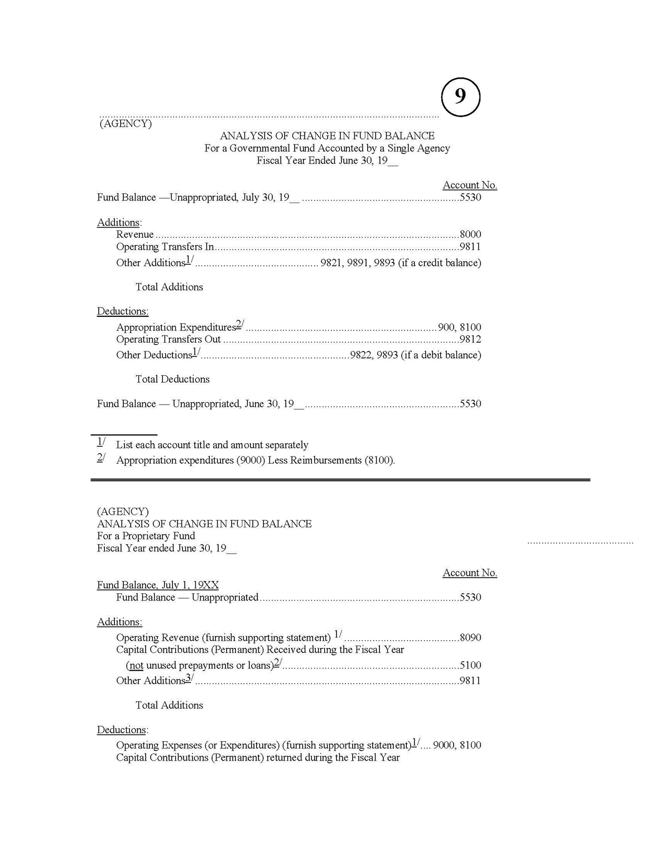

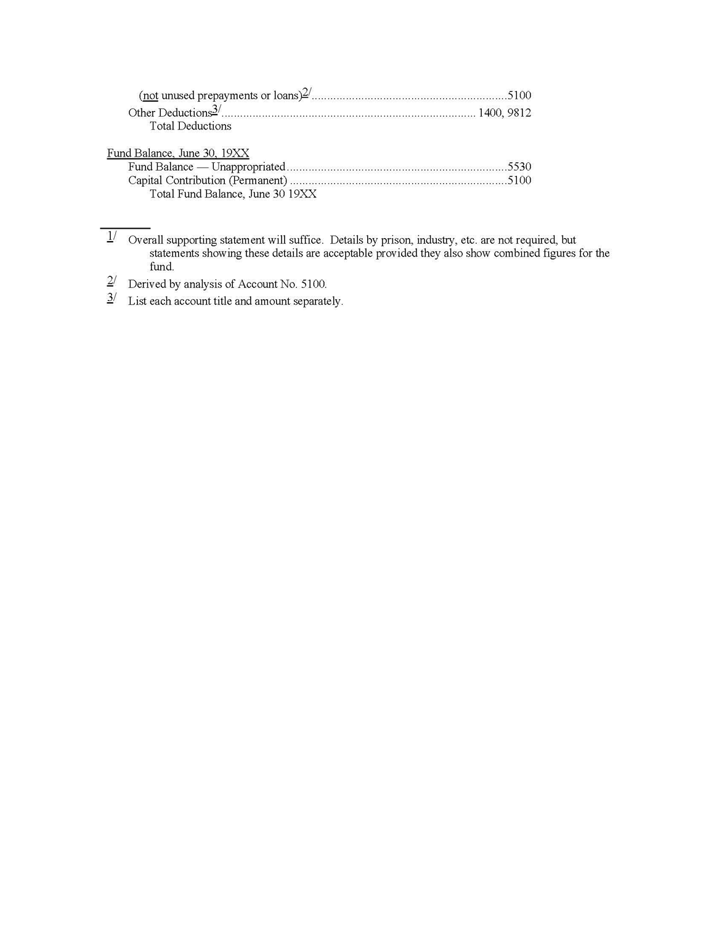

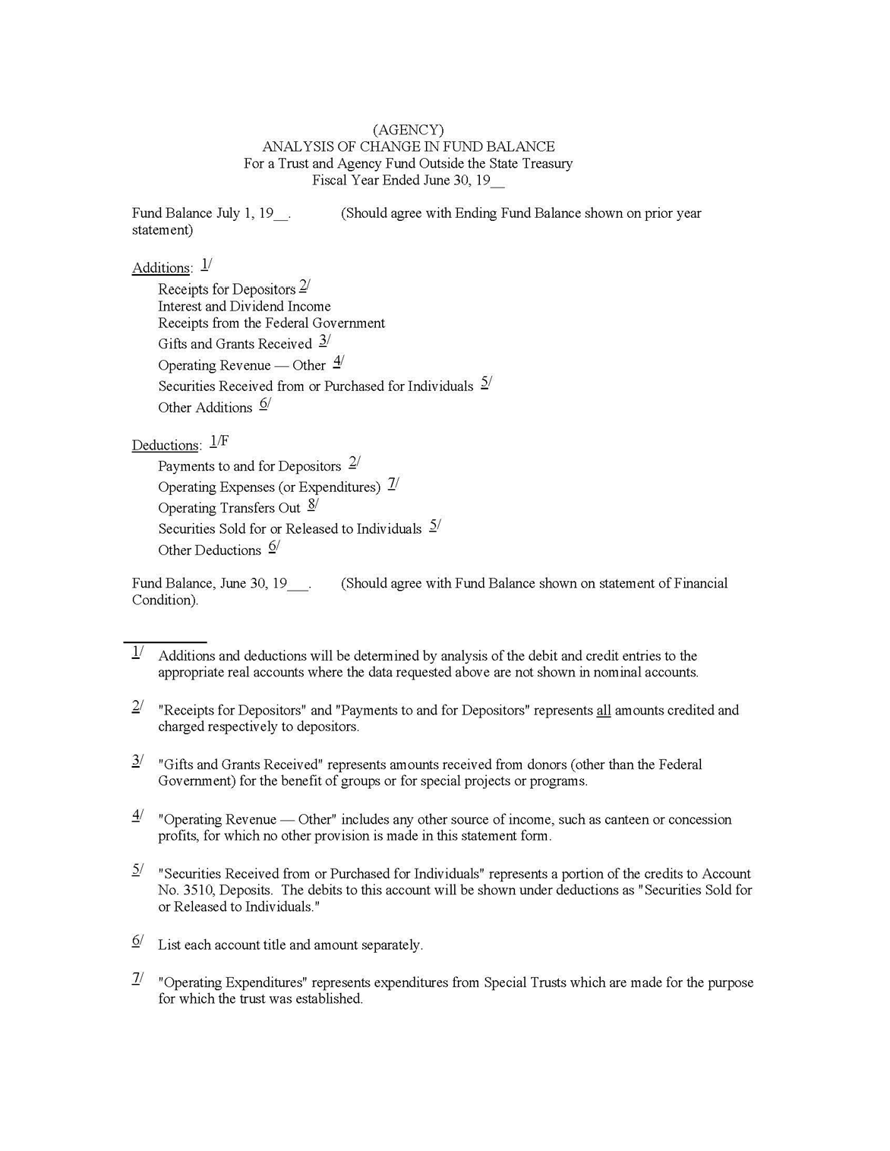

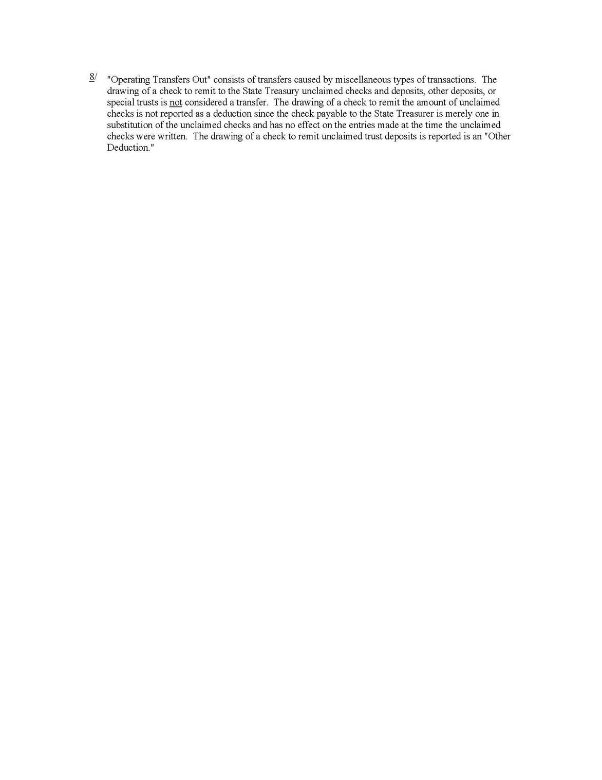

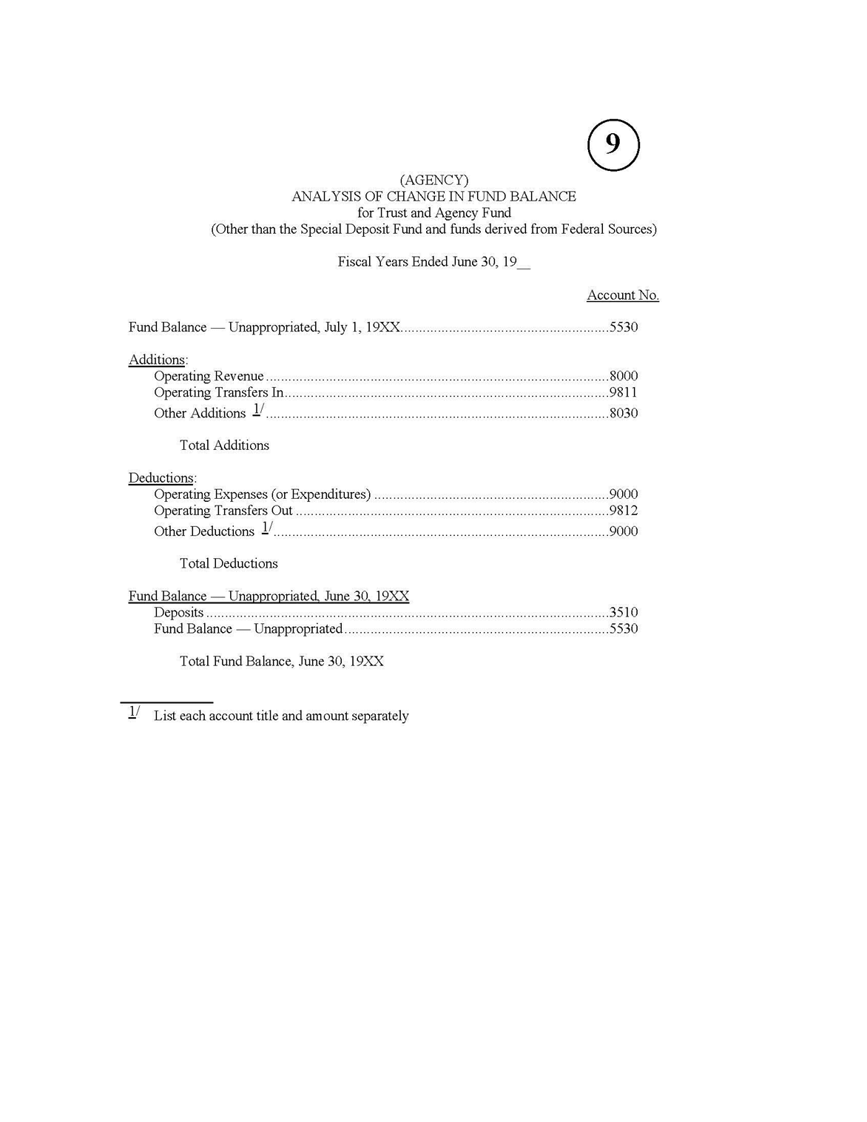

YEAR-END REPORT NO. 10 7965
ANALYSIS AND RECONCILIATION OF REVOLVING FUND ACCOUNTABILITY
(Revised 03/11)

During the fiscal year, Account No. 1130, Revolving Fund Cash, is accounted for on an imprest basis. Because the revolving fund consists of items other than cash, this procedure will overstate cash in a department’s year-end reports. Therefore, adjusting entries are necessary at year-end to properly reflect the actual revolving fund composition, as of June 30, for year-end report purposes. The adjusting entries will reduce the balance of the revolving fund cash account to the balance of the revolving fund portion of the department’s checking account. The adjusting entries are recorded in the fund the revolving fund was withdrawn from and are reversed as of July 1. The amounts of these entries will also be shown on the Accrual Worksheet, Report No. 2 as Revolving Fund Adjustments. See SAM section 10601.

The source for the adjusting entries is an Analysis and Reconciliation of Revolving Fund Accountability, Report No.
- The report consists of the following:

  - Cash in subrevolving funds, undeposited receipts, and unreceipted SCO warrants in transit issued for reimbursement of the revolving fund.
  - Cash book balance – Amount of revolving fund cash in the department’s general checking account.
  - Salary and travel advances – Amount of outstanding advances to employees for salary and travel advances.
  - Claims filed on or before June 30 to reimburse the revolving fund but not paid by June 30.

  - Revolving fund disbursements not scheduled for reimbursement by June 30 and expenditures have been accrued via the A-8 entry.
  - Amount of revolving fund withdrawn from appropriation or pursuant to statute.
Report No. 10 is not submitted to the SCO, but it is kept on file with other year-end reports for audit purposes.

A sample of Report No. 10, Analysis and Reconciliation of Revolving Fund Accountability, is shown in the 7965 Illustration.

YEAR-END REPORT NO. 11, BANK RECONCILIATION 7967
(Revised 03/11)

This report will be prepared by departments in accordance with SAM section 7923 requirements for monthly bank reconciliations. Report No. 11 is not submitted to the SCO, but it is kept on file with other year-end reports for audit purposes.

A sample of Report No. 11, Bank Reconciliation, is shown in the 7967 Illustration.

YEAR-END REPORT NO. 13, REPORT OF EXPENDITURES OF FEDERAL FUNDS 7974
(Revised 09/13)

At year-end, departments will prepare a Report of Expenditures of Federal Funds, Report No. 13, for all federal funds. Departments must report expenditures and encumbrances for each federal award by Catalog of Federal Domestic Assistance (CFDA) number and program title. Expenditures shall include accruals of all valid obligations incurred and receivables earned as of June 30, with the exception of payments to sub-recipients which must be recorded on a cash basis. Circular A-133 defines a sub-recipient as a non-federal entity that expends federal awards received from a pass-through entity to carry out a federal program, but does not include an individual that is a beneficiary of such a program. For additional guidance on year-end reporting, refer to SAM section 17130. (Continued)

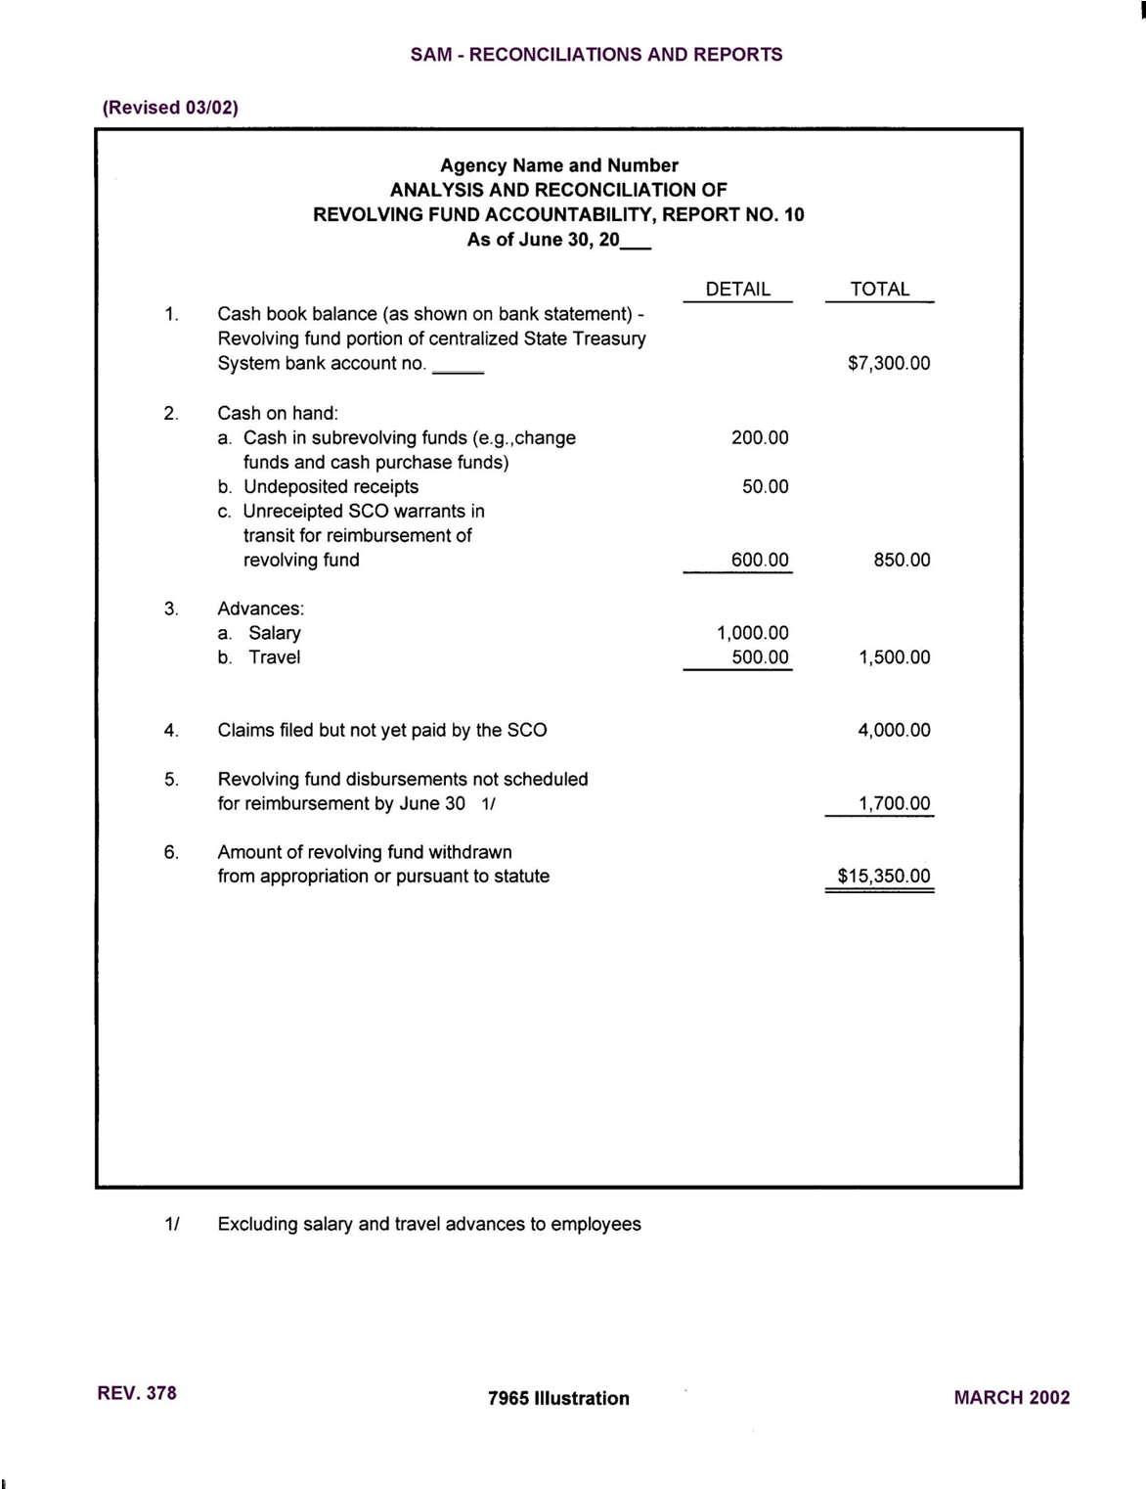

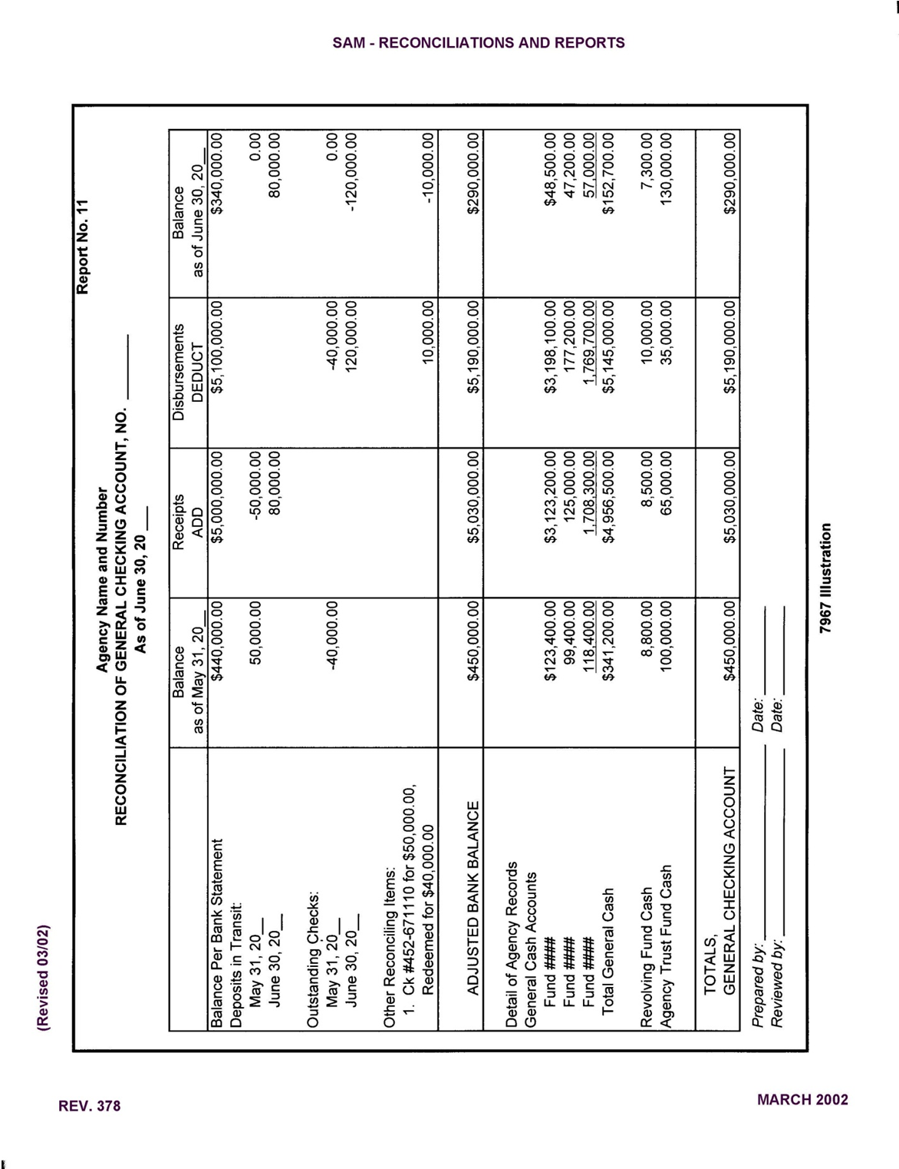

(Continued)

YEAR-END REPORT NO. 13, REPORT OF EXPENDITURES OF FEDERAL FUNDS 7974 (Cont. 1)
(Revised 09/13)

The remaining balance of the grant shall not be accrued as an expenditure if it does not represent valid obligations incurred as of June 30. Encumbrances shall include commitments that will become expenditures after June 30 when goods or services are received. In addition, segregate American Recovery and Reinvestment Act (ARRA) expenditures from non-ARRA expenditures in instances where the same CFDA number is used.

The original signed Report No. 13 is submitted to the Department of Finance (Finance), Fiscal Systems and Consulting Unit by August 20th. A copy of Report No. 13 must be submitted to the State Controller’s Office with the year-end financial reports. Supporting documentation used to prepare the Report No. 13 must be maintained by the department in the event Finance, Office of State Audits and Evaluations or the California State Auditor’s Office requests to review.

A sample of Report No. 13 is shown in the 7974 Illustration.

YEAR-END REPORT NO. 14, 7975
REPORT OF BANK/SAVINGS AND LOAN ASSOCIATION ACCOUNT OUTSIDE THE TREASURY SYSTEM
(Revised 06/13)
At year-end, departments (including agencies) must prepare a Report No. 14, Report of Accounts Outside the State Treasury, form STD. 445. The Report No. 14 must include any account outside the centralized State Treasury System (CTS) in which state money is deposited or must indicate that there are no accounts to report. Department of Finance (Finance), Fiscal Systems and Consulting Unit (FSCU) approval (See SAM section 8002) or statutory authority is required to maintain accounts outside of the CTS.

Each Report 14 shall include the department name, address, organization code, fiscal year-end date, signature, name and title of officer signing the report, contact telephone number and date signed. Only one Report No. 14 per department shall be submitted.

If no accounts exist outside the CTS, indicate “No accounts outside State Treasury” on the Report 14. When there are accounts outside of the CTS, the Report No. 14 shall include the following:
    - Account title and number appearing on bank/savings and loan/other depository statement.
    - Type of account (savings, checking, ZBA, certificate of deposits, investment, etc.).
    - Brief description and purpose of account. Must be consistent with the purpose approved by Finance, FSCU or authorized by law.
    - Name and address of depository and branch.
    - “Finance approval” and date or specific statutory authority.
    - Book balance of account as of June 30. If the account was closed during the reporting period, include “N/A” and the date when the account was closed.
    - Indicate whether the account is collateralized or if collateral is not required.

Accounts outside the CTS shall be reviewed periodically to ensure compliance with Finance approval and/or legal authority. If the account was approved by Finance and there is a need to update any conditions of the approval, including the purpose of the account or the banking information, a new request for approval must be submitted to Finance FSCU.

The department head is required to certify under penalty of perjury all information stated on the Report No. 14 is true and correct and the use of the account(s) is consistent with Finance approval or as authorized by law. The certification also affirms the deposited funds will be adequately collateralized throughout the year in accordance with law. For additional information regarding the security and collateral requirements, consult with the State Treasurer’s Office (STO).

The original Report No. 14 must be sent to the STO and a copy must be sent to Finance, FSCU by August 20. A copy of the Report No. 14 should only be submitted to the State Controller’s Office when there are accounts outside of the CTS.

A sample of Report No. 14 is shown in the 7975 Illustration.
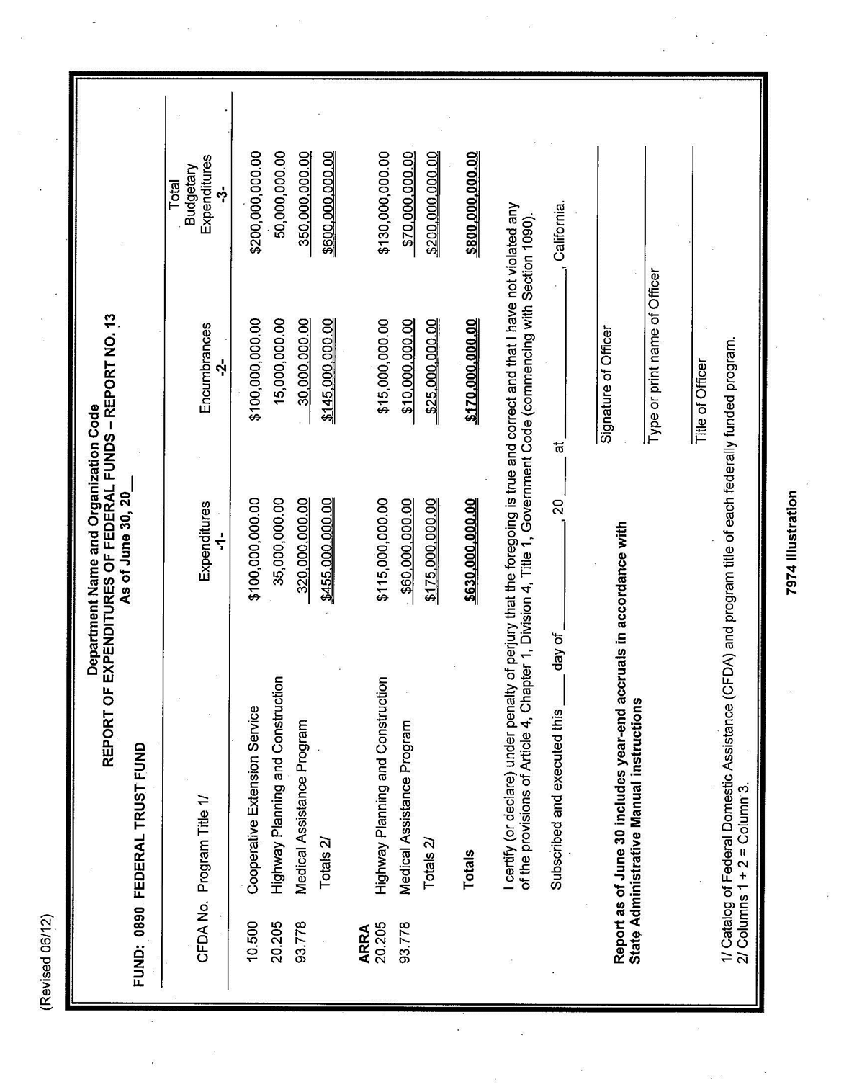

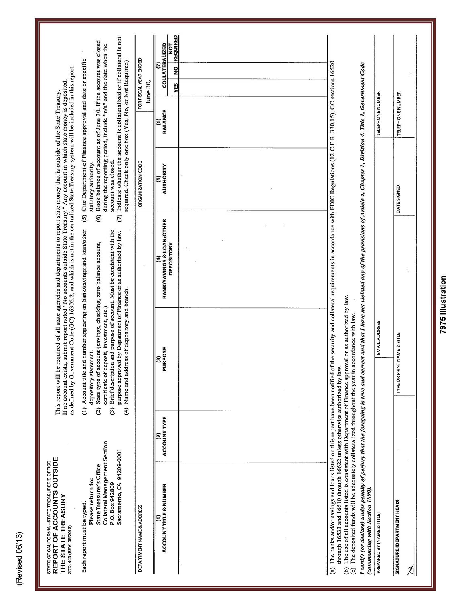

YEAR-END REPORT NO. 15, 7976
RECONCILIATION OF AGENCY ACCOUNTS WITH TRANSACTIONS PER STATE CONTROLLER
(Revised 06/13)

This report assures the accuracy and completeness of a department's revenue and expenditure accounts reported on its year-end reports. The Report No. 15 presents a reconciliation of a department's nominal accounts, the 8000 and 9000 series general ledger accounts with transactions per the State Controller as of June 30. The fund administrator will also include on Report 15 certain statewide assessments charged to the fund. Submit this report with other year- end reports to the SCO.

A sample and instructions of how to complete Report No. 15, Reconciliation of Agency Accounts with Transactions per State Controller, is shown in the 7976 Illustration 1 and Illustration 2.

YEAR-END REPORT NO. 18, 7977
STATEMENT OF CHANGES IN CAPITAL ASSETS GROUP OF ACCOUNTS
(Revised 09/10)

This report accounts for changes resulting from capital asset acquisitions and dispositions during the fiscal year. Submit this report with other year-end reports to the SCO. See SAM Sections 7463 and 8660 for additional information.
A sample of Report No. 18, Statement of Changes in Capital Assets Group of Accounts, is shown in the 7977 Illustration.

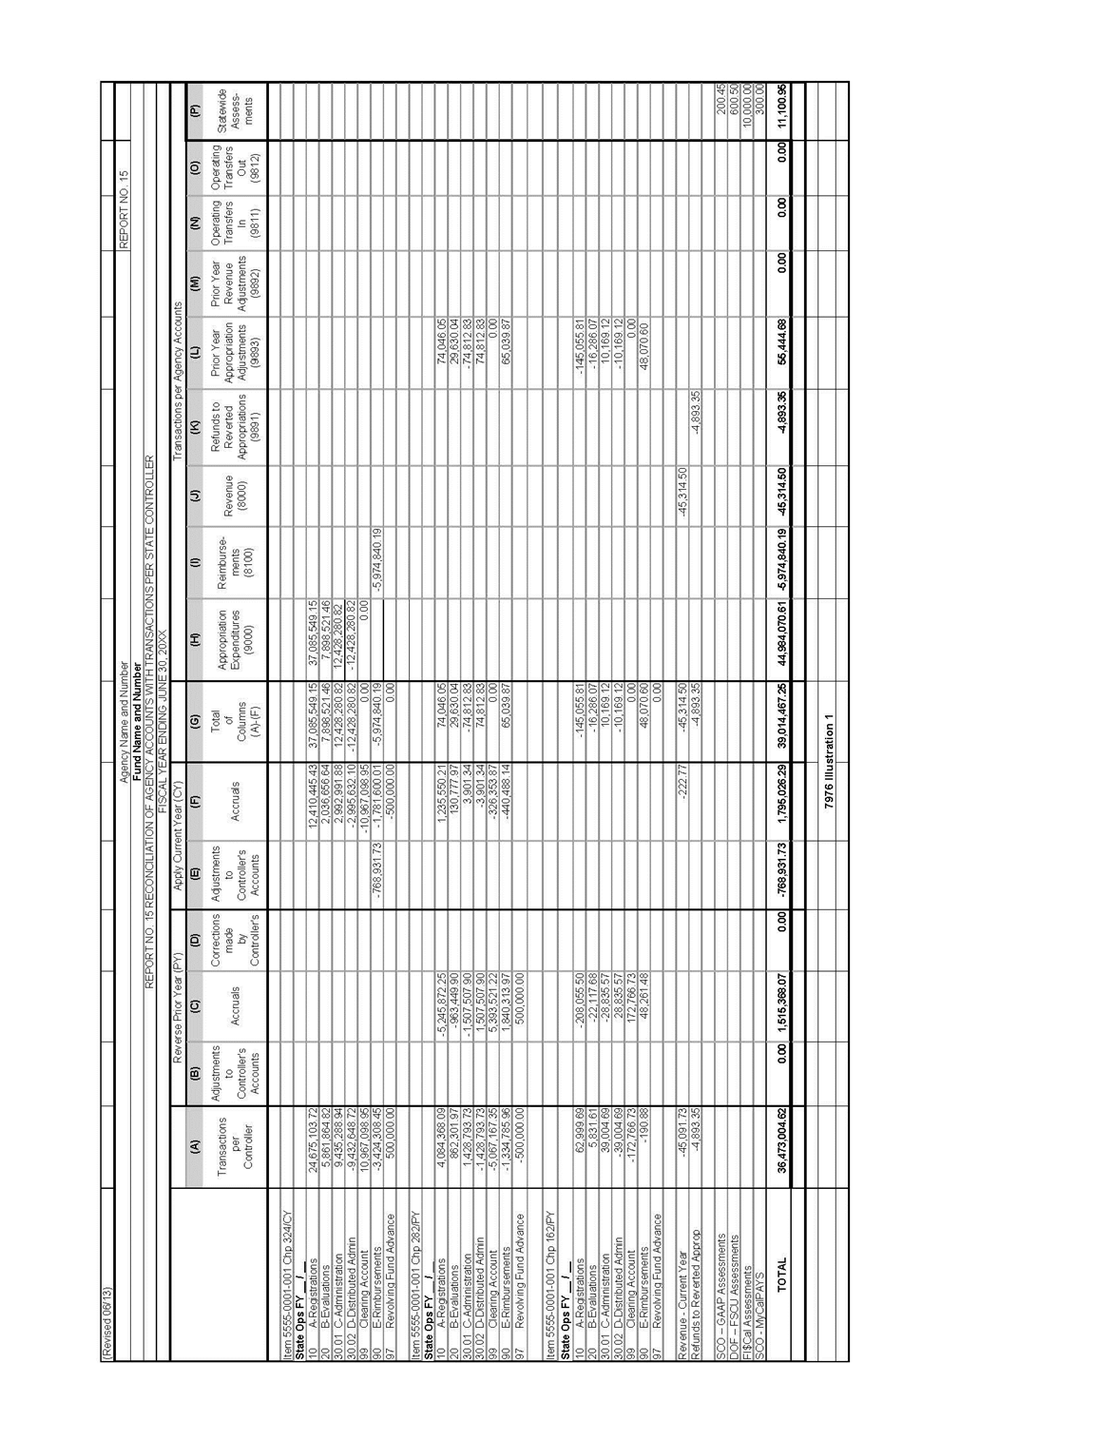

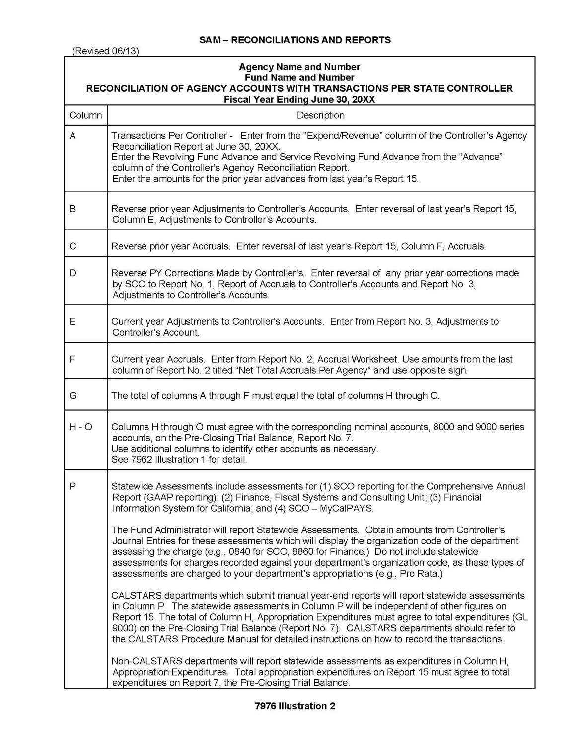

YEAR-END REPORT NO. 19, 7978
STATEMENT OF CAPITAL ASSETS GROUP OF ACCOUNTS
(Revised 09/10)

This report accounts for the total capital assets of an agency and identifies the fund that purchased the capital assets. Report No. 19 summarizes the information contained in Report No. 18 as of June 30. Submit this report with other year-end reports to the SCO. See SAM Sections 7463 and 8660 for additional information.
A sample of Report No. 19, Statement of Capital Assets Group of Accounts, is shown in the 7978 Illustration.

PUBLIC WORKS PROJECTS 8454
(Revised 12/89)

After (1) moneys have been budgeted for a public works project, (2) general agreement as to the scope of the project and its cost has been reached between the agency and the Office of the State Architect, Department of General Services, and (3) the approval of the Public Works Board has been obtained, if required, the normal procedure is as follows:

- The Office of the State Architect will prepare a Public Works Project Authorization and Transfer Request, OAC Form 22, in septuplicate, retaining one copy and forwarding the original and five copies to the agency concerned.

- The agency or institution accounting officer will certify as to the availability of funds on the original and five copies of the document.

- An agency executive officer will sign his approval on the original and all copies forwarded to him.

- As requirements differ among agencies, each agency will determine the specific routing and distribution of copies to meet its needs, but will forward the original and at least three copies promptly to the Department of Finance for approval as to compliance with budget requirements. Agencies are urged to minimize internal routing of the form to expedite its processing, the transfer of funds, and the initiation of the project.

- After approval, the Department of Finance will forward the original to the State Controller's Office, the duplicate to the Office of the State Architect, retain one copy for its own files, and forward the remaining copy or copies to the agency concerned.

- The Office of the State Architect will proceed with scheduling the work when its approved copy is returned.

- The State Controller's Office, upon receipt of the approved copy, will transfer the amount requested from the fund and appropriation specified to the Architecture Revolving Fund. If cash is not immediately available in the fund concerned, the State Controller's Office will make the transfer as soon as the necessary cash becomes available.

On those projects for which a written agreement between the agency and the Office of the State Architect is necessary, an Interagency Agreement, Std. Form 13. will be initiated by the Office of the State Architect. These agreements will cover the entire scope of a project; when more than one OAC Form 22 will be initiated as funds are needed.

Agencies will encumber Public Works Project Authorization and Transfer Requests, OAC Form 22, at the time those requests are approved by the agency.

SERVICES PROVIDED BY THE DEPARTMENT OF GENERAL SERVICES

ADVANCES TO THE DEPARTMENT OF GENERAL SERVICES FOR SERVICES PROVIDED 8471
(Revised 09/13 and renumbered from 8471.1)

Departments using services provided by the Department of General Services (DGS) will make advances from their operating funds and appropriations to assist in financing these services. DGS will calculate the advance amount based on an approved percentage of the annual cost of services rendered to departments. (See Government Code sections 11256 - 11263, 11290, and 11370.4). No advances or portions thereof will be returned until the following fiscal year budget has been passed and all prior year’s invoices have been paid.

The normal flow of transactions for advances to the DGS is shown in the 8471 Illustration.

RECORDING SERVICE ESTIMATES AND ADVANCES 8471.1
(Revised 09/13 and renumbered from 8471.23)
When the State Controller's Office (SCO) issues a Notice of Transfer journal entry for the advance, it will be recorded as of the SCO’s date on the journal entry. Departments will keep a subsidiary file by fund, agency, and appropriation to record the amount of the original advance, subsequent liquidation of the advance, and the balance owing on each advance.

ELECTRONIC FUND TRANSFER FOR DEPARTMENT OF GENERAL SERVICES' INVOICES 8471.2
(Revised 09/13 and renumbered from 8471.13)

DGS has implemented the Electronic Fund Transfer (EFT) system to streamline the payment of invoices and to eliminate the need for departments to prepare and submit claim schedules to SCO.
Under the EFT system, DGS continues to produce individual invoices for services and products provided to departments. The Notices of EFT are compiled into one electronic file by the end of the month and submitted to the SCO on the 2nd workday of the following month for processing.
Approximately 8 working days are required by the SCO to process the EFT requests and to post the journal entries.
A copy of the individual invoices is available to view and print on the DGS-OFS website by the 5th calendar day of the following month at: www.ofs.dgs.ca.gov.
An access account is needed to retrieve this information. To set up an access account, the departments will need to contact: SRFFiscalServices@dgs.ca.gov.
For information regarding the EFT program contact: Department of General Services
Office of Fiscal Services - SRF 707 Third Street, 10th Floor West Sacramento, CA 95605

FAX: (916) 376-5165
E-Mail: SRFFiscalServices@dgs.ca.gov

The normal flow of transactions for the EFT System is provided in 8471.2 Illustration.

.

RECORDING STATE CONTROLLER'S DOCUMENTS FOR ELECTRONIC FUND TRANSFER 8471.3
(Revised 09/13 and renumbered from 8471.45)

The SCO will issue a Notice of Transfer journal entry for the DGS charges received via the EFT. The journal entry will either (1) reduce the advance, if there is an advance or (2) transfer the money, if the advance has not been issued.
Departments will record the transaction as of the SCO’s date on the journal entry.

DELINQUENT DEPARTMENT OF GENERAL SERVICES' INVOICES 8471.4
(Revised 09/13 and renumbered from 8471.51)
DGS will collect delinquent invoices in accordance with Government Code section 11291 which states: "If a state agency refuses to pay the charges fixed by the Department of General Services pursuant to this article, the department may file a claim for such charges against any appropriations made for the support or maintenance of all or any part of the work and affairs of the state agency." Allowing invoices to become delinquent will be considered a refusal to pay.
An invoice will be considered delinquent if it is not scheduled by the department within 60 days from the date of the invoice unless the total amount due is less than $10. DGS may submit an EFT with the SCO when a department allows invoices to become delinquent and the SCO will transfer the payment from the department's appropriation.

CONTESTED DEPARTMENT OF GENERAL SERVICES' INVOICES 8471.5
(Revised 09/13 and renumbered from 8471.52)
If a department is billed by DGS for (1) services that were not performed, or (2) services that are not in accordance with an interagency agreement (IA), the department should notify DGS within 60 days of the invoice date. The department shall submit a STD. 209, Invoice Dispute Notification form directly to the contact information indicated on the invoice. The absence of an IA does not preclude the payment of valid invoices.
This form is available at: http://www.dgs.ca.gov/osp/Forms/Search/pdf_fillPrint.aspx

GENERAL SERVICES BILLING INFORMATION 8471.6
(Revised 09/13 and renumbered from 8471.71)
DGS assigns a six digit numeric code to state departments referred to as a Customer Account Number (CAN) in billing for services provided. To request a new CAN or to revise an existing CAN (e.g., update billing address), departments must properly fill out AFS-94A, CUSTOMER ACCOUNT NUMBER (CAN) REQUEST form available on DGS’s website at: http://www.documents.dgs.ca.gov/ofs/Afs94a.pdf
The completed form AFS-94A, approved by the department fiscal officer, should be submitted to:

Department of General Services
Office of Fiscal Services - SRF (IMS Code Z-1) 707 Third Street, 10th Floor
West Sacramento, CA 95605

FAX to: (916) 376-5165
E-mail to: SRFFiscalServices@dgs.ca.gov

(Revised 09/13) ADVANCES TO THE DEPARTMENT OF GENERAL
SERVICES FOR SERVICES PROVIDED

NORMAL FLOW OF TRANSACTIONS
Accounting Section
Dept. of General Services Department State Controller’s Office

Receives journal entry and records advance payment.
Calculates the advances based on an approved percentage for the annual cost of services provided. Prepares Transfer Requests to collect the current fiscal year advances and returns prior year advances.
Audits Transfer Requests.
Issues journal entry for current fiscal year advances.
Receives journal entry and records advance collection.

Receives journal entry and records returned advance.
Issues journal entry for return of unused prior year advances.
Receives journal entry and records returned advance.

8471 Illustration

(Revised 09/13) ELECTRONIC FUND TRANSFER (EFT) FOR DEPARTMENT OF GENERAL SERVICES’ INVOICES

NORMAL FLOW OF TRANSACTIONS
Accounting Section
Dept. of General Services Department State Controller’s Office

Receives services/products from DGS.

Bills departments for services rendered.

Submits EFT file to SCO to transfer request.

Audits EFT file.

Prepares Notice of EFT and notify Departments.

Reviews Notice of EFT.

Records journal entry.

Posts journal entry to transfer the payment.

Records journal entry and reconciles Notice of EFT against individual invoices.

Note: If any department discovers an invoice discrepancy, the department should notify Department of General Services who will issue an adjustment or credit that will automatically be recorded in the following EFT.

8471.2 Illustration

PRINTING
INVOICES FOR PRINTING SERVICES AND SUPPLIES) 8472.1
(Revised and Renumbered 8/70

(See SAM Section 2812 for other instructions on the preparation of requisitions.)
Printing Requisition-Invoice, Std. Form 67, serves as a requisition on and as an invoice of the Department of General Services, Office of State Printing. Agencies will submit Std. Form 67 in quadruplicate, the original and two copies of which will be used by the Office of State Printing as invoices when the services or supplies are furnished. At the top of each Std. Form 67, agencies will show the fund, appropriation, and budget act item from which the charge is to be paid.
The form also authorizes the State Controller to make a journal entry for the amount of the charges from funds advanced to the Service Revolving Fund. This authorization must be signed by a person of the agency properly authorized to approve claims in accordance with Board of Control Rule 624.

PROCESSING BY OFFICE OF STATE PRINTING 8472.2
(Revised and Renumbered 8/70)

After furnishing agencies with services or supplies, the Office of State Printing will:

- Enter the job cost on the original and two copies of the appropriate Std. Form 67 in the box reserved for this purpose.

- Prepare a journal entry request in triplicate for each group of invoices (Std. Form 67) chargeable to a single appropriation applicable to one agency. Each request will show: (a) request number, (b) name of agency, (c) fund,
(d) appropriation, (e) budget act item, (f) list by job number of the amount of each supporting Std. Form 67, and (g) total amount chargeable to the appropriation.

- The original copy of the request and the original copies of the Std. Form 67 will be sent to the State Controller's Office for audit and preparation of the journal entry.

- The duplicate copy of the request will be attached to the duplicate copies of the Std. Form 67 and forwarded to the agency.

- The triplicate copy of the request and the triplicate copies of the Std. Form 67 will be retained as supporting detail of accounts receivable pending receipt of the Controller's Journal Entry.

- Record payment in the Service Revolving Fund accounts when the State Controller's Journal Entry is received.

PROCESSING BY STATE CONTROLLER'S OFFICE 8472.3
(Revised and Renumbered 8/70)

The State Controller's Office will audit and determine the correctness and propriety of each journal entry request received from the Office of State Printing.

Any errors disclosed by this audit will be corrected in the usual manner by claim corrections. One copy of the claim corrections will be sent to the Office of State Printing and one copy will be sent to the agency. (Agencies will not use such claim corrections as accounting documents since expenditures are recorded on the basis of State Controller's Journal Entries.)

After audit and approval of the request by the State Controller's Office, Audits Division, the Controller's Accounting Division will issue a State Controller's Journal Entry or Transfer. (The State Controller's Office will settle the request by (a) a Controller's Journal Entry reducing the advance, if there is an advance, or (b) a Controller's Transfer, transferring the funds if the advance has been returned or if no advance has been made.) One copy of the State Controller's Journal Entry or State Controller's Transfer will be sent to the Office of State Printing and one copy will be sent to the agency.

Upon request from the agency, the State Controller's Office will reverse the amount of any journal entry previously made, or any part of such amount, if the agency believes the amount should not have been paid because of non-receipt of the services or supplies, excessive cost, or other valid reason after negotiation with the Office of State Printing. Request for adjustment of previous journal entry will be forwarded by the agency to the State Controller's Audit Division and will refer to the particular State Controller's Journal Entry by date and number. The request also will refer to the item and amount and will include a statement as to why the journal entry should not have been made. After examination and approval by the Controller's Audits Division, the request for adjustment will be routed to the Controller's Accounting Division for preparation of the Journal Entry. One copy of the journal entry will be. sent to the Office of State Printing and one copy will be sent to the agency.

PROCESSING BY AGENCY 8472.4
(Revised and Renumbered 8/70)

Agencies will review the Office of State Printing's journal entry request and supporting invoices in the same manner in which it reviews other invoices. However, agencies will not prepare claims for submission of these invoices to the State Controller's Office nor will they account these expenditures until the State Controller's Journal Entry is received.

If the agency finds any errors or believes any invoice should not have been paid because of non-receipt of services or supplies, excessive cost, or another valid reason, it will negotiate directly with the Office of State Printing for adjustment. Adjustments can be made by either of the following methods:

  - The agency may let the journal entry stand and ask the Office of State Printing to make the adjustments agreed upon by issuing a credit memorandum in a subsequent request from the same appropriation.

  - The agency may request the State Controller's Office to make a reversing entry in the amount under question pending its settlement of differences with the Office of State Printing. After agreement is reached as to the amount to be paid, a request for journal entry in such amount will be presented to the State Controller's Office in the usual manner by the Office of State Printing.

RECORDATION IN AGENCY ACCOUNTS 8472.41
(Revised 5/87)

Since the elapsed time from presentation of a journal entry request by the Office of State Printing to the issuance of the State Controller's journal entry normally will not exceed one week, the agency will not record the transaction in its accounts until receipt of the State Controller's Journal Entry. Agencies having a sufficient volume of such journal entries should record them in a Controller's Journal Entry Register under the Controller's document date and post them to the appropriate allotment-expenditure accounts. The following General Ledger entries are required to record the State Controller's Journal Entry. (Also refer to SAM Section 10516.)

Dr. 5350 Reserve for Encumbrances

Dr. 9000 Appropriation Expenditures (or other appropriate expenditure account) Cr. 1730 Prepayment to Other Funds or Appropriations
Cr. 6150 Encumbrances

The entries would be reversed for State Controller's Journal Entries that reverse previous journal entries.

INTEREST ON LIQUIDATED CLAIMS 8473
(Revised 3/91)

In order to encourage governments to act rapidly on claims filed with them, Government Code Section 926.10 provides that claimants shall be paid interest on liquidated claims filed with public entities which have not been paid within 60 days.
Interest shall be at six percent per year.
The code section does not apply to claims filed as follows:
- Claims of a State agency or fund against another State agency or fund.
- Claims of the Federal Government.
- Claims filed pursuant to construction contracts. (Please refer to SAM Section 8473.1)
A liquidated claim is a claim which can be determined with exactness from the parties agreement or by arithmetical process or application of definite rules of law. For Government Code Section 926.10 to apply, there must be no disagreement over the validity of the claim and the claim must be due and payable.

(Continued)

(Continued)

INTEREST ON LIQUIDATED CLAIMS 8473 (Cont. 1)
(Revised 3/91)

Agencies will add interest to claims 60 days after one of the following dates, whichever occurs later:
- The date goods or services are received.
- The date the claim is received by the agency.
- The date of completion of an engineering, legal, post audit, or other review, if required, to determine the validity of questionable claims. A claim is not considered filed until all disputes are settled.
Liquidated claims and their related interest charges generally will be paid through the claim schedule process. However, if the amount of the claim is $1,000 or more, agencies may pay the claim by use of a revolving fund check. If the claim is
$10,000 or more and a revolving fund check is not prepared, an expedite claim schedule will be used. When preparing claim schedules, an additional five days of interest will be added for a regular claim schedule and two days of interest for an expedite claim schedule to compensate for the State Controller's processing time. Interest paid will be shown on the Remittance Advice as follows:
"Interest pursuant to Government Code Section 926.10" $ Interest is payable from the same appropriation from which the claim is paid.
In determining the amount of interest due, the table on 8473 Illustration may be used. The figures shown in the table are the decimal equivalent of interest from the beginning of the year to the dates shown in the columns. For example, interest from the first of the year to July 24 would be the decimal equivalent of 3.370 percent or .03370. Since all interest does not begin to run from the first of the year, interest from the beginning of the year the date interest begins must be subtracted from the date shown in the table. For example, if the date interest begins is March 4 and the date payment is made is June 12, the amount shown in the table for March 4 (.01036) must be subtracted from the amount shown at June 12 (.02679) to arrive at the proper interest factor of .01643 for the period. The amount of the claim is multiplied by this interest factor to determine the interest due.
If interest runs past December, the interest from the date interest begins to the end of the year is calculated. Then, interest from the beginning of the year to the date interest ceases is added to that. In leap years, one additional day of interest must be calculated when interest periods span February 29. This may be accomplished by adding an additional day to the interest period. See SAM Sections 8474.1 and 8474.4, if applicable.

PENALTY FOR LATE PAYMENT ON CONSTRUCTION CONTRACT CLAIMS 8473.1
(New 3/91)
Section 10261.5 of the Public Contract Code provides for the payment of interest on construction contracts at an annual rate of 10% (i.e., the rate set forth in subdivision (a) of Section 685.010 of the Code of Civil Procedure) when a State agency fails to pay a contractor's properly submitted and undisputed payment request within 30 days of receipt of such request by the State agency.
Section 10261.5 of the Public Contract Code also provides as follows:
- Any State agency which independently calculates the amount due on a progress payment and fails to make the progress payment within 30 days of the first submittal of the estimate by the contractor shall pay interest to the contractor at the rate specified above.
- A State agency shall pay interest to the contractor at the rate specified above when the payment is not made within 30 days of receipt of a properly submitted and undisputed request for payment and the State Controller processes the payment within 14 days of receipt of the payment claim filed by the contracting State agency.
- The State Controller shall pay interest to the contractor at the rate specified above when the payment is not made within 30 days of a properly submitted and undisputed request for payment and the contracting State agency has filed and the State Controller has accepted the payment claim within 16 days after receipt of the contractor's request for payment by the State agency.

This page left blank intentionally.

EMPLOYEE SEPARATIONS 8580.4
(Revised 06/05)
Departments are responsible to ensure that payments to separating employees are in accordance with Labor Code Sections 201 and 202.

Salary warrants will not be distributed to separating employees until the department has verified that all travel and salary advances have been paid (cleared). The verification must be provided by office revolving fund staff. See SAM Section 8595.

It is recommended that a check-out list acknowledging the return of state-owned items such as credit cards, keys, state records, and equipment be completed for separating employees prior to the release of the final warrant. The check-out list may also include the verification from the office revolving fund staff that there are no outstanding advances.

Government Code Section 19838 authorizes the state to withhold amounts owed for outstanding travel and salary advances from an employee’s final separation pay, provided the employee receives an amount sufficient to satisfy the state’s minimum wage requirement. Departments should direct all questions regarding the state’s minimum wage requirements to their departmental legal staff.

Amounts owed by the employee, other than salary and travel advances will not be deducted from an employee’s final separation pay. If, after the check-out, the separating employee leaves owing the department money, it is the responsibility of the department to pursue collections as described in SAM Section 8776.6.

UNDELIVERED SALARY WARRANTS 8580.5
(Revised 2/99)
Salary warrants not delivered within five days of pickup shall be returned to the office which distributes salary warrants. A written record of all undelivered warrants will be maintained and a copy given to the payroll office.
Warrants not delivered within 90 calendar days of receipt must be deposited and remitted to an escheat revenue account in the original fund that provided the resources to the State Payroll Revolving Fund.
Agencies will maintain a subsidiary ledger of all amounts credited to and disbursed from the escheat revenue accounts. Subsequent claims made by payees within 2 years of the date the warrant was credited to the escheat revenue account will be processed by filing a claim schedule against an escheat revenue account. For those amounts credited in the current fiscal year, the claim schedule shall be filed against the current year escheat revenue account. For those amounts credited in a prior fiscal year, the claim schedule will be filed against the prior year escheat revenue account. The State Controller's Office will process the claims regardless of the balances in the escheat revenue accounts.

PAYROLL EXPENDITURE ACCOUNTING 8590
(Revised 09/13)
The State Controller’s Office (SCO), Uniform State Payroll System (USPS), will process each state department’s payroll transactions entered by their human resources office and generate the following documents:

- A Payment History File - available to the department monthly
- Payroll expenditures and recoveries - posted to each department’s appropriation in the SCO’s Fiscal System
- Payroll warrants and direct deposits - printed and distributed
- Notice of State Payroll Revolving Fund Transfer, Form SM62 (SM62) - printed and distributed

(Continued)

(Continued)

PAYROLL EXPENDITURE ACCOUNTING 8590 (Cont. 1)

Payroll expenditures listed on the SM62 consist of gross salary plus the state contributions. The state’s contributions include:

- Retirement
- Old-Age, Survivors, and Disability Insurance (OASDI)
- Miscellaneous Benefits
- Premium
- Dental and health
- Administration
- Fees

Recoveries to payroll occur when warrants are voided or re-deposited or when overpayments are collected.

The SM62 reports payroll transactions for the departments which will be recorded using a Payroll Expenditure Register (see SAM section 10504). The SM62 reflects Clearance Type (CT) codes indicating transfers in or out of the State Payroll Revolving Fund (SPRF) as follows:

Transfers in the SPRF that increase departmental expenditures (entered as plus entries if a manual Payroll Expenditure Register is maintained):

- CT 1: Issue Payment - Registers of warrants issued
- CT 7: Transfer of Funds - Registers of payroll adjustments
- CT 8: Non-USPS Transaction - Corrections of previous transfers
- CT 9: Reverse Accounts Receivable - Corrections of previous transfers

Transfers out of the SPRF that decrease expenditures (entered as minus entries if a manual Payroll Expenditure Register is maintained):

- CT 4: Redeposit - Register of warrants re-deposited
- CT 5: Accounts Receivable - Transfers of amounts collected on overpayments
- CT 6: Transfer of Funds - Registers of payroll adjustments
- CT 8: Non-USPS Transaction - Corrections of previous transfers

Payroll transfers will be distributed to the applicable expenditure accounts and, if applicable, entered in the Payroll Expenditure Register where used in a manual system. The month during which the expenditures were incurred will generally be indicated by the date on the Controller’s Transfer. An exception to this procedure occurs when the month indicated by the transfer date is different from the month the expenses were incurred. Then post the payroll transfer to the matching month. If the payroll period and the transfer date are in different fiscal years, the transfer date takes precedence. Note: In automated systems i.e. CALSTARS, the Payroll Expenditure Register is automatically produced as a by-product of labor distribution system and these entries are not applicable.

OVERPAYMENTS 8593
(Revised 09/13)

When Adjustment Notices, reporting amounts overpaid to employees, are processed by the State Controller's Office (SCO), they will send a Notice of Payroll Accounts Receivable (AR) to the department. The AR shows the total and gross amount of the salary overpayment, the payment type, the amount of overpayment of the employer’s share of contributions for employees’ retirement, OASDI, and other benefits. In addition, the AR shows the employee deductions that will be recovered by the SCO and the amount of the overpayment to be recovered from the employee by either a payroll deduction or an agency collection.

(Continued)

OVERPAYMENTS 8593 (Cont. 1)

The gross amount and state share amounts of benefits of the AR will be entered as a credit to the expenditure accounts and a debit to Accounts Receivable-Abatements. See SAM section 10504 Entry No. 4 (Payrolls Are Paid). The AR is established in an open file pending full recovery of the overpayment and transfer of the amount recovered to the department appropriation and/or fund.

The AR file is the subsidiary to that portion of Account No. 1311, Accounts Receivable-Abatements representing salary overpayments and will show the amounts to be collected from employees.

The AR will be removed from the open file upon full recovery of payroll deductions or agency collections.

If the overpayment is collected through payroll deduction, the SCO transfers funds from the State Payroll Revolving Fund to the appropriation that incurred the payroll expenditure. The department receives an SCO Journal Entry (JE), Notice of Transfer (TC-38), for the amount of the transaction. The JE document typically begins with an AR or AP.

The ARO Notice of Transfer (TC-38) generated by the SCO is the total state share and employee deduction on the AR Notice. The ARO posts to SCO Fiscal System (Fiscal) and can be printed from ViewDirect.

Note: A reversal to an overpayment is also identified as an ARO (TC-38) and is titled as Notice of Payroll Accounts Receivable Reversal on the AR Notice.

The APO Notice of Transfer (TC-38) generated by the SCO is the amount of the employee payroll deduction. The APO posts to Fiscal and can be printed from SCO, ViewDirect.

Note: Agency collections are processed through the Electronic Fiscal Input Transaction System (eFITS) and shown on the SCO generated “CRE” Notice of Transfer of Fund (TC-47). The CRE posts to Fiscal and can be printed from SCO, ViewDirect.

The APC Notice of Transfer (TC-38) is a manual correction to the APO. The APC posts to Fiscal and can be printed from SCO, ViewDirect.

RECOVERY BY CASH COLLECTION 8593.1
(Revised and Renumbered From 8593.2 10/88)

When cash collection is made from the employee of the net amount he/she was overpaid, the amount collected will be debited to Account No. 1110, General Cash, and credited to Account No. 3730, Uncleared Collections.

The amount collected from the employee will be remitted to the State Treasury to the credit of the State Payroll Revolving Fund. Upon remittance to the State Treasury the amount will be debited to Account No. 1150, Cash in Transit to State Treasury, and credited to Account No. 1110, General Cash. When the Controller's Receipt is received ordering the collection into the State Payroll Revolving Fund, the amount will be debited to Account No. 3730.

The gross amount of the overpayment recovered will be transferred by the State Controller's Office to the agency appropriation and/or fund. The transfer will be entered as a debit to Account No. 1140, Cash in State Treasury. Account No. 1311 will be credited. If the agency is using a manual Payroll Expenditure Register, a minus entry in the transfer column and a credit to Accounts Receivable–Abatements will be made.

RECOVERY BY PAYROLL DEDUCTION 8593.2
(Renumbered From 8593.3 10/88)

When overpayments are deducted from subsequent payrolls, the State Controller's Office will deposit the amount deducted in the State Payroll Revolving Fund and notify the agency by a listing of accounts receivable deductions. The transaction should be noted on the Controller's Accounts Receivable Register, clearing the portion of the overpayment due from the employee and increasing the amount due from the State Payroll Revolving Fund.

The total amount of the overpayment so recovered will be transferred by the State Controller's Office to the agency appropriation and/or fund. The transfer will be entered as a debit to Account No. 1140, Cash in State Treasury account. Account No. 1311 will be credited. If the agency is using a manual Payroll Expenditure Register, a minus entry in the transfer column and a credit to Accounts Receivable–Abatements will be made.

RECOVERY FROM SEPARATED EMPLOYEES 8593.3
(Revised 03/02)

State agencies will request the State Controller's Office (SCO), Division of Personnel/Payroll Services (PPSD) to flag its records to notify the agency if a separated employee returns to State service if:

after three months from date of separation, the agency is unable to collect the amount owed and the employee is not precluded reentry to State service.

Requests will be made by submitting a Personnel Action Request form, STD 680-A, prepared in accordance with instructions contained in the Payroll Procedures Manual, maintained by the SCO, PPSD.
The SCO, PPSD, will notify the agency of the date the employee returns to State service, the name of the employing agency, and the location of employment. Upon receipt of this information the agency will take necessary action to recover amounts owed it.

ABSENCE FOR JURY DUTY 8594
(Revised 9/07)

State employees may be required to serve as a juror for the following:

  - Civil or criminal trial
  - Grand jury
  - Jury of inquest

Employees who receive regular compensation while serving as a trial juror on a civil or criminal case will not be paid an attendance fee, pursuant to Section 215 of the Code of Civil Procedure.

Jurors serving on a grand jury or jury of inquest may receive an attendance fee. If employees elect to retain these attendance fees, such jury duty time off is not compensable. The employee must charge absence without pay, or if a sufficient balance exists, vacation, annual leave, or CTO on the Absence and Additional Time Worked Report form, STD. 634. If employees do not elect to retain the attendance fees, such jury duty time off is compensable and employees must remit the attendance fees to the state. This will be reported on the STD. 634 form. The human resources office will submit a copy of the STD. 634 form to the accounting office. The form will serve as a source document for recording an accounts receivable – abatement.

When serving as any type of juror, employees may be reimbursed for mileage by the governing body, e.g. court, city, or county. Any mileage reimbursement shall be retained by the employee.

ABSENCE AS A COURT SUBPOENED WITNESS 8594.1
(Revised 06/13)

If an employee is requested to appear as a witness, the employee will confer with the court or attorney to determine if certified copies of appropriate documents would be suitable to eliminate the need for a court appearance. If a court appearance waiver is not approved, the employee will request a subpoena and whatever fees and travel allowances that may be allowed by law from the party requesting the employee's appearance. Government Code (GC) section 1230.1 requires a compensable absence be granted to subpoenaed employees, unless he/she is an expert witness (SAM section 8594.2) or is a party to the suit. GC sections 68093-68097.10 govern witness fees for a civil trial; Penal Code sections 1329-29.1 govern witness fees for a criminal trial.

The treatment of attendance fees and travel expenses of an employee serving as a subpoenaed witness depends on whether the appearance is in the interest of the state. The following are payment and leave instructions when an employee is subpoenaed:

Interest of the State
The employing department will pay the employee his/her regular salary in addition to any actual necessary and reasonable traveling expenses incurred by the employee in complying with the subpoena. The employee must remit to the state all fees received for court attendance and travel. The employee's absence as a court witness is authorized time off with pay. Vacation, annual leave, or compensating time off (CTO) will not be charged.

For civil actions, the party at whose request the subpoena is issued shall provide, together with the subpoena,
$275 for each day the employee's attendance is required, in accordance with GC section 68097.2 (b). This amount must be tendered to the person accepting the subpoena: the subpoenaed party, his/her immediate supervisor, or an agent designated by the supervisor. After the employee's appearance, the department will calculate the employee's personal services costs in accordance with the SAM section 8740. If the total costs, e.g., personal services, travel, and indirect (SAM sections 8752-8752.1), are less then the amount remitted, the difference shall be refunded. If the total costs are greater then the amount remitted, the difference shall be paid by the party whose request the subpoena was issued.

Not in the Interest of the State
When an employee is subpoenaed as a witness in a matter not in the interest of the state and in which the employee is not a party to the suit, the employing department will pay regular salaries to the employee for the period of absence, providing the employee remits to the state all attendance fees received. Any court travel allowance may be retained by the employee. Travel expenses, if any, will not be paid by the state.

If the employee elects to retain the attendance fees, the subpoenaed witness time off is not compensable. The employee may charge absence without pay or, if a sufficient balance exists, vacation, annual leave, or CTO.

When an employee is subpoenaed as a witness and is a party to the suit, the employee must use vacation, annual leave, CTO, or be charged dock time for the period of absence. Attendance fees and travel allowances may be kept by the employee; travel expenses will not be paid by the state.
.

ABSENCE AS AN EXPERT WITNESS 8594.2
(Revised 03/02)

Generally, an expert witness testifies upon opinions formed from specialized knowledge or courses of study. An employee, when called as an expert witness, is not bound by any court limitation on fees but is free to negotiate any reasonable amount agreeable to the employee (or the State) and the party requesting the testimony (Government Code Section 68092.5). Normally, an expert witness gives testimony by arrangement or negotiation and is not subpoenaed.

The treatment of fees and travel expenses of an employee serving as an expert witness depends upon whether the employee testifies on behalf of the State or not on behalf of the State. Following are payment and leave instructions to be used by the employing department when an employee serves as an expert witness:

Testimony on Behalf of the State

The employing department will bill the party or court requesting the appearance for all costs in accordance with SAM Sections 8752 – 52.1 (e.g. preparation, travel, appearance, and indirect). The hourly rate of the employee’s salary will be calculated in accordance with SAM Section 8740. The employee’s absence as an expert witness is authorized time off with pay; vacation, annual leave, or CTO will not be charged. The employee will submit a Travel Expense Claim form, STD. 262, for travel expenses. The employee must remit to the State all court fees.

Testimony Not on Behalf of the State
When an employee appears as an expert witness not on behalf of the State, the employee must use vacation, annual leave, CTO, or be charged dock time for the period of absence. The employee will not submit a Travel Expense Claim for travel expenses. The employee will retain all negotiated attendance and travel fees.

If the employee's expertise has been gained from State employment, the employee should check with the department's human resources office to determine whether a conflict of interest exists regarding the retention of fees.

ABSENCE REPORTING FOR WITNESSES 8594.3
(Revised 03/02)

An Absence and Additional Time Worked Report form, STD. 634, will be used to report compensable absences as a subpoenaed witness or an expert witness. One copy of the STD. 634 will be prepared for the accounting office to serve as a source document for recording an accounts receivable-abatements if the absence is compensable and fees are due the State from the employee or others. Accounts receivable will be established in an amount as provided for in law.

STD. 634 is required to support time off reported for witness appearances on the Time and Attendance Report form, STD. 672.

ABSENCE FOR COLLECTIVE BARGAINING ACTIVITIES 8594.4
(Revised 9/91)

Certain designated employees are allowed to take paid leaves of absence to participate in employer/employee collective bargaining activities. Employee organizations will repay the State for the paid leave of absence time employees spend away from work on collective bargaining issues.

The department Labor Relations Officer (LRD) will notify the accounting office of all approved leaves of absences for collective bargaining activities. A copy of each approved leave of absence will be sent to the accounting office.

(Continued)

(Continued)

ABSENCE FOR COLLECTIVE BARGAINING ACTIVITIES 8594.4

Employee time spent on collective bargaining issues will be kept by the employee's collective bargaining organization. Paid collective bargaining leave time will be accounted in whole day increments. Employee organizations will notify the department LRO of the number(s) of days spent by each employee on collective bargaining issues during each calendar month. The notification will be made by the fifth working day of the following month. The LRO will compare the names of employees listed by the employee organization with the file of employees who have approved collective bargaining leaves of absences. The LRO will also reconcile the employee time spent on collective bargaining issues kept by the employee organization against the time kept by the department. After the reconciliations are complete, the LRO will notify the accounting office of the number of paid collective bargaining leave days for each employee.

The accounting office will compute billings in accordance with SAM Section 8740 unless the Memorandum of Understanding (MOU) specifies otherwise. If there is a conflict between SAM and the MOU, the MOU shall have precedence. These billings will be invoiced monthly. Amounts billed shall be accounted as abatements.

REVOLVING FUND ADVANCES 8595
(Revised 12/11)

Normally, departments will only issue office revolving fund checks to employees for salary earned when (1) there have been errors or delays in submitting or processing documents making it impossible for the State Controller's Office (SCO) to prepare and deliver proper salary warrants within a reasonable time, or (2) separating employees are in immediate need of their final salary payments. However, departments at their discretion may make payments of salaries earned when this is necessary to alleviate serious, unforeseeable hardship. Departments will prepare criteria for advances including the procedures that must be followed before advances are given. The specific reason for the advance must be written on the request.

Salary advances shall be issued for amounts as close as possible to the actual net pay. Upon receipt of the SCO warrant for the full salary payment, departments shall pay the difference between the employee's warrant and the salary advance. (Refer to SAM section 8160 for endorsement of SCO warrants).

If the SCO warrant is not received by the department within 30 calendar days following the issuance of the revolving fund advance, the department must report the amount of the advance, compute withholdings on the advance, and remit to the SCO. (See SCO Payroll Procedures Manual.)

RECOVERY OF LUMP SUM PAYMENTS 8596
(Revised and Renumbered from 8599 10/88)

Upon separation from State Service, with no fault on the part of the employee, a person may be entitled to a lump sum payment for annual vacation and compensating time off, (reference Government Code Section 19839). If a person receives a lump sum separation payment and subsequently returns to State service, the person may repurchase the vacation and/or compensating time off for which payment has been received covering the period that exceeds the person's break in service. The employee will then have the balance of vacation and/or leave credit restored to what they would have been if the employee had remained in State Service and taken time off.

Repayments will be recovered directly from the employee. (See SAM Section 8593.1.) The amount of such repayments received by agencies will be remitted to the State Treasury to the credit of the State Payroll Revolving Fund. Subsequently, it will be transferred by the State Controller's Office to the fund and the appropriation from which the lump sum payment was made and will be accounted as an abatement.

ENTRY NO. 3 10503
(Revised 5/87

Nature of Transaction:
Claims are filed with the State Controller's Office for payment.

Journal Entry for General Ledger Accounts: Debit:
3410 | Revenue Collected in Advance | a/
5350 | Reserve for Encumbrances | b/
8000 | Revenue | c/
9000 | Appropriation Expenditures | d/
9893 | Prior-Year Appropriation Adjustments | e/
 | Credit:  3020 Claims Filed | f/
 | 6150 Encumbrances | b/

a/ amount of claims filed for refunds of revenue collected in advance. b/ amount of encumbrances liquidated by claims filed.
c/ amount of claims filed for refunds of revenue.
d/ amount of claims filed against appropriations currently available for encumbrance.
e/ amount of claims filed against prior-year appropriations that are no longer available for encumbrance. f/ total amount of claims filed less claim corrections as recorded in the Claims Filed Register.

Source:
Documents:
Schedule of Bills Filed Notice of Claim Corrections
Register:
Claims Filed Register

Explanation:
The amount of claims filed less claim corrections received is summarized in this entry. From this summary (1) expenditures and refunds of revenue with the accompanying liability for claims filed are recorded and (2) currently outstanding encumbrances are liquidated.

(Continued)

(Continued)

ENTRY NO. 3 10503 (Cont. 1)
(Revised 5/87)
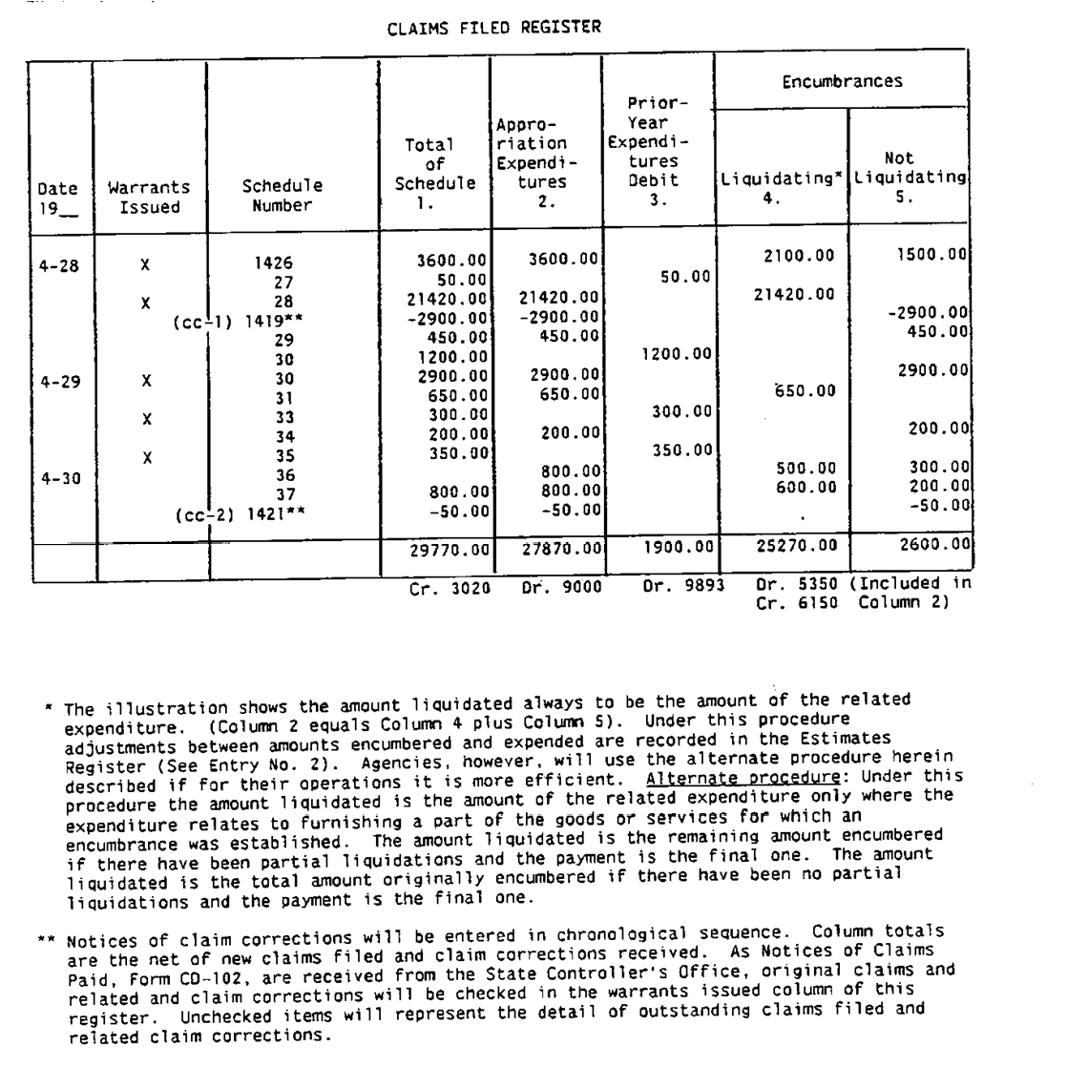

ENTRY NO. 4 [PAYROLLS ARE PAID] 10504
(Revised 09/13)

Journal Entry for General Ledger Accounts:

Debit:
9000 Appropriation Expenditures

Credit:
1140 Cash in State Treasury

Source Documents:

- Payroll Revolving Fund Transfer Notice, Form SM62 - Clearance Type codes 1, 7, 8, and 9 are transfers in the State Payroll Revolving Fund (SPRF). Clearance Type codes 4, 5, 6, and 8 are transfers out of the SPRF. See SAM section 8590 for Clearance Type definitions.

- State Controller’s Office (SCO) Payroll Warrant Register, Form CD38 lists the details of the individual warrants.

Register:
Payroll Expenditure Register

Explanation:
Under the Uniform State Payroll System, department payrolls are prepared by the SCO and salary warrants are drawn on the SPRF. The SCO transfers from the department's appropriation and/or fund the gross amount of each such payroll plus the amount of related state contributions for employees' retirement, OASDI, health and dental benefits, and returns by transfer to the department's appropriation and/or fund any amounts remaining in the SPRF as a result of warrants voided or re-deposited and overpayments recovered. These transfers, supported by payroll warrant register forms, are recorded by the department in a Payroll Expenditure Register, the net total of which represent payroll expenditures to be recorded in the department accounts. See SAM sections 8590 and 8593 for additional information.

PAYROLL EXPENDITURE REGISTER

Type of Transfer | Transfer Date | Issue Date | Clearance No. | Transfer No. | Transfers | Accounts Receivable Abatements |  | Expenditures Current Year | Expenditures Prior Year
 |  |  |  |  |  | DR | CR
1 | 8-3 | 8-3 | 892 | 457 | 10,000 |  |  | 10,000
1 | 8-4 | 8-4 | 901 | 465 | 1,000 |  |  |  | 1,000
AR 1/ |  | 8-15 | 943 |  |  | 50 |  | -50
5 2/ | 8-20 | 6-8 | 2146 | 502 | -50 |  | 50
1 3/ | 8-28 | 9-1 | 961 | 524 | 100,000 |  |  | 100,000
 |  |  |  |  | 110,950 | 50 | 50 | 109,950 | 1,000
 |  |  |  |  | CR 1140 | DR 1311 | CR 1311 | DR 9000 | DR 9893

(Continued)

(Continued)

ENTRY NO. 4 [PAYROLLS ARE PAID] 10504 (Cont. 1)

1/The debit to Account No. 1311 in this register is the gross amount of the overpayment as recorded from the SCO's accounts receivable warrant register.

2/The credit to Account No. 1311 is the gross amount of the overpayment recovered and returned to the department appropriation by transfer. The debit to Account No. 1311 for the same overpayment would have been recorded in the Payroll Expenditure Register for the month in which the SCO prepared an accounts receivable warrant register covering the overpayment.

3/Except at the close of the fiscal year, the transfer covering the main regular monthly payroll for a given monthly pay period is recorded in the Payroll Expenditure Register for that month even though the transfer may be dated in the following month. Payroll transfers dated in July covering payrolls for services rendered in June must be recorded in the Payroll Expenditure Register for July.

Source: Documents:
Notice of State Payroll Revolving Fund Transfer, Form CD–62. (Transfers coded type 1, 7, and 9 are transfers to the State Payroll Revolving Fund. Transfers coded type 3, 4, 5, 6, and 8 are transfers from the State Payroll Revolving Fund. See Section 8590 for additional explanation.)
Controller's Register of Accounts Receivable. (These Controller's registers list overpayments reported to or by the State Controller's Office and will be covered by transfers type 5 when the overpayments are recovered.)
Register:
Payroll Expenditure Register (Continued)

(Continued)

ENTRY NO. 4 10504 (Cont. 2)
(Revised 5/87)

Explanation:
Under the uniform state payroll system, agency payrolls are prepared by the State Controller's Office and salary warrants are drawn on the State Payroll Revolving Fund. The State Controller's Office transfers from the agency's appropriation and/or fund the gross amount of each such payroll plus the amount of related state contributions for employees' retirement, OASDI, health and dental benefits, and returns by transfer to the agency's appropriation and/or fund any amounts remaining in the State Payroll Revolving Fund as a result of warrants voided or redeposited and overpayments recovered. These transfers, supported by payroll warrant register forms, are recorded by the agency in a Payroll Expenditure Register, the net total of which represent payroll expenditures to be recorded in the agency accounts. See Sections 8590 and 8593 for additional explanation.

PAYROLL EXPENDITURE REGISTER

Type of  Transfer | Trans- fer Date | Issue Date | Clear- ance No. | Transfer No. | Transfers 1. | Accounts Receivable-- Abatements  Dr. Cr.  2. 3. |  | Expendi- tures-- Current Year  4. | Expendi- tures- Prior Year  5. | Encum- brances Liquidated 6.
1 | 8-3 | 8-3 | 892 | 457 | 10,000 |  |  | 10,000 |  | 9,000
1 | 8-4 | 8-4 | 901 | 465 | 1,000 |  |  |  | 1,000
3 | 8-11 | 8-12 | 922 | 489 | -3,000 |  |  | -3,000
AR (1) |  | 8-15 | 943 |  |  | 50 |  | -50
S (2) | 8-20 | 6-8 | 2146 | 502 | -40 |  | 40
1 (3) | 8-28 | 9-1 | 961 | 524 | 100,000 |  |  | 100,000 |  | 91,000
 |  |  |  |  | 107,960 | 50 | 40 | 106,950 | 1,000 | 100,000
Cr. 1140 |  |  |  |  |  | Dr. 1311 | Cr. 1311 | Dr. 9000 | Dr. 9893 | Dr. 5350  Cr. 6150
  - The debt to Account No. 1311 in this register is the gross amount of the overpayment as recorded from the Controller's accounts receivable register.

  - The credit to Account No. 1311 is the gross amount of the overpayment recovered and returned to the agency appropriation by transfer. The debit to Account No. 1311 for the same overpayment would have been recorded in the Payroll Expenditure Register for the month in which the State Controller's Office prepared an accounts receivable register covering the overpayment.

  - Except at the close of the fiscal year, the transfer covering the main regular monthly payroll for a given monthly pay period is recorded in the Payroll Expenditure Register for that month even though the transfer may be dated in the following month. Payroll transfers dated in July covering payrolls for services rendered in June must be recorded in the Payroll Expenditure Register for July.

ENTRY NO. 5 10505
(Revised 5/87)

Nature of Transaction:

Notices of Claims Paid, Form CD–102, are received from the State Controller's Office for warrants issued in payment of claims. The warrants are either (1) centrally mailed to payees by the State Controller's Office or (2) delivered for distribution to payees to the agency that submitted the claim schedule. (This entry is made as a transaction of the month in which the Controller's Warrants were issued as indicated on Form CD–102.) See 10515 for entry to record settlement of "NO WARRANT" claims.

Journal Entry for General Ledger Accounts: Debit:
3020 Claims Filed
Credit:
1140 Cash in State Treasury

Source:
Document:
Notice of Claims Paid, Form CD–102

Register:
None. Use an adding machine tape of Forms CD–102

Explanation:
This entry is made at the close of each month to record Notices of Claims Paid, Form CD–102, received from the State Controller's Office. The total of warrants issued as shown on each Form CD–102 is checked with the amount of the claim filed. Inclusive warrant numbers or warrant dates are entered on agency copies of Schedule of Bills Filed, Form 210. The Forms CD–102 are filed and monthly an adding machine tape of the CD–102's dated in that month is used as the basis for the entry to the general ledger accounts.

(Continued)

INTERNAL CONTROL 20050 (Cont. 2)
(Revised 09/13)

Internal control consists of five interrelated components:

- Control Environment. The organization’s tone; the foundation for all other components of internal control.
- Risk Assessment. Management establishes activity-level objectives and mechanisms for identifying and analyzing risks related to their achievement.
- Control Activities. Policies and procedures that ensure management’s directives are carried out and help ensure that necessary actions are taken to minimize risks to achievement of the entity’s objectives.
- Information and Communication. Information must be identified, captured, and communicated in a form and time frame that enable people to carry out their responsibilities.
- Monitoring. Assessing the quality of the system’s performance over time. This is accomplished through ongoing monitoring activities, separate evaluations or a combination of the two.

INTERNAL CONTROL REPORTING 20060
(Revised 09/13)

Pursuant to FISMA (GC 13405), the head of each state entity shall, on a biennial basis but no later than December 31 of each odd-numbered year, conduct an internal review and prepare a report on the adequacy of their entity’s systems of internal accounting and administrative control in accordance with the guidance provided by Finance. The report shall identify any material inadequacy or material weakness in an entity’s systems of internal accounting and administrative control that prevents the head of the entity from stating that the entity’s systems comply with FISMA. The submission should consist of a transmittal letter and the review report on internal accounting and administrative control.

For entities that report to an Agency Secretary, the transmittal letter and review report should be addressed and sent to the Agency Secretary. The entity should e-mail copies of the transmittal letter and review report to the Legislature, State Auditor, Governor’s Office, Director of Finance, State Library, State Controller’s Office, State Treasurer’s Office, and Attorney General. Refer to Audit Memo on the Finance website for instructions.

For entities that do not report to an Agency Secretary, the transmittal letter and review report should be addressed and e-mailed to the Director of Finance at FISMAhotline@dof.ca.gov. The entity should e-mail copies of the transmittal letter and review report to the Legislature, State Auditor, Governor’s Office, State Library, State Controller’s Office, State Treasurer’s Office, and Attorney General. Refer to Audit Memo on the Finance website for instructions.

Within 30 days after the report is submitted, the entity will provide to the Director of Finance at FISMAhotline@dof.ca.gov a plan and schedule for correcting the identified inadequacies and weaknesses described in the entity’s report. The plan will be updated and submitted every six months until all corrections are completed.

The state entity head must investigate any allegation that an employee provided false or misleading information in connection with the review of an entity’s system of internal control or in connection with the preparation of the biennial report. The state entity head must submit a report on all the allegations made and the actions taken to resolve them to the Director of Finance within 90 days of receiving the allegation.

(Continued)

INTERNAL CONTROL REPORTING 20060 (Cont. 1)

All internal reviews are to be completed in accordance with the guidance provided by Finance. The management of each entity is responsible for conducting the review, identifying risks and controls, mitigating the identified risks, and reporting the results. Internal audit units may support this effort by reviewing the design and operating effectiveness of the entity’s controls, in accordance with appropriate standards as required by GC 13886.5. The review shall examine internal accounting control and fiscal compliance practices in use at the time of the review.

Tools, templates, Audit Memos, and other guidance are available on the Finance website at http://www.dof.ca.gov/osae/fisma/. Questions on the review and reporting processes can be addressed to Finance’s FISMA Hotline e-mail address at FISMAhotline@dof.ca.gov.

FEDERAL PASS-THROUGH FUNDS 20070
(Revised 09/13)

The Federal Single Audit Act of 1984 as amended by the Single Audit Act Amendment of 1996 and amendments in conjunction with OMB Circular A-133, defines a pass-through entity as a non-federal entity that provides a federal award to a sub recipient to carry out a federal program. OMB Circular A-133, section .310(b), requires a schedule of expenditures of federal awards be prepared each year and lists the requirements for completing the schedule of expenditures, including the requirement to identify the total amount provided to sub recipients.

To facilitate the identification and tracking of federal funds transferred between state agencies or state agencies and local governments, each contract, interagency agreement, or any other document controlling the disbursement of federal financial assistance must cite the applicable catalog number from the Catalog of Federal Domestic Assistance. If state matching funds are involved, specify the percentage of state and federal funds. Where federal funds are disbursed through a claim schedule, the catalog number should be recorded.

OMB Circular A-133, Subpart D, describes the responsibilities of federal agencies and pass-through entities. Specifically, section .400(d) prescribes the responsibilities of a pass-through entity for the federal awards it makes.

To ensure that the State of California carries out its responsibilities in accordance with this federal act, the following procedures shall apply:

- As part of the annual Single Audit, Finance requires state agencies to provide certain financial information related to federal awards received. Specifically, agencies must provide schedules of cash and non-cash federal assistance. The information provided is consolidated by Finance and forwarded to the State Auditor for inclusion in the Single Audit Report. Refer to Audit Memos on the Finance website for further guidance.

(Continued)

FEDERAL PASS-THROUGH FUNDS 20070

- The SCO will coordinate single audit compliance with local governments.

  - Each state entity will monitor the federal funds it disburses to local governments to ensure compliance with federal laws and regulations. State entities will receive local government audit reports performed in accordance with the Single Audit Act of 1984, P.L. 98-502, and the Single Audit Act Amendments of 1996, P.L. 104-156, from the SCO when the audit report includes a schedule of findings and questioned costs with respect to federal funds that were passed through state entities. In addition, the SCO will distribute the single audit reports to state entities when the prior fiscal year’s single audit report included audit findings related to federal funds. The state entity will review these reports and evaluate the corrective action plans submitted in response to findings of noncompliance.
  - All contracts or agreements issued by state entities concerning disbursement of federal funds to local governments will include the requirement for an audit in accordance with P.L. 104-156 and amendments.
  - The SCO will inform units of local government to submit copies of audit reports and corrective action plans, when warranted, prepared in accordance with P.L. 104-156 and amendments directly to the SCO.
  - The SCO will distribute copies of each audit report and corrective action plan to state entities affected by audit findings.
  - State entities will follow up on audit findings pertaining to federal programs which they administer, and the SCO will follow up on general findings such as those relating to internal control.
  - The SCO will review and monitor the audit reports issued by external independent auditors. The SCO will determine whether or not the audit reports conform to Government Auditing Standards.

NOTIFICATION OF ACTUAL OR SUSPECTED FRAUDS AND IRREGULARITIES 20080
(Revised 09/13)

An entity will notify OSAE and the State Auditor of all cases of actual or suspected fraud, theft, or other irregularities it has become aware of either internally or by referral. This requirement applies to all incidents involving state assets, whether alleged against state employees or others.

Notification will be made to OSAE and the State Auditor in writing not later than the first business day following the actual or suspected fraud, theft, or irregularity. The notification will include, as a minimum, the sequence of events, the internal controls that failed, the means of discovery, the corrective actions taken, the actual or estimated dollar amount, and any punitive actions taken or being considered. In those instances where complete information is not available by the first business day following discovery, a preliminary notification will be made. A complete notification will be made within thirty days. If not completed within thirty days, a progress report will be submitted every thirty days until the entity has resolution or has referred the incident to the proper authority.

Additionally, agencies will notify OSAE of material irregularities in their annual Letter of Representation in accordance with SAM section 20020 (Single Audit Coordination). For reporting lost, stolen or destroyed property, see SAM section 8643.

REPORTING MATRIX 20090
(Revised 09/13)

Document Required from Due Date Submit to

Single Audit Representation Letter All State entities Upon notification, each year Finance

FISMA Transmittal Letter and Review Report
All State entities Biennial, but no later than
December 31 of each odd-numbered year
See SAM 20060

Corrective Action Plan All State entities Within 30 days after submitting the FISMA Report
Finance

Subsequent Corrective Action Plan All State entities Every six months until all
corrections are completed
Finance

