CHAPTER/ SECTION | SUMMARY
CHAPTER 1300
Section 1310.2 | Removed reference to outdated MM 04-17.
CHAPTER 2800
Section 2850 | Revised. Added a more in-depth program summary to conform to the section title and include a more thorough description of CALPIA and services provided. Information from section 2865 was moved here for simplification.
Section 2855 | Revised. Authority language changed to mirror language in Penal Code Section 2807.
Section 2860 | Revised. Information on how to order services was updated to eliminate the use of form STD. 54 and fax since those methods are no longer used, and order by email was added. Contact information was moved to the bottom of the section. And information on how to request a custom quote was also added.
Section 2865 | Revised. Eliminated section and incorporated information into Section 2850.
CHAPTER 3500
Section 3520.11 | New Section added in conjunction with Management Memo 20-03, Laptop Donation for Foster Youth
CHAPTER 3700
Section 3730 | Revised. Removed reference to annuity tables and added link to DGS/PD Financial Marketplace webpage.
Section 3740 | Revised. Removed references to annuity tables and added comment directing readers to DGS/PD Financial Marketing webpage.
CHAPTER 4100

Section 4121.6 | Section 4121.6 has been revised to include the following new requirements:  - Beginning July 1, 2021, when submitting their Fleet Acquisition Plan (FAP) to OFAM, state agencies shall submit a DGS OS-1 ZEV Infrastructure Planning and Readiness Site Assessment along with their FAP.  - State agencies requesting an exemption from ZEV & Hybrid First Purchasing Mandates of SAM Sections 4121, 4121.1, 4121.9 due to the inability to install EV charging infrastructure must submit a DGS OS-1 approved by DGS OS. Also, state agencies must certify on DGS OFAM 161 B that there is no publicly available infrastructure in the area that could be accessed to support the vehicles requested for exemption.
Section 4121.9 | New section describing mandate for purchasing ZEV & hybrid medium and heavy duty vehicles.
CHAPTER 7400
Section 7400 | Revised. Added the Uniform Codes Manual and Manual of State Funds.
Section 7410 | Revised. Updated fund descriptions.
Section 7420 | Revised. Updated fund descriptions.
Section 7430 | New. Added the measurement focuses by fund type.
Section 7440 | New. Added the bases of accounting by fund type.
Section 7450 | Revised. Expanded the methods for creating funds.
Section 7455 | New. Added the methods for abolishing funds.
Section 7463 | Revised. Minor update.
CHAPTER 7900
Section 7950 | Revised 7950d for the following:  - Update CALSTARS to FI$Cal  - Update CALSTARS Client Support Unit to Finance, Fiscal Systems and Consulting Unit, FI$Cal Department Support staff  Revised 7950f to say that the SCO will notify departments of the reports availability dates in the State Controller’s Budgetary/Legal Basis Year- End Financial Reports Procedure Manual instead of by letter.
7951 Illustration | Updated content and remediated for ADA accessibility.
7955 Illustration | Updated content and remediated for ADA accessibility.

CHAPTER 8000
Section 8034.2 | - Removed reference to illustration on page 1.  - Removed outdated illustration
CHAPTER 8100
Section 8116.1 | - Removed reference to sample memo in bullet 1.  - Removed outdated sample memo illustration.
CHAPTER 8400
Section 8400 | Section deleted.
Section 8400.1 | 8400.1 diagram deleted, outdated.
CHAPTER 8700
Section 8755.2 | - Updated title from “INDIRECT COST RATE RECOVERIES” to “FEDERAL INDIRECT COST RECOVERIES.” Please note the TOC is correct; however the section title was mislabeled.  - Removed reference to 8755.2 (Sample TR, CA 504) Illustration in paragraphs 2 and 3.  - Removed Sample TR, CA 504 (8755.2 Illustration), the illustrated form is outdated.
Section 8756.2 | - Last sentence of paragraph one changed from “See 8756.1 Illustration 1 for…” to “See below for…”  - Removed 8756.2 Illustration and replaced with updated information in text format.  - Removed sample image of outdated ICRP form.
CHAPTER 10500
Section 10507 | - Removed reference to illustration on page 1  - Removed outdated illustration
Section 10508 | - Removed outdated illustration
CHAPTER 10800

All sections | Deleted Chapter 10800, Institutional Stores Accounting instructions in the State Administrative Manual (SAM) were developed for state institutions financed by the General Fund that maintain stores systems. Due to the ever changing nature of state enterprise stores/canteens and the use of third party suppliers, it is more appropriate for state agencies/departments that perform these operations as part of their daily activity to develop internal policies and procedures, as well as instructions that will enable their operations to keep up with industry practices, while complying with relevant laws and standards. As such, Department of Finance, Fiscal Systems and Consulting Unit (FSCU) will no longer maintain this chapter of the SAM.  State agencies/departments with specialized accounting policy and procedural needs may contact the FSCU. The policies and principles covering Institutional Stores Accounting can also be found in the SAM sections for purchases, requisitions, invoices, inventory, estimating and ordering and donations.  State agencies/departments should consult other policies and principles covering Institutional Stores Accounting that can be found in the SAM sections below.  Receipts, Stock Receipts SAM 8422.20 Purchases SAM 3500, 3600  Requisitions SAM 3550  Invoices SAM 8422  Inventory SAM 8600  Estimating and Ordering SAM 3550-3559 Donations SAM 3520.5
CHAPTER 10900

All sections | Deleted Chapter 10900, Institutional Farming and Processing Operations of the State Administrative Manual (SAM) was developed principally for those state institutions that conducted farming and processing operations and have farming and processing units financed by the General Fund. Due to the significant reduction in farming and processing operations at state institutions resulting from more efficient food purchasing systems, the procedures and instructions contained in this SAM chapter have become less relevant. Additionally, other SAM chapters have extensive discussions of procedures and instructions that can be applied to any farming and processing unit still in existence. As a result, the Department of Finance, Fiscal Systems and Consulting Unit (FSCU) will not be maintaining this chapter.  State agencies/departments with specialized accounting policy and procedural needs may contact FSCU. The policies and principles covering Farming and Processing Operations can also be found by consulting the SAM sections below along with Government Code sections 11330-11335.  State agencies/departments should consult other policies and principles covering Institutional Stores Accounting that can be found in the SAM sections below.  Receipts, Stock Receipts SAM 8422.20 Purchases SAM 3500, 3600  Requisitions SAM 3550  Inventory SAM 8600  Estimating and Ordering SAM 3550-3559 Lease/Purchase Equipment SAM 3700 Payrolls SAM 8500

PORTFOLIO MANAGEMENT SECTION 1310.2
(Revised 56/202014)

The Portfolio Management Section is the initial point of contact for new RESD projects and serves as a liaison to RESD for state agencies.

Customer Services Managers (CSMs) are assigned by agency and are the central point of contact to RESD. CSMs review incoming CRUISE requests for completeness and direct each request to the appropriate branch for project execution. This unit maintains an understanding of the customer’s programs, real estate and facility requirements, and assists with collaboration among RESD programs.

Regional Portfolio Managers (RPMs) review all project requests to ensure RESD services are provided from a statewide, strategic asset management perspective and reflect state management, policy and statutory priorities. The RPMs also maintain a profile of the state’s real estate portfolio by managing the utilization of space in a state- owned or DGS-controlled office building, assisting agencies with planning short and long term real estate needs, and developing regional plans for future state office requirements.

While managing space assignments in state facilities pursuant to the State Administrative Manual Management Memo 04-17, tThe following terms and conditions in the DGS Building Occupancy Policy (Policy) pertain to state agencies (occupant agencies) that hire from the DGS certain premises with the appurtenances situated in various cities within the State of California. Occupant agencies are assigned space subject to the terms contained in the Policy, Building Rules and Regulations, Space Assignment GS 4091, legislative mandates, and any and all applicable State of California statutes, policies, and regulations.

SAM – PUBLISHING/PRINTING
CALIFORNIA PRISON AUTHORITY (CALPIA) 2850
CALPIA PROGRAM SUMMARY
(Revised 12/201301/2020)

CALPIA is a self-supporting, customer-focused business that reduces recidivism, increases prison safety, and enhances public safety by providing offenders productive work and training opportunities.

Printing and reproduction services may also be obtained from CALPIA. CALPIA is not limited to items listed below and may be able to produce custom services not listed. For questions and additional information, please contact sales at 916.323.2419 or e-mail print.services@calpia.ca.gov.

Print Products available from CALPIA: If CALPIA or OSP cannot produce an item on this list, an exemption from OSP is needed prior to purchasing from "in-plants" or the private sector. (See SAM 2800 for additional information)

Banners Booklets Brochures Business Cards Calendars
Certificate Folders Commercial Print Digital Printing Envelopes
File Folders Flyers
Forms (Single & Multipart) Labels
Maps Posters Tabs Tags
Misc. Custom Print Items (not listed below)

CALPIA Exclusive Products: An exemption from CALPIA is needed prior to purchasing any items on this list from the private sector. (CALPIA Exemption Process)
Binders
Braille (Embossing & Transcription) Decals
Diploma Covers Name Plates Notecards Notepads Placards Plaques

Portfolios Registration Tags
Signs (Including metal, vinyl, and other materials) Survey Tags
Tab Dividers
Vehicle Logbooks/Peg Books

CALPIA STATUTORY AUTHORITY
(Revised 12/201301/2020)

Penal Code Section 2807 authorizes CALPIA to provide products and services needed by the state, or any political subdivision thereof, or by the federal government, or any department, agency, or corporation thereof, or for any other public use. printing services to state and local government entities.

CALIFORNIA PRISON AUTHORITY (CALPIA) 2860
HOW TO ORDER CALPIA SERVICES
(Revised 12/201301/2020)

- TO PLACE AN ORDER:

Printing and reproduction services may be obtained from CALPIA by submitting a purchase order or Reproduction Order form, STD. 54, to Customer Service, 560 East Natoma Street, Folsom, CA 95630-2200 or by e-mail at customerservice@calpia.ca.gov. faxing the purchase order to (916) 358-2660. Customers needing information or assistance may call (916) 323-24 Custom quotes should be attached to purchase orders submitted to customer service. Stock forms do not need an attached quote if pricing has been verified on the CALPIA website.

- QUOTES:

Stock Forms: Use the Forms Library to determine item number and price.

Custom Quotes: Please send requests for customer quotes to print.services@calpia.ca.gov.
Information to provide (if known):
  - How would you describe the item (ex. brochure, form, notepad, etc.)? 2. How many are needed?
- Full color or black & White?
- What is the size?
- What type of paper?
- If it has multiple pages: How many? How is it bound? Color throughout or just the cover?
- Brochures: Bi-fold or tri-fold or quad-fold? 8. Do you have a sample?
9. Did you provide hi-resolution artwork?

For questions and additional information, please contact sales at 916.323.2419 or e-mail print.services@calpia.ca.gov.

CALIFORNIA PRISON AUTHORITY (CALPIA) 2865

CALPIA SERVICES
(Revised 12/2013)

The following describes printing and reproduction services provided by the California Prison Industry Authority (CALPIA). For additional information call Customer Services at (916) 323-2419.

- Preparing and planning print jobs.
- Typesetting for booklets, reports, newsletters, forms, etc.
- Preparing of camera ready copy for printing and reproduction. 4. Copying and duplication work.
- Presswork that includes offset printing of forms, envelopes, publications, etc. This includes sheet fed or web fed to a maximum of 18” x 24” finished sheets.
- Two color printing from mechanical separation or multiple color process printing. 7. All bindery operations such as cutting, folding, stitching, drilling, etc.
8.1. Special Services that include labels mounted on a carrier base produced in rolls or flat fold configuration; screen printed labels, signs, and posters; ticket and script books; inventory tags; decals; OCR forms; bar- coding; and sequential numbering up to 8” x 10” stock.

SURPLUS ELECTRONIC EQUIPMENT – FOSTER YOUTH 3520.11
(New 04/2020)
State departments are encouraged to donate surplus laptops and other portable computer equipment to the foster youth attending a California state college or university. Donation of this equipment is enabled through the Department of General Services (DGS) State Surplus Property Program.
Entities eligible to receive this equipment include the aforementioned institutions of higher education, and non-profit 501(c)(3) organizations associated with those institutions. To donate a computing device to a foster youth, state agencies will follow state surplus property procedures outlined in SAM Section 3520 et seq., and shall ensure the computing device has been sanitized in accordance with SAM section 3520.10.
The device then will then be listed on the DGS California Surplus Property System (CSPS) as a donation and can be delivered to the eligible entity for subsequent distribution to the student.

March 2020

SAM—TRANSPORTATION SERVICES
ZEV INFRASTRUCTURE PLANNING AND READINESS 4121.6
(Revised 212/202019)

- When submitting a Fleet Acquisition Plan (FAP) to the Department of General Services (DGS), Office of Fleet and Asset Management (OFAM), state agencies must be able to demonstrate that they have appropriately planned for, and currently have, zero emission vehicle (ZEV) charging infrastructure necessary to support their existing and requested ZEV’s in order to receive approval.sufficient zero emission vehicle (ZEV) charging infrastructure (to support an agency’s existing and requested ZEV’s) in order to receive approval.
A.

Until June 30, 2021, Tto demonstrate sufficient charging infrastructure, agencies must submit answers to the following applicable questions with their FAP. Please see the Fleet Acquisition Plan Narrative Instructions form for more details.
  - What is the address of the location where this vehicle will be domiciled at (please provide this address on the FAP spreadsheet in the column titled “ZEV Domicile Address”)?
  - How many electric vehicle (EV) chargers (broken down bmy charger type) are currently installed at the vehicle’s anticipated domicile location?
  - Are the EV chargers single or dual capacity?
  - Does the facility utilize a charging rotation schedule?
  - Are there any other electric charging outlets that could be, or are being, used for EV charging?
  - Are any EV charging stations being currently installed and, if so, when is the anticipated completion date of the installation?
  - How many plug-in electric vehicles are currently domiciled at the anticipated location?
  - For requested Fuel Cell Vehicles, where is the closest Hydrogen Fueling Station?

- (1) Starting July 1, 2021, to ensure proper ZEV infrastructure planning is taking place and to demonstrate that sufficient EV charging infrastructure exists, agencies shall submit a DGS OS-1 form with their FAP, which has been signed off by DGS Office of Sustainability (OS), in lieu of the answers to the questions above. To complete the DGS OS-1, state agencies must work with and have assessments conducted by OS for each site where fleet assets on their intended FAP will be domiciled.

- To initiate the OS review and assessment process, agencies shall complete Sections 1, 2, and 3 of the DGS OS-1 and submit the form to EVSE@dgs.ca.gov (enter OS intake email here).
- Agencies must submit the DGS OS-1 to OS at least six months prior to the planned submittal date of the FAP to OFAM to ensure assessments are completed and infrastructure installations have started prior to approval of the FAP.
- Once the assessments have been completed and OS has signed off on the DGS OS-1, agencies shall submit that form with their subsequent FAP to OFAM.
- In the FAP review process, OFAM will review and validate the responses provided on the DGS OS-1 to ensure there is appropriate charging

infrastructure to support agency’s existing and requested ZEVs.

(2) State agencies requesting an exemption to the ZEV and Hybrid-Electric Alternative Fuel Vehicle First Purchasing Mandates of SAM Sections 4121, 4121.1, and 4121.9, due to the inability to install EV charging infrastructure at the vehicle’s domicile site, must submit a DGS OS-1, on which OS has identified the site as not feasible for EV charging infrastructure. Additionally, state agencies must certify on their OFAM-161 B (Fleet Acquisition Certification) that there is no publicly available infrastructure in the area that could be accessed to support the vehicle(s) requested for exemption.

SAM – TRANSPORTATION

ZEV & HYBRID FIRST PURCHASING MANDATE FOR MEDIUM- AND HEAVY-DUTY VEHICLES
(New 2/2020)

4121.9

- ZEV & Hybrid-Electric Alternative Fuel Vehicle First Purchasing Mandate for Medium- and Heavy-Duty Vehicles
As of July 1, 2020, state agencies are required to prioritize purchasing of Zero Emission Vehicles (ZEVs) (including Battery Electric, Fuel Cell, and Plug-In Hybrid) and Hybrid- Electric Alternative Fuel Vehicles (Hybrid AFVs), in designated medium- and heavy-duty vehicle categories where programmatically feasible.

These purchases shall be prioritized over medium- and heavy-duty vehicles that are powered solely by internal combustion engines utilizing fossil fuels and flex-fuel vehicles or bi-fuel vehicles powered by petroleum-based fuels and other alternative fuels, such as ethanol. Designated medium- and heavy-duty vehicle categories subject to this policy are listed on the Department of General Services (DGS), Office of Fleet and Asset Management’s (OFAM) website (https://www.dgs.ca.gov/-
/media/Divisions/OFAM/FAMS_FARS/Vehicle-Categories-subject-to-MD-and-HD-ZEV- First-Mandate.pdf).
When submitting a Fleet Acquisition Plan (FAP) to DGS for the acquisition of additional or replacement vehicles, as mandated in SAM Section 4120, state agencies shall select vehicles in medium- and heavy-duty categories subject to this policy based on the following priority structure:
Priority 1: Pure ZEVs (Battery Electric & Fuel Cell Vehicles) Priority 2: Plug-in Hybrid ZEVs
Priority 3: Hybrid AFVs
Priority 4: Internal Combustion and Bi/Flex-Fuel Vehicles

If requesting a vehicle subject to this policy in a Priority level other than Pure ZEV, agencies must be able to sufficiently demonstrate and justify why their programmatic transportation requirements could not be satisfied with a vehicle from each higher Priority level. Each requested drop in Priority level must be fully justified in accordance with criteria outlined in Section C. ZEV & Hybrid AFV Priority Level Exemptions for Medium-and Heavy-duty Vehicle Categories.
This requirement does not apply to requests for vehicles with special performance requirements necessary for the protection of public safety and welfare as outlined in SAM Section 4121.4.
(Continued)

ZEV & Hybrid AFV Acquisition Planning for Medium- and Heavy-Duty Vehicles

To account for the time necessary to plan for and install the requisite charging/fueling infrastructure to support new medium- and heavy-duty ZEVs, DGS has created a medium- and heavy-duty ZEV acquisition planning schedule. The ZEV acquisition planning schedule allows state agencies to plan for appropriate charging and fueling infrastructure by setting the vehicle classes that will be subject to the medium- and heavy-duty ZEV purchasing requirements, two years in advance.
Accordingly, in fiscal year (FY) 2019-20, DGS will establish a list of designated medium- and heavy-duty vehicle categories subject to the ZEV and Hybrid AFV First Purchasing Mandate for Medium- and Heavy-Duty Vehicles policy, which will be valid for three fiscal years, or until June 30, 2022.
By July 1, 2020, DGS will establish a new list of designated medium- and heavy-duty vehicle categories subject to the ZEV and Hybrid AFV First Purchasing Mandate for Medium- and Heavy-Duty Vehicles, which will be valid for FY 2022-23.
By July 1st of each year, thereafter, DGS will publish new designated medium- and heavy-duty vehicle categories subject to the ZEV and Hybrid AFV First Purchasing Mandate for Medium- and Heavy-Duty Vehicles, which be valid for the FY two years from the creation of the applicable list.

Medium- and Heavy-duty ZEV Acquisition Planning Schedule
Year Designated Medium- and Heavy- duty Vehicle Category List Was Created | Fiscal Year the Designated Vehicle Category List Applies to
2019-20 | 2019-20
2019-20 | 2020-21
2019-20 | 2021-22
2020-21 | 2022-23
2021-22 | 2023-24
2022-23 | 2024-25

- ZEV & Hybrid AFV Priority Level Exemptions for Medium- and Heavy-duty Vehicle Categories

Agencies requesting exemptions from ZEV and Hybrid AFV Priority levels must submit justifications and/or certifications, in accordance with the guidelines below, with the agency’s FAP for each vehicle being exempted. To be approved for exemption from a Priority level, vehicles must meet one of the exemption criteria listed for that Priority level and agencies must provide the certification and/or justification required for that specific exemption.
(Continued)

Priority 1: Pure ZEVs (Battery Electric & Fuel Cell Vehicles)

Exemptions
  - Range Limitation Exemptions (for Battery Electric Vehicles only):
    - Range Limitations for non-Specialized Vehicles: vehicle requested is used more than 72 times in a 12-month period, or 36 times in a 3-month period, for trips lasting less than 24 hours that exceed 75 percent of the mileage range of the Pure ZEV on the statewide vehicle contract in that vehicle category, or;
    - Range Limitations for Specialized Vehicles: vehicle requested has been modified or configured for a specialized function, preventing the use of a temporary vehicle to perform its function, and is used at least once in the previous 12-month period for trips lasting less than 24 hours that that exceed 75 percent of the mileage range of the Pure ZEV on the statewide vehicle contract, or;

  - Inability to Install Necessary Electric Vehicle (EV) Charging Infrastructure: it has been determined that the installation of EV charging infrastructure is not feasible at the site where the vehicle(s) will be domiciled.

  - Charging/Fueling Availability Exemptions for Battery Electric and Fuel Cell Vehicles:
    - Onsite Charging Availability Exemption (for Battery Electric Vehicles only): until June 30, 2021, vehicle requested will not have appropriate onsite charging infrastructure to support it, or;
    - Charging/Fueling Availability Exemptions for non-Specialized Vehicles: vehicle requested is used more than 72 times in a 12-month period, or 36 times in a 3-month period, for trips lasting more than 24 hours in locations with limited and/or unreliable fueling/charging stations, or;
    - Charging/Fueling Availability Exemptions for Specialized Vehicles: vehicle requested has been modified or configured for a specialized function, preventing the use of a temporary vehicle to perform its function, and is used at least once in the previous 12-month period for trips lasting more than 24 hours in locations with limited and/or unreliable fueling/charging stations, or;

(Continued)

  - Operational Ability for Battery Electric and Fuel Cell Vehicles: vehicle requested has a certain operational use case or need that prevents the use of one of the Pure ZEVs on the statewide vehicle contract. Examples of acceptable use cases or operational needs that would prevent the use of a Pure ZEV are:
    - Need for high towing capabilities
    - Operation in extreme weather environments
    - Operation in mountainous terrain
    - Large cargo/passenger/payload capacity need
    - Vehicle equipped with Power Take Off (PTO)

Required Certifications/Justifications
- Range Limitations for Battery Electric Vehicles Only:
  - Until June 30, 2021, state agencies shall submit Directorate level certification, to be included on the FAP Certification, that the vehicle(s) being requested meets one of the two range limitation exemptions for Pure ZEVs.
  - Beginning July 1, 2021, state agencies shall submit vehicle usage reports demonstrating that the vehicle(s) requested met the range limitation exemptions for Pure ZEVs. If the exemption being requested is for Specialized Vehicles, state agencies shall also submit a description of the modification and/or configuration that prevents the use of a temporary vehicle to perform its function in situations where longer range is needed.

- Inability to Install Necessary EV Charging Infrastructure:
  - State agencies shall submit a DGS OS-1 form with their FAP that indicates that the installation of EV charging infrastructure at the current domicile site for the requested vehicle(s) is not feasible.
  - State agencies shall certify on DGS OFAM-161 B (Fleet Acquisition Certification) that there is no publicly available infrastructure in the area that could be accessed to support the vehicle(s) requested for exemption.

- Charging/Fueling Availability Exemptions:
  - Until June 30, 2021, state agencies shall submit Directorate level certification, to be included on the FAP Certification, that the vehicle(s) being requested meets one of the three charging/fueling limitation exemptions for Pure ZEVs.
  - Beginning July 1, 2021, state agencies shall submit vehicle usage reports demonstrating that the vehicle(s) requested met one of the charging/fueling availability exemptions for Pure ZEVs. If the exemption being requested is for Specialized Vehicles, state agencies shall also submit a description of the modification and/or configuration that prevents the use of a temporary vehicle to perform its function in situations where charging/fueling infrastructure is not available.
(Continued)

- Operational Ability Exemption:
  - Until June 30, 2021, state agencies shall submit Directorate level certification, to be included on the FAP Certification, that the vehicle(s) being requested has a use case or operational need that cannot be met by one of the Pure ZEVs available on the statewide vehicle contract.
  - Beginning July 1, 2021, state agencies shall submit narrative justifications or telematics reports, demonstrating that the vehicle(s) requested has an operational use case and need that cannot be met by one of the Pure ZEVs available on the statewide vehicle contract.

Priority 2: Plug-in Hybrid ZEVs

Exemptions
- Operational Ability for Plug-in Hybrid Vehicle: vehicle requested has a certain operational use case or need that prevents the use of one of the Plug-in Hybrid ZEVs on the statewide vehicle contract. Examples of acceptable use cases or operational needs that would prevent the use of a Plug-in Hybrid ZEV are:
  - High towing capabilities
  - Large cargo/passenger capacity need

- Inability to Install the Necessary EV Charging Infrastructure: it has been determined that the installation of EV charging infrastructure is not feasible at the site where the vehicle(s) will be domiciled.

Required Certifications/Justifications
- Operational Ability Exemption:
  - Until June 30, 2021, state agencies shall submit Directorate level certification, to be included on the FAP Certification, that the vehicle(s) being requested has a use case or operational need that cannot be met by one of the Plug-in Hybrid ZEVs available on the statewide vehicle contract.
  - Beginning July 1, 2021, state agencies shall submit narrative justifications or telematics reports, demonstrating that the vehicle(s) requested has an operational use case and need that cannot be met by one of the Plug-in Hybrid ZEVs available on the statewide vehicle contract.

- Inability to Install the Necessary EV Charging Infrastructure:
  - State agencies shall submit a DGS OS-1 form with their FAP that indicates that the installation of EV charging infrastructure at the current domicile site for the requested vehicle(s) is not feasible.
(Continued)

  - State agencies shall certify on the OFAM-161 B (Fleet Acquisition Certification) that there is no publicly available infrastructure in the area that could be accessed to support the vehicles requested for exemption.

Priority 3: Hybrid AFVs

Exemptions
- Operational Ability for Hybrid AFVs: vehicle requested has a certain operational use case or need that prevents the use of one of the Hybrid AFVs on the statewide vehicle contract. Examples of acceptable use cases or operational needs that would prevent the use of a Hybrid AFV are:
  - High towing capabilities
  - Large cargo/passenger capacity need

- Environmental Impact: vehicle requested has a higher U.S. Environmental Protection Agency (EPA) Fuel Economy and Greenhouse Gas (GHG) Emissions score (1 through 10 scale, with 10 being the best) than the contracted Hybrid AFVs in that vehicle category.

Required Certifications/Justifications
- Operational Ability Exemption:
  - Until June 30, 2021, state agencies shall submit Directorate level certification, to be included on the FAP Certification, that the vehicle(s) being requested has a use case or operational need that cannot be met by one of the Hybrid AFVs available on the statewide vehicle contract.
  - Beginning July 1, 2021, state agencies shall submit narrative justifications or telematics reports, demonstrating that the vehicle(s) requested has an operational use case and need that cannot be met by one of the Hybrid AFVs available on the statewide vehicle contract.

- Comparison of the Environmental Protection Agency’s (EPA) Fuel Economy and GHG Emissions score for the requested vehicle to the EPA score of the comparable Hybrid AFVs on the statewide vehicle contract. EPA Fuel Economy and GHG Emissions scores can be found by:
  - Use the “Find a Car” feature on the U.S. Department of Energy Website (https://www.fueleconomy.gov/) to look up the vehicle for which you would like the score.
  - Once at the vehicle’s information page, click on the “Energy and Environment” tab to find the GHG Emissions score.

(Revised 096/142020)
LIST OF REQUIRED YEAR-END FINANCIAL REPORTS

No. | Year-end Report d/ | Form or CALSTARS  FI$Cal Report ID | Governmental Cost Funds and Bond Funds | Non-Governmental Cost Funds (excludes Bond Funds) | Distribution gf/  DOF | Distribution gf/  SCO | Distribution g/  STO | SAM  Section
1 | Report of Accruals to Controller’s Accounts | 571 c/ | X |  |  | X |  | 7952
2 | Accrual Worksheet | a/ | X |  |  | X |  | 7953
3 | Adjustments to Controller’s Accounts | 576 c/ | X | X |  | X |  | 7955
4 | Statement of Revenue (includes reconciliation with Controller’s Accounts | RPTGL065Q26  b/ | X |  |  | X |  | 7956
5 | Final Reconciliation of Controller’s Accounts with Final Budget Report | 573 c/ | X |  |  | X |  | 7957
6 | Final Budget Report | RPTGL067B06  b/ | X | X h/ |  | X f/ |  | 7961
7 | Pre-Closing Trial Balance | RPTGL068G02  b/ | X | X |  | X |  | 7962
8 | Post-Closing Trial Balance | RPTGL069G02  b/ | X | X |  | X |  | 7962
9 | Analysis of Change in Fund Balance (Statement of Operations) | RPTGL113G04  b/ |  | X |  | X |  | 7963
10 | Analysis and Reconciliation Revolving Fund Accountability | a/ | X | X |  |  |  | 7965
11 | Bank Reconciliation | a/ | X | X |  |  |  | 7967
13 | Report of Expenditures of Federal Funds | RPTGL072Q34  b/ |  | X | X h/ | X |  | 7974
14 | Report of Accounts Outside the State Treasury (1 report per department) | STD. 445  b/ | X | X |  | X | X | 7975
15 | Reconciliation of Agency Accounts with Transactions per State Controller | a/ | X |  |  | X |  | 7976
18 | Statement of Changes in Capital Assets Group of Accounts (1 report per fund) | RPTGL075G05  b/ | X | X |  | X |  | 7977
19 | Statement of Capital Assets Group of Accounts (1 report per department) | RPTGL076G05  b/ | X | X |  | X |  | 7978
20 | Statement of Financial Condition | RPTGL07G04  b/ |  | X |  | X |  | 7979
22 | Statement of Contingent Liabilities | a/ | X | X e/ |  | X |  | 7980

a/ If a standard form/report is not listed, refer to SAM for illustrations of the suggested format.
b/ Listed reports are produced by CALSTARSFI$Cal. Non-CALSTARSFI$Cal departments should refer to SAM for illustrations of the suggested format.
c/ These reports are available from the SCO website at http://www.sco.ca.gov/ard_reporting.html. Departments may produce these forms by personal computer, if prior approval has been received from the SCO.
d/ See SAM section 7951 for required certification.
e/ For non-Treasury Trust Funds, Report No. 22 is not submitted.
f/ Mailing Address Interagency Mail & Messenger Service (IMS) Code and Email AddressFor CALSTARS departments that have successfully submitted electronic year-end financial reports to SCO. (see below)
g/ Mailing address and Interagency Mail & Messenger Service (IMS) CodeFI$Cal must be used to submit to STO.. h/ May be submitted to Fiscal Systems and Consulting Unit by email.
h/ To support Past/Prior Year expenditures during the budget development process.
A-15  Department of Finance  Fiscal Systems & Consulting Unit | B-08  State Controller’s Office  Division of Accounting and ReportingState Accounting and Reporting Division | C-15  State Treasurer’s Office Collateral Management Section
915 L Street, 7th Floor | 3301 C Street, Suite 70053 | P.O. Box 942809
Sacramento, CA 95814 | Sacramento, CA 95816
FSCUHOTLINE@DOF.CA.GOV | BLFINREP@SCO.CA.GOV | Sacramento, CA 94209-0001
7951 Illustration

Revise Illustration 2 (Delete)
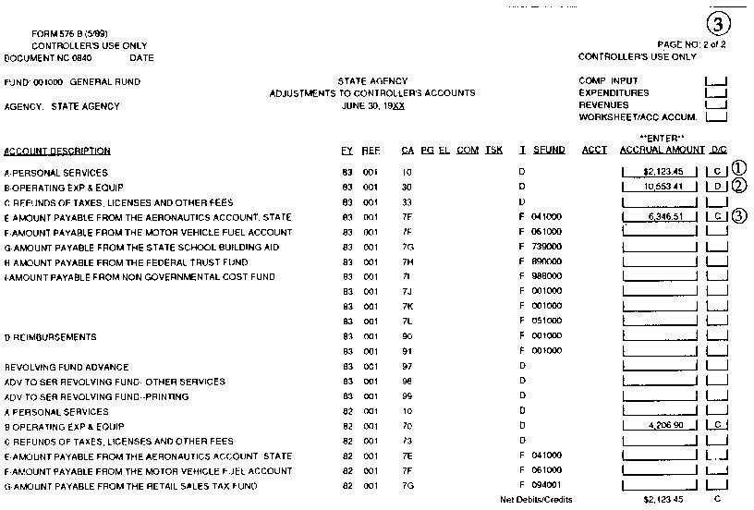

Revise Illustration 2 (Addition)
SCO USE ONLY
Document No. | C C Y Y M M D D | Fund | Agency
B

REPORT NO. 3 Form 576 B (Rev. 4/17) |  |  |  |  |  |  |  |  | Adjustments to Controller's Accounts
 |  |  |  |  |  |  |  |  |  |  |  |  |  |  | June 30, 20XX
 |  |  |  |  |  |  |  |  |  |  |  |  |  |  |  | Page 2 of 2
ORIGINAL - State Controller's Office, State Accounting and Reporting Division

Agency Name and Number | Fund Name and Number
Agency (5555) |  | General Fund (0001)
Name of Contact Person, Title | Telephone Number | Email Address
Jane Smith, Accounting Administrator | (916)444-5555 | Jsmith@Agency.ca.gov

APPROPRIATION AND REVENUE ACCOUNT TITLES | FY | M | REF/ ITEM | CAT | PGM | ELE | COMP | TASK | T | SOURCE FUND | B | S  C O | REVENUE/ OBJECT | AMOUNT | D C
Clearing Account | XXXX |  | 001 |  | 99 |  |  |  | D |  |  |  |  | 768,931.73 | C
Net Debits/Credits |  |  |  |  |  |  |  |  |  |  |  |  |  | 768,931.73 | C

Delete Illustration 3
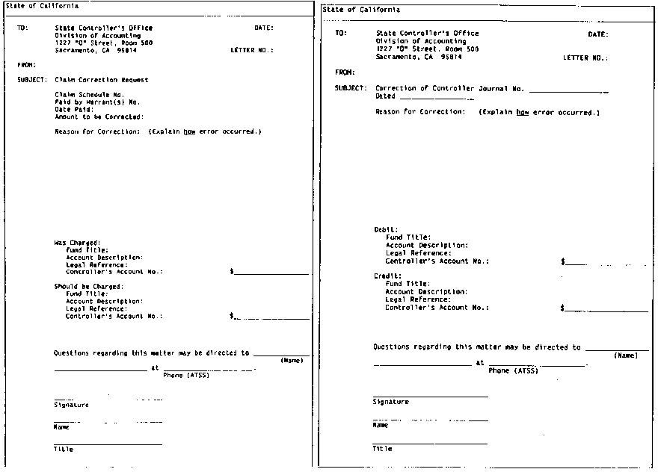

SAM – OFFICE REVOLVING FUNDS
RECOVERY OF OUTSTANDING TRAVEL ADVANCES 8116.1
(Revised 0612/20112020)
Departments must adhere to the provisions of Government Code section 19838 and SAM section 8776.7 regarding notification and collection of overpayments from employees. In addition, the following procedures which are specific to the collection of travel advances will be followed:
- A monthly notification must be sent to request employees who have travel advances but have not submitted a TEC to substantiate the travel expenses and/or have not returned any excess travel advance amount. An example of a memorandum is shown in 8116.1 Illustration.

- If an employee does not submit a TEC to substantiate the travel expenses within 15 calendar days of the monthly notification date, the total amount of outstanding advances must be deducted from the employee’s next regular payroll warrant(s).

- If an employee does submit a TEC within 15 calendar days of the notification date, but does not return any excess travel advance amount within the same 15 calendar days, the excess travel advance amount must be deducted from the employee’s next regular payroll warrant(s).

- If the amount of the revolving fund check paid to the employee exceeds the amount of the State Controller’s reimbursement (due to claim correction by SCO), the employee must reimburse the revolving fund for the difference. The amount owed to the revolving fund must be returned no later than 15 calendar days of the notification date. If the employee does not clear the outstanding amount, it must be deducted from the employee’s next regular payroll warrant(s).

- If an employee has payroll direct deposit, the notification must inform the employee that if the excess travel amount was not returned within the 15 calendar days of the notification, the direct deposit will be cancelled and the payroll deduction for the outstanding travel advance amount will be made in the next regular payroll warrant(s).

(Continued)

Rev. 416
SAM – OFFICE REVOLVING FUNDS

(Continued)
RECOVERY OF OUTSTANDING TRAVEL ADVANCES 8116.1 (Cont.1)
(Revised 12/201106/2020)

An example of “deducted from the next regular payroll warrant” for items (2) and (3) above is as follows:

02/01/11 Travel advance is issued to the employee 02/10/11 Travel date of employee
02/17/11 End date of employee travel
02/27/11 TEC should be submitted and/or return excess travel advance Actions for non-compliance:
02/27/11 Employee does not submit a TEC or return the travel advance 03/01/11 Employee is sent a monthly notification to request him/her to submit a
TEC or return the travel advance by 03/15/11. (The 1st of the month is the department’s established mail out date for the monthly notification)
03/16/11 Employee does not submit a TEC or return the travel advance. (This is 15 calendar days from the notification date). Outstanding advance amount will be deducted from the employee’s current regular payroll warrant

Note: For an employee who has direct deposit, the department accounting or personnel office must send a notification to SCO by the 15th of the month to cancel the direct deposit.

SAM – OFFICE REVOLVING FUNDS

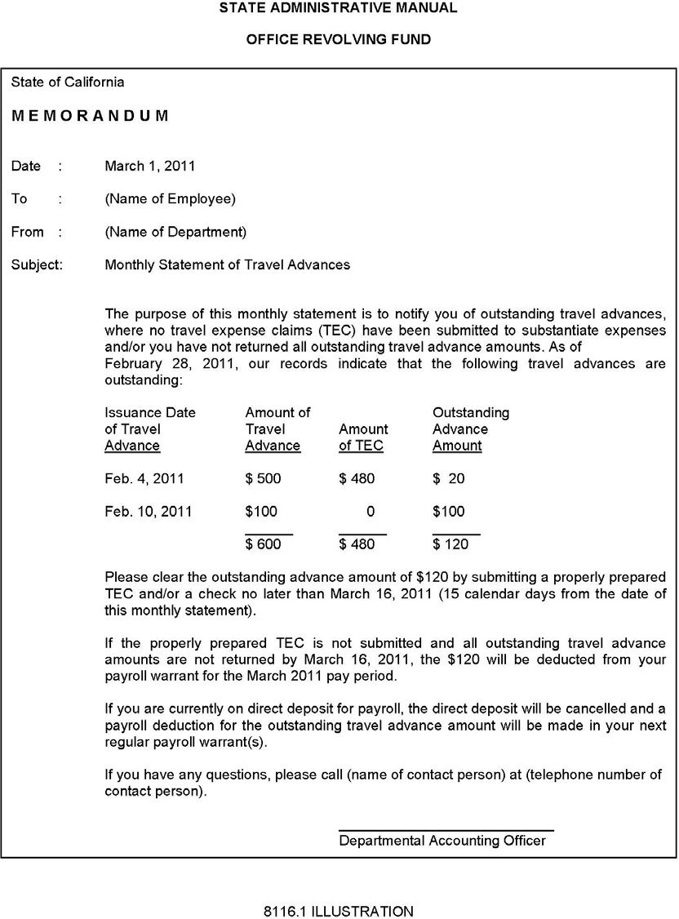

INTRODUCTION 8400
(Rev. 03/2013Deleted 06/2020)

The term disbursement is the payment process for payroll, purchases, and other expenditures. The State Controller prepares (1) Controller's Warrants and (2) Controller's Transfers for payment of State expenditures (see SAM section 8400.1 Illustration). Controller's Warrants are treated like bank checks. Governmental Accounting, Auditing and Financial Reporting defines a warrant as "an order drawn by the legislative body or an officer of a government upon its treasurer directing the latter to pay a specific amount to the person named or to the bearer." Claim schedules, with invoices attached, support the warrants. Departments file claims with the State Controller’s Office (SCO) for payment of purchases and other expenditures. The directions for processing specific claims are shown in the references below.

References Types of Invoices

8422.101 Freight and Transportation

8422.102 Gasoline and Oil

8422.103 Purchases by Sub-Purchase Orders

8422.104 Contractual Services

8422.105 Blue Printing and Other Reproduction

8422.106 Telephone

8422.108 Revolving Fund

8422.113 Training

8422.114 Airline

8422.115 Automobile Rental

(Continued)

(Continued)
INTRODUCTION 8400 (Cont. 1) (Rev. 03/2013)

Controller's payroll warrants are supported by the Payroll Warrant Register. The SCO disburses payroll warrants from the State Payroll Revolving Fund after transfer has been made from the department’s fund(s).

Controller's Transfers authorize an increase or decrease of cash between funds or appropriations without a warrant. The SCO will settle "No Warrant" claims by (1) a Controller's Journal Entry reducing the department's advance at the service department or (2) a Controller's Transfer transferring the money if no advance was made at the service department. (See SAM section 8400.1 Illustration.)

Other sections of SAM that relate to the disbursements section are provided below:

Sections Chapters

  - Contracts 1200

  - Publishing/Printing 2800

  - Purchases 3500

  - Transportation Management 3800

  - Transportation Services 4100

6. Telecommunications 4500

7. California Technology Agency 4800

8. Introduction to Uniform System of 7000
Accounting

9. Structure of General Ledger Accounts 7600

10. Checks 8041

11. Office Revolving Funds 8100

12. Fiscal Affairs - Allotment-Expenditure 8300
Accounting

13. Payrolls 8500

14. Standard Entries 10500

GENERAL 8400.1
(Revised 10/2018Deleted 06/2020)
Rules and Regulations of the California Victim Compensation Board prescribe the method of filing claims for disbursement of moneys from the State Treasury. This section is confined to procedures relating to the preparation and accounting of such claims.
State disbursements normally consist of: (1) expenditures, (2) refunds to payers, (3) advances for office revolving funds, (4) purchases of investments, (5) transfers between funds for nonexpenditure purposes, and (6) withdrawals of trust deposits. The following illustration shows the normal flow for the authorization, incurrence, and payment of State expenditures.

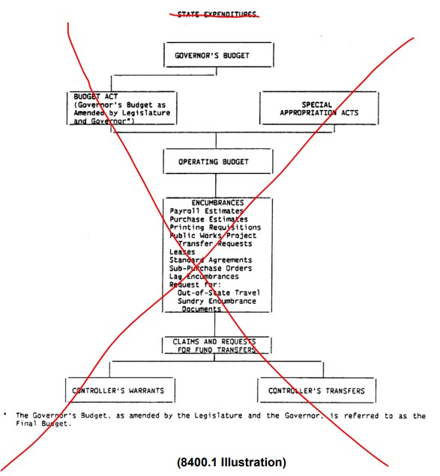
RS 6/24/2020

FEDERAL INDIRECT COST RATE RECOVERIES 8755.2
(Revised 1006/20162020)
For state departments that receive federal funds, Government Code section 13332.01 and 13332.02 require the recovery of SWCAP costs from the federal government and to transfer the SWCAP recoveries to the General Fund (GF). In accordance with SAM section 8755.1, these transfers are due within 30 days after the end of each quarter. In order to meet this objective and substantiate recovery amounts, departments must first prepare an Indirect Cost Rate Proposal, a Cost Allocation Plan, or Public Assistance Cost Allocation Plan as prescribed in SAM section 8756 and 8756.1.
To transfer SWCAP recoveries, departments are required to complete a Transaction Request (TR), form CA 504 and send it to the State Controller’s Office (SCO) for processing. The TR must include the quarterly SWCAP amount by fiscal year to be transferred and a brief explanation in the legal authority and reason for request section. The Illustration below includes a Sample TR showing how to transfer recoveries from the Federal Trust Fund to the GF.
8755.2 Illustration (Sample TR, CA 504)

Rev. 427

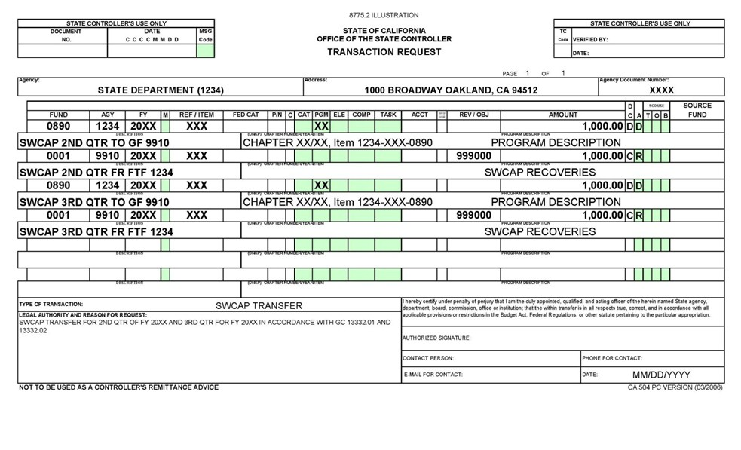
8755.2 Illustration

Rev. 427

NON-FEDERAL INDIRECT COST RECOVERIES 8756.2
(Revised 306/902020)
Departments which receive reimbursements from other than Federal funding sources will also ensure that full costs are included in charges for goods provided and services performed. The basic principles and cost elements included are the same as for Federal ICRPs (see SAM Section 8756.1) with one exception; non-Federal cost recoveries will include the larger of the department's central service costs, SWCAP or Pro Rata. See 8756.1 Illustration 1below for a sample indirect cost calculation.

Rev. 411

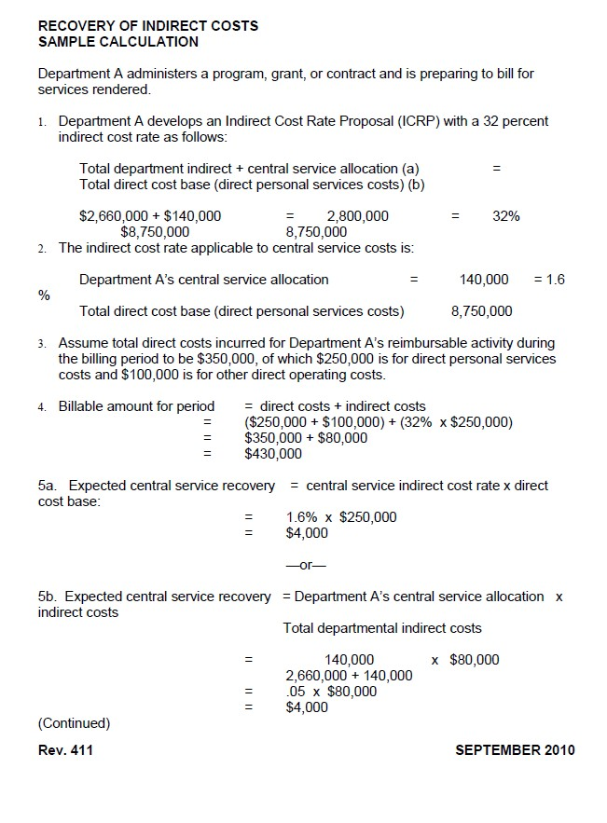

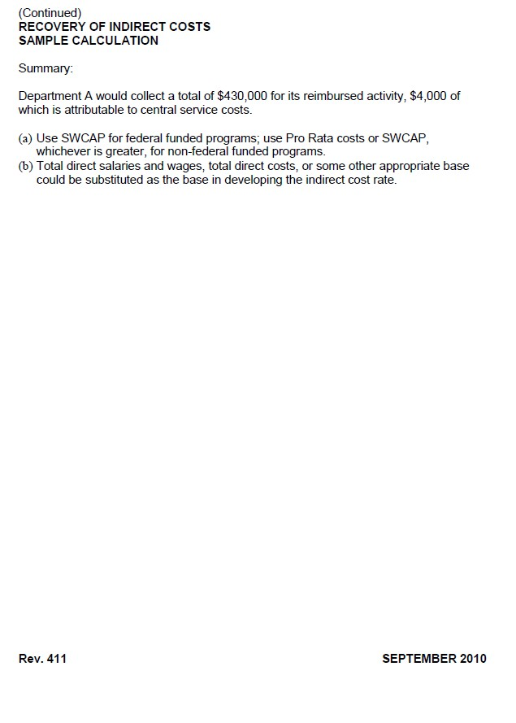

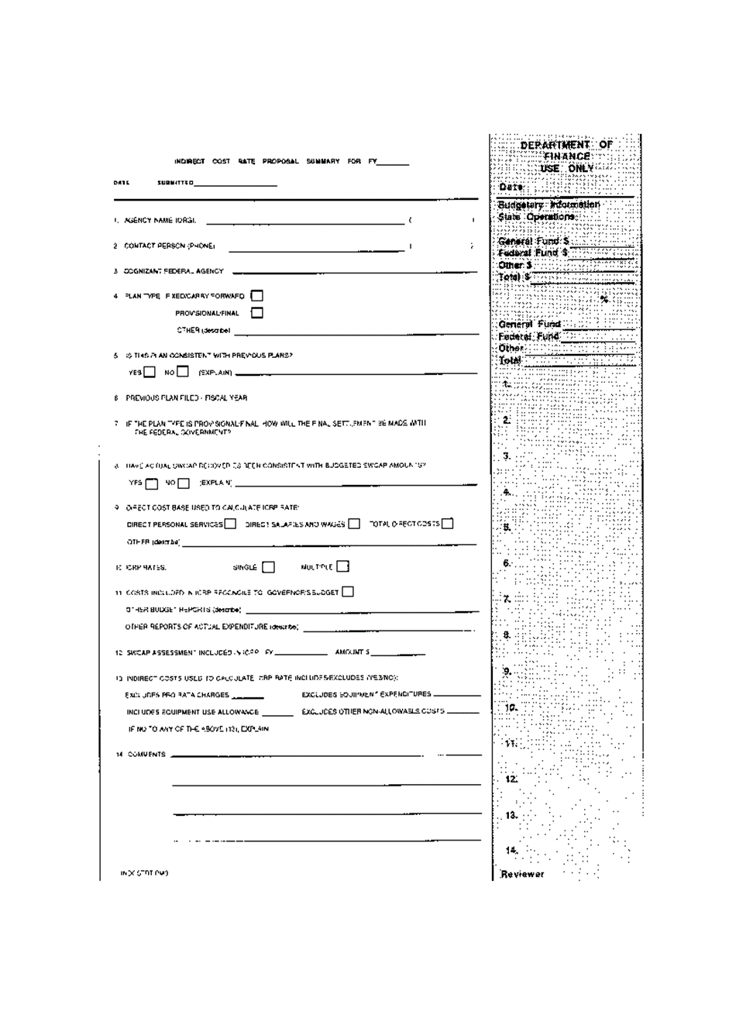

Rev. 411

RECOVERY OF INDIRECT COSTS SAMPLE CALCULATION

Department A administers a program, grant, or contract and is preparting to bill for services rendered.

- Department A develops an Indirect Cost Rate Proposal (ICRP) with a 32 percent indirect cost rate as follows:

Total department indirect (a) = $2,660,000 Central service allocation (b) = $140,000
Total direct cost base (direct personal services costs) (c) = $8,750,000

ICRP = (a+b)/c = ($2,660,000 + $140,000 / $8,750,000
= $2,800,000 / $8,750,000 = 32%

- The indirect cost rate applicable to central service costs is:

Central service allocation (a) / Total direct cost base (direct personal services cost (c)

= $140,000 / $8,750,000 = 1.6%

- Assume total direct costs incurred for Department A’s reimbursable activity during the billing period to be $350,000, of which $250,000 is for direct personal services costs and
$100,000 is for other direct operating costs.

- Billable amount for period = direct costs + indirect costs
= ($250,000 + $100,000) + (32% x $250,000)
= $350,000 + $80,000
= $430,000

5a. Expected central service recovery = central service indirect cost rate x direct
cost base:
= 1.6% x $250,000
= $4,000

-or-

5b. Expected central service recovery = (Department A’s central service allocation / Total
department direct cost) x Indirect costs

= {$140,000/($2,660,000 + $140,000)} x $80,000
= ($140,000 / $2,800,000) x $80,000
= 0.05 x $80,000
= $4,000
(Continued)

SAM – MISCELLANEOUS ACCOUNTING PROCEDURES

(Continued)
RECOVERY OF INDIRECT COSTS SAMPLE CALCULATION

Summary:

Department A would collect a total of $430,000 for its reimbursement activity, $4,000 of which is attributable to central service costs.

- Use SWCAP for federal funded programs; use Pro Rata costs or SWCAP, whichever is greater, for non-federal funded programs
- Total direct salaries and wages, total direct costs, or some other appropriate base could be substituted as the base in developing the indirect cost rate.

ENTRY NO. 7 – [GENERAL CASH IS RECEIVED] 10507
(Revised 06/20162020)

This entry is made to record general cash received for deposit in the department’s general checking account maintained with the State Treasurer’s Office.

Information:
Receipts consist of abatements, reimbursements and revenue not previously billed; collections applicable to accounts receivable for items previously billed; and items whose identity or accounting cannot readily be determined.

Accounts Receivable—Revenue and Accounts Receivable—Other are deferred when recorded. They must, therefore, be applied as revenue when collected.

Reimbursements may be of one of the following categories depending upon specific laws governing the accounting of such transactions: (1) receipts which accrue to the year in which the transaction occurred, (2) receipts which accrue to the year in which cash is collected by the department, and (3) receipts which accrue to the year in which cash is ordered into the treasury. Transactions in the third category, when collected are credited to a suspense account (Uncleared Collections) pending receipt of notice from the State Controller's Office that cash has been ordered into the treasury, see SAM section 10510. Items in category 1 (if not billed or accrued previously) and in category 2 are applied at the time cash is collected by the department.

The recording of cash receipts deposited in the general cash account is shown in Illustration 10507. The General Cash Receipts Register will show both the date of receipt and the date of deposit of all cash receipts. All cash collections must be deposited in approved depositories, see SAM section 8031, and are later either (1) refunded if determined to be unacceptable or
(2) remitted to the State Treasury at least once each month. Current collections are used also to satisfy bank demands for reimbursement for dishonored checks until ultimate collection is made from the drawers or relief from accountability is granted.

Source Document:
General Cash Receipt

Register:
General Cash Receipts Register (Continued)

Journal Entry for General Cash Received:

Debit:
1110 General Cash a/ Credit:
1311 Accounts Receivable—Abatements b/ 1312 Accounts Receivable—Reimbursements c/ 1313 Accounts Receivable—Revenue d/
3110 Due to Other Funds or Appropriations e/ 3410 Revenue Collected in Advance f/
3420 Reimbursements Collected in Advance g/ 3710 Cash Overages h/
3730 Uncleared Collections i/ 8000 Revenue j/
8100 Reimbursements k/
9000 Appropriation Expenditures l/
9892 Prior-Year Revenue Adjustments m/ 9893 Prior-Year Appropriation Adjustments n/

a/ total cash received for deposit in the General Cash account.
b/ amount of cash receipts applicable to expenditure abatements receivables (excluding collections from employees for salary overpayments).
c/ amount of cash receipts applicable to reimbursement receivables. d/ amount of cash receipts applicable to revenue receivables.
e/ amount of cash received applicable to revenue collected for other funds earned in the current fiscal year plus cash received applicable to revenue collected for other funds but not identifiable to the fiscal year in which it was earned.
f/ amount of cash received which will be accounted as revenue of a succeeding fiscal year. g/ amount of cash received which will be accounted as a reimbursement to a current or
subsequent fiscal year's appropriation when earned. h/ amount of cash received representing cash overages.
i/ amount of cash received for items whose identity or accounting cannot be readily determined; amount of cash received applicable to reimbursements (billed or unbilled) which, according to law, can be applied only at the time the cash is ordered into the treasury; or salary overpayments collected from employees by the department.
j/ amount of cash received applicable to revenue earned in the current fiscal year plus cash received applicable to revenue but not identifiable to the fiscal year in which it was earned.
k/ amount of cash received applicable to (1) billed reimbursements which, according to law, can be applied only at the time cash is received and (2) all unbilled reimbursements except those applicable to prior fiscal years and those that can be applied only at the time cash is ordered into the treasury.
l/ amount of cash receipts applicable to current year expenditure abatements not billed or accrued previously.

(Continued)

m/ amount of cash received applicable to revenue (except reimbursements) which was identified as being earned as of the preceding June 30.
n/ amount of cash received in excess of amounts accrued in prior fiscal years as expenditure abatements or reimbursements. If the amount of cash received is less than amounts accrued in prior fiscal years, Account No. 9893 will be debited.

Journal Entry for General Cash Received for Deferred Receivables: The Deferred Receivables entry requires a corresponding entry to record the General Cash received for revenue, reimbursement, or appropriation expenditure.

Debit:
1600 Provision for Deferred Receivables o/ Credit:
1315 Accounts Receivable—Dishonored Checks p/ 1319 Accounts Receivable—Other q/

AND
Debit:
1110 General Cash
Credit:
8000 Revenue
8100 Reimbursements
9000 Appropriation Expenditures

o/ amount of cash received applicable to receivables accounted during the year on a fully- reserved basis and applied when collected to the appropriate revenue account.
p/ amount of cash received in payment of dishonored checks (unless alternate procedure is used).
q/ amount of cash received in payment of other accounts receivable.

Journal Entry for General Cash Lost/Received for Cash Shortages: The Cash Shortages entry requires a corresponding entry to record the General Cash lost or received for revenue, reimbursement, or appropriation expenditure.

(Continued)

(Continued)
ENTRY NO. 7 – [GENERAL CASH IS RECEIVED] 10507 (Cont.3)
(Revised 06/20162020)

General Cash Lost
Debit:
1316 Accounts Receivable—Cash Shortages r/ Credit:
1600 Provision for Deferred Receivables s/

AND
Debit:
8000 Revenue
8100 Reimbursements
9000 Appropriation Expenditures Credit:
1110 General Cash

General Cash Received
Debit:
1600 Provision for Deferred Receivables s/ Credit:
1316 Accounts Receivable—Cash Shortages t/

AND
Debit:
1110 General Cash Credit:
8000 Revenue
8100 Reimbursements
9000 Appropriation Expenditures

r/ amount of cash shortages occurring during the month for which cashiers are held accountable.
s/ amount of cash received applicable to receivables accounted during the year on a fully- reserved basis and applied when collected to the appropriate revenue account.
t/ amount of cash received from cashiers in payment of cash shortages. (Continued)

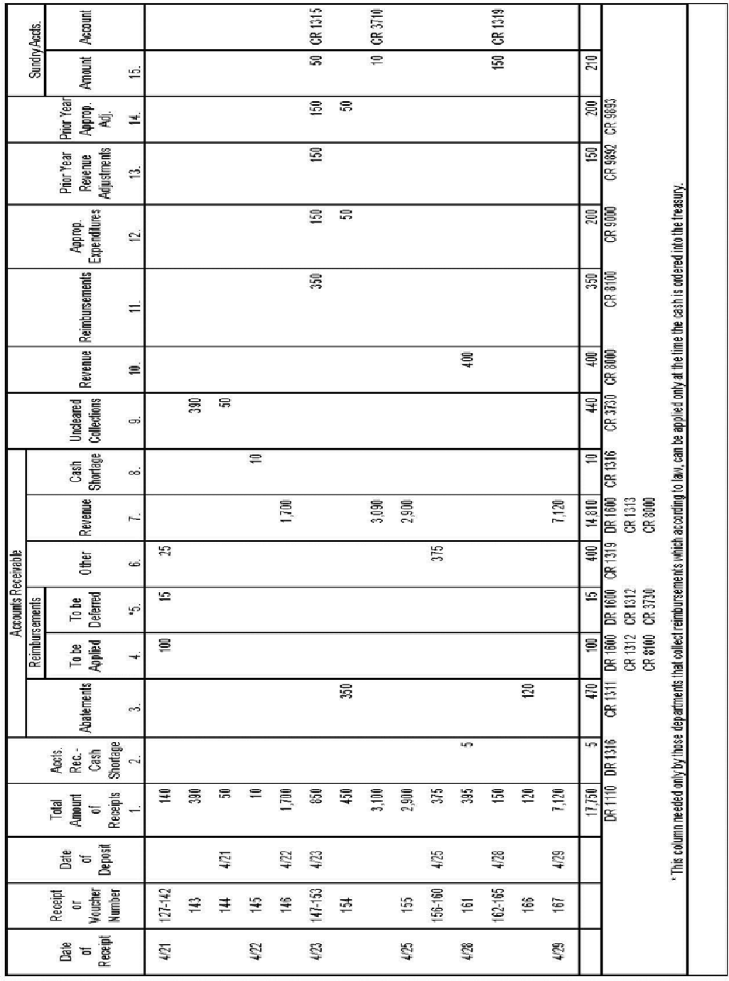

ENTRY NO. 8 – [UNIDENTIFIED CASH RECEIPTS ARE APPLIED] 10508
(Revised 10/201506/2020)

This entry is made to record cash receipts which could not be identified, or for which accounting treatment could not be determined, at time of collection are applied to appropriate accounts.

Information:
Varying circumstances determine the clearance of each transaction, but as each item or group of items is cleared it is entered in the Clearance Register and applied to appropriate accounts.

Uncleared collections (other than those applied through the Controller's Receipts Register in Entry No. 12) and cash overages are applied. Cash overages items should be cleared as revenue at least once each quarter.

Source Documents:
Licenses, permits, or other documents evidencing revenue, reimbursements, and abatements earned.

Register:
Clearance Register

Journal Entry for Uncleared Collections being applied: The reversal of an uncleared collections entry requires a corresponding entry to record the cash receipt to the appropriate account.

Debit:
3730 Uncleared Collections a/ Credit:
1311 Accounts Receivable—Abatements b/ 1312 Accounts Receivable—Reimbursements c/ 1313 Accounts Receivable—Revenue d/
3110 Due to Other Funds or Appropriations e/ 3410 Revenue Collected in Advance f/
3420 Reimbursements Collected in Advance g/ 8000 Revenue h/
8100 Reimbursements i/
9000 Appropriation Expenditures j/
9892 Prior-Year Revenue Adjustments k/ 9893 Prior-Year Appropriation Adjustments l/

a/ amount of cash receipts accounted previously as uncleared collections, now applied to appropriate accounts.
b/ amount of collections now applied to expenditure abatement receivables (excluding collections from employees for salary overpayments).
c/ amount of collections now applied to reimbursement receivables. d/ amount of collections now applied to revenue receivables.

(Continued)

e/ amount of collections now applied as revenue collected for other funds earned in the current fiscal year plus collections now applied as revenue collected for other funds but not identifiable to the fiscal year in which they were earned.
f/ amount of collections now applied to revenue of the succeeding fiscal year.
g/ amount of collections now applied as a reimbursement to a current or subsequent fiscal year's appropriation.
h/ amount of collections now applied as revenue earned in the current fiscal year plus collections now applied as revenue but not identifiable to the fiscal year in which they were earned.
i/ amount of collections now applied as current year reimbursements that were not billed previously or were deferred when billed because, according to law, they are to be applied to the year in which they are collected by the agency.
j/ amount of collections now applied as abatements to current year appropriation expenditures.
k/ amount of collections now applied to revenue (except reimbursements) which was identified as being earned as of the preceding June 30.
l/ amount of collections now applied in excess of amounts accrued in prior fiscal years as expenditure abatements or reimbursements. If the amount of cash cleared is less than amounts accrued in prior fiscal years, Account No. 9893 will be debited.

Journal Entry for Cash Overages being applied:

Debit:
3710 Cash Overages m/
Credit:
8000 Revenue n/

m/ amount of cash accounted previously as cash overages, now applied as revenue, less any amounts cleared from the uncleared collections account to the cash overages account.
n/ amount of collections now applied as revenue earned in the current fiscal year plus collections now applied as revenue but not identifiable to the fiscal year in which they were earned.

(Continued)

Journal Entry for Deferred Receivables being applied: If cash received above was for a Deferred Receivable the below entry will need to be done.

Debit:
1600 Provision for Deferred Receivable o/ Credit:
1315 Accounts Receivable—Dishonored Checks p/ 1316 Accounts Receivable—Cash Shortages q/ 1319 Accounts Receivable—Other r/

AND
Debit:
1110 General Cash Credit:
8000 Revenue
8100 Reimbursements
9000 Appropriation Expenditures

o/ amount of collections now applied to receivables accounted during the year on a fully-reserved basis and applied when collected to the appropriate revenue account.
p/ amount of collections now applied in payment of dishonored checks. q/ amount of collections now applied in payment of cash shortages.
r/ amount of collections now applied to other accounts receivable.

(Continued)

