Ascent Environmental Logo

Final Environmental Impact Report

Gregory Bateson  
Building Renovation ProjectSCH#2019039119

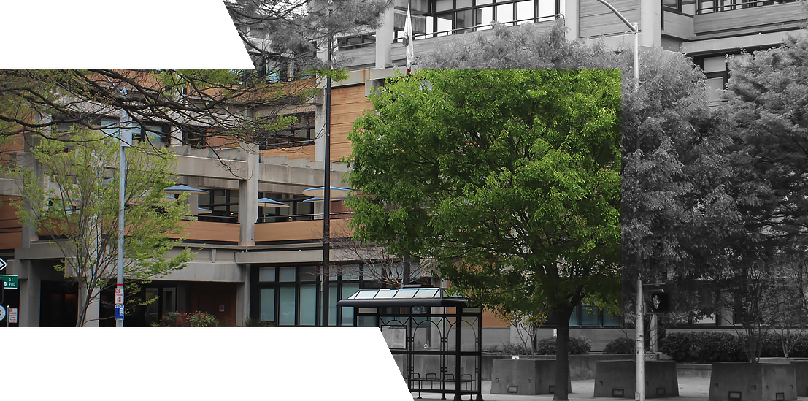

Prepared for:



California Department of General Services

707 3rd Street, MS-509

West Sacramento, CA 95605

October 1, 2019

Final Environmental Impact Report

Gregory Bateson  
Building Renovation Project

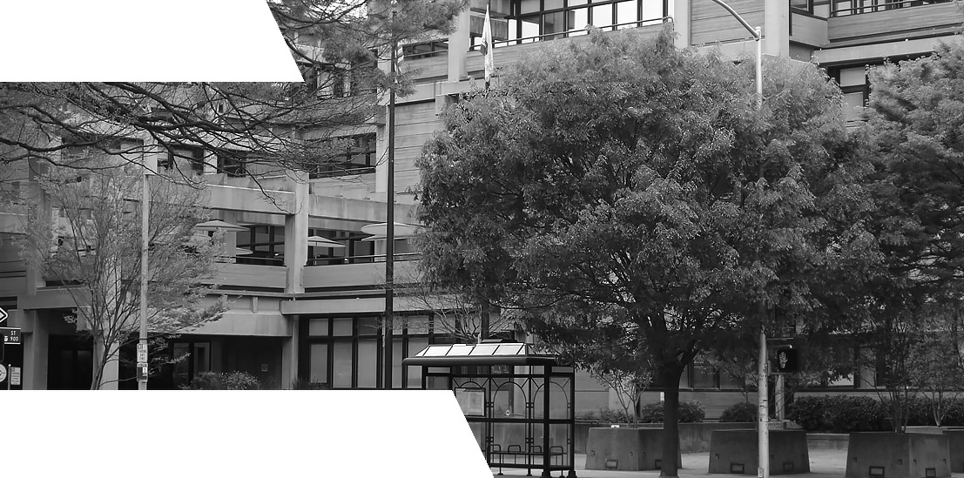

SCH#2019039119

Prepared for:

California Department of General Services

707 3rd Street, MS-509

West Sacramento, CA 95605

Contact:

Jennifer Parson

Senior Environmental Planner

Prepared by:

Ascent Environmental, Inc.  
455 Capitol Mall, Suite 300  
Sacramento, CA 95814

Contact:

Suzanne Enslow  
Project Manager

18010127.01 October 1, 2019

Table of Contents

**Section Page**

LIST OF ABBREVIATIONS ii

1 introduction 1-1

1.1 Overview 1-1

1.2 Summary Description of the Project 1-1

1.3 Major Conclusions of the Environmental Analysis 1-3

2 Responses to Comments 2-1

2.1 List of Commenters on the Draft EIR 2-1

2.2 Comments and Responses 2-1

2.3 Agencies 2-1

3 Revisions to the Draft EIR 3-1

3.1 Project Modifications 3-1

3.2 Revisions to the Draft EIR 3-1

4 References 4-1

5 Report Preparers 5-3

Figures

Figure 1-1 Site Location 1-2

# Tables

Table 2-1 List of Commenters 2-1

# LIST OF ABBREVIATIONS

BMP Best Management Practices

CAP Capitol Area Plan

CEQA California Environmental Quality Act

DGS California Department of General Services

Draft EIR draft environmental impact report

Final EIR final environmental impact report

HVAC heating, ventilation, and air conditioning

LEED Leadership in Energy and Environmental Design

SF square feet

# introduction

## Overview

On July 16, 2019, the State of California Department of General Services (DGS) distributed to public agencies and the general public a draft environmental impact report (Draft EIR) prepared pursuant to the California Environmental Quality Act (CEQA) for the Gregory Bateson Building Renovation Project in downtown Sacramento, California. The building would be renovated to ensure the safety and comfort of the tenants, and to avoid falling into an irreversible state of disrepair.

The Draft EIR was made available for a period of 45-days during which public and agency comments were received. The public review period ended on August 30, 2019. Four comment letters were received on the document. No comments were received during the August 21, 2019 public hearing, hosted by DGS.

This final environmental impact report (Final EIR) has been prepared under the direction of DGS in accordance with the requirements of CEQA and the State CEQA Guidelines (CCR Section 15132). The Final EIR consists of the Draft EIR and this document (response to comments document), which includes comments received on the Draft EIR, responses to those comments, and revisions to the Draft EIR.

This document responds to the comments received on the Draft EIR and has been prepared in accordance with Sections 15089 and 15132 of the State CEQA Guidelines. It is divided into five chapters:

Chapter 1, “Introduction,” provides an overview of the environmental review process and a summary of the proposed Gregory Bateson Building Renovation Project.

Chapter 2, “Responses to Comments,” reproduces public comments received on the Draft EIR and presents responses to those comments.

Chapter 3, “Revisions to the Draft EIR,” identifies changes made to the Draft EIR since its publication and public review. The changes are presented in the order in which they appear in the original Draft EIR and are identified by the Draft EIR page number. The text deletions are shown in ~~strikethrough~~ and text additions are shown in underline.

Chapter 4, “References,” lists references cited in this document.

Chapter 5, “List of Preparers,” identifies the preparers of the document.

## Summary Description of the Project

### Project Location

The Gregory Bateson Building is located at 1600 9th Street in downtown Sacramento, California (Figure 1-1). The four-story building occupies a full city block (approximately 2.5 acres) owned by the State of California, bounded by 9th Street, P Street, 8th Street, and Q Street, across the street from Roosevelt Park, near the California State Capitol. The gross building area is approximately 293,600 square feet (SF). The net tenant usable area is approximately 214,600 SF.

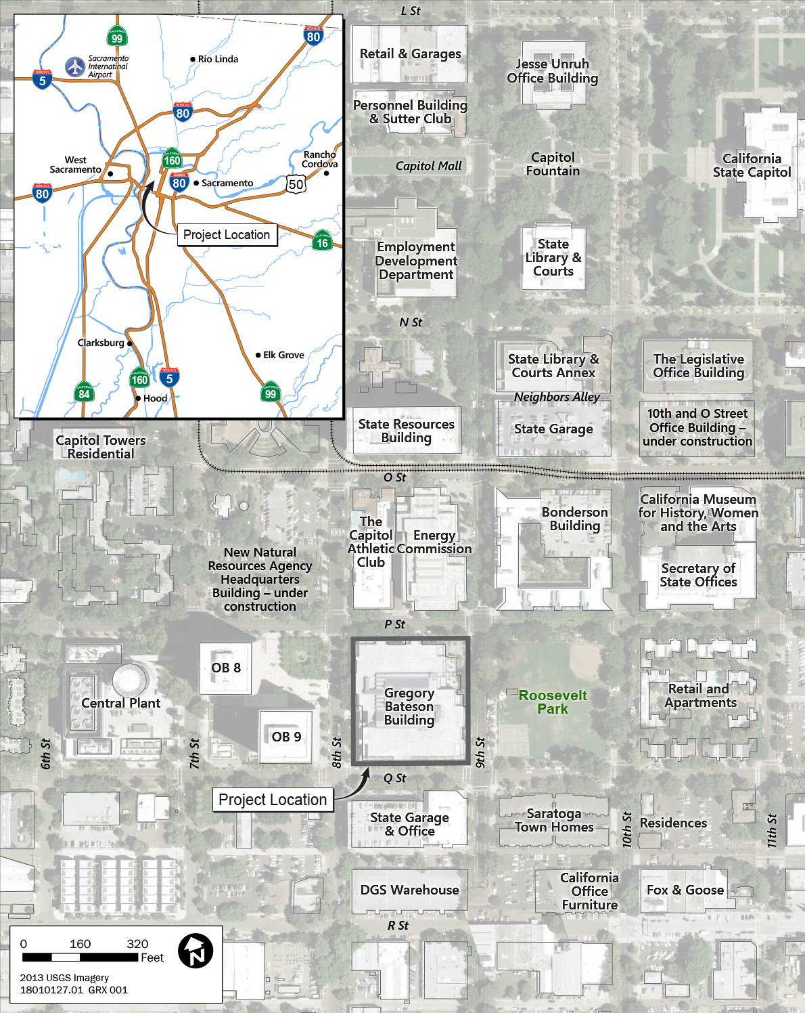

Source: Data compiled by Ascent Environmental in 2019

Figure 1-1 Site Location

### Synopsis of Project Characteristics

The following is a synopsis of the project characteristics. For further information on the proposed project, see Chapter 3, “Project Description,” of the Draft EIR. The DGS Real Estate Services Division is responsible for the planning, permitting, and implementation of the Gregory Bateson Building Renovation Project, which would be funded by the State of California (State) through the State Projects Infrastructure Fund, as administered by DGS. The building is within the Capitol Area, subject to the 1997 Capitol Area Plan (CAP), and is designated as “Office” (DGS 1997). The building, designed in the 1970s and dedicated in 1981, is historically significant due to its innovative design elements, which at the time were considered to be cutting edge for architectural design and energy efficiency.

An infrastructure study, completed by DGS 2008, as well as a facility condition assessment completed by DGS in 2015, identified a variety fire and life safety, building code, hazardous materials, and other infrastructure deficiencies. The proposed renovation project would address building-wide deficiencies, including: fire and life safety improvements; hazardous materials removal; water intrusion repairs and prevention; detailing of exterior facades and their components; updates and repairs for disabled accessibility compliance; applicable reinstatement of energy systems and enhancements; installation of modern heating, ventilation, and air conditioning (HVAC) and lighting controls; addition of security systems; and improvement of interior spaces (e.g., replacement of finishes) that are at the end of their useful life. The building renovation is needed to ensure the safety and comfort of the tenants, and to avoid falling into an irreversible state of disrepair. Because of the building’s historic designation, the proposed renovations would be designed to address the building’s historic character, as well as correct the critical fire and life safety issues and other code deficiencies. The project goal is to achieve Zero Net Energy and Leadership in Energy and Environmental Design (LEED) v4 Silver certification.

## Major Conclusions of the Environmental Analysis

The Draft EIR evaluated the potential for the Gregory Bateson Building Renovation Project to result in physical environmental effects related to Archaeological, Historic, and Tribal Cultural Resources; Transportation and Circulation; Utilities and Infrastructure; Air Quality; Greenhouse Gas Emissions and Climate Change; Energy; Noise; Hazards and Hazardous Materials; and Biological Resources. As summarized in Table 2-1 of the Draft EIR, the project’s impacts were determined to be less than significant for all resources except Archaeological, Historic, and Tribal Cultural Resources and Biological Resources; however, Mitigation Measures 4.3-1 through 4.3-4 and 4.11-1 through 4.11-3 reduce the project’s impacts on these resources to less-than-significant levels. The project would not result in any significant and unavoidable adverse impacts (i.e., impacts that cannot be reduced to less than significant levels with feasible mitigation).

This page intentionally left blank.

# Responses to Comments

This chapter contains comment letters received during the public review period for the Draft EIR, which concluded on August 30, 2019. No comments were received during the August 21, 2019 public hearing. In conformance with Section 15088(a) of the State CEQA Guidelines, written responses have been prepared addressing comments on environmental issues received from reviewers of the Draft EIR.

## List of Commenters on the Draft EIR

Table 2-1 presents the list of commenters, including a numerical designation for each comment letter received (A1, A2, A3, etc.), the author of the comment letter, and the date of the comment letter.

Table 2-1 List of Commenters

| Letter No. | Commenter / AGENCIES | Date |
| --- | --- | --- |
| A1 | Uzma Rehman, Transportation Planner  California Department of Transportation (Caltrans), District 3 | July 19, 2019 |
| A2 | Brianna Moland, Assistant Planner, Park Planning and Development Services  Department of Youth, Parks, and Community Enrichment  City of Sacramento | August 12, 2019 |
| A3 | Lorenzo Hernandez, Assistant Civil Engineer  City of Sacramento, Utilities Department | August 19, 2019 |
| A4 | Nicole Goi, Regional and Local Government Affairs  Sacramento Municipal Utility District (SMUD) | August 29, 2019 |
| A5 | Scott Morgan, Director  State of California Governor’s Office of Planning and Research, State Clearinghouse and Planning Unit (SCH) | August 30, 2019 |

## Comments and Responses

The written comments received on the Draft EIR and the responses to those comments are provided below. Each individual comment within the letters (Comment A1-1, Comment A1-2, etc.) is reproduced in its entirety and is followed by the response (Response A1-1, Response A1-2, etc.).

## Agencies

Letter A1 **California Department of Transportation, District 3**

Uzma Rehman, Transportation Planner

Planning, Local Assistance, and Sustainability

July 19, 2019

Comment A1-1

Thank you for submitting the Gregory Bateson Building Renovation Project for review. We don’t have any comments at this time.

Let us know if anything changes.

Response A1-1

DGS appreciates Caltrans’ review. Caltrans will be informed of future actions related to the CEQA process for the Gregory Bateson Building Renovation Project and DGS will coordinate with Caltrans staff as necessary through the project construction process.

Letter A2 **City of Sacramento, Parks Department**

Brianna Moland, Assistant Planner, Park Planning and Development Services

Department of Youth, Parks, and Community Enrichment

August 12, 2019

Comment A2-1

I work for the City’s Parks department and have a few minor comments. We noted that Roosevelt Park is considered a noise‐sensitive receptor under this DEIR. We will alert park programs that are scheduled during project demolition and construction.

There would be minor inconveniences due to traffic control measures around the park, and views from the park would probably be impacted during the demolition and construction phase. We noted that there would be no off‐site staging at Roosevelt Park.

Please let me know if there are any questions for the Park Planning and Development Services Division on this project.

Response A2-1

DGS appreciates review by City Parks Planning and Development Services and for alerting the programs at Roosevelt Park of the potential for construction activities at the neighboring Gregory Bateson Building. As noted, and as described in Section 3.4.6 of the Project Description in the Draft EIR, that there would be no offsite construction staging for this project. In addition, as noted by the comment and as explained in Section 3.4.5 of the Draft EIR, there may be restriction or redirection of pedestrian, bicycle, and vehicular movements around the Gregory Bateson Building during construction to accommodate construction activities; such restrictions would include fencing off the sidewalks around the building but would not require extended vehicular lane closures. Material deliveries and haul trips would require temporary truck parking next to the building, using existing street parking. However, vehicular, pedestrian, and bicycle access to surrounding land uses, including Roosevelt Park, would be maintained at all times.

Letter A3 **City of Sacramento, Utilities Department**

Lorenzo Hernandez, Assistant Civil Engineer

August 19, 2019

Comment A3-1

**Draft EIR page 2-11, Table 2-1, Impact 4.5-1: New or Expanded Utility Infrastructure**

The Gregory Bateson Building Renovation Project would include new irrigation and water supply infrastructure at the project site.

On Section 3.4.1, Table 3-1, a new fire water connection is being proposed, but is not included in here, please add it here too.

Response A3-1

The text of Impact 4.5-1: New or Expanded Utility Infrastructure is hereby revised as follows:

The Gregory Bateson Building Renovation Project would include a new fire-water connection, new irrigation, and water supply infrastructure at the project site. Trenching to install the pipeline connection between the building and the main would occur incompliance with Best Management Practices (BMPs) set forth in the Stormwater Quality Design Manual for the Sacramento Region. No additional new or expanded infrastructure beyond those already identified for the project would be required. This impact would be **less than significant**.

Comment A3-2

**Draft EIR page 2-12, Table 2-1, Impact 4.5-3: Impacts to Wastewater Infrastructure and Treatment Capacity**

Mitigation Measures: No mitigation is required for this impact.

See comment on Section 4.5.

Response A3-2

Please see Response A3-5, below.

Comment A3-3

**Draft EIR page 4.5-13, Impact 4.5-1: New or Expanded Utility Infrastructure**

The Gregory Bateson Building Renovation Project would include new irrigation and water supply infrastructure at the project site.

On Section 3.4.1, Table 3-1, a new fire water connection is being proposed, but is not included in here, please add it here too.

Response A3-3

The text of Impact 4.5-1: New or Expanded Utility Infrastructure is hereby revised as follows:

The Gregory Bateson Building Renovation Project would include a new fire-water connection, new irrigation, and water supply infrastructure at the project site. Trenching to install the pipeline connection between the building and the main would occur incompliance with Best Management Practices (BMPs) set forth in the Stormwater Quality Design Manual for the Sacramento Region. No additional new or expanded infrastructure beyond those already identified for the project would be required. This impact would be **less than significant**.

Comment A3-4

**Draft EIR page 4.5-14, Impact 4.5-3: Impacts to Wastewater Infrastructure and Treatment Capacity**

Based on the potential for a 10 percent increase in occupancy at the Gregory Bateson Building (96 additional employees), water use is conservatively estimated to increase by 10 percent, resulting in an increase of approximately

Approximately What?

Response A3-4

The text of Impact 4.5-3: Impacts to Wastewater Infrastructure and Treatment Capacity is hereby revised as follows:

Based on the potential for a 10 percent increase in occupancy at the Gregory Bateson Building (96 additional employees), water use is conservatively estimated to increase by 10 percent, resulting in an increase of approximately 610 gpd, from 6,100 gpd to 6,710 gpd.

Comment A3-5

**Draft EIR page 4.5-14, Impact 4.5-3: Impacts to Wastewater Infrastructure and Treatment Capacity**

For these reasons, and because there is sufficient capacity to treat wastewater flows from the project during dry weather, implementation of the Gregory Bateson Building Renovation Project would not adversely affect the CSS wastewater conveyance or treatment capacity. The project’s impact on wastewater infrastructure would therefore be less than significant.

**Mitigation Measures**

No mitigation is required for this impact.

Projects in the CSS that will increase sewer flows to the City system are subject to a CSS development fee; or may be allowed to construct or contribute toward the construction of a project that will mitigate the impact on the CSS. Therefore, a mitigation measure for this project will be to pay the CSS Development fee.

Response A3-5

The Gregory Bateson Building is currently served with water and wastewater service. The Draft EIR analysis of water usage and wastewater generation, provided in Section 4.5, “Utilities and Infrastructure,” conservatively accounted for a 10 percent increasing in employees and associated water use. Although such an increase in employees may not occur, accounting for a minor increase ensures full evaluation of the project’s potential impacts and allows for flexibility in staffing in the building. As described in Chapter 3, “Project Description,” of the Draft EIR, the building renovation would include water efficiency measures, and would achieve LEED v4 Silver certification, resulting in decreased water use that is not accounted for in the impacts to utilities services. As presented in Impact 4.5-3, the conservative project-related increase of 10 percent increase over current conditions, approximately 610 gpd, of wastewater would result in total projected wastewater discharge form the renovated building of 6,710 gpd. There is sufficient capacity to continue to treat wastewater flows from the renovated Gregory Bateson Building during dry weather, and the minimal increase to current wastewater flows from the building would not adversely affect the CSS wastewater conveyance or treatment capacity. The project’s impact on wastewater infrastructure would therefore be less than significant. Nonetheless, DGS will continue to coordinate with the City on utility services and will work with the City to determine if there is any increase in sewer flows due to the renovated building and occupancy and whether the CSS development fee would apply.

Comment A3-6

**Draft EIR page 4.10-3, City of Sacramento Department of Utilities**

The City of Sacramento regulates the discharge of groundwater to the City’s sewer and separated drainage systems. The City’s Department of Utilities Engineering Services Resolution No. 92-439 requires approval of a Memorandum of Understanding (MOU) for long-term (greater than 30 days), and an approval letter for short term (less than 30 days), groundwater dewatering discharges to the City’s sewer and/or separated drainage system. The MOU must cover proposed dewatering details such as flow rate, system design, and contaminant monitoring plan.

Prior to any dewatering taking place, applicant or developer will be required to obtain all necessary approvals and permit from the DOU, SRCSD and CVRWQCB.

Response A3-6

DGS recognizes that permits and other approval actions would likely be necessary before implementation of construction activities, as listed in Section 1.4.3, “Required Permits and Approvals,” in the Draft EIR. DGS will coordinate with the City of Sacramento Department of Utilities, the Central Valley Regional Water Quality Control Board, and the Sacramento Regional County Sanitation District if dewatering is necessary for project construction activities.

Letter A4 **Sacramento Municipal Utility District**

Nicole Goi, Regional and Local Government Affairs

August 29, 2019

Comment A4-1

The Sacramento Municipal Utility District (SMUD) appreciates the opportunity to provide comments on the Draft Environmental Impact Report (DEIR) for the Gregory Bateson Building Renovation Project (Project, SCH 2019039119). SMUD is the primary energy provider for Sacramento County and the proposed Project area. SMUD’s vision is to empower our customers with solutions and options that increase energy efficiency, protect the environment, reduce global warming, and lower the cost to serve our region. As a Responsible Agency, SMUD aims to ensure that the proposed Project limits the potential for significant environmental effects on SMUD facilities, employees, and customers.

It is our desire that the Project DEIR will acknowledge any Project impacts related to the following:

* Overhead and or underground transmission and distribution line easements. Please view the following links on smud.org for more information regarding transmission encroachment:
* https://www.smud.org/en/Business-Solutions-and-Rebates/Design-and-Construction-Services
* https://www.smud.org/en/Corporate/Do-Business-with-SMUD/Land-Use/Transmission-Right-of-Way
* Utility line routing
* Electrical load needs/requirements
* Energy Efficiency
* Climate Change
* Cumulative impacts related to the need for increased electrical delivery
* The potential need to relocate and or remove any SMUD infrastructure that may be affected in or around the project area

Response A4-1

DGS appreciates SMUD’s review. The Gregory Bateson Building Renovation Project Draft EIR describes SMUD’s electrical service to the building in Section 3.3, and addresses impacts related to utilities in Section 4.5, impacts related to electrical demand and energy efficiency in Section 4.8, impacts related to greenhouse gas emissions and climate change in Section 4.7, and cumulative impacts related to these resources in Chapter 5. DGS will continue to coordinate with SMUD regarding electrical infrastructure throughout project design and construction.

Comment A4-2

More specifically, SMUD would like to have the following details related to the electrical infrastructure incorporated into the project description:

* The description of SMUD’s system on page 4.5-10 is incorrect. Service to this particular building is from Station B, located at 19th and N Streets, not from Station D as indicated in the document. Station B steps down the 115 kV to 12 kV.

Response A4-2

The text on page 4.5-10 of the Draft EIR, under “Energy,” “Electricity,” is hereby revised as follows:

SMUD transmits power to the downtown Sacramento area by a series of overhead and underground 115-kilovolt (kV) transmission lines that feed 12-kV and 21-kV distribution systems (SMUD 2017). Transmission lines run parallel to R Street east of 19th Street and along 19th and 20th Streets south of R Street. These lines connect to SMUD Station B at 19th and ~~O~~ N Streets. ~~An underground 115-kV loop connects SMUD Station D at 8th and R Streets.~~ Station ~~D~~ B ~~drops~~ steps the 115 kV down to ~~21 kV and~~ 12 kV to serve the project site ~~overall downtown area~~. The 12-kV system is a high-reliability network with redundant feeds, intended to serve the high-rise core area where it is important to keep critical government and business facilities operating. ~~The 21-kV system serves the balance of the downtown area.~~

Comment A4-3

The applicant correctly indicates that there are no required SMUD changes as a result of this renovation project.

We aim to be partners in the efficient and sustainable delivery of the proposed Project. Please ensure that the information included in this response is conveyed to the Project planners and the appropriate Project proponents.

Environmental leadership is a core value of SMUD and we look forward to collaborating with you on this Project. Again, we appreciate the opportunity to provide input on this DEIR. If you have any questions regarding this letter, please contact SMUD’s Environmental Management Specialist, Rob Ferrera, at Rob.Ferrera@smud.org or 916.732.6676.

Response A4-3

DGS appreciates SMUD’s review and input and will continue to coordinate with SMUD regarding electrical infrastructure throughout design and construction of this project.

Letter A5 **State of California Governor’s Office of Planning and Research, State Clearinghouse and Planning Unit**

Scott Morgan, Director

August 30, 2019

Comment A5-1

The State Clearinghouse submitted the above named EIR to selected state agencies for review. The review period closed on 8/29/2019, and no state agencies submitted comments by that date. This letter acknowledges that you have complied with the State Clearinghouse review requirements for draft environmental documents, pursuant to the California Environmental Quality Act, https://ceqanet.opr.ca.gov/2019039119/3.

Please call the State Clearinghouse at (916) 445-0613 if you have any questions regarding the environmental review process. If you have a question about the above-named project, please refer to the ten-digit State Clearinghouse number when contacting this office.

Response A5-1

The letter documents that the State Clearinghouse submitted the Gregory Bateson Building Renovation Project Draft EIR to selected state agencies and that, as of the close of the comment period on August 29, 2019, no state agency comments were received. The project complied with the State Clearinghouse review requirements for draft environmental documents pursuant to CEQA.

# Revisions to the Draft EIR

This chapter presents revisions to the Draft EIR text made in response to comments, or to amplify, clarify or make minor modifications or corrections to information in the Draft EIR. Changes in the text are signified by ~~strikeouts~~ where text is removed and by underline where text is added. The information contained within this chapter clarifies and expands on information in the Draft EIR and does not constitute “significant new information” requiring recirculation. (See Public Resources Code Section 21092.1; CEQA Guidelines Section 15088.5.)

## Project Modifications

There have been no modifications to the Gregory Bateson Building Renovation Project, as described in Draft EIR Chapter 3, “Project Description,” since publication of the Draft EIR on July 16, 2019.

Revisions to the Draft EIR

This section presents specific text changes made to the Draft EIR since its publication and public review. The changes are presented in the order in which they appear in the original Draft EIR and are identified by the Draft EIR page number.

Revisions to Chapter 2, Executive Summary

Based on input from the City of Sacramento Utilities Department, the information in Table 2-1, Impact 4.5-1: New or Expanded Utility Infrastructure on page 2-11 of the Draft EIR, is hereby revised as follows:

The Gregory Bateson Building Renovation Project would include a new fire-water connection, new irrigation, and water supply infrastructure at the project site. Trenching to install the pipeline connection between the building and the main would occur incompliance with Best Management Practices (BMPs) set forth in the Stormwater Quality Design Manual for the Sacramento Region. No additional new or expanded infrastructure beyond those already identified for the project would be required. This impact would be **less than significant**.

Revisions to Section 4.5, Utilities and Infrastructure

Based on input from SMUD, the text on page 4.5-10 of the Draft EIR, under “Energy,” “Electricity,” is hereby revised as follows:

SMUD transmits power to the downtown Sacramento area by a series of overhead and underground 115-kilovolt (kV) transmission lines that feed 12-kV and 21-kV distribution systems (SMUD 2017). Transmission lines run parallel to R Street east of 19th Street and along 19th and 20th Streets south of R Street. These lines connect to SMUD Station B at 19th and ~~O~~ N Streets. ~~An underground 115-kV loop connects SMUD Station D at 8th and R Streets.~~ Station ~~D~~ B ~~drops~~ steps the 115 kV down to ~~21 kV and~~ 12 kV to serve the project site ~~overall downtown area~~. The 12-kV system is a high-reliability network with redundant feeds, intended to serve the high-rise core area where it is important to keep critical government and business facilities operating. ~~The 21-kV system serves the balance of the downtown area.~~

Based on input from the City of Sacramento Utilities Department, the information in Impact 4.5-1: New or Expanded Utility Infrastructure on page 4.5-13 of the Draft EIR, is hereby revised as follows:

The Gregory Bateson Building Renovation Project would include a new fire-water connection, new irrigation, and water supply infrastructure at the project site. Trenching to install the pipeline connection between the building and the main would occur incompliance with Best Management Practices (BMPs) set forth in the Stormwater Quality Design Manual for the Sacramento Region. No additional new or expanded infrastructure beyond those already identified for the project would be required. This impact would be **less than significant**.

The text of Impact 4.5-3: Impacts to Wastewater Infrastructure and Treatment Capacity on page 4.5-14 of the Draft EIR is hereby revised as follows:

Based on the potential for a 10 percent increase in occupancy at the Gregory Bateson Building (96 additional employees), water use is conservatively estimated to increase by 10 percent, resulting in an increase of approximately 610 gpd, from 6,100 gpd to 6,710 gpd.

# References

Chapter 1, Introduction

California Department of General Services. 1997 (July). 1997 Capitol Area Plan, an Update of the 1977 Capitol Area Plan. Managed by Office of Project Development and Management and Office of Real Estate and Design Services. Prepared by Dyett & Bhatia, Urban and Regional Planners, with assistance from ROMA Design Group, Van Meter Williams Pollack, and The Hoyt Company.

Chapter 2, Responses to Comments

No references cited.

Chapter 3, Revisions to the Draft EIR

No references cited.

This page intentionally left blank.

# Report Preparers

California Department of General Services (Lead Agency)

Jennifer Parson Senior Environmental Planner

Paul Wilburn Project Director

Lyn Hooper, NCARB, CASp, ADAC Supervising Architect

Ascent Environmental, Inc. (CEQA Compliance)

Sydney Coatsworth, AICP Principal

Suzanne Enslow Project Manager

Kirsten Burrowes Assistant Project Manager, Hazards, Utilities

Poonam Boparai Senior Air Quality, GHG and Climate Change, Energy Specialist

Alyssa Way Air Quality, GHG and Climate Change, Energy

Dimitri Antoniou Senior Noise Specialist

Kim Untermoser Noise

Allison Fuller Biological Resources

Lisa Merry GIS Specialist

Phi Ngo GIS Specialist

Gayiety Lane Publishing Specialist

Michelle Mattei Publishing Specialist

Corey Alling Graphic Specialist

Brian Perry Graphic Specialist

ICF International (Archaeological, Historic, and Tribal Cultural Resources)

David Lemon, MA Senior Architectural Historian

Colleen Davis, MA Senior Architectural History

Amanda Reese, MA Architectural Historian

Joshua Severn Architectural Historian

Christiaan Havelaar Senior Archaeologist

Erik Allen Archaeologist

Fehr & Peers (Transportation and Circulation)

David Carter, AICP Associate in Charge

Carly Panos Project Manager

Chase McFadden Traffic Operations Analyst

Elizabeth Connell Traffic Operations Analyst

Jacobs (Construction Project Management)

Kevin McCauley Construction Project Manager

Dreyfuss + Blackford Architecture (Master Architect)

Courtney McLeod Golden, AIA, LEED AP, NCARB Partner

John Zorich, AIA, NCARB Project Manager

Jennifer Costa, AIA Project Manager

Page & Turnbull (Historic Architectural Resources)

Melissa Gaudreau, AIA Director

This page intentionally left blank.