JOB AID
Reviewing Contracts
Purpose: This job aid helps suppliers review their contracts in the California eMarketplace (eMarketplace) Supplier Portal. It walks them through the “Contract” menu in a more in-depth fashion than the Getting Started in the Supplier Portal Job Aid.
Step 1: Welcome to the eMarketplace Supplier Portal.
Start at the homepage of the Supplier Portal.
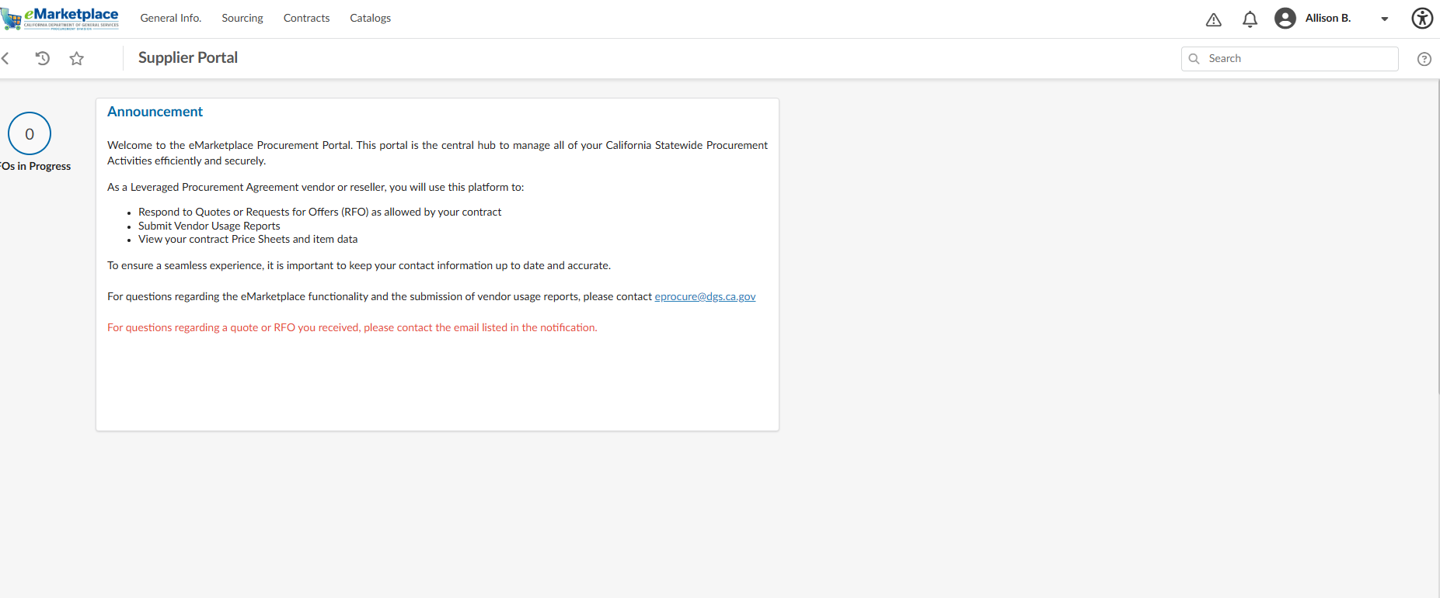

Step 2: Start reviewing your contracts and catalog information.
Review your Contracts
Select Contracts from the top navigation menu, then select Manage Contracts.
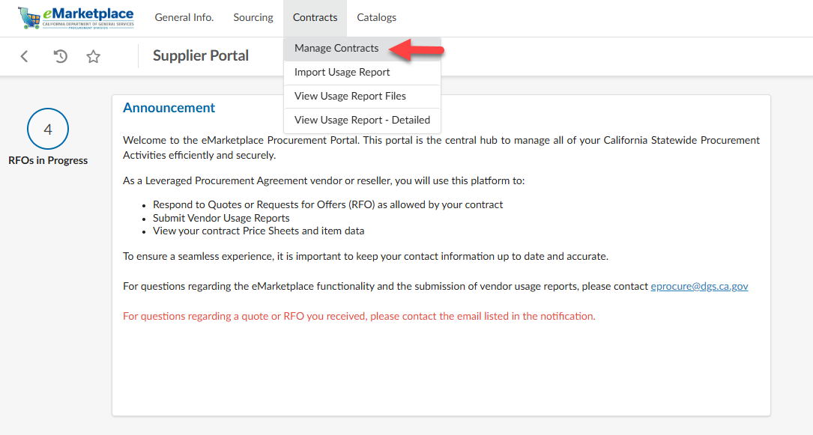
The Manage Contracts page displays the contracts associated with your supplier account. Review the Contract Number, Contract Name, Object Type, End Date, and Contract Workflow Status to confirm your contract information is accurate.
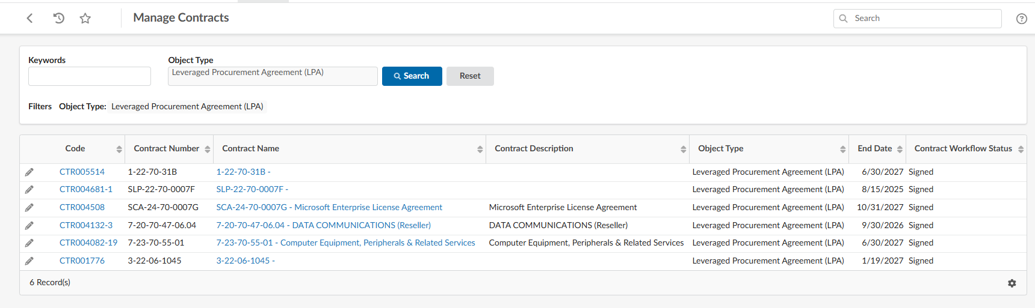
Step 3: View high-level information about your contracts.
Click the pencil icon next to the contract of interest.

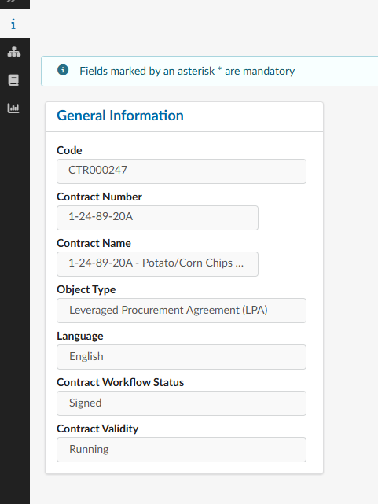
The four tabs on the left will provide additional information about your contract.
- “i” Tab: General information about your contract.
- Hierarchy Tab: Shows any association between your contract and others (ex. Portfolio groupings).
- Documents Tab: View any documents associated with your contract, as added by you (the supplier) and the DGS contract administrator.
- Usage Report Extranet Tab: View usage reporting information.

Step 4: View your contract catalogs in line-item detail.
Go to the “Catalogs” tab and click “Browse Catalogs.”
Use the “Keywords” field to search within the “Item Label” column. If you know your Contract Number, you can use the dropdown to search your own contracts.

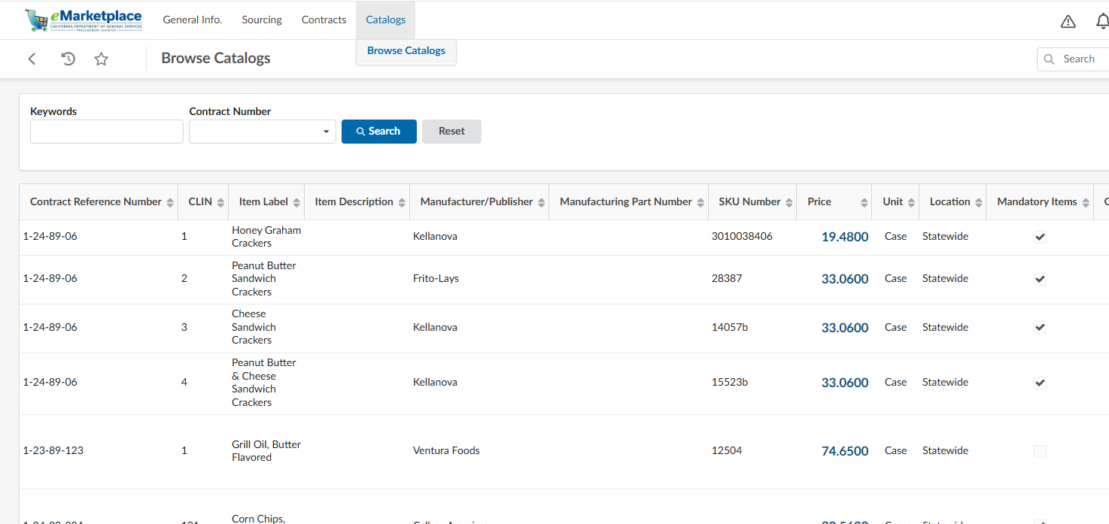

The Browse Catalogs page displays the catalog content and line-item information associated with your supplier account. Review your catalog information frequently to ensure your products, services, pricing (if applicable), and other catalog details are displayed correctly.

You now know how to manage your contracts in eMarketplace.
You have viewed your contracts, reviewed the information about those contracts, learned how to check your catalogs for accuracy.
Resources
For questions, contact the eMarketplace team at eMarketplace@dgs.ca.gov

