How to determine the correct UNSPSC Code
- Log in to FI$Cal
- Click “Main Menu”
- Click “FI$Cal SCPRS”
- Click “Run SCPRS Data Entry”
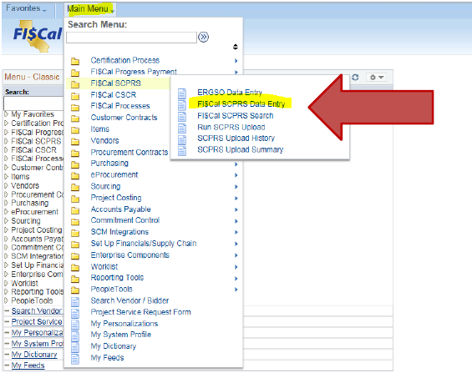
- Click “Add a New Value”
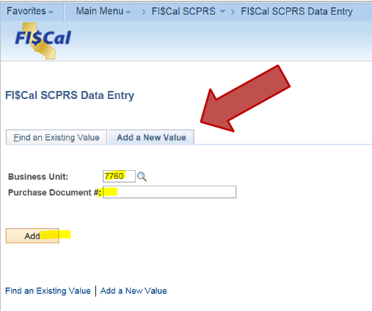
- Enter your four digit “Business Unit” and make up a “Purchase Document #”
- Click “Add” button”
- Enter UNSPSC code listed from the contract in the UNSPSC field. 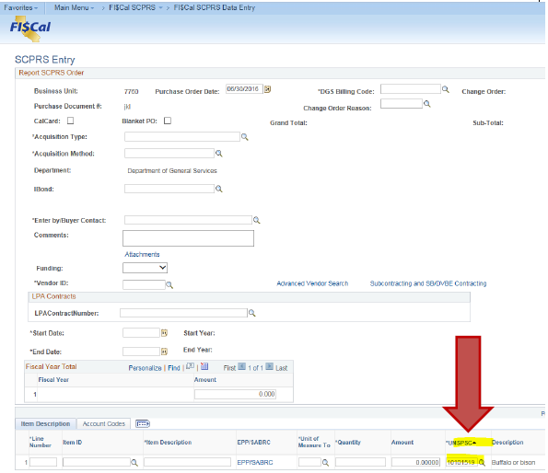
- Click the “Look Up” button (small magnifying glass)
- Description: Using drop-down arrow change “begins with” to “contains” enter name of product. 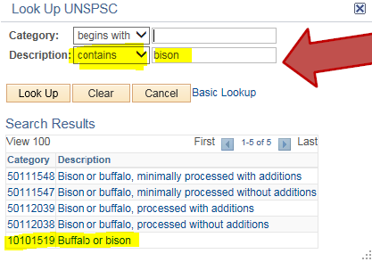
- If your UNSPSC code cannot be found, please contact: helpunspsc@dgs.ca.gov

