How to look up an LPA in FI$Cal
- Log in to FI$Cal
- Click “Main Menu” then “Procurement Contracts”
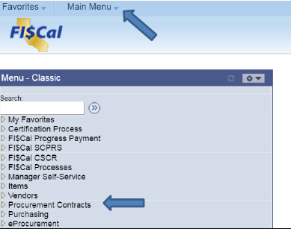
- Click “LPA/Department Contract Search”
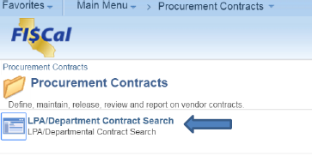
- Choose the scenario that works best for you
  - Scenario 1: Have LPA Number: Enter LPA number into “Contract ID”, select “Show LPAs”, and click “Search”.
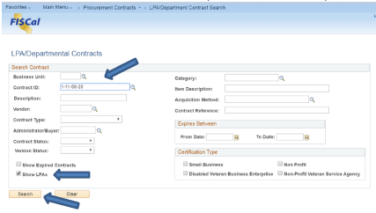
  - Scenario 2: Have contract item description: Enter item into “Description” field, select “Show LPAs”, and click “Search”.
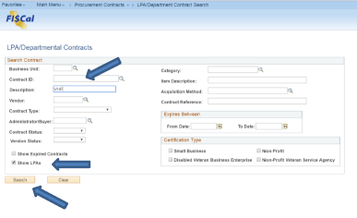
- Result will appear at the bottom of the screen, click “View” to open contract details.
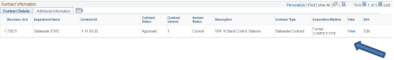
- View LPA Contract
