How to look up an LPA on Cal eProcure
- Visit the Cal eProcure website at http://www.caleprocure.ca.gov
- On the large, blue bar on the top of the page, click “Quicklinks”
- From the drop down menu, click “View/Search Contracts”
  - Scenario 1: You have a Contract Number
    - Enter LPA number into “Contract ID” input box and click the “Search” button 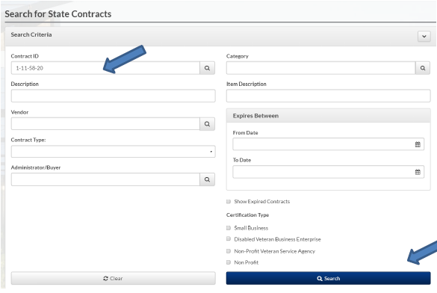
  - Scenario 2: Have description or other information for purchase
    - Enter “Description” into search field or into whichever input box matches the information you have and click the “Search” button.
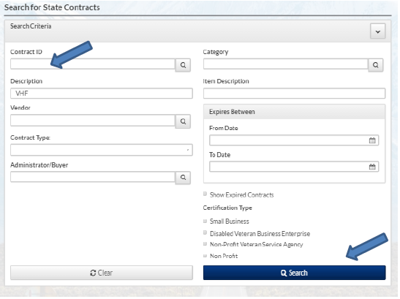
- View search results and click the “View” button to see LPA contract details. LPA Details will include: Contract ID, Type, Description, Status, Acquisition Type, Department, Administrator or Buyer name and email, Begin Date, Expire Sate, Vendor and Line Items.