Finding LPA and Matching Supplier IDs
- Open Cal eProcure
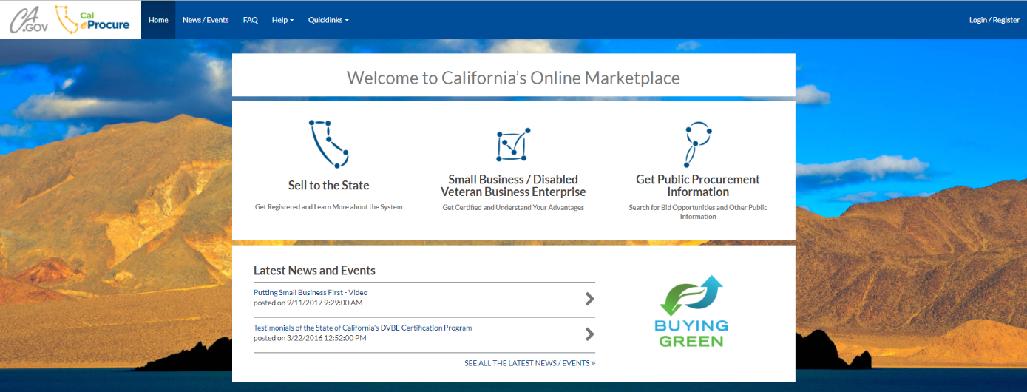
- Choose “Quick links”, then “View/Search Contracts”
- Enter a Contract ID (including any dashes and/or letters) and click “Search” 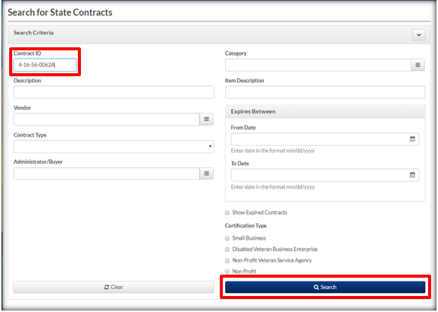
- Contract and Vendor/Supplier IDs can be verified in the search results.