How to Conduct a SCPRS Data Search
Please note: If user is already logged into the FISCal System, they will skip steps 1 -5 and access the same search by selecting: Main Menu, FISCal SCPRS, FISCal SCPRS Search
- Visit Cal eProcure at https://www.caleprocure.ca.gov/pages/index.aspx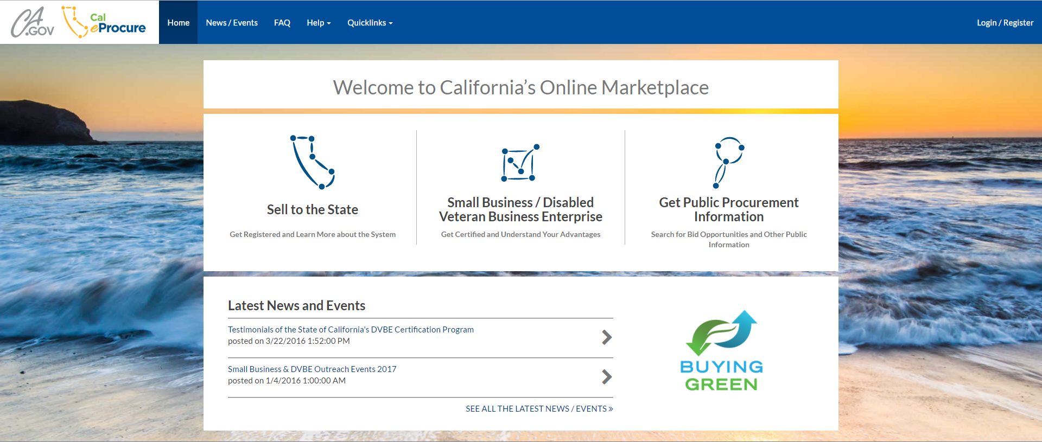
- On the home page, select the 3rd icon: “Get Public Procurement Information” 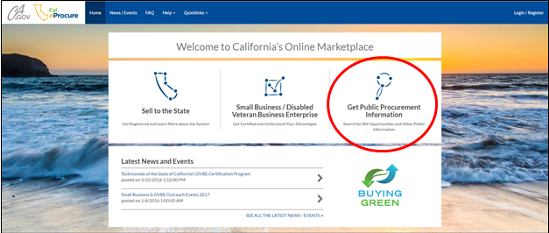
- From the Public Procurement page, select “Search State Contracting and Procurement Registration System (SCPRS) Data”. 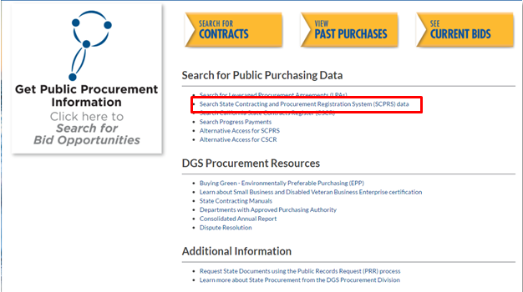
- A pop up warning will appear. Select “YES” 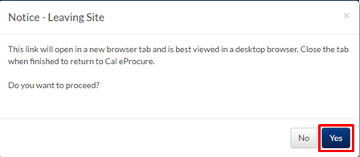
- User is now at the FISCal SCPRS Search (Basic/Advanced Searches Available). 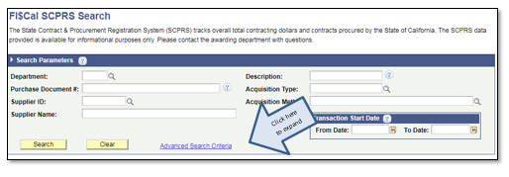 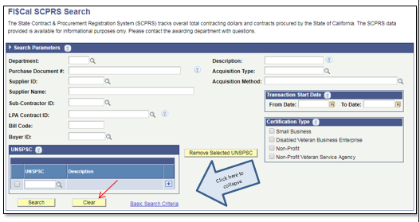
- At any point user can click “Clear” to delete all fields and start over.
- From here, searches can be done by the following parameters:

  - Department
  - Purchase Document Number
  - Supplier ID
  - Supplier Name
  - Sub-Contractor ID
  - LPA Contract ID
  - Bill Code
  - Buyer ID
  - Description
  - Acquisition Type
  - Acquisition Method
  - Transactions Dates – any range
  - Certification Types
  - UNSPSC’s

- Click the looking glass icon to pull up additional parameters to search by.
- When available, help text question mark icon will provide the user with additional information to aid their search.

Key Features of SCPRS Search
- Search using partial, full match and key words.
  - In any of the fields that do not contain a looking glass icon, user may enter part of the number or a word (example a). 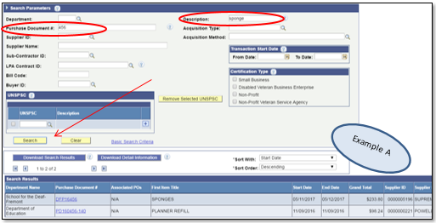
  - When using the looking glass icon, a new window will appear and fields allow for partial words and numbers. Best practice: When searching by the looking glass icon, use drop down menu to select “Contains” prior to searching (example b) 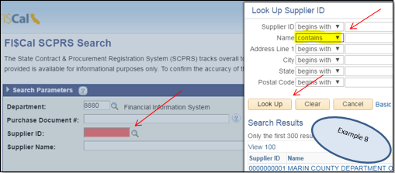
- Search Multiple UNSPSC Codes. Users may add or remove codes and search by category or description (partial or full). To add, click the looking glass icon to search and select code. Click the plus sign icon to add additional codes. To remove a code, user must select the box to the left of the code prior to clicking “Remove Selected UNSPSC”.

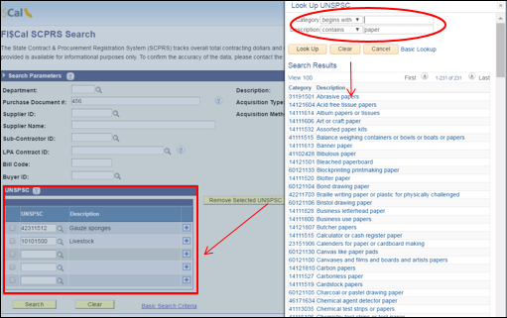
- Download Search Results
  - Users can download and save results to an excel file.
  - Click Download Search Results and “OK” to the pop up message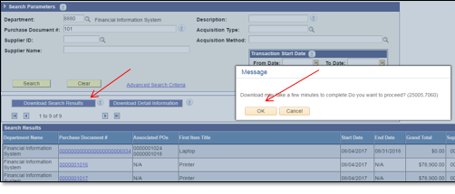
  - Click the “Summary Information” attachment at the bottom of the screen.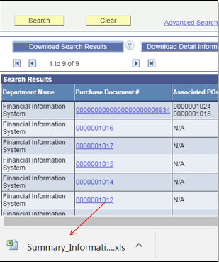
  - Click “Yes” to the excel message and view downloaded results. 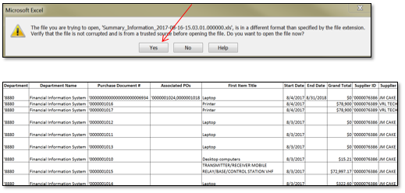

- Download Detailed Information
  - You can also download a more detailed report, by clicking the “Download Detailed Information” button and following the same steps as above. 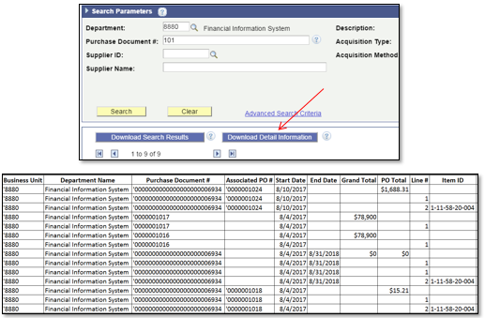

- Search Transactions In Any Date Range
  - Users may enter any date length of time to conduct search, all results are sortable by headings.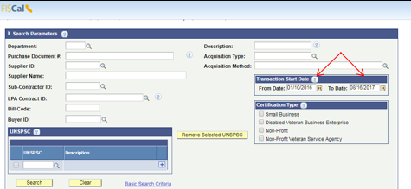
- Various Sorting Features
  - Users may sort at the header level from the options in the drop down menu. The sort defaults automatically to a start date descending order. The user is able to utilize the drop downs to choose the order of results. The sort will apply to every result in the search grid. 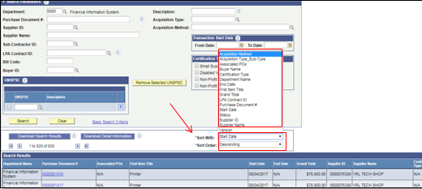
- View Contracts, Associated Purchase Orders, and Line Item Details
  - Users may select “Purchase Document” link to view the contract details and associated “Purchase Orders”. A new window will open with details of the transactions known as “FISCal SCPRS Details – Detailed Information”.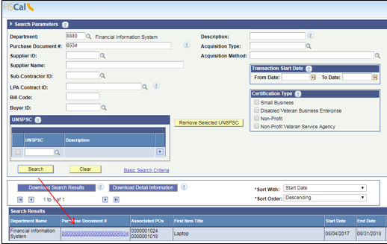
  - The screen will display “Line Item” detailed information for the purchase document, if the entry has associated transactions (they will be listed under “Associated Transactions”) and users may click any of the blue links within the results to pull up additional transaction details. 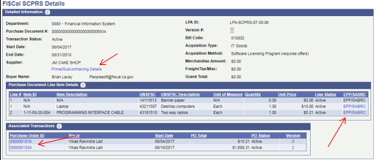
  - Upon clicking the link for “Associated Transactions” this is the screen that appears when the user clicks any of the “Associated Transaction” links. It displays purchase order information and “Line Item Details”; users are also able to see if any amendments have been done by clicking “Version #”. 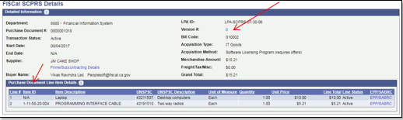

- View Version History (Amendments)
  - When a Version History is available, users will see a blue underlined hyperlink that is clickable.
  - The Version History will appear in a new window; here, users can view reason for change, dollar amount, date changed and the date it was updated. 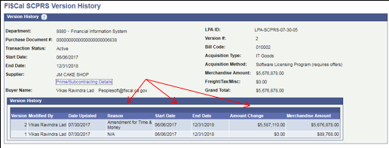
- View Leveraged Purchase Agreements (LPA’s) and Associated Purchases (Advanced Search Criteria).
  - Using the looking glass icon, users can search by LPA by any of the fields in the table. Once the LPA is selected, it will automatically populate in the “LPA Contract ID” field. Click search to display all transactions that were procured by the LPA selected. 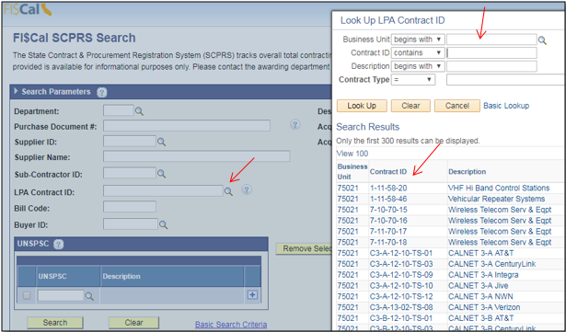
  - The results will contain LPA transactions, and have links that users may click to open up detailed information on the purchases. 