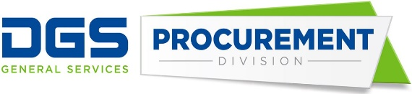
Department of General Services
Procurement Division
707 Third Street, Second Floor, West Sacramento, CA 95605
(916) 375-4400 (800) 559-5529
Broadcast Date: January 10, 2023 Bulletin #: K-01-23
TO: Purchasing Authority Contacts (PACs)
Procurement and Contracting Officers (PCOs)
RE: Electronic Information Library Services – Master Agreement – New
The Department of General Services, Procurement Division (DGS-PD), is pleased to announce the award of a new non-mandatory Master Agreement (MA) for Electronic Information Library Services (EILS) through December 31, 2027.

Agreement Number | Contractor Name
5-23-70-40-01 | RELX, Inc.

MA details, User Instructions, and pricing can be found on our website at Cal eProcure or by clicking the agreement number above.

If you have any questions regarding this notification, please contact:
Robert Cosgrove
(279) 946-8303
Robert.Cosgrove@dgs.ca.gov

