Update Existing Requisition Submitted to DGS One Time Acquisitions (OTA) and How to Retrigger a Requisition to Allow for Changes

Use these procedures if you are a FI$Cal transacting agency and you need to update a previously submitted FI$Cal Requisition.

NOTE: OTA NO LONGER ACCEPTS A STD. 96 FROM FI$CAL TRANSACTING AGENCIES WHEN REQUESTING A REQUISITION/PURCHASE ORDER CHANGE

- Login to FI$Cal

- Under ‘Sign On’ Click on the ‘PeopleSoft’ link
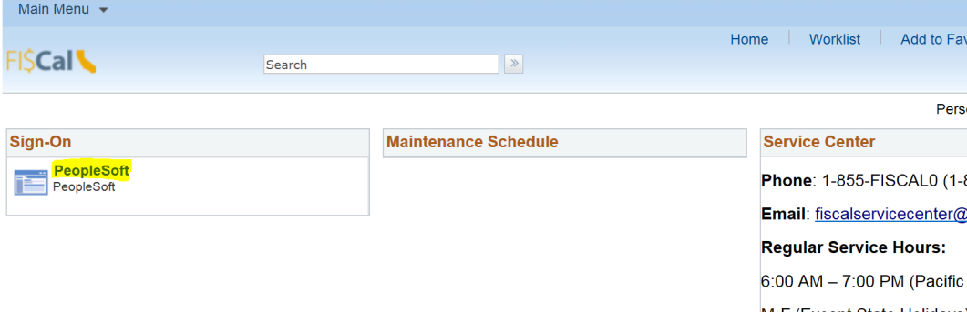

- Navigate: Main Menu > eProcurement > Manage Requisitions
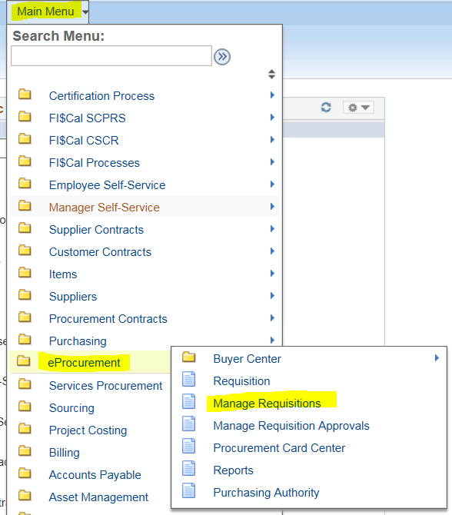

- Enter the appropriate values into the following fields to locate the previously submitted FI$Cal requisition:

Business Unit: Use the lookup icon to search for, or manually type your agency Business Unit (BU)
Requisition ID: Use the lookup icon to search for, or manually type the Requisition ID number (e.g., 0000000345)
Date From: Remove default value and leave blank
Requester: Remove default value and leave blank
Requisition Name: Leave blank
Request State: Leave as is “All but Complete”
Budget Status: Leave as is
Date to: Remove default value and leave blank
Entered By: Leave blank
PO ID: Leave blank

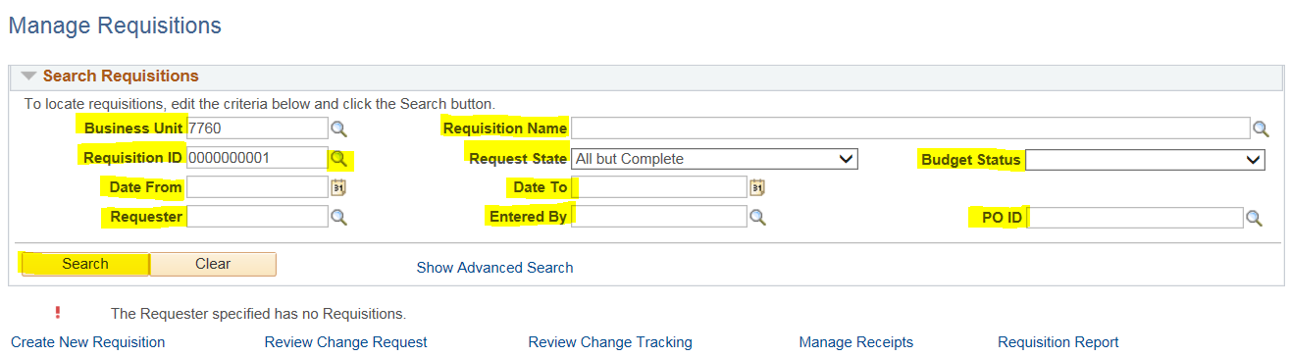

- Click the ‘Search’ button

- Locate the desired Requisition in the search results

- Scroll to far right of the Requisition line

- Use the ‘Select Action’ drop down to select ‘Edit’

- Click the ‘Go’ button

- When warning message appears, click the ‘OK’ button

- On the ‘Edit Requisition – Review and Submit’ page make all the desired changes to the Requisition (e.g. add a line item, remove line item, change quantity on existing line item)

- Add OTA Requisition Approver (MaryElizabeth Asselin) to the end of the approval path.

DO NOT ADD any other DGS - One Time Acquisitions employee to the approval path.

- Click the ‘Submit for Approval’ button. Send an email to: PurchaseRequest@dgs.ca.gov to let OTA know you have submitted a Requisition.

- Click the ‘Approval Inquiry’ button to check if the OTA Requisition Approver is the last approver in the approval path. This guarantees that OTA sees the changes made to your request. If the OTA MST is not in the approval path, OTA will not be able to see or process your change request

NOTE: If you are decreasing the line-item quantity or unit price, add a new line item with the new quantity and/or dollar amount and remove the original line item from the requisition. If you are increasing the line-item quantity or unit price, make the changes on the existing line item. The system will not retrigger the approval path when the quantity or dollar amount is decrease, only when it is increased.

How to retrigger a Requisition to allow for changes:
Re-trigger the approval process to allow you to make changes (e.g., insert MST as an Approver).
Edit the Requisition by going to Main Menu ð eProcurement ð Manage Requisitions.
Once there, press Clear and enter the BU # and Requisition ID #, then Search.
To the far right, you need to select Edit, then hit the GO button. Once the on the Requisition page, you should be able to make changes. You may need to change one of the fields, so that it will re-trigger the approval process. Try that and see if it will re-trigger the approval process to add me as an Approver.

