CREATE REQUISITION FOR DGS – OTA SUBMITTAL

NEW PURCHASE REQUEST/PURCHASE ORDER CHANGE (POC) REQUEST
Use these procedures if you are a FI$Cal transacting agency and you need to submit a FI$Cal Requisition to request a new purchase or to submit a Purchase Order Change (POC) change request.
NOTE: OTA NO LONGER ACCEPTS A STD. 66 OR STD. 96 FROM FI$CAL TRANSACTING AGENCIES FOR A PURCHASE REQUEST OR PURCHASE ORDER CHANGE
- Login to FI$Cal
- Under “Sign On” Click on the “PeopleSoft” link
- Navigate: Main Menu > eProcurement > Requisition
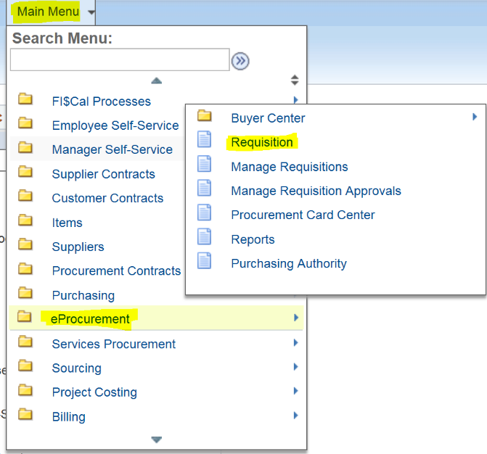
- Click the “Special Requests” link
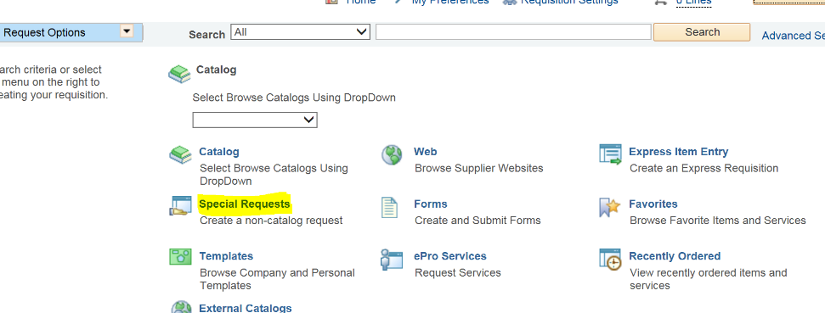
- Enter valid values into the following fields for line item #1:
Item Description:
New Request: Enter appropriate item description matching the vendor’s quote
Change Request: Use the following item description format (POC #X – Description of change)(e.g. POC #1 – Optional Year One 2/2/17 – 2/1/18 – Software Maintenace and Support)
Price: Enter unit price of line item matching the vendor’s quote
Quantity: Enter the quantity for the line item matching the vendor’s quote
Unit of Measure: Use Look Up to select appropriate UOM matching the vendor’s quote
Category: Use Look Up to search and select the appropriate UNSPSC code
Due Date: Use the calendar icon to select the appropriate date the line item will be delivered or services will start, if this information is unknown at this time leave this field blank
Additional Information: Type any additional information that pertains to the item (e.g. model #)
Example:
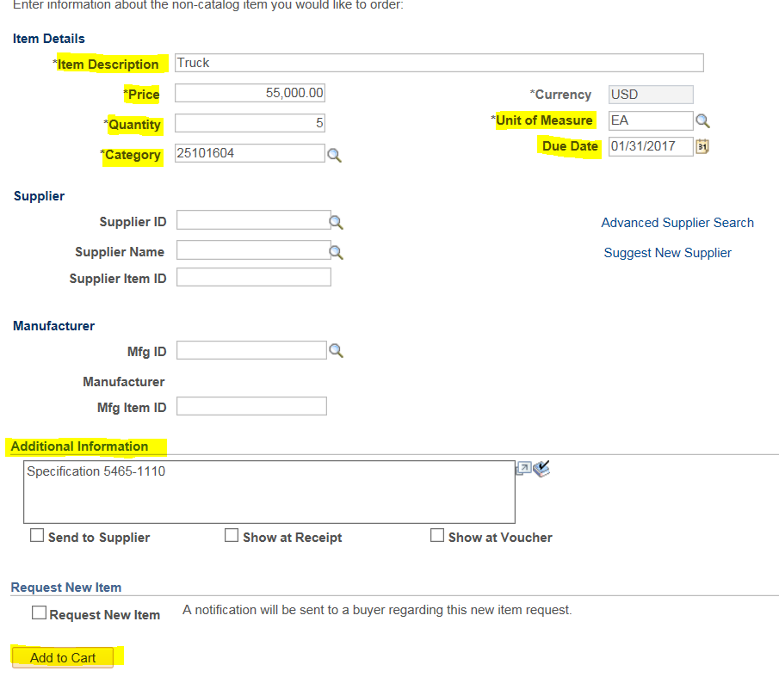
- Click the “Add to Cart” button
- Repeat Step #5-6 to add additional line items
NOTE: Enter a Sales/Use tax line item if applicable. FI$Cal Requisitions do not calculate tax per line item automatically

- Click the “Checkout” button at the top of the page
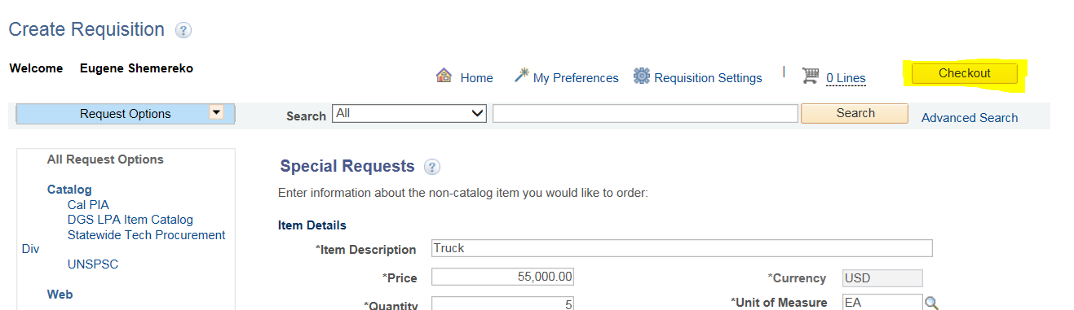
- On the ‘Checkout-Review and Submit’ page enter values into the following fields:
Requisition Name: New Request: Enter a brief description of your request, Change Request: Enter description of Purchase Order Change (POC) using the following format (POC #X for PO #X)(e.g. POC #2 for PO #100349, POC #5 for PO #2750-0000004586)
Acquiition Type: Use Look Up to select the appropriate acquisition type
Acquisition Method: Use Look Up to select the appropriate acquisition method
Example:
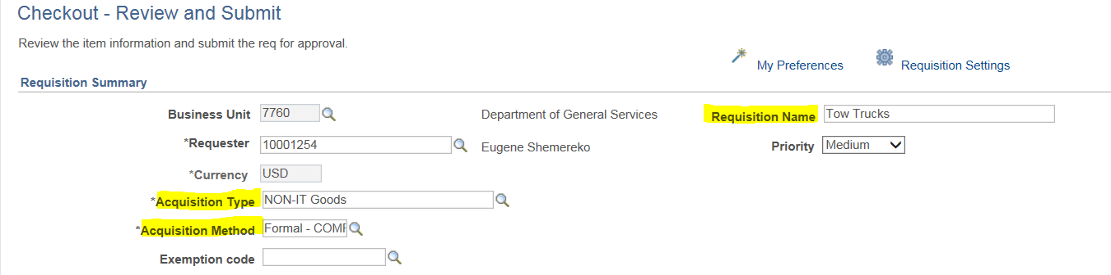
- Click the ‘Add EPP/SABRC’ button for each line items that contains recycled materials or falls under the CalRecycle reporting guidelines. Please review the following links for more information on what needs to be reported: EPP Buying Green; CalRecycle Buying Recycled Products; State Agency Buy Recycled Campaign (SABRC)
If the line items do not contain recycle materials or fall under the CalRecycle reporting guidelines skip to step #13
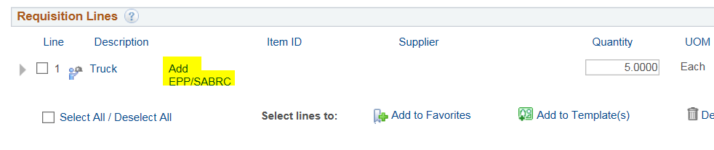
- For each SABRC line item enter values into the following fields on the ‘EPP/SABRC’ page:
DGS Purchasing Standard: Use the Look Up to select the appropraite item from the list (if this line item is related to an LPA, leave this field blank)
Take Back: Use Drop Down to select ‘Yes’ or ‘No” (Take Back applies to toner cartridges, CFL light bulbs, batteries, paint and carpet)
SABRC Reportable: Use Drop down to select ‘Yes’ or ‘No’ (Yes = item is included in 1 of the 11 categories)
SABRC Category: Use Look Up to select the appropriate item from the list (identifies which of the 11 categories is applicable) Product Categories and Examples
SABRC Subcategory: Use Look Up to select the appropriate item from the list
Postconsumer Recycle Content %: Enter the percent of postconsumer recycle content
Total Recycled Content %: Enter the percent of recycled content (total recycled includes the postconsumer recycled content)
PCRC Source: Use the drop down to select the appropriate PCRC Source
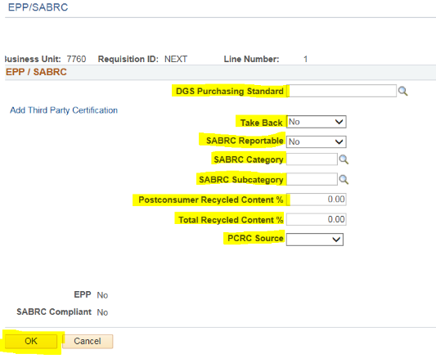
- Click the ‘OK’ button

- Click on the ‘Comments’ icon for the first line item
- Enter appropriate comment(s) into the comment box(es), to add more comments click the ‘+’ button
NOTE: Ensure that one of your comments is your DGS Billing Code, formerly known as your CAN. This information is required on the PO in FI$Cal, and the OTA buyer cannot complete the dispatch of your PO without this number. Also, make sure to provide contact information for the Subject Matter Expert (SME) for the procurement.
- Check the ‘Send to Supplier’ checkbox for each comment and attachment
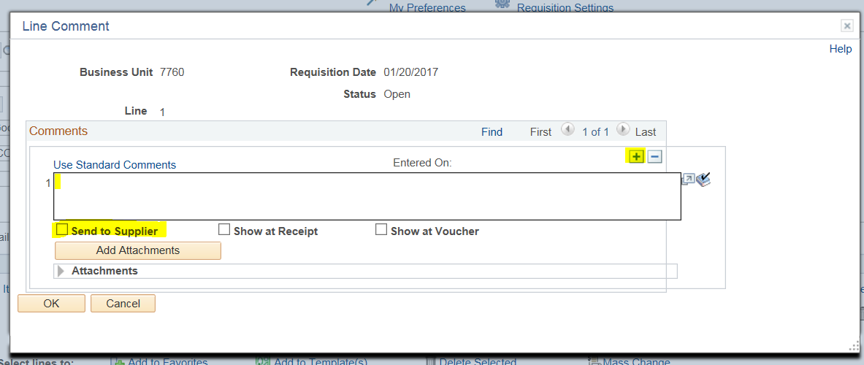
- Click the “Add Attachments” button
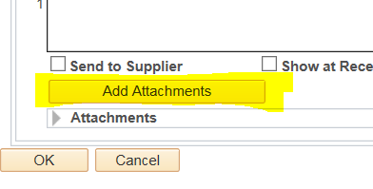

- Click the “Browse” button and search for and select the desired attachment
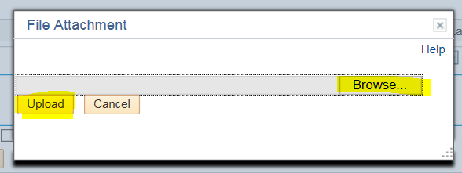
NOTE: MINIMUM ATTACHMENT REQUIREMENTS FOR IT PURCHASE REQUESTS:
SOW IN WORD WITH NO HEATHERS, SIMM 71B (IF IT),INFORMAL QUOTE(S), SOLE SOURCE FROM SUPPLIER (IF PROPRIETARY), PRIOR PO (IF APPLICABLE), EXCEL COST WORSHEET (MUST USE OTA TEMPLATE)
- Click the “Upload” button
- For additional attachments repeat steps #16-18
- Click the “OK” button
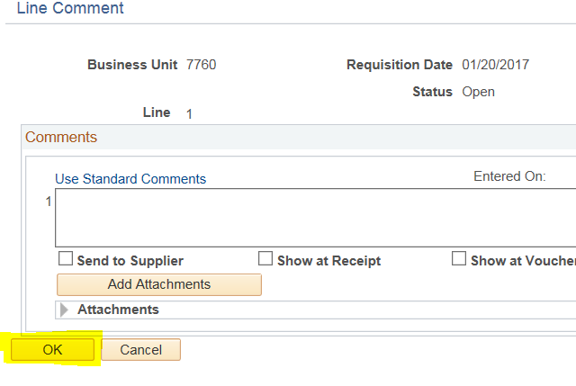

- Click the small arrow to the left of the first line item to expand
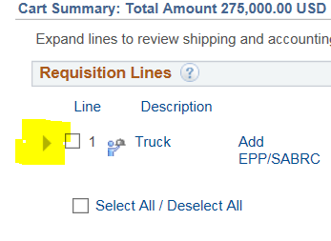
- Use the Look Up to change the ‘Ship To’ field to the correct ship to location for that line item (once selected the correct address should display next to ‘Address’
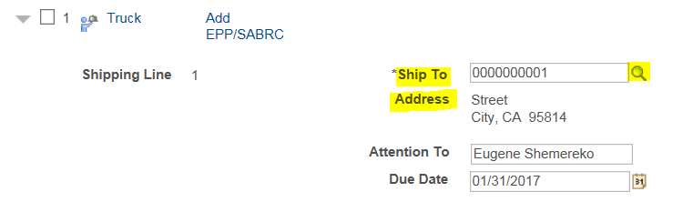
- Click small arrow next to ‘Accounting Lines’
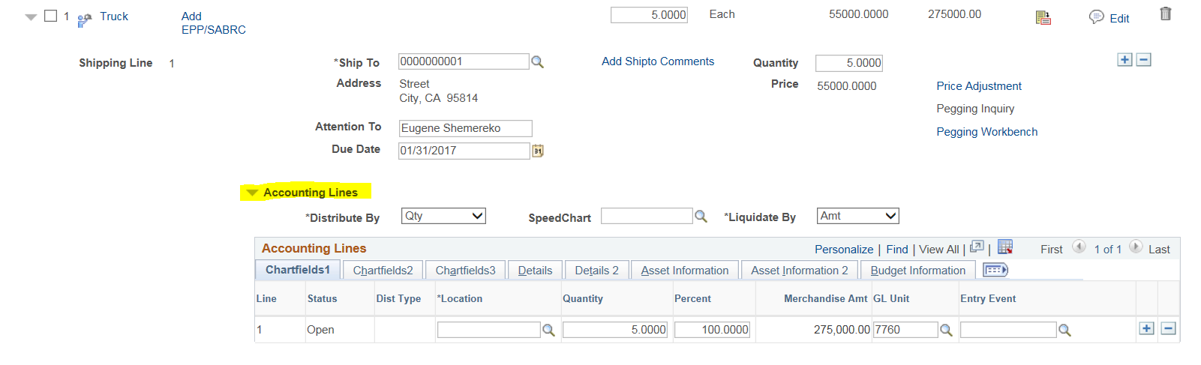
- Use the ‘Accounting Lines” Section to select all the appropriate Chartfields “Accounting Information” for the line item
- Repeat steps #21-24 for all line items
- Collapse the ‘Accounting Lines’ by clicking the small arrow next to where it says ‘Accounting Lines’

- Click on the ‘Check Budget’ link
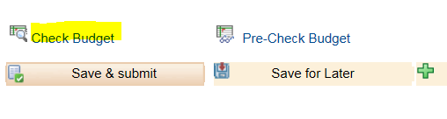
- When the warning message appears click the ‘OK’ button (the system will now take some time to think)
- Once the budget check is complete you should now see Budget Checking Status: Valid. OTA WILL NOT ACCEPT THE REQUISITION IF BUDGET IS NOT PASSED
- Click the “Preview Approvals” link
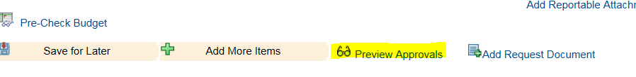
NOTE: Approver #1 should be a procurement supervisor/manager; Approver #2 should be an accounting official. If your approval path does not contain the correct approvers, please contact fiscalservicecenter@fiscal.ca.gov.
Departments are able to decide who should fill the approval roles within their department, and often times due to size, approver #1 and approver #2 might be the same person.
NOTE: All Requisitions being submitted to OTA that require additional approvers (e.g. OFAM) within the approval path must be inserted prior to submitting to OTA data entry employee (see below)

- In the Approver Path, click on the green “+” sign to ad hoc the OTA data entry employee (MaryElizabeth Asselin) as the last approver
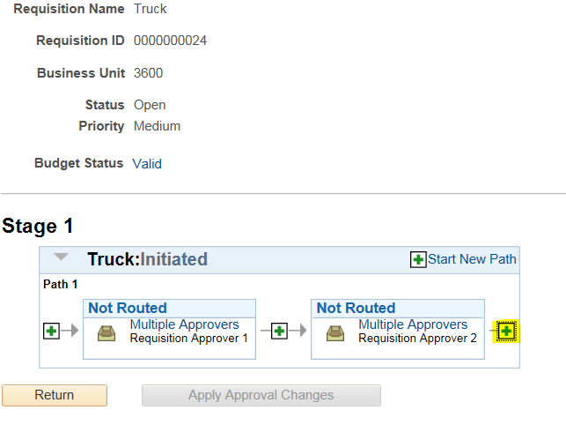
- At the top of the page you will now see a ‘Requisition ID’ (make note of this number, this number is now your official request number)
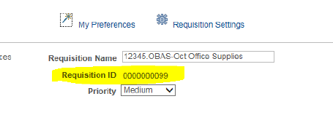
- Click the Look Up for the ‘User ID:’ field
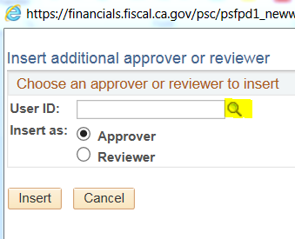
- Use the ‘Name’ search field to find the appropriate OTA data entry employee, and then click the “Insert” button (contact PurchaseRequest@dgs.ca.gov to confirm the current OTA Requisition ad hoc approver)
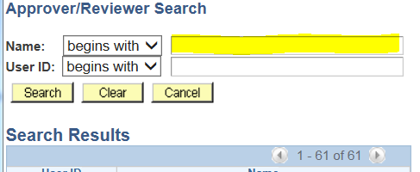
- Click the ‘Insert’ button
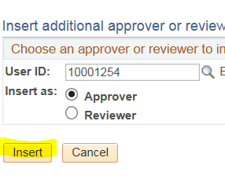
- Click the “Apply Approval Changes” button
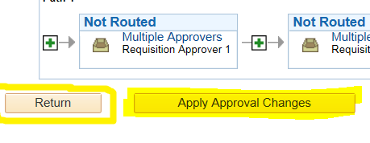
- Click the “Return” button
- Click the “Save & submit” button, this will submit the Requisition to the approvers in the approval path as well as One Time Acquisitions for processing. Send an email to PurchaseRequest@dgs.ca.gov to confirm your Requisition has been received.

NOTE: ENSURE THE CHARTFIELD AND ACCOUNT INFORMATION IS ACCURATE BEFORE SUBMITTING THE REQUISITION FOR PROCESSING. ONCE WE BEGIN TO PROCESS YOUR REQUISITION, ANY CHANGES THAT NEED TO BE MADE TO THE PURCHASE ORDER OR REQUISITION MAY REQUIRE CANCELLING THE PURCHASE ORDER. REVISING A REQUISITION WILL RETRIGGER THE INITIAL APPROVAL PROCESS AND ADD UNNECESSARY DELAYS IN THE PROCUREMENT PROCESS.
How to retrigger a Requisition to allow for changes:
Re-trigger the approval process to allow you to make changes (e.g., insert MST as an Approver).
Edit the Requisition by going to Main Menu ð eProcurement ð Manage Requisitions.
Once there, press Clear and enter the BU # and Requisition ID #, then Search.
To the far right, you need to select Edit, then hit the GO button. Once the on the Requisition page, you should be able to make changes. You may need to change one of the fields, so that it will re-trigger the approval process. Try that and see if it will re-trigger the approval process to add me as an Approver.

