Attachment 2

Model Agreement Template
(w/Exhibits)

STATE OF CALIFORNIA
STANDARD AGREEMENT
STD 213 (Rev 06/03) |  |  |  |  |  |  |  |  | AGREEMENT NUMBER
 |  |  |  |  |  |  |  |  | REGISTRATION NUMBER
1. This Agreement is entered into between the State Agency and the Contractor named below:
 | STATE AGENCY'S NAME
 | , hereinafter referred to as “State”
 | CONTRACTOR'S NAME
 | , hereinafter referred to as “University”
2. | The term of this |  |  |  |  | through
 | Agreement is:
3. The maximum amount |  |  |  |  | $
of this Agreement is:
4. The parties agree to comply with the terms and conditions of the following Exhibits, which by this reference are made a part of the Agreement.
 |  | Exhibit A – A5: A–Scope of Work; A1–Deliverables; A2–Key Personnel; A3–Authorized Representatives; A4–Preexisting Data; A5–CV/Resumes |  |  |  |  |  |  |  |  |  | page(s)
 |  | Other Exhibits A (when applicable): A6–Current & Pending Support; A7–Third Party Confidential Information Requirement |  |  |  |  |  |  |  |  |  | page(s)
 |  | Exhibit B – B–Budget; B1–Budget Justification; B2–Subrecipient Budgets (if applicable); B3–Invoice Elements |  |  |  |  |  |  |  |  |  | page(s)
 |  | Exhibit C* – University Terms and Conditions |  |  |  |  |  |  |  |  |  | UTC-116
 |  | Check mark additional Exhibits below, and attach Exhibits or provide internet link:
 |  |  |  | Exhibit D – Additional Requirements Associated with Funding Sources |  |  |  |  |  |  |  | page(s)
 |  |  |  | Exhibit E – Special Conditions for Security of Confidential Information |  |  |  |  |  |  |  | page(s)
 |  | Exhibit F – Access to State Facilities and Computing Resources |  |  |  |  |  |  |  |  |  | page(s)
 |  | Exhibit G – If applicable |  |  |  |  |  |  |  |  |  | page(s)

Items shown with an Asterisk (*) are hereby incorporated by reference and made part of this agreement as if attached hereto.
These documents can be viewed at http://www.dgs.ca.gov/ols/Resources/StandardContractLanguage.aspx.

IN WITNESS WHEREOF, this Agreement has been executed by the parties hereto.
CONTRACTOR |  |  |  |  |  |  |  |  |  | California Department of General Services Use Only
CONTRACTOR’S NAME (if other than an individual, state whether a corporation, partnership, etc.)
BY (Authorized Signature) |  |  |  |  |  |  | DATE SIGNED (Do not type)
PRINTED NAME AND TITLE OF PERSON SIGNING
ADDRESS
STATE OF CALIFORNIA
AGENCY NAME
BY (Authorized Signature) |  |  |  |  |  |  | DATE SIGNED (Do not type)
PRINTED NAME AND TITLE OF PERSON SIGNING |  |  |  |  |  |  |  |  |  | Exempt per:
ADDRESS

Exhibit A

Project Summary & Scope of Work

Project Summary/Abstract
Briefly describe the long-term objectives for achieving the stated goals of the project.

If Third-Party Confidential Information is to be provided by the State:
Performance of the Scope of Work is anticipated to involve use of third-party Confidential Information and is subject to the terms of this Agreement; OR
A separate CNDA between the University and third-party is required by the third-party and is incorporated in this Agreement as Exhibit A7.

Scope of Work
Describe the goals and specific objectives of the proposed project and summarize the expected outcomes. If applicable, describe the overall strategy, methodology, and analyses to be used. Include how the data will be collected, analyzed, and interpreted as well as any resource sharing plans as appropriate. Discuss potential problems, alternative strategies, and benchmarks for success anticipated to achieve the goals and objectives.

Exhibit A1

SCHEDULE OF DELIVERABLES
List all items that will be delivered to the State under the proposed Scope of Work. Include all reports, including draft reports for State review, and any other deliverables, if requested by the State and agreed to by the Parties.

Deliverable* | Description | Due Date
The following Deliverables are subject to paragraph 18. Copyrights, Section B of Exhibit C

* If use of any Deliverable is restricted or is anticipated to contain Preexisting Data or copyrightable works with any restricted use, it will be clearly identified in Exhibit A4, Use of Preexisting Data, Copyrighted Works and Deliverables.

Exhibit A2

KEY PERSONNEL
List Key Personnel as defined in the Agreement starting with the PI, by last name, first name followed by Co-PIs. Then list all other Key Personnel in alphabetical order by last name. For each individual listed include his/her name, institutional affiliation, and role on the proposed project. Use additional consecutively numbered pages as necessary.

Last Name, First Name | Institutional Affiliation | Role on Project
PI:
Last name, First name | Institutional affiliation | Role on the project
Co-PI(s) – if applicable:
Last name, First name | Institutional affiliation | Role on the project
Last name, First name | Institutional affiliation | Role on the project
Other Key Personnel (if applicable):
Last name, First name | Institutional affiliation | Role on the project
Last name, First name | Institutional affiliation | Role on the project

Exhibit A3
AUTHORIZED REPRESENTATIVES AND NOTICES

The following individuals are the authorized representatives for the State and the University under this Agreement. Any official Notices issued under the terms of this Agreement shall be addressed to the Authorized Official identified below, unless otherwise identified in the Agreement.

Changes in the University Principal Investigator are subject to the Key Personnel section of this Agreement. Changes in other contact information may be made by notification, in writing, between the parties.

State Agency Contacts  Agency Name: <Agency Name> | University Contacts  University Name: <University Name>
Contract Project Manager (Technical)  Name: <Name>  <Title>  Address: <Department>  <Address>  <City,State,Zip>  Telephone: <Telephone#>  Fax: <Fax#, if available>  Email: <EmailAddress> | Principal Investigator  Name: <Name>  <Title>  Address: <Department>  <Address>  <City,State,Zip>  Telephone: <Telephone#>  Fax: <Fax#, if available>  Email: <EmailAddress>
Authorized Official (contract officer)  Name: <Name>  <Title>  Address: <Department>  <Address>  <City,State,Zip>  Telephone: <Telephone#>  Fax: <Fax#, if available>  Email: <EmailAddress>  Send notices to (if different):  Name: <Name>  <Title>  Address: <Department>  <Address>  <City,State,Zip>  Telephone: <Telephone#>  Fax: <Fax#, if available>  Email: <EmailAddress> | Authorized Official  Name: <Name>  <Title>  Address: <Department>  <Address>  <City,State,Zip>  Telephone: <Telephone#>  Fax: <Fax#, if available>  Email: <EmailAddress>  Send notices to (if different):  Name: <Name>  <Title>  Address: <Department>  <Address>  <City,State,Zip>  Telephone: <Telephone#>  Fax: <Fax#, if available>  Email: <EmailAddress>
Administrative Contact  Name: <Name>  <Title>  Address: <Department>  <Address>  <City,State,Zip>  Telephone: <Telephone#>  Fax: <Fax#, if available>  Email: <EmailAddress> | Administrative Contact  Name: <Name>  <Title>  Address: <Department>  <Address>  <City,State,Zip>  Telephone: <Telephone#>  Fax: <Fax#, if available>  Email: <EmailAddress>
Financial Contact/Accounting  Name: <Name>  <Title>  Address: <Department>  <Address>  <City,State,Zip>  Telephone: <Telephone#>  Fax: <Fax#, if available>  Email: <EmailAddress> | Authorized Financial Contact/Invoicing  Name: <Name>  <Title>  Address: <Department>  <Address>  <City,State,Zip>  Telephone: <Telephone#>  Fax: <Fax#, if available>  Email: <EmailAddress>

Exhibit A4

USE OF PREEXISTING DATA, COPYRIGHTED WORKS AND DELIVERABLES

If the either Party will be using any third-party or pre-existing data or copyrighted works that have restrictions on use, then list all such data or copyrighted works and the nature of the restriction below. If no third-party or pre-existing data or copyrighted works will be used, check “none” in this section.
- State: Preexisting Data and/or copyrighted works to be provided to the University from the State or a third party for use in the performance in the Scope of Work.
None or List:
Owner  (State Agency or 3rd Party) | Type of Data or copyrighted work  (Restricted or Unrestricted) | Description | If Restricted, nature of restriction:

- University: Use of Preexisting Data or copyrighted works included in Deliverables identified in Exhibit A1.
None or List:
Owner  (University or 3rd Party) | Type of Data or copyrighted work  (Restricted or Unrestricted) | Description | If Restricted, nature of restriction:

- Anticipated restrictions on use of Project Data.
If the University PI anticipates that any of the Project Data generated during the performance of the Scope of Work will have a restriction on use (such as subject identifying information in a data set) then list all such anticipated restrictions below. If there are no restrictions anticipated in the Project Data, then check “none” in this section.

None or List:
Owner  (University or 3rd Party) | Description | Nature of Restriction:

Exhibit A5

CURRICULUM VITAES (CV) / RésuméS / Biosketch

Attach CV/Résumé/Biosketch for Key Personnel listed in Exhibit A2.
Exhibit A6
CURRENT & PENDING SUPPORT
(Will be incorporated, if applicable.)

University will provide current & pending support information for Key Personnel identified in Exhibit A2 at time of proposal and upon request from State agency. The “Proposed Project” is this application that is submitted to the State. Add pages as needed.

PI: NAME OF INDIVIDUAL
Status (currently active or pending approval) | Award #  (if available) | Source  (name of the sponsor) | Project  Title |  | Start Date | End Date
Proposed Project |  |  |  |  | 10/1/2010 | 12/31/2012
 |  |  |  |  | 10/1/2010 | 12/31/2012
 |  |  |  |  | 10/1/2010 | 12/31/2012
 |  |  |  |  | 10/1/2010 | 12/31/2012
NAME OF INDIVIDUAL
Status | Award # | Source | Project  Title |  | Start Date | End Date
Proposed Project |  |  |  |  | 10/1/2010 | 12/31/2012
 |  |  |  |  | 10/1/2010 | 12/31/2012
 |  |  |  |  | 10/1/2010 | 12/31/2012
 |  |  |  |  | 10/1/2010 | 12/31/2012
NAME OF INDIVIDUAL
Status | Award # | Source | Project  Title |  | Start Date | End Date
Proposed Project |  |  |  |  | 10/1/2010 | 12/31/2012
 |  |  |  |  | 10/1/2010 | 12/31/2012
 |  |  |  |  | 10/1/2010 | 12/31/2012
 |  |  |  |  | 10/1/2010 | 12/31/2012
NAME OF INDIVIDUAL
Status | Award # | Source | Project  Title |  | Start Date | End Date
Proposed Project |  |  |  |  | 10/1/2010 | 12/31/2012
 |  |  |  |  | 10/1/2010 | 12/31/2012
 |  |  |  |  | 10/1/2010 | 12/31/2012
 |  |  |  |  | 10/1/2010 | 12/31/2012
NAME OF INDIVIDUAL
Status | Award # | Source | Project  Title |  | Start Date | End Date
Proposed Project |  |  |  |  | 10/1/2010 | 12/31/2012
 |  |  |  |  | 10/1/2010 | 12/31/2012
 |  |  |  |  | 10/1/2010 | 12/31/2012
 |  |  |  |  | 10/1/2010 | 12/31/2012

Exhibit A7
Third Party Confidential Information
Confidential Nondisclosure Agreement
(Identified in Exhibit A, Scope of Work – will be incorporated, if applicable)
If the scope of work requires the provision of third party confidential information to either the State or the Universities, then any requirement of the third party in the use and disposition of the confidential information will be listed below. The third party may require a separate Confidential Nondisclosure Agreement (CNDA) as a requirement to use the confidential information. Any CNDA will be identified in this Exhibit A7.

Exhibit B
Budget Estimate for Project Period

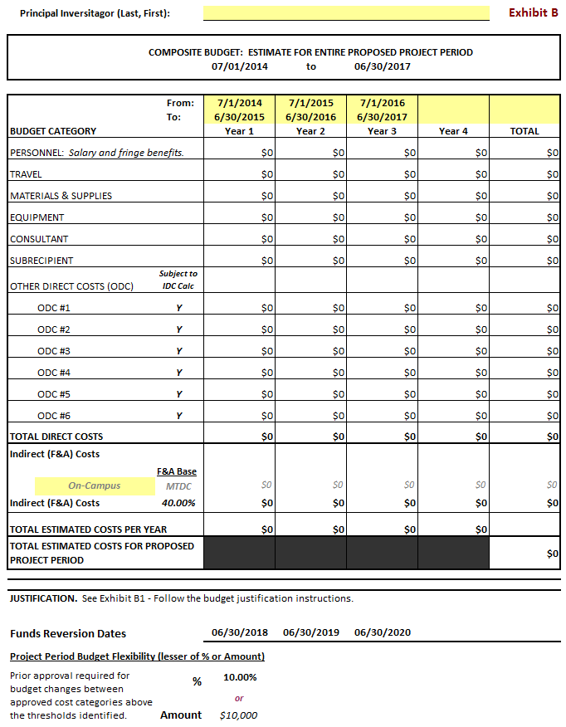
EXAMPLE
Exhibit B1
Budget Justification

The Budget Justification will include the following items in this format.

Personnel
Name. Starting with the Principal Investigator list the names of all known personnel who will be involved on the project for each year of the proposed project period. Include all collaborating investigators, individuals in training, technical and support staff or include as “to be determined” (TBD).
Role on Project. For all personnel by name, position, function, and a percentage level of effort (as appropriate), including “to-be-determined” positions.

Fringe Benefits.
In accordance with University policy, explain the costs included in the budgeted fringe benefit percentages used, which could include tuition/fee remission for qualifying personnel to the extent that such costs are provided for by University policy, to estimate the fringe benefit expenses on Exhibit B.

Travel
Itemize all travel requests separately by trip and justify in Exhibit B1, in accordance with University travel guidelines. Provide the purpose, destination, travelers (name or position/role), and duration of each trip. Include detail on airfare, lodging and mileage expenses, if applicable. Should the application include a request for travel outside of the state of California, justify the need for those out-of-state trips separately and completely.

Materials and Supplies
Itemize materials supplies in separate categories. Include a complete justification of the project’s need for these items. Theft sensitive equipment (under $5,000) must be justified and tracked separately in accordance with State Contracting Manual Section 7.29.

Equipment
List each item of equipment (greater than or equal to $5,000 with a useful life of more than one year) with amount requested separately and justify each.

Consultant Costs
Consultants are individuals/organizations who provide expert advisory or other services for brief or limited periods and do not provide a percentage of effort to the project or program. Consultants are not involved in the scientific or technical direction of the project as a whole.
Provide the names and organizational affiliations of all consultants. Describe the services to be performed, and include the number of days of anticipated consultation, the expected rate of compensation, travel, per diem, and other related costs.

Subawardee (Consortium/Subrecipient) Costs
Each participating consortium organization must submit a separate detailed budget for every year in the project period in Exhibit B2 Subcontracts. Include a complete justification for the need for any subawardee listed in the application.

Other Direct Costs
Itemize any other expenses by category and cost. Specifically justify costs that may typically be treated as indirect costs. For example, if insurance, telecommunication, or IT costs are charged as a direct expense, explain reason and methodology.

Rent
If the scope of work will be performed in an off-campus facility rented from a third party for a specific project or projects, then rent may be charged as a direct expense to the award.

Indirect (F&A) Costs
Indirect costs are calculated in accordance with the University budgeted indirect cost rate in Exhibit B.

Exhibit B2
Budget Estimates Pertaining to Subcontractors (when applicable)
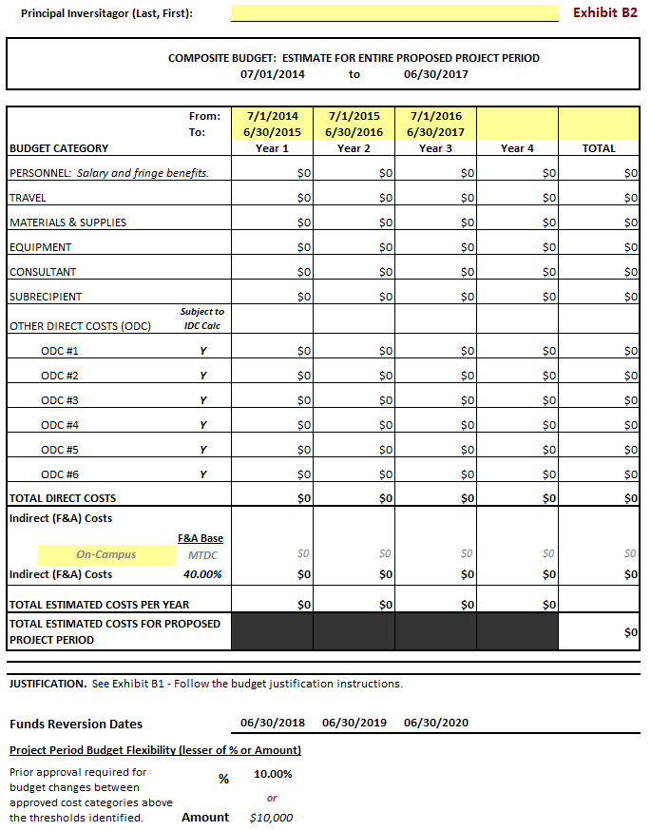
EXAMPLE

Exhibit B3
Invoice and Detailed Transaction Ledger Elements

In accordance with Section 14 – Payment and Invoicing, the invoice, summary report and/or transaction/payroll ledger shall be certified by the University’s Financial Contact and the PI.

Summary Invoice – includes either on the invoice or in a separate summary document – by approved budget category (Exhibit B) – expenditures for the invoice period, approved budget, cumulative expenditures and budget balance available
- Personnel
- Equipment
- Travel
- Subawardee – Consultants
- Subawardee – Subcontract/Subrecipients
- Materials & Supplies
- Other Direct Costs
  - TOTAL DIRECT COSTS (if available from system)
- Indirect Costs
  - TOTAL

Detailed transaction ledger and/or payroll ledger for the invoice period
- Univ Fund OR Agency Award # (to connect to invoice summary)
- Invoice/Report Period (matching invoice summary)
- GL Account/Object Code
- Doc Type (or subledger reference)
- Transaction Reference#
- Transaction Description, Vendor and/or Employee Name ⁶
- Transaction Posting Date ⁶
- Time Worked ⁶
- Transaction Amount ⁶

Exhibit C

UTC-116

AB20 State/University Model Agreement Terms & Conditions
http://www.dgs.ca.gov/ols/Resources/StandardContractLanguage.aspx

Exhibit D (if applicable)
Additional Requirements Associated with Funding Sources
If the Agreement is subject to any additional requirements imposed on the funding State agency by applicable law (including, but not limited to, bond, proposition and federal funding), then these additional requirements will be set forth in Exhibit D. If the University is a subrecipient, as defined in 2 CFR 200 (Uniform Guidance on Administrative Requirements, Audit Requirements and Cost Principles for Federal Financial Assistance), and the external funding entity is the federal government, the name of the federal agency, the prime award number (if available), and the Catalog of Federal Domestic Assistance (CFDA) program number will be listed in Exhibit D. (Please see sections 10.A and 10.B of the UTC.)

Agency  (Required for federal funding source) | Prime Agreement Number (if available) | If Federal, CFDA Number

Exhibit E (if applicable)
Special Conditions for Security of Confidential Information
If the of work or project results in additional legal and regulatory requirements regarding security of Confidential Information, those requirements regarding the use and disposition of the information, will be provided by the funding State agency in Exhibit E. (Please see section 8.E of the UTC.)

Exhibit F (if applicable)
Access to State Facilities or Computing Systems
Agency Requirements/Agreement
If the scope of work or project requires that the Universities have access to State agency facilities or computing systems and a separate agreement between the individual accessing the facility or system and the State agency is necessary, then the requirement for the agreement and the agreement itself will be listed in Exhibit F. (Please see section 20 of the UTC.)

Exhibit G – Negotiated Alternate UTC Terms (if applicable)
While every effort has been made to keep the UTC as universal in its application as possible, there may be unique projects where a given term in the UTC may be inappropriate or inadequate. AB20 allows for those terms to be changed, but only through the mutual agreement and negotiation of the State agency and the University campus. If a given term in the UTC is to be changed, the change should not be noted in Exhibit C, but rather noted separately in Exhibit G.

If this information is not on the invoice or summary attachment, it may be included in a detailed transaction ledger.
For salaries and wages, these elements are anticipated to be included in the detailed transaction ledger. If all elements are not contained in the transaction ledger, then a separate payroll ledger may be provided with the required elements.

