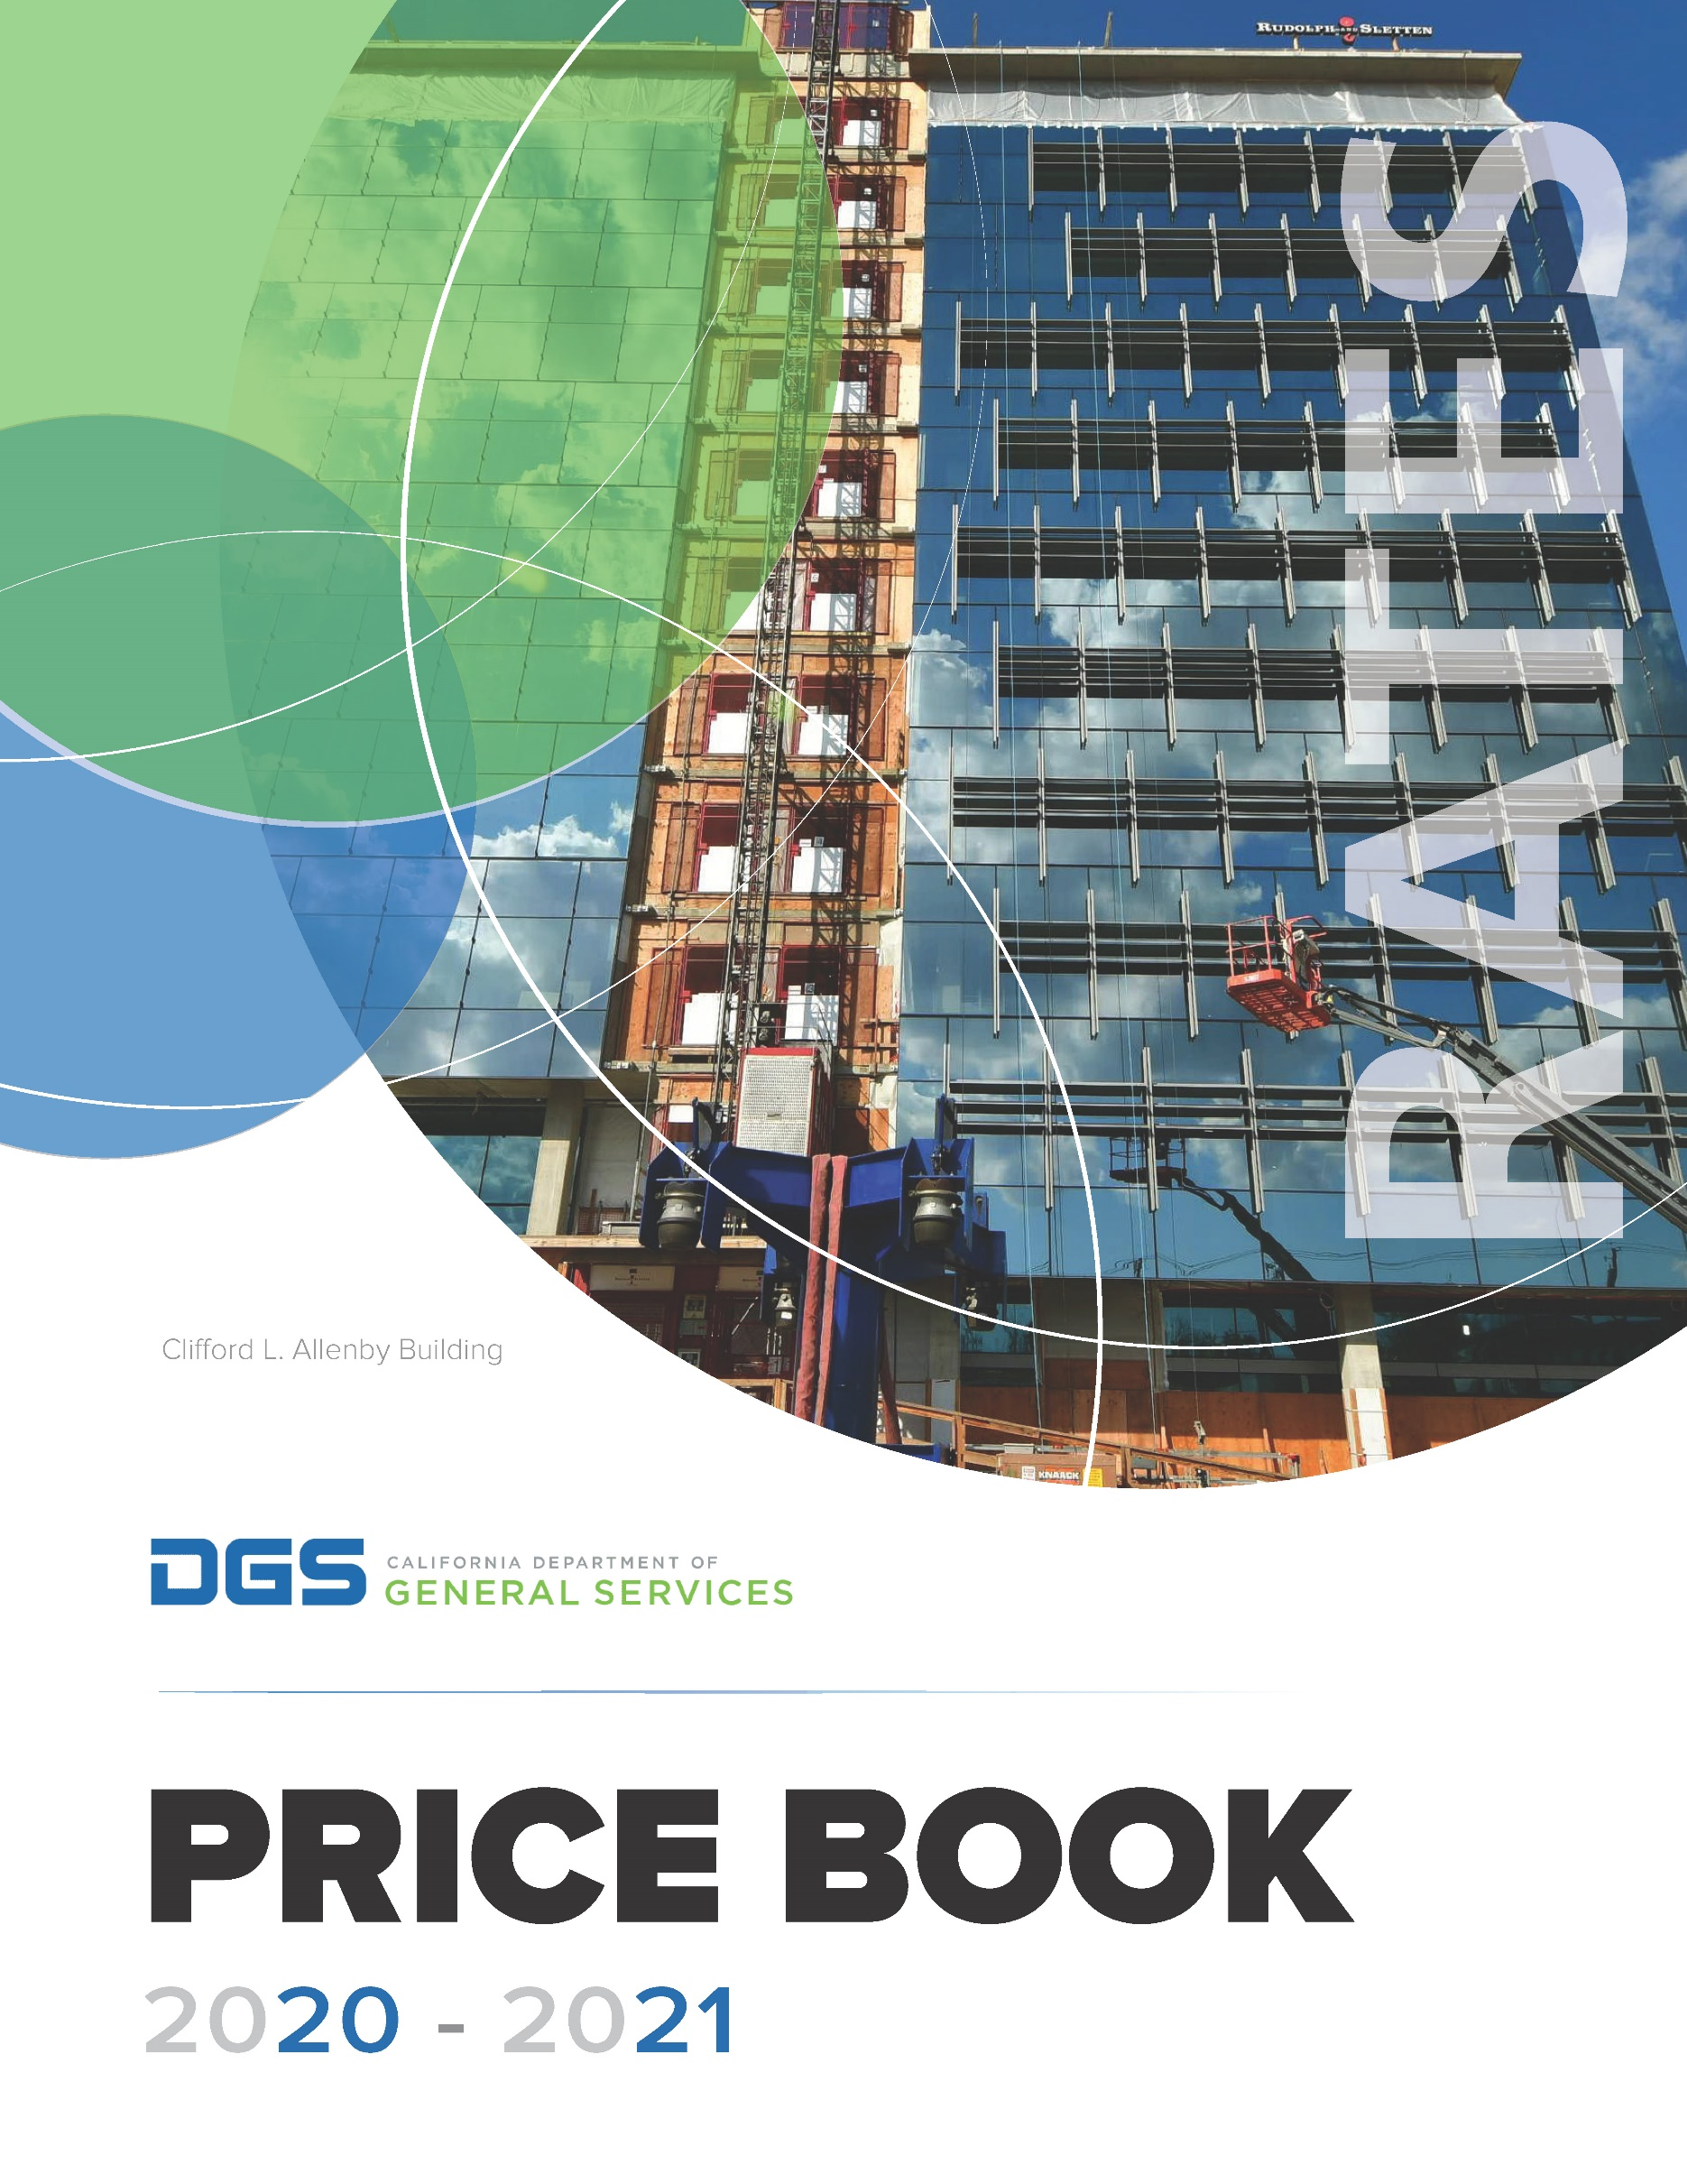

Table of Contents

Purpose of DGS 3
DGS Rates 4
Division of the State Architect 6
Facilities Management Division 9
Office of Administrative Hearings 17
Office of Fleet Asset Management 21
Office of Human Resources 26
Office of Legal Services 28
Office of Risk and Insurance Management 30
Office of State Publishing 33
Office of Sustainability 38
Procurement Division 41
Real Estate Services Division 46
Asset Management Branch 46
Construction Inspection and Management Branch 49
Project Management and Development Branch 50

Who We Are

Purpose of DGS
The Department of General Services (DGS) serves as the business manager for the State of California. With more than 3,500 employees and an operating budget of $1.2 billion, DGS serves the public by providing a variety of services to state agencies, local government, and other clients through innovative procurement and acquisition solutions, creative real estate management and design, environmentally friendly transportation, and through the implementation and enforcement of regulations and rules for the construction of safe schools and buildings throughout the state.

Mission
To deliver results by providing timely, cost-effective services and products that support our customers while protecting the interests of the State of California.

Vision
Excellence in the business of government. We strive to achieve excellence by providing our customers with the products and services they need in a professional manner that adds value.

Values
We have a set of core values that provide an important foundation for how we conduct ourselves and our business. These values are:

- Integrity: We do the right things for the right reasons.
- Accountability: We hold ourselves and each other responsible for all that we do.
- Communication: We listen and share information openly, honestly, and respectfully, with the goal of mutual understanding and transparency.
- Excellence: We strive for the best for each other and our customers.
- Innovation: We cultivate ideas and implement improvements throughout our organization.
- Teamwork: We value and respect our organizational diversity and work together to achieve great results.

DGS Rates
Every spring, the DGS Budget and Planning Section coordinates with each DGS program to develop a cost recovery plan for the upcoming two fiscal years (FY). This effort begins with each program’s baseline budget and the following cost recovery adjustments:

- Personal Services Budget Letters | - Budget Change Proposals
- Pro Rata Adjustments | - DGS Rent Allocation
- FI$Cal Adjustments | - Distributed Administration Adjustments
- Planned Position Realignments | - Planned Vacancies

Guiding Principles
The primary purpose of the rate setting process is to recover the full costs of providing goods or services pursuant to the State Administrative Manual (SAM) section 8752 and Government Code (GC) sections 11010 and 14604. DGS has established guiding principles to achieve full cost recovery while minimizing large fluctuations. Those principles are:

- Limit rate increases to three to five percent per year unless an event or situation dictates otherwise.
- Align rates to ensure consistency with the Governor’s vision for California to incentivize specific statewide efforts such as clean energy, water conservation, green building, and other priority initiatives.
- Each program should be self-sufficient.

Rate Setting Methodology: Billable Hours
Each DGS office is viewed as a separate entity. There are 13 major program areas consisting of over 200 individual rates. Once an accurate cost-to-recover is determined for each program, the program’s staff then analyze the amount of workload anticipated for the next two fiscal years. This is done by calculating the level of work produced over the past three fiscal years and projecting changes to the anticipated service levels or outputs (billable hours, projected statewide spend, square footage, contracts, etc.).

Each program produces multiple deliverables that include output justification packages describing each rate or service, the calculation of the projected outputs, and billable hours worksheets (if applicable). For hourly rates, the program determines the number of billable positions needed to produce the projected outputs, which are measured as billable hours and included in the costs to recover. The DGS rates are set at a level that will generate enough revenue to cover the costs of providing the service.

Changes to DGS Rates for Current and Budget Years
Due to the economic impact of the COVID-19 pandemic, DGS considered a number of revenue and workload scenarios to develop a forecast that would avoid any rate increases that were not necessary to recover the cost of providing services. While the pandemic has resulted in a severe drop in economic activity which has significantly reduced state revenue, the demand for DGS services is higher than ever. We have responded by continuing to provide excellent and cost effective services to our clients; from cleaning and sanitizing to ensuring safe workplaces, publishing materials to inform California voters in this pivotal election year, to coordinating emergency response efforts to help stop the spread of both wildfires and COVID-19. As a result of these efforts, this year’s Price Book includes reductions in four programs from what was proposed last year which includes the Procurement Division, Office of Sustainability, Office of Legal Services, and Office of Fleet Asset Management.

In an ordinary year, DGS would publish rates for two budget years so our clients have the best information possible to plan and make business decisions with confidence. However, this year has been anything but ordinary. As a result of our analysis, and given the current political and economic uncertainty, the best decision for our clients is to hold rates flat at the published 2020-21 rates for 2021-22 , with the exception of building rates. DGS is expecting to move forward on a change in the building rental rate methodology for budget year 2021-22 which will adjust building rent based upon condition and location.

While we currently plan to hold rates constant in the budget year, we will monitor workload, revenue, and client needs, and we will adjust rates as needed. This will ensure DGS is able to carry out its statutory responsibilities and deliver the best customer service at the best rates possible.

Division of the State Architect

The Division of the State Architect (DSA) offers design and construction oversight for K-12 schools, community colleges, and various other state-owned/leased facilities to ensure compliance with 1) structural, 2) access, and 3) fire and life safety requirements. DSA also develops accessibility, structural safety, and historical building codes and standards for various public and private buildings throughout the state of California.

DSA rates are defined in statute by the Government Code sections that establish the guidelines for each of its special funds. These rates can only be adjusted through an approved regulation packet, which proposes a change, addition, or deletion to existing regulations.

DSA Rates

Access Compliance
DSA reviews construction plans and specifications for essential services buildings and other state-funded buildings and facilities. In addition, DSA reviews construction plans and specifications for elementary, secondary, and California Community Colleges that are funded by any California city, county, or special district. Review of these projects is necessary to ensure compliance with state accessibility requirements for persons with disabilities.

DSA also provides plan review and code analysis consulting services as required by local agencies and design professionals.

Fire and Life Safety
DSA reviews plans and specifications for the construction of public schools, California Community Colleges, and state-owned/occupied essential services buildings for compliance with the California State Fire Marshal's building standards (authority: California Health and Safety Code).

Structural Safety
DSA reviews plans and specifications and inspects school building construction to ensure structural safety, as defined in the “Field Act,” for public schools and California Community Colleges.

In addition, DSA reviews plans and specifications and inspects essential services building construction to ensure structural safety, as defined in the “Essential Services Building Act.” This fee includes a charge for Access Compliance review services.

DSA also examines and reports on the structural safety of previously-constructed California public school buildings.

DIVISION OF THE STATE ARCHITECT
ACCESS COMPLIANCE RATES
DESCRIPTION | CY 2020-21 | BY 2021-22
Access Compliance Rates
State funded buildings and facilities access compliance plan review | 0.5% of first $500,000 of project cost plus 0.25% of excess greater than $500,000 to $2,000,000 plus 0.1% of excess greater than $2,000,000 to $25,000,000 plus 0.08% of excess greater than $25,000,000 to $50,000,000 plus 0.06% of excess greater than $50,000,000 to $100,000,000 plus 0.04% of excess greater than $100,000,000 (Minimum Fee $500.00). | 0.5% of first $500,000 of project cost plus 0.25% of excess greater than $500,000 to $2,000,000 plus 0.1% of excess greater than $2,000,000 to $25,000,000 plus 0.08% of excess greater than $25,000,000 to $50,000,000 plus 0.06% of excess greater than $50,000,000 to $100,000,000 plus 0.04% of excess greater than $100,000,000 (Minimum Fee $500.00).
Elementary, secondary, and California Community College access compliance plan review | 0.5% of first $500,000 of project cost plus 0.25% of excess greater than $500,000 to $2,000,000 plus 0.1% of excess greater than $2,000,000 to $25,000,000 plus 0.08% of excess greater than $25,000,000 to $50,000,000 plus 0.06% of excess greater than $50,000,000 to $100,000,000 plus 0.04% of excess greater than $100,000,000 (Minimum Fee $500.00). | 0.5% of first $500,000 of project cost plus 0.25% of excess greater than $500,000 to $2,000,000 plus 0.1% of excess greater than $2,000,000 to $25,000,000 plus 0.08% of excess greater than $25,000,000 to $50,000,000 plus 0.06% of excess greater than $50,000,000 to $100,000,000 plus 0.04% of excess greater than $100,000,000 (Minimum Fee $500.00).
Access compliance plan review and code analysis consulting services | Estimates available upon request. | Estimates available upon request.
Historical Buildings Safety Rates
State historical building plan review | Estimates available upon request. | Estimates available upon request.

Structural Safety Rates
Public school and California Community College structural safety plan review | 0.85% of the first $1,000,000 of project cost plus 0.6% of the project cost exceeding $1,000,000 (Minimum Fee $250.00). | 0.85% of the first $1,000,000 of project cost plus 0.6% of the project cost exceeding $1,000,000 (Minimum Fee $250.00).
Essential services building structural safety plan review | 1.5% of the first $1,000,000 of project cost plus 1.25% of project cost exceeding $1,000,000 (Minimum Fee $250.00). | 1.5% of the first $1,000,000 of project cost plus 1.25% of project cost exceeding $1,000,000 (Minimum Fee $250.00).
Examination and reporting on the structural safety of previously constructed California public school buildings. | Estimates available upon request. | Estimates available upon request.

DSA Certification and Training Program
For more information on programs, including Certified Access Specialist Program (CASp) and the Inspector Program, visit DSA’s website at: www.dgs.ca.gov/DSA

Facilities Management Division

The DGS Facilities Management Division (FMD) is the largest division within DGS and provides administrative, maintenance, and custodial services to approximately 270 buildings statewide. FMD’s oversight responsibilities extend to various office buildings, warehouses, storage locations, the state printing plant, the state’s central heating and cooling plant, stand-alone parking structures, and the state records warehouse.

FMD operates and maintains sustainable state facilities that are both energy and water efficient and environmentally friendly. FMD has an Environmental Health and Safety Unit (E-Shop) which provides support services for meeting or exceeding regulatory compliance with asbestos, lead, chemical exposures, indoor air quality, hazardous waste, ergonomics, and other issues. FMD also provides public work contracts and minor projects for our clients and tenants through a variety of sources and continues to ensure the safety and well-being of our assets, clients, and tenants.

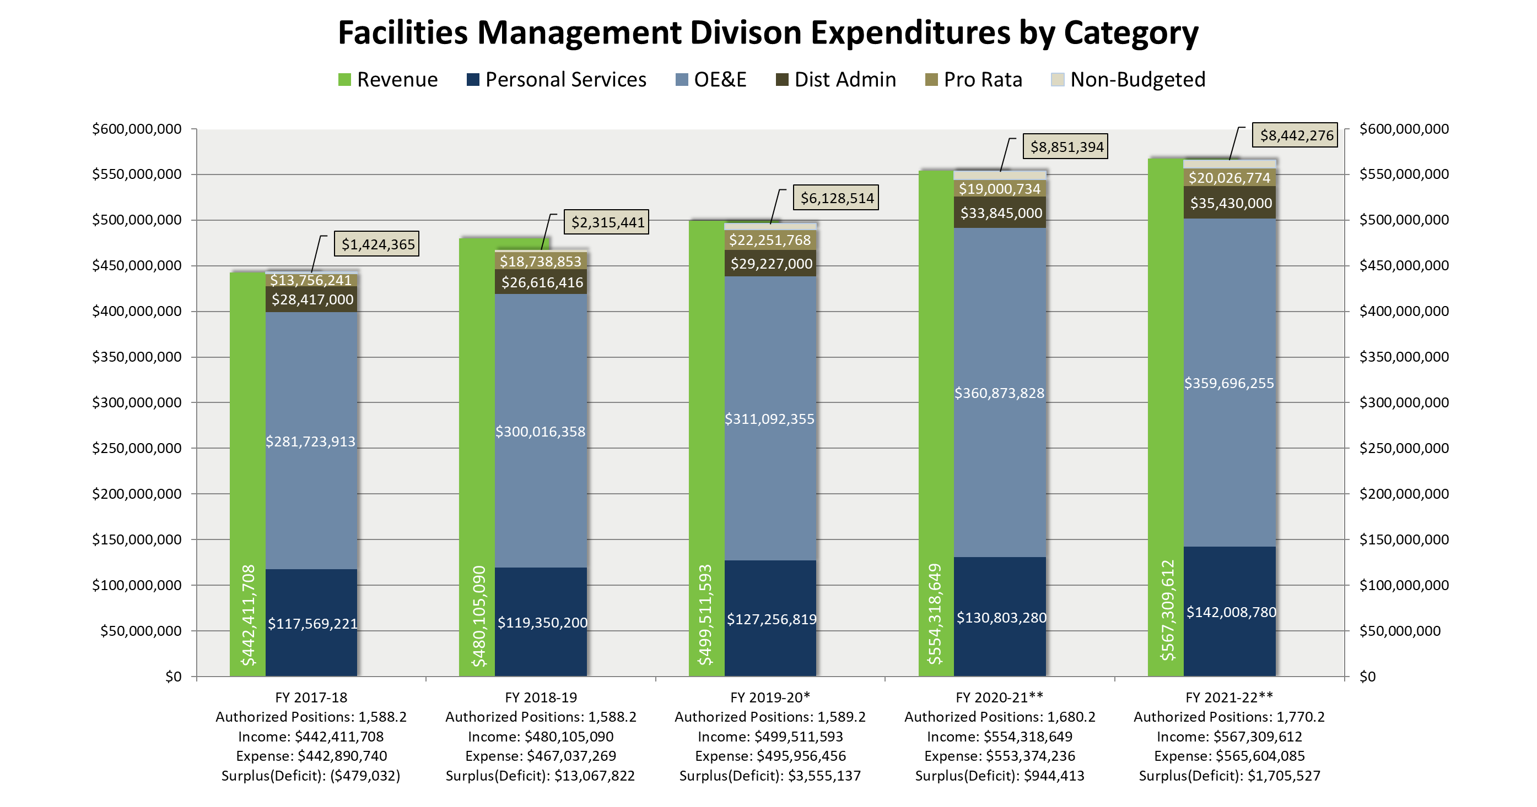

Footnotes:
*FY 2019-20 includes $15,079,000 in General Fund.
**FY 2020-21 includes $72,916,000 in General Fund.
**FY 2021-22 includes $68,644,000 in General Fund and projected surplus will be used to address the Deferred Maintenance backlog

Material Changes to FMD Rates Assumptions

Budget Letter for Employer Retirement Contributions (Control Section 3.60)
This Budget Letter instructs departments to process budget adjustments for employee retirement as prescribed by Control Section 3.60 of the Budget Act. Retirement rates are projected to increase by 1.4% or approximately $1M in both FY 2020-21 and 2021-22.

Budget Letter for Employee Compensation Adjustments (Item 9800)
This Budget Letter instructs departments to process budget adjustments for salaries and wages as prescribed by bargaining unit contract agreements as well as projected health and dental benefits adjustments. The FMD projected budgetary increase is approximately $3.2M in FY 2020-21 and $2.3M in FY 2021-22.

Statewide General Administrative Expenditures (Pro Rata)
The Pro Rata for FMD in FY 2020-21 is approximately $19.0M. DGS Budgets and Planning Section projects an increase in Pro Rata for FY 2021-22 of approximately $1.0M for a total of $20.0M.

Personal Leave Program 2020 (PLP 2020)
Reflected in rates is a reduction of 9.23% in salaries and wages for both FY 2020-21 and 2021-22 in the approximate amounts of $8.5M and $10.0M, respectively. The FY 2021-22 amount is greater due to anticipated new positions from this year’s budget change proposal to support the new Natural Resources Headquarters and Clifford L. Allenby buildings.

New Natural Resources Headquarters and Clifford L. Allenby Buildings
For FY 2020-21, FMD has been informed that the new Allenby building will be occupied for only a portion of the year, and the New Natural Resources HQ is not expected to be sufficiently occupied until FY 2021-22. For revenue projection purposes, the Allenby Building is assumed to be occupied for the final three months of the FY 2020-21 while there is no revenue projected for the New Natural Resources HQ building until FY 2021-22.

Building Closures/Sequencing Plan Considerations
FMD has incorporated anticipated building closures outlined in DGS’ sequencing plan to account for changes in associated revenue.

FMD Rates

Building Rates
Effective FY 2021-22, FMD will utilize an updated approach to setting building rates to create uniformity, standardization, and equity across the portfolio. The new methodology establishes rental rates for each building based on two criteria: the quality of the building based on its determined building grade (Class A, B, or C), and the region in which the building is located.
The office space rate determination starts with a market analysis to determine what “Class A” office space is going for in each region. That amount is then discounted proportionally based on each building’s overall quality (Class B buildings would pay 85% of the Class A rate; Class C buildings would pay 85% of the Class B rate). Building classes are determined based on building industry standards, individual Facility Condition Assessments (FCAs), and the current deferred maintenance needs at each location.

Furthermore, under this new methodology, DGS proposes to standardize storage space rate calculations to charge one quarter of the base office space rate (exclusive of any bond debt attached to the building).

To limit financial impacts to departments currently paying rent below the assessed building grade within their region, rate increases will be phased in over several fiscal years and will be capped at no more than a 3-5% increase each year. As a result, buildings in poor condition or in lower-cost markets would see a limited or zero increase, and in some cases, a decrease to their rental payments. Whereas tenants in higher-quality buildings or higher-cost markets would see no more than a 3-5% increase per year until they reach their target level.

BUILDING RENTAL ACCOUNT (BRA) RATES
DESCRIPTION |  | UNIT | CY 2020-21 | BY 2021-22
Office Space |  | Square Ft. | $2.55 | --
Storage Area |  | Square Ft. | $0.61 | --
BUILDING RENTAL RATES
BUILDING | UNIT |  | CY 2020-21 | BY 2021-22
NEW Allenby Building
Office Space | Square Ft. |  | $3.10 | $3.25
Storage Area | Square Ft. |  | $0.77 | $0.79
NEW Natural Resources HQ
Office Space | Square Ft. |  | $3.10 | $3.25
Storage Area | Square Ft. |  | $0.77 | $0.79
8th and Q Office Buildings
Office Space | Square Ft. |  | $2.55 | $2.62
Storage Area | Square Ft. |  | $0.61 | $0.67
Alfred E. Alquist Building
Office Space | Square Ft. |  | $2.55 | $2.62
Storage Area | Square Ft. |  | $0.61 | $0.67
Attorney General – Sacramento
Office Space | Square Ft. |  | $2.68 | $2.72
Storage Area | Square Ft. |  | $0.86 | $0.60

BUILDING RENTAL RATES (continuation)
REGION | UNIT | CY 2020-21 | BY 2021-22
Bateson Building
Office Space | Square Ft. | $2.55 | N/A
Storage Area | Square Ft. | $0.61 | N/A
Blue Anchor
Office Space | Square Ft. | $2.55 | $2.28
Storage Area | Square Ft. | $0.61 | $0.61
Board of Equalization
Office Space | Square Ft. | $3.99 | $4.04
Storage Area | Square Ft. | $1.30 | $0.60
Buildings and Grounds
Office Space | Square Ft. | $2.55 | $2.28
Storage Area | Square Ft. | $0.61 | $0.61
CALNET
Office Space | Square Ft. | $2.55 | $2.62
Storage Area | Square Ft. | $0.61 | $0.67
Cal-Trans Dist. 3, Marysville
Office Space | Square Ft. | $6.02 | $5.46
Storage Area | Square Ft. | $1.97 | $0.68
Cal Trans Dist. 11, San Diego
Office Space | Square Ft. | $4.55 | $4.63
Storage Area | Square Ft. | $1.48 | $0.71
Central Plant
Office Space | Square Ft. | $0.57 | $0.57
Storage Area | Square Ft. | N/A | N/A
Department of Justice Building
Office Space | Square Ft. | $2.55 | $2.04
Storage Area | Square Ft. | $0.61 | $0.61
East End – Sacramento
Office Space | Square Ft. | $4.05 | $4.10
Storage Area | Square Ft. | $1.32 | $0.60
EDD Headquarters
Office Space | Square Ft. | $2.55 | $2.62
Storage Area | Square Ft. | $0.61 | $0.66
EDD Solar
Office Space | Square Ft. | $2.55 | $2.28
Storage Area | Square Ft. | $0.61 | $0.61

BUILDING RENTAL RATES (continuation)
REGION | UNIT | CY 2020-21 | BY 2021-22
Edmund G. “Pat” Brown Building
Office Space | Square Ft. | $2.55 | $2.62
Storage Area | Square Ft. | $0.61 | $0.66
Elihu Harris – Oakland
Office Space | Square Ft. | $3.85 | $3.91
Storage Area | Square Ft. | $1.25 | $0.60
Food and Agriculture
Office Space | Square Ft. | $3.35 | $3.41
Storage Area | Square Ft. | $1.08 | $0.60
Franchise Tax Board
Office Space | Square Ft. | $2.29 | $2.33
Storage Area | Square Ft. | $0.73 | $0.60
Hugh Burns
Office Space | Square Ft. | $2.55 | $2.04
Storage Area | Square Ft. | $0.61 | $0.61
Jesse Unruh Building
Office Space | Square Ft. | $2.55 | $2.62
Storage Area | Square Ft. | $0.61 | $0.66
Joseph A. Rattigan Building
Office Space | Square Ft. | $2.55 | $2.38
Storage Area | Square Ft. | $0.61 | $0.61
Junipero Serra
Office Space | Square Ft. | $2.55 | $2.44
Storage Area | Square Ft. | $0.61 | $0.62
Library and Courts, 914 Capitol Mall
Office Space | Square Ft. | $7.93 | $8.23
Storage Area | Square Ft. | $2.61 | $0.60
Library and Courts Annex
Office Space | Square Ft. | $2.55 | $2.62
Storage Area | Square Ft. | $0.61 | $0.67
Office Building #08
Office Space | Square Ft. | $3.84 | $3.88
Storage Area | Square Ft. | $1.25 | $0.60

BUILDING RENTAL RATES (continuation)
REGION | UNIT | CY 2020-21 | BY 2021-22
Office Building #09
Office Space | Square Ft. | $3.84 | $3.88
Storage Area | Square Ft. | $1.25 | $0.60
Paul Bonderson Building
Office Space | Square Ft. | $2.55 | $2.28
Storage Area | Square Ft. | $0.61 | $0.61
Red Bluff
Office Space | Square Ft. | $2.55 | $2.04
Storage Area | Square Ft. | $0.61 | $0.61
Redding
Office Space | Square Ft. | $2.55 | $2.04
Storage Area | Square Ft. | $0.61 | $0.61
Rehabilitation (OB-10)
Office Space | Square Ft. | $3.32 | $3.38
Storage Area | Square Ft. | $1.07 | $0.60
Resources Building
Office Space | Square Ft. | $2.55 | N/A
Storage Area | Square Ft. | $0.61 | N/A
Riverside Cal-Towers
Office Space | Square Ft. | $5.65 | $5.00
Storage Area | Square Ft. | $1.85 | $0.83
Ronald Reagan State Building
Office Space | Square Ft. | $2.72 | $2.77
Storage Area | Square Ft. | $0.61 | $0.71
San Diego
Office Space | Square Ft. | $2.55 | $2.35
Storage Area | Square Ft. | $0.61 | $0.61
San Diego Mission Valley
Office Space | Square Ft. | $3.00 | $3.05
Storage Area | Square Ft. | $0.97 | $0.60
San Francisco – Ronald M. George State Office Complex
Office Space | Square Ft. | $4.47 | $4.53
Storage Area | Square Ft. | $1.46 | $0.60

BUILDING RENTAL RATES (continuation)
REGION | UNIT | CY 2020-21 | BY 2021-22
Secretary of State
Office Space | Square Ft. | $2.55 | $2.62
Storage Area | Square Ft. | $0.61 | $0.67
State Capitol
Office Space | Square Ft. | $2.55 | $2.62
Storage Area | Square Ft. | $0.61 | $0.67
State Personnel Building
Office Space | Square Ft. | $2.55 | $2.62
Storage Area | Square Ft. | $0.61 | $0.66
Stockton
Office Space | Square Ft. | $2.55 | $2.04
Storage Area | Square Ft. | $0.61 | $0.61
Van Nuys
Office Space | Square Ft. | $2.55 | $2.04
Storage Area | Square Ft. | $0.61 | $0.61
Warren-Alquist State Energy
Office Space | Square Ft. | $2.55 | $2.62
Storage Area | Square Ft. | $0.61 | $0.67
Water Resources
Office Space | Square Ft. | $2.55 | $2.04
Storage Area | Square Ft. | $0.61 | $0.61

Partial Services
In addition to building management, FMD charges hourly rates to provide operations and maintenance services such as trades and crafts, engineering, grounds keeping, and custodial services at facilities throughout the State for non-DGS owned or managed buildings. The rates for these services are calculated by dividing the cost to be recovered by the billable hours per classification.

PARTIAL SERVICE RATES BY CLASSIFICATION
POSITION CLASSIFICATION | UNIT | CY 2020-21 | BY 2021-22¹
Associate Electrical Engineer | Hourly | $187.00 | --
Associate Industrial Hygienist | Hourly | $162.30 | --
Associate Landscape Architect | Hourly | $207.90 | --
Building Maintenance Worker | Hourly | $85.80 | --
Carpenter I | Hourly | $99.75 | --
Chief Engineer I | Hourly | $140.80 | --
Chief Engineer II | Hourly | $142.70 | --
Clerical Support | Hourly | $70.35 | --
Custodian | Hourly | $53.70 | --
Custodian Supervisor II | Hourly | $73.50 | --
Custodian Supervisor III | Hourly | $77.90 | --
Electrician I | Hourly | $107.80 | --
Electrician II | Hourly | $112.10 | --
Electronic Technician | Hourly | $103.90 | --
Groundskeeper | Hourly | $75.90 | --
Lead Groundskeeper | Hourly | $82.70 | --
Locksmith I | Hourly | $102.30 | --
Maintenance Mechanic | Hourly | $103.20 | --
Mechanical Engineer | Hourly | $195.90 | --
Office Building Manager I | Hourly | $125.60 | --
Office Building Manager II | Hourly | $144.95 | --
Office Building Manager III | Hourly | $151.10 | --
Painter I | Hourly | $99.35 | --
Plumber I | Hourly | $107.30 | --
Stationary Engineer | Hourly | $127.55 | --
Stationary Engineer Apprentice | Hourly | $97.70 | --
Supervising Groundskeeper I | Hourly | $91.55 | --
Supervising Groundskeeper II | Hourly | $104.95 | --
Supervisor of Building Trades | Hourly | $126.85 | --
Tree Maintenance Lead worker | Hourly | $75.90 | --
Tree Maintenance Worker | Hourly | $75.90 | --
Warehouse Worker | Hourly | $77.80 | --
¹ Due to economic uncertainty, for the purpose of forecasting and budgeting, DGS is assuming BY 2021-22 rates are held constant at current levels, but DGS will closely monitor workload, expenditures, and revenues and will modify as necessary next year.

For additional information, please contact the Facilities Management Division at (916) 322-8779 or visit our website at: https://www.dgs.ca.gov/FMD

Office of Administrative Hearings

The Office of Administrative Hearings (OAH) is a quasi-judicial tribunal that hears administrative disputes. Established by the California Legislature in 1945, OAH provides independent Administrative Law Judges (ALJs) to preside as neutral judicial officers at hearings and settlement conferences. OAH consists of two divisions, General Jurisdiction and Special Education, and has regional offices in Sacramento, Oakland, Los Angeles, and San Diego. The General Jurisdiction Division conducts hearings, mediations, and settlement conferences for more than 1,800 state, local, and county agencies. The Special Education Division conducts special education due process hearings and mediations for school districts and parents of children with special education needs throughout the State.

Although OAH is housed within the Department of General Services for administrative purposes, it is an independent state entity under the direction and control of the Director of OAH, who is appointed by the Governor, and subject to confirmation by the Senate. ALJs are highly-trained legal professionals with experience in deciding cases involving complex issues. All ALJs are appointed by the Director of OAH, and act independently from the agencies appearing before OAH in hearings, mediations, and all other administrative matters. OAH offers a wealth of experience, qualified ALJs, professional calendar staff, and the flexibility to mediate, arbitrate, or adjudicate administrative disputes at a cost substantially less than that charged by other providers. They assure that all parties receive a neutral and fair “day in court” while ensuring due process and respect for the dignity of all.

For state agencies whose proceedings are subject to the Administrative Procedure Act (APA) (Gov. Code §11370, et seq.), an interagency agreement is not required. Once an agency is established with OAH, OAH will direct-bill the state agencies using the agencies’ bill code.

For state agencies and local agencies not subject to the APA, an interagency or local agency agreement is required before a case may be filed with OAH.

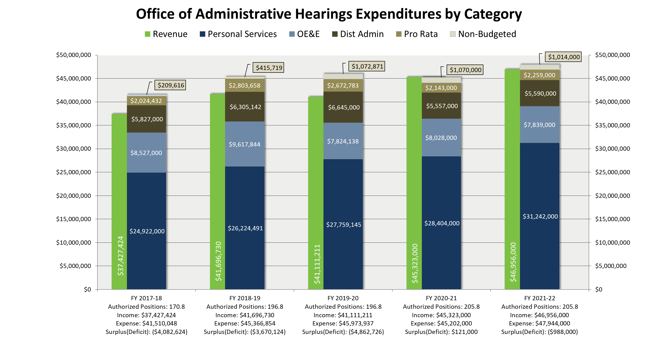
Footnotes:
*FY 2017-18 income includes $2.9M as a prior year adjustment. It should be noted that there was an approved deficit through the unfunded approval process which was added to the income.
** FY 2018-19 revenue includes an accrual of $1.2M, which was not recorded at year-end-close (will be a FY 2018-19 prior period adjustment). Whereas the deficit, includes an approved unfunded need of $1,8M for the San Diego & Los Angeles build out.
***FY 2019-20 is based on Q3 Program Summary Projections. The revenue deficit is due to a shortage in billable hours projected at rates (89,250) vs actual billable hours (83,300) which resulted in a revenue loss of $1.8M coupled with a reduction in hearings due to COVID that is projected to be negative $2.5M for March to June 2020.

Material Changes to OAH Rates Assumptions

Budget Letter for Employer Retirement Contributions (Control Section 3.60)
This Budget Letter instructs departments to process budget adjustments for employee retirement as prescribed by Control Section 3.60 of the Budget Act. Retirement rates are projected to increase by 1.4% in FY 2020-21 and 2021-22. The OAH projected budgetary increase is $274,000 in FY 2020-21 and $292,000 in FY 2021-22.

Budget Letter for Employee Compensation Adjustments (Item 9800)
This Budget Letter instructs departments to process budget adjustments for salaries and wages as prescribed by bargaining unit contract agreements as well as projected health and dental benefits adjustments. OAH’s projected budgetary increase is $64,000 in FY 2020-21 and $668,000 in FY 2021-22.

Statewide General Administrative Expenditures (Pro Rata)
The Pro Rata for OAH in FY 2020-21 is $2,143,000. DGS Budgets and Planning Section projects an increase of 5.4% in Pro Rata for FY 2021-22, which is an increase of $116,000.

Personal Leave Program 2020 (PLP 2020)
Reflected in rates is a salaries and wages reduction of 9.23% in both FY 2020-21 and 2021-22 in response to the economic uncertainty caused by the COVID-19 pandemic to achieve state-wide budget savings.

Cannabis Administrative Hearings
OAH expects to see a significant impact from a new area of licensing cases stemming from the Medicinal and Adult-Use Cannabis Regulation and Safety Act. These provisions created numerous new cannabis-related licenses with hearing rights before the Office of Administrative Hearings effective January 1, 2018. The fiscal impact on OAH will be dependent upon when the three different licensing agencies (Department of Food and Agriculture, Department of Public Health, and the Bureau of Cannabis Control) begin processing (issuing/denying) applications for the various types of cannabis licenses and processing disciplinary cases.

OAH FY 2020-21 Budget Change Proposal (BCP) was approved for the expenditure authority on a limited-term three-year extension beginning in FY 2020-21 as a result of new administrative hearing workload for Medicinal and Adult-Use Cannabis Regulation and Safety Act related cases.

New Electronic Evidence Fee
Due to the shutdown of in-person proceedings (mediations, settlement conferences, prehearing conferences and hearings) OAH had to create a virtual courtroom system. In March/April 2020, OAH signed a contract with CaseLines, a service that allows for the uploading, electronic review, and electronic capture of evidence in their cases. This new fee will enable OAH to recover its cost on a flow-through basis. OAH anticipates that an estimated 2,500 cases per year will utilize CaseLines.

OAH Rates

OFFICE OF ADMINISTRATIVE HEARING RATES
DESCRIPTION | UNIT | CY 2020-21 | BY 2021-22¹
Administration Law Judge  (General jurisdiction) | Per hour | $318.00 | --
Filing Fee  (General jurisdiction) | Per case | $125.00 | --
Electronic Evidence Fee | Per case | Contract Rate | --
Electronic Recording Fee | Per hearing/per calendar day | $30.00 | --
Hearing Reporter |  | Contract Rate | --
Transcript Rate |  | Contract Rate | --
¹ Due to economic uncertainty, for the purpose of forecasting and budgeting, DGS is assuming BY 2021-22 rates are held constant at current levels, but DGS will closely monitor workload, expenditures, and revenues and will modify as necessary next year.

For additional information, please contact the OAH at (916) 263-0550 or visit our website at: https://www.dgs.ca.gov/OAH

Office of Fleet Asset Management

The Office of Fleet and Asset Management (OFAM) provides statewide transportation and commute-related services with a customer-based focus. OFAM provides cost-effective vehicle services to meet the needs of state departments. OFAM is also responsible for the establishment, implementation, and maintenance of policies and procedures governing state owned mobile equipment. OFAM’s transportation-related services include long-term vehicle rentals, vehicle inspections, parking, fully managed travel contracts, vehicle acquisition and disposition, and consultation regarding automotive management issues. In addition to transportation and commute related services, OFAM administers the State Surplus Property and Reutilization Program, the Federal Surplus Property Program, and offers client agencies quality supplemental storage through its Transit Storage Program.
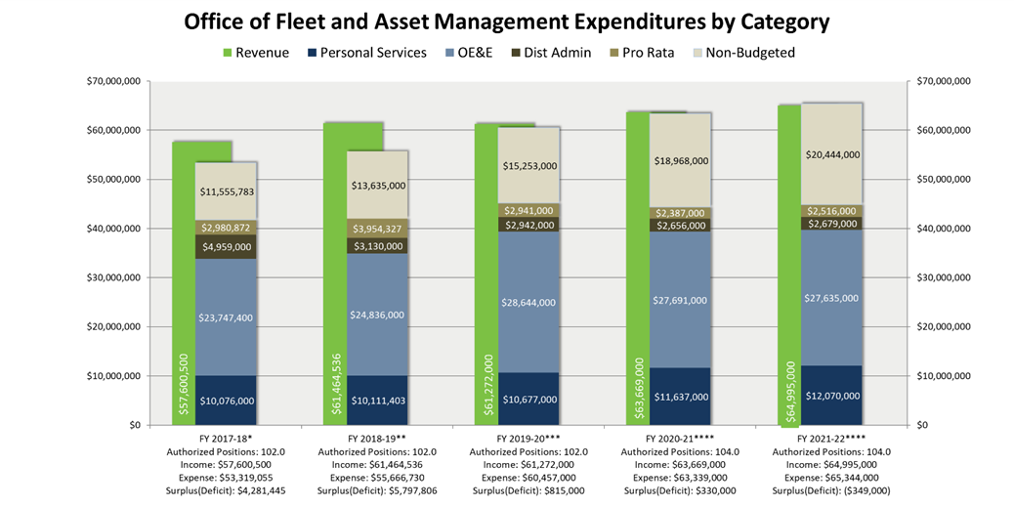
Footnotes:
*FY 2017-18 totals are from the Year End Program Summary. The Distributed Admin Total includes additional department Distributed Admin charges.
**FY 2018-19 totals are from the Budget to Actuals Dashboard.
***FY 2019-20 expenditure totals are from the 3rd Quarter Program Summary and Program’s COVID-19 reports, Revenue Totals are from Program's COVID-19 forecast.
****FY 2020-21 and FY 2021-22 projections are based on the FY 2021-22 RCW.

Material Changes to OFAM Rates Assumptions

Budget Letter for Employer Retirement Contributions (Control Section 3.60)
This Budget Letter instructs departments to process budget adjustments for employee retirement as prescribed by Control Section 3.60 of the Budget Act. Retirement rates are projected to increase by 1.4 The projected budgetary increase is approximately $103,000 in both FY 2020-21 and 2021-22.

Budget Letter for Employee Compensation Adjustments (Item 9800)
This Budget Letter instructs departments to process budget adjustments for salaries and wages as prescribed by bargaining unit contract agreements as well as projected health and dental benefits adjustments. The projected budgetary increase for OFAM is $234,000 in FY 2020-21 and $475,000 in FY 2021-22.

Statewide General Administrative Expenditures (Pro Rata)
Pro Rata in FY 2020-21 for OFAM is $2,387,000. DGS Budgets and Planning Section projects an increase of 5.4 percent in Pro Rata for FY 2021-22 which is an additional $129,000.

Personal Leave Program 2020 (PLP 2020)
Reflected in rates is a salaries and wages reduction of 9.23% in both FY 2020-21 and 2021-22 in response to the economic uncertainty caused by the COVID-19 pandemic to achieve state-wide budget savings.

OFAM Rates

Fleet Asset Management Program (FAMS)
The FAMS is charged with the responsibility of overseeing the state fleet in accordance with laws and mandates.

State agencies report fleet data to OFAM which provides fleet analysis and reports to the administration, legislature and the public. OFAM Inspection Services staff provide periodic and on-demand inspections of mobile equipment to ensure safety and contract oversight of mechanical services, equipment modifications, and repair work performed by private vendors. The program also oversees/performs accident inspections on behalf of the Office of Risk and Insurance Management, develops statewide fleet policy, implements federal fleet rules statewide, investigates and approves/denies vehicle acquisition and disposal requests, provides statewide fleet management consultation, and authorizes repairs by vendors throughout the State.

Vehicle Decommissioning and Disposition
OFAM provides state agencies and departments with decommissioning and disposition services for vehicles or equipment when they are no longer needed or cost-effective to operate and are sold at surplus auctions. Decommissioning services, which are performed by DGS staff, includes removal and disposal of license plates, Vehicle Identification Number (VIN) verification, vehicle cleaning, removal of state decals, and vehicle safety inspections. Disposition services include staffing live auctions, fleet analysis, scheduling services, posting online auctions, security fees, and auctioneer fees. Disposal may be made by live public auction, online public auction, sealed bid, field sale, reutilization, or transfer of a vehicle between agencies. The disposal method is determined by using the most cost-effective method to the State.

Transit Storage Program (TSP)
TSP provides low cost warehouse storage services for state agencies. Located in Sacramento, TSP can provide either pallet racking or high security storage. Material can be delivered to the warehouse or received directly from the supplier. There are no access fees, only a storage rate based on the number of cubic feet of storage. Services include unloading, storing, tracking, and reloading of customer property.

State Surplus Property Program (SSPP)
SSPP is responsible for the proper disposition of all state-owned surplus property. Surplus property that is reusable and cannot be placed within another state agency is made available through online auctions. SSPP provides disposition solutions for surplus and unwanted state-owned personal property for all state agencies. In addition, SSPP disposes of confiscated or abandoned property within the State of California.

Federal Surplus Property Program (FSPP)
FSPP is responsible for obtaining federal surplus personal property for qualifying non-federal organizations within the state for their business and operational needs. To sustain its operations, the FSPP assesses a service and handling fee for each item of federal surplus property that a donee receives. The service and handling fee is 10 percent of the original acquisition cost of the item, or $100, whichever is greater.

Services include determining eligibility of donees, processing new and renewal applications, maintaining a database of donees, processing the requests for federal surplus equipment and preparing the invoices for fees on a monthly basis. In addition, a compliance audit is required annually to ensure that placed equipment is being used appropriately.

Statewide Travel Program (STP)
STP assists state and local government travelers with their travel needs by obtaining the most economical rates available through the use of contracted travel-related services for airfare, car rentals, travel agency, and travel payment system. In addition, STP has contracted with a travel agency to provide state and local government travelers with an online booking tool for one-stop shopping for travel arrangements, including reservations for airline tickets, car rentals, rail, and hotel.

For more information, contact the Statewide Travel Program at (916) 376-3974, or visit our website at: https://www.dgs.ca.gov/OFAM/Travel.

OFFICE OF FLEET MANAGEMENT RATES
DESCRIPTION | UNIT | CY 2020-21 | BY 2021-22¹
Fleet Asset Management Program
Fleet Asset Management Fee | Per asset annually | $134.00 | --
Surplus Property and Reutilization
Disposition Fee | Per vehicle | $390.00 | --
Transit Storage Standard | Cubic Feet | $0.49 | --
Transit Storage Secured | Cubic Feet | $0.50 | --
Federal Surplus Property | Prop Value | 10% or $100  whichever is greater | --
State Travel
Travel Management Fee |  | Vendor charges for travel services are available upon request. | --
¹ Due to economic uncertainty, for the purpose of forecasting and budgeting, DGS is assuming BY 2021-22 rates are held constant at current levels, but DGS will closely monitor workload, expenditures, and revenues and will modify as necessary next year.

MONTHLY RENTAL RATES BY VEHICLE TYPE
DESCRIPTION | UNIT¹ | CY 2020-21 | BY 2021-22²
Gasoline Compact Sedan | Monthly | $407.00 | --
Gasoline Midsize Sedan | Monthly | $433.00 | --
Gasoline Full-size Sedan | Monthly | $477.00 | --
Hybrid Compact Sedan | Monthly | $386.00 | --
Hybrid Midsize Sedan | Monthly | $445.00 | --
Hybrid Full-size Sedan | Monthly | $463.00 | --
Plug-in Hybrid Electric Sedan | Monthly | $403.00 | --
Battery Electric Vehicle | Monthly | $376.00 | --
Hydrogen Fuel Cell Vehicle | Monthly | $494.00 | --
Police Package Vehicle | Monthly | $461.00 | --
Gasoline Small SUV | Monthly | $470.00 | --
Gasoline Medium SUV | Monthly | $496.00 | --
Gasoline Large SUV | Monthly | $533.00 | --
Hybrid Small SUV | Monthly | $462.00 | --
Hybrid Medium SUV | Monthly | $482.00 | --
Plug-in Hybrid Electric SUV | Monthly | $433.00 | --
Mini Pickup Truck | Monthly | $524.00 | --
1/2 Ton Pickup Truck | Monthly | $540.00 | --
3/4 Ton Pickup Truck | Monthly | $601.00 | --
Large Cargo/Passenger Van | Monthly | $479.00 | --
Mini Cargo/Passenger Van | Monthly | $443.00 | --
Plug-in Hybrid Electric Mini Passenger Van | Monthly | $428.00 | --
Fuel & Maintenance Mgmt. Fee | % of total fuel, maintenance, and repair expense | 1.80% | --
- The monthly flat rates do not include fuel, all monthly rental vehicles will be $0.10 per mile.
- Due to economic uncertainty, for the purpose of forecasting and budgeting, DGS is assuming BY 2021-22 rates are held constant at current levels, but DGS will closely monitor workload, expenditures, and revenues and will modify as necessary next year.

For additional information, contact the Office of Fleet and Asset Management, (916) 928- 2550 or view the OFAM website at: https://www.dgs.ca.gov/OFAM

Office of Human Resources

The Contracted Human Resources (CHR) unit within the Office of Human Resources (OHR) provides a comprehensive range of human resources functions for 18 state agencies, primarily boards and commissions. CHR ensures all clients are in compliance with Federal and State personnel laws, rules, regulations, and applicable bargaining unit contracts.
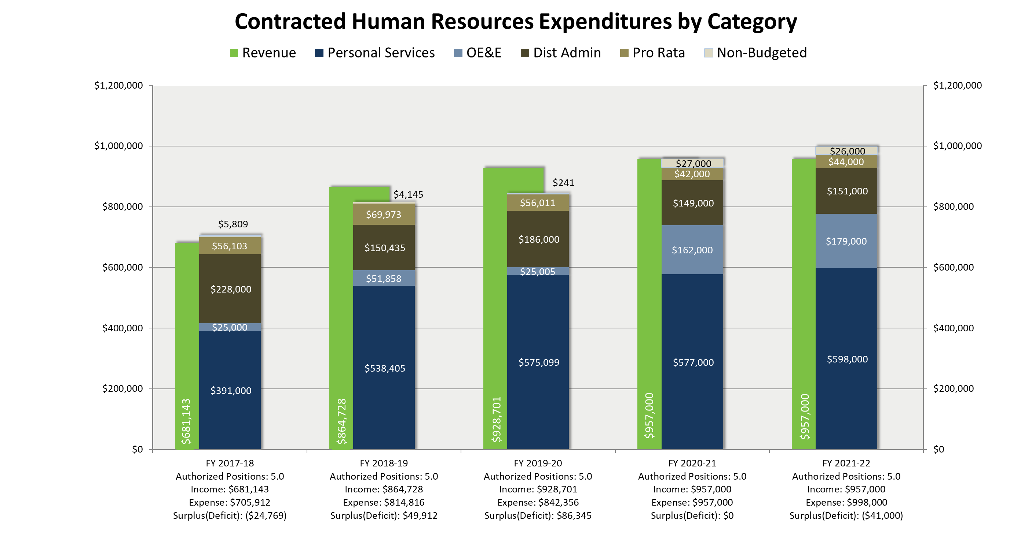
Footnote:
*FY 2020-21 and 2021-22 projections are based on Quarter 3 Program Summary and FY 2020-21 RCW.

Material Changes to CHR Rates Assumptions

Budget Letter for Employer Retirement Contributions (Control Section 3.60)
This Budget Letter instructs departments to process budget adjustments for employee retirement as prescribed by Control Section 3.60 of the Budget Act. Retirement rates are projected to increase by 1.4% in FY 2020-21 and 2021-22. The CHR projected budgetary increase is approximately $5,000 in both FY 2020-21 and 2021-22.

Budget Letter for Employee Compensation Adjustments (Item 9800)
This Budget Letter instructs departments to process budget adjustments for salaries and wages as prescribed by bargaining unit contract agreements as well as projected health and dental benefits adjustments. The CHR projected budgetary increase is approximately $20,000 in FY 2020-21 and $18,000 in FY 2021-22.

Statewide General Administrative Expenditures (Pro Rata)
The Pro Rata for CHR in FY 2020-21 is approximately $42,000. DGS Budgets and Planning Section projects an increase in Pro Rata for FY 2021-22 of approximately $2,000 for a total of $44,000.

Personal Leave Program 2020 (PLP 2020)
Reflected in rates is a salaries and wages reduction of 9.23% or approximately $36,000 in both FY 2020-21 and 2021-22 in response to the economic uncertainty caused by the COVID-19 pandemic to achieve state-wide budget savings.

CHR Rates

Contracted Human Resources (CHR) Services
Human resource services include activities in the specific areas of: Classification and Pay; Constructive Intervention; Examinations and Certifications; Labor Relations; Recruitment; Return to Work; and Personnel and Disability Transactions. These services are especially helpful to small or newly established agencies, boards, and commissions that do not have the funding to establish and manage a full-service human resources office internally. CHR effectively and efficiently mitigates a substantial portion of the risk and responsibility associated with employee administration, including risks associated with position classification, recruitment, examination, salary administration, payroll administration, grievance handling, labor relations consultation, and performance consultation.
Human Resources Service Rate
DESCRIPTION | UNIT | CY 2020-21 | BY 2021-22¹
HR Services per Request | Hourly | $117.00 | --
¹ Due to economic uncertainty, for the purpose of forecasting and budgeting, DGS is assuming BY 2021-22 rates are held constant at current levels, but DGS will closely monitor workload, expenditures, and revenues and will modify as necessary next year.

For additional information, contact the Office of Human Resources at (916) 376-5400 or visit our website at: https://www.dgs.ca.gov/OHR.

Office of Legal Services

The Office of Legal Services (OLS) provides guidance to state departments, internal DGS divisions and offices regarding the State’s contracting and procurement laws and policies. This includes recommending best practices for contracting services, providing contract pre-review and approval of contracts on behalf of DGS, and non-IT services contract training. OLS attorneys serve as hearing officers on bid protests.

OLS in-house counsel services include providing legal advice on the State’s leveraged procurement of goods and services, as well as real estate leasing, acquisition, construction, Public Records Act requests, human resources, labor relations, regulatory adoption, and litigation support. OLS also represents DGS in adverse actions matters before administrative bodies.
Footnotes:
*FY 2017-18 includes unfunded need for a $1M litigation settlement recorded under OLS to avoid delays in closing FY 2017-18.
**FY 2019-20 is based on 3rd Quarter Program Summary Projections.
***FY 2020-21 and FY 2021-22 projections are based on FY 2021-22 RCW.
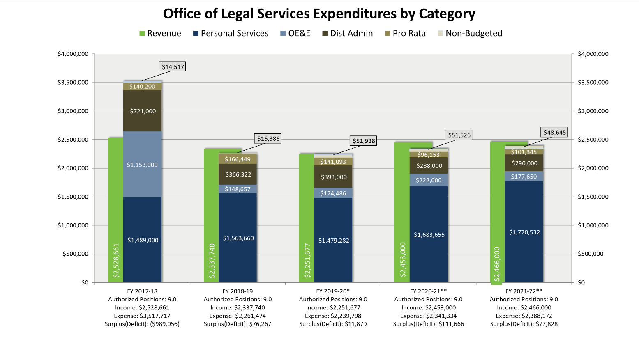

Material Changes to OLS Rates Assumptions

Personal Leave Program 2020 (PLP 2020)
Reflected in rates is a salaries and wages reduction of 9.23% in both FY 2020-21 and 2021-22 in response to the economic uncertainty caused by the COVID-19 pandemic to achieve state-wide budget savings.

Budget Letter for Employer Retirement Contributions (Control Section 3.60)
This Budget Letter instructs departments to process budget adjustments for employee retirement as prescribed by Control Section 3.60 of the Budget Act. Retirement rates are projected to increase by 1.4% in FY 2020-21 and 2021-22. OLS’ projected budgetary increase is $15,000 in FY 2020-21 and $16,000 in 2021-22.

Budget Letter for Employee Compensation Adjustments (Item 9800)
This Budget Letter instructs departments to process budget adjustments for salaries and wages as prescribed by bargaining unit contract agreements as well as projected health and dental benefits adjustments. OLS projected budgetary increase is $1,000 in FY 2020-21 and $38,000 in FY 2021-22.

Statewide General Administrative Expenditures (Pro Rata)
The Pro Rata for OLS in FY 2020-21 is $96,153. For FY 2021-22, based on historical averages, DGS Budgets and Planning Section projected Pro Rata is $101,345, which is an increase of 5.40%.

OLS Rates

Contract Review
Services include assistance and advice in preparing effective solicitations, evaluation of contracts as to legal sufficiency, determining compliance with policy (including matters related to sound fiscal and business practice), and approving contracts on behalf of DGS in accordance with Government Code § 11256 and Public Contract Code § 10295.

External Legal Advice/ Hearing Officer
OLS provides advice on non-IT service solicitations and contracts and provides customized non-IT service contract training upon request. OLS attorneys serve as hearing officer on bid protests.

Office of Legal Services Rates
DESCRIPTION | UNIT | CY 2020-21 | BY 2021-22¹
Contract Review | Per Contract | $366.00 | --
External Legal Advice/Hearing Officer | Hourly | $170.00 | --
¹ Due to economic uncertainty, for the purpose of forecasting and budgeting, DGS is assuming BY 2021-22 rates are held constant at current levels, but DGS will closely monitor workload, expenditures, and revenues and will modify as necessary next year.

For additional information, contact the Office of Legal Services, (916) 376-5080 or view the OLS website at: https://www.dgs.ca.gov/OLS

Office of Risk and Insurance Management

The Office of Risk and Insurance Management (ORIM) provides risk management and insurance services to state agencies and other public entities on an ongoing or project-specific basis.

ORIM assists agencies in managing exposure to accidental losses that result from general operations, employment, motor vehicles, property ownership and risk financing. ORIM oversees the equipment maintenance management insurance program, master property and builders risk programs, defensive driver training, health and safety training, natural gas procurement, government claims and motor vehicle claim program, and the Governor’s Employee Safety Awards. Additionally, ORIM provides emergency planning services to DGS employees to ensure they are in a state of readiness should any unanticipated emergency or disaster occur. Lastly, ORIM’s administers insurance programs for client agencies which includes analyzing risks and needs, insurance consulting and purchasing, and claims adjustments for the lowest available costs.
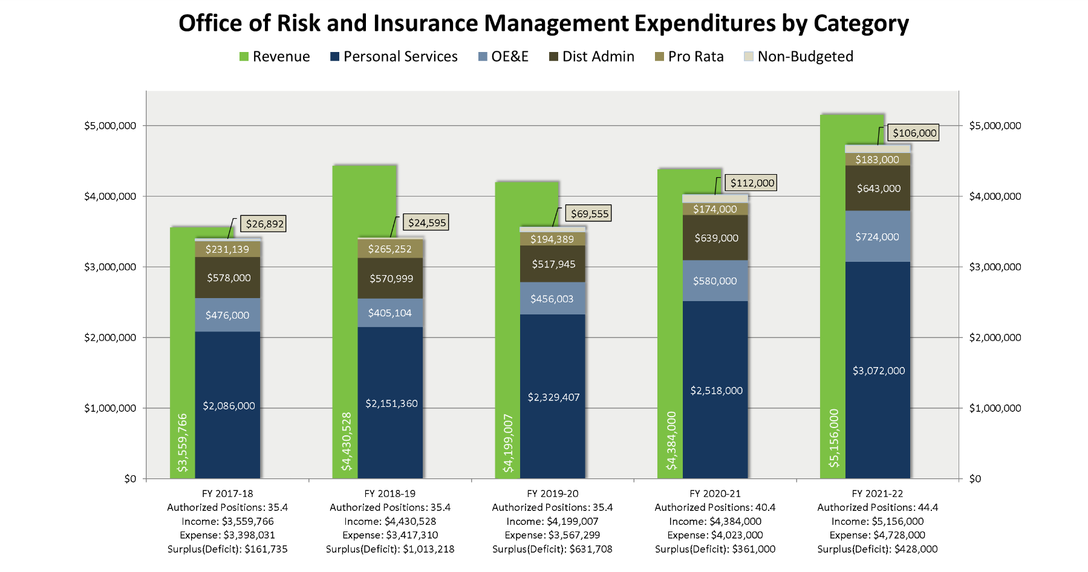
Footnote:
FY 2021-22 increase is a result of a BCP requesting four new positions and a $629,000 annual increase of the Service Revolving Fund.

Material Changes to ORIM Rates Assumptions

Budget Letter for Employer Retirement Contributions (Control Section 3.60 Drill)
This Budget Letter instructs departments to process budget adjustments for employee retirement as prescribed by Control Section 3.60 of the Budget Act. ORIM’s projected budgetary increase is $43,000 in FY 2020-21 and $48,000 in FY 2021-22.

Budget Letter for Employee Compensation Adjustments (Item 9800)
This Budget Letter instructs departments to process budget adjustments for salaries and wages as prescribed by bargaining unit contract agreements as well as projected health and dental benefits adjustments. The projected budgetary increase is $115,000 in FY 2020-21 and $224,000 in FY 2021-22.

Statewide General Administrative Expenditures (Pro Rata)
The Pro Rata assessment in FY 2020-21 is $1,642,000. DGS Budgets and Planning Section projects an increase of 5.4% in Pro Rata for FY 2021-22, which is an increase of $89,000.

Personal Leave Program 2020 (PLP 2020)
Reflected in rates is a salaries and wages reduction of 9.23% in both FY 2020-21 and 2021-22 in response to the economic uncertainty caused by the COVID-19 pandemic to achieve state-wide budget savings.

ORIM Rates

Equipment Maintenance Management Insurance Program
The program was established to reduce costs attributed to service and maintenance agreements on equipment. The program is based on time and materials used versus traditional service agreements. As a result, up to a 25 percent savings is realized. ORIM contracts with an insurance broker who purchases the insurance for the program. ORIM provides quotes through its broker, processes invoices, and markets the program to other state agencies.

Insurance Procurement
Government Code § 11077.7 provides that the purchase of insurance is subject to the approval of DGS. Furthermore, when no state agency or department is specifically authorized to purchase insurance, DGS may procure the insurance. Included in purchasing is the policy administration for the term of the policy, administration of claims presented under the policy, and advice on loss and accident prevention to assist in the mitigation of risk. ORIM charges a surcharge to recover these administration expenses. In addition, ORIM purchases transit insurance directly for some client agencies based on actual costs.

Claims Adjusting
In accordance with Health and Safety Code §1527 et. seq., and §2580.2, ORIM provides claims adjusting services through an interagency agreement for the Department of Social Services (DSS). The services involve worker’s compensation claims adjusting and consultation for DSS’ In-House Support Services, CalWORKs, and Food Stamps Employment Training programs. In addition, ORIM provides claims services for the DSS’ Foster Care Liability Program. The claims involve foster children injured while in the care of a foster parent(s). ORIM acts as a liaison between DSS and the respective parties.

Government Claims Program (GCP)
The Tort Claims Act of 1963 established the manner in which claims against the State are handled and defined the administrative role and remedies offered by the GCP. Pursuant to the Government Code, those who wish to file a lawsuit against the State, or its employees must first pursue an administrative remedy through GCP. The GCP process provides the State an opportunity to investigate and possibly settle claims without incurring litigation expenses. Claimants may not proceed with legal action against the State unless the GCP acts on claims or rejects them. Budget Change Proposal (BCP) 787-001-BCP-BR-2016-GB statutorily established GCP within DGS.

Motor Vehicle Liability
Insured agencies are charged a premium assessment based on past actual accident and loss experience.

OFFICE OF RISK MANAGEMENT AND INSURANCE RATES
DESCRIPTION | UNIT | CY 2020-21 | BY 2021-22¹
Equipment Maintenance Management Program (EMMP) - Purchase of Insurance Premiums | per Premium | 3.50% | --
Insurance Procurement - Purchase of Insurance Premiums | per Premium | 6.60% | --
Claims Adjusting Worker’s Comp – External | Hourly | $113.00 | --
Government Claims Program – Filing Fee | per File | $25.00 | --
Motor Vehicle Liability | Premium | Varies | --
¹ Due to economic uncertainty, for the purpose of forecasting and budgeting, DGS is assuming BY 2021-22 rates are held constant at current levels, but DGS will closely monitor workload, expenditures, and revenues and will modify as necessary next year.

For additional information, contact the Office of Risk and Insurance Management, (916) 376-5300 or view the ORIM website at: https://www.dgs.ca.gov/ORIM

Office of State Publishing

The Office of State Publishing (OSP) provides innovative printing solutions utilizing cutting-edge technology in design, offset print, digital print, finishing and mass mail services for California’s state and public agencies, the California State Legislature, and the Governor’s Office. OSP provides legislative publications to the State Capitol, offers business cards and customized digital printing through its Web Store Front, and offers secure (compliant with Health Insurance Portability and Accountability Act of 1996 (HIPAA) and Internal Revenue Service Publication 1075 (IRS 1075) processing requirements) printing and distribution for insurance and medical notices and statement printing.

In addition to its core print business, OSP operates several beneficial programs and services. The Interagency Mail & Messenger Service provides daily mail service between state offices in the greater Sacramento area, including Elk Grove and Rancho Cordova. The State Records Center provides document storage services for over 144 state agencies. The Document Destruction Center facilitates the destruction of confidential paper records, microfilm, microfiche, cassettes, computer tapes, and other recyclables. The Fulfillment Services Unit offers secure warehousing and distribution services by managing a catalog of literature and marketing materials to meet customer distribution demands. A full range of fulfillment services are also available for customers to request through OSP’s Web StoreFront.

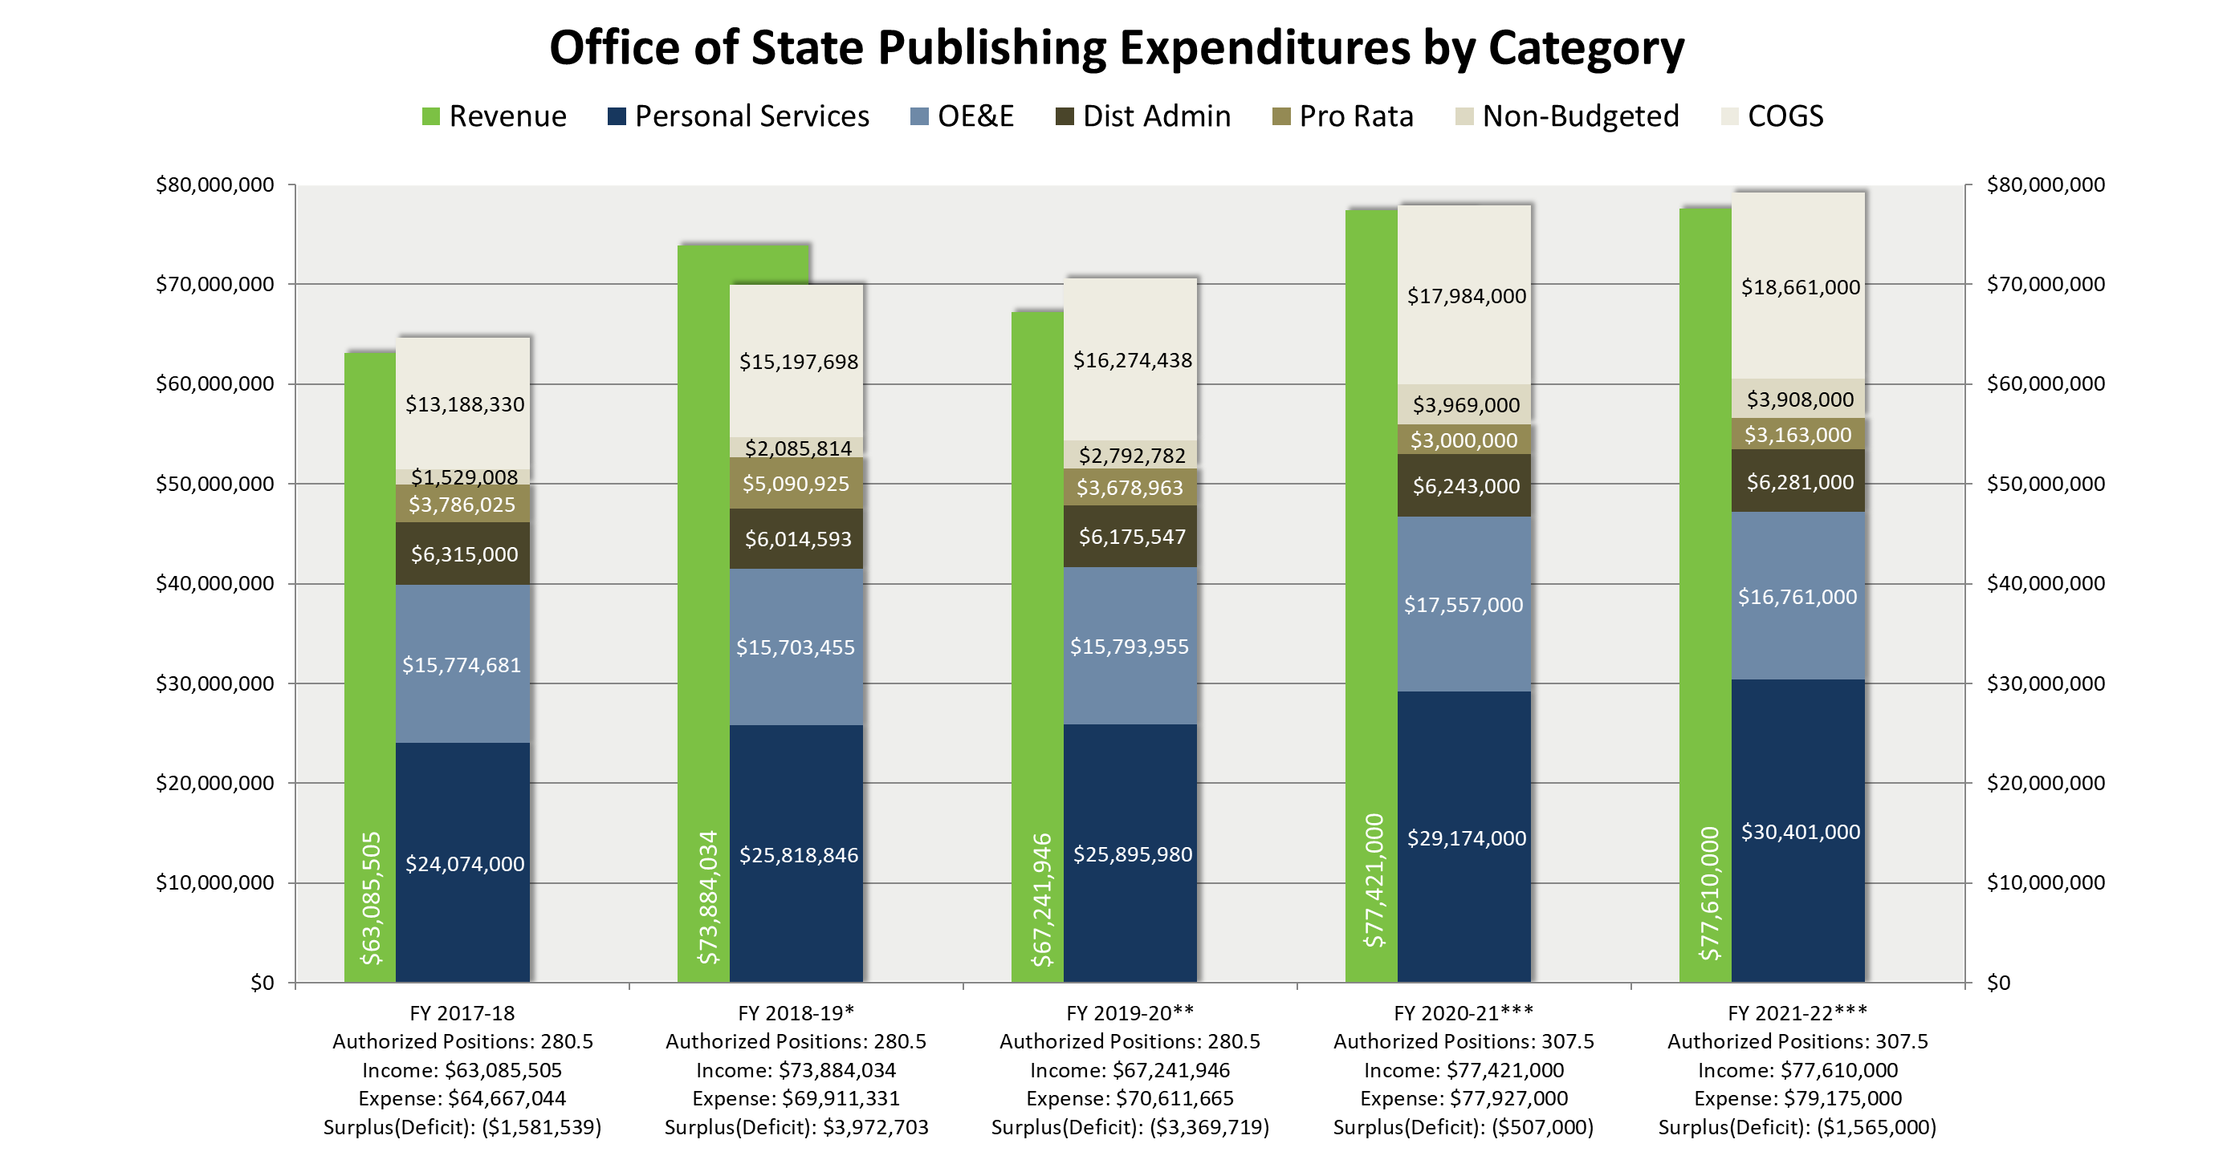
Footnotes:
*FY 2018-19 OSP budgeted a $1 million deficit in anticipation of the move to the new facility, which would cause equipment to be down for a period of time. As the move did not occur during FY 2018-19, OSP generated more revenue than expected.
**FY 2019-20 Projections based on March Income & Expense Statement, encumbrances, and prior year trends. OSP was budgeted at a $0.5 million deficit in anticipation of the move on July 2019. Equipment were down longer than expected due to the move and COVID-19 restrictions prohibiting specialized businesses to travel and make the necessary repairs, which impacted OSP's ability to run jobs in-house increasing vendouts. Unanticipated facility change orders exceeded budgeted expenditures.
***FY 2020-21 COVID-19 impact includes Personal Leave Program 2020 salary reduction of 9.23%, decreased output and revenue. Authorized positions increased by converting 27 positions from blanket to coded permanent positions as authorized by Control Section 4.11 effective July 1, 2020.
***FY 2021-22 COVID-19 impact includes Personal Leave Program 2020 salary reduction of 9.23%, decreased output and revenue projections plus a 5% reduction on projected operating expenditures.

Material Changes to OSP Rates Assumptions

Reorganize Digital and Mass Mail
The reorganization of Digital and Mass Mail effective FY 2020-21 to three units: Digital Prep and Finishing, Digital Print, and Digital Mass Mail.

Budget Letter for Employer Retirement Contributions (Control Section 3.60)
This Budget Letter instructs departments to process budget adjustments for employee retirement as prescribed by Control Section 3.60 of the Budget Act. Retirement rates are projected to increase by 1.4% in FY 2020-21 and 2021-22. The OSP projected budgetary increase is $226,000 in FY 2020-21 and $231,000 in FY 2021-22.

Budget Letter for Employee Compensation Adjustments (Item 9800 Drill)
This Budget Letter instructs departments to process budget adjustments for salaries and wages as prescribed by bargaining unit contract agreements as well as projected health and dental benefits adjustments. Labor Agreements suspend increases for FY 2020-21 and reinstate in FY 2021-22 for $548,000.

Statewide General Administrative Expenditures (Pro Rata)
Pro Rata in FY 2020-21 for OSP is $3,000,000. DGS Budgets and Planning Section projects a decrease of 30% in Pro Rata for FY 2021-22, which is a decrease of $1,284,000. This reflects the decrease in general spending due to COVID-19.

Personal Leave Program 2020 (PLP 2020)
Reflected in rates is a salaries and wages reduction of 9.23% in both FY 2020-21 and 2021-22 in response to the economic uncertainty caused by the COVID-19 pandemic to achieve state-wide budget savings.

OSP Rates

State Records Management
Records Management includes the operation of records centers for the economical storage of records which must be retained, but which need not be kept in high-cost office areas. This service also includes the provision of vault facilities for the permanent storage of the State’s vital or essential records in case of a disaster (microfilm copies only).

The following State Records Management Fees were established to recover costs associated with the State Records Center (SRC) and/or Document Destruction Center (DDC) operations. These services provide low-cost record storage for all State agencies:

- Records Storage Fee
- Long Term Storage Fee
- Essential Records Storage Fee
- Confidential Destruction Fee
- Plastics Destruction Fee
- Record Pulls Fee
- Re-File Fee
- Pre-End Retention/Early Withdrawal Fee
- ePull Fee

OFFICE OF STATE PUBLISHING – STATE RECORDS MANAGEMENT RATES
DESCRIPTION | UNIT | CY 2020-21 | BY 2021-22¹
Records Storage Fee | Cubic Feet | $5.40 | --
Long Term Storage Fee | Cubic Feet | $2.10 | --
Essential Records Storage Fee | Cubic Feet | $25.25 | --
Confidential Destruction Fee | Pounds | $0.17 | --
Plastics Destruction Fee | Pounds | $0.35 | --
Record Pulls | Transaction | $2.50 | --
Re-File Fee | Transaction | $2.50 | --
Pre-End Retention/Early Withdrawal Fee | Transaction | $8.00 | --
e-Pull Fee | Transaction | $11.00 | --
¹ Due to economic uncertainty, for the purpose of forecasting and budgeting, DGS is assuming BY 2021-22 rates are held constant at current levels, but DGS will closely monitor workload, expenditures, and revenues and will modify as necessary next year.

Production
The Production Cost Centers perform a variety of print services for the Legislature and other state agencies. These services include, but are not limited to, composition, offset and digital printing, bindery finishing and mailing services, in order to produce finished printed products. Some of these products include legislative bills and publications, annual reports, driver’s handbooks, voter guides, tax booklets, etc. Government Code sections 14650-14912 form the foundation for the printing services provided. OSP is a fee-for-service agency.

The production unit provides the following services:

- Advertising & Design: Provides state agencies an opportunity to reduce their printing costs through the incorporation of paid advertising in their publications and mailings.

- Electronic Prepress (EPP): Provides electronic prepress services as well as proofreading services. EPP ensures that each offset print project that passes through OSP is prepared and setup correctly for its journey through the presses.

- Press Services: Provides quality printed materials to a wide variety of state agencies as well as providing digital on demand printing for all legislative publications and documents for the Capitol.

- Bindery: Performs all the finishing processes on all jobs including packaging, distribution and mailing. OSP assure the customer receives a quality final product as specified by the customer.

- Digital Print: Uses digital printing equipment to provide quality variable and secure printed materials to a wide variety of state agencies as well as acting as a back-up for all Legislative publications.

- Digital Prep and Finishing: Provides prepress services as well as proofreading services ensuring that each Digital print project that passes through OSP is prepared and setup correctly for its journey through the presses.

- Digital Mass Mail: Uses digital mass mailing equipment to provide mailing services to a wide variety of state agencies.

Estimates and consultation available upon request for brochures, newsletters, bulletins, catalogs, instructional manuals, booklets, magazines, and others. Please contact the Office of State Publishing at
(916) 445-5386 or (800) 963-7860 or visit our website at www.dgs.ca.gov/osp.

Interagency Mail Service
Interagency Mail Service picks-up and deliver state mail between the different state agencies in the greater Sacramento area. Twice daily, mail that is picked up from agencies is returned to OSP for sorting by recipient agency. After sorting, it is delivered to the recipients on the next mail run. No mail will remain in the Interagency Unit longer than 24 hours, excluding weekends. This program is not mandated by statute.

For additional information, contact the Office of State Publishing at (916) 445-5386 or (800) 963-7860 or visit our website at www.dgs.ca.gov/osp.

Office of Sustainability

The Office of Sustainability (OS) provides sustainability-related services for all state agencies, including policy development, energy-saving retrofits, clean energy generation projects, and electric vehicle infrastructure. Key program areas to meet customer needs include renewable clean energy generation (solar and wind), energy retrofits in existing facilities, zero net energy (ZNE) building policy development, electric vehicle supply equipment (EVSE) infrastructure, benchmarking, and recycling. California continues to reduce its environmental footprint through sustainable state government operations and practices, including energy and water efficient building design, construction and operation, renewable energy generation at state facilities, environmentally-preferable purchasing, and green transportation policies.

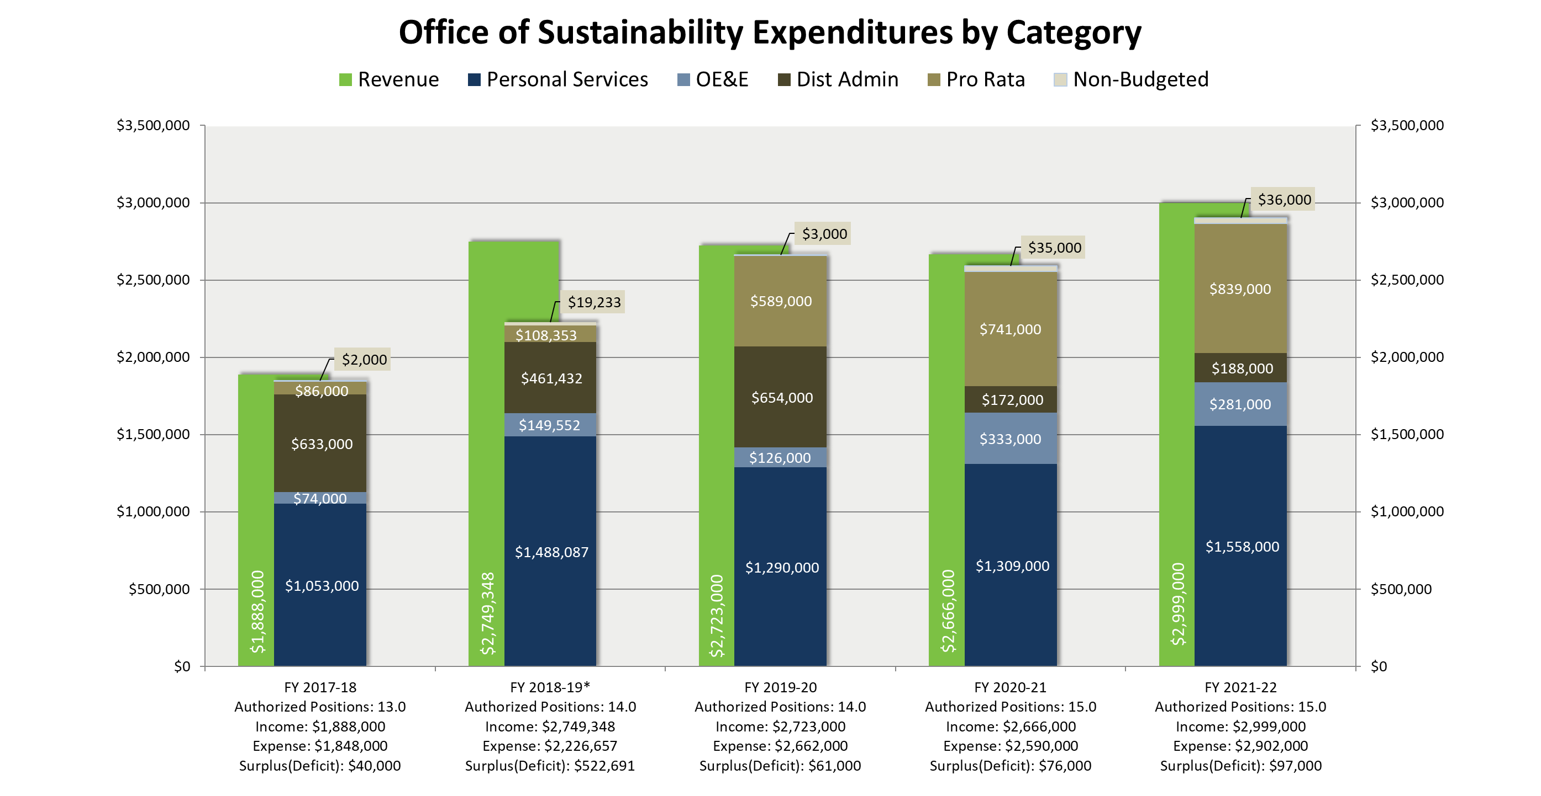
Footnote:
*FY2018-19 income includes revenue code correction of approximately $300,000.

Material Changes to OS Rates Assumptions

Budget Letter for Employer Retirement Contributions (Control Section 3.60)
This Budget Letter instructs departments to process budget adjustments for employee retirement as prescribed by Control Section 3.60 of the Budget Act. Retirement rates are projected to increase by 1.4% in both FY 2020-21 and 2021-22. OS’s projected budgetary increase is $23,000 in FY 2020-21 and $25,000 in FY 2021-22.

Budget Letter for Employee Compensation Adjustments (Item 9800)
This Budget Letter instructs departments to process budget adjustments for salaries and wages as prescribed by bargaining unit contract agreements as well as projected health and dental benefit adjustments. The projected budgetary increase is $0 in FY 2020-21 and $72,000 in FY 2021-22.

Statewide General Administrative Expenditures (Pro Rata)
The Pro Rata for OS in FY 2020-21 is $1,202,000. DGS Budgets and Planning Section projects an increase of 5.4% in Pro Rata for FY 2021-22, which is an increase of $65,000.

Personal Leave Program 2020 (PLP 2020)
Reflected in rates is a salaries and wages reduction of 9.23% in both FY 2020-21 and 2021-22 in response to the economic uncertainty caused by the COVID-19 pandemic to achieve state-wide budget savings.

Zero Emission Vehicle (ZEV) Transportation BCP
OS has requested an augmentation of $29.7M from Service Revolving Fund to begin installation of Electric Vehicle Service Equipment (EVSE) in state facilities in FY 2021-22.

OS Rates

Energy Savings Unit
The Energy Savings Unit provides project management of energy retrofit project in state facilities for small to large and complex energy projects.

Clean Energy Unit
The Clean Energy Unit provides planning, due diligence, tax analysis, California Environmental Quality Act review, contracting of power purchase agreements, site license agreements, and design and construction oversight for renewable energy projects including solar and wind projects in state facilities. Additionally, as new clean energy options become viable, such as evolving storage technologies, this group will develop new clean energy programs in response to technological and industry developments.

Transportation Unit
The Transportation Unit will manage the planning, site assessment, design, and construction of electric vehicle service equipment for charging zero emission vehicles in both fleet and workplace applications. Additionally, this group will support the development of other clean transportation options, including fuel cell charging and the Bike Share program.

OFFICE OF SUSTAINABILITY RATES
DESCRIPTION | UNIT | CY 2020-21 | BY 2021-22¹
Energy Savings Unit | Hourly | $209.00 | --
Clean Energy Unit | Hourly | $209.00 | --
Transpiration Unit | Hourly | $209.00 | --
¹ Due to economic uncertainty, for the purpose of forecasting and budgeting, DGS is assuming BY 2021-22 rates are held constant at current levels, but DGS will closely monitor workload, expenditures, and revenues and will modify as necessary next year.

For additional information, contact the Office of Sustainability, (916) 443-9838 or view the OS website at: https://www.dgs.ca.gov/OS

Procurement Division

The Procurement Division (PD) sets procurement policies and provides purchasing services for state agencies. PD consists of five branches: Acquisitions, Operations, Engineering, Office of Small Business and Disabled Veteran Business Enterprise Services, and Policy, Training and Customer Services. It delegates purchasing authority; certifies small and/or disabled veteran businesses to do business with the State; sponsors the Small Business Council; participates in the Disabled Veterans Business Enterprise Council; and provides innovative purchasing methods that save taxpayers' dollars, integrating quality solutions to meet customers' needs.
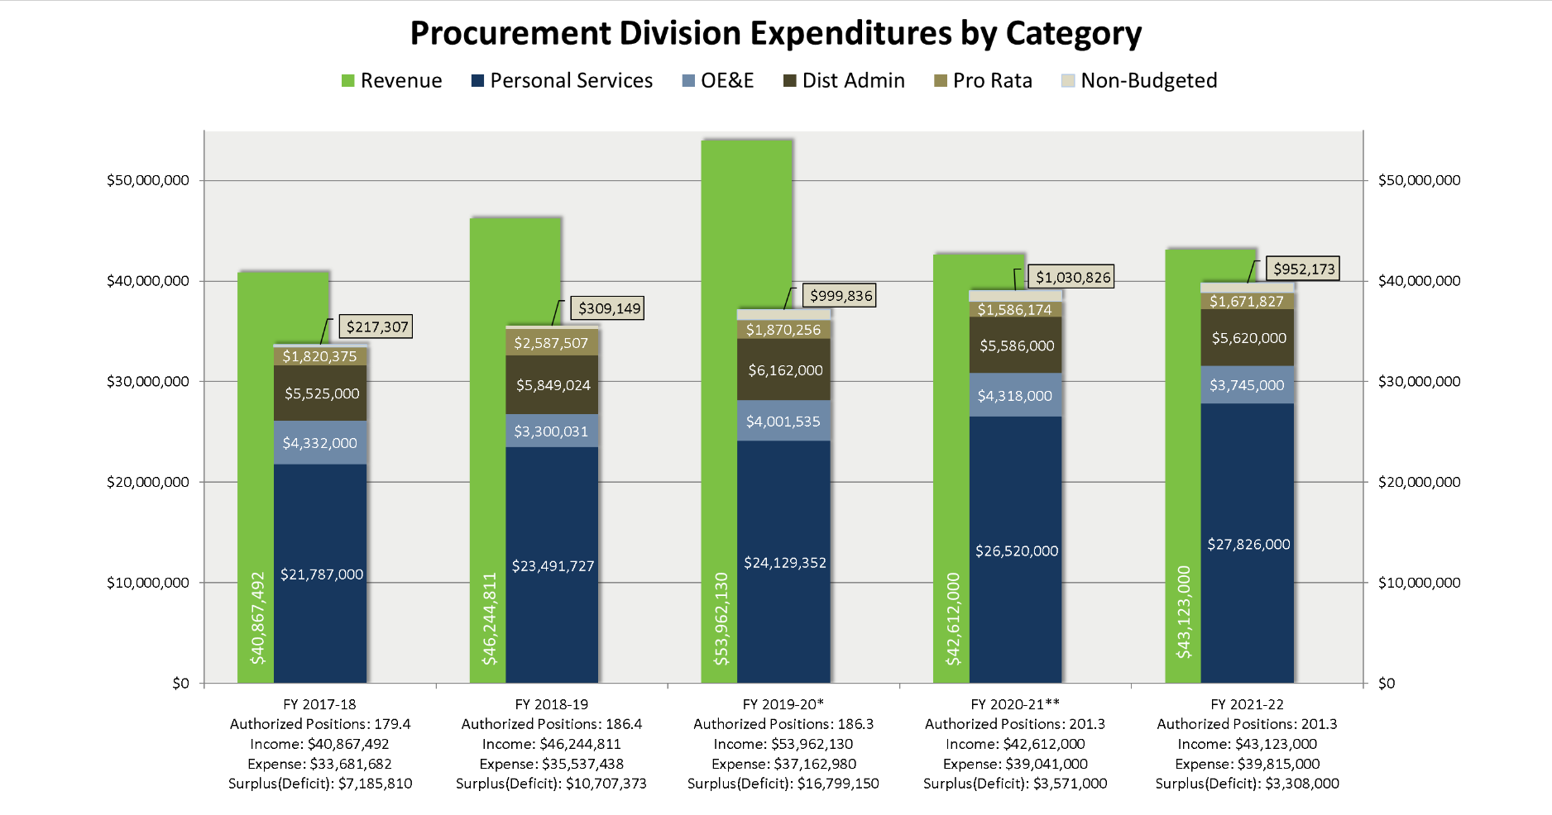
Footnotes:
*FY 2019-20 is based on 3rd quarter actuals plus 4th quarter projections. The projected surplus is a result of 1) RFC 67 implementing multiple corrections to PD billing, (2) increased accurate reporting due to additional departments going live in FI$Cal, and (3) higher than expected billings from new rate changes. Additionally, effective July 1, 2019, PD no longer assesses the Purchasing Services Surcharge on emergency transactions. PD is currently working on processing reimbursements for all billed emergency transactions from July 1, 2019 through September 30, 2020, and no further charges will be assessed on emergency transactions beginning October 1, 2020. Please note that as a result of this decision, FY 2019-20 and FY 2020-21 revenue presented in this document is inflated.
**FY 2020-21 Authorized positions include 4.0 BCP positions and 11.0 positions from Control Section 4.11 Position Transparency drill.

Material Changes to PD Rates Assumptions

Budget Letter for Employer Retirement Contributions (Control Section 3.60)
This Budget Letter instructs departments to process budget adjustments for employee retirement as prescribed by Control Section 3.6 of the Budget Act. Retirement rates are projected to increase by 1.4% in FY 2020-21 and 2021-22. PD’s projected budgetary increase is approx. $244,000 in FY 2020-21 and approx. $250,000 in FY 2021-22.

Budget Letter for Employee Compensation Adjustments (Item 9800)
This Budget Letter instructs departments to process budget adjustments for salaries and wages as prescribed by bargaining unit contract agreements as well as projected health and dental benefits adjustments. PD’s projected budgetary increase is approx. $175,000 in FY 2020-21 and approx. $518,000 in FY 2021-22.

Statewide General Administrative Expenditures (Pro Rata)
The Pro Rata for PD in FY 2020-21 is approx. $1,586,000. DGS Budgets and Planning Section projects an increase of 5.4% in Pro Rata for FY 2021-22, which is an increase of approx. $86,000.

Rate for Local Use of Leveraged Procurement Agreements (LPAs)
Beginning in FY 2019-20, PD started updating the 1% incentive fee collected from the supplier to 1.25% for local use of all LPAs as contracts expire. This conversion is expected to complete in FY 2022-23.

Support for the California Pharmaceutical Collaborative
The BCP was approved for 4.0 positions and $723,000 in three-year limited-term expenditure authority beginning in FY 2020-21. These positions will convert four existing blankets into coded positions in the Pharmaceutical Section of the Acquisitions Branch.

Personal Leave Program 2020 (PLP 2020)
Reflected in rates is a salaries and wages reduction of 9.23% in both FY 2020-21 and 2021-22 in response to the economic uncertainty caused by the COVID-19 pandemic to achieve state-wide budget savings.

Purchasing Surcharge Reduction
Due to the economic uncertainty related to the COVID-19 pandemic and the purchasing restrictions mandated by the Governor in Budget Letter 20-11, a 25% reduction from PD’s 3-year average state spend is projected for the purchasing surcharge beginning in FY 2020-21.

PD is removing the hourly rate structure beginning in FY 2020-21

PD Rates

Contract Advertising
The Procurement Division (PD) publishes state contracting opportunities daily on the Internet via the California State Contracts Register (CSCR). State law requires agencies to advertise their construction and service contracting opportunities of $5,000 or more and commodity contracts over $50,000 in the CSCR. Advertising exemptions may be requested based upon legal exemption criteria. CSCR services are available to local government and special districts.

Purchasing Surcharge
This fee includes all the services listed below, as well as Small Business (SB) and Disabled Veteran Business Enterprise (DVBE) services. The DVBE and SB Certification Programs were established to increase business opportunities for the DVBE and SB communities with the State of California and level playing field with certain advantages when competing against other non-DVBE's and non-SB's for state contracts and purchases.

PD also assists SB's and DVBE's in a variety of ways, including conducting outreach events, providing resource guidance, and supporting the businesses through advocacy. The Disabled Veteran Business Enterprise Certification Program certifies eligible businesses for the DVBE Participation Program, which has a goal to use DVBEs in at least three percent of the State’s overall annual contract dollars. The Small Business Certification Program certifies eligible businesses for the five percent small business preference and the Small Business Participation Program, which has a goal to use SBs in at least 25 percent of the State’s overall annual contract dollars.

- Purchase Order Issuance: Includes SB/DVBE services, purchase estimate processing, bid preparation and evaluation, product testing, product standards and specifications development, quality control review and product inspection, and materials expediting, including vendor performance follow up. The Procurement Division provides stimulus and business information services to further small business participation in state contracting. A surcharge is placed on contracts executed by the State of California. Refer to the State Contracting Manual for submission guidelines and due dates.

- Emergency Authorization to Exceed Dollar Thresholds (Form 42): Reviewing and processing of associated documents.

- Leveraged Procurement Agreements: Issuance of Leveraged Procurement Agreements (Statewide Contracts, Master Purchase/Rental/Service Agreements, and Software Licensing Program Contracts) for use by state and local agencies in acquiring equipment or services. Includes Master Rental Agreements of IT Terminals, Master Purchase Agreements, and Master Service Agreements for IT and telecommunications goods and services. Includes bid preparation and evaluation, product testing, product standards and specifications development, quality control review and product inspection, and materials expediting including vendor performance follow up.

- Purchasing Authority (Delegated Procurements): Charge for management and compliance of delegated procurements made directly by state agencies. Charge does not apply to Interagency agreements executed under a state agency’s purchasing authority.

- California Multiple Award Schedule (CMAS): Agreements with manufacturers and suppliers to provide products and services off Federal General Services Administration (GSA) schedules. This fee is waived when the CMAS supplier is a small business.

- Financing Procurement: Low-interest, lease/purchase financing option for major acquisitions. For additional information contact the GS $Mart within the Procurement Division at (916) 375-4617.

- Purchasing – Recycled Products: The Procurement Division provides information regarding specifications and sources of supply for purchases of products made all or in part from recycled materials. For additional information refer to the Procurement Division’s Environmentally Friendly Purchasing (EPP) Buying Green Guide at https://www.dgs.ca.gov/PD/Resources/Find-EPP-Goods-and-Services.

PROCUREMENT DIVISION RATES
DESCRIPTION | UNIT | CY 2020-21 | BY 2021-22¹
California State Contracts Register
Agency Advertising/Exemption Fee | Each | $50.00 | --
Note: All posted events, regardless of length of time posted, are subject to this fee.
Purchase Surcharge
Purchase Order Issuance | Per transaction | 1.20% of value of transaction | --
Emergency Authorization to Exceed Dollar Thresholds (Form 42) | Per transaction | 1.20% of value of transaction, maximum of $20,000 | --
Leveraged Procurement Agreements | Per transaction | 1.20% of value of transaction | --
Purchasing Authority (Delegated Procurements) | Per transaction | 1.20% of value of transaction | --
California Multiple Award Schedule (CMAS) | Per transaction | 1.20% of value of transaction | --
Financing Procurement | Per transaction | 1.20% of value of transaction, excluding financing charges | --
¹ Due to economic uncertainty, for the purpose of forecasting and budgeting, DGS is assuming BY 2021-22 rates are held constant at current levels, but DGS will closely monitor workload, expenditures, and revenues and will modify as necessary next year.

For information contact the Procurement Division at: PDInvoiceQuestions@dgs.ca.gov, (916) 375-2010, or visit our website at: http://www.dgs.ca.gov/pd/home.aspx.

Real Estate Services Division

The Real Estate Services Division (RESD) provides comprehensive real estate services to all state agencies. Comprised of three operational branches, RESD conducts asset planning, property sales and acquisition, project management, architectural and engineering services, leasing and planning, construction management, energy efficiency and supply programs, and environmental assessments, including the management of state-owned and leased facilities.

For additional information, contact the RESD at (916) 375-4700 or visit the RESD website at: https://www.dgs.ca.gov/RESD. You may also send general inquires via email to DGSRESDGeneralInquiries@dgs.ca.gov.

Asset Management Branch

The Asset Management Branch (AMB) serves as the initial point of contact in the Real Estate Services Division for our customers and is the single point of entry for requesting new services. AMB oversees leasing, space planning and interior design, sales, appraisal, and acquisition services. AMB is also responsible for maximizing the performance of state real estate assets by identifying and implementing value enhancement solutions for unused and underutilized state-owned properties.

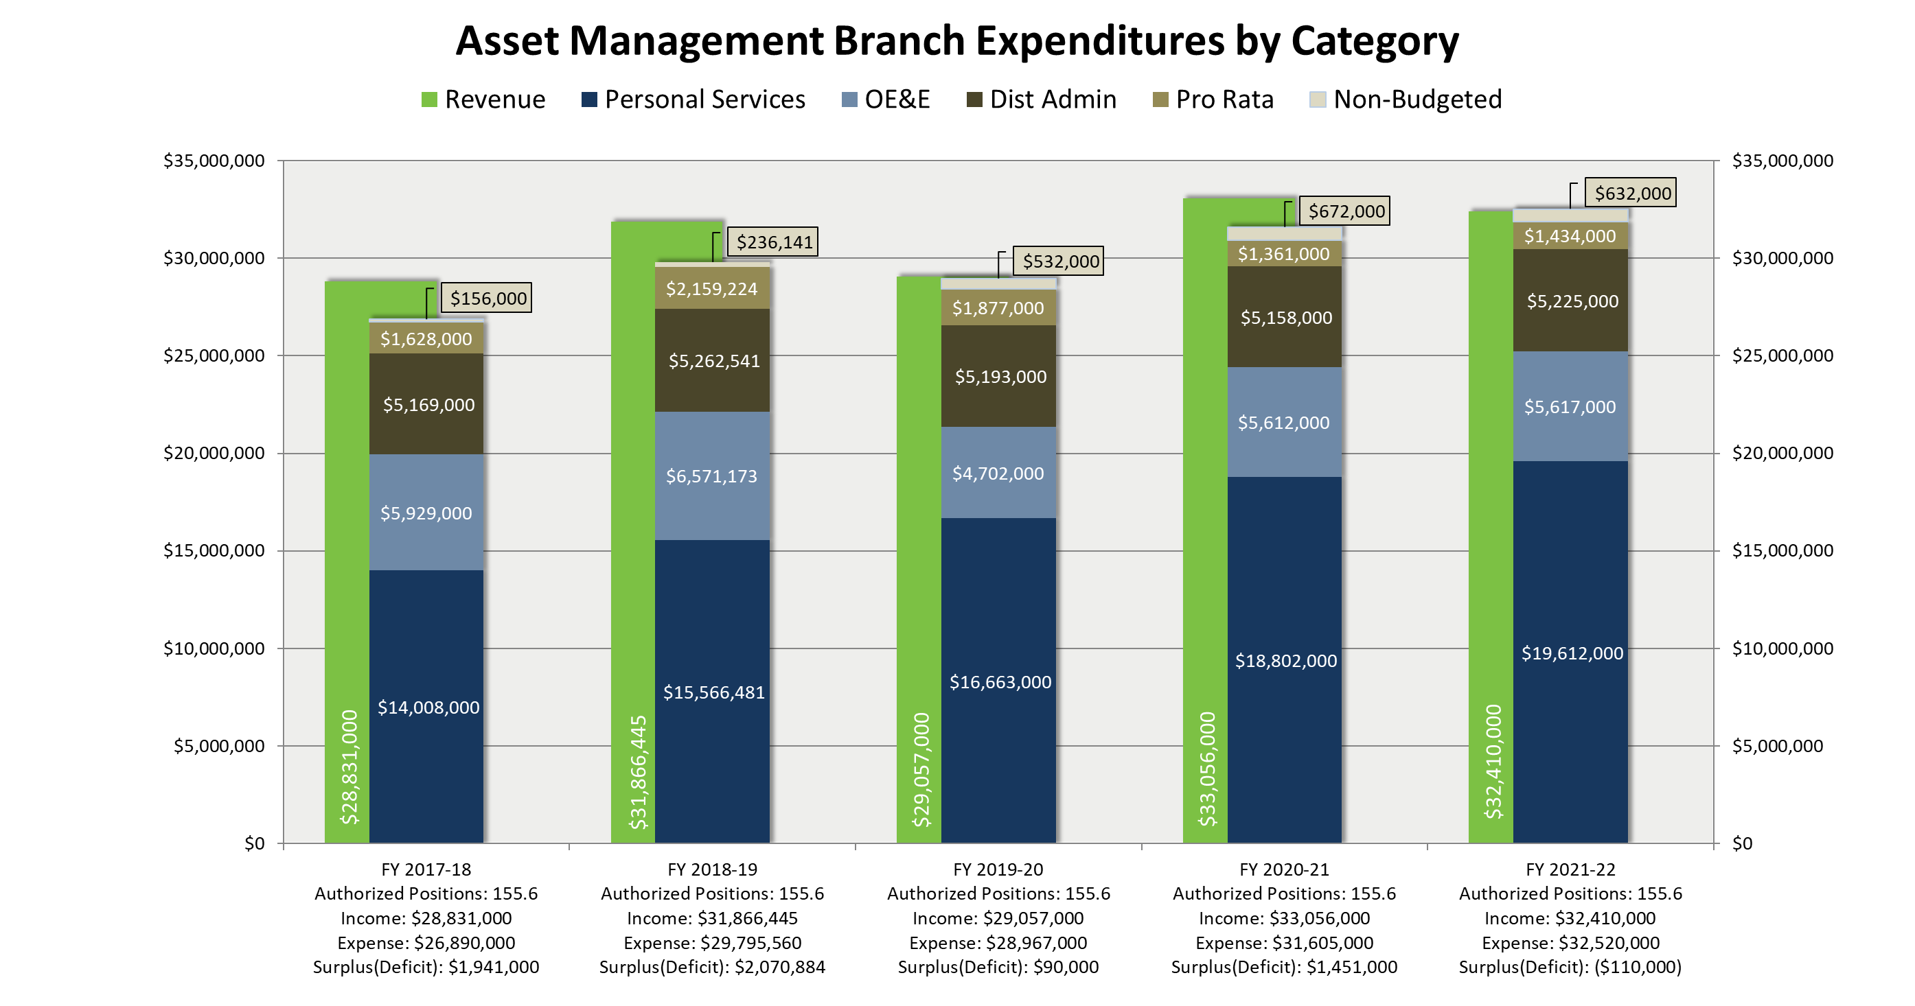

Material Changes to AMB Rates Assumptions

Planned Vacancies
AMB is proposing to hold vacant a total of 7 billable positions in the following units in both FY 2020-21 and 2021-22.

• 3.0 positions in Real Estate Leasing and Planning Services (RELPS)
• 2.5 positions in Portfolio Management and Leasing Management Surcharge
• 1.0 position in Real Estate Leasing and Planning Services (RELPS) Surcharge
• 1.0 position in Real Property Services Section (RPSS)

Budget Letter for Employer Retirement Contributions (Control Section 3.60)
This Budget Letter instructs departments to process budget adjustments for employee retirement as prescribed by Control Section 3.60 of the Budget Act. Retirement rates are projected to increase by 1.4% in FY 2021 and 2021-22. The AMB projected budgetary increase is $187,000 in FY 2020-21 and $199,000 in FY 2021-22.

Budget Letter for Employee Compensation Adjustments (Item 9800)
This Budget Letter instructs departments to process budget adjustments for salaries and wages as prescribed by bargaining unit contract agreements as well as projected health and dental benefits adjustments. The projected budgetary increase is $778,000 in FY 2020-21 and $110,000 in FY 2021-22.

Personal Leave Program 2020 (PLP 2020)
Reflected in rates is a salaries and wages reduction of 9.23% in both FY 2020-21 and 2021-22 in response to the economic uncertainty caused by the COVID-19 pandemic to achieve state-wide budget savings.

Statewide General Administrative Expenditures (Pro Rata)
Pro Rata in FY 2020-21 for AMB is $1,361,000, and projects an increase of 5.4% or $73,000 in FY 2021-22.

Other Savings
In FY 2020-21, there is a projected salaries and wages savings of $802,000 related to the timing of current and anticipated vacancies expected to be backfilled.

AMB Rates

Portfolio Management
The Portfolio Management Section ensures RESD real estate services are provided to state agencies from a statewide, strategic asset management perspective and reflect state management, policy, and statutory priorities. To fulfill this broad role, Customer Services Managers (CSMs) work with specific assigned state agencies, and Regional Portfolio Managers (RPMs) maintain comprehensive information on an assigned group of buildings within geographic regions.

Statewide Property Inventory Records
The SPI Unit keeps a detailed inventory of the State’s real property assets including land, structures/improvements, leased space, and State-owned space leased to others. State agencies are required to submit this data to the SPI Unit and are assessed an annual per record surcharge rate on proprietary land holding records for maintenance of the inventory system. An inventory of all state proprietary land holdings and leases is maintained and available for reference.

Real Estate Leasing and Planning Services (RELPS)
RELPS provides statewide leasing, lease management, and space planning services in both privately-owned and state-owned space for state tenants. The section develops and implements policies and applicable laws for conducting lease negotiations, competitive bidding, and all leasing and planning work processes to meet client program requirements.

State Owned Leasing and Development (SOLD)
The SOLD Unit manage a statewide program to lease underutilized State real property to non-state entities. SOLD currently manages over 650 state leases including 67 leases in DGS controlled buildings and provides leasing management services to over 50 departments and agencies. SOLD also currently manages over 400 telecommunication leases of private property on behalf of state tenants such as the California Highway Patrol and the leasing of state-owned property to private telecommunication firms.

Real Property Services Section (RPSS)
RPSS provides real estate review, regulatory, and support services related to the acquisition, use, and sale of state-owned, other public, and private real property. Services are provided to state agencies, other public, and private sector entities. Services include appraisal, appraisal review, project coordination, site selection and acquisition, acquisition review, real estate due diligence, easement conveyances, state-owned property leasing and telecommunications leasing of state-owned, other public, and private real property.

Construction Inspection and Management Branch

The Construction Inspection and Management Branch (CIMB) provides a full range of construction phase services for public works projects statewide to ensure the highest quality of construction is provided to the state in its state-owned buildings and facilities. These services include construction management, quality assurance inspection and observation, California building codes and regulations compliance, construction contract compliance, after-contract guarantee enforcement and dispute resolution.

Any combination of construction phase services is available to state agencies that have authorization to administer their own construction programs. The services are tailored to suit the size, complexity and specific project needs of the client agency’s management staff, and their operational and program needs. CIMB’s goal as the State’s representative in the construction process is to provide the client with the best possible outcome with the least amount of disruption while bringing a positive attitude, and exercising tact, good judgement, and fairness in a professional manner.

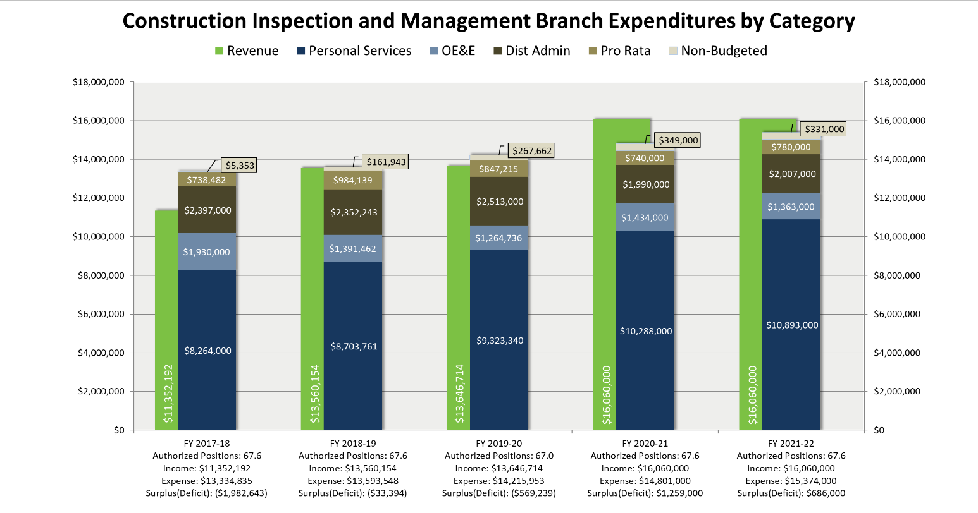

Material Changes to CIMB Rates Assumptions

Budget Letter for Employer Retirement Contributions (Control Section 3.60)
This Budget Letter instructs departments to process budget adjustments for employee retirement as prescribed by Control Section 3.60 of the Budget Act. Retirement rates are projected to increase by 1.4% in FY 2020-21 and 2021-22. CIMB’s projected budgetary increase is $104,000 in FY 2020-21 and $107,000 in FY 2021-22.

Budget Letter for Employee Compensation Adjustments (Item 9800)
This Budget Letter instructs departments to process budget adjustments for salaries and wages as prescribed by bargaining unit contract agreements as well as projected health and dental benefits adjustments. CIMB’s projected budgetary increase is $22,000 in FY 2020-21 and $325,000 in FY 2021-22.

Statewide General Administrative Expenditures (Pro Rata)
The Pro Rata for CIMB in FY 2020-21 is $740,000. DGS Budgets and Planning Section projects an increase of 5.4% in Pro Rata, based on historical averages, for FY 2021-22, which is an increase of $40,000.

Personal Leave Program 2020 (PLP 2020)
Reflected in rates is a salaries and wages reduction of 9.23% in both FY 2020-21 and 2021-22 in response to the economic uncertainty caused by the COVID-19 pandemic to achieve state-wide budget savings.

Output Variances in FY 2020-21
The variance in outputs for FY 2019-20 from 83,325 to 74,572 is due to vacancies. The projected increase in outputs from FY 2019-20 to FY 2020-21 is accounting for continued aggressive hiring efforts.

Project Management and Development Branch

The Project Management and Development Branch (PMDB) provides architectural and engineering services, space planning and interior design, construction and construction inspection services, energy and environmental services, and other competencies such as seismic retrofits, asbestos abatement, and underground tank removal.

PMDB additionally provides project management services for complex real estate projects. PMDB manages the design and construction process on behalf of state agencies and departments. PMDB assists state agencies and departments in developing conceptual documents for cost and budget control, programming, site planning and master planning, and other documents for conceptualizing capital outlay projects that are necessary to obtain legislative authorization and funding projects.

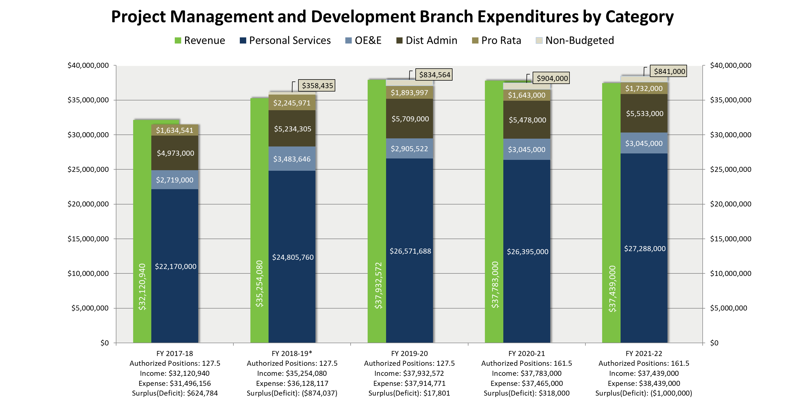
Footnote:
*2018-19 deficit is due to unanticipated Supplemental Pension Repayment (SB 84) in the amount of $339,000 and delay in intra-fund transfer of $400,000 from FMD.

Material Changes to PMDB Rates Assumptions

Planned Vacancies
PMDB is proposing to hold vacant a total of 6 billable positions in both FY 2020-21 and 2021-22 in the following units.
• 5.0 in Architecture, Engineering and Project Management
• 1.0 in Environmental Planning Services

Budget Letter for Employer Retirement Contributions (Control Section 3.60)
This Budget Letter instructs departments to process budget adjustments for employee retirement as prescribed by Control Section 3.60 of the Budget Act. Retirement rates are projected to increase by 1.4% in FY 2020-21 and FY 2021-22. The PMDB projected budgetary increase is $277,000 in FY 2020-21 and $284,000 in FY 2021-22.

Budget Letter for Employee Compensation Adjustments (Item 9800)
This Budget Letter instructs departments to process budget adjustments for salaries and wages as prescribed by bargaining unit contract agreements as well as projected health and dental benefits adjustments. The projected budgetary increase is $625,000 in FY 2020-21 and $338,000 in FY 2021-22.

Personal Leave Program 2020 (PLP 2020)
Reflected in rates is a salaries and wages reduction of 9.23% in both FY 2020-21 and 2021-22 in response to the economic uncertainty caused by the COVID-19 pandemic to achieve state-wide budget savings

Statewide General Administrative Expenditures (Pro Rata)
Pro Rata in FY 2020-21 for PMDB is $1,644,000. There is a projected increase of 5.4% or $88,000 in FY 2021-22.

Other Savings
In FY 2020-21, there is a projected salaries and wages savings of approximately $1.1M related to the timing of current and anticipated vacancies expected to be backfilled.

PMDB Rates

Environmental Planning Services
Environmental Planning Services provides a wide range of environmental planning and regulatory expertise to client agencies, DGS, and the Department of Finance. This expertise includes, but is not limited to, project site planning and analysis, preparation of environmental documents required by the California Environmental Quality Act and National Environmental Policy Act, compliance with historic preservation and other environmental regulatory statutes, and environmental due diligence.

Architectural Assistant Services
Architectural Assistant services provides design support services and minor design services to Architectural and Engineering staff. These services are technical in nature, but do not need to be performed by more experienced or licensed staff. Examples include minor CAD/REVIT work and 3D modeling.

External Contract Administration Fee
The contract administration fee covers the administrative costs related to the execution of PMDB contracts. These costs include branch administrative costs related to contracts, program overhead costs, the branch’s share of FI$Cal cost, and administrative support outside of the branch within DGS. All projects with external contracts are assessed this fee. For large projects, PMDB applies a cap for this fee to prevent it from exceeding $1 million.

Administrative support, beyond branch administrative support, for the development and execution of contracts, related to external contracts includes:

- The Office of Business and Acquisition Services (OBAS) provides program support through the solicitation, preparation, approval, and execution of contracts.

- The Office of Fiscal Services (OFS) provides accounting oversight and guidance, ensures that policies and procedures are consistently applied to maintain the integrity of the financial records. OFS services include certification of project funds, approval of encumbrance releases, audit and process vendor invoices, payment scheduling, and reconciliation of projects and contracts. OFS maintains detailed records on payment history and contract balances.

- The Office of Legal Services (OLS) provides leadership and guidance on the State’s contracting and procurement laws and policies. This includes establishing the State’s services contracting standards and providing contract pre-review and approval. In addition, OLS serves as in-house counsel providing legal advice on the State’s leveraged procurements of goods and services, real estate leasing, acquisition, construction, and litigation support. OLS also exercises the services contract review and approval function for DGS.

Architecture, Engineering and Project Management
Architecture, Engineering and Project Management provides complete architectural, civil, structural, mechanical, and electrical engineering services; project management for large and complex projects including capital outlay, energy, hazardous materials, special repairs, studies and surveys and program management of programs with a defined scope that respond to special needs identified by state initiatives, departments, Legislative mandates. or the Governor.

REAL ESTATE SERVICES DIVISION RATES
DESCRIPTION | UNIT | CY 2020-21 | BY 2021-22¹
Asset Management Branch
Portfolio Management-Lease Management Surcharge | Per Lease | 0.60% | --
State Property Inventory Records | Per Record | $2.50 | --
SPI-Lease Management Surcharge | Per Lease | 0.08% | --
RELPS-Planning Services | Hourly | $155.00 | --
RELPS-Lease Management Surcharge | Per Lease | 1.24% | --
RPSS-Real Estate Services | Hourly | $155.00 | --
Construction Inspection and Management Branch
Construction Supervision | Per hour | $189.00 | --
Project Management and Development Branch
Environmental Planning Services | Per hour | $155.00 | --
Architectural Assistant Services | Per hour | $146.00 | --
Planning External Contract Admin Fee | Doc value | 1.00% | --
Architecture, Engineering, and Project Management Services | Per hour | $216.00 | --
¹ Due to economic uncertainty, for the purpose of forecasting and budgeting, DGS is assuming BY 2021-22 rates are held constant at current levels, but DGS will closely monitor workload, expenditures, and revenues and will modify as necessary next year.

