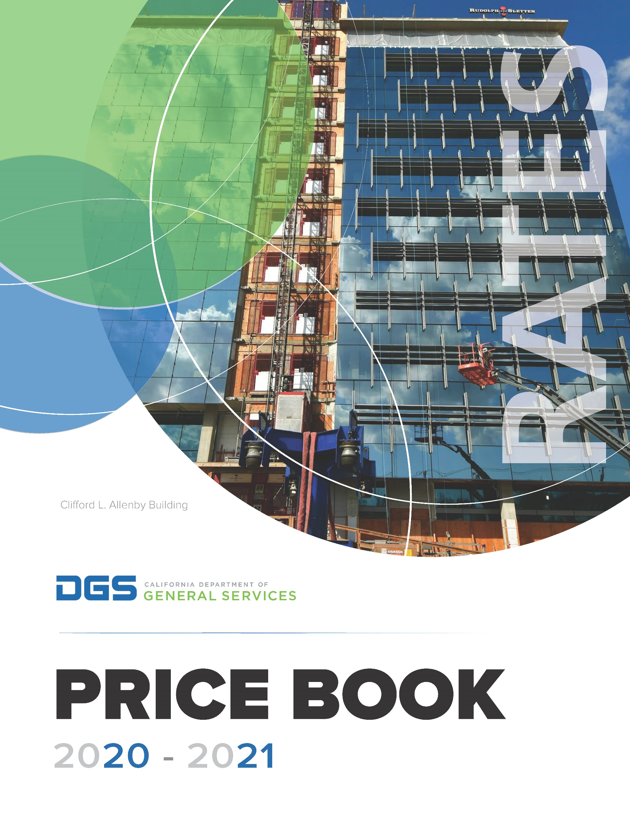

Fadmini

**2021-2022**

# Table of Contents

Table of Contents 2

Purpose of DGS 6

DGS Rates 7

Division of the State Architect 8

Facilities Management Division 11

Office of Administrative Hearings 19

Office of Fleet Asset Management 23

Office of Legal Services 30

Office of Risk and Insurance Management 33

Office of State Publishing 37

Office of Sustainability 43

Procurement Division 46

Real Estate Services Division 51

Asset Management Branch 51

Construction Inspection and Management Branch 54

Project Management and Development Branch 57

# Table of Contents

Table of Contents 1

Purpose of DGS 3

DGS Rates 4

Division of the State Architect 5

Facilities Management Division 8

Office of Administrative Hearings 16

Office of Fleet Asset Management 20

Office of Legal Services 26

Office of Risk and Insurance Management 29

Office of State Publishing 33

Office of Sustainability 39

Procurement Division 42

Real Estate Services Division 47

Asset Management Branch 47

Construction Inspection and Management Branch 50

Project Management and Development Branch 53

**Who We Are**

# Purpose of DGS

The Department of General Services (DGS) serves as the business manager for the State of California. With more than 4,000 employees and an operating budget of $1.6 billion, DGS serves the public by providing a variety of services to state agencies, local government, and other clients through innovative procurement and acquisition solutions, creative real estate management and design, environmentally friendly transportation, and through the implementation and enforcement of regulations and rules for the construction of safe schools and buildings throughout the state.

**Mission**

To deliver results by providing timely, cost-effective services and products that support our customers while protecting the interests of the State of California.

**Vision**

Excellence in the business of government. We strive to achieve excellence by providing our customers with the products and services they need in a professional manner that adds value.

**Values**

We have a set of core values that provide an important foundation for how we conduct ourselves and our business. These values are:

* **Integrity**: We do the right things for the right reasons.
* **Accountability**: We hold ourselves and each other responsible for all that we do.
* **Communication**: We listen and share information openly, honestly, and respectfully, with the goal of mutual understanding and transparency.
* **Excellence**: We strive for the best for each other and our customers.
* **Innovation**: We cultivate ideas and implement improvements throughout our organization.
* **Teamwork**: We value and respect our organizational diversity and work together to achieve great results.

# DGS Rates

Every spring, the DGS Budget and Planning Section coordinates with each DGS program to develop a cost recovery plan for the upcoming two fiscal years (FY). This effort begins with each program’s baseline budget and the following cost recovery adjustments:

| * Personal Services Budget Letters | * Budget Change Proposals |
| --- | --- |
| * Pro Rata Adjustments | * DGS Rent Allocation |
| * FI$Cal Adjustments | * Distributed Administration Adjustments |
| * Planned Position Realignments | * Planned Vacancies |

## Guiding Principles

The primary purpose of the rate setting process is to recover the full costs of providing goods or services pursuant to the State Administrative Manual (SAM) section 8752 and Government Code (GC) sections 11010 and 14604. DGS has established guiding principles to achieve full cost recovery while minimizing large fluctuations. Those principles are:

1. Limit rate increases to three to five percent per year unless an event or situation dictates otherwise.
2. Align rates to ensure consistency with the Governor’s vision for California to incentivize specific statewide efforts such as clean energy, water conservation, green building, and other priority initiatives.
3. Each program should be self-sufficient.

## Rate Setting Methodology: Billable Hours

Each DGS office is viewed as a separate entity. There are 11 major program areas consisting of over 200 individual rates. Once an accurate cost-to-recover is determined for each program, the program’s staff then analyze the amount of workload anticipated for the next two fiscal years. This is done by calculating the level of work anticipated for the next two fiscal years and projecting changes to the estimated service levels or outputs (billable hours, projected statewide spend, square footage, contracts, etc.).

Each program produces multiple deliverables that include output justification packages describing each rate or service, the calculation of the projected outputs, and billable hours worksheets (if applicable). For hourly rates, the program determines the number of billable positions needed to produce the projected outputs, which are measured as billable hours and included in the costs to recover. The DGS rates are set at a level that will generate enough revenue to cover the costs of providing the service.

# Division of the State Architect

The Division of the State Architect (DSA) offers design and construction oversight for K-12 schools, community colleges, and various other state-owned/leased facilities to ensure compliance with 1) structural, 2) access, and 3) fire and life safety requirements. DSA also develops accessibility, structural safety, and historical building codes and standards for various public and private buildings throughout the state of California.

DSA rates are defined in statute by the Government Code sections that establish the guidelines for each of its special funds. These rates can only be adjusted through an approved regulation packet, which proposes a change, addition, or deletion to existing regulations.

## DSA Rates

### Access Compliance

DSA reviews construction plans and specifications for essential services buildings and other state-funded buildings and facilities. In addition, DSA reviews construction plans and specifications for elementary, secondary, and California Community Colleges that are funded by any California city, county, or special district. Review of these projects is necessary to ensure compliance with state accessibility requirements for persons with disabilities.

DSA also provides plan review and code analysis consulting services as required by local agencies and design professionals.

### Fire and Life Safety

DSA reviews plans and specifications for the construction of public schools, California Community Colleges, and state-owned/occupied essential services buildings for compliance with the California State Fire Marshal's building standards (authority: California Health and Safety Code).

### Structural Safety

DSA reviews plans and specifications and inspects school building construction to ensure structural safety, as defined in the “Field Act,” for public schools and California Community Colleges.

In addition, DSA reviews plans and specifications and inspects essential services building construction to ensure structural safety, as defined in the “Essential Services Building Act.” This fee includes a charge for Access Compliance review services.

DSA also examines and reports on the structural safety of previously-constructed California public school buildings.

|  |  |  |
| --- | --- | --- |
| **DIVISION OF THE STATE ARCHITECT**  **ACCESS COMPLIANCE RATES** | | |
| **DESCRIPTION** | **CY 2021-22** | **BY 2022-23** |
| **Access Compliance Rates** | | |
| State funded buildings and facilities access compliance plan review | 0.5% of first $500,000 of project cost plus 0.25% of excess greater than $500,000 to $2,000,000 plus 0.1% of excess greater than $2,000,000 to $25,000,000 plus 0.08% of excess greater than $25,000,000 to $50,000,000 plus 0.06% of excess greater than $50,000,000 to $100,000,000 plus 0.04% of excess greater than $100,000,000 (Minimum Fee $500.00). | 0.5% of first $500,000 of project cost plus 0.25% of excess greater than $500,000 to $2,000,000 plus 0.1% of excess greater than $2,000,000 to $25,000,000 plus 0.08% of excess greater than $25,000,000 to $50,000,000 plus 0.06% of excess greater than $50,000,000 to $100,000,000 plus 0.04% of excess greater than $100,000,000 (Minimum Fee $500.00). |
| Elementary, secondary, and California Community College access compliance plan review | 0.5% of first $500,000 of project cost plus 0.25% of excess greater than $500,000 to $2,000,000 plus 0.1% of excess greater than $2,000,000 to $25,000,000 plus 0.08% of excess greater than $25,000,000 to $50,000,000 plus 0.06% of excess greater than $50,000,000 to $100,000,000 plus 0.04% of excess greater than $100,000,000 (Minimum Fee $500.00). | 0.5% of first $500,000 of project cost plus 0.25% of excess greater than $500,000 to $2,000,000 plus 0.1% of excess greater than $2,000,000 to $25,000,000 plus 0.08% of excess greater than $25,000,000 to $50,000,000 plus 0.06% of excess greater than $50,000,000 to $100,000,000 plus 0.04% of excess greater than $100,000,000 (Minimum Fee $500.00). |
| Access compliance plan review and code analysis consulting services | Estimates available upon request. | Estimates available upon request. |
| **Historical Buildings Safety Rates** | | |
| State historical building plan review | Estimates available upon request. | Estimates available upon request. |

|  |  |  |
| --- | --- | --- |
| **Structural Safety Rates** | | |
| Public school and California Community College structural safety plan review | 0.765% of the first $1,000,000 of project cost plus 0.54% of the project cost exceeding $1,000,000 (Minimum Fee $250.00). | 0.765% of the first $1,000,000 of project cost plus 0.54% of the project cost exceeding $1,000,000 (Minimum Fee $250.00). |
| Essential services building structural safety plan review | 1.5% of the first $1,000,000 of project cost plus 1.25% of project cost exceeding $1,000,000 (Minimum Fee $250.00). | 1.5% of the first $1,000,000 of project cost plus 1.25% of project cost exceeding $1,000,000 (Minimum Fee $250.00). |
| Examination and reporting on the structural safety of previously constructed California public school buildings. | Estimates available upon request. | Estimates available upon request. |

### DSA Certification and Training Program

For more information on programs, including Certified Access Specialist Program (CASp) and the Inspector Program, visit DSA’s website at: [www.dgs.ca.gov/DSA](https://www.dgs.ca.gov/DSA)

# Facilities Management Division

The DGS Facilities Management Division (FMD) is the largest division within DGS and provides administrative, maintenance, and custodial services to approximately 270 buildings statewide. FMD’s oversight responsibilities extend to various office buildings, warehouses, storage locations. The state printing plant, the state’s central heating and cooling plant, stand-alone parking structures, and the state records warehouse.

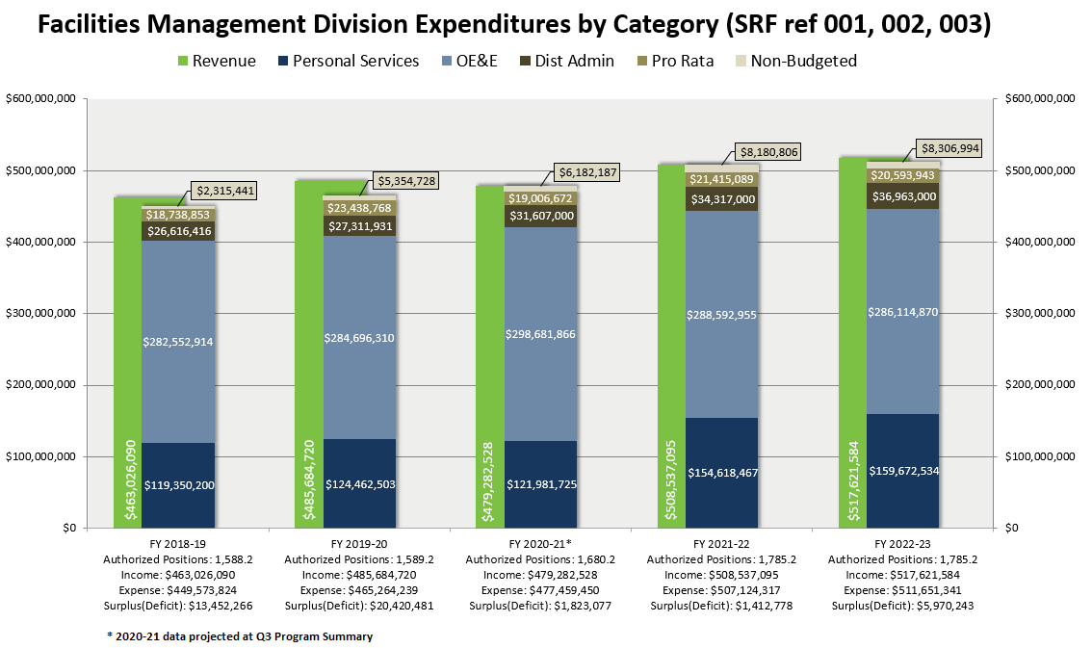FMD operates and maintains sustainable state facilities that are both energy and water efficient and environmentally friendly. FMD has an Environmental Health and Safety Unit (E-Shop) which provides support services for meeting or exceeding regulatory compliance with asbestos, lead, chemical exposures, indoor air quality, hazardous waste, ergonomics, and other issues. FMD also provides public work contracts and minor projects for our clients and tenants through a variety of sources and continues to ensure the safety and well-being of our assets, clients, and tenants.

## Material Changes to FMD Rates Assumptions

### Budget Letter for Employer Retirement Contributions (Control Section 3.60)

Budget adjustments for employee retirement, as prescribed by Control Section 3.60 of the Budget Act, are projected to increase by .3%. The projected budgetary increase is approximately $287,000 in FY 2021-22 and $298,000 in FY 2022-23.

### Budget Letter for Employee Compensation Adjustments (Item 9800)

Per bargaining unit agreements for salary & wages and benefits compensation, the FY 2021-22 adjustments include the regularly scheduled increases for 2021-22 and the FY 2020-21 adjustments that were postponed. An additional .05% has also been included for applicable bargaining units, as negotiated. The projected budgetary increase for FMD is $5,456,000 in FY 2021-22 and $2,278,000 in FY 2022-23.

### Statewide General Administrative Expenditures (Pro Rata)

Pro Rata assessment for FMD in FY 2021-22 is $21,415,000. DGS Budgets and Planning Section projects a decrease of 3.8% in Pro Rata for FY 2022-23, which is a decrease of $821,000.

### Restoration of COVID-19 PLP Salary Reduction (9.23%)

Last year, a 9.23% PLP salary reduction was implemented as a result of the COVID-19 pandemic. This reduction was projected through FY 2021-22. Due to the projected State surplus, the Administration has agreed to restore the salary reduction effective FY 2021-22 and full salaries have been assumed for both fiscal years.

### Rental Rate Revenue Assumptions

FMD is adding two new Sacramento buildings to its portfolio in FY 2021-22. The majority of the occupants at the Allenby building (1215 O Street) and new Natural Resources HQ (715 P Street) will be moving from existing DGS-controlled space to the new locations from June through November 2021. Multiple other buildings within the portfolio will either be backfilled once tenants have moved to the new buildings, utilized temporarily as swing space, or otherwise vacated in preparation for renovation projects. Revenue impacts for FMD at each building affected by this shuffling of occupants have been considered based on a set schedule, and deviations from this schedule will affect actual revenue collected.

## FMD Rates

### Building Rental Rates

Funding for state buildings upkeep comes primarily from rental rates paid by tenant departments in the same way departments pay rent in privately owned buildings.

|  |  |  |  |
| --- | --- | --- | --- |
| **BUILDING RENTAL RATES** | | | |
| **BUILDING** | **UNIT** | **CY 2021-22** | **BY 2022-23** |
| **8th and Q Office Buildings** | | | |
| Office Space | Square Ft. | $2.62 | $2.75 |
| Storage Area | Square Ft. | $0.67 | $0.69 |
| **Alfred E. Alquist Building** | | | |
| Office Space | Square Ft. | $2.62 | $2.75 |
| Storage Area | Square Ft. | $0.67 | $0.69 |
| **Allenby Building** | | | |
| Office Space | Square Ft. | $3.25 | $3.28 |
| Storage Area | Square Ft. | $0.79 | $0.82 |
| **Attorney General – Sacramento** | | | |
| Office Space | Square Ft. | $2.72 | $2.79 |
| Storage Area | Square Ft. | $0.60 | $0.60 |
| **Bateson Building** | | | |
| Office Space | Square Ft. | $2.28 | $2.29 |
| Storage Area | Square Ft. | $0.61 | $0.61 |
| **Blue Anchor** |  |  |  |
| Office Space | Square Ft. | $2.28 | $2.29 |
| Storage Area | Square Ft. | $0.61 | $0.61 |
| **Board of Equalization** |  |  |  |
| Office Space | Square Ft. | $4.04 | $4.13 |
| Storage Area | Square Ft. | $0.60 | $0.60 |
| **Buildings and Grounds** |  |  |  |
| Office Space | Square Ft. | $2.28 | $2.29 |
| Storage Area | Square Ft. | $0.61 | $0.61 |
| **CALNET** |  |  |  |
| Office Space | Square Ft. | $2.62 | $2.75 |
| Storage Area | Square Ft. | $0.67 | $0.69 |
| **Cal-Trans Dist. 3, Marysville** |  |  |  |
| Office Space | Square Ft. | $5.60 | $5.48 |
| Storage Area | Square Ft. | $0.68 | $0.68 |
| **BUILDING RENTAL RATES** | | | |
| **BUILDING** | **UNIT** | **CY 2021-22** | **BY 2022-23** |
| **Cal Trans Dist. 11, San Diego** | | | |
| Office Space | Square Ft. | $4.63 | $4.77 |
| Storage Area | Square Ft. | $0.71 | $0.74 |
| **Central Plant** | | | |
| Office Space | Square Ft. | $0.57 | $0.57 |
| Storage Area | Square Ft. | N/A | N/A |
| **Department of Justice Building** | | | |
| Office Space | Square Ft. | $2.17 | $2.06 |
| Storage Area | Square Ft. | $0.61 | $0.61 |
| **East End – Sacramento** | | | |
| Office Space | Square Ft. | $4.10 | $4.19 |
| Storage Area | Square Ft. | $0.60 | $0.60 |
| **EDD Headquarters** | | | |
| Office Space | Square Ft. | $2.62 | $2.64 |
| Storage Area | Square Ft. | $0.66 | $0.66 |
| **EDD Solar** |  |  |  |
| Office Space | Square Ft. | $2.28 | $2.29 |
| Storage Area | Square Ft. | $0.61 | $0.61 |
| **Edmund G. “Pat” Brown Building** |  |  |  |
| Office Space | Square Ft. | $2.62 | $2.75 |
| Storage Area | Square Ft. | $0.66 | $0.69 |
| **Elihu Harris – Oakland** |  |  |  |
| Office Space | Square Ft. | $3.91 | $4.01 |
| Storage Area | Square Ft. | $0.60 | $0.60 |
| **Food and Agriculture** |  |  |  |
| Office Space | Square Ft. | $3.41 | $3.51 |
| Storage Area | Square Ft. | $0.60 | $0.60 |
| **Franchise Tax Board** |  |  |  |
| Office Space | Square Ft. | $2.33 | $2.40 |
| Storage Area | Square Ft. | $0.60 | $0.60 |
| **Hugh Burns** |  |  |  |
| Office Space | Square Ft. | $2.17 | $2.06 |
| Storage Area | Square Ft. | $0.61 | $0.61 |

|  |  |  |  |
| --- | --- | --- | --- |
| **BUILDING RENTAL RATES** | | | |
| **BUILDING** | **UNIT** | **CY 2021-22** | **BY 2022-23** |
| **Jesse Unruh Building** |  |  |  |
| Office Space | Square Ft. | $2.62 | $2.64 |
| Storage Area | Square Ft. | $0.66 | $0.66 |
| **Joseph A. Rattigan Building** | | | |
| Office Space | Square Ft. | $2.38 | $2.27 |
| Storage Area | Square Ft. | $0.61 | $0.61 |
| **Junipero Serra** | | | |
| Office Space | Square Ft. | $2.44 | $2.56 |
| Storage Area | Square Ft. | $0.62 | $0.64 |
| **Library and Courts Annex** | | | |
| Office Space | Square Ft. | $2.62 | $2.75 |
| Storage Area | Square Ft. | $3.88 | $3.95 |
| **Library and Courts, 914 Capitol Mall** | | | |
| Office Space | Square Ft. | $8.23 | $8.28 |
| Storage Area | Square Ft. | $0.60 | $0.60 |
| **New Natural Resources HQ, 715 P Street** | | | |
| Office Space | Square Ft. | $3.25 | $3.28 |
| Storage Area | Square Ft. | $0.79 | $0.82 |
| **Office Building #08** |  |  |  |
| Office Space | Square Ft. | $3.88 | $3.95 |
| Storage Area | Square Ft. | $0.60 | $0.60 |
| **Office Building #09** |  |  |  |
| Office Space | Square Ft. | $3.88 | $3.95 |
| Storage Area | Square Ft. | $0.60 | $0.60 |
| **Paul Bonderson Building** |  |  |  |
| Office Space | Square Ft. | $2.28 | $2.29 |
| Storage Area | Square Ft. | $0.61 | $0.61 |
| **Red Bluff** |  |  |  |
| Office Space | Square Ft. | $2.17 | $2.06 |
| Storage Area | Square Ft. | $0.61 | $0.61 |
| **Redding** |  |  |  |
| Office Space | Square Ft. | $2.17 | $2.07 |
| Storage Area | Square Ft. | $0.61 | $0.61 |

|  |  |  |  |
| --- | --- | --- | --- |
| **BUILDING RENTAL RATES** | | | |
| **BUILDING** | **UNIT** | **CY 2021-22** | **BY 2022-23** |
| **Rehabilitation (Office Building #10)** |  |  |  |
| Office Space | Square Ft. | $3.38 | $3.48 |
| Storage Area | Square Ft. | $0.60 | $0.60 |
| **Resources Building, 1416 9th Street** |  |  |  |
| Office Space | Square Ft. | $2.28 | $2.29 |
| Storage Area | Square Ft. | $0.61 | $0.61 |
| **Riverside Cal-Towers** | | | |
| Office Space | Square Ft. | $5.17 | $5.03 |
| Storage Area | Square Ft. | $0.83 | $0.83 |
| **Ronald Reagan State Building** | | | |
| Office Space | Square Ft. | $2.77 | $2.90 |
| Storage Area | Square Ft. | $0.71 | $0.73 |
| **San Diego** | | | |
| Office Space | Square Ft. | $2.35 | $2.46 |
| Storage Area | Square Ft. | $0.61 | $0.62 |
| **San Diego Mission Valley** | | | |
| Office Space | Square Ft. | $3.05 | $3.15 |
| Storage Area | Square Ft. | $0.60 | $0.60 |
| **San Francisco – Ronald M. George State Office Complex** | | | |
| Office Space | Square Ft. | $4.53 | $4.63 |
| Storage Area | Square Ft. | $0.60 | $0.60 |
| **Secretary of State** |  |  |  |
| Office Space | Square Ft. | $2.62 | $2.75 |
| Storage Area | Square Ft. | $0.67 | $0.69 |
| **State Capitol** |  |  |  |
| Office Space | Square Ft. | $2.62 | $2.75 |
| Storage Area | Square Ft. | $0.67 | $0.69 |
| **State Personnel Building** |  |  |  |
| Office Space | Square Ft. | $2.62 | $2.64 |
| Storage Area | Square Ft. | $0.66 | $0.66 |
| **Stockton** |  |  |  |
| Office Space | Square Ft. | $2.17 | $2.07 |
| Storage Area | Square Ft. | $0.61 | $0.61 |
| **Van Nuys** |  |  |  |
| Office Space | Square Ft. | $2.17 | $2.07 |
| Storage Area | Square Ft. | $0.61 | $0.61 |
| **BUILDING RENTAL RATES** | | | |
| **BUILDING** | **UNIT** | **CY 2021-22** | **BY 2022-23** |
| **Warren-Alquist State Energy** |  |  |  |
| Office Space | Square Ft. | $2.62 | $2.75 |
| Storage Area | Square Ft. | $0.67 | $0.69 |
| **Water Resources** |  |  |  |
| Office Space | Square Ft. | $2.17 | $2.06 |
| Storage Area | Square Ft. | $0.61 | $0.61 |

### Partial Services Hourly Rates

FMD charges hourly rates to provide operations and maintenance services such as trades & crafts, engineering, grounds keeping, and custodial services at facilities throughout the state for non-DGS owned or managed buildings. These are known as the Partial Services rates.

| **PARTIAL SERVICE RATES BY CLASSIFICATION** | | | |
| --- | --- | --- | --- |
| **POSITION CLASSIFICATION** | **UNIT** | **CY 2021-22** | **BY 2022-23** |
| AGPA | Hourly | $130.19 | $134.09 |
| BUILDING MAINTENANCE WORKER | Hourly | $85.80 | $88.37 |
| CARPENTER I | Hourly | $102.74 | $105.82 |
| CHIEF ENGINEER I | Hourly | $145.02 | $146.41 |
| CHIEF ENGINEER II | Hourly | $146.98 | $151.38 |
| CUSTODIAN | Hourly | $55.31 | $56.96 |
| CUSTODIAN II | Hourly | $50.16 | $51.66 |
| CUSTODIAN SUPERVISOR I | Hourly | $75.70 | $77.97 |
| CUSTODIAN SUPERVISOR II | Hourly | $80.23 | $82.46 |
| DIRECT CONSTRUCTION SUPERVISOR I | Hourly | $167.26 | $172.27 |
| DIRECT CONSTRUCTION SUPERVISOR II | Hourly | $197.50 | $203.42 |
| ELECTRICIAN I | Hourly | $111.03 | $114.36 |
| ELECTRICIAN II | Hourly | $115.46 | $118.92 |
| ELECTRONICS TECHNICIAN | Hourly | $103.90 | $106.60 |
| GROUNDSKEEPER | Hourly | $78.17 | $80.51 |
| LEAD GROUNDSKEEPER | Hourly | $85.18 | $87.73 |
| LEAP | Hourly | $74.85 | $74.85 |
| LOCKSMITH I | Hourly | $102.30 | $104.72 |
| MAINTENANCE MECHANIC | Hourly | $106.29 | $109.47 |
| OFFICE ASSISTANT (GENERAL) | Hourly | $72.46 | $74.63 |
| OFFICE ASSISTANT (TYPING) | Hourly | $72.46 | $74.63 |
| OFFICE BUILDING MANAGER I | Hourly | $129.36 | $133.24 |

| **PARTIAL SERVICE RATES BY CLASSIFICATION** | | | |
| --- | --- | --- | --- |
| **POSITION CLASSIFICATION** | **UNIT** | **CY 2021-22** | **BY 2022-23** |
| OFFICE BUILDING MANAGER II | Hourly | $149.29 | $153.76 |
| OFFICE BUILDING MANAGER III | Hourly | $155.63 | $160.29 |
| OFFICE TECHNICIAN (GENERAL) | Hourly | $72.46 | $74.63 |
| OFFICE TECHNICIAN (TYPING) | Hourly | $72.46 | $74.63 |
| PAINTER I | Hourly | $102.33 | $105.39 |
| PAINTER SUPERVISOR | Hourly | $109.20 | $112.47 |
| PLUMBER I | Hourly | $110.51 | $112.97 |
| STAFF SERVICES ANALYST (GENERAL) | Hourly | $101.81 | $104.86 |
| STAFF SERVICES MANAGER I | Hourly | $139.56 | $143.74 |
| STAFF SERVICES MANAGER II | Hourly | $163.92 | $168.83 |
| STAFF SERVICES MANAGER III | Hourly | $162.77 | $167.65 |
| STATIONARY ENGINEER | Hourly | $127.55 | $127.55 |
| STATIONARY ENGINEER APPRENTICE | Hourly | $100.63 | $103.64 |
| SUPERVISING GROUNDSKEEPER I | Hourly | $94.29 | $97.11 |
| SUPERVISING GROUNDSKEEPER II | Hourly | $104.95 | $107.46 |
| SUPERVISOR OF BUILDING TRADES | Hourly | $130.65 | $132.30 |
| TREE MAINTENANCE LEADWORKER | Hourly | $78.17 | $80.51 |
| TREE MAINTENANCE WORKER | Hourly | $78.17 | $80.51 |

For additional information, please contact the Facilities Management Division at (916) 322-8779 or visit our website at: <https://www.dgs.ca.gov/FMD>

# Office of Administrative Hearings

The Office of Administrative Hearings (OAH) is a quasi-judicial tribunal that hears administrative disputes. Established by the California Legislature in 1945, OAH provides independent Administrative Law Judges (ALJs) to preside as neutral judicial officers at hearings, mediations, arbitrations, and settlement conferences. OAH consists of three divisions, Administration, General Jurisdiction and Special Education, and has five regional offices in Sacramento, Oakland, Los Angeles (two offices), and San Diego. The General Jurisdiction Division conducts hearings, mediations, and settlement conferences for more than 2,500 state and local agencies. The Special Education Division conducts special education due process hearings and mediations involving school districts and parents of children with special education needs throughout the state.

Although OAH is housed within the Department of General Services for administrative purposes, it is an independent state entity under the direction and control of the Director of OAH, who is appointed by the Governor, and subject to confirmation by the Senate. OAH ALJs are highly trained legal professionals with experience in deciding cases involving complex issues. All OAH ALJs are appointed by the Director of OAH, and act independently from the agencies appearing before them in hearings, mediations, and all other administrative matters. OAH offers a wealth of experience, qualified ALJs, professional calendar staff, and the flexibility to mediate, arbitrate, or adjudicate administrative disputes at a cost substantially less than that charged by other providers. OAH assures that all parties receive a neutral and fair “day in court” while ensuring due process and respect for the dignity of all.

For state agencies whose proceedings are subject to the Administrative Procedure Act (APA) (Gov. Code § 11370, et seq.), an interagency agreement is not required. Once an agency is established with OAH, OAH will direct-bill the state agency using the agency’s bill code. For state agencies and local agencies not subject to the APA, an interagency or local agency agreement is required before a case may be filed with OAH.

OAH’s General Jurisdiction Division’s (GJ) rate structure has been in place for well over 20 years. There are a few GJ programs whose rates are contractually negotiated, and their costs are accounted for when developing the proposed hourly rate. Additionally, in 2004, OAH contracted with the California Department of Education (CDE) and OAH’s Special Education Division (SE) was formed resulting in separate rates for each division. The SE rate is determined through negotiations with CDE.

OAH is proposing to incentivize virtual hearings by reducing the Filing Fee rate from the rate of $125 for in-person hearings to a discounted rate of $75 for virtual hearings beginning in FY 2022-23. This initial fee differential is intended to promote the Governor’s initiatives to reduce the state’s carbon footprint by promoting virtual hearings resulting in a reduction in travel for hearing participants.

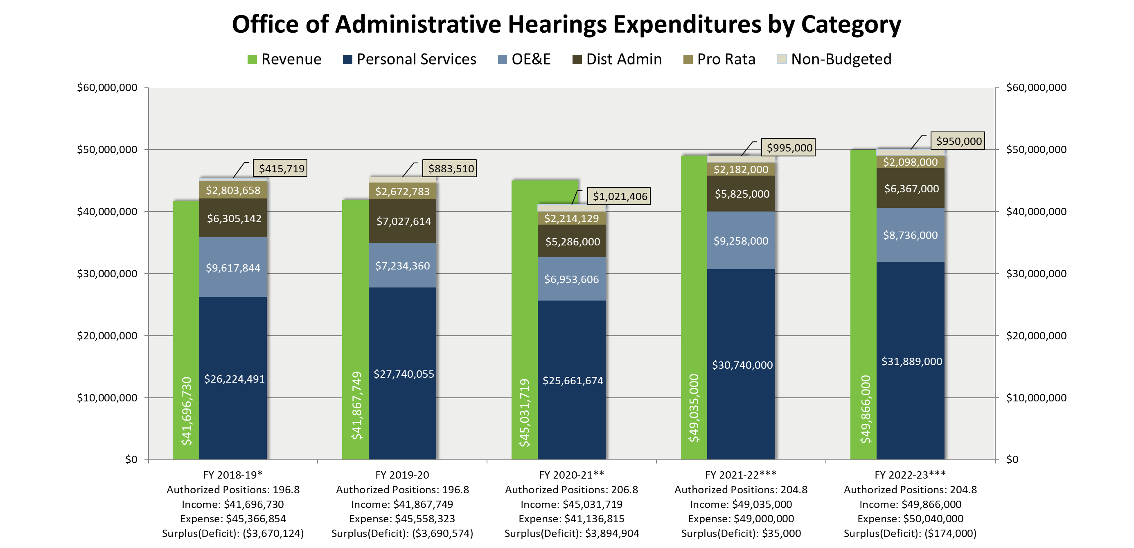

**Footnotes:**

*FY 2018-19 Revenue includes an accrual of $1.236M, which was not recorded at year-end close (will be a 2018-19 prior period adjustment), whereas the deficit includes and approved, unfunded need of $1,832M for the San Diego & Los Angeles build out.

**FY 2020-21 is based on Q3 Program Summary projections.

***Projection based on 2022-23 RCW.

## Material Changes to OAH Rates Assumptions

### Budget Letter for Employer Retirement Contributions (Control Section 3.60)

Budget adjustments for employee retirement, as prescribed by Control Section 3.60 of the Budget Act, are projected to increase by .3%. The projected budgetary increase is approximately $59,000 in FY 2021-22 and $61,000 in FY 2022-23.

### Budget Letter for Employee Compensation Adjustments (Item 9800)

Per bargaining unit agreements for salary & wages and benefits compensation, the FY 2021-22 adjustments include the regularly scheduled increases for 2021-22 and the FY 2020-21 adjustments that were postponed. An additional .05% has also been included for applicable bargaining units, as negotiated. The projected budgetary increase for OAH is $1,184,000 in FY 2021-22 and $671,000 in FY 2022-23.

### Statewide General Administrative Expenditures (Pro Rata)

The Pro Rata assessment for OAH in FY 2021-22 is $2,182,000. DGS Budgets and Planning Section projects a decrease of 4.0% in Pro Rata for FY 2022-23, which is a decrease of $84,000.

### Restoration of COVID-19 PLP Salary Reduction (9.23%)

Last year, a 9.23% PLP salary reduction was implemented as a result of the COVID-19 pandemic. This reduction was projected through FY 2021-22. Due to the projected State surplus, the Administration has agreed to restore the salary reduction effective FY 2021-22 and full salaries have been assumed for both fiscal years.

### Cannabis Administrative Hearings

OAH expects to see an increase in licensing cases stemming from the Medicinal and Adult-Use Cannabis Regulation and Safety Act. These provisions created numerous cannabis-related licenses with hearing rights before OAH effective January 1, 2018. The fiscal impact on OAH will be dependent upon the pace at which new licenses are issued or denied. The three different licensing agencies (Department of Food and Agriculture, Department of Public Health, and the Bureau of Cannabis Control) involved in considering applications for the various types of cannabis licenses and processing disciplinary cases will be unified into the new Department of Cannabis Control if the legislation providing for this unification becomes law on or after July 1, 2021.

OAH’s FY 2020-21 Budget Change Proposal (BCP) was approved for the expenditure authority on a limited-term three-year extension beginning in FY 2020-21 as a result of new administrative hearing workload for Medicinal and Adult-Use Cannabis Regulation and Safety Act related cases.

## OAH Rates

|  |  |  |  |
| --- | --- | --- | --- |
| **OFFICE OF ADMINISTRATIVE HEARING RATES** | | | |
| **DESCRIPTION** | **UNIT** | **CY 2021-22** | **BY 2022-23** |
| Administration Law Judge  (General Jurisdiction) | Per hour | $343.00 | $351.00 |
| In-Person Filing Fee (General Jurisdiction) | Per case | $125.00 | $125.00 |
| *Virtual Filing Fee (General Jurisdiction) | Per case | - | $75.00 |
| Electronic Evidence Fee | Per case | Contract Rate | Contract Rate |
| Electronic Recording Fee | Per hearing/per calendar day | $30.00 | $30.00 |
| Hearing Reporter |  | Contract Rate | Contract Rate |
| Transcript Rate |  | Contract Rate | Contract Rate |
| Interpreter |  | Contract Rate | Contract Rate |
| * OAH is proposing to incentivize virtual hearings by reducing the Filing Fee rate from the rate of $125 for in-person hearings to a discounted rate of $75 for virtual hearings beginning in FY 2022-23. This initial fee differential is intended to promote the Governor’s initiatives to reduce the state’s carbon footprint by promoting virtual hearings resulting in a reduction in travel for hearing participants. | | | |

For additional information, please contact OAH at (916) 263-0550 or visit our website at: <https://www.dgs.ca.gov/OAH>

**Original Price Book Page**

# Office of Fleet Asset Management

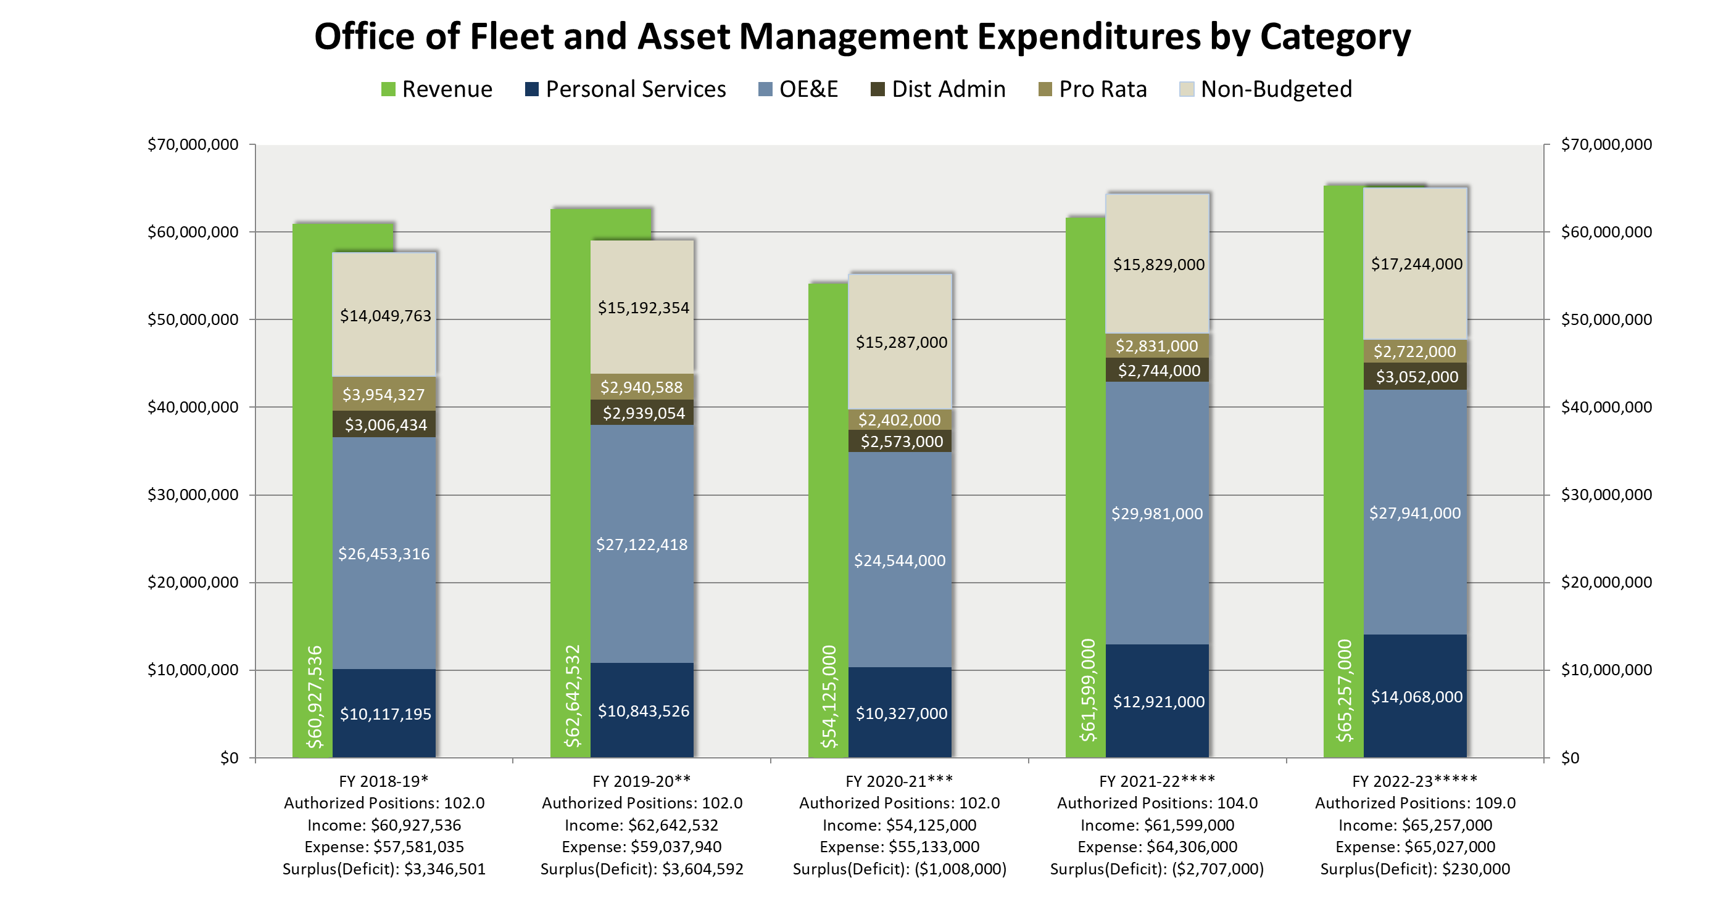The Office of Fleet and Asset Management (OFAM) provides statewide transportation and commute-related services with a customer-based focus. OFAM provides cost-effective vehicle services to meet the needs of state departments. OFAM is also responsible for the establishment, implementation, and maintenance of policies and procedures governing state owned mobile equipment. OFAM’s transportation related services include long-term vehicle rentals, vehicle inspections, parking, fully managed travel contracts, vehicle acquisition and disposition, and consultation regarding automotive management issues. In addition to transportation and commute related services, OFAM administers the State Surplus Property and Reutilization Program, the Federal Surplus Property Program, and offers client agencies quality supplemental storage through its Transit Storage Program.

**Footnotes:**

*FY 2018-19 Fiscal Year 2018-19 Totals are from the Year End Program Summary. The Distributed Admin Total includes additional department Distributed Admin Charges.

** FY 2019-20 Fiscal Year 2019-20 Totals are from the Year End Program Summary.

***FY 2020-21 Fiscal Year 2020-21 Expenditure totals are from the 3rd Quarter Program Summary and Programs COVID-19 reports, Revenue Totals are from Program's COVID-19 forecast. Expenditures include $4.2 million SRF P3 for new vehicle purchases.

****FY 2021-22 Expenditures include $3.2 million MVPF for necessary fire, life, and safety improvements for Parking Lot 32.

*****FY 2022-23 Projections

**Material Changes to OFAM Rates Assumptions**

### Budget Letter for Employer Retirement Contributions (Control Section 3.60)

Budget adjustments for employee retirement, as prescribed by Control Section 3.60 of the Budget Act, are projected to increase by .3%. The projected budgetary increase is approximately $22,000 in FY 2021-22 and $25,000 in 2022-23.

### Budget Letter for Employee Compensation Adjustments (Item 9800)

Per bargaining unit agreements for salary and wages, and benefits compensation, the FY 2021-22 adjustments include the regularly scheduled increases for that year and the FY 2020-21 adjustments that were postponed. An additional .05% has also been included for applicable bargaining units, as negotiated. The projected budgetary increase for OFAM is $420,000 in FY 2021-22 and $244,000 in FY 2022-23.

### Statewide General Administrative Expenditures (Pro Rata)

The Pro Rata assessment in FY 2021-22 for OFAM is $2,831,000. DGS Budgets and Planning Section projects a decrease of 3.85% in Pro Rata for FY 2022-23, which is a decrease of $109,000.

### Restoration of COVID-19 PLP Salary Reduction (9.23%)

Last year, a 9.23% Personal Leave Program (PLP) salary reduction was implemented in response to the COVID-19 pandemic. This reduction was projected through FY 2021-22. Due to the projected State surplus, the administration has agreed to restore the salary reduction effective FY 2021-22 and full salaries have been assumed for both fiscal years.

**Statewide Travel Program (STP) BCP: Staffing Emergency Situations**

For FY 2022-23, an increase of authority for 5.0 positions and $1,434,000 Service Revolving Fund (SRF) is provided for the STP to manage increased workload for year-round emergency response functions and support for the training and compliance auditing of statewide travel policy.

## OFAM Rates

### Fleet Asset Management Program (FAMS)

FAMS is charged with the responsibility of overseeing the state fleet in accordance with laws and mandates. State agencies report fleet data to OFAM which provides fleet analysis and reports to the administration, legislature, and the public. OFAM Inspection Services staff provide periodic and on-demand inspections of mobile equipment to ensure safety and contractual oversight of mechanical services, equipment modifications, and repair work performed by private vendors. The program also performs and oversees accident inspections on behalf of the Office of Risk and Insurance Management, develops statewide fleet policy, implements federal fleet rules statewide, investigates and approves/denies vehicle acquisition and disposal requests, provides statewide fleet management consultation, and authorizes repairs by vendors throughout the State.

### 

### Fleet Operations Program (Fleet OPS)

### Fleet OPS provides long-term rental vehicles to meet the transportation needs of state employees while conducting official state business. A vehicle rate uses original cost, insurance, operating and maintenance costs, and decommissioning and disposal costs to determine the monthly rate. Fleet OPS also provides both a Statewide Fuel Payment Card and Payment Incentive System for fleet fuel and maintenance services to state agencies and departments.

### State Surplus Property Program (SSPP)

SSPP is responsible for the proper disposition of all state-owned surplus personal property and provides disposition solutions for surplus and unwanted state-owned personal property for all state agencies. Surplus property that is reusable and cannot be placed within another state agency is made available to eligible local government agencies and school districts, before being made available to the public via online auctions. In addition, SSPP disposes of confiscated or abandoned property within the State of California.

### Federal Surplus Property Program (FSPP)

FSPP is responsible for obtaining federal surplus personal property for qualifying non-federal (local) governmental, non-profit, and small business organizations within the state for their business and operational needs. To sustain its operations, FSPP assesses a service and handling fee based upon the original acquisition cost (OAC) of the property acquired and placed with an eligible organization. FSPP also conducting annual compliance audits. Historically, this program does not recover all its operating costs, but does provide a non-monetary value to the state by enabling local government agencies, non-profits, and small businesses access to surplus federal personal property.

### Transit Storage Program (TSP)

TSP provides low-cost warehouse storage services for agencies and departments. Located in Sacramento, TSP can provide either pallet racking or high security storage. Material can be delivered to the warehouse or received directly from the supplier. There are no access fees, only a storage rate based on the number of cubic feet of storage. Services include unloading, storing, tracking, and reloading of customer property.

### Vehicle Decommissioning and Disposition

OFAM provides state agencies and departments with decommissioning and disposition services for vehicles or equipment when they are no longer needed or cost-effective to operate and are sold at auctions. Decommissioning services include removal and disposal of license plates, Vehicle Identification Number (VIN) verification, cleaning, removal of state decals, and safety inspections. Disposition services include facilitating public in-person and online auctions, fleet analysis, and scheduling services. Disposal may be made by interactive auction, sealed bid, field sale, reutilization, or transfer of a vehicle between agencies. The disposal method is determined by using the most cost-effective method to the State.

### Statewide Travel Program (STP)

STP assists state and local government travelers with their travel needs by obtaining the most economical rates available using contracted travel-related services for airfare, car rentals, travel agency, and travel payment system. Additionally, STP provides services to support emergency response efforts and state policy compliance audits to ensure appropriate and cost-effective travel. STP also provides an online booking tool for travelers to make airline tickets, car rentals, rail, and hotel reservations all in one spot.

|  |  |  |  |  |
| --- | --- | --- | --- | --- |
| **OFFICE OF FLEET AND ASSET MANAGEMENT RATES** | | | | |
| **DESCRIPTION** | **UNIT** | **CY 2021-22** | **BY 2022-23** |
| **Fleet Asset Management Program** | | | | |
| Fleet Asset Management Fee | Per Mobile Equipment Asset | $134.00 | $140.00 |

|  |  |  |  |
| --- | --- | --- | --- |
| **OFFICE OF FLEET AND ASSET MANAGEMENT RATES** | | | |
| **DESCRIPTION** | **UNIT** | **CY 2021-22** | **BY 2022-23** |
| **State Surplus Property Program** | | | |
| State Surplus Property | Variable | Actual Sales | Actual Sales |
| Federal Surplus Property | OAC | 10% or $100 whichever is greater | 10% or $100 whichever is greater |
| Transit Storage Standard | Cubic Feet | $0.49 | $0.50 |
| Transit Storage Secured | Cubic Feet | $0.50 | $0.52 |
| Vehicle Decommissioning and Disposition Fee | Per Vehicle | $390.00 | $400.00 |
| **Fleet Operations Program** | | | |
| **DESCRIPTION** | **UNIT**1 | **CY 2021-22** | **BY 2022-23** |
| Gasoline Compact Sedan | Monthly | $407.00 | $420.00 |
| Gasoline Midsize Sedan | Monthly | $433.00 | $447.00 |
| Gasoline Full-size Sedan | Monthly | $477.00 | $492.00 |
| Hybrid Compact Sedan | Monthly | $386.00 | $398.00 |
| Hybrid Midsize Sedan | Monthly | $445.00 | $459.00 |
| Hybrid Full-size Sedan | Monthly | $463.00 | $478.00 |
| Plug-in Hybrid Electric Sedan | Monthly | $403.00 | $403.00 |
| Battery Electric Vehicle | Monthly | $376.00 | $376.00 |
| Hydrogen Fuel Cell Vehicle | Monthly | $494.00 | $494.00 |
| Police Package Vehicle | Monthly | $461.00 | $475.00 |
| Gasoline Small SUV | Monthly | $470.00 | $485.00 |
| Gasoline Medium SUV | Monthly | $496.00 | $512.00 |
| Gasoline Large SUV | Monthly | $533.00 | $550.00 |
| Hybrid Small SUV | Monthly | $462.00 | $477.00 |
| Hybrid Medium SUV | Monthly | $482.00 | $497.00 |
| Plug-in Hybrid Electric SUV | Monthly | $433.00 | $433.00 |
| Mini Pickup Truck | Monthly | $524.00 | $541.00 |
| 1/2 Ton Pickup Truck | Monthly | $540.00 | $557.00 |
| 3/4 Ton Pickup Truck | Monthly | $601.00 | $620.00 |

|  |  |  |  |
| --- | --- | --- | --- |
| **OFFICE OF FLEET AND ASSET MANAGEMENT RATES** | | | |
| **DESCRIPTION** | **UNIT** | **CY 2021-22** | **BY 2022-23** |
| Large Cargo/Passenger Van | Monthly | $479.00 | $494.00 |
| Mini Cargo/Passenger Van | Monthly | $443.00 | $457.00 |
| Plug-in Hybrid Electric Mini Passenger Van | Monthly | $428.00 | $428.00 |
| Fuel & Maintenance Management Fee | Percent of total fuel, maintenance, and repair expense | 1.80% | 1.80% |
| 1. The monthly flat rates do not include fuel, all monthly rental vehicles will be $0.10 per mile. | | | |

|  |  |  |  |
| --- | --- | --- | --- |
| **Statewide Travel Program** | | | |
| **DESCRIPTION** | **UNIT** | **CY 2021-22** | **BY 2022-23** |
| Travel Management Fee | Transactions | Vendor charges for travel services are available upon request. | Vendor charges for travel services are available upon request |

For additional information, contact the Office of Fleet and Asset Management, (916) 928- 2550 or view the OFAM website at: <https://www.dgs.ca.gov/OFAM>

# Office of Legal Services

The Office of Legal Services (OLS) reviews non-IT service contracts for compliance with law and policy. OLS also provides guidance to state departments, internal DGS divisions and offices regarding the State’s contracting and procurement laws. This guidance includes recommending best practices for contracting services, providing contract pre-review and approval of contracts on behalf of DGS, and non-IT services contract training. OLS attorneys serve as hearing officers on bid protests.

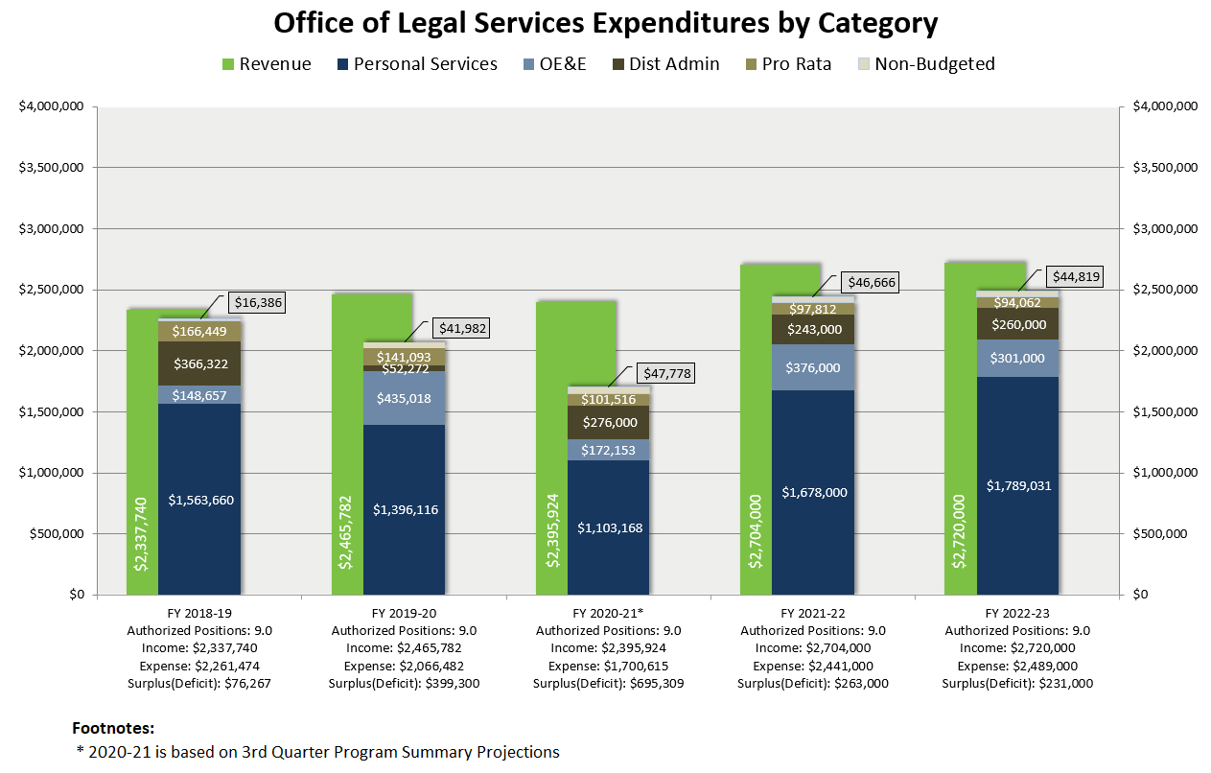OLS in-house counsel services include providing legal advice on the State’s leveraged procurement of goods and services, as well as real estate leasing, acquisition, construction, Public Records Act requests, human resources, labor relations, regulatory adoption, and litigation support. OLS also represents DGS in personnel matters before administrative bodies.

## Material Changes to OLS Rates Assumptions

### Budget Letter for Employer Retirement Contributions (Control Section 3.60)

Budget adjustments for employee retirement, as prescribed by Control Section 3.60 of the Budget Act, are projected to increase by 0.3%. The projected budgetary increase is approximately $3,000 in FY 2021-22 and $3,000 in 2022-23.

### Budget Letter for Employee Compensation Adjustments (Item 9800)

Per bargaining unit agreements for salary & wages and benefits compensation, the FY 2021-22 adjustments include the regularly scheduled increases for 2021-22 and the FY 2020-21 adjustments that were postponed. An additional .05% has also been included for applicable bargaining units, as negotiated. The projected budgetary increase for OLS is $85,000 in FY 2021-22 and $35,000 in FY 2022-23.

### Statewide General Administrative Expenditures (Pro Rata)

The Pro Rata assessment for OLS in FY 2021-22 is $98,000. DGS Budgets and Planning Section projects a decrease of 4.1% in Pro Rata for FY 2022-23, which is a decrease of $4,000.

### Personal Leave Program 2020 (PLP 2020)

Last year, a 9.23% PLP salary reduction was implemented as a result of the COVID-19 pandemic. This reduction was projected through FY 2021-22. Due to the projected State surplus, the Administration has agreed to restore the salary reduction effective FY 2021-22 and full salaries have been assumed for both fiscal years.

## OLS Rates

### Contract Review

Services include assistance and advice in preparing effective solicitations, evaluation of contracts as to legal sufficiency, determining compliance with policy (including matters related to sound fiscal and business practice), and approving contracts on behalf of DGS in accordance with Government Code § 11256 and Public Contract Code § 10295.

### External Legal Advice/ Hearing Officer

OLS provides advice on non-IT service solicitations and contracts and provides customized non-IT service contract training upon request. OLS attorneys serve as hearing officer on bid protests.

|  |  |  |  |
| --- | --- | --- | --- |
| **OFFICE OF LEGAL SERVICES RATES** | | | |
| **DESCRIPTION** | **UNIT** | **CY 2021-22** | **BY 2022-23**1 |
| Contract Review | Per Contract | $366.00 | $366.00 |
| External Legal Advice/Hearing Officer | Hourly | $170.00 | $170.00 |
| 1 Due to economic uncertainty, for the purpose of forecasting and budgeting, DGS is assuming BY 2022-23 rates are held constant at current levels, but DGS will closely monitor workload, expenditures, and revenues and will modify as necessary next year. | | | |

For additional information, contact the Office of Legal Services, (916) 376-5080 or view the OLS website at: <https://www.dgs.ca.gov/OLS>

# Office of Risk and Insurance Management

The Office of Risk and Insurance Management (ORIM) provides risk management and insurance services to state agencies and other public entities on an ongoing or project-specific basis.

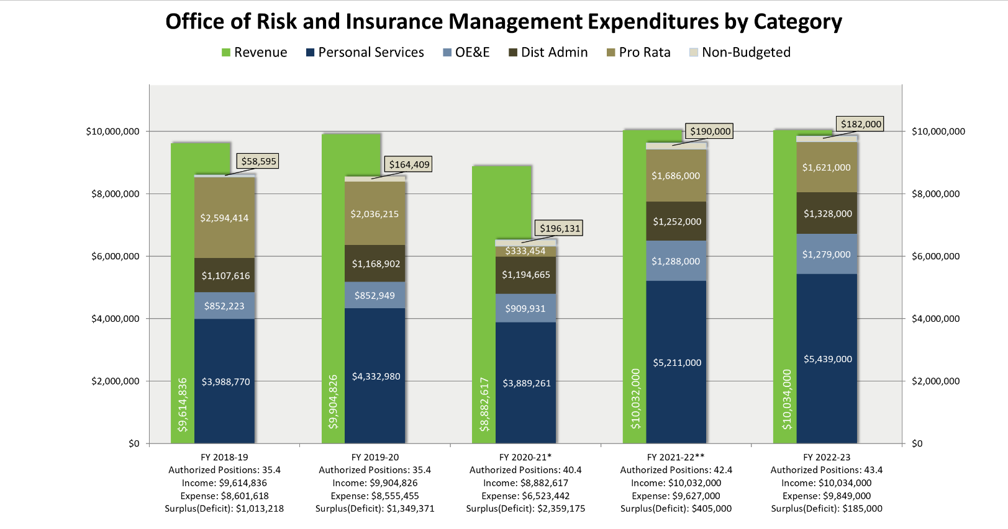ORIM assists agencies in managing exposure to accidental losses that result from general operations, employment, motor vehicles, property ownership and risk financing. ORIM oversees the equipment maintenance management insurance program, master property and builders risk programs, defensive driver training, health and safety training, natural gas procurement, government claims and motor vehicle claim program, and the Governor’s Employee Safety Awards. Additionally, ORIM provides emergency planning services to DGS employees to ensure they are in a state of readiness should any unanticipated emergency or disaster occur. Lastly, ORIM’s administers insurance programs for client agencies which includes analyzing risks and needs, insurance consulting and purchasing, and claims adjustments for the lowest available costs.

**Material Changes to ORIM Rates Assumptions**

### Budget Letter for Employer Retirement Contributions (Control Section 3.60 Drill)

Budget adjustments for employee retirement, as prescribed by Control Section 3.60 of the Budget Act, are projected to increase by .3%. The projected budgetary increase is approximately $10,000 in FY 2021-22 and $10,000 in FY 2022-23.

### Budget Letter for Employee Compensation Adjustments (Item 9800)

Per bargaining unit agreements for salary & wages and benefits compensation, the FY 2021-22 adjustments include the regularly scheduled increases for 2021-22 and the FY 2020-21 adjustments that were postponed. An additional .05% has also been included for applicable bargaining units, as negotiated. The projected budgetary increase for ORIM is $147,000 in FY 2021-22 and $102,000 in FY 2022-23.

### Statewide General Administrative Expenditures (Pro Rata)

The Pro Rata assessment for ORIM in FY 2021-22 is $1,686,000. DGS Budgets and Planning Section projects a decrease of 3.8% in Pro Rata for FY 2022-23, which is a decrease of $66,000.

### Restoration of COVID-19 PLP Salary Reduction (9.23%)

Last year, a 9.23% PLP salary reduction was implemented as a result of the COVID-19 pandemic. This reduction was projected through FY 2021-22. Due to the projected State surplus, the Administration has agreed to restore the salary reduction effective FY 2021-22 and full salaries have been assumed for both fiscal years.

**ORIM Rates**

### Equipment Maintenance Management Insurance Program

The program was established to reduce costs attributed to service and maintenance agreements on equipment. The program is based on time and materials used versus traditional service agreements. As a result, up to a 25 percent savings is realized. ORIM contracts with an insurance broker who purchases the insurance for the program. ORIM provides quotes through its broker, processes invoices, and markets the program to other state agencies.

### Insurance Procurement

Government Code § 11077.7 provides that the purchase of insurance is subject to the approval of DGS. Furthermore, when no state agency or department is specifically authorized to purchase insurance, DGS may procure the insurance. Included in purchasing is the policy administration for the term of the policy, administration of claims presented under the policy, and advice on loss and accident prevention to assist in the mitigation of risk. ORIM charges a surcharge to recover these administration expenses. In addition, ORIM purchases transit insurance directly for some client agencies based on actual costs.

### Claims Adjusting

In accordance with Health and Safety Code §1527 et. seq., and §2580.2, ORIM provides claims adjusting services through an interagency agreement for the Department of Social Services (DSS). The services involve worker’s compensation claims adjusting and consultation for DSS’ In-House Support Services, CalWORKs, and Food Stamps Employment Training programs. In addition, ORIM provides claims services for the DSS’ Foster Care Liability Program. The claims involve foster children injured while in the care of a foster parent(s). ORIM acts as a liaison between DSS and the respective parties.

### Government Claims Program (GCP)

The Tort Claims Act of 1963 established the manner which claims against the State are handled and defined the administrative role and remedies offered by the GCP. Pursuant to the Government Code, those who wish to file a lawsuit against the State, or its employees must first pursue an administrative remedy through GCP. The GCP process provides the State an opportunity to investigate and possibly settle claims without incurring litigation expenses. Claimants may not proceed with legal action against the State unless the GCP acts on claims or rejects them. Budget Change Proposal (BCP) 787-001-BCP-BR-2016-GB statutorily established GCP within DGS.

### Motor Vehicle Liability

Insured agencies are charged a premium assessment based on past actual accident and loss experience.

|  |  |  |  |
| --- | --- | --- | --- |
| **OFFICE OF RISK MANAGEMENT AND INSURANCE RATES** | | | |
| **DESCRIPTION** | **UNIT** | **CY 2021-22** | **BY 2022-23**1 |
| Equipment Maintenance Management Program (EMMP) - Purchase of Insurance Premiums | per Premium | 3.50% | 3.50% |
| Insurance Procurement - Purchase of Insurance Premiums | per Premium | 6.60% | 6.60% |
| Claims Adjusting Worker’s Comp – External | Hourly | $113 | $113 |
| Government Claims Program – Filing Fee | per File | $25 | $25 |
| Motor Vehicle Liability | Premium | Varies | Varies |

For additional information, contact the Office of Risk and Insurance Management, (916) 376-5300 or view the ORIM website at: <https://www.dgs.ca.gov/ORIM>

# Office of State Publishing

The Department of General Services’ (DGS) Office of State Publishing (OSP) provides innovative printing solutions utilizing cutting-edge technology in design, offset print, digital print, finishing and mass mail services for California’s state and public agencies, the California State Legislature, and the Governor’s Office. OSP provides legislative publications to the State Capitol, offers business cards and customized digital printing through its Web Store Front, and offers secure (compliant with Health Insurance Portability and Accountability Act of 1996 (HIPAA) and Internal Revenue Service Publication 1075 (IRS 1075) processing requirements) printing and distribution for insurance and medical notices and statement printing.

In addition to its core print business, OSP operates several other programs and services which are beneficial to our state agency customers. The Interagency Mail & Messenger Service provides daily mail service between state offices in the greater Sacramento area, including Elk Grove and Rancho Cordova. The State Records Center offers secure and convenient offsite storage solutions for over 144 state agencies and our vault storage option features a temperature and humidity-controlled environment for essential records. The Document Destruction Center facilitates the destruction of confidential paper records, microfilm, microfiche, cassettes, computer tapes and other recyclable materials.

The Fulfillment Services Unit offers secure warehousing and distribution services by managing a catalog of literature and marketing materials to meet customer distribution demands. A full range of fulfillment services are also available for customers to request through OSP’s Web StoreFront.

During fiscal year 2020-21, OSP experienced several operational disruptions which prevented OSP from fully recovering its costs. The COVID-19 pandemic has and continues to have an impact on OSP’s operations, as OSP has delayed onboarding new business, while enduring unforeseen customer order cancellations, and foregoing new equipment purchases, which were anticipated to generate additional revenue and savings.

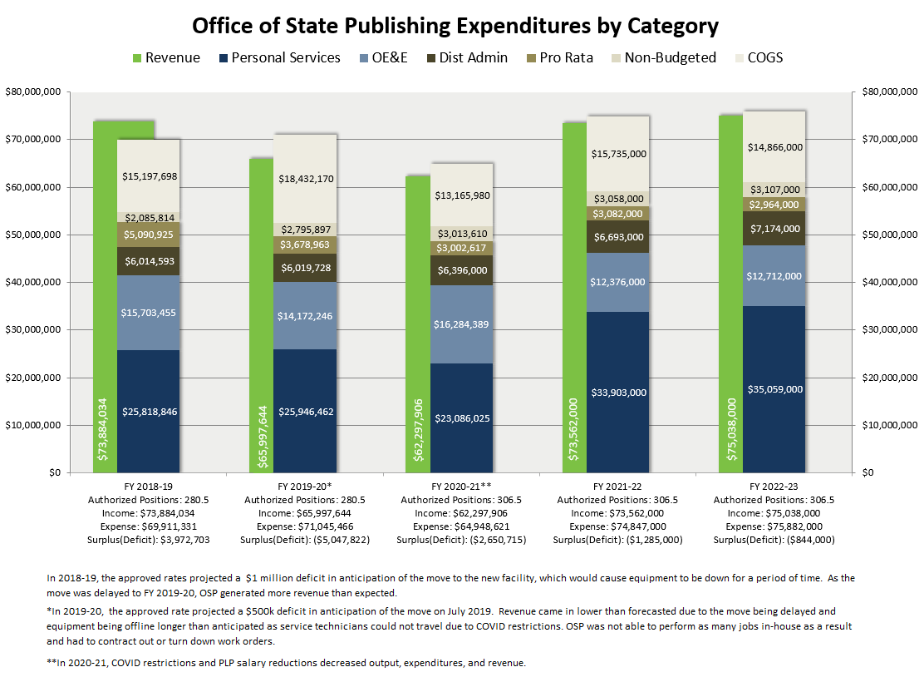

**Material Changes to OSP Rates Assumptions**

**Budget Letter for Employer Retirement Contributions (CS 3.60 Drill)**

Budget adjustments for employee retirement, as prescribed by Control Section 3.60 of the Budget Act, are projected to increase by .3%. The projected budgetary increase is approximately $56,000 in FY 2021-22 and $61,000 in 2022-23.

**Budget Letter for Employee Compensation Adjustments (9800 Drill)**

Per bargaining unit agreements for salary & wages and benefits compensation, the FY 2021-22 adjustments include the regularly scheduled increases for 2021-22 and the FY 2020-21 adjustments that were postponed. An additional .05% has also been included for applicable bargaining units, as negotiated. The projected budgetary increase for OSP is $1,030,000 in FY 2021-22 and $549,000 in FY 2022-23.

**Statewide General Administrative Expenditures (Pro Rata) Decrease**

The Pro Rata assessment for OSP in 2021-22 is $3,082,000. DGS Budgets and Planning Section projects a decrease of 3.8% in Pro Rata for 2022-23, which is a decrease of $118,000. This reflects the decrease in general spending due to COVID-19.

**Restoration of COVID-19 PLP Salary Reduction (9.23%)**

Last year, a 9.23% PLP salary reduction was implemented as a result of the COVID-19 pandemic. This reduction was projected through FY 2021-22. Due to the projected State surplus, the Administration has agreed to restore the salary reduction effective FY 2021-22 and full salaries have been assumed for both fiscal years.

**OSP Rates**

OSP has been utilizing the same basic rate structure since 2015, as identified throughout this package.

Rates are set based on the forecasted total machine output hours divided by the total costs to operate the machine, which includes fixed and variable overhead expenses. The methodology used to absorb OSP Admin, Distributed Admin, and Statewide Pro Rata across OSP rates remains the same as in prior years. This methodology uses position dollars (50% number of positions and 50% position dollars), which mirrors the departmental methodology for allocating Distributed Admin.

OSP’s hourly machine rates are not a direct correlation of the cost to the customer. Due to the complexity of customized print job specifications, OSP provides all its customers with an all-inclusive cost estimate for each print order. OSP uses improvements in efficiencies, production practices, and economies of scale to minimize the overall cost to its customers.

The Price Book includes rates for the State Record Center, Document Destruction, Graphic Design, Interagency Mail and Messenger Service, Business Cards, and all items posted on the Web Store Front.

### State Records Management

Records Management includes the operation of records centers for the economical storage of records which must be retained, but which need not be kept in high-cost office areas. This service also includes the provision of vault facilities for the permanent storage of the State’s vital or essential records in case of a disaster (microfilm copies only).

The following State Records Management Fees were established to recover costs associated with the State Records Center (SRC) and/or Document Destruction Center (DDC) operations. These services provide low-cost record storage for all State agencies:

1. Records Storage Fee
2. Long Term Storage Fee
3. Essential Records Storage Fee
4. Confidential Destruction Fee
5. Plastics Destruction Fee
6. Record Pulls Fee
7. Re-File Fee
8. Pre-End Retention/Early Withdrawal Fee
9. E-Pull Fee

|  |  |  |  |
| --- | --- | --- | --- |
| **OFFICE OF STATE PUBLISHING – STATE RECORDS MANAGEMENT RATES** | | | |
| **DESCRIPTION** | **UNIT** | **CY 2021-22** | **BY 2022-23** |
| Records Storage Fee | Cubic Feet | $5.40 | $5.56 |
| Long Term Storage Fee | Cubic Feet | $2.10 | $2.16 |
| Essential Records Storage Fee | Cubic Feet | $25.25 | $26.01 |
| Confidential Destruction Fee | Pounds | $0.17 | $0.18 |
| Plastics Destruction Fee | Pounds | $0.35 | $.36 |
| Record Pulls | Transaction | $2.50 | $2.58 |
| Re-File Fee | Transaction | $2.50 | $2.58 |
| Pre-End Retention/Early Withdrawal Fee | Transaction | $8.00 | $8.24 |
| e-Pull Fee | Transaction | $11.00 | $11.33 |

### Production

The Production Cost Centers perform a variety of print services for the Legislature and other state agencies. These services include, but are not limited to, composition, offset and digital printing, bindery finishing and mailing services, in order to produce finished printed products. Some of these products include legislative bills and publications, annual reports, driver’s handbooks, voter guides, tax booklets, etc. Government Code sections 14650-14912 form the foundation for the printing services provided. OSP is a fee-for-service agency.

The production unit provides the following services:

1. **Advertising & Design:** Provides state agencies an opportunity to reduce their printing costs through the incorporation of paid advertising in their publications and mailings.
2. **Electronic Prepress (EPP):** Provides electronic prepress services as well as proofreading services. EPP ensures that each offset print project that passes through OSP is prepared and setup correctly for its journey through the presses.
3. **Press Services:** Provides quality printed materials to a wide variety of state agencies as well as providing digital on demand printing for all legislative publications and documents for the Capitol.
4. **Bindery:** Performs all the finishing processes on all jobs including packaging and some distribution and mailing. OSP assure the customer receives a quality final product as specified by the customer.
5. **Digital Print:** Uses digital printing equipment to provide quality variable and secure printed materials to a wide variety of state agencies as well as acting as a back-up for all Legislative publications.
6. **Digital Prep and Finishing:** Provides prepress services as well as proofreading services ensuring that each Digital print project that passes through OSP is prepared and setup correctly for its journey through the presses.
7. **Digital Mass Mail:** Uses digital mass mailing equipment to provide mailing services to a wide variety of state agencies.

Estimates and consultation available upon request for brochures, newsletters, bulletins, catalogs, instructional manuals, booklets, magazines, and others. Please contact the Office of State Publishing at

(916) 445-5386 or (800) 963-7860 or visit our website at [www.dgs.ca.gov/osp](http://www.dgs.ca.gov/osp).

# Office of Sustainability

The Office of Sustainability (OS) provides sustainability-related services for all state agencies, including policy development, energy-saving retrofits, clean energy generation projects, and electric vehicle infrastructure. Key program areas to meet customer needs include renewable clean energy generation (solar and wind), energy retrofits in existing facilities, zero net energy (ZNE) building policy development, electric vehicle supply equipment (EVSE) infrastructure, benchmarking, and recycling. California continues to reduce its environmental footprint through sustainable state government operations and practices, including energy and water efficient building design, construction and operation, renewable energy generation at state facilities, environmentally preferable purchasing, and green transportation policies.

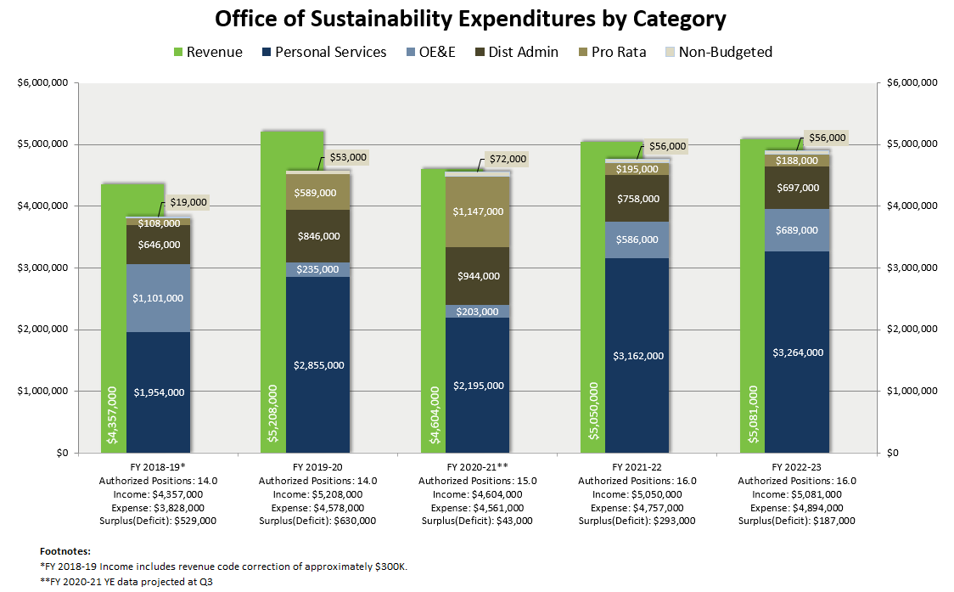

**Material Changes to OS Rates Assumptions**

### Budget Letter for Employer Retirement Contributions (Control Section 3.60)

Budget adjustments for employee retirement, as prescribed by Control Section 3.60 of the Budget Act, are projected to increase by .3%. The projected budgetary increase is approximately $6,000 in FY 2021-22 and $7,000 in FY 2022-23.

### Budget Letter for Employee Compensation Adjustments (Item 9800)

Per bargaining unit agreements for salary & wages and benefits compensation, the FY 2021-22 adjustments include the regularly scheduled increases for 2021-22 and the FY 2020-21 adjustments that were postponed. An additional .05% has also been included for applicable bargaining units, as negotiated. The projected budgetary increase for OS is $133,000 in FY 2021-22 and $4,000 in FY 2022-23.

### Statewide General Administrative Expenditures (Pro Rata)

The Pro Rata assessment for OS in FY 2021-22 is $195,000. DGS Budgets and Planning Section projects a decrease of 3.8% in Pro Rata for FY 2022-23, which is a decrease of $7,000.

### Restoration of COVID-19 PLP Salary Reduction (9.23%)

Last year, a 9.23% PLP salary reduction was implemented as a result of the COVID-19 pandemic. This reduction was projected through FY 2021-22. Due to the projected State surplus, the Administration has agreed to restore the salary reduction effective FY 2021-22 and full salaries have been assumed for both fiscal years.

### Electric Vehicle Service Equipment Infrastructure Assessment and Facility Development BCP

OS has requested a onetime budget augmentation of $50M in General Fund and $1.3M in Service Revolving Fund for FY 2021-22, to fund year five of the DGS Zero Emission Vehicles (ZEV) Five-Year Infrastructure Investment Plan.

**OS Rates**

### Energy Savings Unit

The Energy Savings Unit provides project management of energy retrofit project in state facilities for small to large and complex energy projects.

### Clean Energy Unit

The Clean Energy Unit provides planning, due diligence, tax analysis, California Environmental Quality Act review, contracting of power purchase agreements, site license agreements, and design and construction oversight for renewable energy projects including solar and wind projects in state facilities. Additionally, as new clean energy options become viable, such as evolving storage technologies, this group will develop new clean energy programs in response to technological and industry developments.

### Transportation Unit

The Transportation Unit will manage the planning, site assessment, design, and construction of electric vehicle service equipment for charging zero emission vehicles in both fleet and workplace applications. Additionally, this group will support the development of other clean transportation options, including fuel cell charging and the Bike Share program.

### Rates Structure:

OS was created as a part of the Real Estate Services Division (RESD) reorganization for FY 2017-18. The rate structure was established in 2017-18. The rate structure is consistent with RESD’s rate structure.

|  |  |  |  |
| --- | --- | --- | --- |
| **OFFICE OF SUSTAINABILITY RATES** | | | |
| **DESCRIPTION** | **UNIT** | **CY 2021-22** | **BY 2022-23** |
| Energy Savings Unit | Hourly | $209 | $215 |
| Clean Energy Unit | Hourly | $209 | $215 |
| Transportation Unit | Hourly | $209 | $215 |
|  | | | |

For additional information, contact the Office of Sustainability, (916) 443-9838 or view the OS website at: <https://www.dgs.ca.gov/OS>

# Procurement Division

The Procurement Division (PD) sets procurement policies and provides purchasing services for state agencies. PD consists of five branches: Acquisitions, Operations, Engineering, Office of Small Business and Disabled Veteran Business Enterprise Services, and Policy, Training and Customer Services. It delegates purchasing authority; certifies small and/or disabled veteran businesses to do business with the State; sponsors the Small Business Council; participates in the Disabled Veterans Business Enterprise Council; and provides innovative purchasing methods that save taxpayers' dollars, integrating quality solutions to meet customers' needs.

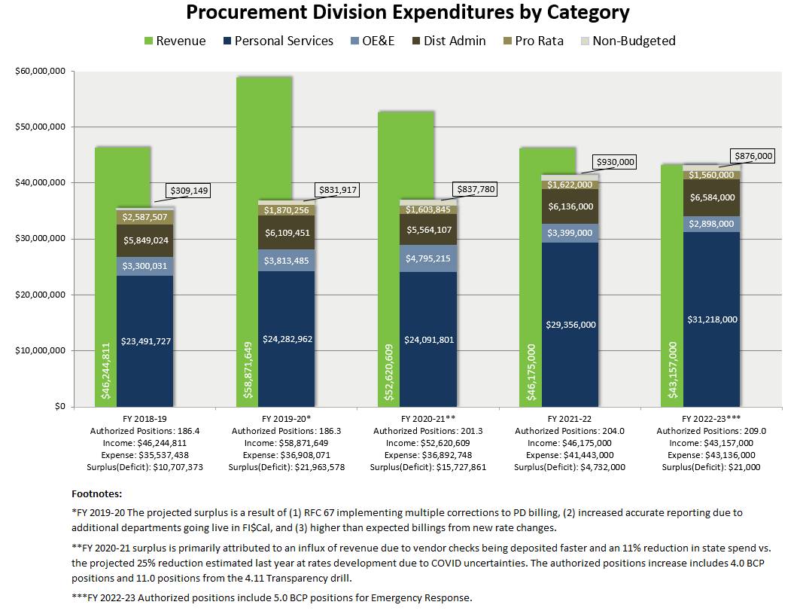

## Material Changes to PD Rates Assumptions

**Budget Letter for Employer Retirement Contributions (Control Section 3.60)**

Budget adjustments for employee retirement, as prescribed by Control Section 3.60 of the Budget Act, are projected to increase by 0.3%. The projected budgetary increase is approximately $53,000 in FY 2021-22 and $56,000 in 2022-23.

**Budget Letter for Employee Compensation Adjustments (Item 9800)**

Per bargaining unit agreements for salary & wages and benefits compensation, the FY 2021-22 adjustments include the regularly scheduled increases for 2021-22 and the FY 2020-21 adjustments that were postponed. An additional .05% has also been included for applicable bargaining units, as negotiated. The projected budgetary increase for PD is $944,000 in FY 2021-22 and $603,000 in FY 2022-23.

### Statewide General Administrative Expenditures (Pro Rata)

The Pro Rata assessment for PD in FY 2021-22 is approx. $1,622,000. DGS Budgets and Planning Section projects a decrease of 3.83% in Pro Rata for FY 2022-23, which is a decrease of $62,000.

### Restoration of COVID-19 PLP Salary Reduction (9.23%)

Last year, a 9.23% PLP salary reduction was implemented as a result of the COVID-19 pandemic. This reduction was projected through FY 2021-22. Due to the projected State surplus, the Administration has agreed to restore the salary reduction effective FY 2021-22 and full salaries have been assumed for both fiscal years.

### Rate for Local Use of Leveraged Procurement Agreements (LPAs)

Beginning in FY 2019-20, PD started updating the 1% incentive fee collected from the supplier to 1.25% for local use of all LPAs as contracts expire. This conversion is expected to complete in FY 2021-22.

### Purchasing Surcharge Reduction

Due to the economic uncertainty related to the COVID-19 pandemic and the purchasing restrictions mandated by the Governor in Budget Letter 20-11, a 10% reduction from PD’s 3-year average state spend is projected for the purchasing surcharge in FY 2021-22.

## PD Rates

### Contract Advertising

The Procurement Division (PD) publishes state contracting opportunities daily on the Internet via the California State Contracts Register (CSCR). State law requires agencies to advertise their construction and service contracting opportunities of $5,000 or more and commodity contracts over $50,000 in the CSCR. Advertising exemptions may be requested based upon legal exemption criteria. CSCR services are available to local government and special districts.

### Purchasing Surcharge

This fee includes all the services listed below, as well as Small Business (SB) and Disabled Veteran Business Enterprise (DVBE) services. The DVBE and SB Certification Programs were established to increase business opportunities for the DVBE and SB communities with the State of California and level the playing field with certain advantages when competing against other non-DVBE's and non-SB's for state contracts and purchases.

PD also assists SB's and DVBE's in a variety of ways, including conducting outreach events, providing resource guidance, and supporting the businesses through advocacy. The Disabled Veteran Business Enterprise Certification Program certifies eligible businesses for the DVBE Participation Program, which has a goal to use DVBEs in at least three percent of the State’s overall annual contract dollars. The Small Business Certification Program certifies eligible businesses for the five percent small business preference and the Small Business Participation Program, which has a goal to use SBs in at least 25 percent of the State’s overall annual contract dollars.

1. **Purchase Order Issuance**: Includes SB/DVBE services, purchase estimate processing, bid preparation and evaluation, product testing, product standards and specifications development, quality control review and product inspection, and materials expediting, including vendor performance follow up. The Procurement Division provides stimulus and business information services to further small business participation in state contracting. A surcharge is placed on contracts executed by the State of California. Refer to the State Contracting Manual for submission guidelines and due dates.
2. **Leveraged Procurement Agreements**: Issuance of Leveraged Procurement Agreements (Statewide Contracts, Master Purchase/Rental/Service Agreements, and Software Licensing Program Contracts) for use by state and local agencies in acquiring equipment or services. Includes Master Rental Agreements of IT Terminals, Master Purchase Agreements, and Master Service Agreements for IT and telecommunications goods and services. Includes bid preparation and evaluation, product testing, product standards and specifications development, quality control review and product inspection, and materials expediting including vendor performance follow up.
3. **Purchasing Authority (Delegated Procurements):** Charge for management and compliance of delegated procurements made directly by state agencies. Charge does not apply to Interagency agreements executed under a state agency’s purchasing authority.
4. **California Multiple Award Schedule (CMAS):** Agreements with manufacturers and suppliers to provide products and services off Federal General Services Administration (GSA) schedules. This fee is waived when the CMAS supplier is a small business.
5. **Financing Procurement:** Low-interest, lease/purchase financing option for major acquisitions. For additional information contact the GS $Mart within the Procurement Division at (916) 375-4617.
6. **Purchasing – Recycled Products:** The Procurement Division provides information regarding specifications and sources of supply for purchases of products made all or in part from recycled materials. For additional information refer to the Procurement Division’s Environmentally Friendly Purchasing (EPP) Buying Green Guide at <https://www.dgs.ca.gov/PD/Resources/Find-EPP-Goods-and-Services.>

|  |  |  |  |
| --- | --- | --- | --- |
| **PROCUREMENT DIVISION RATES** | | | |
| **DESCRIPTION** | **UNIT** | **CY 2021-22** | **BY 2022-23** |
| **California State Contracts Register** | | | |
| Agency Advertising/Exemption Fee | Each | $50.00 | $50.00 |
| Note: All posted events, regardless of length of time posted, are subject to this fee. | | | |
| **Purchase Surcharge1** | | | |
| Purchase Order Issuance | Per transaction | 1.10% of value of transaction | Percent-to-total based on 3-Year Average Billable Spend |
| Leveraged Procurement Agreements | Per transaction | 1.10% of value of transaction | Percent-to-total based on 3-Year Average Billable Spend |
| Purchasing Authority (Delegated Procurements) | Per transaction | 1.10% of value of transaction | Percent-to-total based on 3-Year Average Billable Spend |
| California Multiple Award Schedule (CMAS) | Per transaction | 1.10% of value of transaction | Percent-to-total based on 3-Year Average Billable Spend |
| Financing Procurement | Per transaction | 1.10% of value of transaction, excluding financing charges | Percent-to-total based on 3-Year Average Billable Spend |
| 1 Beginning in FY 2022-23, each customer will be billed quarterly based on their 3-year average billable spend percent-to-total applied to PD’s costs to recover (minus other projected revenue sources). | | | |

For information contact the Procurement Division at: [PDInvoiceQuestions@dgs.ca.gov](mailto:PDInvoiceQuestions@dgs.ca.gov), (916) 375-2010, or visit our website at: <http://www.dgs.ca.gov/pd/home.aspx>.

.

# Real Estate Services Division

The Real Estate Services Division (RESD) provides comprehensive real estate services to all state agencies. Comprised of three operational branches, RESD conducts asset planning, property sales and acquisition, project management, architectural and engineering services, leasing, and planning, construction management, energy efficiency and supply programs, and environmental assessments, including the management of state-owned and leased facilities.

## Asset Management Branch

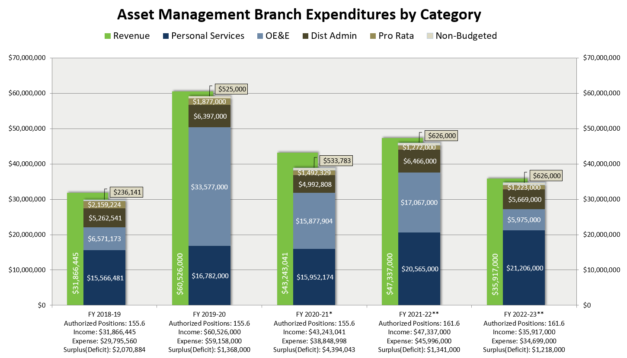The Asset Management Branch (AMB) serves as the initial point of contact in the Real Estate Services Division (RESD) for our customers and is the single point of entry for requesting new services. AMB oversees leasing, space planning and interior design, sales, appraisal, and acquisition services. AMB is also responsible for maximizing the performance of state real estate assets by identifying and implementing value enhancement solutions for unused and underutilized state-owned properties.

**Footnotes:**

*FY 2020-21 is based on Q3 Program Summary projections.

**Revenue displayed includes GF funding of $13.6M in FY 2021-22 and $1.5M in 2022-23, but it is not part of the rates development calculation. GF includes Sonoma Development Center (ended June 2022), SB6/AB1255 - Affordable Housing Database (ending June 2024) and Mercury Cleaner Remediation (ending June 2037).

## Material Changes to AMB Rates Assumptions

### Budget Letter for Employer Retirement Contributions (Control Section 3.60)

Budget adjustments for employee retirement, as prescribed by Control Section 3.60 of the Budget Act, are projected to increase by .3%. The projected budgetary increase is approximately $43,000 in FY 2021-22 and $45,000 in FY 2022-23.

### Budget Letter for Employee Compensation Adjustments (Item 9800)

Per bargaining unit agreements for salary & wages and benefits compensation, the FY 2021-22 adjustments include the regularly scheduled increases for 2021-22 and the FY 2020-21 adjustments that were postponed. An additional .05% has also been included for applicable bargaining units, as negotiated. The projected budgetary increase for AMB is $783,000 in FY 2021-22 and $367,000 in FY 2022-23.

### Statewide General Administrative Expenditures (Pro Rata)

The Pro Rata assessment for AMB in FY 2021-22 is $1,272,000. DGS Budgets and Planning Section projects a decrease of 4.0% in Pro Rata for FY 2022-23, which is a decrease of $49,000.

### Restoration of COVID-19 PLP Salary Reduction (9.23%)

Last year, a 9.23% PLP salary reduction was implemented as a result of the COVID-19 pandemic. This reduction was projected through FY 2021-22. Due to the projected State surplus, the Administration has agreed to restore the salary reduction effective FY 2021-22 and full salaries have been assumed for both fiscal years.

### Output Variances

AMB is proposing its rates for 2020-21 and 2021-22 with 6.0 anticipated billable vacancies and 5.0 vacancies in the units with surcharge.

• 6.0 in RELPS – Planning Services & SOLD

• 3.0 in Portfolio Management and Leasing Management Surcharge

• 2.0 in RELPS- Leasing Activities Surcharge

### Personal Services Adjustments for Temp Help, Vacancies, and Anticipated Retirements

DGS Budgets and Planning Section has projected salary and benefits savings due to the vacancies in the program and when they are anticipated to be filled. The projected savings for 2021-22 and 2022-23 is $1.2M.

## AMB Rates

### Portfolio Management

The Portfolio Management Section ensures RESD real estate services are provided to state agencies from a statewide, strategic asset management perspective and reflect state management, policy, and statutory priorities. To fulfill this broad role, Customer Services Managers (CSMs) work with specific assigned state agencies, and Regional Portfolio Managers (RPMs) maintain comprehensive information on an assigned group of buildings within geographic regions.

### Statewide Property Inventory Records

The SPI Unit keeps a detailed inventory of the State’s real property assets including land, structures/improvements, leased space, and State-owned space leased to others. State agencies are required to submit this data to the SPI Unit and are assessed an annual per record surcharge rate on proprietary land holding records for maintenance of the inventory system. An inventory of all state proprietary land holdings and leases is maintained and available for reference.

### Real Estate Leasing and Planning Services (RELPS)

RELPS provides statewide leasing, lease management, and space planning services in both privately-owned and state-owned space for state tenants. The section develops and implements policies and applicable laws for conducting lease negotiations, competitive bidding, and all leasing and planning work processes to meet client program requirements.

### State Owned Leasing and Development (SOLD)

The SOLD Unit manage a statewide program to lease underutilized State real property to non-state entities. SOLD currently manages over 650 state leases including 67 leases in DGS controlled buildings and provides leasing management services to over 50 departments and agencies. SOLD also currently manages over 400 telecommunication leases of private property on behalf of state tenants such as the California Highway Patrol and the leasing of state-owned property to private telecommunication firms.

### Real Property Services Section (RPSS)

RPSS provides real estate review, regulatory, and support services related to the acquisition, use, and sale of state-owned, other public, and private real property. Services are provided to state agencies, other public, and private sector entities. Services include appraisal, appraisal review, project coordination, site selection and acquisition, acquisition review, real estate due diligence, easement conveyances, state‑owned property leasing and telecommunications leasing of state-owned, other public, and private real property.

## Construction Inspection and Management Branch

The Construction Inspection and Management Branch (CIMB) provides a full range of construction phase services for public works projects statewide to ensure the highest quality of construction is provided to the state in its state-owned buildings and facilities. These services include construction management, quality assurance inspection and observation, California building codes and regulations compliance, construction contract compliance, after-contract guarantee enforcement and dispute resolution.

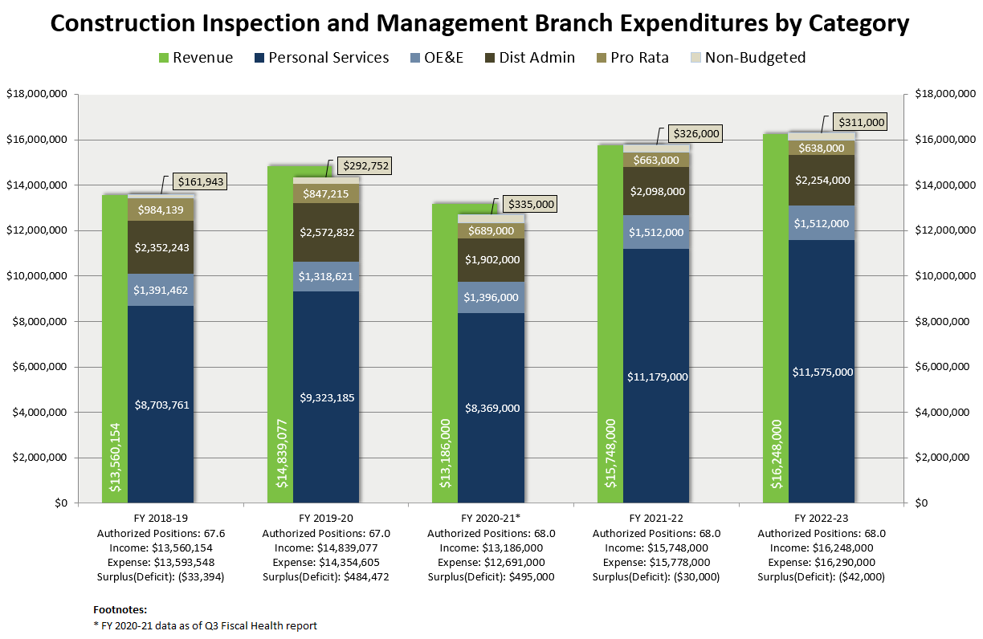Any combination of construction phase services is available to state agencies that have authorization to administer their own construction programs. The services are tailored to suit the size, complexity and specific project needs of the client agency’s management staff, and their operational and program needs. CIMB’s goal as the State’s representative in the construction process is to provide the client with the best possible outcome with the least amount of disruption while bringing a positive attitude, and exercising tact, good judgement, and fairness in a professional manner.

## Material Changes to CIMB Rates Assumptions

### Budget Letter for Employer Retirement Contributions (Control Section 3.60)

Budget adjustments for employee retirement, as prescribed by Control Section 3.60 of the Budget Act, are projected to increase by .3%. The projected budgetary increase is approximately $22,000 in FY 2021-22 and $24,000 in FY 2022-23.

### Budget Letter for Employee Compensation Adjustments (Item 9800)

Per bargaining unit agreements for salary & wages and benefits compensation, the FY 2021-22 adjustments include the regularly scheduled increases for 2021-22 and the FY 2020-21 adjustments that were postponed. An additional .05% has also been included for applicable bargaining units, as negotiated. The projected budgetary increase for CIMB is $504,000 in FY 2021-22 and $12,000 in FY 2022-23.

### Statewide General Administrative Expenditures (Pro Rata)

The Pro Rata assessment for CIMB in FY 2021-22 is $663,000. DGS Budgets and Planning Section projects a decrease of 3.8% in Pro Rata for FY 2022-23, which is a decrease of $25,000.

### Restoration of COVID-19 PLP Salary Reduction (9.23%)

Last year, a 9.23% PLP salary reduction was implemented as a result of the COVID-19 pandemic. This reduction was projected through FY 2021-22. Due to the projected State surplus, the Administration has agreed to restore the salary reduction effective FY 2021-22 and full salaries have been assumed for both fiscal years.

## CIMB Rates

CIMB’s billable hourly rate structure has been in place since the program’s inception.

CIMB’s rate structure has not changed from previous years although the hourly rate for services has increased from $170.00 per hour in Fiscal Year (FY) 2018-19 to $183.00 per hour in FY 2019-20 and most recently $189 for FY 2020-21. The proposed FY 2021-22 rate remains unchanged at $189.00 per hour.

CIMB rates are competitive with those of commercial construction supervision. For example, the 10-year average of the California Construction Cost Index is 2.5%, while CIMB’s FY 2021-22 rate will not increase. CIMB’s proposed FY 2022-23 rate of $195.00 is an increase of 3.2% over 2021-22 rates.

CIMB’s rate structure is transparent to both its internal customer, DGS, and its external clients such as the California Department of Corrections and Rehabilitation (CDCR). External clients understand how the rates are formulated and have neither strong objections nor issues with the year-to-year rate increases.

CIMB’s services are not subsidized, nor do they subsidize any other DGS provided services. CIMB has a single rate charged to all customers for specific services during construction.

Due to ongoing vacancies in hard-to-fill billable positions, in FY 2021-22 CIMB reduced its billable positions by 5.5 to 50.5 billable positions. In the Napa area office, vacant positions are due to a combination of factors including skilled labor shortage in the area and higher costs of living relative to salaries. In FY 2022-23, CIMB will keep the assumed vacant billable position reduction to 5.5 for 50.5 billable positions as CIMB plans to fill these vacancies with aggressive recruitment efforts and a streamlined examination procedure.

**Original Price Book Page**

## Project Management and Development Branch

The Project Management and Development Branch (PMDB) provides architectural and engineering services, space planning and interior design, construction and construction inspection services, energy and environmental services, and other competencies such as seismic retrofits, asbestos abatement, and underground tank removal.

PMDB additionally provides project management services for complex real estate projects. PMDB manages the design and construction process on behalf of state agencies and departments. PMDB assists state agencies and departments in developing conceptual documents for cost and budget control, programming, site planning and master planning, and other documents for conceptualizing capital outlay projects that are necessary to obtain legislative authorization and funding projects.

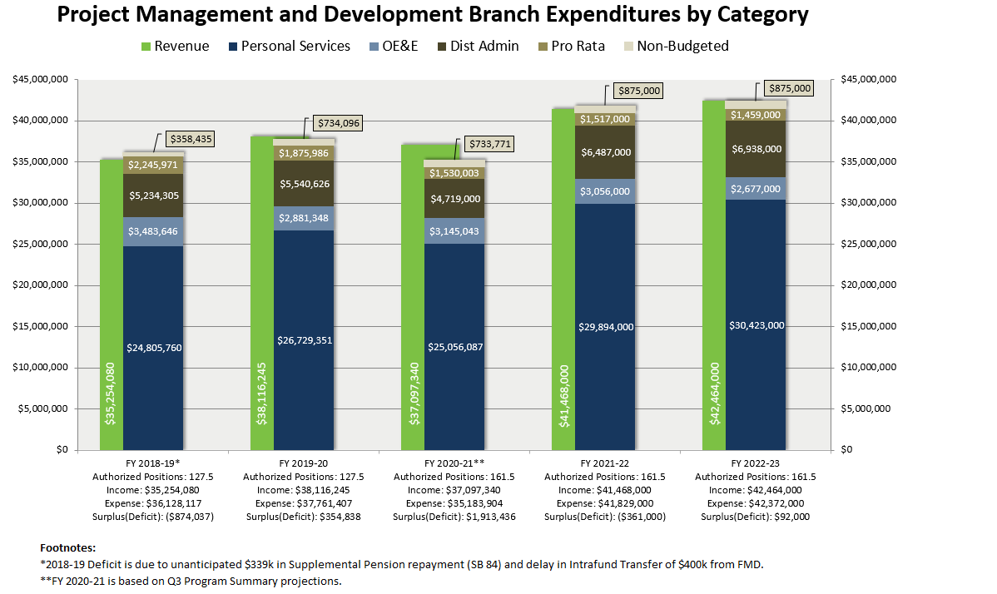

### Material Changes to PMDB Rates Assumptions

### Budget Letter for Employer Retirement Contributions (Control Section 3.60)

Budget adjustments for employee retirement, as prescribed by Control Section 3.60 of the Budget Act, are projected to increase by .3%. The projected budgetary increase is approximately $60,000 in FY 2021-22 and $61,000 in FY 2022-23.

### Budget Letter for Employee Compensation Adjustments (Item 9800)

Per bargaining unit agreements for salary & wages and benefits compensation, the FY 2021-22 adjustments include the regularly scheduled increases for 2021-22 and the FY 2020-21 adjustments that were postponed. An additional .05% has also been included for applicable bargaining units, as negotiated. The projected budgetary increase for PMDB is $1,334,000 in FY 2021-22 and $89,000 in FY 2022-23.

### Statewide General Administrative Expenditures (Pro Rata)

The Pro Rata assessment for PMDB in FY 2021-22 is $1,517,000. DGS Budgets and Planning Section projects a decrease of 4.0% in Pro Rata for FY 2022-23, which is a decrease of $58,000.

### Restoration of COVID-19 PLP Salary Reduction (9.23%)

Last year, a 9.23% PLP salary reduction was implemented as a result of the COVID-19 pandemic. This reduction was projected through FY 2021-22. Due to the projected State surplus, the Administration has agreed to restore the salary reduction effective FY 2021-22 and full salaries have been assumed for both fiscal years.

### Planned Vacancies

PMDB is proposing to hold vacant a total of 8 billable positions in both FY 2021-22 and 2022-23 in the following units.

• 7.0 in Architecture, Engineering and Project Management

• 1.0 in Environmental Planning Services

### Other Savings

In FY 2021-22 and 2022-23, there is a projected salaries and wages savings of approximately $1.2M related to the timing of current and anticipated vacancies expected to be backfilled.

## PMDB Rates

### Environmental Planning Services

Environmental Planning Services provides a wide range of environmental planning and regulatory expertise to client agencies, DGS, and the Department of Finance. This expertise includes, but is not limited to, project site planning and analysis, preparation of environmental documents required by the California Environmental Quality Act and National Environmental Policy Act, compliance with historic preservation and other environmental regulatory statutes, and environmental due diligence.

### Architectural Assistant Services

Architectural Assistant services provides design support services and minor design services to Architectural and Engineering staff. These services are technical in nature, but do not need to be performed by more experienced or licensed staff. Examples include minor CAD/REVIT work and 3D modeling.

### External Contract Administration Fee

The contract administration fee covers the administrative costs related to the execution of PMDB contracts. These costs include branch administrative costs related to contracts, program overhead costs, the branch’s share of FI$Cal cost, and administrative support outside of the branch within DGS. All projects with external contracts are assessed this fee. For large projects, PMDB applies a cap for this fee to prevent it from exceeding $1 million.

Administrative support, beyond branch administrative support, for the development and execution of contracts, related to external contracts includes:

* The Office of Business and Acquisition Services (OBAS) provides program support through the solicitation, preparation, approval, and execution of contracts.
* The Office of Fiscal Services (OFS) provides accounting oversight and guidance, ensures that policies and procedures are consistently applied to maintain the integrity of the financial records. OFS services include certification of project funds, approval of encumbrance releases, audit and process vendor invoices, payment scheduling, and reconciliation of projects and contracts. OFS maintains detailed records on payment history and contract balances.
* The Office of Legal Services (OLS) provides leadership and guidance on the State’s contracting and procurement laws and policies. This includes establishing the State’s services contracting standards and providing contract pre-review and approval. In addition, OLS serves as in-house counsel providing legal advice on the State’s leveraged procurements of goods and services, real estate leasing, acquisition, construction, and litigation support. OLS also exercises the services contract review and approval function for DGS.

### Architecture, Engineering and Project Management

Architecture, Engineering and Project Management provides complete architectural, civil, structural, mechanical, and electrical engineering services; project management for large and complex projects including capital outlay, energy, hazardous materials, special repairs, studies and surveys and program management of programs with a defined scope that respond to special needs identified by state initiatives, departments, Legislative mandates. or the Governor.

|  |  |  |  |
| --- | --- | --- | --- |
| **REAL ESTATE SERVICES DIVISION RATES** | | | |
| **DESCRIPTION** | **UNIT** | **CY 2021-22** | **BY 2022-23** |
| **Asset Management Branch** | | | |
| Portfolio Management-Lease Management Surcharge | Per Lease | 0.60% | 0.60% |
| State Property Inventory Records | Per Record | $2.50 | $2.50 |
| SPI-Lease Management Surcharge | Per Lease | 0.08% | 0.08% |
| RELPS-Planning Services | Hourly | $162.00 | $170.00 |
| RELPS-Lease Management Surcharge | Per Lease | 1.24% | 1.24% |
| RPSS-Real Estate Services | Hourly | $162.00 | $170.00 |
| **Construction Inspection and Management Branch** | | | |
| Construction Supervision | Per hour | $189.00 | $195.00 |
| **Project Management and Development Branch** | | | |
| Environmental Planning Services | Per hour | $165.00 | $175.00 |
| Architectural Assistant Services | Per hour | $155.00 | $165.00 |
| Planning External Contract Admin Fee | Doc value | 1.00% | 1.00% |
| Architecture, Engineering, and Project Management Services | Per hour | $230.00 | $240.00 |
|  | | | |

