Setting Up a Profile in Concur
Statewide Travel Program

Introduction
To access Concur, please reach out to your agency Travel Coordinator.
Upon accessing Concur, you will need to complete your profile. To do so, you will need to add the following information. Keep in mind that inaccurate information entered in your Concur profile will lead to inaccurate information in your travel reservations. Especially with air travel, an inaccurate name or date of birth will be grounds to deny boarding of the aircraft. It is your responsibility to ensure all information is entered accurately and updated whenever necessary.
All required fields of the profile must be completed before travel can be booked. It is strongly encouraged to complete the remaining optional fields.
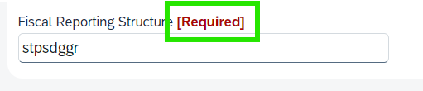

Complete the Profile

2.1 Personal Information
Fill in your first, middle, and last name as shown on your photo identification. If you don’t have a middle name, click the option ‘No Middle Name.’ You may be turned away at airport security if the name on your identification does not match your ticket.
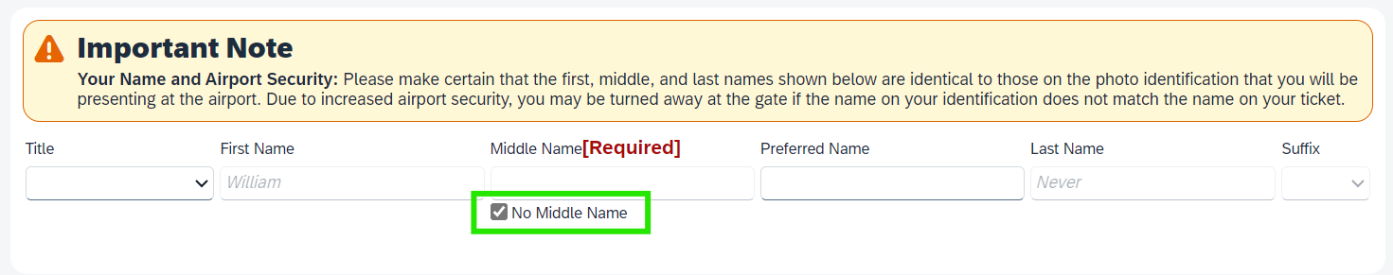
Once you have saved, your name will not be editable. To make any name changes, you will need to reach out to your agency Travel Coordinator(s).

2.2 Company Information
Under company information, fill in your employee ID and manager. If your agency has chosen to require expense information, such as Fi$Cal reporting structure numbers or PCA/index coding, this information must be provided to complete the section.
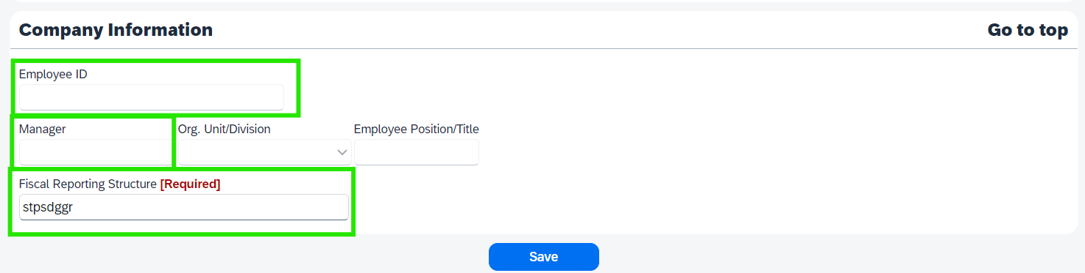

2.3 Work Address
This is not required but can be helpful when wanting to search for travel by company location.
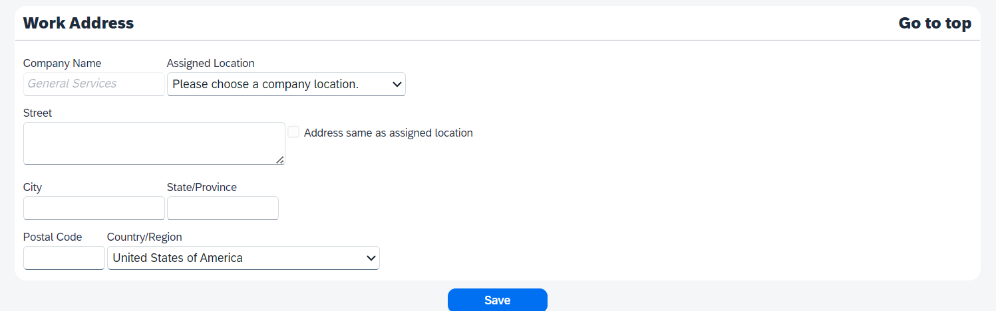

2.4 Home Address
Home address is also not required but can be helpful for various search categories.
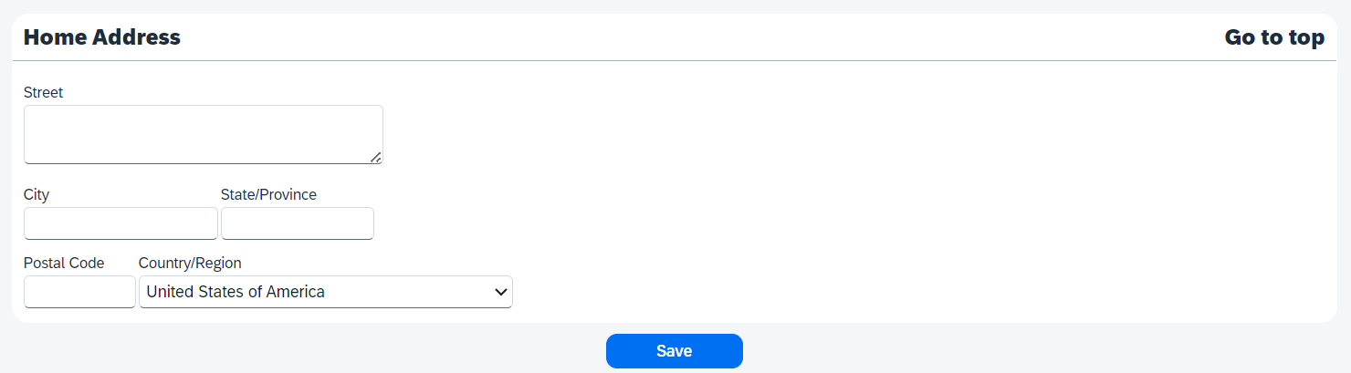

2.5 Contact Information
Under contact information, you are required to include either a work or a home phone. You may provide a cell phone number as your home phone.
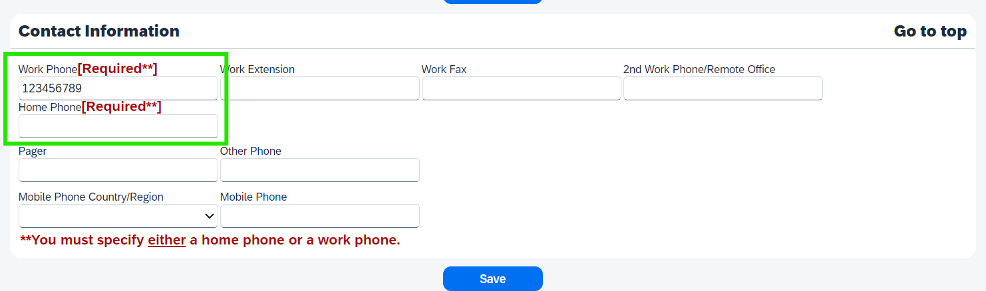

2.6 Email Address
Here, you can add any email address(es) you may want to receive your trip information, including managers, travel coordinators, and personal emails. Please note that if you assign someone as your Primary Travel Arranger, they will receive an email with trip information automatically.
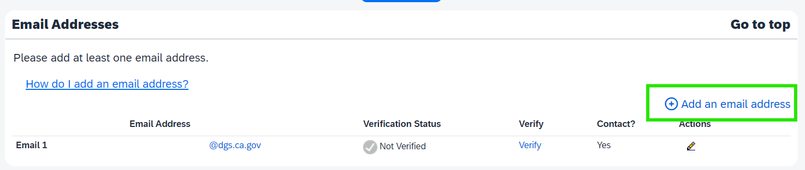

2.7 Emergency Contact
Emergency contact is not required but is a helpful section to have completed.
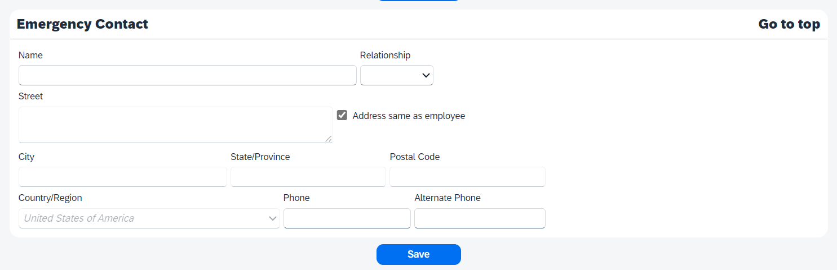

2.8 Travel Preferences

2.8.1 Discount Rates
Please note that if you choose any of the discount travel rates, you must be able to provide that proper identification or membership. For example, if you choose AAA, you must show your AAA card when checking into a hotel. The box for “government” travel rates/fares should not be checked as it applies to federal government rates.

2.8.2 Air Travel Preferences
This section allows the traveler to filter their searches by desired amenities as well as transmit any travel needs/requests to the vendor. When you enter a preferred departure airport into your profile, it auto-populates when searching for tickets. You can alter this within the search process without returning to your profile. This section also allows you to notify the airline of any medical restrictions you may have.
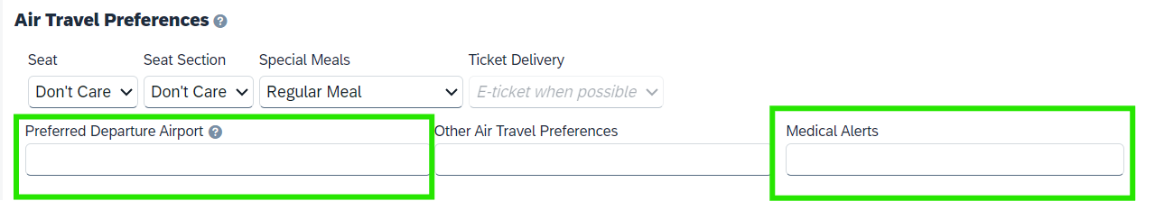

2.8.3 Hotel and Car Rental Preferences
Your hotel and car rental preferences will make sure to highlight the search results that have amenities that match your needs. Please note that the state does not reimburse rental of a navigational/GPS system or ski rack.
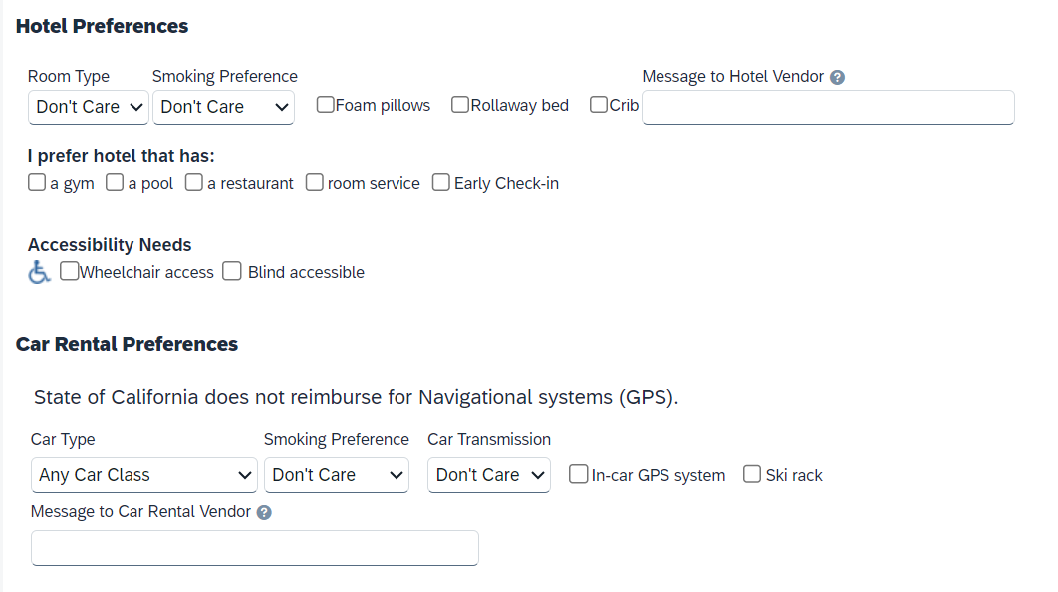

2.8.4 Frequent-Traveler and Advantage Programs
The state follows federal guidelines allowing travelers to retain frequent traveler benefits for personal use. You may add any frequent-traveler and/or advantage programs you belong to. To add, click the "Add a program" button.
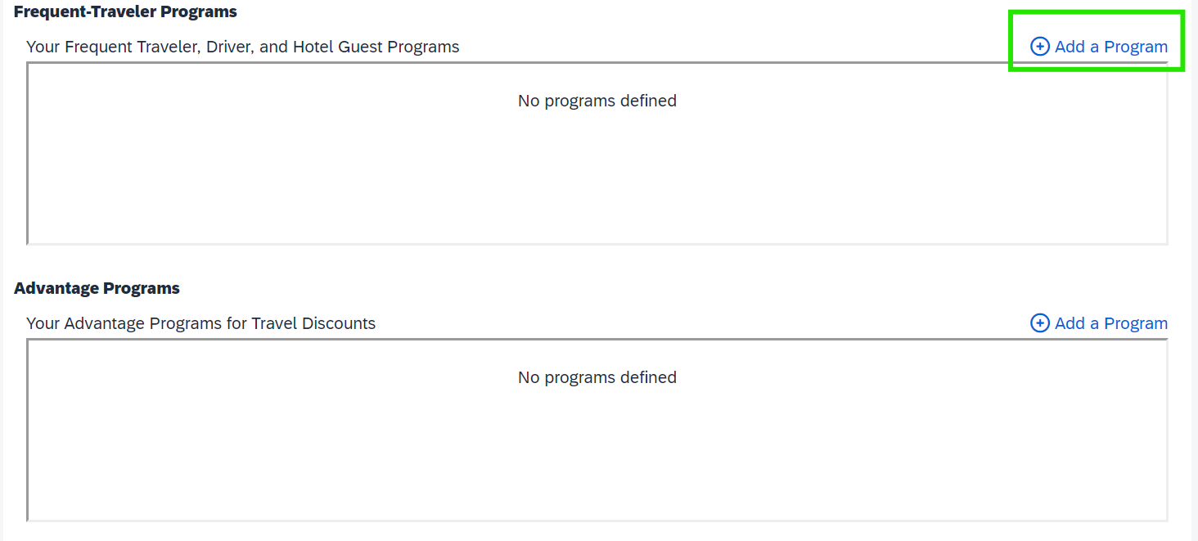

You can add up to 5 programs at a time in the popup box that it produces. After adding your programs, click save at the bottom of the page. If you have more than 5 rewards program numbers, you may click the "Add a program" link again top add any additional programs.
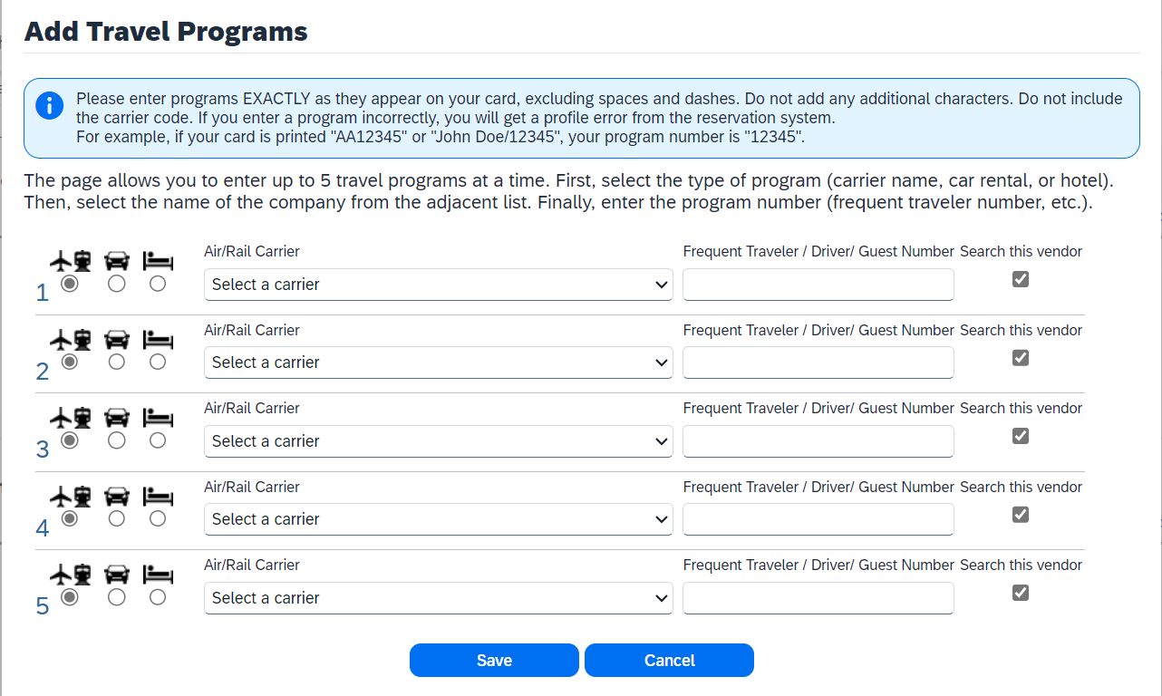
To change the program information, click on the pencil next to the rewards card and make the changes. To delete the program information, click the trash can next to the rewards card.
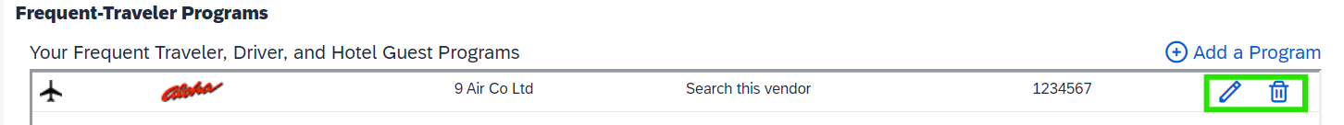

2.8.5 Unused Tickets
This section stores any applicable unused airline ticket credits. Unused airline ticket credits must always be utilized for future business trips. Contact your agency Travel Coordinator(s) for more information about unused ticket credits.

TSA Secure Flight
Within the TSA section, you must provide your gender and date of birth. If you have a TSA Pre-Check Known Traveler Number, you may enter it. If you participate in the Pre-Check program, please not that it is a non-reimbursable expense.
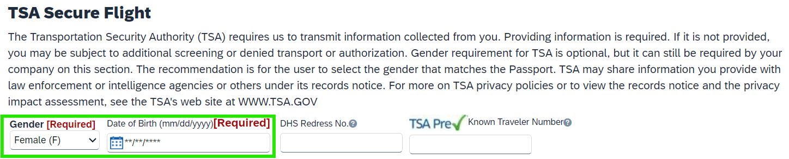

International Travel: Passports and Visas
This section allows you to add your passport information to include in your travel reservations. The completion of this field is helpful if you expect to book international travel but is optional for all users.
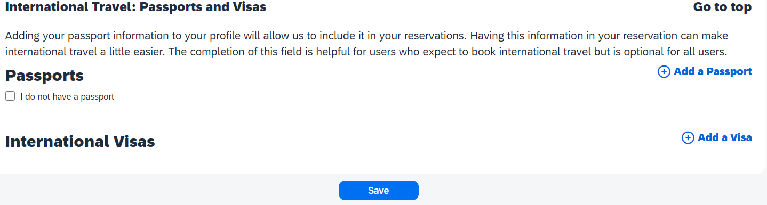

2.9 Assistants and Travel Arrangers
You can add as many Assistants or Arrangers as you would like, but only one can be the primary assistant. The primary assistant has the added benefit of always receiving emails with your trip information. Assistants are authorized to book travel on your behalf. You can add an assistant by clicking on the "Add an Assistant" Link.
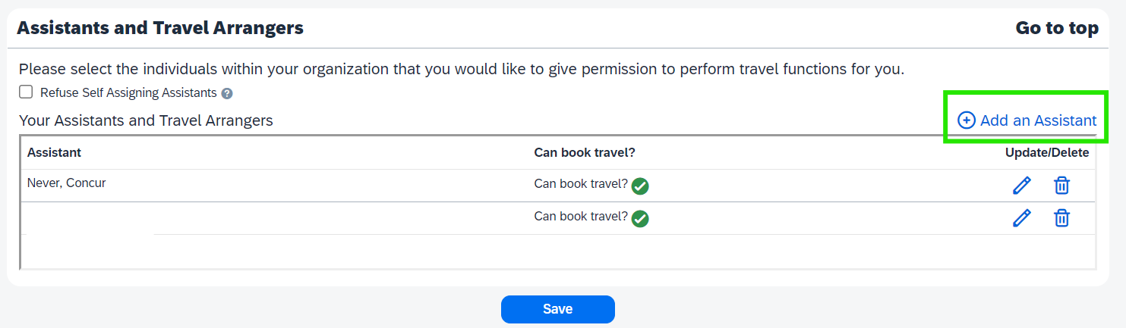
The add an assistant popup window operates similarly to Microsoft Outlook. You type in the person's name, and it brings up their information. Whomever you choose to be your travel assistant must have a Concur profile before you can search for and choose them. If they do not have a Concur profile, they will not show up as an option. After you’ve selected the travel assistant, make sure you click 'Save'.
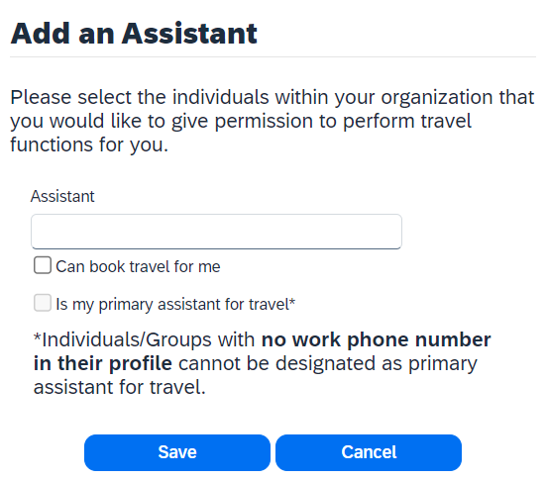
To edit an assistant, click the pencil icon and complete any edits needed in the pop-up box. Click ‘Save Changes’ when done.
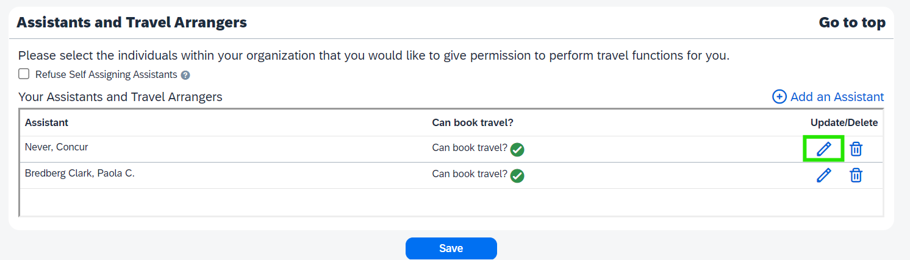
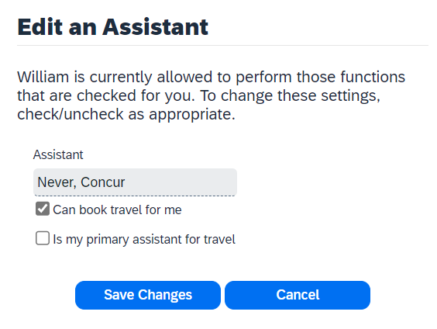
To delete a Travel Arranger, click the trash can icon and click ‘OK’ in the pop-up.
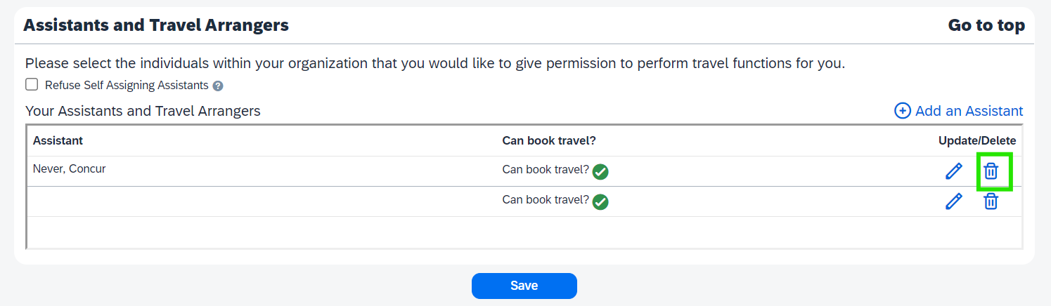

2.10 Credit Cards
Flights and car rentals are billed directly to your agency, but if your agency is not using the Virtual Card Number program to book and pay for hotels, your personal credit card is required to hold any hotel reservation. Your credit card information will be encrypted - once it is entered, even you don’t have access to it.
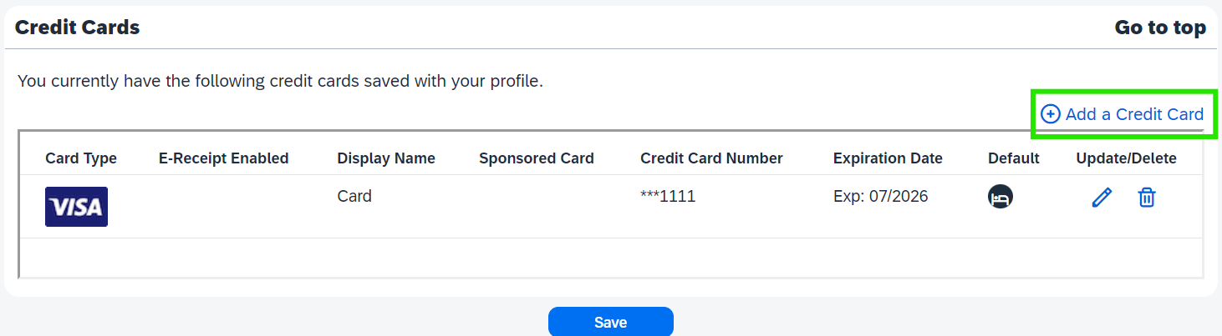

2.11 Save Your Profile
You will notice there is a ‘Save’ button under each section. You only need to save once, as each time you click save, it saves the whole page. Once your profile is complete, click any of the 'Save' buttons throughout the page.
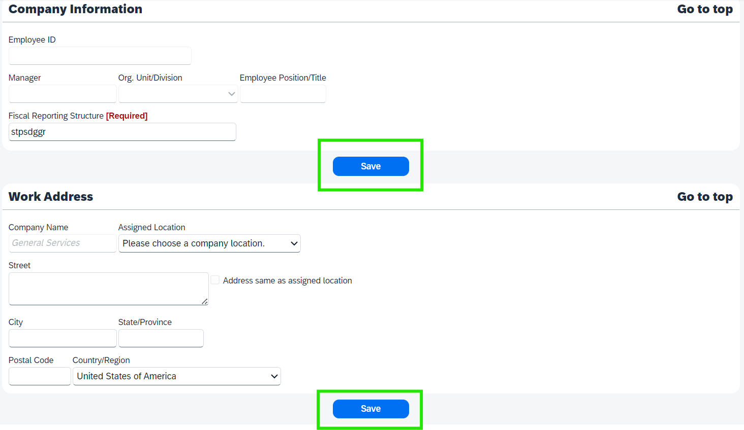
You will know you were successful because you will see a green box that says, 'Profile Saved' in the upper right corner of the screen.


3. Make a Change
If you want to make any changes to your profile, you need to click on your initials in the top right corner of the page, then choose 'Profile Settings'.
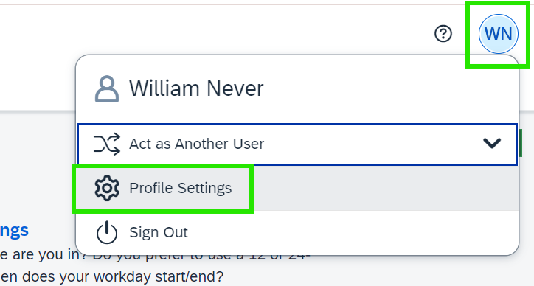
Here, you can choose any section of the profile which you need to edit. For example, adding another travel assistant.
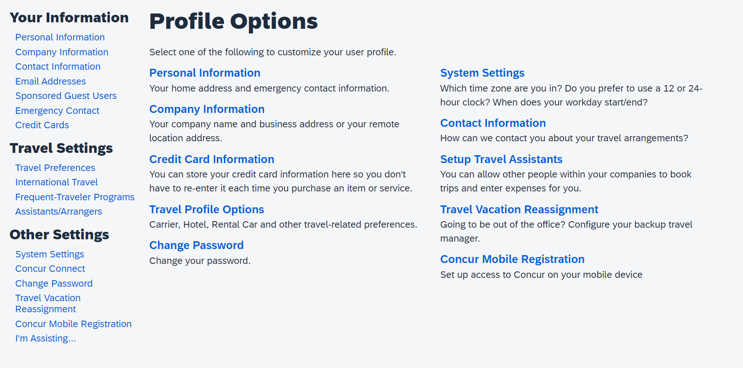
From there, you can make changes to any section except your name. Please see Section 2 on this document for more information.

Additional Resources
As a traveler, your first resource for all travel-related inquiries is your agency Travel Coordinator(s). Other helpful resources are:
How does a Traveler Request Access to Concur? (PDF Guide)
How does a Traveler Request Access to Concur? (Video)
Logging Into Concur (PDF Guide)
Logging Into Concur (Video)
Setting up a Profile in Concur (Video)
Statewide Travel Program Training Resources Page
CI Azumano Webpage
Concur Login Page

