Town Hall: Car Rentals and Uber for Business
Statewide Travel Program

Content
1. Rideshare 3
1.1 Justifications 3
1.2 Limitations and Restrictions 4
1.3 Lyft 5
1.4 Reimbursements 5
1.5 Tips 6
1.6 Uber for Business Account 7
1.7 Uber for Business Accounts for Travelers 7
2. Car Rental 9
2.1 Justifications and Reimbursements 9
2.2 Miscellaneous 9
2.3 Rates 10
2.4 Vehicle Recharge and Refuel 11
3. Additional Resources 13
3.1 CI Azumano 13
3.2 Concur 13
3.3 Statewide Travel Program 13

Rideshare

Justifications
One of our travelers claimed there were no approved vehicle classes available at the time of booking. Is this possible?
Travelers should document as much as possible to justify the higher cost choice. When it comes to Uber for Business, we recommend screenshots within the Uber application showing the vehicle options.
Is Uber, Lyft, and/or taxi still the best option for employees while on travel status?
Employees should always use the most cost-effective option. Before traveling, employees need to perform a cost comparison to justify their reasoning.
An employee took a cab, which is more expensive than Uber and Lyft. The explanation was that the employee did not trust Uber or Lyft. Is this justification acceptable?
STP cannot advise on acceptable justifications. Executive branch/state agencies, please contact CalHR at TravelManager@calhr.ca.gov. Non-executive branch/optional user agencies, please refer to your internal policies.
Is using Uber for Business to go to restaurants from the hotel and back while on travel status considered personal use?
Not necessarily. It would largely depend on the distance/cost to pick up a meal and return. It would be quite similar to having a rental car on travel status and driving to get food. However, executive branch agencies should contact CalHR, and non-executive branch/optional user agencies should refer to internal policies, regarding what is acceptable distance and cost wise.
What is considered a reasonable distance to use Uber for Business when seeking meals while on travel status?
Executive branch/state agencies, please contact CalHR at TravelManager@calhr.ca.gov for allowable justifications. Non-executive branch/optional user agencies, please consult internal travel policies.
Will the OFAM 100 be required when a larger size vehicle is requested within Uber for Business?
No, an OFAM 100 is not required for any Uber for Business vehicles. If your travelers are using larger vehicles, they should be prepared to justify the need for a higher cost vehicle over the permitted cost. Travelers can add the justification as a memo within the Uber application during the booking process.
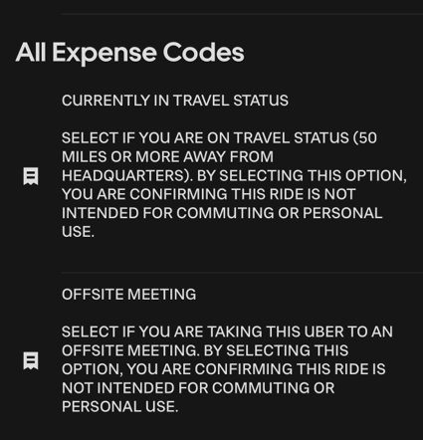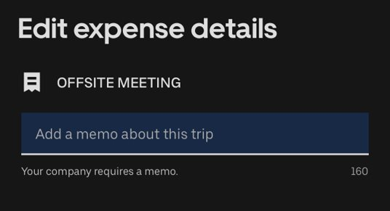
Travel Coordinators can use the agency’s Uber for Business account dashboard to audit rides.

Limitations and Restrictions
Can we use Uber for Business for out-of-state business travel?
Just like car rentals, lodging, and airfare, travelers can use Uber for Business for out-of-state business travel if approved by their agency.
Is Uber for Business only for executive travel, or can it be used for all types of travel, such as employee conference travel?
Uber for Business can be used for any approved employee travel. Each agency can decide which travelers can be added to the Uber for Business account and set limitations within the dashboard. We recommend each agency create an Uber for Business policy using the Uber for Business (U4B) Policy Template.
Is there a limitation on how many Uber rides a traveler can request?
There is no general limitation. This is something that the agency’s Uber for Business policy would outline. If desired, Travel Coordinators can set limitations in the agency’s Uber for Business account dashboard.
Is there an option to limit Uber rides per day instead of per ride? Like the rider would have a $100/day limit - if their first ride cost $20, they only have $80 for any other rides that same day.
Yes, this is an option an agency can implement. However, we do not recommend a cost limit, as each city will have different rates. It is difficult to predict a threshold that will apply to all cities.
Can we restrict certain types of vehicles, such as UberX?
Yes, Travel Coordinators can limit the vehicle class permitted to travelers within the agency’s Uber for Business account dashboard.
Is priority pick-up and reservation allowed on Uber?
While Uber for Business cannot restrict the use of these services (and their applicable fees), they are not recommended as they are non-mandatory fees. From a policy standpoint, we recommend prohibiting these types of fees. For further clarification, please contact CalHR at TravelManager@calhr.ca.gov (executive branch agencies only).
How does the Uber reservation process work?
Uber Reserve, or scheduling a ride (reservation) in advance, is not allowed for executive branch agencies due to a separate reservation fee being charged.
I'm on the Uber dashboard and I don't see the option to remove requesting an Uber in advance.
There is not an option to remove the reservation capability as it is imbedded into the mobile app for business and personal use.
We recommend each agency create an Uber for Business policy using the Uber for Business (U4B) Policy Template. Reserving an Uber in advance should not be permitted in the policy and employees should sign/acknowledge the policy before using Uber for Business.
As is true with all areas of travel, travelers are accountable for reimbursement if they do not book within policy.

Lyft
Can we use Lyft?
The state of California does not have a partnership with Lyft, which means that there is not an option to direct-bill Lyft charges to your agency. However, travelers are still able to use Lyft when it is the most economical option. They will need to request reimbursement from their agency after the travel is completed. Executive branch agency Travel Coordinators and travelers can visit the CalHR Online HR Manual to find information on allowances and reimbursements for Transportation Network Companies (“Travel/Relocation” Sections 2201 and 2203).

Reimbursements
Which rideshare vehicle bookings are reimbursable?
Within Uber, Uber X is the preferred ride type. Uber Pool, Uber Comfort, or Uber Green are permitted when the cost is less than Uber X. Travelers should take screenshots of the Uber search results to show lower cost justification. Agency Travel Coordinators can limit the types of rides permitted within the agency’s Uber for Business account dashboard.
Within Lyft, Standard Lyft is the preferred ride type.
Does Uber for Business include UberEATS?
No, UberEATS is not activated for use within Uber for Business accounts. Executive branch agencies should reach out to CalHR with any questions about reimbursements.
Do tolls incurred while using Uber for Business appear in the direct-billing for tolls?
Tolls incurred while using Uber (for business and in general) will be charged through Uber and will appear on the ride receipt.
If the Uber ride incurred a toll charge, the total will be part of the Uber charge. Is it necessary to separate the Uber and toll charges on the CalATERS claim? (Applies to executive branch agencies only)
Please reach out to the State Controller’s Office at CalATERS@sco.ca.gov for clarification on how to submit the claim.

Tips
Will Uber for Business automatically charge tips to the traveler’s personal credit card?
Yes, Uber for Business will automatically look for a personal form of payment to charge tips. If there is no personal form of payment in the traveler’s Uber account, Uber for Business will not allow a tip to be added to the ride.
How can an employee request reimbursement for Uber tips in CalATERS? (Applies to executive branch agencies only)
If an employee paid out-of-pocket for Uber, they can request reimbursement for the ride and tip within CalATERS, assuming it is all within policy.
If an employee used Uber for Business, they could only request reimbursement on the tip (assuming it is all within policy) since the ride was already direct-billed to the agency.
Please see the CalHR Online HR Manual for tip guidance (Sections 2201 and 2203).
Is an Uber receipt always required to be submitted to get reimbursed regardless of the amount? What if tips are paid with cash?
Cash tips are up to internal agency policy. We recommend each agency create an Uber for Business policy using the Uber for Business (U4B) Policy Template. Employees should sign/acknowledge the policy before using Uber for Business. As is true with all areas of travel, travelers are accountable for reimbursement if they do not book within policy.
The Department of General Services’ Uber for Business internal policy does not allow cash tips, as they are not trackable. Tips paid through the Uber app are trackable and viewable for both the traveler (in the Uber app) and Travel Coordinator (through the agency’s Uber for Business dashboard).
How do travelers provide the required documentation for the Uber charges to determine allowed tip?
The traveler can provide a receipt of their Uber ride to show the cost of the ride. In addition, trips are viewable for both the traveler (in the Uber app) and Travel Coordinator (through the agency’s Uber for Business dashboard).
Tips paid through the Uber app are trackable and viewable for both the traveler (in the Uber app) and Travel Coordinator (through the agency’s Uber for Business dashboard).
If Uber for Business is used by the department, would the tip have to be requested for reimbursement through a Travel Expense Claim (TEC)?
Yes, reimbursement can be requested for any tips paid for by the traveler.
Executive branch agencies, please visit the CalHR Online HR Manual - 2203 Allowances and Reimbursements - and reference "Tips for Allowable Transportation Expenses" for guidance on tipping.
Optional user agency travelers should refer to internal policies for guidance on tipping.

Uber for Business Account
Does the state have a contract with Uber for Business?
No, the state of California does not have a contract with any rideshare vendors Uber for Business is purely for direct-billing benefits and to reduce out-of-pocket costs for travelers.
What is the process of getting an Uber for Business account?
Please email StatewideTravelProgram@dgs.ca.gov, Attention: Uber for Business, and we can begin the process for your agency.
Will Uber for Business be linked to our business travel credit card account?
The agency’s Uber for Business account is linked to an agency’s U.S. Bank Meeting Card Account. If your agency does not currently have a Meeting Card Account, we will create one as part of the Uber for Business implementation process. There is no other acceptable form of payment for Uber for Business.
Can we have multiple Uber for Business accounts since they’re linked to the agency meeting cards?
Yes, we can add supplemental Uber for Business accounts within your agency. Please email StatewideTravelProgram@dgs.ca.gov to set this up. That being said, the Uber for Business dashboard allows for the creation of multiple “programs” within a single account. This provides additional customization options for specific divisions/offices within your agency, with their own dedicated U.S. Bank Meeting Card.

Uber for Business Accounts for Travelers
Do we only need one Uber for Business account to share with staff, or would every employee need to register for an Uber for Business account?
There will only be one Uber for Business account created for the agency, but each traveler will need to have their own personal Uber account that they will link to the agency’s Uber for Business account. Uber for Business does not create/require a separate “business” account for the traveler, it merely allows a traveler's personal Uber account to link to the agency’s Uber for Business account.
Can Uber for Business be used on a work cell phone?
Before downloading the Uber app on your business phone, please check with your internal information technology team/office to see if it is a permissible application.
Do travelers need a personal Uber for Business account if they are using their work cell instead of their personal phone?
Regardless of whether the traveler uses their personal or work cell phone, they will need a personal Uber account to link to the agency’s Uber for Business account. The traveler does not need a separate Uber “business” account.
When a traveler requests Uber for Business access, what type of permission should we give them?
There are two types of accounts for Uber for Business: “Rider” or “Administration.” “Rider” would apply to anyone who will be using Uber for Business simply to reserve rides. Administration would apply to anyone who would need access to the agency’s Uber for Business account dashboard for program management: adding/removing riders, reconciliation, reporting, or troubleshooting purposes.
Can non-employee travelers that use Uber while traveling for agency business be linked to our Uber for Business account?
This would be an internal policy decision for your agency to make. There is nothing on the Uber for Business side that would prevent this.

Car Rental

Justifications and Reimbursements
Is there a way to decide how much mileage has been driven on a rental car to verify it was not used for personal reasons?
The pre-and post- rental milage is listed on the Enterprise receipt and monthly statements. Travel Coordinators can then use resources such as Google Maps to see the estimated milage and compare the data.
How should travelers do a rental car vs. rideshare cost comparison?
The Enterprise Mileage Reimbursement Calculator gives travelers an idea of the possible costs. However, travelers will need to complete their own research to include parking, tolls, and other applicable transportation costs. There is no standard cost comparison template or form.

Miscellaneous
For long-term rental, do we go through Enterprise or Concur?
Long-term rentals are NOT booked in Concur.
For instructions on booking a long-term rental, please see the ‘Renting a Long-Term Vehicle’ section of our Car Rental Resources for State Travel page.
For optional users, please contact StatewideTravelProgram@dgs.ca.gov to inquire about long-term rentals.
What should we do when our travelers need a car rental in Cresent City?
There are no Enterprise or National branches in or around Cresent City; so, travelers must book a non-contracted car rental and seek reimbursement after travel. Whenever a traveler books a non-contracted vendor, they must pay for the rental using a personal form of payment, add any needed insurance at the time of pick-up, and seek reimbursement.
For executive branch agencies, per SAM section 4117.2 - Commercial Car Rentals, travelers do not have to complete an OFAM 100 form when booking with a non-contracted vendor at the Crescent City airport. This is noted on the OFAM 100 form itself as well.
New York seems to have a different car rental rate, what is the normal range for the rental cars in New York?
The state of New York is a known exception to the base rental rates in the Commercial Car Rental contract. Travelers booking a car rental in New York are subject to open-market rates.
Are we able to have the accounting codes updated on our monthly report?
Please email StatewideTravelProgram@dgs.ca.gov for assistance.
If our agency opts into direct billing for tolls, will we see the toll information on the traveler’s Enterprise receipt?
No, the toll information will not appear on the traveler’s Enterprise receipt because it has not been charged yet. If the agency has direct billing for tolls set up, they will receive a direct-bill statement from Enterprise showing the toll information. This will include the toll amount (A), road (B), and date/time (C).
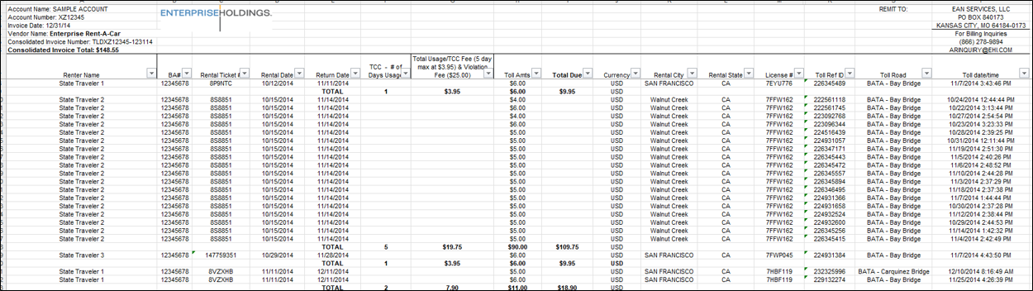
C
B
A
If the agency does not have direct billing for tolls set up, the traveler will receive the toll invoice/payment request directly. The traveler will need to pay the toll in a timely manner and seek reimbursement.

Rates
What is the maximum state rate amount allowable for a hybrid/electric vehicle?
The rate for all vehicles, including electric and hybrid vehicles, is on the Short Term Rates and Long Term Rates documents which can be found on our Car Rental Resources for State Travel page.
Why do some vehicles have a rate of $42.12 and others $43.52?
The intermediate sedan rate is $42.12. This is the largest vehicle class allowable without needing justification (for executive branch agencies only). All intermediate sedans should be listed as $42.12 for Enterprise and National car rentals. If you come across a different rate, please email StatewideTravelProgram@dgs.ca.gov.
The standard sedan rate is $43.52. Any time an executive branch agency traveler books a standard sedan or larger, they need to complete an OFAM 100 form to justify the higher cost. See SAM section 4117.2 - Commercial Car Rentals for further policy information.
If a traveler booked an intermediate or larger vehicle and received a compact, what rate should they be charged for?
The charge should be for the smaller vehicle’s rate. The traveler or agency Travel Coordinator is responsible for verifying the rate charged on the Enterprise receipt. Please see columns AM/AN in the Enterprise monthly statement to check:​
- What vehicle was requested.​
- What vehicle was received.​
- What the rate should be for the requested car class can be cross-referenced on the Short-Term rate sheet.​

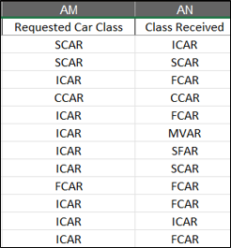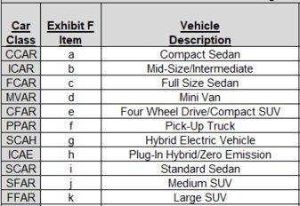
What type of electric car can employees rent?
When booking a car rental in Concur, the traveler must select an ‘Intermediate’ vehicle and answer ‘Yes’ to “Would you prefer an electric car if available?” Please see How to Book a Car Rental for more information.
The electric vehicle the traveler will receive will be based on availability at the branch upon pick-up. The Enterprise car class codes for electric vehicles are ICAE (intermediate sedan) and GXAE (Tesla).
We came across that the traveler claimed there were no approved vehicle classes available at the time of booking. Is this possible?
Per our contract with Enterprise, there should always be the ability to book an intermediate sedan car class. Concur sites are programed to always allow an intermediate sedan to be booked.
Please ensure the traveler is searching for pick-up/drop-off within the branch’s business hours.
If Concur is still showing no vehicles available, travelers should search on Enterprise.com to determine vehicle availability at the same branch.
If Enterprise.com shows vehicle availability and Concur does not, please email StatewideTravelProgram@dgs.ca.gov and provide screenshots from both sites.
Why is it that there isn't a vehicle available if the pick-up time or drop-off time is outside of office hours?
Searching for car rentals on Concur during hours that a specific branch is closed will not yield any search results. We suggest altering the search criteria (date/drop off and pick up time) to avoid this.

Vehicle Recharge and Refuel
Who is responsible for paying for electric vehicle recharging?
During the time the traveler has/uses the rental car, the traveler is responsible for charging the vehicle. Per our current contract with Enterprise, once the traveler has returned the vehicle to Enterprise, the branch will recharge at no additional fee.
If staff pay to charge the vehicle, do they get reimbursed through a CalATERS claim? (Executive branch agencies only)
Yes, staff get reimbursed through a CalATERS claim. The manner in which to submit the reimbursement request through CalATERS is outside of Statewide Travel Program’s scope.
I have noticed fuel overcharges on multiple rentals. Do we need to send a dispute or just rely on the quarterly fuel reviews refund?
Please send your billing dispute to TSS_StateofCA@em.com and attach the completed Enterprise research template. If you need assistance, please email StatewideTravelProgram@dgs.ca.gov.
If an employee rented a car with National, does the "no need to refuel when returning" also apply?
The contract with Enterprise extends to National, so travelers will not need to refuel before returning the car.
The Enterprise refuel rates can be found at the bottom of the Car Rental Resources page.​

Additional Resources

CI Azumano
Website: www.caltravel.ciazumano.com
Email: CalTravel@ciazumano.com
Phone: 1 (877) 454-8785

Concur
Concur Login Page

Statewide Travel Program
Website: www.dgs.ca.gov/OFAM/Travel
Email: StatewideTravelProgram@dgs.ca.gov
Phone: 1 (916) 376-3974
- Car Rentals 101
- Car Rental Resources
- Events Page
- How to Book a Car Rental (Video)
- Rideshare 101
- Ridesharing Ground Transportation Resources
- SAM section 4117.2
- State Travel Policy Resources
- Trainings Resource Page
- Travel Coordinator 101
- Travel Coordinator Resource Page
- Travel Updates Subscription
- Uber for Business Policy Template
If you have a training need and don’t see it on the Trainings Resource page, please reach out to StatewideTravelProgram@dgs.ca.gov Attention: Training, with suggestions.

