CI Azumano Business Travel
Grasp report user guide
CI Azumano
Created by
Arif Vohra/Kim Haveman
2026
Contents
Login Page 2
Reset Password 3
Home Page 5
Dashboard 6
Reports 7
How to Run Reports 9
Data Cafe 10
Support 11

Login Page
Step: 1
grASP URL: https://adminciazumano.graspdata.com/Public/login.aspx?ReturnUrl=%2fPrivate%2fReports%2fMyReports.aspx
Step 2:
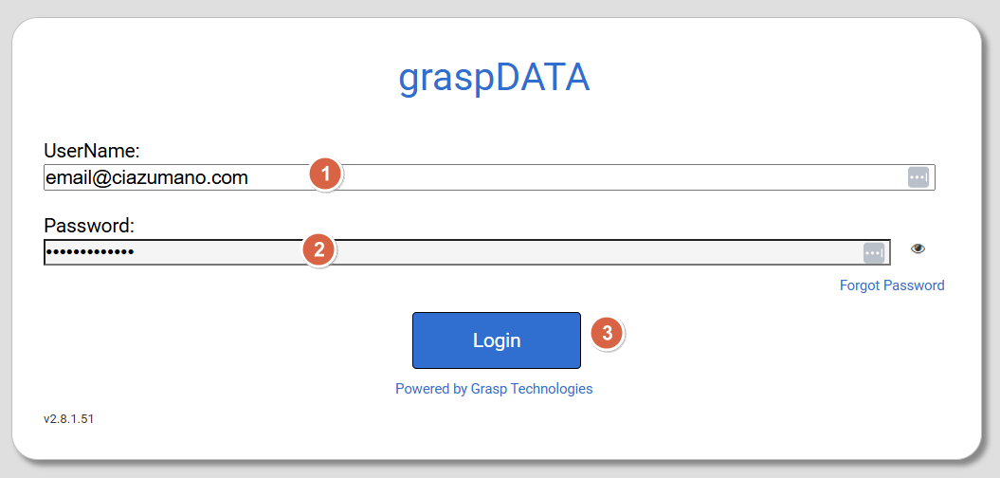

Login Page
1: Enter User Name (Email Address).
2: Enter Password.
3: Click Login.
Note:
Home Page
When signing in you will be directed to the Home page

Reset Password
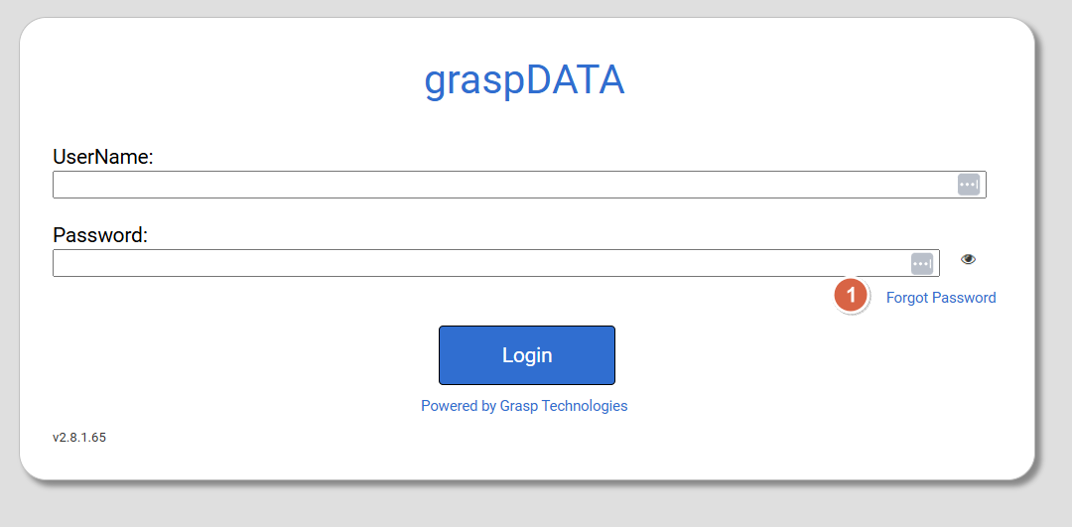
1: Click on Forgot Password.
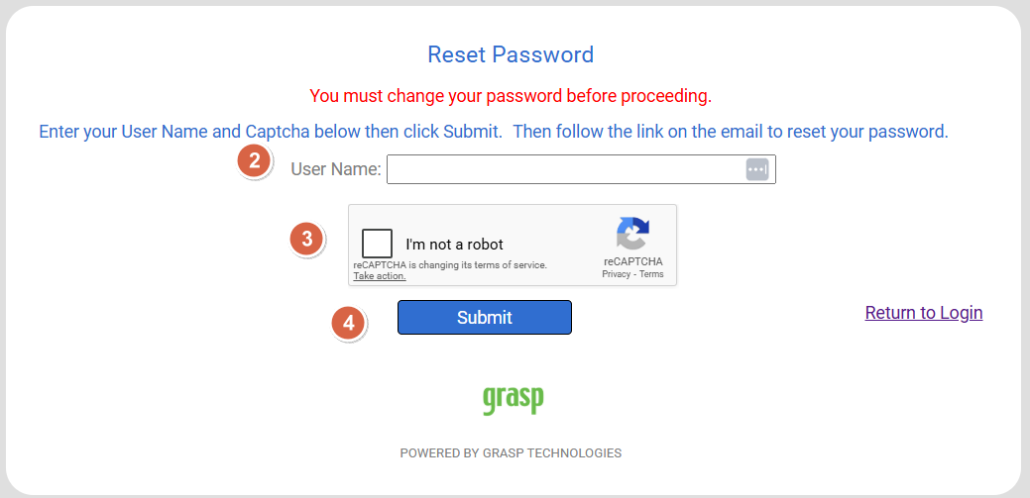
2: Enter your Email in the User Name text box.
3: Check I’m not a robot.
4: Click Submit button.
Wait for your email from grasp with temporary password and reset password link Email sample shown below.
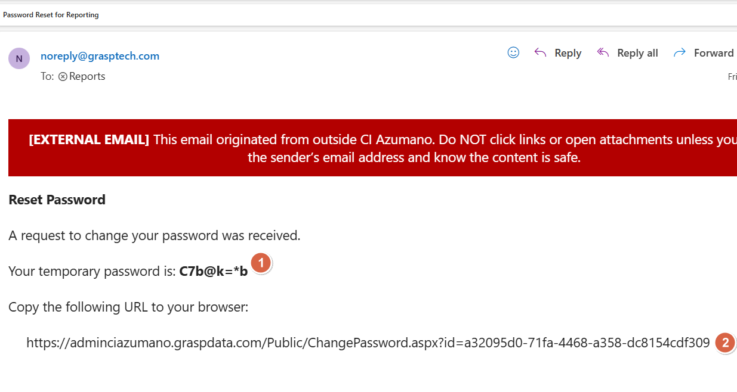
1: Temporary Password.
2: Link for resetting the password.
3: Copy Paste link in your browser address bar.
4: Reset Password.
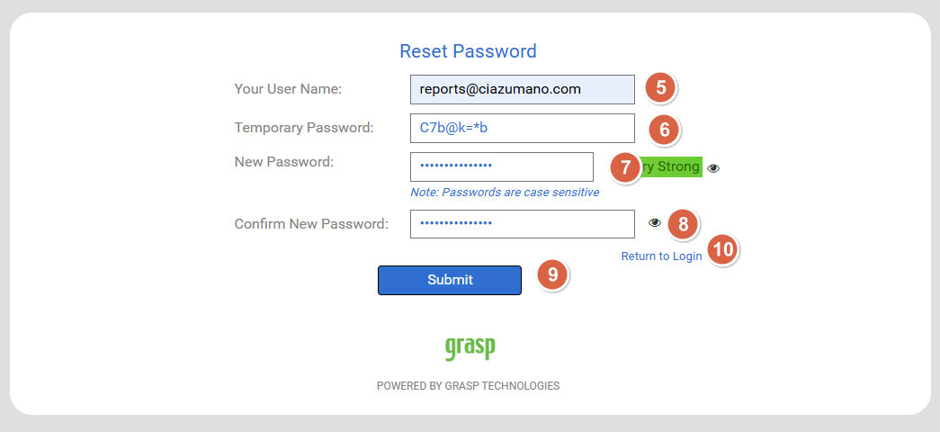
5: Enter your username.
6: Enter the temporary password you have received in the email.
7: Enter your new password
Password Requirements:
- Password must have at least 8 characters.
- Uppercase letter (A-Z).
- lower case letter (a-z).
- number (0-9).
- non-alphanumeric characters (!,@,#,$,etc).

8: Reenter your new password.
9: Click submit to reset your password.
10: Click Return to login page to use grasp.

Home Page
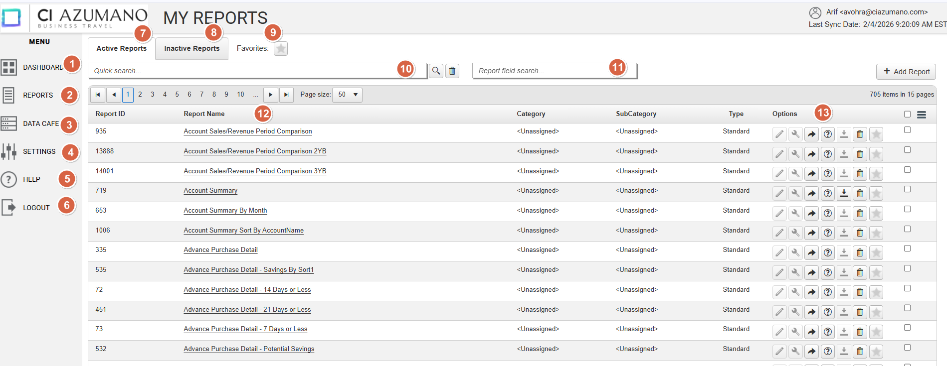
1: Dashboard.
2: Reports.
3: Data Cafe.
4: Settings.
5: Help.
6: Logout.
7: Active Reports.
7: Active Reports.
8: Inactive Reports.
9: Favorites (Reports).
10: Search Reports.
11: Reports Field Search.
12: Reports List.
13: Options (Report).

Dashboard
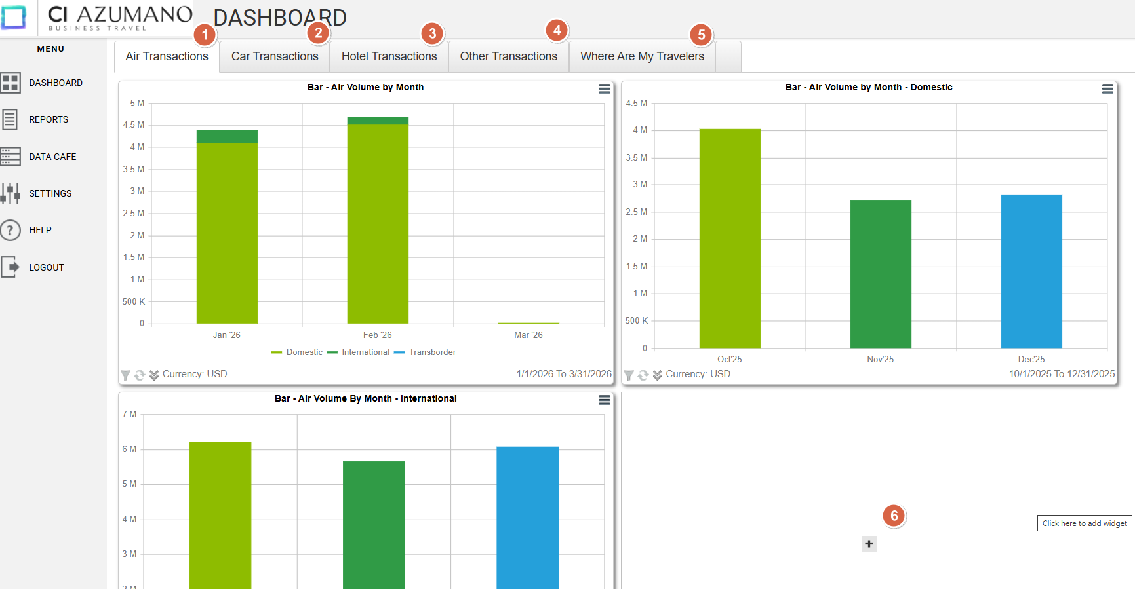

- Air Transactions
  - Air-related graphs and charts
  - Insights into air travel activity and performance metrics
- Car Transactions
  - Car rental–related graphs and charts
  - Analysis of car rental activity and trends
- Hotel Transactions
  - Hotel booking–related graphs and charts
  - Visibility into hotel transaction activity
- Other Transactions
  - Graphs and charts for other transaction types
  - Total Spend by Category
- Where Are My Travelers
  - Travelers’ location on a map
- Additional Widgets
  - Custom widgets added based on evolving business needs
Video Training: View Dashboard Training

Reports
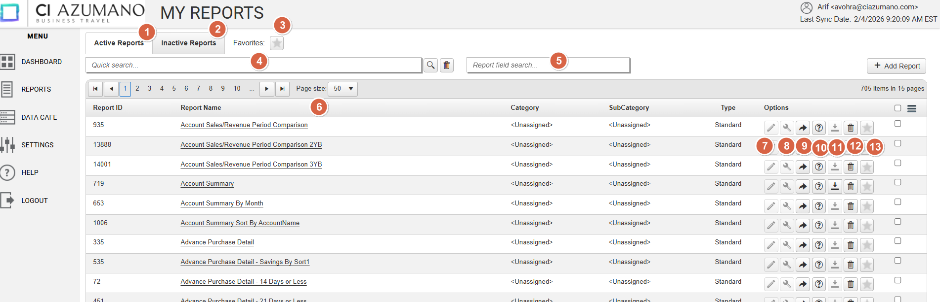

- Active Reports
  - Reports I currently have access to
  - Displayed in my Active Reports list
- Inactive Reports
  - Reports I have access to but are not shown in my Active Reports list
- Favorites
  - My frequently used reports
  - Quick access to preferred reports
- Search Report
  - Locate a specific report by name
- Report Field Search
  - Search across all accessible reports containing a specific field
- Report List
  - Complete list of all reports I have access to
- Edit Report
  - Available only for Builder-type reports
- Interact with Report
  - Add filters and interact with report data
- Run Report
  - Execute the selected report
- Help
  - Provides high-level information about the report
- Download Report
  - Download reports that have been run previously
- Inactivate Report
  - Move a report to the Inactive Reports list
- Add to Favorites
  - Move a report to the Favorites list

Video Training: View Reports Training

How to Run Reports
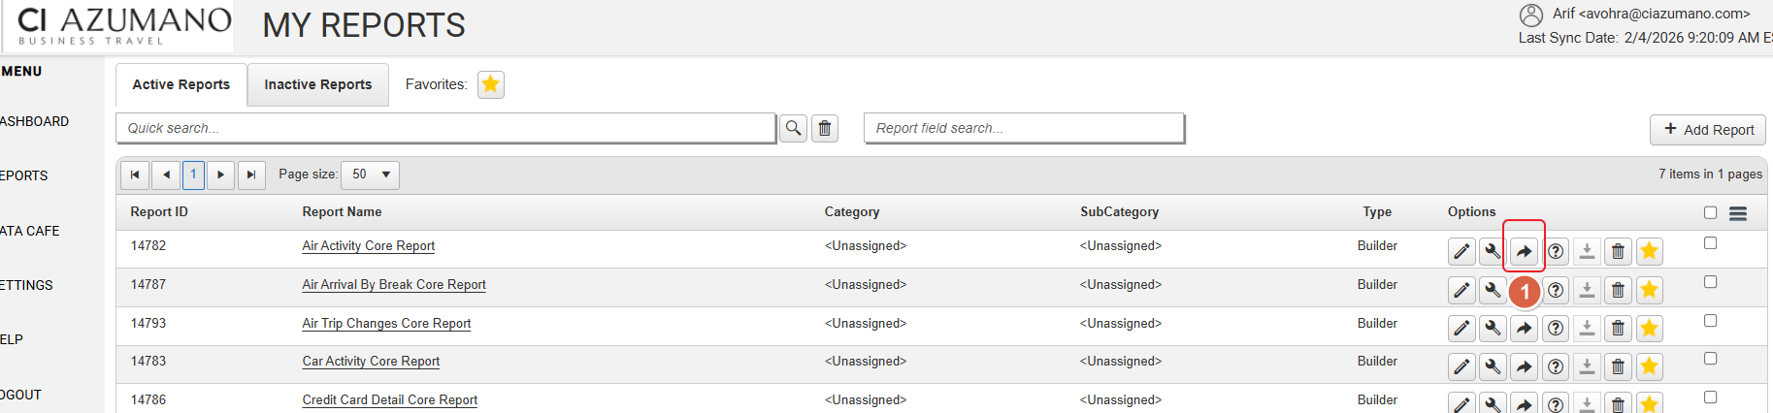
- Click on icon 
- Select Options
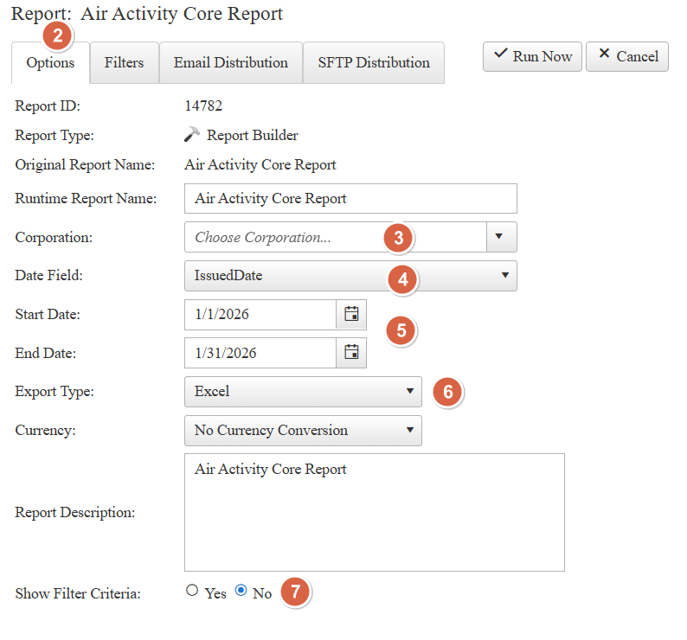
- Select the Agency Name
  - Use the Agency Name dropdown to choose the appropriate agency.
- Select the Data Field
  - Choose the required Data Field from the available options.
- Select Date Filter Option(s)
  - Apply one or more Date Filter options as needed.
- Select the Export Filter Type
  - Use the Export Filter Type dropdown to specify how the data should be filtered.
Click Run Now to execute the export.
Note: To apply additional criteria, click the Filters tab to add more filters.
Video Training: Run Report

Data Cafe
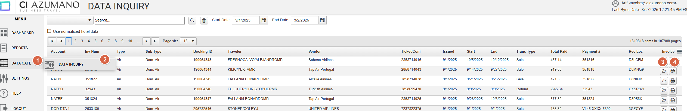
- Data Cafe
  - Click to access Child Menu.
- Data Inquiry
  - Click Data Inquiry link to load data.
- Folder Icon
  - Click Data Folder Icon to View Invoice.
- Printer Icon
  - Click Printer Icon to Print an Invoice.

Support
Email Support: careports@ciazumano.com
Please do not use Support link provided in the grasp portal.

