Uber for Business Dashboard and Audit Guide
Statewide Travel Program



Table of Contents

Dashboard Overview 3
Activity 5
Team 7
Insights 8
Sustainability 10
Unauthorized U4B Activity 11
Questionable U4B Activity 11

Purpose: This Uber for Business (U4B) review guide will provide a baseline for California state departments when analyzing data from their associated travelers in U4B. This guide will look into the tabs that can be found on the left-hand side of the dashboard: Programs, Activity, Team (People & Groups), Billing, Insights, and Sustainability.
This guide will explain what activity is not allowed by a traveler on official state business and what information may require follow-up, depending on the circumstances.

Dashboard Overview

When logging into the U4B dashboard, you will see the below tabs:

- Programs: Will list the department associated with the account, description of the program for the users, and the rules for expense codes/spending allowance/trip allowance/locations.
- Activity: Shows the date, time, traveler name, location, program (department), and fee amount for each trip taken.
- Team: Includes all travelers for each department who are active, awaiting approval, not joined, and what group (department) they’re associated with.
- Billing: Outlines the account spending for the month, remaining credit limit, payment methods, statements/invoices, past payments, and service fees.
- Insights: Divided into two tabs (Travel & People).
  - The Travel tab displays the total number of rides booked, number of people, total spent per person, ride times by hour, ride types booked.
  - The people tab shows those who are active, have linked U4B accounts, and have taken their first trip with U4B.
- Sustainability: Provides insights on emissions related to Uber rides broken down by electric vehicles, hybrids, and internal combustion engine vehicles.

Programs

The “Programs” tab shows the active and inactive tabs broken down by the group (department) with which it’s associated. If you edit your program, you will be able to alter the program name (how it appears in the Uber app) and the program description (shown in the Uber app). You can also create rules for the traveler to follow, such as an expense code, spending allowance, trip allowance, location, time, ride type, and schedule.

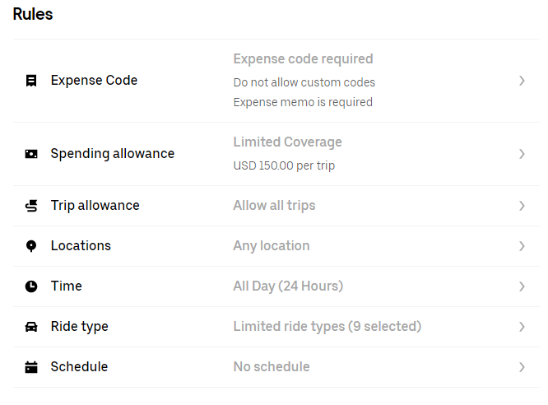

Activity

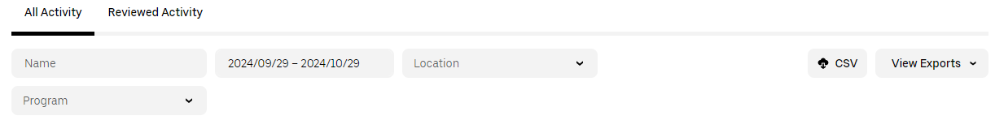
- The “Activity” tab can be filtered for names, dates, or locations. Once filters are selected, select “CSV.” The filtered report will be sent to the email address you have on file with Uber. The CSV file will include:
  - Time of pickup and drop-off, often including the full address.
  - Duration of the ride.
  - Type of car and the distance traveled.
  - Trip fare, subtotal, taxes or surcharges, total fare.
  - Expense code/Expense memo
    - Travel status.
    - Off-site meeting.
    - *Please note* Expense codes will only apply to a department if they have set this up with their U4B account. Expense codes are an easy way to manage charges and expenses for a Travel Expense Claim (TEC).

- Review addresses for pickup and drop-off with expense codes.
  - “Currently in Travel Status” is used when traveler is away from assigned headquarters on official business.
    - Itinerary – Date and/or times are within normal business hours/days?
    - Location – Pickup and/or drop-off locations are business-related locations?
    - Purpose of travel – If not business-related, then the traveler and/or traveler’s manager should provide additional information.
  - An offsite meeting is generally seen as traveling between headquarters and local offices/worksites on official business.
    - Location of meeting – Is the location a bona fide business or is it a residence/social spot/bar?
  - “Expense Memo” is a freeform justification for the expense code.
    - Must be included and informative relating to reason for ride if the ride is in question due to date/time/location appearing non-business related.

- The “Service” column is the class of service used. Review types of classes allowed.
  - Approved vehicle classes:
    - UberX: private vehicle (standard class).
    - Uber Assist: specialist training providing additional assistance for seniors & disabilities.
    - Uber Pool: picking up multiple travelers & being paid along the way.
    - WAV: Wheelchair assisted vehicle.
    - Wait and Save: opt to not take closest/soonest ride to get cheaper fare if traveler is willing to wait.
  - Additional vehicle classes that must be approved by a traveler’s manager (justification must be included in Expense Memo):
    - UberXL: larger vehicles.
      - List of passengers is required, and/or
      - Description of cargo traveling with traveler.
    - Uber Green: Eco-Friendly.
      - If costs are the same as UberX, it’s allowable. If costs are higher, this class is not allowed.
  - Non-approved classes under any circumstances:
    - Uber Comfort.
    - Uber Black SUV.
    - Priority / Reservation.
    - *Please note* The non-approved ride classes may expand over time due to new features on the U4B website. There won’t always be a memo to cover the immediate changes to the U4B ride classes, but Travel Coordinators (TC) are expected to educate the travelers on the current rules and regulations relating to using U4B.

- Associated Fees
  - When booking a ride with U4B, there will be fees associated with the basic trip fare. Examples of these fees include Booking Fee, CA Driver Benefits Fee, Access for All Fee, and occasionally an Airport Surcharge Fee.
  - You can review these fees by selecting the desired traveler/trip in the Activity tab, then clicking on the email receipt prompt at the bottom of the pop-up page. If you click on the blue question mark (?) next to the fee, it will provide you with an explanation of what the fee represents.
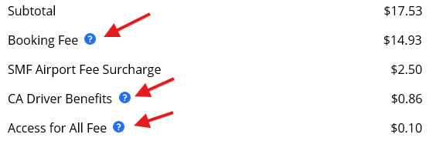

  - Undesirable fees: Cancellation fees, wait time fees, and reservation fees are all examples of charges that should be avoided on your agency’s U4B transaction reports. These charges are unnecessary expenses that are charged to the department by a traveler on official state business.

Team
The “Team” tab is broken down into People and Groups.
In the “People” section, you are able to view the travelers that are active, awaiting approval, and not joined. If a traveler is listed as not joined, this means that they have been added to the U4B dashboard and the invitation email has been sent, but they have yet to connect their personal Uber account to the Uber business account. This section is also where you would add a new user to U4B, delete a U4B user, or modify a U4B profile. You can search for a traveler by name, email, role (usually employee), or group (department).
The Group section simply displays the number of travelers in each associated department.
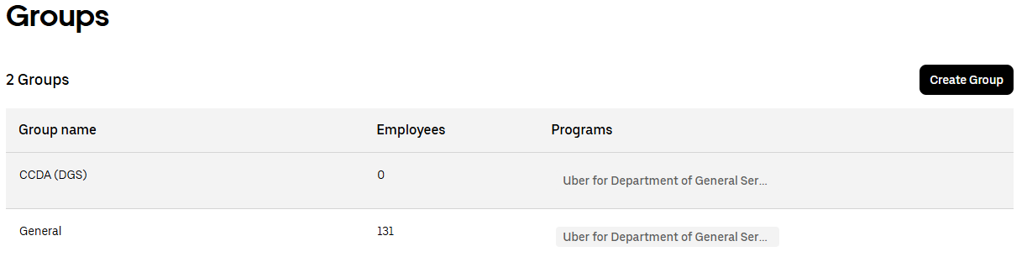
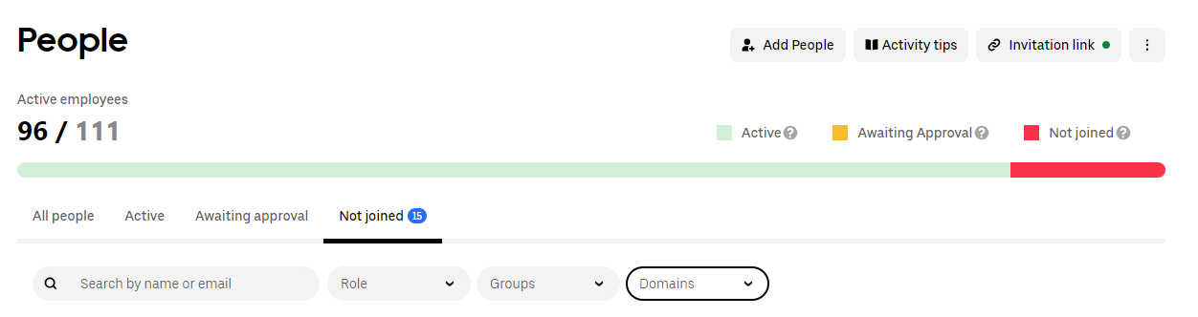
Billing
The “Billing” tab provides payment and statement information such as the current spending for the month, the credit limit for the account, virtual cards listed under payment methods, monthly invoices, past payments and service fees. On this page you will be able to make a payment on the current monthly charges, add a payment method, or update a payment method.

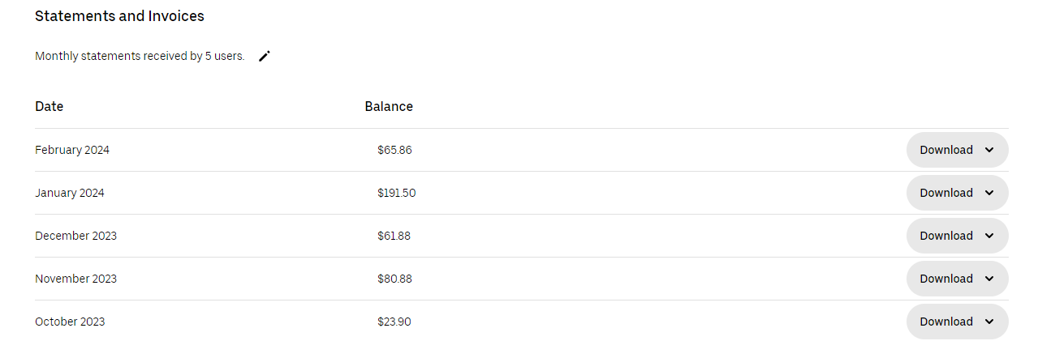

Insights
The “Insights” tab is broken down into content for Travel and People. The Travel section will display the number of rides booked within a custom date range, the total amount of money spent on the rides, the number of people who booked the rides, the cities and locations where the rides were booked, and outliers who have booked the most expensive rides.

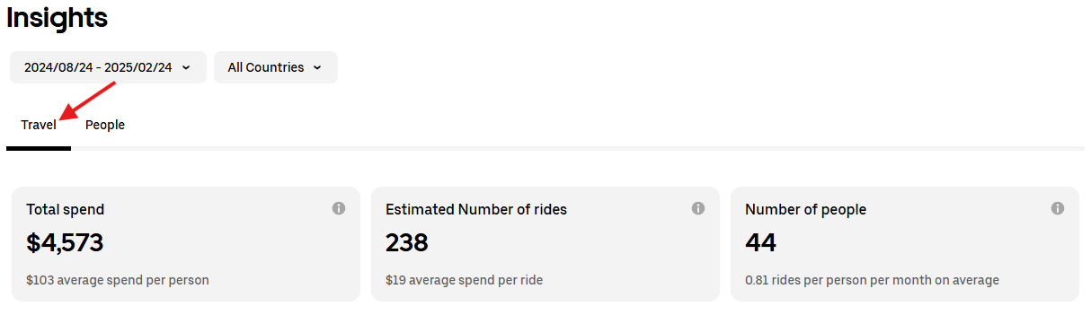
Data shown on the Travel Insights tab includes:
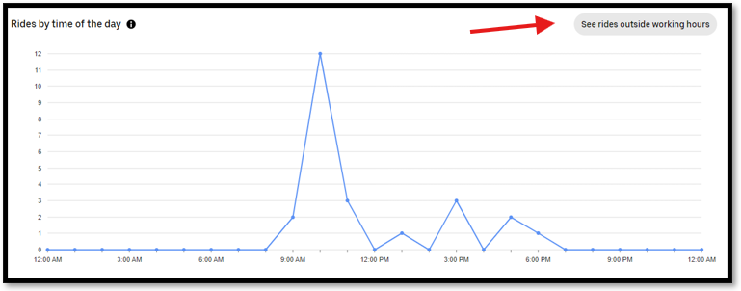
- Rides by time of day, including option to “see rides outside working hours”

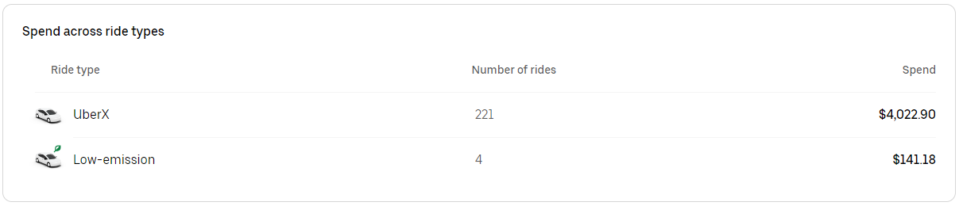
- Ride type:

Data shown on the People Insights tab includes:
- Graph displaying total travelers invited:
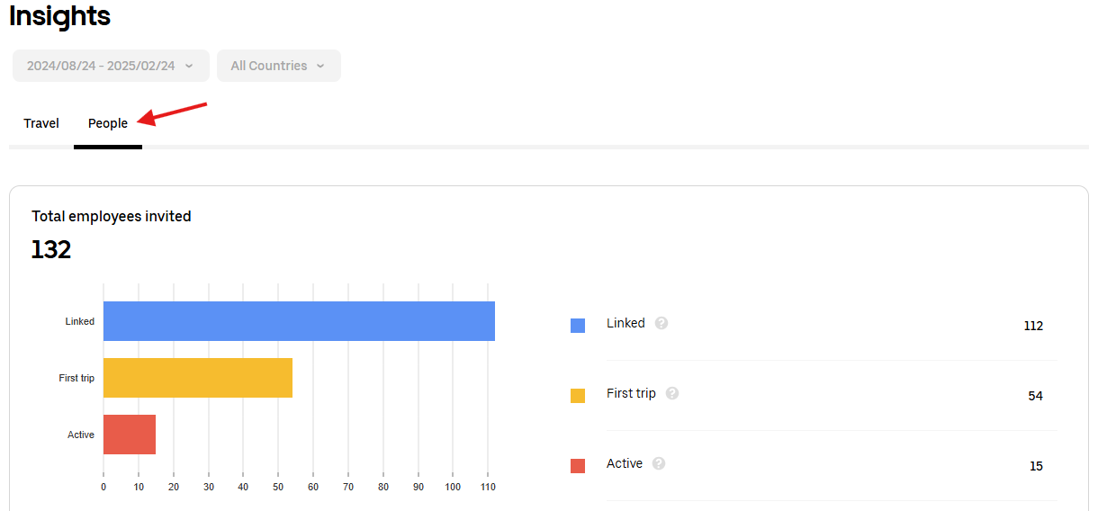

Sustainability
The “Sustainability” tab shows data on emissions related to Uber rides from electric vehicles, hybrids, and internal combustion engine vehicles. On this tab, you can find data on the number of low-emission trips, the estimated miles traveled, total C02 emissions, and the average C02 emissions per mile. You are able to filter the data based on a custom date range and the associated program (department).

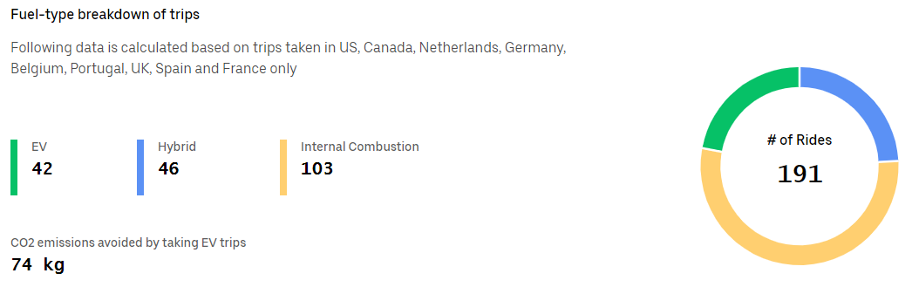

Unauthorized U4B Activity
Each state department or agency is able to tailor what is allowed on their U4B account to best suit their traveler’s needs. Each agency’s executive leadership or administrative travel team will decide what charges are authorized for their U4B program. For example, when the Department of General services (DGS) is conducting an audit of their traveler’s U4B activity, the following activities are not allowed on the DGS U4B policy:
- Booking personal rides on U4B
- Using U4B to commute from their home to the office (and vice versa)
- Charging tips to the U4B account
  - For more information on tips, please click here: Human Resources Manual / Tips - CalHR
- Booking premium rides (Uber Comfort, Uber Black, Uber Black SUV)
- Reservation fee
  - This fee is for the driver’s additional wait time and time/distance spent traveling to pick-up location

Questionable U4B Activity
- Booking UberXL or larger vehicle rides
  - Listed in the expense memo should include a justification as to why the traveler needs a XL vehicle, including but not limited to multiple travelers sharing a ride and cargo/equipment that is being traveling with.
- Higher than usual fares for distance (surge pricing)
  - Rush hours or surge pricing can affect price. This automatically goes into effect when there are more travelers in each area than available drivers.
- Rides from unusual locations or times
  - Look for rides out of state or that do not coincide with the traveler’s itinerary.
- Booking multiple U4B trips in one day by the save traveler
  - Would it be cheaper for a traveler to rent a car verses making multiple U4B trips?
  - Travelers can complete a cost comparison for renting a car here: Enterprise Rent-A-Car

