State Activity Detail Report Audit Guide
Statewide Travel Program

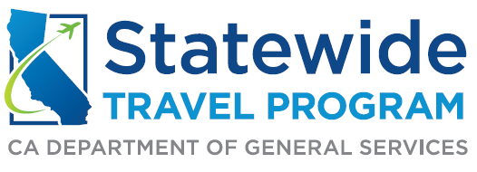

Table of Contents

Receiving the Monthly Report: 3
Reviewing the Report: 3
Transaction Fees: 4
Reviewing the Individual Charges: 5
Preferred Traveler Activity for Sad Report: 5

Receiving the Monthly Report:

Your department should receive a monthly State Activity Detail (SAD) report from CI Azumano within the first week of the month. Upon receiving your SAD report, you will want to verify that the following information is accurate:
- Client Account Number (Ex. 444xxxx)
- Client Account Name (Department/Agency)

Reviewing the Report:

When reviewing the rows of data within the report, you will find columns labeled Rec. Loc. (Record Locator Numbers), Invoice Number, Passenger Name, and Ticket/Conf No. (Confirmation Number). Ideally these four columns will contain the same data for each trip, because that shows the traveler has booked all their travel needs within one reservation. This saves the state money because it reduces the amount of booking fees. You would not want to see a traveler booking multiple different parts of their trip separately, because it increases the amount of booking fees.

In the SAD report, you will also find columns labeled Fee Type, Fee Amount, and Paid by DGS. It is important to verify that the type of fee associated with the traveler’s itinerary matches the fee amount charged by CI Azumano. For example, in the picture below you can see that the free amount is properly associated with the charge for online booking of a flight, a CI Azumano agent assisted booking fee, and an online lodging booking fee (paid by DGS).

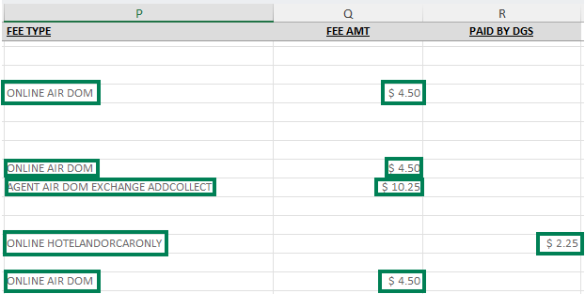

Transaction Fees:

Transaction Fees Covered by Departments

When booking departmental specific travel, the following fees are paid by the department:
- $4.50 (Online transaction fee for booking air or rail, plus hotel and/or car)
- $10.25 (Agent assisted transaction fee for air or rail, plus hotel and/or car)
- $10.25 (Agent assisted transaction fee for hotel and/or car only)
- $10.25 (Ticket exchange fee)

Transaction Fees Covered by Department of General Services (DGS)

The Department of General Services (DGS) will cover certain transaction fees on behalf of the participating user agency. These charges will show up in its own column on the SAD report as “Paid by DGS”:
- $2.25 (Online hotel and/or car only transaction fee)
- $4.00 (Virtual payment deployment fee)

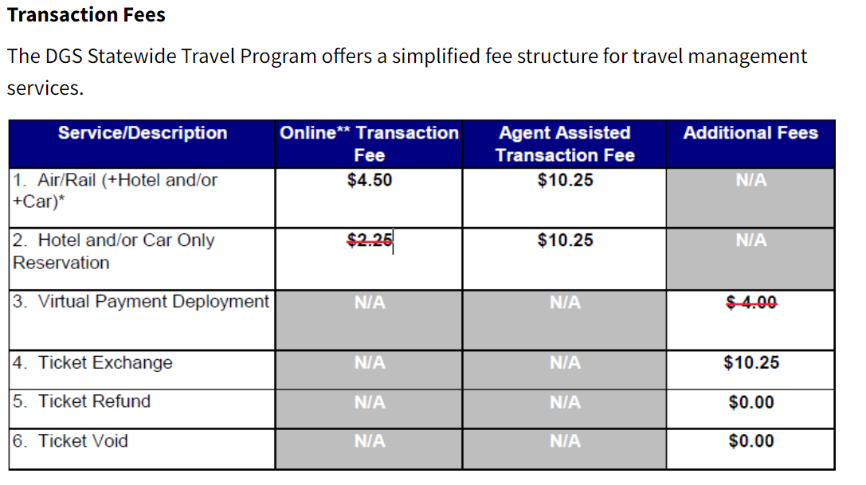
For more information about transaction fees, visit: Travel Management Services Resources

Reviewing the Individual Charges:

If you would like to see more information on a booking made by a traveler or arranger, you can look up their trip itinerary by using this website: CI Azumano Business Travel | Print my Invoice.

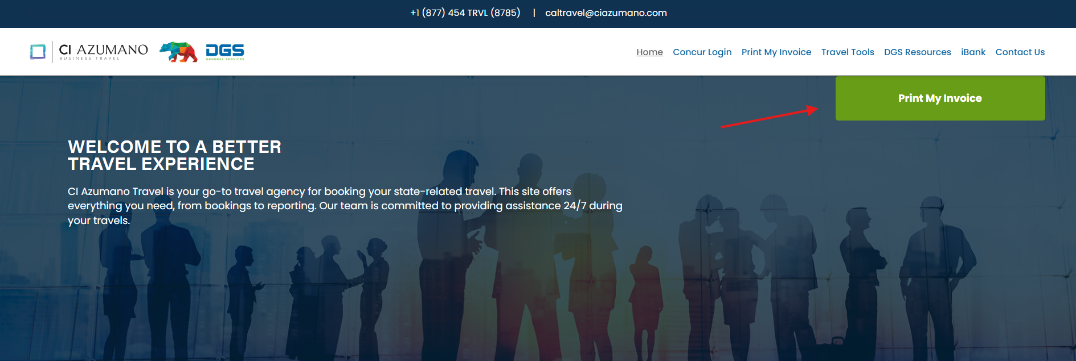

With the ‘Print My Invoice’ feature, you can look up a traveler’s itinerary by entering their name and either the invoice number, record locator number, or ticket/confirmation number as shown on the SAD report. This will generate a PDF that will display the traveler’s name, travel location, travel dates, amount paid, payment method, and more. Then you can compare the itinerary information to what is shown on the SAD report to see if everything aligns and is justified.
- *Please note* The data displayed from the ‘Print My Invoice’ feature reflects travel expenses that are booked, but not necessarily billed yet. For example, airfare is paid for at the time of purchase and other reservations such as hotel booking is paid for when checking out.

Preferred Traveler Activity for Sad Report:

To reduce the amount of transaction fees paid by your agency and DGS, a traveler should book their entire trip in the same itinerary verses booking parts of the trip separately. Additionally, the cheapest transaction fees are charged by booking the trip online though Concur. It is important for a traveler to know the details of their trip before booking with a CI Azumano agent or through Concur. This could include the dates of travel, the location, lodging requirements, and if a rental car is needed. Changing the accommodation details as few times as possible will reduce the amount of transaction fees paid. If a traveler or Travel Coordinator makes multiple changes to the itinerary, it could start accumulating fees that their agency will have to pay for. To ensure the traveler is complying, make sure they are booking round trip nonrefundable flights through contracted STP carriers.

If any discrepancies are found in your SAD report, you can reach out to the following email address for clarification: statewidetravelprogram@dgs.ca.gov. If any travel activity can be improved by the traveler within your agency, please provide them and the manager with a list of best practices and resources that can be found on the STP website STP Frequently Asked Questions or STP Training & Guides.

