- Where can I find the state’s airline policy?
  - SAM Airlines - 4117.1 is located here.
- What date did SAM Airlines - 4117.1 take effect?
  - August 1, 2021
- How are airline policy exceptions collected?
  - Concur: The online booking tool, Concur, will prompt and require a reason code justification(s) be provided before booking a flight that violates any of the SAM Airlines - 4117.1 policies.
  - Travel Management Services company: When making a reservation with a live travel agent, the travel agent will require the traveler/travel arranger to provide a reason code justification(s) before they may proceed with booking a flight that violates any of the SAM Airlines - 4117.1 policies.
- Are there any exceptions to SAM 4117.1?
  - There are a limited number of approved exceptions. Click here to navigate to the State Travel Policy page and download the “Policy Violation Reason Codes Legend” list of exceptions.
- I must book a flight that violates one or more of the SAM 4117.1 policies. Can I proceed with booking that flight?
  - Yes, however the reason(s) must be an approved exception.
  - Click here to navigate to the State Travel Policy page and download the “Policy Violation Reason Codes Legend” list of exceptions. The traveler/travel arranger must provide a reason why the flight selected violates one or more of the SAM Airlines - 4117.1 policies.
  - The traveler/travel arranger must retain supporting documents as substantiation to support why a flight that requires a policy violation reason code justification was selected.
  - Upon request, the traveler/travel arranger must provide the supporting documentation to the agency travel unit and/or the Statewide Travel Program (STP) to support selecting the reason code justification for booking a flight that violates SAM Airlines - 4117.1 policies.
- Does the agency travel unit need to retain proof to support the Reason Code justification that a traveler selected when they booked a flight that violates a SAM Airlines - 4117.1 policy?
  - STP recommends the traveler or agency travel unit staff retain supporting documentation as substantiation to support the reason code justification(s) selected during the booking process.
- Examples of supporting documentation that a traveler and/or agency travel unit should retain when selecting a flight that violates a SAM 4117.1 policy.
  - Booking a flight with a non-contracted carrier: The contracted carrier(s) don’t have a seat/flight available for the required date and time of departure. The traveler must retain proof, such as a time stamped screenshot of the Concur results page, showing that no contracted carriers had available flights or seats at the time of booking.
  - Selecting a refundable fare: Only refundable flights are available at the time of booking. The traveler must retain time stamped screenshots of the Concur results page illustrating no non-refundable flights were available to choose from at time of booking.
  - Booking a flight less than seven (7) days in advance: The traveler must retain a copy of the assignment/email/memo from leadership that required them to book less than seven (7) days in advance.
- Will state agencies be responsible for tracking and ensuring compliance with airfare purchasing requirements?
  - Yes. On a monthly basis, agency travel unit staff receive the “Policy Violation report - Invoice dates from MM/DD/YYYY to MM/DD/YYYY” report that agency travel unit staff must process to identify violations.
- Where can I download the “Policy Violation” report?
  - Yes. The name of the report is “Policy Violation” report, and it can be found in the “Saved Filters” section of the iBank dashboard.
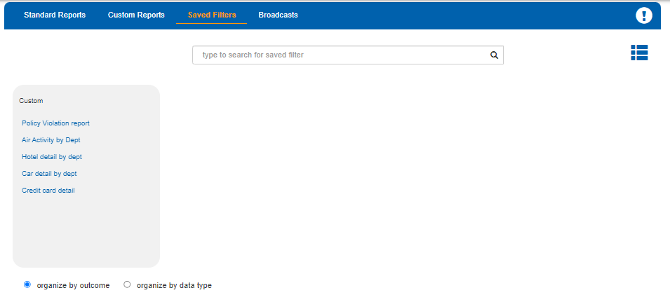
- Will the Deputy Director of Administration (or equivalent) be emailed the same “Policy Violation” report ? If so, how often?
  - Yes. On a semi-annual basis, DGS STP will email each state agency Deputy Director of Administration (or equivalent) the same exception reports. The semi-annual reports will also have a summary of violations and the list of all flights booked during the semi-annual period. If a flight was booked that violated a policy, the agency’s Deputy Director of Administration (or equivalent) will also be provided with the reason that flight was selected.
- Is there a report we can pull to ensure our employees are purchasing non-refundable fares?
  - Yes. Using the “Policy Violation” report, sort the “Reason for Refundable Fare” column. Blank cells mean the flight booked was non-refundable. Populated cells mean the flight booked was refundable.
- How will DGS be monitoring booking refundable and non-refundable flights?
  - DGS has access to exception report data mentioned in SAM Airlines - 4117.1. DGS, along with each state agency, will be responsible for monitoring flights booked non-refundable and refundable to ensure state travelers are adhering to the SAM Airlines - 4117.1 policies.

- There is an error in the ”Policy Violation” report this month. Whom do I escalate the error to?
  - To inquire about a possible reporting error, please send an email to Careports@ciazumano.com and MM21-07Reporting@dgs.ca.gov. Provide as much information about the issue, include screenshots and a copy of the report, and staff will look into the issue further.
- What does the data provided in the Sort columns of the ”Policy Violations” report represent?
  - Each report has three “Sort” columns: Sort 1, Sort 2, and Sort 3. Data may be populated in all, some, or none of the Sort cells. The data collected depends on the account and what the agency selected to be populated in the cells. For example, an agency may choose to collect the agency Reporting Structure, which will be populated into the Sort 1 cell for each reservation. Other data that may be collected and populated into any of the sort cells are traveler name and phone number, agency index, Program Cost Account (PCA), Reporting Structure, Object, Agency/Department Number, etc.
- Is booking a domestic flight on day 7 a violation?
  - No, booking 7 days in advance for a domestic flight is not a violation. Booking a domestic flight on day 6, 5, 4, 3, 2, 1 or 0 (same day) is a violation and a reason code justification is required.
- Is booking an international flight on day 30 a violation?
  - No, booking 30 days in advance for an international flight is not a violation. Booking an international flight on day 29, 28, 27, 26, to 1 or 0 (same day) is a violation and a reason code justification is required.

