

Map Viewer User Guide for the California Green Lodging Program

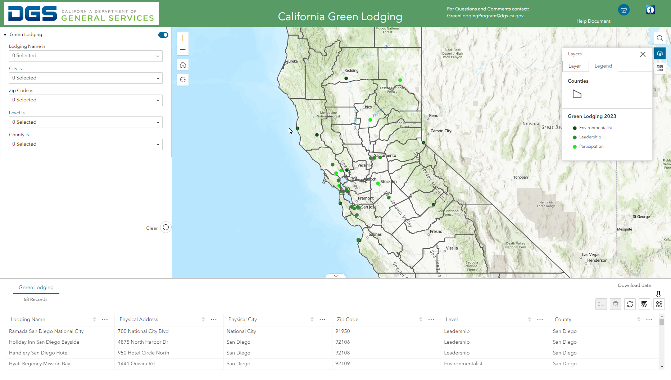

Table of Contents
Terms 3
Overview of the Map Viewer 4
Performing a Query - You can perform a query on Lodging Name, City, Zip Code, “Greenness” Level, and County 6
- Example Query Search by County 6
Closing and Opening Widgets 7
- Closing a Widget 7
- Opening a Widget 7
Layer List and Legend Widgets 8
Changing the Basemap 9
Identifying Features on the Map 10
Print Widget 11
Advanced Print Options 12
About Widget 13
Troubleshooting 14

Terms
Layer List Widget: Lists the layers and their symbols found on the map and allows the user to turn individual layers on and off.
Query Widget: Predefined queries that allow the user to retrieve information from the map.
Widget: A component of the map interface, that enables a user to perform a function.

Overview of the Map Viewer
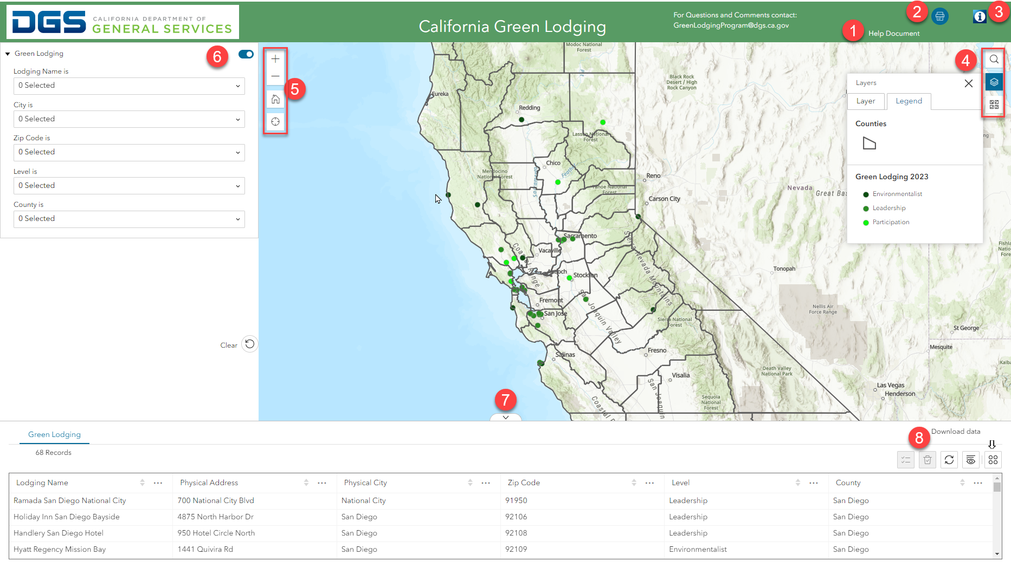
- Help Document
- Print Widget
- Information Widget (Information on how to certify your Hotel: Apply for Green Hotel Certification )
- Search (Search for addresses or place), Layer List (Ability to turn layers on and off), Legend (A visual explanation of the symbols used on the map), Basemap Gallery (Background options for the map)
- Navigation Tools - (Plus/Minus) Zoom in and out of the map, (House) go back to original extent of the map, (Target) find your exact location on the map
- Query Widget – Predefined queries that allow the user to retrieve information from the map.
- Attribute Tables – Opens tables corresponding to layers in the map
- Attribute Table Widgets – Download data, clear selections, refresh the table, show and hide columns

Performing a Query - You can perform a query on Lodging Name, City, Zip Code, “Greenness” Level, and County
  - Querying by County will be used as the example; however, these instructions apply to all of the Query options:
    - Select a county from the dropdown list by clicking on the arrow
    - Select one or multiple counties by checking the box
    - Clear all selection by clicking the trash can icon
    - Your selection is shown in the County drop down
    - You can press the clear button to remove all selections from the query widget

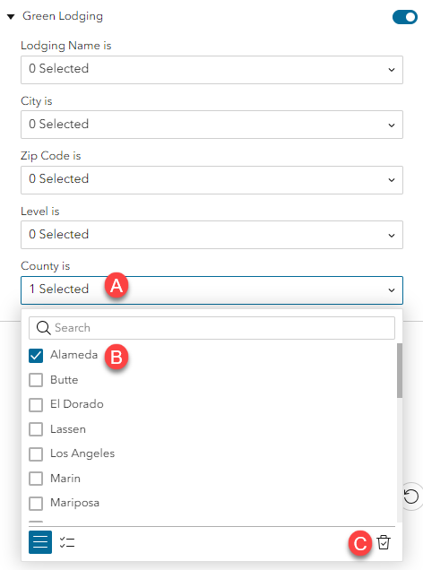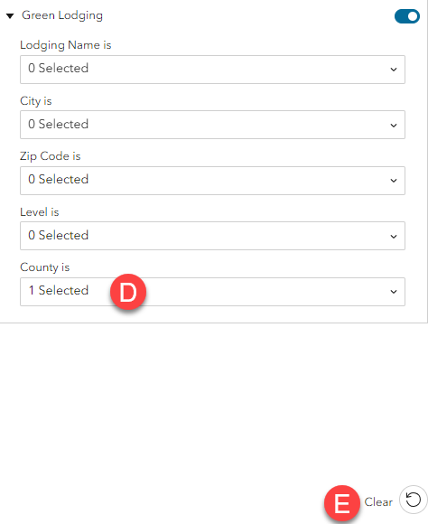

Closing and Opening Widgets
- Closing a Widget
  - Click on the X in the upper-right hand corner
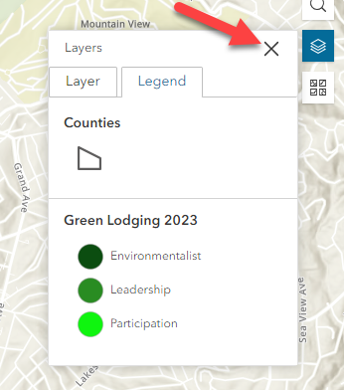
- Opening a Widget
  - Simply click on a widget to reopen it 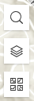

Layer List and Legend Widgets
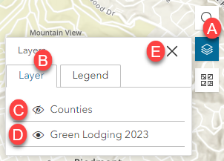
    - Click on the Layer List icon to open the widget
    - The Layer List widget contains tabs for Layer and Legend
    - An eyeball icon with a slash through it will indicate the layer is not currently visible on the map, click on the eyeball to make it visible
    - An eyeball icon indicates that this layer is currently visible on the map
    - Click the X to close the widget

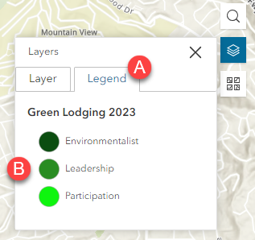

- Click on the Legend tab
- Symbols from active layers on the map will be shown

Changing the Basemap

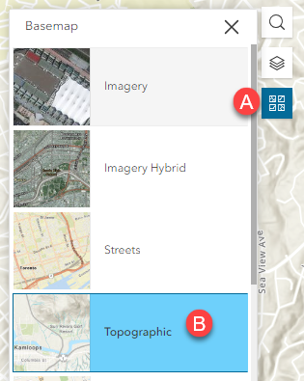

- Click on the Basemap Gallery widget
- Select an option from the list of Basemaps

Identifying Features on the Map
  - Click on a feature on the map
  - In this example, there are two results
  - Click on the arrow to scroll through the results
  - The square will expand move the results window to the right side of the screen so you can still observe the map
  - The X closes the window
  - Zoom to the feature
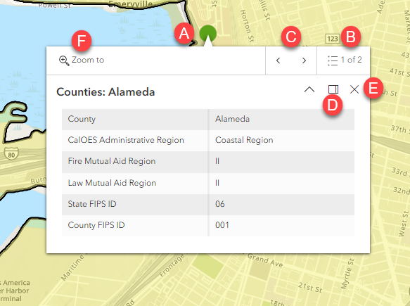

Print Widget
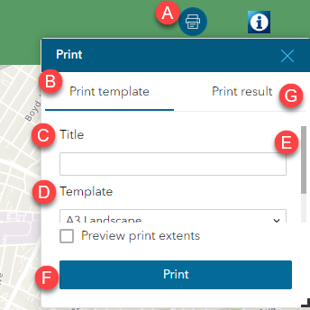
- Click on the Print icon to open the widget
- The print Template Tab is where you will make your selection for the job
- You can add a Title to the map
- Choose which template you want the map printed in
- Scroll down to make changes to other print options
- Print your map
- Click on the Print Results tab to see your completed print job

Advanced Print Options
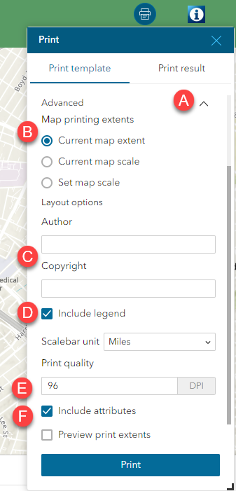
- Click on the Advanced dropdown arrow to access the advanced printing options
- map scale causes the printed map to maintain its scale while recalculating the extent around the existing center point
map extent causes the scale to adjust to fit the current map extent onto the printed map
Force scale provide a scale current to populate the value with the present scale of the map
- Specify values for the Author and Copyright properties to provide current information to the print service
- Check the Include legend check box to display the legend on the printed map
- Allows you to update the resolution of the printed map
- If Include attributes is checked, then the feature's attributes are included in feature collection layers

About Widget
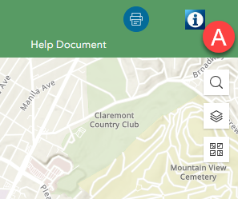
  - Click on the Information icon to open a new browser window for Apply for Green Hotel Certification

This will take you to a DGS website with more information on how to certify your Hotel as “Green”

Troubleshooting
If any issues arise with the map viewer try these solutions first:
- Make sure you are using Google Chrome version 74 or higher.
- Refresh the map viewer using the arrow to the left of the URL.
- Clear your browsing data:
  - Click on the three dots (ellipses)
  - Click on History
  - Click on the three dots (ellipses) again
  - Click on Clear Browsing Data

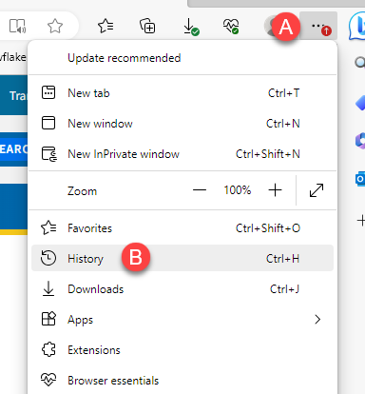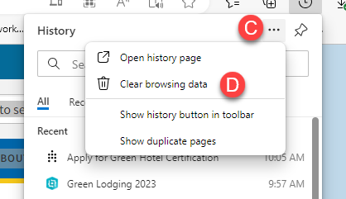
In the Clear browsing dialog box click:
- Set Time Range to All Time
- Make sure all boxes are checked
- Click Clear Now
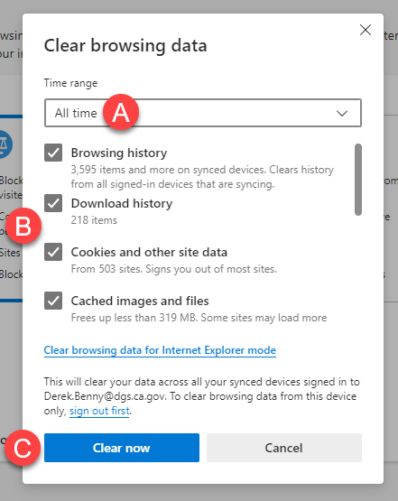

Close Google Chrome and then reopen the Map Viewer. If problems persist contact GreenLodgingProgram@dgs.ca.gov

