Run Reports
This instructional step by step takes place after you have used the filter feature to locate the report you want to run. Use the following steps to run a selected report.
Click on Run Reports Video to access a short step-by-step video about this subject (https://7162671.grasptech.com/knowledge/graspdata-run-reports-video).

This instructional step by step takes place after you have used the filter feature to locate the report you want to run. Use the following steps to run a selected report.
After finding the report you want to run on the My Reports tab, under the Options column, click on the arrow to open the Run Report window.
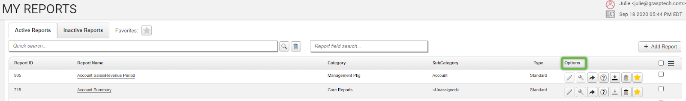
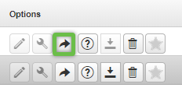
Useful Report ID
Report ID 30 Traveler Activity by Passenger
Report ID 268 Top Travelers Summary
Report 755 Air Activity by Passenger
Report 52 Car Detail by Invoice Date
Report 17 Hotel Detail by Passenger
The Run Report window will open and contains the following:
Options tab: You will need to either select ALL or a Corporation in the Corporation field, and the Start and End Dates will auto-fill with the last full calendar month. All fields are listed below.
- Report ID and Report Type
- Original Report Name
- Runtime Report Name (can customize - this will be what shows on the report header)
- Corporation (if a profile is created in Settings for Corporation, select in drop down)
- Date Field (use drop down to select option – Issued Date is default)
- Start Date
- End Date
- Export Type (PDF, Excel, Excel Data Only most common)
- Currency (Add On Feature) Select Currency Type if necessary
- Show Filter Criteria (will show report filter options and Report Descriptions as page 1 of the report if select ‘Yes’)
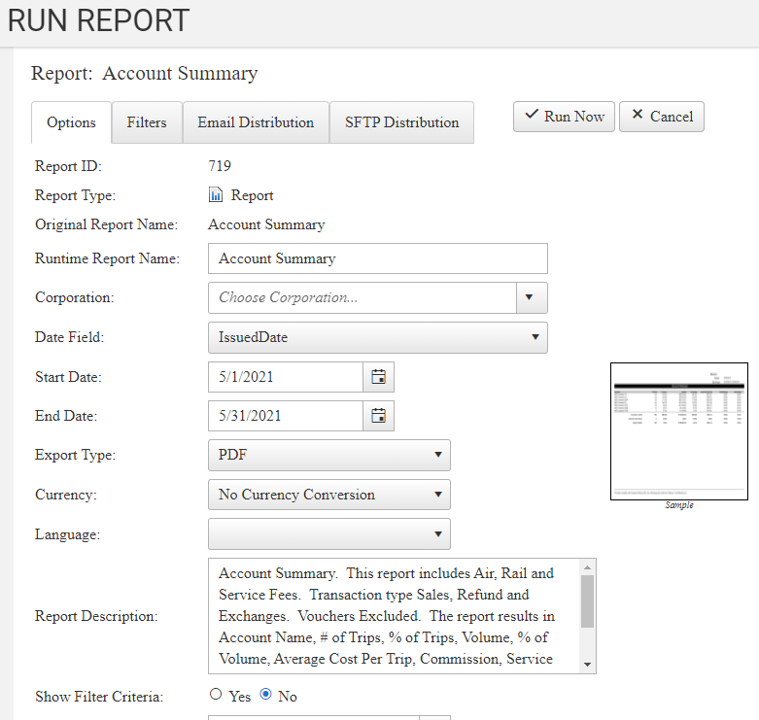
Filters tab: The filters tab provides the ability to run a report and filter to only see certain data, or remove certain data. With 5 Data Filters this allows for a wide variety of filtering possibilities.

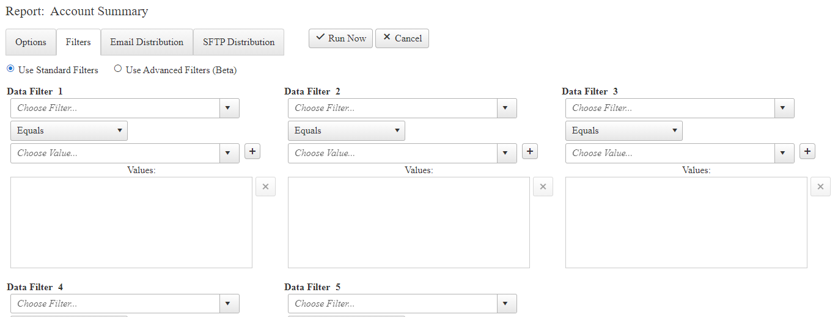
Please Note: Depending on the filter selected, some filters will allow the selection of multiple values where some may only allow one value. In addition, if using more than one Data Filter, the report will only return data that applies to each Data Filter.
For example, the filter Booking Type allows you to choose more than one filtering option. So, if you are running a report that shows air, car, hotel and more, you can filter it to ONLY show air by choosing Air in the drop down. Always be sure to click on the plus sign (+) on the right side to lock your selection in.
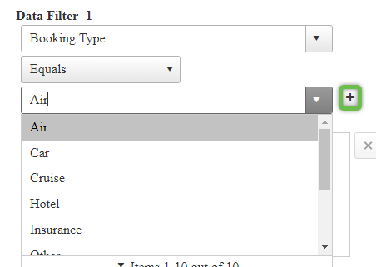
You will want to see your selection in the Values box after clicking on the plus sign. Again, you can choose more than one option if you see the plus sign, you’ll need to click on the plus sign to lock in each selection.
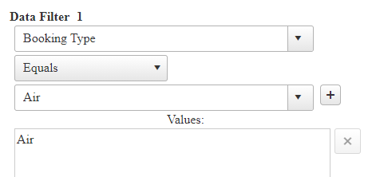
Some filters only allow for one option, such as Segment Arrive/Depart City. In the example below, you can only select one city in the drop down.
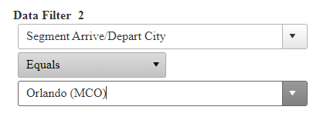
So, if in Data Filter 1 you have chosen Booking Type = Air, and in Data Filter 2 you have chosen Segment Arrive/Depart City = Orlando, your report will only return air bookings where the traveler went to/from Orlando.
You can also change the drop down of Equals to other options if you would like the filter to exclude certain items, be Greater Than Or Equal to, etc.

Email Distribution tab: Emailing a report from the Run Reports tab is an option. Please click on Emailing Reports page to be taken to the page with information about Emailing Reports (https://7162671.grasptech.com/knowledge/graspdata-reports-emailing-reports).

SFTP Distribution tab: This is an add-on product. Please reach out to Grasptech Support for more information (support@grasptech.com).

Once you have the completed the fields and filters (if applicable) needed, click on the Run Now button to run your report.
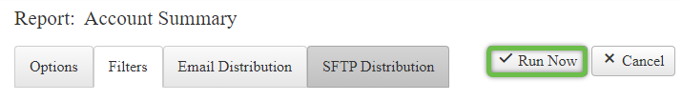

Report History: After clicking on Run Now, you will be automatically taken to the Report History page. You can also get to this page from the Menu > Reports > Report History.
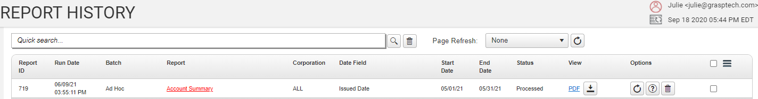
From Report History you can view, rerun, email reports and more. Please click on Report History page for more information about Report History (https://7162671.grasptech.com/knowledge/graspdata-reports-report-history).

iBank Report Name | Grasp Report ID | Note
Account Summary Air - Year to Year Comparison | 13512
Advance Booking - Air | 335
Air Activity | 4 0r 6
Air Activity by UDID | 4 0r 6
Analysis by City - Car | 319
Analysis by City - Hotel | 20
Arrival | 105
Car Activity | 52
Class of Service | 649
Departures | 106
Electronic Invoice - Combined | 533
Exceptions - Air | 14070 | Summary
Executive Summary with Graphs | 165
Executive Summary Year to Year | 845
Fare Savings - Air | 23
Hotel Activity | 17
Carrier Concentration | 19511
Market Pair | 280
Missed Hotel Opportunities | 22
Top Travelers - Combined | 268
Top/Bottom Cars | 29
Top/Bottom City Pair | 882
Top/Bottom Destinations | 1642 | Top 10
Top/Bottom Hotels | 24
Top/Bottom Validating Carriers | 217 | W Graphs
Transaction Analysis by Credit Card | 898
Travel Management Summary | 938
Traveler by Country | 647 | Summary
Trip Detail | 30
Trip Duration | 1601
Validating Carrier | 46
Weekly Traveler Activity | 30

