

FAMS 3.0 Job Aid
Contents
1. General Information 1
1.1. Remove “ca.gov” in the compatibility view setting under Internet Explorer (IE) Tools. 1
1.2. Session Time out 1
1.3. Clear Browser history 2
2. Log in 2
2.1. Email Configuration 2
2.2. First time log in 3
3. Forgot Password 4
3.1. Reset your password message 4
3.2. Reset password 4
4. Administration 5
4.1. My Account 5
4.1.1. My profile 5
4.1.2. Change Password 5
4.2. User Administration 6
4.2.1. Create new user 6
4.2.2. User Account Management 7
5. Fleet Management 8
5.1. Asset 8
5.1.1 Asset Search 8
5.1.2. Quick Search 8
5.1.3. Advance Search 8
5.1.4. Asset Export 9
5.1.5. Asset Search Results (FI$Cal) 9
5.1.6. Asset Update (FI$Cal) 10
5.1.7. Asset Search Results (Non-FI$Cal) 11
5.1.8. Asset Insert and Update (Non-FI$Cal) 12
5.1.9. Asset Bulk Upload (FI$Cal & Non-FI$Cal) 12
5.2. Usage 14
5.2.1. Usage Search 14
5.2.2 Usage Report 15
5.2.3. Usage Search Results 15
5.2.4. Usage Update 16
5.2.5. Equipment Usage History 16
5.2.6. Usage Upload 17
5.2.7. Usage update Tips 19
5.3. Agency Fuel 19
5.3.1. Fuel Search 19
5.3.2. Fuel Export 20
5.3.3. Fuel Search Results 21
5.3.4. Fuel Insert 21
5.3.5. Fuel Update 21
5.3.6. Fuel Upload 22
6. Reports 23
6.1. Report Criteria Screen 23
6.2. Report Result Page 24
7. Documentation 24
7.1. Bulk Upload Template 24
8. Support 24

1. General Information

1.1. Remove “ca.gov” in the compatibility view setting under Internet Explorer (IE) Tools.

1.2. Session Time out
A session expiration message will pop up if there is no activity on your session for 20 minutes.
Single Session (one FAMS 3.0 screen open) time out: After you click on “OK,” it will take you to the log in screen.
Multi Sessions (multiple FAMS 3.0 screens open) time out: After you click on “OK” on the expired session while the other session is still active, it will take you to the landing page.

1.3. Clear Browser history
If no response from menu button in FAMS 3.0, try to re-log into the system. If the issue still exists, please delete browsing history as below screen.
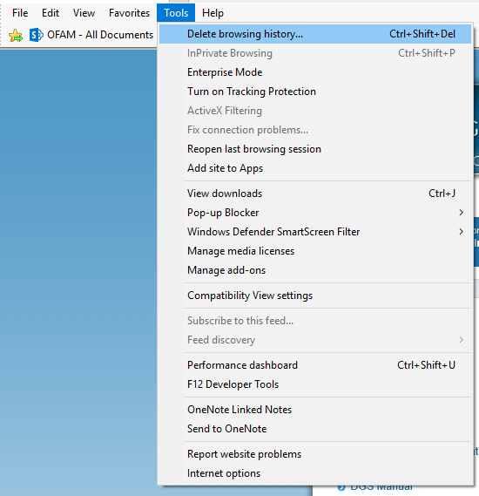

2. Log in

2.1. Email Configuration
Department Admin, FAMS Analyst and IT Admin can create new users with a valid email address. (Please see chart in section 4.2.2. for the user role matrix). Once new user is created. Confirmation message will be sent to the registered email address.
Please check your inbox or junk email box for email confirmation link with temporary password from FAMS Noreply@dgs.ca.gov
Note: Email confirmation link will expire after 72 hours. If the link has expired, please request your department Admin or FAMS analyst to resend email confirmation message through account management.

2.2. First time log in
- New user created in FAMS 3.0 first time log in:
  - User confirms his email address by clicking on email confirmation link.
  - User logs in with his email address and the temporary password sent by FAMS Noreply@dgs.ca.gov
  - Once use logs in, system will require password change.
- Existing FAMS 2.0 user first time log in:
  - User clicks on “Forgot Your Password” link from the login screen.
  - System sends password reset link to user’s email address.
  - User clicks on password reset link sent by FAMS Noreply@dgs.ca.gov/
  - User resets password in FAMS 3.0 to log in.
After login, landing page is Asset Search page. You can see your user role as well as FI$Cal and confidential access status below the email address on each page. Click on “Log Out” to log out of the system.

3. Forgot Password
Enter valid email address where the reset password email will be sent. Click on “Reset” button to generate a reset password email and send it to email address.

3.1. Reset your password message
Please check your inbox or junk email box for password reset link from FAMS Noreply@dgs.ca.gov
Note: Password reset link will expire after 72 hours. If the link is expired, please request password reset from your Department Admin or FAMS analyst.

3.2. Reset password
Enter new password and confirm. Clicking on “Reset” button will reset the password to the new and confirmed password. The contents of the two fields must match.
Password requirements:
- Password must contain at least eight characters.
- Password needs to be changed every 90 days.
- Password must contain at least three of the following four elements.
  - Uppercase letters
  - Lowercase lettersi
  - Numeric (0 through 9)
  - Special characters: ~!@#$%^&*_-+=|\(){}[]:;””<>,.?/
- Password must not be reused for 12 iterations.
- The user account must be automatically disabled after six unsuccessful login attempts.

4. Administration

4.1. My Account

4.1.1. My profile
- User role and email address cannot be modified through “My profile.”
- First name, last name and phone number can be updated by the user.
- Click on “Save” button to save updated user profile information to database.

4.1.2. Change Password
Enter current password and new password to change to new password. The new password and confirm new password fields must match. Click on “Save” button to change the password.
Password requirements:
- Password must contain at least eight characters.
- Password need to be changed every 90 days.
- Password must contain at least three of the following four elements.
  - Uppercase letters
  - Lowercase letters
  - Numeric (0 through 9)
  - Special characters: ~!@#$%^&*_-+=|\(){}[]:;””<>,.?/
- Password must not be reused for 12 iterations.
- The user account must be automatically disabled after six unsuccessful login attempts.

4.2. User Administration
Only applies to Department Admin, FAMS analyst and FAMS manager user roles.

4.2.1. Create new user
- Enter new user information to create the new user.
- Email address must be unique in FAMS.
- Click on “Save” button to save new user profile to database.
- Confirmation email will be sent to email address with temporary password.

4.2.2. User Account Management
Click on edit button to open up editable fields: last name, first name, agency. Phone number, role name, confidential access, active (account), locked (account) and resend email confirmation.
- You can deactivate user account if the user no longer needs access to FAMS.
- You can unlock user account if the user account is locked after max password attempts.
- You can resend email confirmation if new user email confirmation link is expired.
- Agency edit only applies to FAMS Analyst and FAMS Manager.
Click on arrow icon to sort last name by ascending or descending order. Click on filter icon next to last name, first name, and email address and role name to populate filter box and then type in the value in below red circled blank box before click on Filter. Click on Clear to clear all the filters.
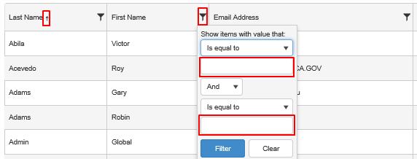
To create new user Administration, follow the below user role matrix:
User | User Role Selection | User Agency Selection
Department Admin | Department User | Default Agency
FAMS Analyst | Department Admin | Any Agency
FAMS Analyst | Department User | Any Agency
FAMS Manager | FAMS Analyst | Any Agency
FAMS Manager | Department Admin | Any Agency
FAMS Manager | Department User | Any Agency

5. Fleet Management

5.1. Asset

5.1.1 Asset Search
Navigation: Log in as department Fleet Management Asset Search.
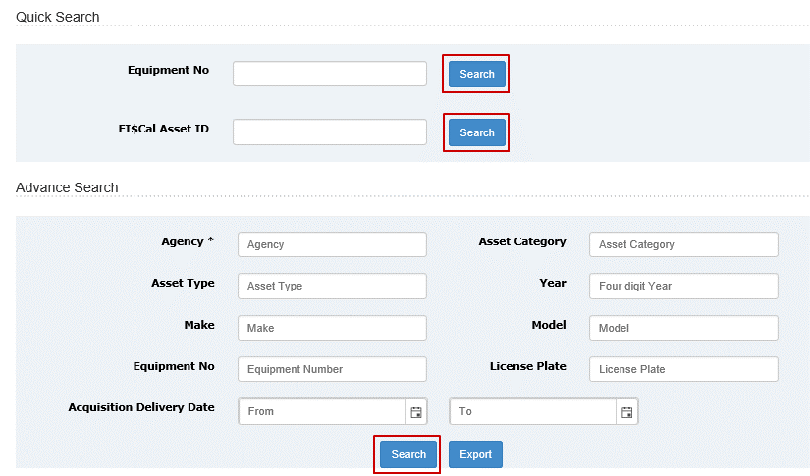
Field with * beside the label indicates that it is a mandatory field.

5.1.2. Quick Search
Only need to enter Equipment Number of FI$Cal Asset ID. FI$Cal Asset ID field is only viewable and applies to FI$Cal department. If you are FAMS analyst or FAMS manager, quick search will search equipment number across all agencies in the database.

5.1.3. Advance Search
- Agency, Asset category, Asset Type, Make and Model are text fields that populate with a dropdown when user inputs 3 characters for selection.
- Asset Category, Asset Type, Make and Model are multi selection fields with comma separation.
- Agency is required. Other fields help narrow down the search results.
If you are FAMS Analyst and FAMS manager, you can choose different agency. If you are department user or department admin, agency field is locked to your default agency.
- Entering a FI$Cal Agency will return FI$Cal results Grid View Interface (GVI).
- Entering a Non FI$Cal Agency will return Non FI$Cal results GVI.
- Click on Search button after entering search criteria will perform search and return results in GVI

5.1.4. Asset Export
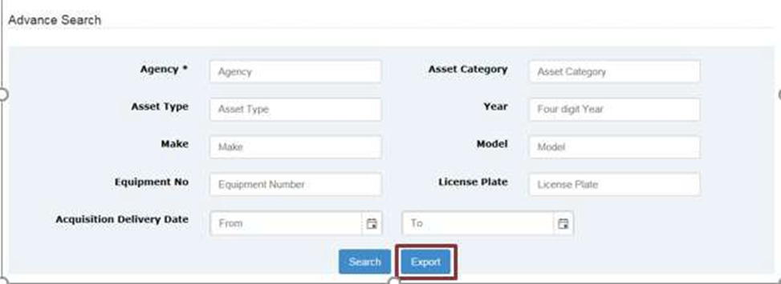
Enter search criteria, and click on “Export” button to export the search results into csv file. Save the file to any location (local or network).

5.1.5. Asset Search Results (FI$Cal)
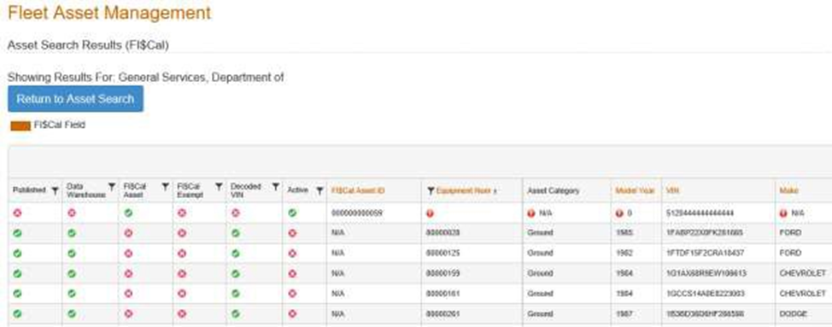
- Field label in orange color label are FI$Cal fields.
- New asset insert needs to be performed through FI$Cal.
- Field validation rules refer to appendix 1 for validation matrix quick review.
  - Warning message indicator – yellow triangle with exclamation mark.
  - Error message indicator – red circle with exclamation mark.
- Click on filter icon to open up the filter box for indicator fields (published, data warehouse, FI$Cal Asset, FI$Cal Exempt, Decoded VIN, Active) and Equipment Number
- Click on arrow icon next to equipment number to sort the equipment number in ascending or descending order.
- Indicators are only available in web screen and will not be included in export file.
- Click on “Return to Asset Search” to go back to screen criteria screen.
FI$CAL Asset GVI Indicators Condition Matrix
Indicator | Condition | Icon | Tooptip (text displayed when user hovers mouse over icon)
Published | Asset meets all the validation rules and ready to be inserted into data warehouse |  | Yes
Published | Asset does not meet all the validation rules and cannot be inserted into data warehouse |  | No
Data Warehouse | Asset is inserted into data warehouse after ETL run at 12:00am and 12:00pm and will be included in the reports |  | Yes
Data Warehouse | Asset is not inserted into data warehouse and will not be included in the reports |  | No
FI$Cal Asset | Asset in FI$Cal (only apply to FI$Cal agency) |  | Yes
FI$Cal Asset | Asset NOT in FI$Cal (only apply to FI$Cal agency) |  | No
FI$Cal Exempt | Asset is exempt from FI$Cal reporting |  | Yes
FI$Cal Exempt | Asset is NOT exempt from FI$Cal reporting |  | No
Decoded VIN | VIN is decoded by VIN decoder |  | Yes
Decoded VIN | VIN is not decoded by VIN decoder |  | No
Active | Asset is active |  | Yes
Active | Asset is disposed if meeting following conditions: Published asset with disposition date, disposition sold amount and disposition method |  | No

5.1.6. Asset Update (FI$Cal)
- Double clicking on a row will open the row in form for editing.
- FI$Cal fields are labeled in orange and protected from editing.
- Field validation rules refer to appendix 1 for validation matrix quick view.
- Click on ‘Update’ button save edited data into database.
- Click on ‘Cancel’ button returns to search result GVI.
- Exception rules for certain FI$Cal fields are documented in FAMS Portal – Asset Data Source Priority Matrix in Appendix 3

5.1.7. Asset Search Results (Non-FI$Cal)
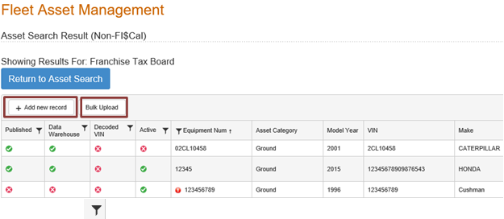
- Click on filter icon to open up the filter box for indicator fields (published, data warehouse, FI$Cal Asset, FI$Cal Exempt, Decoded VIN, Active) and Equipment Numebr
- Click on arrow icon next to equipment number to sort the equipment number in ascending or descending order.
- Indicators are only available in web screen and will not be included in export file.
  - Warning message indicator – yellow triangle with exclamation mark.
  - Error message indicator – red circle with exclamation mark.
- Click on “Return to Asset Search” to go back to screen criteria screen.
Non FI$Cal Asset GVI Indicators Condition Matrix
Indicator | Condition | Icon | Tooltip (text displayed when user hovers mouse over icon)
Published | Asset meets all the validation rules and ready to be inserted into data warehouse |  | Yes
Published | Asset does not meet all the validation rules and cannot be inserted into data warehouse |  | No
Data Warehouse | Asset is inserted into data warehouse after ETL run at 12:00am and 12:00pm and will be included in the reports |  | Yes
Data Warehouse | Asset is not inserted into data warehouse and will not be included in the reports |  | No
Decoded VIN | VIN is decoded by VIN decoder |  | Yes
Decoded VIN | VIN is not decoded by VIN decoder |  | No
Active | Asset is active |  | Yes
Active | Asset is disposed |  | No

5.1.8. Asset Insert and Update (Non-FI$Cal)
- Click on ‘Add new record’ button open up pop up screen for entering non FI$Cal asset.
  - Fields with red * are required.
  - Click ‘Add Asset’ button to save data to database.
  - Click on ‘Cancel’ button to return to search result GVI.
- Double clicking on a row will open up pop up screen in form for editing.
  - Click ‘Update’ button to save data to database.
  - Click on ‘Cancel’ button to return to search result GVI.
Note: Disposed asset cannot be updated before reactivation.
No ‘Update’ button is available for disposed asset pop up screen.
- Field validation rules refer to Appendix 1 for validation matrix quick view.
- Confidential asset insert should be only conducted by the user with confidential access.
  - FAMS 3.0 will not prevent non confidential user to insert confidential asset.
- Click on ‘Bulk Upload’ button to upload a csv file of assets.
  - Upload file must follow the export template, refer to Appendix 2 for layout spec.

5.1.9. Asset Bulk Upload (FI$Cal & Non-FI$Cal)
Navigation: Long in as department user Fleet Management Asset Upload.
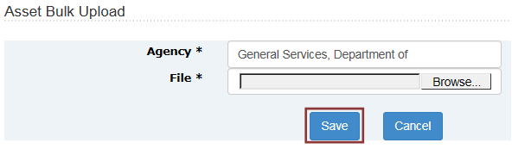
- Browse to location of file (local or network) and click save to perform bulk upload.
- The file is required to be in csv format and follow the export template.
  - Refer to Appendix 2 for asset data layout spec.
- Confidential asset bulk upload should be conducted by the user with confidential access.
  - FAMS 3.0 will not prevent non confidential user to upload confidential asset.
- If the upload file contains invalid format or duplicate VIN, or fails the below minimal validation rules, an error message will display.
  - Equipment number: Alphanumeric value plus dash, space, period and slash.
  - Model Year: Must be a numeric value between 1900 and 2099.
  - Purchase price: Numeric value, up to 9 characters in length.
  - Annual Lease Rental Rate: Numeric value, up to 9 characters in length.
  - Acquisition Mileage: Numeric value, up to 9 characters in length.
  - Disposition Sold Amount: Numeric value, up to 9 characters in length
- Bulk upload file error message follows 2 steps error sequence:
  - Layout mismatch;
  - Minimal data value validation & duplicate VIN check.
- If asset bulk upload file contains both layout and invalid data value or duplicates, you need to perform bulk upload twice to identify all the errors.
Sample error messages:
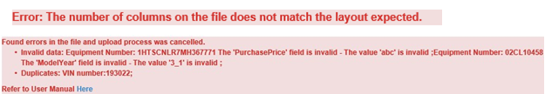
- If file is uploaded successfully, informational message will display as below example:
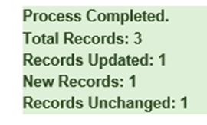
New Records: any new equipment in bulk upload file will be counted as new record. Records updated: any changes under existing equipment number will be counted as updated record.
- Tips for asset bulk upload through export file
Step 1: Export asset records
Step 2: Open the file
Step 3: Edit and add new records as necessary
Step 4: Remove all other non-change records
Step 5: Save the change into local file in csv
Warning: For the fields with numeric value, in Excel numbers with more than 12 characters will convert the number into scientific notation as below example.
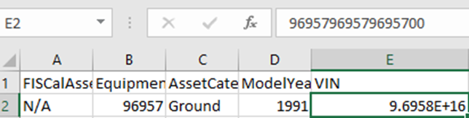
To avoid scientific notation for numeric value, you can add =”xxxx” as below example.
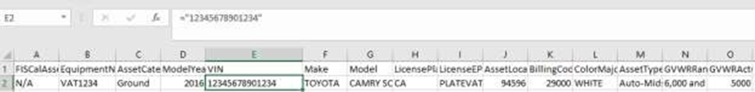
Don’t open the file after save. Excel will remove the leading 0. If you do open the file after save, please check the fields with numeric value, such as billing code and equipment number to add leading 0 as following screen shot.
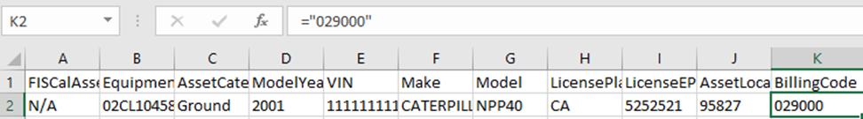
Step 6. Perform bulk upload.
- Highlights for FI$Cal department bulk upload.
  - As FI$cal user, you can only update non-FI$Cal fields through bulk upload.
  - When FI$Cal user clicks on asset bulk upload, warning message will appear.
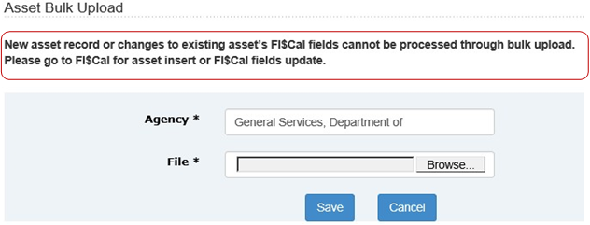
  - Exception rules for certain FI$cal fields are documented in FAMS portal – Asset Data Source Priority Matrix in Appendix 3.
  - VIN decoded fields can’t be updated through bulk upload for assets with decoded VIN.

5.2. Usage

5.2.1. Usage Search
Navigation: Log in as department user Fleet Management Usage Search
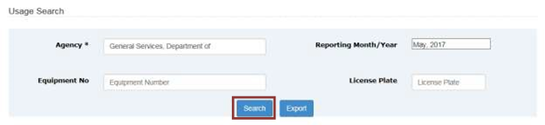
- Agency is required. Other fields help narrow down the search.
- Reporting Month/Year will be default to current reporting month/year.
If you need to change the reporting month/year, please click anywhere in the box will populate month and year selection. Click on Done after your selection will update your reporting month/year.
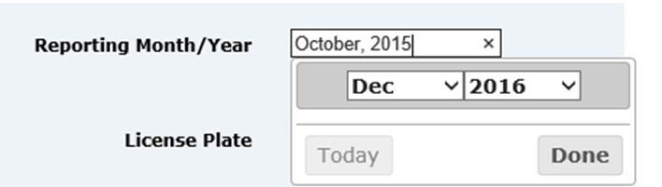
- Click on “Search” button after entering search criteria will perform search and return results in GVI.

5.2.2 Usage Report
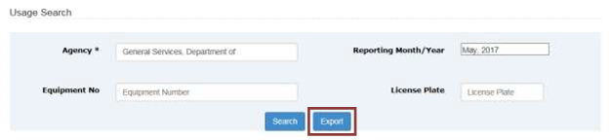
- Enter search criteria.
- Agency is required field.
- Click on “Export” button to export the search results into csv file/
- Save the file to any location (local or network)

5.2.3. Usage Search Results
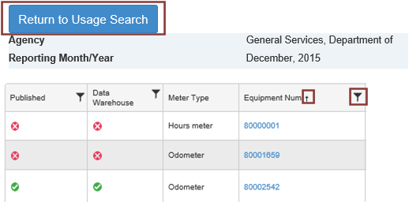
- Click on filter icon to open up the filter box for Published, Data Warehouse and Equipment number.
- Click on arrow icon next to the equipment number to sort the equipment number in ascending or descending order.
- When error icon (red exclamation point) pops up, use your mouse to scroll over to populate error message.
- Published and Data Warehouse indicators are only available in web screen and will NOT be included in export file
- Disposed asset usage can be updated only during the period of time the asset was active
- Click on ‘Return to Usage Search’ link will open the Usage Search screen
Usage GVI Indicators Condition Matrix
Indicator | Condition | Icon | Tooltip (text displayed when user hovers mouse over icon)
Published | Usage update meets all the validation rules and ready to be inserted into data warehouse |  | Yes
Published | Usage update does not meet all the validation rules and cannot be inserted into data warehouse |  | No
Data Warehouse | Usage update is inserted into data warehouse after ETL run at 12:00am and 12:00pm and will be included in the reports |  | Yes
Data Warehouse | Usage update is not inserted into data warehouse and will not be included in the reports |  | No

5.2.4. Usage Update
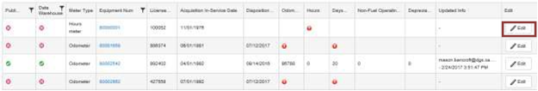
Edit button is available within the asset active period (between acquisition in-service date and disposition date).
Click on Edit, open up Odometer, Hours, Days Used, Non Fuel Operating Cost, Depreciation for editing.
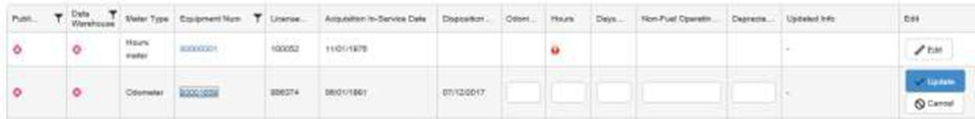
Equipment Num, License Plate, Disposition Date, Acquisition in-Service Date are not editable in the usage update screen.
- Those fields can be edited through Asset GVI or through FI$Cal.

5.2.5. Equipment Usage History
Click on the equipment number to open up equipment usage history page to update usage record.
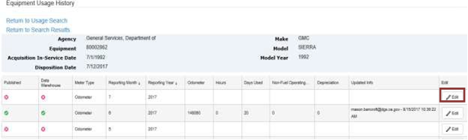
- Usage history screen lists all the required reporting month/year to allow user to insert missing month usage data.
- Click on Edit, Odometer, Hours, Days Used, Non Fuel Operating Cost and Depreciation are open for editing.
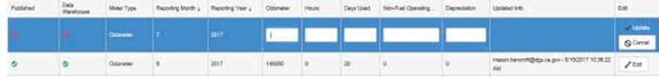

5.2.6. Usage Upload
Navigation: log in as department user Fleet Management Usage Upload
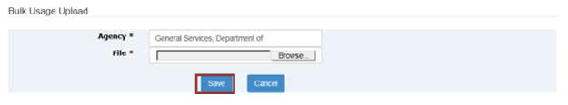
- Browse to location of file (local or network) and click save to perform bulk upload.
- The file is required in csv format and follow the export template.
  - Refer to Appendix 2 for usage data layout spec.
- If the upload file contains invalid format or fails the following minimal validation rules, or duplicate equipment number, error message will display.
  - Equipment Number: Alphanumeric value plus dash, space, period and slash.
  - Model Year: Must be a numeric value between 1900 and 2099.
  - Reporting Year: Must be a numeric value between 1900 and 2099.
  - Reporting Month: A value between 1 and 12.
  - Odometer Reading: A numeric value.
  - Hours Meter Reading: A numeric value.
  - Days Used: A numeric value
  - Non Fuel Operating Cost: A numeric value.
  - Depreciation: A numeric value.
- Bulk upload file error message follows 2 step error sequence:
  - Layout mismatch.
  - Minimal data value validation & duplicate equipment number check.
If usage bulk upload file contains both layout and invalid data value or duplicates, you need to perform bulk upload twice to identify all the errors.
Sample error messages:
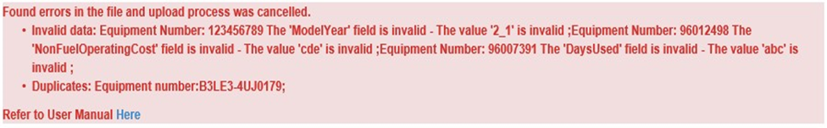
If the file is uploaded successfully, informational message will display as below example:
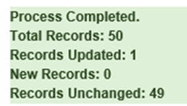
New records: any new usage record in bulk upload file.
Records updated: any changes under existing usage record in bulk upload file.
- Tips for usage bulk upload through export file
Step 1: Export usage records
Step 2: Open the file
Step 3: Edit records as necessary
Warning: following fields data is extracted from asset record and should not be edited in bulk upload file.
EquipmentNum VIN ModelYear Make Model LicensePlateNum
Step 4: Remove all other records that do not need to be changed
Step 5: Save the change into local file in csv
Warning: For the fields with numeric value, from 12th character excel will convert the number into scientific notation as below example.
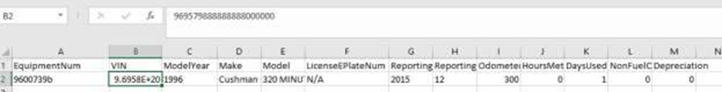
To avoid scientific notation for numeric value, you can add =”xxxx” as below example.
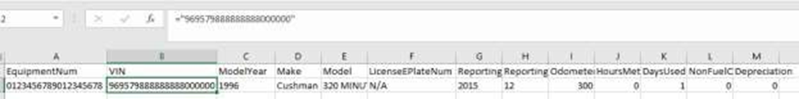

Don’t open the file after save. Excel will remove the leading 0. If you do open the file after save, please check the fields with numeric value, such as equipment number to add leading 0 as following screen shot.
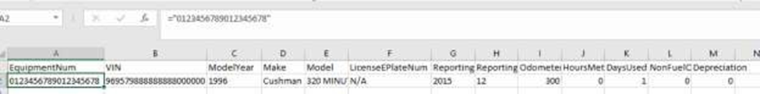

5.2.7. Usage update Tips
- Leverage bulk upload to clean usage data based on FAMS Web Portal - Data Entry Validation Matrix in Appendix 1.
- Utilize usage history screen to view inconsistent usage records with error indicator.
  - Multiple usage records update might be required to fix one specific record.
  - Start from first error record and update upwards in usage history screen
- Web screen usage update case study
Below example shows 9/2008 usage record is published because the data value is valid comparing to 8/2008 and 10/2008 based on data entry validation matrix. However, in order to fix 8/2008 data, it is necessary to edit 9/2008 data to be consistent with previous usage records instead of previous month record.
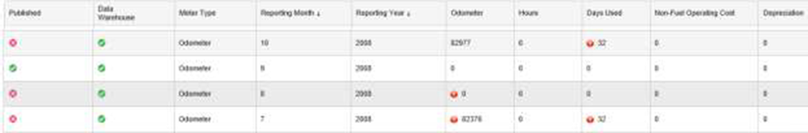

Bulk upload process should be used for below example with multiple records update.

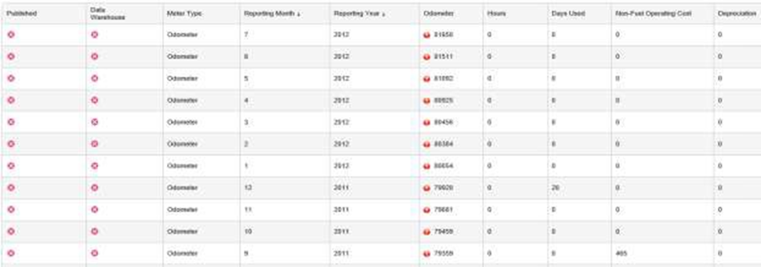

5.3. Agency Fuel

5.3.1. Fuel Search
Navigation: Log in as department user Fleet Management Fuel Search
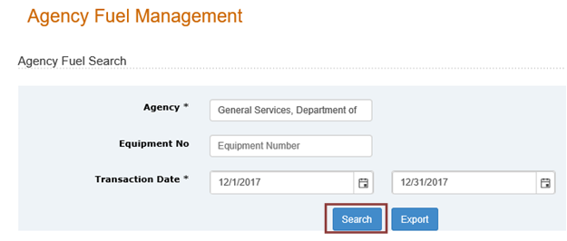
- Agency and transaction date are required. Equipment No help narrow down the search.
- Click on ‘Search’ button after entering search criteria will perform search and return results in GVI.
- Fuel search will only display agency bulk fuel in GVI.

5.3.2. Fuel Export
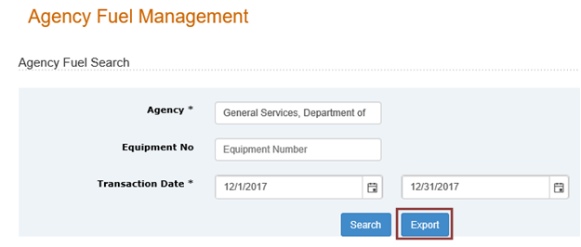
- Enter search criteria.
- Click on ‘Export’ button to export the search results into csv file.
- Save the file to any location (local or network).

5.3.3. Fuel Search Results
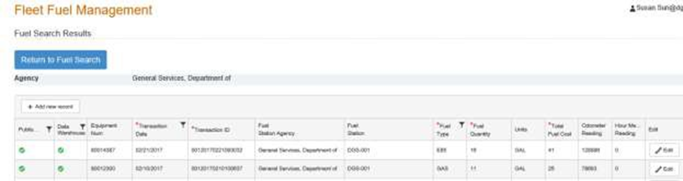
- Click on filter icon to open up the filter box for Published, Data Warehouse, Transaction Date, and Fuel Type.
- When you get an error warning icon (Red circle with exclamation point mark), hover over it to populate the error message.
- Published and Data Warehouse indicators are only available in web screen and will NOT be included in export file.
- Click on “Return to Fuel Search” link will open Usage Search screen.
Fuel GVI Indicators Condition Matrix
Indicator | Condition | Icon | Tooltip (text displayed when user’s mouse hover over icon)
Published | Fuel update meets all the validation rules and ready to be inserted into data warehouse |  | Yes
Published | Fuel update does not meet all the validation rules and cannot be inserted into data warehouse |  | No
Data Warehouse | Fuel update is inserted into data warehouse after ETL run at 12:00am and 12:00pm and will be included in the reports |  | Yes
Data Warehouse | Fuel update is not inserted into data warehouse and will not be included in the reports |  | No

5.3.4. Fuel Insert
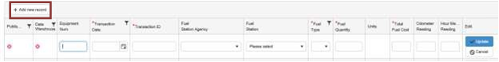
- Click on ‘Add new record’ button and new row is added to top for new fuel record data entry.
- Required fields are labeled with * (Red asterisk)

5.3.5. Fuel Update
- Click the edit on existing record, all fields open up for edits.
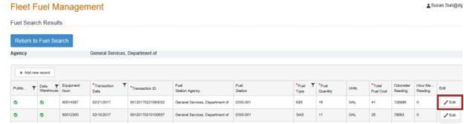
- Click on update to save the change.
- Click on cancel to discard the change.

5.3.6. Fuel Upload
Navigation: Log in as department user Fleet Management Fuel Bulk Upload
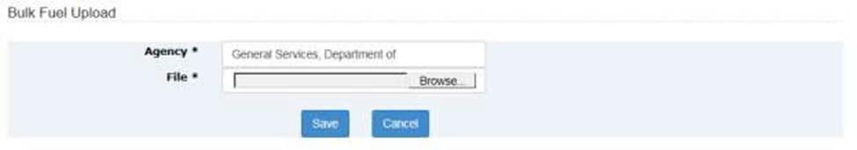
- Browse to location of file (local or network) and click save to perform bulk upload.
- The file is required in csv format and follow the export template.
  - Refer to Appendix 2 for agency fuel data layout spec.
- If the upload file contains invalid format or fails following minimal validation rules, or duplicate transaction ID, error message will display.
  - Equipment Number: Alphanumeric value plus dash, space, period and slash.
  - Transaction Date: A valid date (month/day/year).
  - Fuel Quantity: A numeric value.
  - Total Fuel Cost: A numeric value.
  - Odometer Reading: A numeric value.
  - Hours Meter Reading: A numeric value.
- Bulk upload file error message follows 2 steps error sequence:
  - Layout mismatch;
  - Minimal data value validation & duplicate transaction ID check
- If Fuel bulk upload file contains both layout and invalid data value or duplicates, you need to perform bulk upload twice to identify all the errors.
Sample error messages:
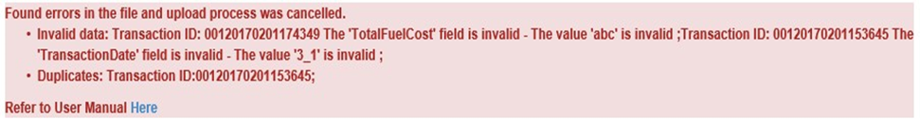
- If file is uploaded successfully, informational message will display as below example:
New records: any new transaction ID in bulk upload file.
Records updated: any changes under existing transaction ID.
- Tips for fuel bulk upload through export file
Step 1: Export fuel records
Step 2: Open the file
Step 3: Edit records as necessary
Step 4: Remove all other non-change records
Step 5: Save the change into local file in csv
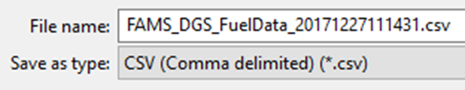
Warning: For the fields with numeric value, from 12th character excel will convert the number into scientific notation as below example.
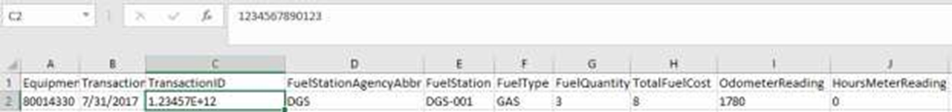

To avoid scientific notation for numeric value, you can add =”xxxx” as below example.
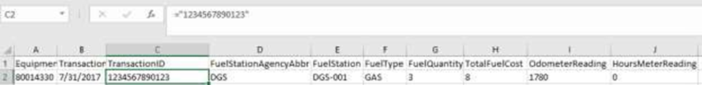
Don’t open the file after save. Excel will remove the leading 0. If you do open the file after save, please check the fields with numeric value, such as transaction ID to add leading 0 as following screen shot.
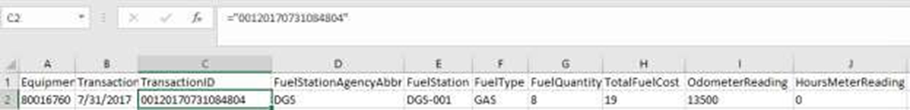
Step 6: Perform bulk upload

6. Reports
These reports allow agencies to access reports for their agency data. Required fields are labeled with * (asterisk).

6.1. Report Criteria Screen

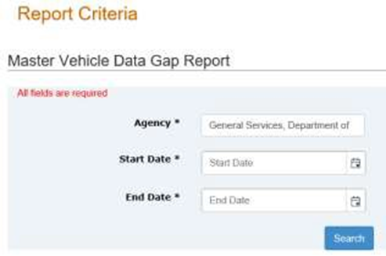

6.2. Report Result Page
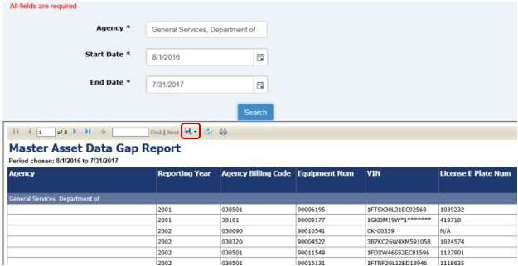
- Click on blue forward icon to view the next page or click on blue reverse icon to view the previous page.
- Click on blue forward to the end icon to view the last page or click on blue reverse to the beginning icon to view the first page.
- Click on the green arrow icon to export the report to excel.

7. Documentation

7.1. Bulk Upload Template
Asset, Usage and Fuel Bulk Upload CSV file template. For more information on the bulk upload file specification, refer to appendix 2.

8. Support
Clicking “Contact Us” will generate outlook email to FAMSSupport@dgs.ca.gov

