DSA Code Amendment development

Tracking
Date Received: -
DSA Tracking Number: N/A
Date Reviewed: 6/24/2019
Status: Under consideration

Applicable Code
Applicable Code Section(s):CBC Ch. 1, Scope and Administration
Topic: Public housing

Current Code Language
1.9.1.3 Application ─ public housing and private housing available for public use. See Government Code Sections 4450 and 12955.1(c).

Suggested Text of Proposed Amendment
1.9.1.3 Application ─ public housing. and private housing available for public use. See Government Code Sections 4450 and Section 12955.1(c) and the definition for public housing in Chapter 2.

Code Text if Adopted
1.9.1.3 Application ─ public housing. See Government Code Section 12955.1(c) and the definition for public housing in Chapter 2.

Rationale
DSA is proposing to amend this section to delete the term “private housing available for public use” and the reference to GC § 4450 for the following reasons:
- Section 4450 states “all buildings, structures, sidewalks, curbs, and related facilities, constructed in this state by the use of state, county, or municipal funds, or the funds of any political subdivision of the state shall be accessible to and usable by persons with disabilities”.
- Section 4451 states “this chapter shall be limited in its application to all buildings and facilities stated in Section 4450 intended for use by the public, with any reasonable availability to, or usage by, persons with disabilities, including all facilities used for education and instruction, including the University of California, the California State University, and the various community college districts, that are constructed in whole or in part by the use of state, county, or municipal funds, or the funds of any political subdivision of the state”.
- The application of these Government Code sections and the term “private housing available for public use” creates confusion for code users when determining the application of Chapter 11B to public housing. Code users typically understand “private housing available for public use” to be one of the types of housing regulated as a place of public accommodation. Those types of housing are social service center establishments, transient lodging and housing at a place of education and Section 1.9.1.2 Application is the appropriate citation.
- In the context of the definition of public housing and the application of Chapter 11B receipt of public funds is one of any number of methods that a public entity may use in the administration of a public housing program. Citing § 4450 creates confusion for code users who interpret the application to only apply to facilities that receive public funds.
- The more specific Government Code Section for the application cited in § 1.9.1.3 is § 12955.1(c) which states “regulations adopting building standards necessary to implement, interpret, or make specific the provisions of this section shall be developed by the Division of the State Architect for public housing”.
This code change proposal is intended to provide consistency and clarity for code users when applying Chapter 11B to public housing projects. This item was removed for consideration during the 2018 rulemaking cycle at recommendation of the Code Advisory Committee in order for DSA to request an opinion from Department of General Services (DGS) legal counsel. DSA requested an opinion from DGS, Office of Legal Services and received this analysis and conclusion.
Analysis of Amendment. The rationale for this amendment is largely to bring the CBC Ch. 11B in line with historic interpretation and application of Chapter 11B to “public housing”, a defined term. This revision clarifies the application of the proper government code reference for public housing from GC §12955.1(c). The continued citation of GC §4450 confuses the application of GC §12955.1(c) to private housing for public accommodation, a different type of housing. Repealing the reference to GC §4450 would not allow for DSA to provide a lesser standard of accessibility than that required by federal regulations and standards, since this change is not substantive. This change only clarifies the scope of application, to be consistent with DSA policy and California statute. Greater or equal protection than the federal standards is required by GC §12955.1(c), and is not affected by this amendment. The proposed amendment seeks only to clarify its application to “public housing”, a defined term in the regulations.
Conclusion. This amendment does not affect any substantive accessibility standard, so it does not enhance or diminish accessibility.

DSA Comments:
N/A

DSA Code Amendment development

Tracking
Date Received: -
DSA Tracking Number: N/A
Date Reviewed: 6/24/2019
Status: Under consideration

Applicable Code
Applicable Code Section(s):CBC Chapter 2, Definitions
Topic: Bottle filling station

Current Code Language
This definition is from CBC Part 5 of the Plumbing Code, Chapter 2 Definitions. Bottle Filling Station. A plumbing fixture connected to the potable water distribution system and sanitary drainage system that is designed and intended for filling personal use drinking water bottles or containers not less than 10 inches (254 mm) in height. Such fixtures can be separate from or integral to a drinking fountain and can incorporate a water filter and a cooling system for chilling the drinking fountain.

Suggested Text of Proposed Amendment
Bottle Filling Station. A plumbing fixture connected to the potable water distribution system and sanitary drainage system that is designed and intended for filling personal use drinking water bottles or containers not less than 10 inches (254 mm) in height. Such fixtures can be separate from or integral to a drinking fountain. and can incorporate a water filter and a cooling system for chilling the drinking fountain.

Code Text if Adopted
Bottle Filling Station. A fixture that is designed and intended for filling personal use drinking water bottles or containers. Such fixtures can be separate from or integral to a drinking fountain.

Rationale
DSA is proposing to provide a definition in Chapter 2 for bottle filling stations based on the definition currently in the plumbing code. The language in the definition from the plumbing code that is not included in the proposed code change is better suited to the plumbing code requirements and is unnecessary in the definition proposed for inclusion in Chapter 2 related to accessibility. This code proposed change is related to proposed amendments in Sections 11B-211.4 and 11B-602.10.

DSA Comments
N/A

DSA Code Amendment development

Tracking
Date Received: -
DSA Tracking Number: N/A
Date Reviewed: 6/24/2019
Status: Under consideration

Applicable Code
Applicable Code Section(s):CBC Chapter 2 Definitions
Topic: Definition of PRIMARY FUNCTION

Current Code Language
N/A

Suggested Text of Proposed Amendment
Primary function. A “primary function” is a major activity for which the facility is intended. Areas that contain a primary function include, but are not limited to, the dining area of a cafeteria, the meeting rooms in a conference center, as well as offices and other work areas in which the activities of the entity using the facility are carried out. Mechanical rooms, boiler rooms, supply storage rooms, employee lounges or locker rooms, janitorial closets, entrances, and corridors are not areas containing a primary function. Restrooms are not areas containing a primary function unless the provision of restrooms is a primary purpose of the area, e.g., in highway rest stops.

Code Text if Adopted
Primary function. A “primary function” is a major activity for which the facility is intended. Areas that contain a primary function include, but are not limited to, the dining area of a cafeteria, the meeting rooms in a conference center, as well as offices and other work areas in which the activities of the entity using the facility are carried out. Mechanical rooms, boiler rooms, supply storage rooms, employee lounges or locker rooms, janitorial closets, entrances, and corridors are not areas containing a primary function. Restrooms are not areas containing a primary function unless the provision of restrooms is a primary purpose of the area, e.g., in highway rest stops.

Rationale
CBC Section 11B-202.4 Exception 10 uses the term “primary function” to distinguish between alterations solely for the purpose of installing electric vehicle charging stations at facilities that are required or not required to provide a path of travel. However, “primary function” is not defined in the CBC. DSA-AC proposes to add a new definition of primary function consistent with the definitions provided in the ADA Standards for Accessible Design for Title II and III facilities.

DSA Comment
- 2010 ADAS 28 CFR Part 35, § 35.151(b)(4)(i):
(i) Primary function. A “primary function” is a major activity for which the facility is intended. Areas that contain a primary function include, but are not limited to, the dining area of a cafeteria, the meeting rooms in a conference center, as well as offices and other work areas in which the activities of the public entity using the facility are carried out.
(A) Mechanical rooms, boiler rooms, supply storage rooms, employee lounges or locker rooms, janitorial closets, entrances, and corridors are not areas containing a primary function. Restrooms are not areas containing a primary function unless the provision of restrooms is a primary purpose of the area, e.g., in highway rest stops.
(B) For the purposes of this section, alterations to windows, hardware, controls, electrical outlets, and signage shall not be deemed to be alterations that affect the usability of or access to an area containing a primary function.
- 2010 ADAS 28 CFR Part 36, Subpart D, § 36.403(b):
(b) Primary function. A “primary function” is a major activity for which the facility is intended. Areas that contain a primary function include, but are not limited to, the customer services lobby of a bank, the dining area of a cafeteria, the meeting rooms in a conference center, as well as offices and other work areas in which the activities of the public accommodation or other private entity using the facility are carried out. Mechanical rooms, boiler rooms, supply storage rooms, employee lounges or locker rooms, janitorial closets, entrances, corridors, and restrooms are not areas containing a primary function.
- 2010 ADAS Advisory 202.4 Alterations Affecting Primary Function Areas.
An area of a building or facility containing a major activity for which the building or facility is intended is a primary function area. Department of Justice ADA regulations state, “Alterations made to provide an accessible path of travel to the altered area will be deemed disproportionate to the overall alteration when the cost exceeds 20% of the cost of the alteration to the primary function area.” (28 CFR 36.403 (f)(1)). See also Department of Transportation ADA regulations, which use similar concepts in the context of public sector transportation facilities (49 CFR 37.43 (e)(1)).
There can be multiple areas containing a primary function in a single building. Primary function areas are not limited to public use areas. For example, both a bank lobby and the bank’s employee areas such as the teller areas and walk-in safe are primary function areas.
Also, mixed use facilities may include numerous primary function areas for each use. Areas containing a primary function do not include: mechanical rooms, boiler rooms, supply storage rooms, employee lounges or locker rooms, janitorial closets, entrances, corridors, or restrooms.

DSA Code Amendment development

Tracking
Date Received: -
DSA Tracking Number: N/A
Date Reviewed: 6/24/2019
Status: Under Consideration

Applicable Code
Applicable Code Section(s):CBC Ch. 11B, 11B-203.8
Topic: Scoping

Current Code Language
11B-203.8 Residential facilities. In residential facilities, common use areas that do not serve residential dwelling units required to provide mobility features complying with Sections 11B-809.2 through 11B-809.4 and adaptable features complying with Chapter 11A, Division IV shall not be required to comply with these requirements or to be on an accessible route.

Suggested Text of Proposed Amendment
11B-203.8 Residential facilities. In residential facilities, common use areas that do not serve residential dwelling units required to provide mobility features complying with Sections 11B-809.2 through 11B-809.4 and or adaptable features complying with Chapter 11A, Division IV Sections 11B-809.6 through 11B-809.12 shall not be required to comply with these requirements or to be on an accessible route.

Code Text if Adopted
11B-203.8 Residential facilities. In residential facilities, common use areas that do not serve residential dwelling units required to provide mobility features complying with Sections 11B-809.2 through 11B-809.4 or adaptable features complying with Sections 11B-809.6 through 11B-809.12 shall not be required to comply with these requirements or to be on an accessible route.

Rationale
DSA is proposing to amend this section to delete the reference to Chapter 11A. The features for the dwelling units in public housing facilities that DSA currently adopts in Chapter 11A have been revised and reformatted for consistency with the numbering and format used in Chapter 11B. Sections 11B-809.6 through 11B-809.12 are the sections that contain those revisions that are included as part of an overall package of public housing code change proposals. In addition, “and” is proposed for revision to “or” so that the provisions in this section apply when either type of unit is provided. As written, with “and” in the section the provisions apply only when both types of units are provided.

DSA Comments
N/A

DSA Code Amendment development

Tracking
Date Received: -
DSA Tracking Number: N/A
Date Reviewed: 6/24/2019
Status: Under consideration

Applicable Code
Applicable Code Section(s):CBC Ch. 11B, 11B-205.1
Topic: Electrical Outlets

Current Code Language
11B-205.1 General. Operable parts on accessible elements, accessible routes, and in accessible rooms and spaces shall comply with Section 11B-309.
Exceptions:
1. Operable parts that are intended for use only by service or maintenance personnel shall not be required to comply with Section 11B-309.
2. Electrical or communication receptacles serving a dedicated use shall not be required to comply with Section 11B-309.
3. Reserved.
4. Floor electrical receptacles shall not be required to comply with Section 11B-309.
5. HVAC diffusers shall not be required to comply with Section 11B-309.
6. Except for light switches, where redundant controls are provided for a single element, one control in each space shall not be required to comply with Section 11B-309.
7. Cleats and other boat securement devices shall not be required to comply with Section 11B-309.3.
8. Exercise machines and exercise equipment shall not be required to comply with Section 11B-309.

Suggested Text of Proposed Amendment
11B-205.1 General. Operable parts on accessible elements, accessible routes, and in accessible rooms and spaces shall comply with Section 11B-309.
Exceptions:
1. Operable parts that are intended for use only by service or maintenance personnel shall not be required to comply with Section 11B-309.
2. Electrical or communication receptacles serving a dedicated use shall not be required to comply with Section 11B-309.
3. Reserved. 3. Where two or more outlets are provided in a kitchen above a length of counter top that is uninterrupted by a sink or appliance, one outlet shall not be required to comply with 11B-309.
4. Floor electrical receptacles shall not be required to comply with Section 11B-309.
5. HVAC diffusers shall not be required to comply with Section 11B-309.
6. Except for light switches, where redundant controls are provided for a single element, one control in each space shall not be required to comply with Section 11B-309.
7. Cleats and other boat securement devices shall not be required to comply with Section 11B-309.3.
8. Exercise machines and exercise equipment shall not be required to comply with Section 11B-309.

Code Text if Adopted

11B-205.1 General. Operable parts on accessible elements, accessible routes, and in accessible rooms and spaces shall comply with Section 11B-309.
Exceptions:
1. Operable parts that are intended for use only by service or maintenance personnel shall not be required to comply with Section 11B-309.
2. Electrical or communication receptacles serving a dedicated use shall not be required to comply with Section 11B-309.
3. Where two or more outlets are provided in a kitchen above a length of counter top that is uninterrupted by a sink or appliance, one outlet shall not be required to comply with 11B-309.
4. Floor electrical receptacles shall not be required to comply with Section 11B-309.
5. HVAC diffusers shall not be required to comply with Section 11B-309.
6. Except for light switches, where redundant controls are provided for a single element, one control in each space shall not be required to comply with Section 11B-309.
7. Cleats and other boat securement devices shall not be required to comply with Section 11B-309.3.
8. Exercise machines and exercise equipment shall not be required to comply with Section 11B-309.

Rationale
DSA is proposing this code change to alleviate the conflict between the electrical code and Chapter 11B for the placement of electrical outlets and access compliance. The outlet locations required by the electrical code create a conflict with complying with the reach ranges in Section 11B-308. This proposed code change also aligns Chapter 11B with the 2010 ADAS.

DSA Comments
N/A

DSA Code Amendment development

Tracking
Date Received: -
DSA Tracking Number: N/A
Date Reviewed: 6/24/2019
Status: Under consideration

Applicable Code
Applicable Code Section(s):CBC Ch. 11B, 11B-206.2.3
Topic: Scoping

Current Code Language
11B-206.2.3 Multi-story buildings and facilities. At least one accessible route shall connect each story and mezzanine in multi-story buildings and facilities.
Exceptions:
4. In residential facilities, an accessible route shall not be required to connect stories where residential dwelling units with mobility features required to comply with Sections 11B-809.2 through 11B-809.4, residential dwelling units with adaptable features complying with Chapter 11A, Division IV, all common use areas serving residential dwelling units with mobility features required to comply with Sections 11B-809.2 through 11B-809.4, all common use areas serving residential dwelling units with adaptable features complying with Chapter 11A, Division IV, and public use areas serving residential dwelling units are on an accessible route.

Suggested Text of Proposed Amendment
11B-206.2.3 Multi-story buildings and facilities. At least one accessible route shall connect each story and mezzanine in multi-story buildings and facilities.
Exceptions:
4. In residential facilities, an accessible route shall not be required to connect stories where residential dwelling units with mobility features required to comply with Sections 11B-809.2 through 11B-809.4, residential dwelling units with adaptable features complying with Chapter 11A, Division IV, Sections 11B-809.6 through 11B-809.12, all common use areas serving residential dwelling units with mobility features required to comply with Sections 11B-809.2 through 11B-809.4, all common use areas serving residential dwelling units with adaptable features complying with Chapter 11A, Division IV Sections 11B-809.6 through 11B-809.12, and public use areas serving residential dwelling units are on an accessible route.

Code Text if Adopted
11B-206.2.3 Multi-story buildings and facilities. At least one accessible route shall connect each story and mezzanine in multi-story buildings and facilities.
Exceptions:
4. In residential facilities, an accessible route shall not be required to connect stories where residential dwelling units with mobility features required to comply with Sections 11B-809.2 through 11B-809.4, residential dwelling units with adaptable features complying with Sections 11B-809.6 through 11B-809.12, all common use areas serving residential dwelling units with mobility features required to comply with Sections 11B-809.2 through 11B-809.4, all common use areas serving residential dwelling units with adaptable features complying with Sections 11B-809.6 through 11B-809.12, and public use areas serving residential dwelling units are on an accessible route.

Rationale
DSA is proposing to amend this section to delete the reference to Chapter 11A. The features for the dwelling units in public housing facilities that DSA currently adopts in Chapter 11A have been revised and reformatted for consistency with the numbering and format used in Chapter 11B. Sections 11B-809.6 through 11B-809.12 are the sections that contain those revisions that are included as part of an overall package of public housing code change proposals.

DSA Comments
N/A

DSA Code Amendment development

Tracking
Date Received: -
DSA Tracking Number: N/A
Date Reviewed: 6/24/2019
Status: Under consideration

Applicable Code
Applicable Code Section(s):CBC Ch. 11B, 11B-206.7.6
Topic: Scoping

Current Code Language
11B-206.7.6 Guest rooms and residential dwelling units. Platform lifts shall be permitted to connect levels within transient lodging guest rooms required to provide mobility features complying with Section 11B-806.2 or residential dwelling units required to provide mobility features complying with Sections 11B-809.2 through 11B-809.4 and adaptable features complying with Chapter 11A, Division IV.

Suggested Text of Proposed Amendment
11B-206.7.6 Guest rooms and residential dwelling units. Platform lifts shall be permitted to connect levels within transient lodging guest rooms required to provide mobility features complying with Section 11B-806.2 or residential dwelling units required to provide mobility features complying with Sections 11B-809.2 through 11B-809.4 and or adaptable features complying with Chapter 11A, Division IV. Sections 11B-809.6 through 11B-809.12.

Code Text if Adopted

11B-206.7.6 Guest rooms and residential dwelling units. Platform lifts shall be permitted to connect levels within transient lodging guest rooms required to provide mobility features complying with Section 11B-806.2 or residential dwelling units required to provide mobility features complying with Sections 11B-809.2 through 11B-809.4 or adaptable features complying with Sections 11B-809.6 through 11B-809.12.

Rationale
DSA is proposing to amend this section to delete the reference to Chapter 11A. The features for the dwelling units in public housing facilities that DSA currently adopts in Chapter 11A have been revised and reformatted for consistency with the numbering and format used in Chapter 11B. Sections 11B-809.6 through 11B-809.12 are the sections that contain those revisions that are included as part of an overall package of public housing code change proposals. In addition, “and” is proposed for revision to “or” so that the provisions in this section apply when either type of unit is provided.

DSA Comments
N/A

DSA Code Amendment development

Tracking
Date Received: -
DSA Tracking Number: N/A
Date Reviewed: 6/24/2019
Status: Under consideration

Applicable Code
Applicable Code Section(s):CBC Ch. 11B, 11B-208.1
Topic: Scoping for parking spaces and electric vehicle chargers

Current Code Language
11B-208.1 General. Where parking spaces are provided, parking spaces shall be provided in accordance with Section 11B-208. For the purposes of this section, electric vehicle charging stations are not parking spaces; see Section 11B-228.
Exception: Parking spaces used exclusively for buses, trucks, other delivery vehicles, or vehicular impound shall not be required to comply with Section 11B-208 provided that lots accessed by the public are provided with a passenger drop-off and loading zone complying with Section 11B-503.

Suggested Text of Proposed Amendment
11B-208.1 General. Where parking spaces are provided, parking spaces shall be provided in accordance with Section 11B-208. For the purposes of this section, electric vehicle charging stations are not parking spaces; see Section 11B-228.
Exception: Exceptions:
1. Parking spaces used exclusively for buses, trucks, other delivery vehicles, or vehicular impound shall not be required to comply with Section 11B-208 provided that lots accessed by the public are provided with a passenger drop-off and loading zone complying with Section 11B-503.
2. In public housing facilities, electric vehicle chargers are permitted to be installed at an accessible parking space assigned to the resident.

Code Text if Adopted
11B-208.1 General. Where parking spaces are provided, parking spaces shall be provided in accordance with Section 11B-208. For the purposes of this section, electric vehicle charging stations are not parking spaces; see Section 11B-228.
Exceptions:
1. Parking spaces used exclusively for buses, trucks, other delivery vehicles, or vehicular impound shall not be required to comply with Section 11B-208 provided that lots accessed by the public are provided with a passenger drop-off and loading zone complying with
Section 11B-503.
2. In public housing facilities, electric vehicle chargers are permitted to be installed at an accessible parking space assigned to the resident.

Rationale
DSA is proposing to amend this section to allow for the installation of an electric vehicle charger when an accessible parking space is assigned to the resident. This code change proposal provides for a resident to use their parking space to charge a vehicle without having the inconvenience of charging their vehicle at one location and then having to move the vehicle to park.

DSA Comments
N/A

DSA Code Amendment development

Tracking
Date Received: -
DSA Tracking Number: N/A
Date Reviewed: 6/24/2019
Status: Under consideration

Applicable Code
Applicable Code Section(s):CBC Ch. 11B, 11B-208.2.3
Topic: Scoping for parking spaces

Current Code Language
11B-208.2.3 Residential facilities. Parking spaces provided to serve residential facilities shall comply with Section 11B-208.2.3.
11B-208.2.3.1 Parking for residents. Where at least one parking space is provided for each residential dwelling unit, at least one parking space complying with Section 11B-502 shall be provided for each residential dwelling unit required to provide mobility features complying with Sections 11B-809.2 through 11B-809.4. Where fewer than one parking space is provided for each residential dwelling unit, parking spaces complying with Section 11B-502 shall be provided in accordance with Table 11B-208.2.
11B-208.2.3.2 Additional parking spaces for residents.
11B-208.2.3.3 Parking for guests, employees, and other non-residents.
NOTE: When assigned parking is provided, Chapter 11A indicates designated accessible parking for the adaptable residential dwelling units shall be provided on requests of residents with disabilities on the same terms and with the full range of choices (e.g., off-street parking, carport or garage) that are available to other residents.

Suggested Text of Proposed Amendment
11B-208.2.3 Residential facilities. Parking spaces provided to serve residential facilities shall comply with Section 11B-208.2.3.
11B-208.2.3.1 Parking for residents.
11B-208.2.3.2 Additional parking spaces for residents.
11B-208.2.3.3 Parking for guests, employees, and other non-residents.
NOTE: When assigned parking is provided, Chapter 11A indicates designated accessible parking for the adaptable residential dwelling units shall be provided on requests of residents with disabilities on the same terms and with the full range of choices (e.g., off-street parking, carport or garage) that are available to other residents.
NOTE: When accessible parking spaces are assigned to a resident, additional accessible parking may be required on requests of residents with disabilities on the same terms and with the full range of choices (e.g., off-street parking, carport or garage) that are available to other residents.

Code Text if Adopted
11B-208.2.3 Residential facilities. Parking spaces provided to serve residential facilities shall comply with Section 11B-208.2.3.
11B-208.2.3.1 Parking for residents.
11B-208.2.3.2 Additional parking spaces for residents.
11B-208.2.3.3 Parking for guests, employees, and other non-residents.
NOTE: When accessible parking spaces are assigned to a resident, additional accessible parking may be required on requests of residents with disabilities on the same terms and with the full range of choices (e.g., off-street parking, carport or garage) that are available to other residents.

Rationale
DSA is proposing to amend this section to delete the reference to Chapter 11A as part of an overall package of public housing code change proposals that if approved would make Chapter 11B a standalone chapter. Therefore, the reference to Chapter 11A in the note would no longer be necessary.

DSA Comments
N/A

DSA Code Amendment development

Tracking
Date Received: -
DSA Tracking Number: N/A
Date Reviewed: 6/24/2019
Status: Under consideration

Applicable Code
Applicable Code Section(s):CBC Ch. 11B, 11B-208.3.2
Topic: Scoping

Current Code Language
11B-208.3.2 Residential facilities. In residential facilities containing residential dwelling units required to provide mobility features complying with Sections 11B-809.2 through 11B-809.4, and adaptable features complying with Chapter 11A, Division IV parking spaces provided in accordance with Section 11B-208.2.3.1 shall be located on the shortest accessible route to the residential dwelling unit entrance they serve. Spaces provided in accordance with Section 11B-208.2.3.2 shall be dispersed throughout all types of parking provided for the residential dwelling units.

Suggested Text of Proposed Amendment
11B-208.3.2 Residential facilities. In residential facilities containing residential dwelling units required to provide mobility features complying with Sections 11B-809.2 through 11B-809.4, and adaptable features complying with Chapter 11A, Division IV Sections 11B-809.6 through 11B-809.12 parking spaces provided in accordance with Section 11B-208.2.3.1 shall be located on the shortest accessible route to the residential dwelling unit entrance they serve. Spaces provided in accordance with Section 11B-208.2.3.2 shall be dispersed throughout all types of parking provided for the residential dwelling units.

Code Text if Adopted
11B-208.3.2 Residential facilities. In residential facilities containing residential dwelling units required to provide mobility features complying with Sections 11B-809.2 through 11B-809.4, and adaptable features complying with Sections 11B-809.6 through 11B-809.12 parking spaces provided in accordance with Section 11B-208.2.3.1 shall be located on the shortest accessible route to the residential dwelling unit entrance they serve. Spaces provided in accordance with Section 11B-208.2.3.2 shall be dispersed throughout all types of parking provided for the residential dwelling units.

Rationale
DSA is proposing to amend this section to delete the reference to Chapter 11A. The features for the dwelling units in public housing facilities that DSA currently adopts in Chapter 11A have been revised and reformatted for consistency with the numbering and format used in Chapter 11B. Sections 11B-809.6 through 11B-809.12 are the sections that contain those revisions that are included as part of an overall package of public housing code change proposals.

DSA Comments
N/A

DSA Code Amendment development

Tracking
Date Received: -
DSA Tracking Number: N/A
Date Reviewed: 6/24/2019
Status: Under consideration

Applicable Code
Applicable Code Section(s):11B-211.4
Topic: Bottle filling stations

Current Code Language
11B-211 Drinking fountains11B-211.1 General.

Suggested Text of Proposed Amendment
11B-211 Drinking fountains and bottle filling stations11B-211.1 General.
11B-211.4 Bottle filling stations. Where bottle filling stations are provided they shall comply with Section 11B-602.10. Exception: In detention or correctional facilities, bottle filling stations only serving holding or housing cells not required to comply with Section 11B-232 shall not be required to comply with Section 11B-211.4.

Code Text if Adopted
11B-211 Drinking fountains and bottle filling stations11B-211.1 General.
11B-211.4 Bottle filling stations. Where bottle filling stations are provided they shall comply with Section 11B-602.10. Exception: In detention or correctional facilities, bottle filling stations only serving holding or housing cells not required to comply with Section 11B-232 shall not be required to comply with Section 11B-211.4.

Rationale
DSA is proposing this code change in response to requests from code users and facility owners. Bottle filling station provisions are addressed in the plumbing code and currently there are no specific provisions for accessibility for this type of fixture in Chapter 11B. This proposed code change specifically addresses bottle filling stations and the scoping provisions to provide for access compliance.

DSA Comments
N/A

DSA Code Amendment development

Tracking
Date Received: -
DSA Tracking Number: N/A
Date Reviewed: 6/24/2019
Status: Under consideration

Applicable Code
Applicable Code Section(s):CBC Ch. 11B, 11B-224.8
Topic: Social Service Center Establishments

Current Code Language
11B-224.8 Social service center establishments. Group homes, halfway houses, shelters, or similar social service center establishments that provide either temporary sleeping accommodations or residential dwelling units subject to this section shall comply with Sections 11B-224.1 through 11B-224.6 and Section 11B-233.3.

Suggested Text of Proposed Amendment
11B-224.8 Social service center establishments. Group homes, halfway houses, shelters, or similar social service center establishments that provide either temporary sleeping accommodations or residential dwelling units subject to this section shall comply with Sections 11B-224.1 through 11B-224.6 and Section 11B-233.3.

Code Text if Adopted
11B-224.8 Social service center establishments. Group homes, halfway houses, shelters, or similar social service center establishments that provide either temporary sleeping accommodations or residential dwelling units subject to this section shall comply with Section 11B-233.3.

Rationale
DSA is proposing to repeal the adoption of Sections of 11B-224.1 through 11B-224.6 that create confusion when applying the provisions to social service center establishments. The transient lodging standards do not apply to social service center establishments under the 2010 ADA Standards for Accessible Design or Housing and Urban Development Section 504 Regulations. The proposed code change aligns Chapter 11B with the 2010 ADA Standards for Accessible Design and Housing and Urban Development Section 504 Regulations. In addition, using the scoping Section 11B-233.3 and the technical provisions for residential dwelling units requires features that provide for greater access such as turning spaces within kitchens and the amount of storage required within reach ranges.

DSA Comments
N/A

DSA Code Amendment development

Tracking
Date Received: -
DSA Tracking Number: N/A
Date Reviewed: 6/24/2019
Status: Under consideration

Applicable Code
Applicable Code Section(s):CBC, Ch. 11B, 11B-226.4
Topic: Baby changing tables

Current Code Language
11B-226.4 Baby changing tables. Baby changing tables shall comply with Sections 11B-309 and 11B-902. Baby changing tables when deployed shall not obstruct the required width of an accessible route except as allowed by Section 11B-307.2. Baby changing tables shall not be located in toilet compartments complying with Section 11B-604.8 within a multiple accommodation toilet facility.

Suggested Text of Proposed Amendment
11B-226.4 Baby changing tables. Baby diaper changing station. Baby changing tables Baby diaper changing stations shall comply with Sections 11B-309 and 11B-902. Baby changing tables Baby diaper changing stations when deployed shall not obstruct the required width of an accessible route except as allowed by Section 11B-307.2. Baby changing tables Baby diaper changing stations shall not be located in toilet compartments complying with Section 11B-604.8 within a multiple accommodation toilet facility.

Code Text if Adopted
11B-226.4 Baby diaper changing station. Baby diaper changing stations shall comply with Sections 11B-309 and 11B-902. Baby diaper changing stations when deployed shall not obstruct the required width of an accessible route except as allowed by Section 11B-307.2. Baby diaper changing stations shall not be located in toilet compartments complying with Section 11B-604.8 within a multiple accommodation toilet facility.

Rationale
DSA is proposing to amend this section in order to use the same title for baby diaper changing stations consistent with Government Code § 50535 and 118506 and Health and Safety Code § 118506 in response to a request by a code user. Chapter 11B does not require baby changing tables, however when provided they must be accessible. The Government and Health and Safety Codes require baby diaper changing stations in certain facilities and under certain conditions.

DSA Comments
N/A

DSA Code Amendment development

Tracking
Date Received: -
DSA Tracking Number: N/A
Date Reviewed: 6/24/2019
Status: Under consideration

Applicable Code
Applicable Code Section(s):CBC Ch. 11B, 11B-228.2
Topic: Scoping

Current Code Language
11B-228.2 Mail boxes. Where mail boxes are provided in an interior location, at least 5 percent, but no fewer than one, of each type shall comply with Section 11B-309. In residential facilities, where mail boxes are provided for each residential dwelling unit, mail boxes complying with Section 11B-309 shall be provided for each residential dwelling unit required to provide mobility features complying with Sections 11B-809.2 through 11B-809.4 and adaptable features complying with Chapter 11A, Division IV.

Suggested Text of Proposed Amendment
11B-228.2 Mail boxes. Where mail boxes are provided in an interior location, at least 5 percent, but no fewer than one, of each type shall comply with Section 11B-309. In residential facilities, where mail boxes are provided for each residential dwelling unit, mail boxes complying with Section 11B-309 shall be provided for each residential dwelling unit required to provide mobility features complying with Sections 11B-809.2 through 11B-809.4 and adaptable features complying with Chapter 11A, Division IV. Sections 11B-809.6 through 11B-809.12.

Code Text if Adopted
11B-228.2 Mail boxes. Where mail boxes are provided in an interior location, at least 5 percent, but no fewer than one, of each type shall comply with Section 11B-309. In residential facilities, where mail boxes are provided for each residential dwelling unit, mail boxes complying with Section 11B-309 shall be provided for each residential dwelling unit required to provide mobility features complying with Sections 11B-809.2 through 11B-809.4 and adaptable features complying with Sections 11B-809.6 through 11B-809.12.

Rationale
DSA is proposing to amend this section to delete the reference to Chapter 11A. The features for the dwelling units in public housing facilities that DSA currently adopts in Chapter 11A have been revised and reformatted for consistency with the numbering and format used in Chapter 11B. Sections 11B-809.6 through 11B-809.12 are the sections that contain those revisions that are included as part of an overall package of public housing code change proposals.

DSA Comments
N/A

DSA Code Amendment development

Tracking
Date Received: -
DSA Tracking Number: N/A
Date Reviewed: 6/24/2019
Status: Under consideration

Applicable Code
Applicable Code Section(s):CBC Ch. 11B, 11B-228.3
Topic: Scoping for EVCS in public housing facilities

Current Code Language
11B-228.3.2 Minimum number. EVCS complying with Section 11B-812 shall be provided in accordance with Section 11B-228.3.2. Where EVCS are provided in more than one facility on a site, the number of EVCS complying with Section 11B-228.3.2 provided on the site shall be calculated according to the number required for each facility. Where an EV charger can simultaneously charge more than one vehicle, the number of EV chargers provided shall be considered equivalent to the number of electric vehicles that can be simultaneously charged.
Exceptions:
- EVCS not available to the general public and intended for use by a designated vehicle or driver shall not be required to comply with Section 11B-228.3.2. Examples include, but are not limited to, EVCS serving public or private fleet vehicles and EVCS assigned to an employee.
- In public housing facilities, EVCS intended for use by an EV owner or operator at their residence shall not be required to comply with Section 11B-228.3.2.

Suggested Text of Proposed Amendment
11B-228.3.2 Minimum number. EVCS complying with Section 11B-812 shall be provided in accordance with Section 11B-228.3.2. Where EVCS are provided in more than one facility on a site, the number of EVCS complying with Section 11B-228.3.2 provided on the site shall be calculated according to the number required for each facility. In public housing facilities, EVCS provided for common use of residents shall comply with Section 11B-228.3.2. Where an EV charger can simultaneously charge more than one vehicle, the number of EV chargers provided shall be considered equivalent to the number of electric vehicles that can be simultaneously charged.
Exceptions:
- EVCS not available to the general public and intended for use by a designated vehicle or driver shall not be required to comply with Section 11B-228.3.2. Examples include, but are not limited to, EVCS serving public or private fleet vehicles and EVCS assigned to an employee.
- In public housing facilities, EVCS intended for use by an EV owner or operator at their residence shall not be required to comply with Section 11B-228.3.2. Note: Electric vehicle charging spaces are also subject to the California Green Building Standards Code.

Code Text if Adopted
11B-228.3.2 Minimum number. EVCS complying with Section 11B-812 shall be provided in accordance with Section 11B-228.3.2. Where EVCS are provided in more than one facility on a site, the number of EVCS complying with Section 11B-228.3.2 provided on the site shall be calculated according to the number required for each facility. In public housing facilities, EVCS provided for common use of residents shall comply with Section 11B-228.3.2. Where an EV charger can simultaneously charge more than one vehicle, the number of EV chargers provided shall be considered equivalent to the number of electric vehicles that can be simultaneously charged.
Exceptions:
- EVCS not available to the general public and intended for use by a designated vehicle or driver shall not be required to comply with Section 11B-228.3.2. Examples include, but are not limited to, EVCS serving public or private fleet vehicles and EVCS assigned to an employee.
- In public housing facilities, EVCS intended for use by an EV owner or operator at their residence shall not be required to comply with Section 11B-228.3.2. Note: Electric vehicle charging spaces are also subject to the California Green Building Standards Code.

Rationale
DSA is proposing to amend this section to provide for accessible electric vehicle charging stations to clarify the requirements for EVCS in located in public housing facilities.

DSA Comments
N/A

DSA Code Amendment development

Tracking
Date Received: -
DSA Tracking Number: N/A
Date Reviewed: 6/24/2019
Status: Under consideration

Applicable Code
Applicable Code Section(s):CBC Chapter 11B, Section 11B-228.3.2
Topic: EVCS – Distinct Facilities for Different Charging Levels

Current Code Language
11B-228 Depositories, vending machines, change machines, mail boxes, fuel dispensers, and electric vehicle charging stations.
11B-228.3 Electric vehicle charging stations
11B-228.3.2 Minimum number. EVCS complying with Section 11B-812 shall be provided in accordance with Section 11B-228.3.2. Where EVCS are provided in more than one facility on a site, the number of EVCS complying with Section 11B-228.3.2 provided on the site shall be calculated according to the number required for each facility. Where an EV charger can simultaneously charge more than one vehicle, the number of EV chargers provided shall be considered equivalent to the number of electric vehicles that can be simultaneously charged.
Exceptions:1. EVCS not available

Suggested Text of Proposed Amendment
11B-228 Depositories, vending machines, change machines, mail boxes, fuel dispensers, and electric vehicle charging stations.
11B-228.3 Electric vehicle charging stations
11B-228.3.2 Minimum number. EVCS complying with Section 11B-812 shall be provided in accordance with Section 11B-228.3.2 for each charging level (e.g. Level 1, Level 2, DC Fast Charge, etc.). Each charging level provided shall be considered as a facility. Where EVCS are provided in more than one facility on a site, the number of EVCS complying with Section 11B-228.3.2 provided on the site shall be calculated according to the number required for each facility. Where an EV charger can simultaneously charge more than one vehicle, the number of EV chargers provided shall be considered equivalent to the number of electric vehicles that can be simultaneously charged.
Exceptions: 1. EVCS not available

Code Text if Adopted
11B-228 Depositories, vending machines, change machines, mail boxes, fuel dispensers, and electric vehicle charging stations.
11B-228.3 Electric vehicle charging stations11B-228.3.2 Minimum number. EVCS complying with Section 11B-812 shall be provided in accordance with Section 11B-228.3.2 for each charging level (e.g. Level 1, Level 2, DC Fast Charge, etc.). Each charging level provided shall be considered as a facility. Where EVCS are provided in more than one facility on a site, the number of EVCS complying with Section 11B-228.3.2 provided on the site shall be calculated according to the number required for each facility. Where an EV charger can simultaneously charge more than one vehicle, the number of EV chargers provided shall be considered equivalent to the number of electric vehicles that can be simultaneously charged.
Exceptions: 1. EVCS not available

Rationale
DSA has received comments from building officials and had discussions with electric vehicle charging station (EVCS) providers where it was suggested that lower charging level EVCS may be provided at accessible EVCS when higher level charging is provided at the rest of the EVCS in a facility. These suggestions are contrary to state and federal law which require accessibility at each new or altered facility. DSA-AC is proposing clarifying language in Section 11B-228.3.2 to indicate accessibility is required at each EVCS charging level provided.

DSA Comments
N/A

DSA Code Amendment development

Tracking
Date Received: -
DSA Tracking Number: N/A
Date Reviewed: 6/24/2019
Status: Under Consideration

Applicable Code
Applicable Code Section(s):CBC Ch. 11B, Sect. 11B-233.3.1
Topic: Residential Facilities

Current Code Language
11B-233.3 Public housing facilities. Public housing facilities with residential dwelling units shall comply with Section 11B-233.3.
11B-233.3.1 Minimum number: new construction. Newly constructed facilities with residential dwelling units shall comply with Section 11B-233.3.1.
Exception:
11B-233.3.1.1 Residential dwelling units with mobility features.
11B-233.3.1.2 Residential dwelling units with adaptable features. In facilities with residential dwelling units, adaptable residential dwelling units complying with Chapter 11A, Division IV – Dwelling Unit Features shall be provided as required by Sections 11B-233.3.1.2.1 through 11B-233.3.1.2.6. Adaptable residential dwelling units shall be on an accessible route as required by Section 11B-206.
Exception:
11B-233.3.1.2.1 Elevator buildings.
11B-233.3.1.2.2 Non-elevator buildings.
11B-233.3.1.2.3 Ground floors above grade.
11B-233.3.1.2.4 Multi-story residential dwelling units in buildings with one or more elevators. In elevator buildings, facilities with multi-story residential dwelling units shall comply with the following:
1. The primary entry of the multi-story residential dwelling unit shall be on an accessible route.
2. At least one powder room or bathroom and kitchen shall be located on the primary entry level.
3. Rooms or spaces located on the primary entry level shall be served by an accessible route and comply with Chapter 11A, Division IV – Dwelling Units features.
11B-233.3.1.2.5 Multi-story residential dwelling units in buildings with no elevator. In non-elevator buildings, a minimum of 10 percent but not less than one of the ground floor multi-story residential dwelling units shall be calculated using the total number of multi-story residential dwelling units in buildings on a site and shall comply with the following:
1. The primary entry of the multi-story residential dwelling unit shall be on an accessible route.
2. At least one powder room or bathroom and kitchen shall be located on the primary entry level.
3. Rooms or spaces located on the primary entry level shall be served by an accessible route and comply with Chapter 11A, Division IV – Dwelling Units features.

Suggested Text of Proposed Amendment
11B-233.3 Public housing facilities. Public housing facilities with residential dwelling units shall comply with Section 11B-233.3.
Note: Senior citizen housing may also be subject to Civil Code, Division 1. Part 2. Sections 51.2, 51.3 and 51.4.
11B-233.3.1 Minimum number: new construction. Newly constructed facilities with residential dwelling units shall comply with Section 11B-233.3.1.
Exception:
11B-233.3.1.1 Residential dwelling units with mobility features.
11B-233.3.1.2 Residential dwelling units with adaptable features. In facilities with residential dwelling units, adaptable residential dwelling units complying with Chapter 11A, Division IV – Dwelling Unit Features Sections 11B-809.6 through 11B-809.12. shall be provided as required by Sections 11B-233.3.1.2.1 through 11B-233.3.1.2.6. Adaptable residential dwelling units shall be on an accessible route as required by Section 11B-206.
Exception:
11B-233.3.1.2.1 Elevator buildings.
11B-233.3.1.2.2 Non-elevator buildings.
11B-233.3.1.2.3 Ground floors above grade.
11B-233.3.1.2.4 Multi-story residential dwelling units in buildings with one or more elevators. In elevator buildings, facilities with multi-story residential dwelling units shall comply with the following:
1. The primary entry of the multi-story residential dwelling unit shall be on an accessible route.
2. At least one powder room or bathroom and kitchen shall be located on the primary entry level.
3. Rooms or spaces located on the primary entry level shall be served by an accessible route and comply with Chapter 11A, Division IV – Dwelling Units features. Sections 11B-809.6 through 11B-809.12.
11B-233.3.1.2.5 Multi-story residential dwelling units in buildings with no elevator. In non-elevator buildings, a minimum of 10 percent but not less than one of the ground floor multi-story residential dwelling units shall be calculated using the total number of multi-story residential dwelling units in buildings on a site and shall comply with the following:1. The primary entry of the multi-story residential dwelling unit shall be on an accessible route.2. At least one powder room or bathroom and kitchen shall be located on the primary entry level.3. Rooms or spaces located on the primary entry level shall be served by an accessible route and comply with Chapter 11A, Division IV – Dwelling Units features. Sections 11B-809.6 through 11B-809.12.

Code Text if Adopted
11B-233.3 Public housing facilities. Public housing facilities with residential dwelling units shall comply with Section 11B-233.3.
Note: Senior citizen housing may also be subject to Civil Code, Division 1. Part 2. Sections 51.2, 51.3 and 51.4.
11B-233.3.1 Minimum number: new construction. Newly constructed facilities with residential dwelling units shall comply with Section 11B-233.3.1.
Exception:
11B-233.3.1.1 Residential dwelling units with mobility features. …..
11B-233.3.1.2 Residential dwelling units with adaptable features. In facilities with residential dwelling units, adaptable residential dwelling units complying with Sections 11B-809.6 through 11B-809.12. shall be provided as required by Sections 11B-233.3.1.2.1 through 11B-233.3.1.2.6. Adaptable residential dwelling units shall be on an accessible route as required by Section 11B-206.
Exception:
11B-233.3.1.2.1 Elevator buildings.
11B-233.3.1.2.2 Non-elevator buildings.
11B-233.3.1.2.3 Ground floors above grade.
11B-233.3.1.2.4 Multi-story residential dwelling units in buildings with one or more elevators. In elevator buildings, facilities with multi-story residential dwelling units shall comply with the following:
1. The primary entry of the multi-story residential dwelling unit shall be on an accessible route.
2. At least one powder room or bathroom and kitchen shall be located on the primary entry level.
3. Rooms or spaces located on the primary entry level shall be served by an accessible route and comply with Sections 11B-809.6 through 11B-809.12.
11B-233.3.1.2.5 Multi-story residential dwelling units in buildings with no elevator. In non-elevator buildings, a minimum of 10 percent but not less than one of the ground floor multi-story residential dwelling units shall be calculated using the total number of multi-story residential dwelling units in buildings on a site and shall comply with the following:
1. The primary entry of the multi-story residential dwelling unit shall be on an accessible route.
2. At least one powder room or bathroom and kitchen shall be located on the primary entry level.
3. Rooms or spaces located on the primary entry level shall be served by an accessible route and comply with Sections 11B-809.6 through 11B-809.12.

Rationale
DSA is proposing to amend this section to delete the reference to Chapter 11A. The features for the dwelling units in public housing facilities that DSA currently adopts in Chapter 11A have been revised and reformatted for consistency with the numbering and format used in Chapter 11B. Sections 11B-809.6 through 11B-809.12 are the sections that contain those revisions that are included as part of an overall package of public housing code change proposals. A reference note is also proposed for inclusion in this section to alert code users of the requirements in the Civil Code for senior housing requirements that are often overlooked by design professionals.

DSA Comments
N/A

DSA Code Amendment development

Tracking
Date Received: -
DSA Tracking Number: N/A
Date Reviewed: 6/24/2019
Status: Under consideration

Applicable Code
Applicable Code Section(s):CBC Ch. 11B, Sect. 11B-233.3.1.2.6
Topic: Site Impracticality

Current Code Language
11B-233.3.1.2.6 Public housing facility site impracticality. The number of adaptable residential dwelling units required in non-elevator building public housing facilities shall be determined in accordance with Chapter 11A, Section 1150A.1. The remaining ground floor residential dwelling units shall comply with the following requirements:
1. Grab bar reinforcement complying with Section 11B-609.
2. Doors complying with Section 11B-404.
3. Communication features complying with Section 11B-809.5.5.
4. Electrical receptacle and switches complying with Section 11B-308.1.
5. Toilet and bathing facilities complying with Section 11B-809.4.
6. Kitchen sink removable cabinets complying with Section 11B-606.2, Exception 3.

Suggested Text of Proposed Amendment
11B-233.3.1.2.6 Public housing facility site impracticality. The number of adaptable residential dwelling units required in non-elevator building public housing facilities shall be determined in accordance with Chapter 11A, Section 1150A.1. The remaining ground floor residential dwelling units shall comply with the following requirements:
1. Grab bar reinforcement complying with Section 11B-609.
2. Doors complying with Section 11B-404.
3. Communication features complying with Section 11B-809.5.5.
4. Electrical receptacle and switches complying with Section 11B-308.1.
5. Toilet and bathing facilities complying with Section 11B-809.4.
6. Kitchen sink removable cabinets complying with Section 11B-606.2, Exception 3.
11B-233.3.1.2.6 Public Housing Facility Site Impracticality. The site impracticality tests in this section may be used to determine the number of required residential dwelling units with adaptable features in buildings without an elevator, located on sites with difficult terrain conditions or unusual characteristics. Except as provided for in Section 11B-233.3.1.2.5, the provisions of this section do not apply to multistory dwelling units in non-elevator buildings.
11B-233.3.1.2.6.1 Single building with one common (lobby) entrance. The following may only be used for determining required access to multifamily dwelling units, in a single building with one common (lobby) entrance, located on a site with difficult terrain conditions or unusual characteristics: All ground floor units in non-elevator buildings shall be adaptable and on an accessible route unless an accessible route to the common (lobby) entrance is not required as determined by Test No. 1, Individual Building Test, or Test No. 3, Unusual Characteristics Test, as described in this section. Sites where either Test No. 1 or Test No. 3 is used and it is determined that an accessible route to the common (lobby) entrance is not required, a minimum of 20 percent of the ground floor dwelling units shall comply with Section 11B-809.6, and all remaining ground floor dwelling units shall comply with the features listed in Section 11B-233.3.1.2.6.2 unless exempted by Test No. 3, Unusual Characteristics Test.
Test No. 1 -- Individual Building Test may only be used if the site has terrain over 15 percent slope. Test No. 3 -- Unusual Characteristics Test may be used if applicable.
Provisions to Test Nos. 1 and 2. Where a building elevator is provided only as means of creating an accessible route to dwelling units on a ground floor, the building is not considered to be an elevator building for purposes of this code; hence, only the ground floor dwelling units would be covered.
11B-233.3.1.2.6.2 Test number one, individual building test
It is not required by this code to provide an accessible route when the terrain of the site is such that both of the following apply:
1. The slopes of the undisturbed site measured in a straight line between the planned entrance and all vehicular or pedestrian arrival points within 50 feet (15,240 mm) of the planned entrance exceed 15 percent; and
2. The slopes of the planned finished grade measured between the entrance and all vehicular or pedestrian arrival points within 50 feet (15,240 mm) of the planned entrance also exceed 15 percent.
If there are no vehicular or pedestrian arrival points within 50 feet (15,240 mm) of the planned entrance, the slope for the purposes of Test No. 1 will be measured to the closest vehicular or pedestrian arrival point.
For purposes of these requirements, vehicular or pedestrian site arrival points include public or resident parking areas, public transportation stops, passenger loading zones and public streets or sidewalks. To determine site impracticality, the slope would be measured at ground level from the point of the planned entrance on a straight line to
- Each vehicular or pedestrian arrival point that is within 50 feet (15,240 mm) of the planned entrance, or If there are no vehicular or pedestrian arrival points within the specified area, the vehicular or pedestrian arrival point closest to the planned entrance. In the case of sidewalks, the closest point to the entrance will be where a public sidewalk entering the site intersects with the walk to the entrance. In the case of resident parking areas, the closest point to the planned entrance will be measured from the entry point to the parking area that is located closest to the planned entrance.
11B-233.3.1.2.6.3 Test number two, site analysis test
For a site having multiple buildings, or a site with a single building with multiple entrances, it is not required to provide an accessible route to all ground floor units under the following conditions:
1. Calculate the percentage of the total buildable area of the undisturbed site with a natural grade less than 10 percent slope. The analysis of the existing slope (before grading) shall be done on a topographic survey with 2 foot (610 mm) contour intervals with slope determination made between each successive interval. The accuracy of the slope analysis shall be certified by a licensed engineer, landscape architect, architect or surveyor.
2. Determine the requirement of providing an accessible route to planned multifamily dwellings based on the topography of the existing natural terrain. The minimum percentage of ground floor units required on an accessible route shall equal the percentage of the total buildable area (not restricted-use areas) of the undisturbed site with an existing natural grade of less than 10 percent slope. In no case shall less than 20 percent of the ground floor dwelling units be on an accessible route and comply with the provisions of Section 11B-809.6 through 11B-809.12.
3. In addition to the percentage established in paragraph (2), all additional ground floor units in a building, or ground floor units served by a particular entrance, that fall within an 8.33 percent slope between their planned entrances and an arrival point, shall be on an accessible route and comply with the provisions of Section 11B-809.6.
4. All additional ground floor units in a building, or ground floor units served by a particular entrance, not on an accessible route shall comply with the features listed in Section 11B-233.3.1.2.6.5.
11B-233.3.1.2.6.4 Test number three, unusual characteristics test
Unusual characteristics include sites located in a state or federally designated floodplain or coastal high-hazard areas and sites subject to other similar requirements of law or code that require the lowest floor or the lowest structural member of the lowest floor be designed to a specified level at or above the base flood elevation. An accessible route to a building entrance is impractical due to unusual characteristics of the site when:
1. The original site characteristics result in a difference in finished grade elevation exceeding 30 inches (762 mm) and 10 percent measured between an entrance and all vehicular or pedestrian arrival points within 50 feet (15 240 mm) of the planned entrance; or
2. If there are no vehicular or pedestrian arrival points within 50 feet (15 240 mm) of the planned entrance, the unusual characteristics result in a difference in finished grade elevation exceeding 30 inches (762 mm) and 10 percent measured between an entrance and the closest vehicular or pedestrian arrival point.
11B-233.3.1.2.6.5 Additional requirements.
- Grab bar reinforcement complying with Sections 11B-809.10.5.2, 11B-809.10.6.4, or 11B-809.10.7.3.
- Interior door opening width complying with Section 11B-404.3.1.
- Door and gate hardware complying with Section 11B-404.2.7.
- Door signal devices complying with Section 11B-809.8.1.
- Door maneuvering clearance complying with Section 11B-809.8.
- Water closet seat height complying with Section 11B-809.10.7.4.
- Electrical receptacles, switches and controls complying with Section 11B-809.12.
- Faucets complying with Section 11B-809.10.8.6.
- Water closet, bathtub and lavatory maneuvering clearances complying with Section 11B-809.10.
- Removable base cabinets complying with Section 11B-809.9.3.

Code Text if Adopted
11B-233.3.1.2.6 Public Housing Facility Site Impracticality. The site impracticality tests in this section may be used to determine the number of required residential dwelling units with adaptable features in buildings without an elevator, located on sites with difficult terrain conditions or unusual characteristics.
Except as provided for in Section 11B-233.3.1.2.5, the provisions of this section do not apply to multistory dwelling units in non-elevator buildings.
11B-233.3.1.2.6.1 Single building with one common (lobby) entrance. The following may only be used for determining required access to multifamily dwelling units, in a single building with one common (lobby) entrance, located on a site with difficult terrain conditions or unusual characteristics:
All ground floor units in non-elevator buildings shall be adaptable and on an accessible route unless an accessible route to the common (lobby) entrance is not required as determined by Test No. 1, Individual Building Test, or Test No. 3, Unusual Characteristics Test, as described in this section.
Sites where either Test No. 1 or Test No. 3 is used and it is determined that an accessible route to the common (lobby) entrance is not required, a minimum of 20 percent of the ground floor dwelling units shall comply with Section 11B-809.6, and all remaining ground floor dwelling units shall comply with the features listed in Section 11B-233.3.1.2.6.2 unless exempted by Test No. 3, Unusual Characteristics Test.
Test No. 1 -- Individual Building Test may only be used if the site has terrain over 15 percent slope.
Test No. 3 -- Unusual Characteristics Test may be used if applicable.
Provisions to Test Nos. 1 and 2. Where a building elevator is provided only as means of creating an accessible route to dwelling units on a ground floor, the building is not considered to be an elevator building for purposes of this code; hence, only the ground floor dwelling units would be covered.
11B-233.3.1.2.6.2 Test number one, individual building test.
It is not required by this code to provide an accessible route when the terrain of the site is such that both of the following apply:
1. The slopes of the undisturbed site measured between the planned entrance and all vehicular or pedestrian arrival points within 50 feet (15,240 mm) of the planned entrance exceed 15 percent; and
2. The slopes of the planned finished grade measured between the entrance and all vehicular or pedestrian arrival points within 50 feet (15,240 mm) of the planned entrance also exceed 15 percent.
If there are no vehicular or pedestrian arrival points within 50 feet (15,240 mm) of the planned entrance, the slope for the purposes of Test No. 1 will be measured to the closest vehicular or pedestrian arrival point.
For purposes of these requirements, vehicular or pedestrian site arrival points include public or resident parking areas, public transportation stops, passenger loading zones and public streets or sidewalks. To determine site impracticality, the slope would be measured at ground level from the point of the planned entrance on a straight line to
- Each vehicular or pedestrian arrival point that is within 50 feet (15,240 mm) of the planned entrance, or
- If there are no vehicular or pedestrian arrival points within the specified area, the vehicular or pedestrian arrival point closest to the planned entrance. In the case of sidewalks, the closest point to the entrance will be where a public sidewalk entering the site intersects with the walk to the entrance. In the case of resident parking areas, the closest point to the planned entrance will be measured from the entry point to the parking area that is located closest to the planned entrance.
11B-233.3.1.2.6.3 Test number two, site analysis test.
For a site having multiple buildings, or a site with a single building with multiple entrances, it is not required to provide an accessible route to all ground floor units under the following conditions:
1. Calculate the percentage of the total buildable area of the undisturbed site with a natural grade less than 10 percent slope. The analysis of the existing slope (before grading) shall be done on a topographic survey with 2 foot (610 mm) contour intervals with slope determination made between each successive interval. The accuracy of the slope analysis shall be certified by a licensed engineer, landscape architect, architect or surveyor.
2. Determine the requirement of providing an accessible route to planned multifamily dwellings based on the topography of the existing natural terrain. The minimum percentage of ground floor units required on an accessible route shall equal the percentage of the total buildable area (not restricted-use areas) of the undisturbed site with an existing natural grade of less than 10 percent slope. In no case shall less than 20 percent of the ground floor dwelling units be on an accessible route and comply with the provisions of Section 11B-809.6 through 11B-809.12.
3. In addition to the percentage established in paragraph (2), all additional ground floor units in a building, or ground floor units served by a particular entrance, that fall within an 8.33 percent slope between their planned entrances and an arrival point, shall be on an accessible route and comply with the provisions of Section 11B-809.6.
4. All additional ground floor units in a building, or ground floor units served by a particular entrance, not on an accessible route shall comply with the features listed in Section 11B-233.3.1.2.6.5.
11B-233.3.1.2.6.4 Test number three, unusual characteristics test.
Unusual characteristics include sites located in a state or federally designated floodplain or coastal high-hazard areas and sites subject to other similar requirements of law or code that require the lowest floor or the lowest structural member of the lowest floor be designed to a specified level at or above the base flood elevation. An accessible route to a building entrance is impractical due to unusual characteristics of the site when:
1. The original site characteristics result in a difference in finished grade elevation exceeding 30 inches (762 mm) and 10 percent measured between an entrance and all vehicular or pedestrian arrival points within 50 feet (15 240 mm) of the planned entrance; or
2. If there are no vehicular or pedestrian arrival points within 50 feet (15 240 mm) of the planned entrance, the unusual characteristics result in a difference in finished grade elevation exceeding 30 inches (762 mm) and 10 percent measured between an entrance and the closest vehicular or pedestrian arrival point.
11B-233.3.1.2.6.5 Additional requirements.
Grab bar reinforcement complying with Sections 11B-809.10.5.2, 11B-809.10.6.4, or
11B-809.10.7.3. Interior door opening width complying with Section 11B-404.3.1.Door and gate hardware complying with Section 11B-404.2.7.Door signal devices complying with Section 11B-809.8.1.Door maneuvering clearance complying with Section 11B-809.8.Water closet seat height complying with Section 11B-809.10.7.4.Electrical receptacles, switches and controls complying with Section 11B-809.12.Faucets complying with Section 11B-809.10.8.6.Water closet, bathtub and lavatory maneuvering clearances complying with Section
11B-809.10. Removable base cabinets complying with Section 11B-809.9.3.

Rationale
DSA is proposing repeal the current Section 11B-233.3.1.2.6 Public housing facility site impracticality and the adoption of the Chapter 11A, Division VI Site Impracticality Tests. This amendment is a related item consistent with the intent to include the provisions related to public housing in Chapter 11B. The provisions are revised and rewritten for consistency with the format in Chapter 11B. DSA is proposing this code change in response to comments from code users who asked that one set of regulations be used for public housing projects. With this code change, and the related amendments in other sections, Chapter 11B becomes the set of regulations to refer to in the CBC for accessibility in public housing projects.

DSA Comments

DSA Code Amendment development

Tracking
Date Received: -
DSA Tracking Number: N/A
Date Reviewed: 6/24/2019
Status: Under consideration

Applicable Code
Applicable Code Section(s):CBC Ch. 11B, 11B-233.3.2
Topic: Residential dwelling units for sale

Current Code Language
11B-233.3.2 Residential dwelling units for sale. Residential dwelling units designed and constructed or altered by public entities that will be offered for sale to individuals shall provide accessible features to the extent required by this chapter.
Exception: Existing residential dwellings or residential dwelling units acquired by public entities that will be offered for resale to individuals without additions or alterations shall not be required to comply with this chapter.

Suggested Text of Proposed Amendment
11B-233.3.2 Residential dwelling units for sale. Residential dwelling units designed and constructed or altered by public entities that will be offered for sale to individuals shall provide accessible features to the extent required by this chapter.
11B-233.3.2.1 Buyer identified residential dwelling units for sale. The requirements of Section 11B-233.3.2 also apply to housing programs that are operated by public entities where design and construction of particular residential dwelling units take place only after a specific buyer has been identified. In such programs, the covered entity must provide the units that comply with the requirements for accessible features to those pre-identified buyers with disabilities who have requested such a unit.
Exception: Existing residential dwellings or residential dwelling units acquired by public entities that will be offered for resale to individuals without additions or alterations shall not be required to comply with this chapter.

Code Text if Adopted
11B-233.3.2 Residential dwelling units for sale. Residential dwelling units designed and constructed or altered by public entities that will be offered for sale to individuals shall provide accessible features to the extent required by this chapter.
11B-233.3.2.1 Buyer identified residential dwelling units for sale. The requirements of Section 11B-233.3.2 also apply to housing programs that are operated by public entities where design and construction of particular residential dwelling units take place only after a specific buyer has been identified. In such programs, the covered entity must provide the units that comply with the requirements for accessible features to those pre-identified buyers with disabilities who have requested such a unit.

Rationale
DSA is proposing to amend this section for residential dwelling units that are offered for sale. The definition of “public housing” that is also proposed for amendment includes the provision that public housing may be for sale or rent. The language in Section 11B-233.3.2.1 is taken from CFR Part 35, Section 35.151(j)(2) Facilities with residential dwelling units for sale to individual owners. The addition of this section will provide the means for building officials to perform plan review and inspection for residential dwelling units required to comply with these sections. If a residential dwelling is without an addition or not being altered, then the building code is not triggered which makes the exception an unnecessary requirement. DSA is therefore proposing that the exception be repealed.

DSA Comments
N/A
DSA Code Amendment development

Tracking
Date Received: -
DSA Tracking Number: N/A
Date Reviewed: 6/24/2019
Status: Under Consideration

Applicable Code
Applicable Code Section(s):CBC Ch. 11B, Sect. 11B-233.3.4.2
Topic: Residential Facilities

Current Code Language
11B-233.3.4.2 Alterations to individual residential dwelling units. In public housing facilities with individual residential dwelling units, where a bathroom or a kitchen is substantially altered, and at least one other room is altered, the requirements of Section 11B-233.3.1 shall apply to the altered residential dwelling units until the total number of residential dwelling units complies with the minimum number required by Sections 11B-233.3.1.1, and 11B-233.3.1.3. Residential dwelling units required to comply with Section 11B-233.3.1.1 shall be on an accessible route as required by Section 11B-206.

Suggested Text of Proposed Amendment
11B-233.3.4.2 Alterations to individual residential dwelling units. In public housing facilities with individual residential dwelling units, where a bathroom or a kitchen is substantially altered, and at least one other room is altered, the requirements of Section 11B-233.3.1 shall apply to the altered residential dwelling units until the total number of residential dwelling units complies with the minimum number required by Sections 11B-233.3.1.1, and 11B-233.3.1.3. Residential dwelling units required to comply with Section 11B-233.3.1.1 shall be on an accessible route as required by Section 11B-206.

Code Text if Adopted
1B-233.3.4.2 Alterations to individual residential dwelling units. In individual residential dwelling units, where a bathroom or a kitchen is substantially altered, and at least one other room is altered, the requirements of Section 11B-233.3.1 shall apply to the altered residential dwelling units until the total number of residential dwelling units complies with the minimum number required by Sections 11B-233.3.1.1, and 11B-233.3.1.3. Residential dwelling units required to comply with Section 11B-233.3.1.1 shall be on an accessible route as required by Section 11B-206.

Rationale
DSA is proposing to amend this section to delete “public housing facility.” The current provision limits the requirements to existing public housing facilities where alterations are planned. An alteration to an existing building may be undertaken as part of a program on behalf of a public entity that would then require compliance with Chapter 11B if the project meets the definition of public housing in Chapter 2. As written, existing facilities that are not public housing would be exempt from compliance with this section. The proposed amendment is also consistent with language in the 2010 ADA Standards for Accessible Design.

DSA Comments
N/A

DSA Code Amendment development

Tracking
Date Received: -
DSA Tracking Number: N/A
Date Reviewed: 6/24/2019
Status: Under consideration

Applicable Code
Applicable Code Section(s):11B-403.5.1 Exception 5
Topic: Clearance requirement at routes to wheelchair accessible compartments

Current Code Language
11B-401 General
11B-403 Walking surfaces
11B-403.5.1 Clear width
Exceptions:
5. The clear width for accessible routes to accessible toilet compartments shall be 44 inches (1118 mm) except for door opening widths and door swings.

Suggested Text of Proposed Amendment
11B-401 General.
11B-403 Walking surfaces
11B-403.5.1 Clear width.
Exceptions:
5. The clear width for accessible routes to wheelchair accessible toilet compartments shall be 44 inches (1118 mm) except for door opening widths and door swings.

Code Text if Adopted
11B-401 General
11B-403 Walking surfaces
11B-403.5.1 Clear width
Exceptions:
5. The clear width for accessible routes to wheelchair accessible toilet compartments shall be 44 inches (1118 mm) except for door opening widths and door swings.

Rationale
DSA is proposing to amend this section in order to correct a drafting error made during the 2012 Rulemaking cycle when Chapter 11B was rewritten using the 2010 ADA Standards for Accessible Design as model language with California amendments.
The 2010 CBC, Section 1115B.3.1, item 4.5 required minimum 44 inch of clear, unobstructed access to wheelchair accessible water closets in multi-accommodation toilet facilities.
During the 2012 rulemaking process, the 44-inch access provision was inadvertently applied to “accessible compartments” which included both wheelchair accessible and ambulatory accessible compartments instead of solely to wheelchair accessible compartments. The ambulatory accessible compartment was not subject Section to 2010 CBC 1115B.3.1, item 4.5 as requirements for ambulatory accessible compartments were addressed in Section 115B.3.1, item 5.

Comments

DSA Code Amendment development

Tracking
Date Received: -
DSA Tracking Number: N/A
Date Reviewed: 6/24/2019
Status: Under consideration

Applicable Code
Applicable Code Section(s):CBC Chapter 11B, Sections 11B-502.3 and 11B-812.7.2
Topic: Access Aisle – Shared Use Between Acc. Parking and Acc. EVCS

Current Code Language
11B-502 Parking spaces
11B-502.3 Access aisle. Access aisles serving parking spaces shall comply with Section 11B-502.3. Access aisles shall adjoin an accessible route. Two parking spaces shall be permitted to share a common access aisle.
…
11B-812 Electric vehicle charging stations
…
11B-812.7 Access aisle. Access aisles shall adjoin an accessible route. Two vehicle spaces shall be permitted to share a common access aisle. Access aisles shall be 60 inches (1524 mm) wide minimum and shall extend the full required length of the vehicle spaces they serve.
…
11B-812.7.2 Marking. Access aisles at vehicle spaces shall be marked with a painted borderline around their perimeter. The area within the borderlines shall be marked with hatched lines a maximum of 36 inches (914 mm) on center. The color of the borderlines, hatched lines, and letters shall contrast with that of the surface of the access aisle. The blue color required for identification of access aisles for accessible parking shall not be used. Access aisle markings may extend beyond the minimum required length.

Suggested Text of Proposed Amendment
11B-502 Parking spaces
…
11B-502.3 Access aisle. Access aisles serving parking spaces shall comply with Section 11B-502.3. Access aisles shall adjoin an accessible route. Two parking spaces or one parking space and one electric vehicle charging space shall be permitted to share a common access aisle.
…
11B-812 Electric vehicle charging stations
…
11B-812.7 Access aisle. Access aisles shall adjoin an accessible route. Two vehicle spaces or one parking space and one electric vehicle charging space shall be permitted to share a common access aisle. Access aisles shall be 60 inches (1524 mm) wide minimum and shall extend the full required length of the vehicle spaces they serve.
11B-812.7.2 Marking. Access aisles at vehicle spaces shall be marked with a painted borderline around their perimeter. The area within the borderlines shall be marked with hatched lines a maximum of 36 inches (914 mm) on center. The color of the borderlines, hatched lines, and letters shall contrast with that of the surface of the access aisle. The blue color required for identification of access aisles for accessible parking shall not be used. Access aisle markings may extend beyond the minimum required length.
Exception: Where one parking space and one electric vehicle charging space share an access aisle, access aisle marking shall comply with Section 11B-502.3.3 and shall not be required to comply with Section 11B-812.7.2.

Code Text if Adopted
11B-502 Parking spaces
…
11B-502.3 Access aisle. Access aisles serving parking spaces shall comply with Section 11B-502.3. Access aisles shall adjoin an accessible route. Two parking spaces or one parking space and one electric vehicle charging space shall be permitted to share a common access aisle.
11B-812 Electric vehicle charging stations
…
11B-812.7 Access aisle. Access aisles shall adjoin an accessible route. Two vehicle spaces or one parking space and one electric vehicle charging space shall be permitted to share a common access aisle. Access aisles shall be 60 inches (1524 mm) wide minimum and shall extend the full required length of the vehicle spaces they serve.
…
11B-812.7.2 Marking. Access aisles at vehicle spaces shall be marked with a painted borderline around their perimeter. The area within the borderlines shall be marked with hatched lines a maximum of 36 inches (914 mm) on center. The color of the borderlines, hatched lines, and letters shall contrast with that of the surface of the access aisle. The blue color required for identification of access aisles for accessible parking shall not be used. Access aisle markings may extend beyond the minimum required length.
Exception: Where one parking space and one electric vehicle charging space share an access aisle, access aisle marking shall comply with Section 11B-502.3.3 and shall not be required to comply with Section 11B-812.7.2.

Rationale
Current CBC requirements do not directly address whether an accessible parking space and an accessible electric vehicle charging station may share an access aisle. Currently, CBC Section 11B-812.7.2 prohibits use the “…blue color required for identification of access aisles for accessible parking…” – this language suggests shared use of the access aisle is not permitted.
DSA-AC is not aware of any detriment to the shared use of the access aisle between an accessible parking space and an accessible electric vehicle charging station. DSA-AC is proposing to explicitly state the access aisle may be shared, and the access aisle must be marked consistent with the requirements for access aisles at accessible parking spaces (Section 11B-502.3.3) – not access aisles at accessible electric vehicle charging spaces (Section 11B-812.7.2).

DSA Comments
CBC Section 11B-502.3.3:
11B-502.3.3 Marking. Access aisles shall be marked with a blue painted borderline around their perimeter. The area within the blue borderlines shall be marked with hatched lines a maximum of 36 inches (914 mm) on center in a color contrasting with that of the aisle surface, preferably blue or white. The words "NO PARKING" shall be painted on the surface within each access aisle in white letters a minimum of 12 inches (305 mm) in height and located to be visible from the adjacent vehicular way. Access aisle markings may extend beyond the minimum required length.

DSA Code Amendment development

Tracking
Date Received: -
DSA Tracking Number: N/A
Date Reviewed: 6/24/2019
Status: Under consideration

Applicable Code
Applicable Code Section(s):CBC Ch. 11B, 11B-602.10
Topic: Bottle filling stations

Current Code Language
11B-602 Drinking fountains
11B-602.1 General. Drinking fountains shall comply with Sections 11B-307 and 11B-602.

Suggested Text of Proposed Amendment
11B-602 Drinking fountains and bottle filling stations
11B-602.1 General. Drinking fountains shall comply with Sections 11B-307 and 11B-602.
11B-602.10 Bottle filling stations. Bottle filling stations shall comply with Sections 11B-307 and 11B-309.
Exception: Where bottle filling stations are provided at a drinking fountain for standing persons, the bottle filling station is not required to comply with this section provided a bottle filling station is located at the drinking fountain complying with Sections 11B-602.2 through 11B-602.6.

Code Text if Adopted
11B-602 Drinking fountains and bottle filling stations
11B-602.1 General. Drinking fountains shall comply with Sections 11B-307 and 11B-602.
11B-602.10 Bottle filling stations. Bottle filling stations shall comply with Sections 11B-307 and 11B-309.
Exception: Where bottle filling stations are provided at a drinking fountain for standing persons, the bottle filling station is not required to comply with this section provided a bottle filling station is located at the drinking fountain that complies with Sections 11B-602.2 through 11B-602.6.

Rationale
DSA is proposing this code change in response to requests from code users and facility owners. Bottle filling station provisions are addressed in the plumbing code and currently there are no specific provisions for accessibility for this type of fixture in Chapter 11B. This proposed code change specifically addresses bottle filling stations and the technical provisions to provide for access compliance.

DSA Comments
N/A

DSA Code Amendment development

Tracking
Date Received: -
DSA Tracking Number: N/A
Date Reviewed: 6/24/2019
Status: Under consideration

Applicable Code
Applicable Code Section(s):CBC, Ch. 11B, 11B-603.5
Topic: Baby changing tables

Current Code Language
11B-603.5 Accessories. Where towel or sanitary napkin dispensers, waste receptacles, or other accessories are provided in toilet facilities, at least one of each type shall be located on an accessible route. All operable parts, including coin slots, shall be 40 inches (1016 mm) maximum above the finish floor.
Exception: Baby changing tables are not required to comply with Section 11B-603.5.

Suggested Text of Proposed Amendment
11B-603.5 Accessories. Where towel or sanitary napkin dispensers, waste receptacles, or other accessories are provided in toilet facilities, at least one of each type shall be located on an accessible route. All operable parts, including coin slots, shall be 40 inches (1016 mm) maximum above the finish floor.
Exception: Baby changing tables Baby diaper changing stations are not required to comply with Section 11B-603.5.

Code Text if Adopted
11B-603.5 Accessories. Where towel or sanitary napkin dispensers, waste receptacles, or other accessories are provided in toilet facilities, at least one of each type shall be located on an accessible route. All operable parts, including coin slots, shall be 40 inches (1016 mm) maximum above the finish floor.
Exception: Baby diaper changing stations are not required to comply with Section 11B-603.5.

Rationale
DSA is proposing to amend this section in order to use the same title for baby diaper changing stations consistent with Government Code § 50535 and 118506 and Health and Safety Code § 118506 in response to a request by a code user. Chapter 11B does not require baby changing tables, however when provided they must be accessible. The Government and Health and Safety Codes require baby diaper changing stations in certain facilities and under certain conditions.

DSA Comments
N/A

DSA Code Amendment development

Tracking
Date Received: -
DSA Tracking Number: N/A
Date Reviewed: 6/24/2019
Status: Under consideration

Applicable Code
Applicable Code Section(s):CBC, Ch. 11B, 11B-604.3.2Exception
Topic: Overlap of Water Closet Clearance

Current Code Language
11B-604.3.2 Overlap.
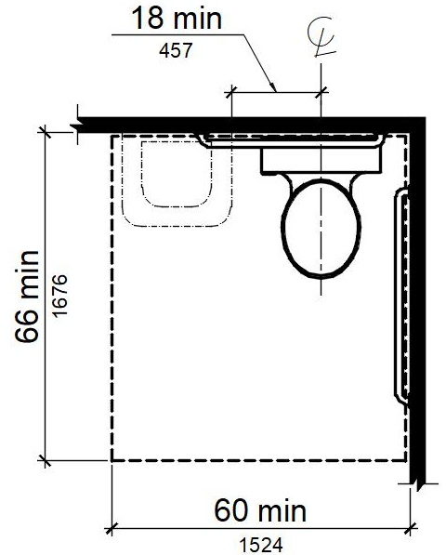
Exception: In residential dwelling units, a lavatory complying with Section 11B-606 shall be permitted on the rear wall 18 inches (457 mm) minimum from the water closet centerline where the clearance at the water closet is 66 inches (1676 mm) minimum measured perpendicular from the rear wall.
Figure 11B-604.3.2 (Exception)
Overlap of Water Closet Clearance in Residential Dwelling Units

Suggested Text of Proposed Amendment
11B-604.3.2 Overlap.
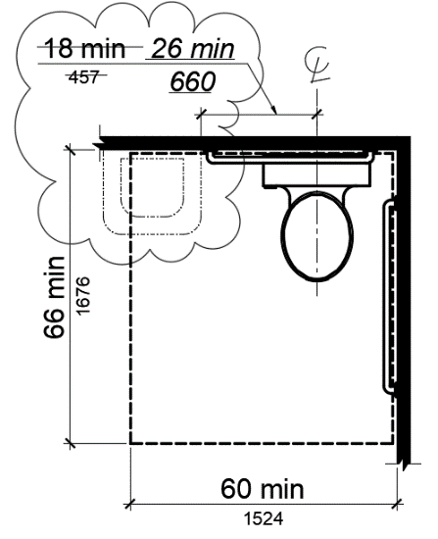
Exception: In residential dwelling units, a lavatory complying with Section 11B-606 shall be permitted on the rear wall 18 inches (457 mm) 26 inches (660 mm) minimum from the water closet centerline where the clearance at the water closet is 66 inches (1676 mm) minimum measured perpendicular from the rear wall.
Figure 11B-604.3.2 (Exception)Overlap of Water Closet Clearance in Residential Dwelling Units

Code Text if Adopted
11B-604.3.2 Overlap.
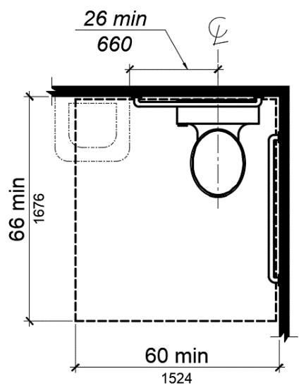
Exception: In residential dwelling units, a lavatory complying with Section 11B-606 shall be permitted on the rear wall 26 inches (660 mm) minimum from the water closet centerline where the clearance at the water closet is 66 inches (1676 mm) minimum measured perpendicular from the rear wall.
Figure 11B-604.3.2 (Exception)
Overlap of Water Closet Clearance in Residential Dwelling Units

Rationale
DSA is proposing to amend this figure for the location of a lavatory within the water closet clearance in response to a discussion with the United States Access Board and comments from code users. DSA posed a question to the Access Board related to the figure and whether or not this indicates a compliant installation for the clearance required at the grab bar. The representative from the Access Board stated that the Access Board recognizes that the figure is incorrect and if and when amendments are proposed to the 2010 ADAS one of the items they would propose to correct is this figure.
In addition, the representative stated that 2010 ADAS Section 604.3.2 must be viewed in conjunction with 2010 ADAS Section 604.5 Grab bars. In residential dwelling units backing is required for the future installation of grab bars, however when not using the provisions in both section sufficient space and backing may not be provided to allow a compliant grab bar installation. Unless otherwise noted figures are not regulatory the requirements for clearances at grab bars must be reviewed in conjunction with the mounting height for lavatories. Installing a lavatory at 34 inches to the rim does not allow for the required clearance below the grab bar.
That being said DSA is proposing to amend an inaccurate figure and amend associated code language to provide clarity for the code user and for compliant installations of grab bars and lavatories.

DSA Comments
N/A

DSA Code Amendment development

Tracking
Date Received: -
DSA Tracking Number: N/A
Date Reviewed: 6/24/2019
Status: Under consideration

Applicable Code
Applicable Code Section(s):11B-604.8.1.2
Topic: Accessible toilet compartment – 4” stile

Current Code Language
11B-604.8.1.2 Doors. Toilet compartment doors.
Doors shall be located in the front partition or in the side wall or partition farthest from the water closet. Where located in the front partition, the door opening shall be 4 inches (102 mm) maximum from the side wall or partition farthest from the water closet. Where located in the side wall or partition, the door opening shall be 4 inches (102 mm) maximum from the front partition.
Related:
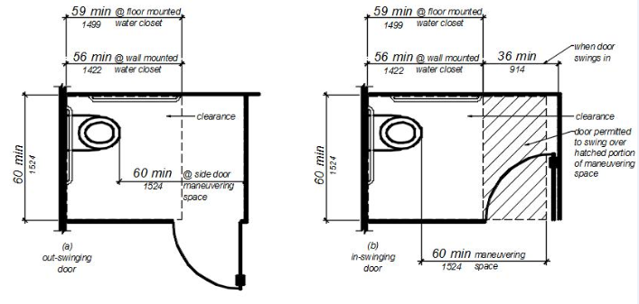FIGURE 11B-604.8.1.2
MANEUVERING SPACE WITH SIDE-OPENING DOOR

Suggested Text of Proposed Amendment
11B-604.8.1.2 Doors. Toilet compartment doors.
Doors shall be located in the front partition or in the side wall or partition farthest from the water closet. Where located in the front partition, the door opening shall be 4 inches (102 mm) maximum from the side wall or partition farthest from the water closet. Where located in the side wall or partition, the door opening shall be 4 inches (102 mm) maximum from the front partition the door opening shall be farthest from the water closet and shall be 54 inches (1372 mm) minimum from the rear wall…
Related:
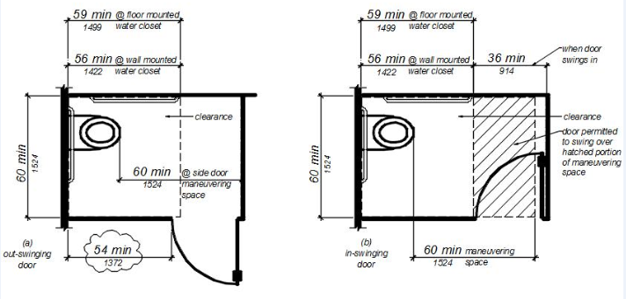FIGURE 11B-604.8.1.2
MANEUVERING SPACE WITH SIDE-OPENING DOOR

Code Text if Adopted
11B-604.8.1.2 Doors. Toilet compartment doors.
Doors shall be located in the front partition or in the side wall or partition farthest from the water closet. Where located in the front partition, the door opening shall be 4 inches (102 mm) maximum from the side wall or partition farthest from the water closet. Where located in the side wall or partition, the door opening shall be farthest from the water closet and shall be 54 inches (1372 mm) minimum from the rear wall.
Related:
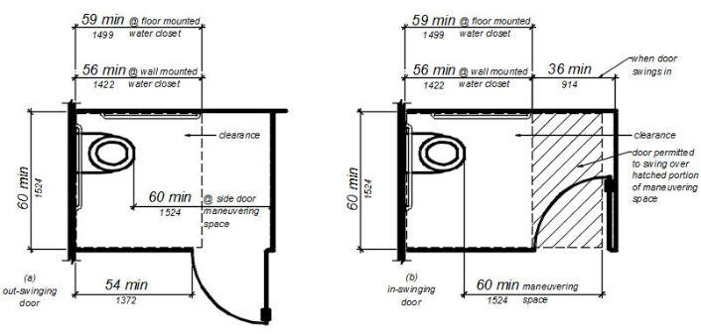FIGURE 11B-604.8.1.2
MANEUVERING SPACE WITH SIDE-OPENING DOOR

Rationale
DSA-AC is proposing to amend Section 11B-604.8.1.2 and Figure 11B-604.8.1.2 to revise the required location for out-swinging toilet compartment doors in the side wall or partition of an accessible toilet compartment. The current provisions require the door to be 4 inches maximum from the front partition. This proposal allows the toilet compartment door to be located in a variety of locations in the side wall or partition while maintaining equal or greater accessibility than the current CBC Chapter 11B requirements and the 2010 ADA Standards for Accessible design.

Comments
Required door location provides direct access to the wide side of the water closet. Existing CBC language is from the 2010 ADA Standards which, in turn, was illustrated in the 1991/1994 ADA Standards. The federal illustrations showed the 4” dimension only in the minimum sized federal accessible toilet compartment. California accessible toilet compartment depth requirements significantly exceed the federal requirements.

DSA Code Amendment development

Tracking
Date Received: -
DSA Tracking Number: N/A
Date Reviewed: 6/24/2019
Status: Under consideration

Applicable Code
Applicable Code Section(s):11B-604.8.2.2, Figure 11B-604.8.2
Topic: Clearance requirement at approach to ambulatory accessible compartment

Current Code Language
11B-604 Water closets and toilet compartments.
11B-604.8.2 Ambulatory accessible compartments.
11B-604.8.2.1 Size. Ambulatory accessible compartments shall have a depth of 60 inches (1524 mm) minimum and a width of 35 inches (889 mm) minimum and 37 inches (940 mm) maximum.
11B-604.8.2.2 Doors. Toilet compartment doors, including door hardware, shall comply with Section 11B-404, except that if the approach is to the latch side of the compartment door, clearance between the door side of the compartment and any obstruction shall be 44 inches (1118 mm) minimum. The door shall be self-closing. A door pull complying with Section 11B-404.2.7 shall be placed on both sides of the door near the latch. Toilet compartment doors shall not swing into the minimum required compartment area.
Related:
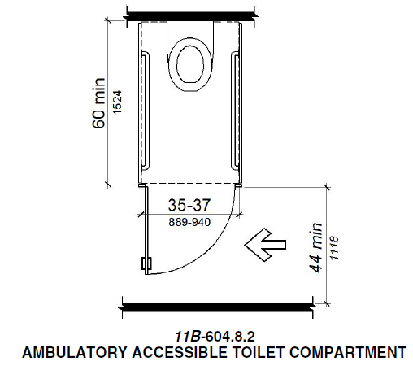

Suggested Text of Proposed Amendment
11B-604 Water closets and toilet compartments.
11B-604.8.2 Ambulatory accessible compartments.
11B-604.8.2.1 Size. Ambulatory accessible compartments shall have a depth of 60 inches (1524 mm) minimum and a width of 35 inches (889 mm) minimum and 37 inches (940 mm) maximum.
11B-604.8.2.2 Doors. Toilet compartment doors, including door hardware, shall comply with Section 11B-404, except that if the approach is to the latch side of the compartment door, clearance between the door side of the compartment and any obstruction shall be 44 inches (1118 mm) 42 inches (1067 mm) minimum. The door shall be self-closing. A door pull complying with Section 11B-404.2.7 shall be placed on both sides of the door near the latch. Toilet compartment doors shall not swing into the minimum required compartment area.
Related:
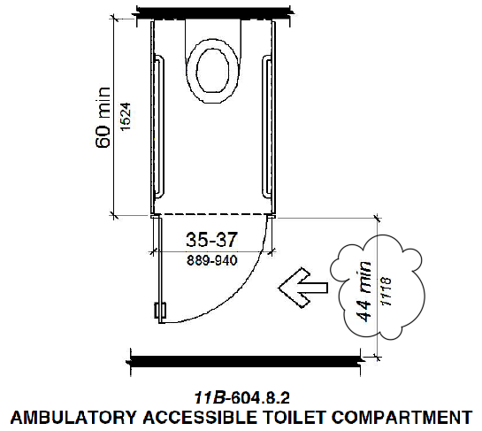

Code Text if Adopted
11B-604 Water closets and toilet compartments.
11B-604.8.2 Ambulatory accessible compartments.11B-604.8.2.1 Size. Ambulatory accessible compartments shall have a depth of 60 inches (1524 mm) minimum and a width of 35 inches (889 mm) minimum and 37 inches (940 mm) maximum.
11B-604.8.2.2 Doors. Toilet compartment doors, including door hardware, shall comply with Section 11B-404, except that if the approach is to the latch side of the compartment door, clearance between the door side of the compartment and any obstruction shall be 42 inches (1067 mm) minimum. The door shall be self-closing. A door pull complying with Section 11B-404.2.7 shall be placed on both sides of the door near the latch. Toilet compartment doors shall not swing into the minimum required compartment area.
Related:
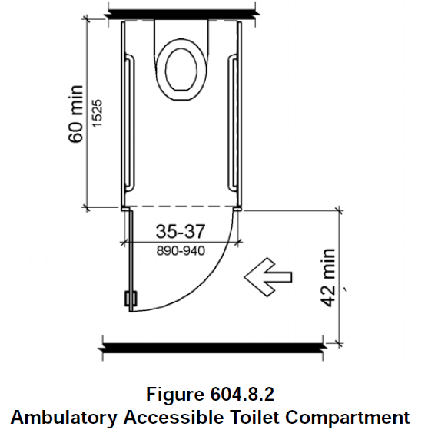

Rationale
DSA is proposing to amend this section in order to correct a drafting error made during the 2012 Rulemaking cycle when Chapter 11B was rewritten using the 2010 ADA Standards for Accessible Design as model language with California amendments.
- The 2010 CBC did not address minimum access width requirements for latch side approach to ambulatory accessible toilet compartments. Section 1115B.3.1, item 4.5 did require minimum 44 inch of clear, unobstructed access to wheelchair accessible water closets in multi-accommodation toilet facilities.
- During the 2012 rulemaking process, the 44-inch access provision was inadvertently applied to “accessible compartments” which included both wheelchair accessible and ambulatory accessible compartments instead of solely to wheelchair accessible compartments. The ambulatory accessible compartment was not subject Section to 2010 CBC 1115B.3.1, item 4.5 as requirements for ambulatory accessible compartments were addressed in Section 115B.3.1, item 5.

Comments
Excerpt from 2010 CBC:1115B.3 Toilet facilities.1115B.3.1 Multiple-accommodation toilet facilities. See Figure 11B-1B. Multiple-accommodation toilet facilities shall have the following:
1.Wheelchair clearance. . . .
4. Accessible water closet compartment. Accessible water closet compartments shall comply with the following:
4.1. The compartment shall be a minimum of 60 inches (1524 mm) wide.
4.2. If the compartment has a side-opening door, either in-swinging or out-swinging, a minimum 60 inches (1524 mm) wide and 60 inches (1524 mm) deep maneuvering space shall be provided in front of the water closet.
4.3. If the compartment has an end-opening door (facing the water closet), either in-swinging or out-swinging, a minimum 60 inches (1524 mm) wide and 48 inches (1219 mm) deep maneuvering space shall be provided in front of the water closet. The door shall be located in front of the clear floor space and diagonal to the water closet, with a maximum stile width of 4 inches (102 mm).
4.4. The water closet compartment shall be equipped with a door that has an automatic- closing device, and shall have a clear, unobstructed opening width of 32 inches (813 mm) when located at the end and 34 inches (864 mm) when located at the side with the door positioned at an angle of 90 degrees from its closed position.
4.5. The inside and outside of the compartment door shall be equipped with a loop or U-shaped handle immediately below the latch. The latch shall be flip-over style, sliding or other hardware not requiring the user to grasp or twist. Except for door-opening widths and door swings, a clear, unobstructed access of not less than 44 inches (1118 mm) shall be provided to water closet compartments designed for use by persons with disabilities. Maneuvering space at the compartment door shall comply with Sections 1133B.2.4.2 and 1133B.2.4.3, and in no case shall the space immediately outside of the water closet compartment door be less than 48 inches (1219 mm) as measured perpendicular to the compartment door in its closed position.
5. Large toilet rooms. Where six or more compartments are provided within a multiple-accommodation toilet room, in addition to the water closet and compartment required by Items 3 and 4 above, provide at least one ambulatory accessible compartment. The ambulatory accessible compartment shall be 36 inches (914 mm) wide with an outward swinging self-closing door and parallel grab bars complying with Section 1115B.4.1, Item 3.

DSA Code Amendment development

Tracking
Date Received: -
DSA Tracking Number: N/A
Date Reviewed: 03/25/2019
Status: Under consideration

Applicable Code
Applicable Code Section(s):11B-608.5
Topic: Shower controls

Current Code Language
11B-608.5 Controls. Controls, faucets, and shower spray units shall comply with Section 11B-309.4. Controls and faucets shall allow the user to close and open the water supply.
11B-608.5.1 Transfer Type Shower Compartments.
11B-608.5.2 Standard roll-in type shower compartments. In standard roll-in type shower compartments, operable parts of controls and faucets shall be installed on the back wall of the compartment adjacent to the seat wall 19 inches (483 mm) minimum and 27 inches (686 mm) maximum from the seat wall; and shall be located above the grab bar, but no higher than 48 inches (1219 mm) above the shower floor, with their centerline at 39 inches (991 mm) to 41 inches (1041 mm) above the shower floor.
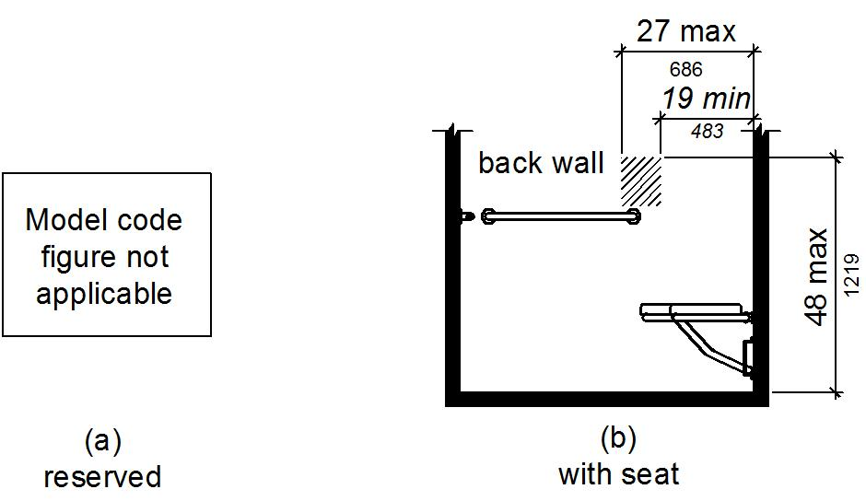
Operable parts of the shower spray unit, including the handle, shall be installed on the back wall adjacent to the seat wall 19 inches (483 mm) minimum and 27 inches (686 mm) maximum from the seat wall; and shall be located above the grab bar, but no higher than 48 inches (1219 mm) above the shower floor.
Figure 11B-608.5.2
Standard Roll-In Type Shower Compartment Control Location
11B-608.5.3 Alternate roll-in type shower compartments. In alternate roll-in type shower compartments, operable parts of controls and faucets shall be installed on the side wall of the compartment adjacent to the seat wall 19 inches (483 mm) minimum and 27 inches (686 mm) maximum from the seat wall; and shall be located above the grab bar, but no higher than 48 inches (1219 mm) above the shower floor, with their centerline at 39 inches (991 mm) to 41 inches (1041 mm) above the shower floor.
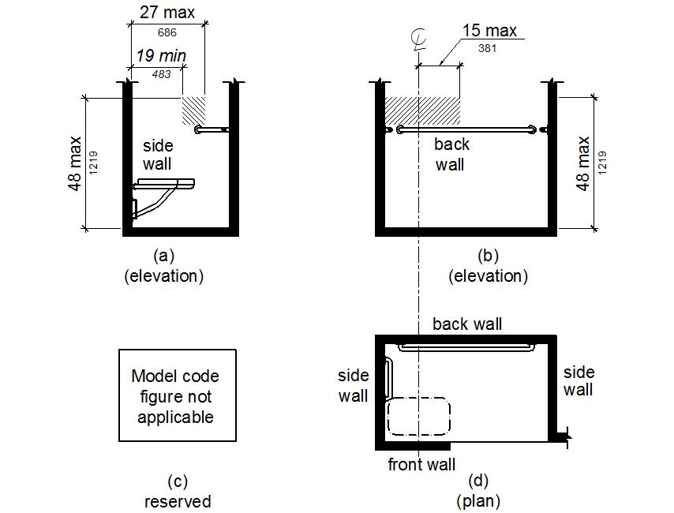
Operable parts of the shower spray unit, including the handle, shall be installed on the side wall of the compartment adjacent to the seat wall 17 inches (432 mm) minimum and 19 inches (483 mm) maximum from the seat wall or on the back wall opposite the seat 15 inches (381 mm) maximum, left or right, of the centerline of the seat; and shall be located above the grab bar, but no higher than 48 inches (1219 mm) above the shower floor.
Figure 11B-608.5.3
Alternate Roll-In Type Shower Compartment Control Location

Suggested Text of Proposed Amendment
11B-608.5 Controls. Controls, faucets, and shower spray units shall comply with Section 11B-309.4. Controls and faucets shall allow the user to close and open the water supply.
11B-608.5.1 Transfer Type Shower Compartments.
11B-608.5.2 Standard roll-in type shower compartments. In standard roll-in type shower compartments, operable parts of controls and faucets shall be installed on the controls, faucets, and the shower spray unit shall be located on the back wall of the compartment adjacent to the seat wall 19 inches (483 mm) minimum and 16 inches (406 mm) minimum and 27 inches (686 mm) maximum from the seat wall; and shall be located above the grab bar, but no higher than 48 inches (1219 mm) above the shower floor. , with their centerline at 39 inches (991 mm) to 41 inches (1041 mm) above the shower floor.
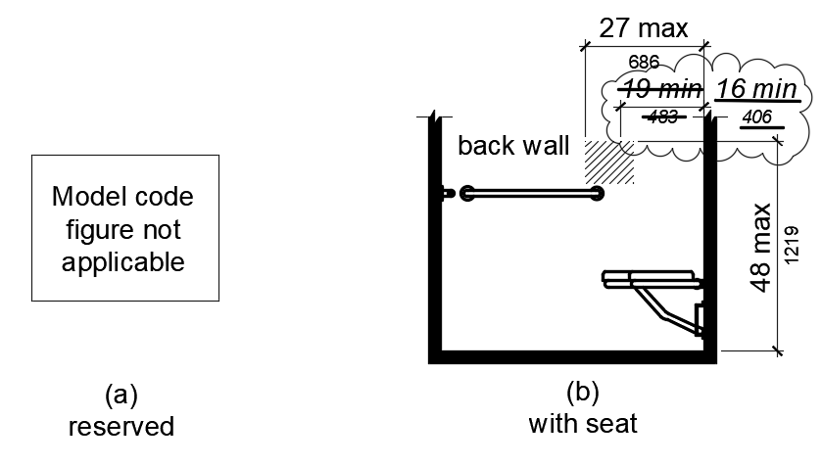
Operable parts of the shower spray unit, including the handle, shall be installed on the back wall adjacent to the seat wall 19 inches (483 mm) minimum and 27 inches (686 mm) maximum from the seat wall; and shall be located above the grab bar, but no higher than 48 inches (1219 mm) above the shower floor.
Figure 11B-608.5.2
Standard Roll-In Type Shower Compartment Control Location
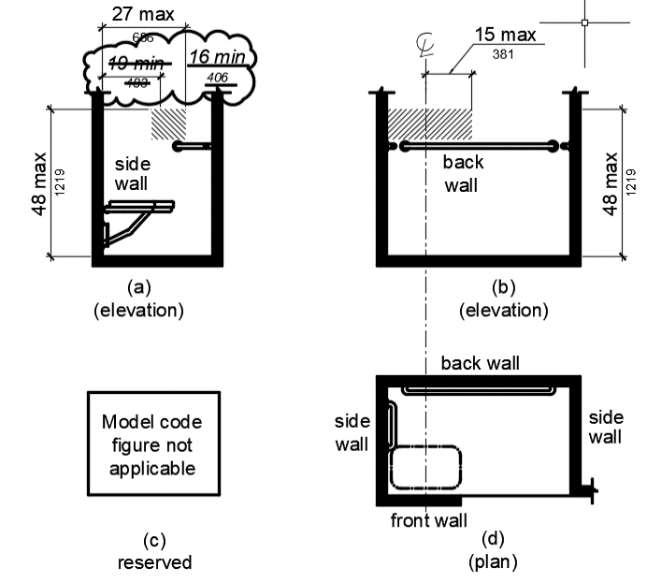
11B-608.5.3 Alternate roll-in type shower compartments. In alternate roll-in type shower compartments, operable parts of controls and faucets shall be installed the controls, faucets, and shower spray unit shall be located on the side wall of the compartment adjacent to the seat wall 19 inches (483 mm) minimum and 16 inches (406 mm) minimum and 27 inches (686 mm) maximum from the seat wall; or shall be located on the back wall opposite the seat 15 inches (381 mm) maximum, left or right of the centerline of the seat. and The operable parts of controls, faucets, and shower spray units shall be located above the grab bar, but no higher than 48 inches (1219 mm) above the shower floor., with their centerline at 39 inches (991 mm) to 41 inches (1041 mm) above the shower floor. Operable parts of the shower spray unit, including the handle, shall be installed on the side wall of the compartment adjacent to the seat wall 17 inches (432 mm) minimum and 19 inches (483 mm) maximum from the seat wall or on the back wall opposite the seat 15 inches (381 mm) maximum, left or right, of the centerline of the seat; and shall be located above the grab bar, but no higher than 48 inches (1219 mm) above the shower floor.
Figure 11B-608.5.3
Alternate Roll-In Type Shower Compartment Control Location

Code Text if Adopted
11B-608.5 Controls. Controls, faucets, and shower spray units shall comply with Section 11B-309.4. Controls and faucets shall allow the user to close and open the water supply.
11B-608.5.1 Transfer Type Shower Compartments.
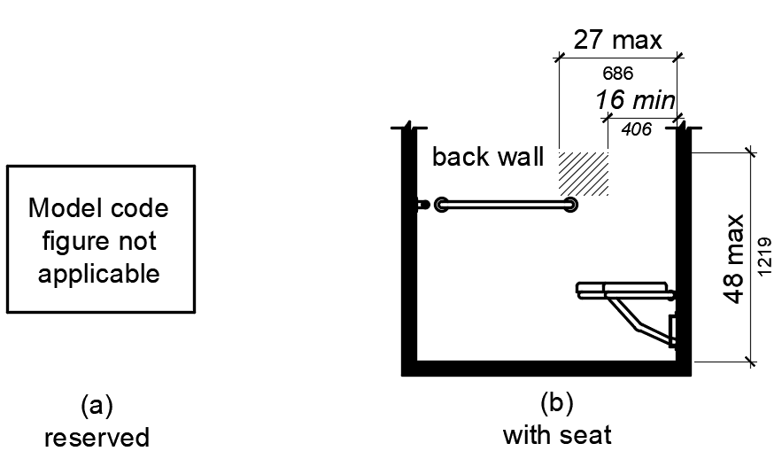
11B-608.5.2 Standard roll-in type shower compartments. In standard roll-in type shower compartments, the controls, faucets, and the shower spray unit shall be located on the back wall of the compartment adjacent to the seat wall 16 inches (406 mm) minimum and 27 inches (686 mm) maximum from the seat wall; and shall be located above the grab bar, but no higher than 48 inches (1219 mm) above the shower floor.
Figure 11B-608.5.2
Standard Roll-In Type Shower Compartment Control Location
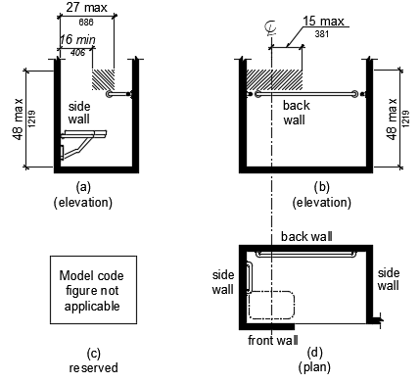
11B-608.5.3 Alternate roll-in type shower compartments. In alternate roll-in type shower compartments, the controls, faucets, and shower spray unit shall be located on the side wall of the compartment adjacent to the seat 16 inches (406 mm) minimum and 27 inches (686 mm) maximum from the seat wall or shall be located on the back wall opposite the seat 15 inches (381 mm) maximum, left or right of the centerline of the seat. The controls, faucets, and shower spray units shall be located above the grab bar, but no higher than 48 inches (1219 mm) above the shower floor.
Figure 11B-608.5.3
Alternate Roll-In Type Shower Compartment Control Location

Rationale
DSA is proposing to amend these sections in response to comments from code users to address the following issues:
- Section 11B-608.5.2 in one sentence refers to the installation of the shower faucets and controls and in another sentence the term location is used. The language is proposed for amendment to use consistent terminology within the section therefore installation is proposed to be replaced with location.
- Unlike the 2010 ADAS, Chapter 11B requires that seats be installed in shower compartments with the one exception for residential dwelling units. The 2010 ADAS requires seats to be installed only in transient lodging guest rooms with mobility features and also includes the exception for residential dwelling units. DSA’s proposed code change aligns with the 2010 ADAS for the location of controls, faucets and shower spray units when seats are provided.
- DSA does not use the International Building Code or ANSI A117.1 Accessibility Standard as model code, however the range proposed in this code change is consistent with ANSI A117.1 and is more restrictive than the 2010 ADAS.
- Complying with the more restrictive current requirements in Chapter 11B results in installations that are non-compliant when controls, faucets and the shower spray unit can’t be accommodated in a control area that is 8 inches in width. Increasing the width of the control area is still more restrictive than the 2010 ADAS and providing an additional 3 inches allows the few inches necessary to accommodate the controls, faucets and shower spray unit within the control area.
- Chapter 11B requires that the controls and faucets be installed with their centerlines at 39 inches to 49 inches above the shower floor. When a diverter and faucet is provided in one unit with an escutcheon the dimension between the diverter and the faucet is well within the control area but does not comply with the requirement for the centerline location. Removing the requirement for the dimension to the centerline of the controls would allow this type of unit to be installed that does provide for a compliant installation.
- Section 11B-309.3 requires operable parts to be within one or more of the reach ranges specified in 11B-308. The requirement that the handle of the shower spray unit is required within one of the reach ranges is redundant and unnecessary language and is therefore proposed for repeal.

DSA Comments
N/A

DSA Code Amendment development

Tracking
Date Received: -
DSA Tracking Number: N/A
Date Reviewed: 01/31/2019
Status: Under consideration

Applicable Code
Applicable Code Section(s):CBC Ch. 11B, 11B-804.3
Topic: Scoping

Current Code Language
11B-804.3 Kitchen work surface. In residential dwelling units required to comply with Section 11B-809, at least one 30 inches (762 mm) wide minimum section of counter shall provide a kitchen work surface that complies with Section 11B-804.3.

Suggested Text of Proposed Amendment
11B-804.3 Kitchen work surface. In residential dwelling units required to comply with Section 11B-809, at least one 30 inches (762 mm) wide minimum section of counter shall provide a kitchen work surface that complies with Section 11B-804.3. In kitchens within multi-bedroom housing units and on floors containing accessible sleeping rooms with adaptable features in undergraduate student housing, at least one 30 inches (762 mm) wide minimum section of counter shall provide a kitchen work surface that complies with Section 11B-804.3.

Code Text if Adopted
11B-804.3 Kitchen work surface. In residential dwelling units required to comply with Section 11B-809, at least one 30 inches (762 mm) wide minimum section of counter shall provide a kitchen work surface that complies with Section 11B-804.3. In kitchens within multi-bedroom housing units and on floors containing accessible sleeping rooms with adaptable features in undergraduate student housing, at least one 30 inches (762 mm) wide minimum section of counter shall provide a kitchen work surface that complies with Section 11B-804.3.

Rationale
DSA is proposing to amend this section to provide the requirements in Chapter 11B from the 2010 ADAS CFR 35.151(f)(1) and CFR 36.406 (e)(1) for work surfaces in undergraduate student housing. Including this requirement in Chapter 11B provides that this provision, that may be overlooked by code users due to the fact that it is in the 2010 ADAS and not in the CBC, will be enforceable by building officials.

DSA Comments
N/A

DSA Code Amendment development

Tracking
Date Received: -
DSA Tracking Number: N/A
Date Reviewed: 01/31/2019
Status: Under consideration

Applicable Code
Applicable Code Section(s):CBC Ch. 11B, 11B-804
Topic: Scoping

Current Code Language
11B-804 Kitchens, kitchenettes, and wet bars.
11B-804.1 General. Kitchens, kitchenettes, and wet bars shall comply with Section 11B-804.

Suggested Text of Proposed Amendment
11B-804 Kitchens, kitchenettes, and wet bars.
11B-804.1 General. Kitchens, kitchenettes, and wet bars shall comply with Section 11B-804.
11B-804.2.3 Turning space. In kitchens within multi-bedroom housing units and on floors containing accessible sleeping rooms with adaptable features in undergraduate student housing, turning spaces complying with Section 11B-304 shall be provided.

Code Text if Adopted
11B-804 Kitchens, kitchenettes, and wet bars.
11B-804.1 General. Kitchens, kitchenettes, and wet bars shall comply with Section 11B-804.
11B-804.2.3 Turning space. In kitchens within multi-bedroom housing units and on floors containing accessible sleeping rooms with adaptable features in undergraduate student housing, turning spaces complying with Section 11B-304 shall be provided.

Rationale
DSA is proposing to amend this section to provide the requirements in Chapter 11B from the 2010 ADAS CFR 35.151(f)(1) and CFR 36.406 (e)(1) for turning spaces required in undergraduate student housing. Including this requirement in Chapter 11B provides that this provision, that may be overlooked by code users due to the fact that it is in the 2010 ADAS and not in the CBC, will be enforceable by building officials.

DSA Comments
N/A

DSA Code Amendment development

Tracking
Date Received: -
DSA Tracking Number: N/A
Date Reviewed: 05/17/2019
Status: Under consideration

Applicable Code
Applicable Code Section(s):CBC Ch. 11B, 11B-809.6 – 11B-809.12
Topic: Residential Dwelling Units with Adaptable Features

Current Code Language
DSA currently adopts Chapter 11A, Division IV, Dwelling Unit features for multifamily ground floor dwelling units with adaptable features. DSA is proposing to repeal the adoption of that section. The provisions for the dwelling unit features are proposed as an amendment to provide new sections in Chapter 11B, 11B-809.6 through 11B-809.12. The provisions are proposed for revision and renumbering to follow the format of Chapter 11B.

Suggested Text of Proposed Amendment
11B-809.6 Residential Dwelling Units with Adaptable Features. Multi-family residential dwelling units with adaptable features shall comply with Sections 11B-809.7 through 11B-809.12.
11B-809.7 Accessible routes. An accessible route shall be provided complying with Section 11B-809.7. The accessible route shall pass through the primary entry door, through all rooms within the dwelling unit and exterior decks and balconies. The accessible route shall adjoin or overlap clear floor spaces and connect all exterior doors.
Exceptions:
1. An accessible route shall not be required from the interior of the unit into to a basement.
2. An accessible route to a garage shall comply with Section 11B-208.3.3.
3. An accessible route shall not be required to rooms or spaces not located on the primary entry level of a multistory dwelling unit.
11B-809.7.1 Width. The clear width for the accessible route shall be 36 inches (914 mm) minimum.
Exception: The clear width shall be permitted to be reduced to 32 inches (813 mm) minimum for a length of 24 inches (610 mm) maximum provided that reduced width segments are separated by segments that are 48 inches (1219 mm) long minimum and 36 inches (914 mm) wide minimum.
11B-809.7.2 Changes in level. Changes in level shall comply with Sections 11B-303.2 and 11B-303.3. Ramps complying with Section 11B-405, elevators complying with Section 11B-407 or platform lifts complying with Section 11B-410 shall be provided where changes in level exceed 1/2 inch (12.7 mm) high.
11B-809.8 Doors. Primary entry doors, required exit doors, secondary exterior doors and interior doors intended for user passage shall comply with Section 11B-404.2.
Exceptions: At primary entry doors, required exit doors, secondary exit doors and interior doors the following exceptions apply:
- The floor or landing at primary entry doors, required exit doors, and secondary exit doors where a change in elevation occurs between the interior and the exterior surface of the floor or landing, shall comply with the following:
a. Exterior landings of impervious construction (e.g., concrete, brick, flagstone) serving primary entry doors and required exit doors are limited to not more than 1/2 inch (12.7 mm) of change in height between floor surfaces. Changes in level shall comply with Section 11B-809.7.2.
b. Exterior landings of pervious construction (e.g., wood decking with spaces) shall be the same level as the interior landing, except that secondary exterior doors may have no more than 1/2 inch (12.7 mm) of change in height between floor surfaces. Changes in level shall comply with Section 11B-809.7.2.
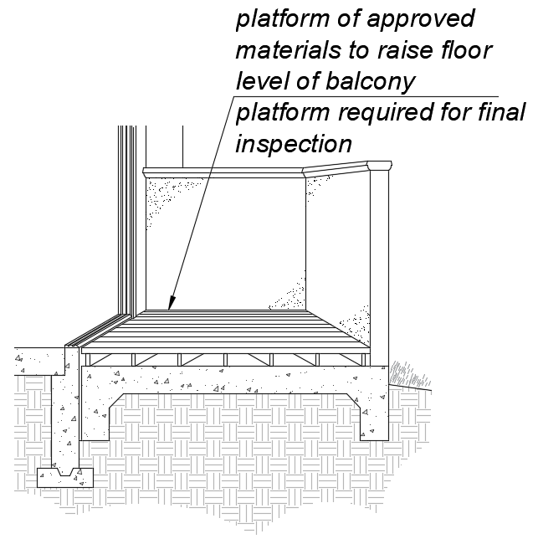
c. Secondary exterior doors onto decks, patios, or balcony surfaces constructed of impervious materials (e.g., concrete, brick, flagstone) may have a maximum change in height from the interior landing of 4 inches (101.6 mm). Changes in height greater than 1/2 inch (12.7 mm) shall be accomplished by means of a ramp complying with Section 11B-405 or by means of a platform constructed to the level of the floor as illustrated in Figure 11B-809.8 (c).
FIGURE 11B-809.8 (c)
PLATFORM AT SECONDARY EXTERIOR DOOR.
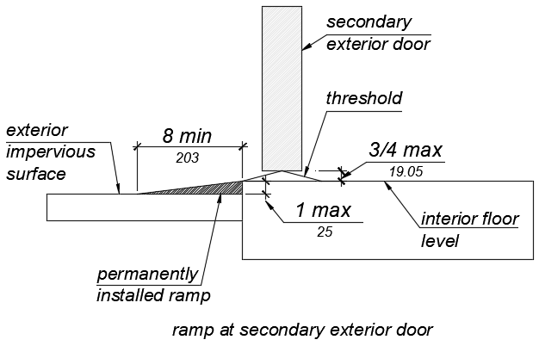
d. Secondary exterior doors onto decks, patios or balcony surfaces constructed of impervious materials (e.g., concrete, brick, flagstone) may have a maximum change in height from the interior landing of 1 inch (25.4 mm), provided a ramp with a maximum slope of 1:8 is permanently installed as illustrated in Figure 11B-809.8 (d).
FIGURE 11B-809.8 (d)
RAMP AT SECONDARY EXTERIOR DOOR.
- Secondary exterior door thresholds, including sliding door tracks, shall be 3/4 inch (19.05 mm) high maximum with a 1:2 maximum slope.
- The opening force for primary entry doors and secondary exterior door shall be 8 ½ pounds (38 N) maximum.
- At the dwelling unit side of the primary entry doors, secondary exterior doors, and required exit doors maneuvering clearances shall be 44 inches (1118 mm) minimum in length measured perpendicular to the face of the door in the closed position.
- At interior doors maneuvering clearances shall be 42 inches (1118 mm) minimum in length on the both sides of the door measured perpendicular to the face of the door in the closed position. A 39 inch (991 mm) minimum length is allowed at interior doors when a clear opening width of 34 inches (864 mm) minimum is provided.
- Doors to small mechanical closets specifically dedicated to furnaces or hot water heaters shall not be required to comply with this section.
11B-809.8.1 Door signal devices. Every primary entrance to a residential dwelling unit with adaptable features shall be provided with a door buzzer, bell, chime or equivalent. The activating mechanism shall be mounted 48 inches (1219 mm) maximum above the floor and connected to permanent wiring.
11B-809.9 Kitchens. Kitchens shall be on an accessible route and shall comply with this section.
11B-809.9.1 Clear floor space. Clear floor spaces 30 inches (762 mm) by 48 inches (1219), with centerlines aligned with the centerline of the work surface, appliance, sink or fixture, shall be provided in the following locations:
- For a parallel approach at the range or cooktop.
- For a parallel or forward approach to the sink and to the work surface required by Sections 11B-809.9.3 and 11B-809.9.4.
- For a parallel or forward approach to all other fixtures or appliances.
11B-809.9.2 Clear width. Kitchens shall have a minimum clear width measured between any cabinet, work surface or the face of any appliance (excluding handles and controls) and the opposing cabinet, work surface, appliance or wall as follows:
a. U-shaped kitchens, designed with parallel approach at a sink, range, cooktop or other fixtures and appliances located at the base of the U without knee and toe clearance, shall provide a clear width of 60 inches (1524 mm) minimum.
b. U-shaped kitchens, with a cooktop or sink located at the base of the U, that provides knee and toe space complying Sections 11B-809.9.3 and 11B-809.9.4 to allow for a forward approach, shall provide a clear width of 48 inches (1219 mm) minimum.
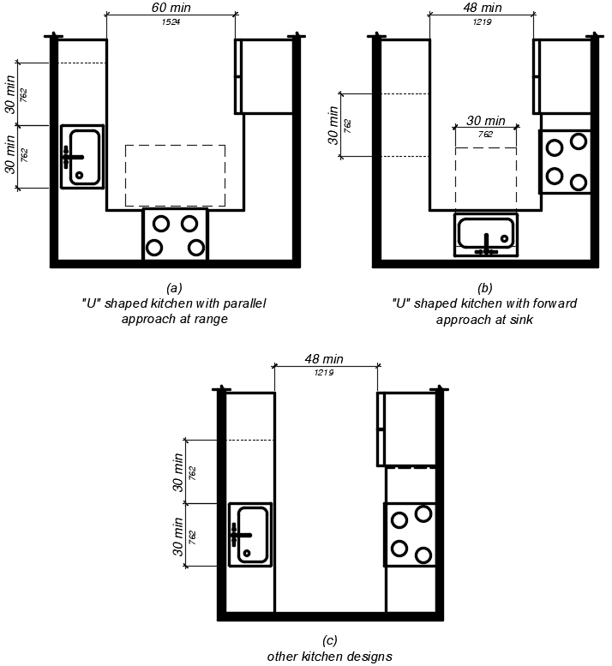
c. All other kitchen designs shall provide a clear width of 48 inches (1219 mm) minimum.
FIGURE 11B-809.9.2
CLEAR WIDTH AT KITCHENS.
11B-809.9.3 Removable base cabinets. Knee and toe space complying with Section 11B-306 shall be provided at sinks and work surfaces required to comply with Section 11B-809.9.4.
Exception: Removable base cabinets shall be permitted under sinks and work surfaces provided that all of the following conditions are met;
- base cabinets can be removed without the use of specialized tools or knowledge.
- the finish floor extends under the base cabinet; and
- the walls behind and surrounding the base cabinets are finished.
11B-809.9.4 Work surfaces. Work surfaces shall be 36 inches (914 mm) maximum above the finish floor with minimum lengths at the following locations as required by this section.
- Linear length of 30 inches (762 mm) minimum for installation of a sink.
- Linear length of 30 inches (762 mm) minimum for work surfaces.
- A sink and work surface in a single integral unit 60 inches (1524 mm) minimum in length, is permitted.
11B-809.9.5 Lower shelving. Lower shelving and/or drawer space shall be provided at a height of 48 inches (1219 mm) maximum above the finish floor.
11B-809.9.6 Controls. Controls for faucets shall comply with Section 11B-309.1. Hand-operated metering faucets shall remain open for 10 seconds minimum.
11B-809.9.7 Exposed pipes and surfaces. Exposed water supply and drain pipes under sinks and lavatories shall comply with Section 11B-606.5.
11B-809.10 Toilet and bathing rooms.
11B-809.10.1 General. All toilet and bathing rooms on an accessible route within residential dwelling units with adaptable features shall comply with Sections 11B-809.7, 11B-809.8, 11B-809.10.6.4, 11B-809.10.7.3 and 11B-809.10.12.
11B-809.10.2 Number of complying bathing rooms and fixtures. One bathing room and one fixture of each type within the dwelling unit shall be designed to comply with the following:
- Maneuvering space in toilet, bathing and shower rooms shall comply with Section 11B-809.10.4.
- Bathtubs complying with Section 11B-809.10.5.
- Showers complying with Section 11B-809.10.6.
- Water closets complying with Section 11B-809.10.7.
- Lavatories, vanities, mirrors and towel bars complying with Section 11B-809.10.8. When two or more lavatories are provided, at least one shall comply with Section 11B-809.10.8.
- Where both a tub and shower are provided in the bathroom, at least one shall be made accessible. Where two or more bathrooms are provided, when a bathtub is installed in the first bathroom in compliance with Section 11B-809.10.5 and a shower compartment is provided in a subsequent bathroom, at least one shower compartment shall comply with Section 11B-809.10.6.
11B-809.10.3 Powder rooms. Powder rooms shall be designed to comply with Sections 11B-809.7, 11B-809.8, 11B-809.10.5.2, 11B-809.10.6.4, 11B-809.10.7.3, and 11B-809.10.12. When the powder room is the only toilet facility located on an accessible level it shall, in addition, comply with Sections 11B-809.10.4, 11B-809.10.7 and 11B-809.10.8.
11B-809.10.4 Sufficient maneuvering space. Where doors swing into the toilet and bathing or powder rooms required to comply with Section 11B-809.10, a clear maneuvering space of 30 (762mm) inches by 48 inches (1219 mm) minimum shall be provided outside the arc of the door swing. The clear maneuvering space shall be permitted to include knee and toe clearance under bathroom fixtures. Doors shall be permitted to encroach into the clear floor space or clearance for fixtures where clear maneuvering space is provided outside the arc of the door swing. A turning space is not required within the room.
11B-809.10.5 Bathtubs. Bathtubs required by Section 11B-809.10 shall comply with this section.
11B-809.10.5.1 Clear floor space. A clear floor space 30 inches (1219 mm) minimum by 48 inches (762 mm) minimum shall be located with the long edge of the clear floor space parallel to the side of the bathtub or bathtub-shower combination. Controls shall be located on the wall at the foot of the bathtub. The edge of the clear floor space shall be flush with the control wall surface. The area under a lavatory, located at the control end of the tub, shall be permitted to encroach on the clear floor space provided the lavatory is 19 inches (483 mm) maximum in depth, and knee and toe clearance complying with Section 11B-306 is provided. Cabinets under lavatories and toilets shall not encroach on the clear floor space.
11B-809.10.5.2 Reinforcement for grab bars. Reinforcement for grabs bars shall comply with the following:
- Where bathtubs are installed without surrounding walls reinforcement shall be provided for floor-mounted grab bars.
- Where bathtubs are installed with surrounding walls, grab bar reinforcement shall be installed as follows:
- At the control end wall and head end wall, between 30 inches (762 mm) maximum to 38 inches (965 mm) minimum above the finish floor, extending 28 inches (711 mm) minimum from the front edge of the bathtub to the back wall of the bathtub. The grab bar reinforcement shall be 8 inches (203 mm) minimum in height.
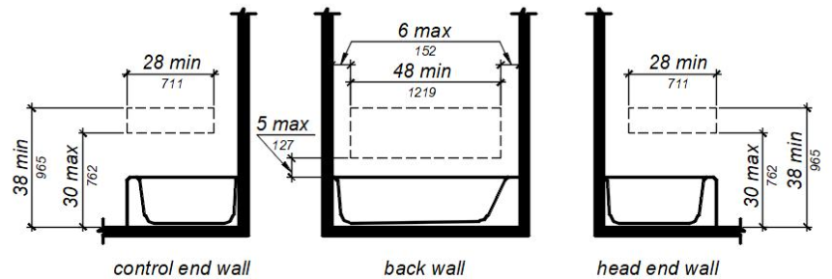
- At the back wall, from 5 inches (127 mm) maximum above the bathtub rim to 38 inches (965 mm) minimum above the finish floor. Grab bar backing shall be installed horizontally to permit the installation of a 48-inch (1219 mm) grab bar with each end 6 inches (152.4 mm) maximum from the end walls of the bathtub.
FIGURE 11B-809.10.5.2 REINFORCEMENT FOR GRAB BARS.
11B-809.10.5.3 Controls. Controls and operating mechanisms shall comply with Section 11B 309.4.
Exception: Shower spray units are not required in bathtubs.
11B-809.10.5.4 Bathtub enclosures. Doors and panels of bathtub enclosures shall be constructed from approved, shatter-resistant materials. Hinged doors shall open outward. Glazing used in doors and panels of bathtub enclosures shall be fully tempered, laminated safety glass or approved plastic. When glass is used, it shall be 1/8 inch (3.17 mm) thick minimum when fully tempered, or 1/4 inch (6.35 mm) thick minimum when laminated, and shall pass the test requirements of this part, Chapter 24 Glass and Glazing. Plastics used in doors and panels of bathtub enclosures shall be of a shatter-resistant type.
11B-809.10.6 Showers. Showers required by Section 11B-809.10 shall comply with this section.
11B-809.10.6.1 Size. When one or more shower stalls are provided within the same dwelling unit, as least one shower stall shall comply with one of the following:
  - A transfer type shower compartment 36 inches (914 mm) wide by 36 inches (914 mm) deep with an entrance opening 36 inches (914 mm) complying with Section 11B-608.1 or;
  - A shower stall 30 inches (762 mm) deep minimum by 60 inches (1524 mm) wide minimum with an entrance opening 60 inches (1524 mm) minimum. A water closet shall be permitted to project 12 inches (305 mm) maximum into the opening provided that 36 inches (914 mm) minimum clear space is maintained between the water closet and the shower wall as illustrated in Figure 11B-809.10.6.1 or;
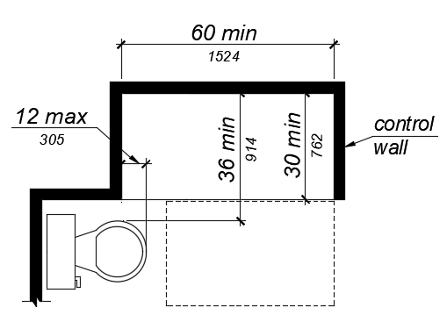
  - A shower stall 36 inches (914 mm) deep by 60 inches (1524 mm) wide minimum with an entrance 36 inches (914 mm) minimum when a wall is installed on the opening side.
FIGURE 11B-809.10.6.1 SHOWERS.
11B-809.10.6.2 Slope. The slope of the shower floor shall be 1/4 inch (6.4 mm) per foot maximum in any direction and shall slope to a drain. The floor surfaces shall be of Carborundum, grit-faced tile or of material providing equivalent slip resistance.
11B-809.10.6.3 Floor space. A clear maneuvering space 30 inches (762 mm) wide minimum by 48 inches (1219 mm) minimum in length shall be located outside the shower, with the width flush with the control wall and the length parallel to the length of the shower.
11B-809.10.6.4 Reinforcement for grab bars. Reinforcement for grabs bars shall comply with the following: Continuous reinforcement shall be installed in the walls of showers 30 inches (762 mm) maximum to 38 inches (965 mm) minimum above the finish floor. The grab bar reinforcement shall be 8 inches (203 mm) minimum in height. Glass-walled shower stalls shall provide reinforcement for installation of floor-mounted or ceiling-mounted grab bars. 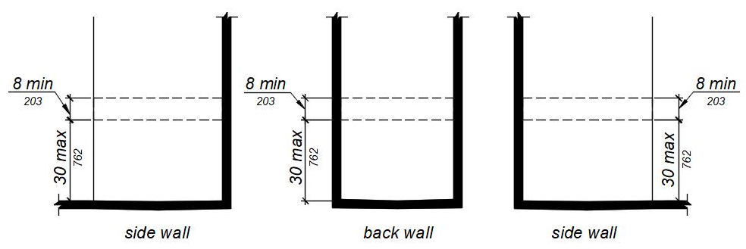FIGURE 11B-809.10.6.4 REINFORCEMENT FOR GRAB BARS.
11B-809.10.6.5 Thresholds. Where provided thresholds shall be 2 inches (50.8 mm) maximum in height and have a beveled or sloped angle not exceeding 1 unit vertical in 2 units horizontal (26.6 degrees from the horizontal). Thresholds 1/2 inch (12.7 mm) or less in height shall have a beveled or sloped angle not exceeding 1 unit vertical in 1 unit horizontal (45 degrees from the horizontal).
11B-809.10.6.6 Controls. Controls and operating mechanisms shall comply with Section 11B 309.4.
11B-809.10.6.7 Shower enclosures. Doors and panels of shower enclosures shall comply with Section 11B-809.10.5.4.
11B-809.10.7 Water closets. Water closets required by Section 11B-809.10 shall comply with this section.
11B-809.10.7.1 Floor space. The floor space at water closets shall be 48 inches (1219 mm) wide minimum measured perpendicular to the side wall. A floor space 48 inches (1219 mm) wide minimum by 36 inches (914 mm) deep minimum shall be provided in front of the water closet.
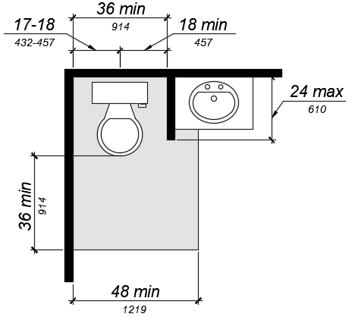
Exception: The 48-inch (1219 mm) minimum clear width may be reduced to 36 inches (914 mm) minimum for lavatories, cabinets, wing walls, or privacy walls located immediately adjacent to a water closet which extend 24 inches (610 mm) maximum in depth.
FIGURE 11B-809.10.7.1 FLOOR SPACE.
11B-809.10.7.2 Location. Water closets shall be located within bathrooms in a manner that permits a grab bar to be installed on at least one side of the fixture. The centerline of the water closet shall be 17 inches (432 mm) minimum to 18 inches (457 mm) maximum from a wall or partition that is 54 inches (1372 mm) minimum in length. In locations where water closets are adjacent to other walls, vanities, lavatories or bathtubs, the centerline of the fixture shall be 18 inches (457 mm) minimum from the obstacle.
11B-809.10.7.3 Reinforcement for grab bars. Reinforcement for grabs bars shall comply with the following:
- Where water closets are not placed adjacent to a side wall capable of accommodating a grab bar, the bathroom shall have provisions for installation of floor-mounted, foldaway or similar alternative grab bars.
- Where water closets are placed adjacent to a side wall, reinforcement shall be installed on both sides or one side and the back. Where reinforcement is installed at the back, it shall be installed between 30 inches (762 mm) maximum and 38 inches (965 mm) minimum above the finish floor. The grab bar reinforcement shall be 8 inches (203 mm) minimum in height. The backing shall 40 inches (1016 mm) minimum in length.
- Where the water closet is located adjacent to lavatories, cabinets, wing walls, or privacy walls the grab bar reinforcement shall be 36 inches (914 mm) in length. Reinforcement installed at the side wall of the water closet shall be between 30 inches (762 mm) minimum to 38 inches (965 mm) maximum above the finish floor. The reinforcement shall be 10 inches (254 mm) maximum from the rear wall and shall extend 30 inches (762 mm) minimum in front of the water closet. The grab bar reinforcement shall be 8 inches (203 mm) minimum in height.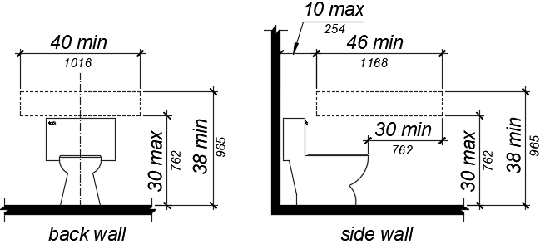FIGURE 11B-809.10.7.3 REINFORCEMENT FOR GRAB BARS.
11B-809.10.7.4 Seat height. Water closet seats shall be 15 inches (381 mm) minimum and 19 inches (483 mm) maximum above the finish floor.
11B-809.10.7.5 Controls. Controls shall be mounted 44 inches (1118 mm) maximum above the finish floor. The force required to activate controls shall be 5 pounds (22.2 mm) maximum.
11B-809.10.8 Lavatories, vanities, mirrors and towel bars. Bathing rooms or powder rooms required to comply with Section 11B-809.10 shall provide lavatories complying with this section. Where mirrors or towel bars are provided, no less than one of each shall comply with this section.
11B-809.10.8.1 Location. Lavatories without base cabinets shall be installed with the centerline 18 inches (457 mm) minimum from an adjoining wall or fixture to allow for forward approach. Lavatories with base cabinets shall be installed with the centerline 24 inches (610 mm) minimum from an adjoining wall or fixture to allow for a parallel approach. The top of the lavatory rim shall be 34 inches (864 mm) maximum above the finished floor.
11B-809.10.8.2 Floor space. A floor space 30 inches (762 mm) minimum by 48 inches (1219 mm) minimum shall be provided centered on the lavatory.
11B-809.10.8.3 Cabinets. Cabinets shall be removable without the use of specialized knowledge and/or tools. The finished floor shall extend to the wall under the lavatory.
11B-809.10.8.4 Knee and toe clearance. Knee and toe clearance shall be provided and comply with Section 11B-306.
11B-809.10.8.5 Plumbing protection. Plumbing protection shall comply with Section 11B-809.9.7.
11B-809.10.8.6 Controls. Faucet controls and operating mechanisms shall comply with Section 11B 309.4.
11B-809.10.8.7 Mirrors and towel bars. Where mirrors are provided the bottom edge of the reflective surface shall be 40 inches (1016 mm) maximum above the finish floor. Where towel bars are provided they shall be installed 40 inches (1016 mm) maximum above the finish floor to the top of the bar.
11B-809.11 Washing machines and clothes dryers. Where washing machines and clothes dryers are provided in residential dwelling units with adaptable features, one of each type shall be provided.
11B-809.12 Electrical receptacles, controls and switches. Electrical receptacles, controls and switches shall comply with Section 11B-205. Where electrical outlets, controls and switches are provided above work surfaces and cabinets within kitchens and bathrooms the work surface shall be 36 inches (915 mm) maximum above the finish floor and 25 1/2 inches (650 mm) maximum in depth. The cabinet shall be 24 inches (610 mm) maximum in depth. Electrical receptacles on walls over work surfaces and cabinets shall be 36 inches (914 mm) minimum from an inside corner.
Exceptions:
- Electrical receptacles installed as part of permanently installed baseboard heaters.
- Electrical receptacles in floors adjacent to sliding panels or walls.
- Baseboard electrical outlets in relocatable partitions, window walls or other electrical convenience floor outlets.
- Appliances (e.g., stoves, dishwashers, range hoods, microwave ovens and similar appliances) which have controls located on the appliance.

Code Text if Adopted
11B-809.6 Residential Dwelling Units with Adaptable Features. Multi-family residential dwelling units with adaptable features shall comply with Sections 11B-809.7 through 11B-809.12.
11B-809.7 Accessible routes. An accessible route shall be provided complying with Section 11B-809.7. The accessible route shall pass through the primary entry door, through all rooms within the dwelling unit and exterior decks and balconies. The accessible route shall adjoin or overlap clear floor spaces and connect all exterior doors.
Exceptions:
1. An accessible route shall not be required from the interior of the unit into to a basement.
2. An accessible route to a garage shall comply with Section 11B-208.3.3.
3. An accessible route shall not be required to rooms or spaces not located on the primary entry level of a multistory dwelling unit.
11B-809.7.1 Width. The clear width for the accessible route shall be 36 inches (914 mm) minimum.
Exception: The clear width shall be permitted to be reduced to 32 inches (813 mm) minimum for a length of 24 inches (610 mm) maximum provided that reduced width segments are separated by segments that are 48 inches (1219 mm) long minimum and 36 inches (914 mm) wide minimum.
11B-809.7.2 Changes in level. Changes in level shall comply with Sections 11B-303.2 and 11B-303.3. Ramps complying with Section 11B-405, elevators complying with Section 11B-407 or platform lifts complying with Section 11B-410 shall be provided where changes in level exceed 1/2 inch (12.7 mm) high.
11B-809.8 Doors. Primary entry doors, required exit doors, secondary exterior doors and interior doors intended for user passage shall comply with Section 11B-404.2.
Exceptions: At primary entry doors, required exit doors, secondary exit doors and interior doors the following exceptions apply:
- The floor or landing at primary entry doors, required exit doors, and secondary exit doors where a change in elevation occurs between the interior and the exterior surface of the floor or landing, shall comply with the following:
  - Exterior landings of impervious construction (e.g., concrete, brick, flagstone) serving primary entry doors and required exit doors are limited to not more than 1/2 inch (12.7 mm) of change in height between floor surfaces. Changes in level shall comply with Section 11B-809.7.2.
  - Exterior landings of pervious construction (e.g., wood decking with spaces) shall be the same level as the interior landing, except that secondary exterior doors may have no more than 1/2 inch (12.7 mm) of change in height between floor surfaces. Changes in level shall comply with Section 11B-809.7.2.
  - Secondary exterior doors onto decks, patios, or balcony surfaces constructed of impervious materials (e.g., concrete, brick, flagstone) may have a maximum change in height from the interior landing of 4 inches (101.6 mm). Changes in height greater than 1/2 inch (12.7 mm) shall be accomplished by means of a ramp complying with Section 11B-405 or by means of a platform constructed to the level of the floor as illustrated in Figure 11B-809.8 (c).
FIGURE 11B-809.8 (c) PLATFORM AT SECONDARY EXTERIOR DOOR.
  - Secondary exterior doors onto decks, patios or balcony surfaces constructed of impervious materials (e.g., concrete, brick, flagstone) may have a maximum change in height from the interior landing of 1 inch (25.4 mm), provided a ramp with a maximum slope of 1:8 is permanently installed as illustrated in Figure 11B-809.8 (d).
FIGURE 11B-809.8 (d) RAMP AT SECONDARY EXTERIOR DOOR.
- Secondary exterior door thresholds, including sliding door tracks, shall be 3/4 inch (19.05 mm) high maximum with a 1:2 maximum slope.
- The opening force for primary entry doors and secondary exterior door shall be 8 ½ pounds (38 N) maximum.
- At the dwelling unit side of the primary entry doors, secondary exterior doors, and required exit doors maneuvering clearances shall be 44 inches (1118 mm) minimum in length measured perpendicular to the face of the door in the closed position.
- At interior doors maneuvering clearances shall be 42 inches (1118 mm) minimum in length on the both sides of the door measured perpendicular to the face of the door in the closed position. A 39 inch (991 mm) minimum length is allowed at interior doors when a clear opening width of 34 inches (864 mm) minimum is provided.
- Doors to small mechanical closets specifically dedicated to furnaces or hot water heaters shall not be required to comply with this section.
11B-809.8.1 Door signal devices. Every primary entrance to a residential dwelling unit with adaptable features shall be provided with a door buzzer, bell, chime or equivalent. The activating mechanism shall be mounted 48 inches (1219 mm) maximum above the floor and connected to permanent wiring.
11B-809.9 Kitchens. Kitchens shall be on an accessible route and shall comply with this section.
11B-809.9.1 Clear floor space. Clear floor spaces 30 inches (762 mm) by 48 inches (1219), with centerlines aligned with the centerline of the work surface, appliance, sink or fixture, shall be provided in the following locations: For a parallel approach at the range or cooktop. For a parallel or forward approach to the sink and to the work surface required by Sections 11B-809.9.3 and 11B-809.9.4. For a parallel or forward approach to all other fixtures or appliances.
11B-809.9.2 Clear width. Kitchens shall have a minimum clear width measured between any cabinet, work surface or the face of any appliance (excluding handles and controls) and the opposing cabinet, work surface, appliance or wall as follows:
a. U-shaped kitchens, designed with parallel approach at a sink, range, cooktop, or other fixtures and appliances located at the base of the U without knee and toe clearance, shall provide a clear width of 60 inches (1524 mm) minimum.
b. U-shaped kitchens, with a cooktop or sink located at the base of the U, that provides knee and toe space complying Sections 11B-809.9.3 and 11B-809.9.4 to allow for a forward approach, shall provide a clear width of 48 inches (1219 mm) minimum.
c. All other kitchen designs shall provide a clear width of 48 inches (1219 mm) minimum.
FIGURE 11B-809.9.2 CLEAR WIDTH AT KITCHENS.
11B-809.9.3 Removable base cabinets. Knee and toe space complying with Section 11B-306 shall be provided at sinks and work surfaces required to comply with Section 11B-809.9.4.
Exception: Removable base cabinets shall be permitted under sinks and work surfaces provided that all of the following conditions are met;
(a) base cabinets can be removed without the use of specialized tools or knowledge.
(b) the finish floor extends under the base cabinet; and(c) the walls behind and surrounding the base cabinets are finished.
11B-809.9.4 Work surfaces. Work surfaces shall be 36 inches (914 mm) maximum above the finish floor with minimum lengths at the following locations as required by this section.
1. Linear length of 30 inches (762 mm) minimum for installation of a sink.
2. Linear length of 30 inches (762 mm) minimum for work surfaces.
3. A sink and work surface in a single integral unit 60 inches (1524 mm) minimum in length, is permitted.
11B-809.9.5 Lower shelving. Lower shelving and/or drawer space shall be provided at a height of 48 inches (1219 mm) maximum above the finish floor.
11B-809.9.6 Controls. Controls for faucets shall comply with Section 11B-309.1. Hand-operated metering faucets shall remain open for 10 seconds minimum.
11B-809.9.7 Exposed pipes and surfaces. Exposed water supply and drain pipes under sinks and lavatories shall comply with Section 11B-606.5.
11B-809.10 Toilet and bathing rooms. 11B-809.10.1 General. All toilet and bathing rooms on an accessible route within residential dwelling units with adaptable features shall comply with Sections 11B-809.7, 11B-809.8, 11B-809.10.6.4, 11B-809.10.7.3 and 11B-809.10.12.
11B-809.10.2 Number of complying bathing rooms and fixtures. One bathing room and one fixture of each type within the dwelling unit shall be designed to comply with the following:
- Maneuvering space in toilet, bathing and shower rooms shall comply with Section 11B-809.10.4.
- Bathtubs complying with Section 11B-809.10.5.
- Showers complying with Section 11B-809.10.6.
- Water closets complying with Section 11B-809.10.7.
- Lavatories, vanities, mirrors and towel bars complying with Section 11B-809.10.8. When two or more lavatories are provided, at least one shall comply with Section 11B-809.10.8. A transfer type shower compartment 36 inches (914 mm) wide by 36 inches (914 mm) deep with an entrance opening 36 inches (914 mm) complying with Section 11B-608.1 or;
- A shower stall 30 inches (762 mm) deep minimum by 60 inches (1524 mm) wide minimum with an entrance opening 60 inches (1524 mm) minimum.
- Where both a tub and shower are provided in the bathroom, at least one shall be made accessible. Where two or more bathrooms are provided, when a bathtub is installed in the first bathroom in compliance with Section 11B-809.10.5 and a shower compartment is provided in a subsequent bathroom, at least one shower compartment shall comply with Section 11B-809.10.6.
11B-809.10.3 Powder rooms. Powder rooms shall be designed to comply with Sections 11B-809.7, 11B-809.8, 11B-809.10.5.2, 11B-809.10.6.4, 11B-809.10.7.3, and 11B-809.10.12. When the powder room is the only toilet facility located on an accessible level it shall, in addition, comply with Sections 11B-809.10.4, 11B-809.10.7 and 11B-809.10.8.
11B-809.10.4 Sufficient maneuvering space. Where doors swing into the toilet and bathing or powder rooms required to comply with Section 11B-809.10, a clear maneuvering space of 30 (762mm) inches by 48 inches (1219 mm) minimum shall be provided outside the arc of the door swing. The clear maneuvering space shall be permitted to include knee and toe clearance under bathroom fixtures. Doors shall be permitted to encroach into the clear floor space or clearance for fixtures where clear maneuvering space is provided outside the arc of the door swing. A turning space is not required within the room.
11B-809.10.5 Bathtubs. Bathtubs required by Section 11B-809.10 shall comply with this section.
11B-809.10.5.1 Clear floor space. A clear floor space 30 inches (762 mm) minimum by 48 inches (1219 mm) minimum shall be located with the long edge of the clear floor space parallel to the side of the bathtub or bathtub-shower combination. Controls shall be located on the wall at the foot of the bathtub. The edge of the clear floor space shall be flush with the control wall surface. The area under a lavatory, located at the control end of the tub, shall be permitted to encroach on the clear floor space provided the lavatory is 19 inches (483 mm) maximum in depth, and knee and toe clearance complying with Section 11B-306 is provided. Cabinets under lavatories and toilets shall not encroach on the clear floor space.
11B-809.10.5.2 Reinforcement for grab bars. Reinforcement for grabs bars shall comply with the following:
- Where bathtubs are installed without surrounding walls reinforcement shall be provided for floor-mounted grab bars.
- Where bathtubs are installed with surrounding walls, grab bar reinforcement shall be installed as follows:
- At the control end wall and head end wall, between 30 inches (762 mm) maximum to 38 inches (965 mm) minimum above the finish floor, extending 28 inches (711mm) minimum from the front edge of the bathtub to the back wall of the bathtub. The grab bar reinforcement shall be 8 inches (203mm) minimum in height.
- At the back wall, from 5 inches (127 mm) maximum above the bathtub rim to 38 inches (965 mm) minimum above the finish floor. Grab bar backing shall be installed horizontally to permit the installation of a 48-inch (1219 mm) grab bar with each end 6 inches (152.4 mm) maximum from the end walls of the bathtub.FIGURE 11B-809.10.5.2 REINFORCEMENT FOR GRAB BARS.
11B-809.10.5.3 Controls. Controls and operating mechanisms shall comply with Section 11B 309.4.
Exception: Shower spray units are not required in bathtubs.
11B-809.10.5.4 Bathtub enclosures. Doors and panels of bathtub enclosures shall be constructed from approved, shatter-resistant materials. Hinged doors shall open outward. Glazing used in doors and panels of bathtub enclosures shall be fully tempered, laminated safety glass or approved plastic. When glass is used, it shall be 1/8 inch (3.17 mm) thick minimum when fully tempered, or 1/4 inch (6.35 mm) thick minimum when laminated, and shall pass the test requirements of this part, Chapter 24 Glass and Glazing. Plastics used in doors and panels of bathtub enclosures shall be of a shatter-resistant type.
11B-809.10.6 Showers. Showers required by Section 11B-809.10 shall comply with this section.
11B-809.10.6.1 Size. When one or more shower stalls are provided within the same dwelling unit, as least one shower stall shall comply with one of the following:
- A transfer type shower compartment 36 inches (914 mm) wide by 36 inches (914 mm) deep with an entrance opening 36 inches (914 mm) complying with Section 11B-608.1 or;
- A shower stall 30 inches (762 mm) deep minimum by 60 inches (1524 mm) wide minimum with an entrance opening 60 inches (1524 mm) minimum. A water closet shall be permitted to project 12 inches (305 mm) maximum into the opening provided that 36 inches (914 mm) minimum clear space is maintained between the water closet and the shower wall as illustrated in Figure 11B-809.10.6.1 or;
- A shower stall 36 inches (914 mm) deep by 60 inches (1524 mm) wide minimum with an entrance 36 inches (914 mm) minimum when a wall is installed on the opening side.
FIGURE 11B-809.10.6.1 SHOWERS.
11B-809.10.6.2 Slope. The slope of the shower floor shall be 1/4 inch (6.4 mm) per foot maximum in any direction and shall slope to a drain. The floor surfaces shall be of Carborundum, grit-faced tile or of material providing equivalent slip resistance.
11B-809.10.6.3 Floor space. A clear maneuvering space 30 inches (762 mm) wide minimum by 48 inches (1219 mm) minimum in length shall be located outside the shower, with the width flush with the control wall and the length parallel to the length of the shower.
11B-809.10.6.4 Reinforcement for grab bars. Reinforcement for grabs bars shall comply with the following:
- Continuous reinforcement shall be installed in the walls of showers 30 inches (762 mm) maximum to 38 inches (965 mm) minimum above the finish floor. The grab bar reinforcement shall be 8 inches (203 mm) minimum in height.
- Glass-walled shower stalls shall provide reinforcement for installation of floor-mounted or ceiling-mounted grab bars.
FIGURE 11B-809.10.6.4 REINFORCEMENT FOR GRAB BARS.
11B-809.10.6.5 Thresholds. Where provided thresholds shall be 2 inches (50.8 mm) maximum in height and have a beveled or sloped angle not exceeding 1 unit vertical in 2 units horizontal (26.6 degrees from the horizontal). Thresholds 1/2 inch (12.7 mm) or less in height shall have a beveled or sloped angle not exceeding 1 unit vertical in 1 unit horizontal (45 degrees from the horizontal).
11B-809.10.6.6 Controls. Controls and operating mechanisms shall comply with Section 11B 309.4.
11B-809.10.6.7 Shower enclosures. Doors and panels of shower enclosures shall comply with Section 11B-809.10.5.4.
11B-809.10.7 Water closets. Water closets required by Section 11B-809.10 shall comply with this section.
11B-809.10.7.1 Floor space. The floor space at water closets shall be 48 inches (1219 mm) wide minimum measured perpendicular to the side wall. A floor space 48 inches (1219 mm) wide minimum by 36 inches (914 mm) deep minimum shall be provided in front of the water closet.
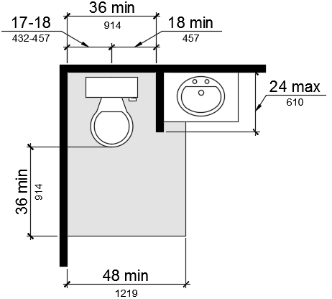
Exception: The 48-inch (1219 mm) minimum clear width may be reduced to 36 inches (914 mm) minimum for lavatories, cabinets, wing walls, or privacy walls located immediately adjacent to a water closet which extend 24 inches (610 mm) maximum in depth.
FIGURE 11B-809.10.7.1 FLOOR SPACE.
11B-809.10.7.2 Location. Water closets shall be located within bathrooms in a manner that permits a grab bar to be installed on at least one side of the fixture. The centerline of the water closet shall be 17 inches (432 mm) minimum to 18 inches (457 mm) maximum from a wall or partition that is 54 inches (1372 mm) minimum in length. In locations where water closets are adjacent to other walls, vanities, lavatories or bathtubs, the centerline of the fixture shall be 18 inches (457 mm) minimum from the obstacle.
11B-809.10.7.3 Reinforcement for grab bars. Reinforcement for grabs bars shall comply with the following:
- Where water closets are not placed adjacent to a side wall capable of accommodating a grab bar, the bathroom shall have provisions for installation of floor-mounted, foldaway or similar alternative grab bars.
- Where water closets are placed adjacent to a side wall, reinforcement shall be installed on both sides or one side and the back. Where reinforcement is installed at the back, it shall be installed between 30 inches (762 mm) maximum and 38 inches (965 mm) minimum above the finish floor. The grab bar reinforcement shall be 8 inches (203 mm) minimum in height. The backing shall 40 inches (1016 mm) minimum in length. Where the water closet is located adjacent to lavatories, cabinets, wing walls, or privacy walls the grab bar reinforcement shall be 36 inches (914 mm) in length.
- Reinforcement installed at the side wall of the water closet shall be between 30 inches (762 mm) minimum to 38 inches (965 mm) maximum above the finish floor. The reinforcement shall be 10 inches (254 mm) maximum from the rear wall and shall extend 30 inches (762 mm) minimum in front of the water closet. The grab bar reinforcement shall be 8 inches (203 mm) minimum nominal in height.
FIGURE 11B-809.10.7.3 REINFORCEMENT FOR GRAB BARS.
11B-809.10.7.4 Seat height. Water closet seats shall be 15 inches (381 mm) minimum and 19 inches (483 mm) maximum above the finish floor.
11B-809.10.7.5 Controls. Controls shall be mounted 44 inches (1118 mm) maximum above the finish floor. The force required to activate controls shall be 5 pounds (22.2 mm) maximum.
11B-809.10.8 Lavatories, vanities, mirrors and towel bars. Bathing rooms or powder rooms required to comply with Section 11B-809.10 shall provide lavatories complying with this section. Where mirrors or towel bars are provided, no less than one of each shall comply with this section.
11B-809.10.8.1 Location. Lavatories without base cabinets shall be installed with the centerline 18 inches (457 mm) minimum from an adjoining wall or fixture to allow for forward approach. Lavatories with base cabinets shall be installed with the centerline 24 inches (610 mm) minimum from an adjoining wall or fixture to allow for a parallel approach. The top of the lavatory rim shall be 34 inches (864 mm) maximum above the finished floor.
11B-809.10.8.2 Floor space. A floor space 30 inches (762 mm) minimum by 48 inches (1219 mm) minimum shall be provided centered on the lavatory.
11B-809.10.8.3 Cabinets. Cabinets shall be removable without the use of specialized knowledge and/or tools. The finished floor shall extend to the wall under the lavatory.
11B-809.10.8.4 Knee and toe clearance. Knee and toe clearance shall be provided and comply with Section 11B-306.
11B-809.10.8.5 Plumbing protection. Plumbing protection shall comply with Section 11B-809.9.7.
11B-809.10.8.6 Controls. Faucet controls and operating mechanisms shall comply with Section 11B 309.4.
11B-809.10.8.7 Mirrors and towel bars. Where mirrors are provided the bottom edge of the reflective surface shall be 40 inches (1016 mm) maximum above the finish floor. Where towel bars are provided they shall be installed 40 inches (1016 mm) maximum above the finish floor to the top of the bar.
11B-809.11 Washing machines and clothes dryers. Where washing machines and clothes dryers are provided in residential dwelling units with adaptable features, one of each type shall be provided.
11B-809.12 Electrical receptacles, controls and switches. Electrical receptacles, controls and switches shall comply with Section 11B-205. Where electrical outlets, controls and switches are provided above work surfaces and cabinets within kitchens and bathrooms the work surface shall be 36 inches (915 mm) maximum above the finish floor and 25 1/2 inches (650 mm) maximum in depth. The cabinet shall be 24 inches (610 mm) maximum in depth. Electrical receptacles on walls over work surfaces and cabinets shall be 36 inches (914 mm) minimum from an inside corner.
Exceptions:
- Electrical receptacles installed as part of permanently installed baseboard heaters.
- Electrical receptacles in floors adjacent to sliding panels or walls.
- Baseboard electrical outlets in relocatable partitions, window walls or other electrical convenience floor outlets.
- Appliances (e.g., stoves, dishwashers, range hoods, microwave ovens and similar appliances) which have controls located on the appliance.

Rationale
DSA is proposing to include the provisions for residential dwelling units with adaptable features in Chapter 11B. These provisions are consistent with the provisions in Chapter 11A, Division IV Dwelling Unit Features. They are revised and rewritten for consistency with the formatting in Chapter 11B. DSA is proposing this code change in response to comments from code users who asked that one set of regulations be used for housing projects. DSA has the statutory authority to regulate public housing. With this code change, and the related amendments in other sections, Chapter 11B becomes regulation to refer to in the CBC for accessibility in public housing projects.

Comments

DSA Code Amendment development

Tracking
Date Received: -
DSA Tracking Number: N/A
Date Reviewed: 6/6/19
Status: Under consideration

Applicable Code
Applicable Code Section(s):CBC Chapter 11B, Section 11B-812.9
Topic: EVCS Surface Marking

Current Code Language
11B-812 Electric vehicle charging stations
…
11B-812.9 Surface marking. EVCS vehicle spaces shall provide surface marking stating “EV CHARGING ONLY” in letters 12 inches (305 mm) high minimum. The centerline of the text shall be a maximum of 6 inches (152 mm) from the centerline of the vehicle space and its lower corner at, or lower side aligned with, the end of the parking space length.

Suggested Text of Proposed Amendment
11B-812 Electric vehicle charging stations
…
11B-812.9 Surface marking. EVCS vehicle spaces shall provide surface marking stating “EV CHARGING ONLY” in letters 12 inches (305 mm) high minimum. The centerline of the text shall be a maximum of 6 inches (152 mm) from the centerline of the vehicle space and its lower corner at, or lower side aligned with, the end of the parking vehicle space length.

Code Text if Adopted
11B-812 Electric vehicle charging stations
…
11B-812.9 Surface marking. EVCS vehicle spaces shall provide surface marking stating “EV CHARGING ONLY” in letters 12 inches (305 mm) high minimum. The centerline of the text shall be a maximum of 6 inches (152 mm) from the centerline of the vehicle space and its lower corner at, or lower side aligned with, the end of the vehicle space length.

Rationale
DSA-AC is proposing to change the term “parking space” to “vehicle space” for consistency with the terms used in Section 11B-812.

DSA Comments
N/A

