

DSA Code Amendment development

The Division of the State Architect (DSA) has prepared initial drafts of proposed code amendments for the 2016 Intervening Code Adoption cycle. The draft of each amendment is presented with the current code language, the suggested text of the proposed amendment, the code text if adopted and a rationale for the proposed change. The code amendments are listed below and will be presented at Access Code Stakeholder Forum scheduled for October 20, 2016.
The initial drafts of the proposed code amendments may be adjusted or refined, based on stakeholder comments, suggestions and additional research by DSA staff. There will also be additional public hearings to discuss the proposed code amendments before their submittal to the Building Standards Commission in December of 2016.
DSA welcomes comments and suggestions on the initial drafts of the proposed code amendments, before, during or after the Forum. You may join the Forum in person at DSA Headquarters, via video conference from DSA’s Regional Offices in Oakland, Los Angeles and San Diego, or via teleconference. The details for participation and comments are provided on the Agenda for the Forum.

Index of Code Amendments

- Chapter 2, Section 202 – Definition of Accessible Route
- Chapter 2, Section 202 – Definition of Accessible
- Chapter 2, Section 202 – Definition of Maximum Extent Feasible
- Chapter 2, Section 202 – Definition of Sign
- Chapter 2, Section 202 – Definition of Technically Infeasible
- Chapter 9, Section 907.4.2.2 Exception – Manual fire alarm boxes
- Chapter 10, Section 1010.1.5 Exception 6 – Doors, floor elevation, exception at equipment spaces
- Chapter 11B, Section 202.4 Exception 2 – Path of travel, immediately preceding edition, clarification
- Chapter 11B, Section 11B-203.9 – Employee workstations, receptacles and switches
- Chapter 11B, Section 11B-206.2.1, 11B-206.4.10, 11B-208.1 Exc., 11B-503.5 – Use of term “Passenger Drop-off and Loading Zone”
- Chapter 11B, Section 11B-212.3 – Exposed pipes and surfaces under sinks
- Chapter 11B, Section 11B-213.3.4 – Exposed pipes and surfaces under lavatories
- Chapter 11B, Section 11B-233.3.1.2.4 Item 2 – Multi-story residential dwelling units
- Chapter 11B, Section 11B-245.3 – Public accommodations in private residences
- Chapter 11B, Section 11B-306.2.3 Exception 2, 11B-306.3.3 Exception 2 – Toe and knee clearance at picnic tables
- Chapter 11B, Section 11B-404.2.4.3 – Maneuvering clearance at recessed doors and gates
- Chapter 11B, Section 11B-502.6.4 – Accessible parking, identification, marking
- Chapter 11B, Section 11B-604.7 – Feminine hygiene disposal units
- Chapter 11B, Figure 11B-703.7.2.1 – ISA dimension points
- Chapter 11B, Section 11B-703.7.2.6 – Toilet and bathing facilities geometric symbols
- Chapter 11B, Figure 11B-705.1(a) – Truncated dome height
- Chapter 11B, Section 11B-812.5.2 – Accessible route to EV charger
- Chapter 11B, Section 11B-812.8.1 – Identification signs for EVCS

DSA Code Amendment development

Tracking
Date Received: -
DSA Tracking Number: N/A
Date Reviewed: 10/7/16
Status: Under consideration

Applicable Code
Applicable Code Section(s):
CBC Ch. 2, Sect. 202 Definitions
Topic:
Definition of “Accessible Route”

Current Code Language

ACCESSIBLE ROUTE. [DSA-AC)] A continuous unobstructed path connecting accessible elements and spaces of an accessible site, building or facility that can be negotiated by a person with a disability using a wheelchair, and that is also safe for and useable by persons with other disabilities. Interior accessible routes may include corridors, hallways, floors, ramps, elevators and lifts. Exterior accessible routes may include parking access aisles, curb ramps, crosswalks of vehicular ways, walks, ramps and lifts.

Suggested Text of Proposed Amendment

ACCESSIBLE ROUTE. [DSA-AC)] (begin strikeout) A continuous unobstructed path connecting accessible elements and spaces of an accessible site, building or facility that can be negotiated by a person with a disability using a wheelchair, and that is also safe for and useable by persons with other disabilities . Interior accessible routes may include corridors, hallways, floors, ramps, elevators and lifts. Exterior accessible routes may include parking access aisles, curb ramps, crosswalks of vehicular ways, walks, ramps and lifts (end strikeout) (begin underline) A continuous path that complies with this code. (end underline)

Code Text if Adopted

ACCESSIBLE ROUTE. [DSA-AC)] A continuous path that complies with this code.

Rationale

DSA received a Petition to revise this definition for consistency with model code language. The Petitioners stated that the current definition does not require compliance with “. . . specific standards of accessibility found in Chapter 11 . . .” and requires highly subjective determinations by building officials on whether or not a route can be “negotiated by a person with a disability using a wheelchair.”

DSA concurs with the Petitioner’s request to revise the definition to require compliance with the “. . . specific standards of accessibility . . .”

The model code for California’s disability access building standards, the 2010 Americans with Disabilities Act Standards (2010 ADAS), does not have a definition of the term “accessible route”. The current 2016 California Building Code instead provides extensive scoping and technical provisions that fully describe how an accessible route is to be designed, constructed and maintained. In drafting the proposed amendment the Petitioner’s reference to Chapter 11 (a reference to the accessibility provisions in the International Building Code) has been broadened to include the entire code, as there are accessibility provisions in other chapters and reference standards.

Comments

DSA:
- Research indicates that variations of the current definition have been consistently used in past editions of the code. For example, the definition in the 1997 edition of the code reads as follows:

  - “ACCESSIBLE ROUTE OF TRAVEL is a continuous unobstructed path connecting in an accessible building or facility that can be negotiated by a person with a severe disability using a wheelchair and that is also safe and usable by persons with other disabilities, and that is consistent with the definition of path of travel in Section 217.”

- The 2010 California Building Code used the following definition:

  - “ACCESSIBLE ROUTE OF TRAVEL is a continuous unobstructed path connecting in an accessible building or facility that can be negotiated by a person with a severe disability using a wheelchair and that is also safe and usable by persons with other disabilities, and that is consistent with the definition of “Path of Travel” in this section. Interior accessible routes may include corridors, hallways, floors, ramps, elevators, lifts and clear floor space at fixtures. Exterior accessible routes may include parking access aisles, curb ramps, crosswalks of vehicular ways, walks, sidewalks, ramps and lifts. An accessible route does not include stairs, steps or escalators.”

- While the 2010 ADAS does not have a definition of the term “accessible route”, the International Building Code provides the following definition:

  - “ACCESSIBLE ROUTE. A continuous, unobstructed path that complies with Chapter 11.”

- This formed the basis for the suggested text of the proposed amendment.

DSA Code Amendment development

Tracking
Date Received: -
DSA Tracking Number: N/A
Date Reviewed: 10/7/16
Status: Under consideration

Applicable Code
Applicable Code Section(s):
CBC Ch. 2, Sect. 202 Definitions
Topic:
Definition of “Accessible”

Current Code Language

ACCESSIBLE. [DSA-AC)] A site, building, facility, or portion thereof that is approachable and useable by persons with disabilities in compliance with this code.

Suggested Text of Proposed Amendment

ACCESSIBLE. [DSA-AC)] A site, building, facility, or portion thereof that (begin strikeout) is approachable and useable by persons with disabilities in compliance (end strikeout) (begin underline) complies (end underline) with this code.

Code Text if Adopted

ACCESSIBLE. [DSA-AC)] A site, building, facility, or portion thereof that complies with this code.

Rationale

During consultation with stakeholders DSA received comments asserting the term “persons with disabilities” was derogatory and requested it be removed from the definition. DSA also received comments on other closely related definitions seeking closer alignment with the federal standards.

While DSA does not concur that the term “persons with disabilities” is derogatory, revising the definition as proposed will provide alignment with the federal standards and clarify that compliance with the code is required for a building site or facility to meet its obligations for accessibility.

Comments

- DSA: Research into past editions of the code indicates the term “persons with disabilities” has been consistently used in the definition of “Accessible”. The definition in the 1997 through 2010 editions of the code reads as follows:
“ACCESSIBLE is approachable and useable by persons with disabilities in compliance with this code.”
The definition was updated during the 2013 code adoption cycle to align with the 2010 ADA Standards and to preserve existing California requirements. The definition in the 2010 ADA Standards reads as follows:
“Accessible. A site, building, facility, or portion thereof that complies with this part.”
The 2013 definition, as proposed by DSA and adopted by the Building Standards Commission, integrated the prior state language with that of the federal standards, resulting in the current language shown above.

DSA Code Amendment development

Tracking
Date Received: -
DSA Tracking Number: N/A
Date Reviewed: 10/7/16
Status: Under consideration

Applicable Code
Applicable Code Section(s):
CBC Ch. 2, Sect. 202 Definitions
Topic:
Adding new definition of “Maximum extent feasible”

Current Code Language

None.

Suggested Text of Proposed Amendment

(begin underline) MAXIMUM EXTENT FEASIBLE. The occasional case where the nature of an existing facility makes it virtually impossible to comply fully with applicable accessibility standards through a planned alteration. In these circumstances, the alteration shall provide the maximum physical accessibility feasible. Any altered features of the facility that can be made accessible shall be made accessible. If providing accessibility in conformance with this section to individuals with certain disabilities (e.g., those who use wheelchairs) would not be feasible, the facility shall be made accessible to persons with other types of disabilities (e.g., those who use crutches, those who have impaired vision or hearing, or those who have other impairments). (end underline)

Code Text if Adopted
MAXIMUM EXTENT FEASIBLE. The occasional case where the nature of an existing facility makes it virtually impossible to comply fully with applicable accessibility standards through a planned alteration. In these circumstances, the alteration shall provide the maximum physical accessibility feasible. Any altered features of the facility that can be made accessible shall be made accessible. If providing accessibility in conformance with this section to individuals with certain disabilities (e.g., those who use wheelchairs) would not be feasible, the facility shall be made accessible to persons with other types of disabilities (e.g., those who use crutches, those who have impaired vision or hearing, or those who have other impairments).

Rationale

DSA has received comments indicating the phrase “to the maximum extent feasible” lacks specificity. DSA is proposing to add the definition of “Maximum extent feasible” for additional clarity where the term is used in Chapter 11B of the California Building Code. The proposed definition incorporates clarifying language from the Americans with Disabilities Act – 28 CFR Part 36, Subpart D, §36.402(c).

Comments

- 28 CFR Part 36, Subpart D, §36.402(c):
“To the maximum extent feasible. The phrase “to the maximum extent feasible,” as used in this section, applies to the occasional case where the nature of an existing facility makes it virtually impossible to comply fully with applicable accessibility standards through a planned alteration. In these circumstances, the alteration shall provide the maximum physical accessibility feasible. Any altered features of the facility that can be made accessible shall be made accessible. If providing accessibility in conformance with this section to individuals with certain disabilities (e.g., those who use wheelchairs) would not be feasible, the facility shall be made accessible to persons with other types of disabilities (e.g., those who use crutches, those who have impaired vision or hearing, or those who have other impairments).
- The phrase “to the maximum extent feasible” is used in the following CBC Chapter 11B locations:
  - Section 11B-202.3 Exception 2
  - Section 11B-232.2.1.3
  - Section 11B-812.5.4 Exception 2

DSA Code Amendment development

Tracking
Date Received: -
DSA Tracking Number: N/A
Date Reviewed: 10/7/16
Status: Under consideration

Applicable Code
Applicable Code Section(s):
CBC Ch. 2, Sect. 202 Definitions
Topic:
Definition of “Sign”

Current Code Language

SIGN [DSA-AC] An element composed of displayed textual, symbolic, tactile, and/or pictorial information.

Suggested Text of Proposed Amendment

SIGN [DSA-AC] An element composed of displayed textual, (begin underline) verbal, (end underline) symbolic, tactile, and/or pictorial information.

Code Text if Adopted
SIGN [DSA-AC] An element composed of displayed textual, verbal, symbolic, tactile, and/or pictorial information.

Rationale

During the 2015 Rulemaking Cycle DSA inadvertently deleted reference to “verbal” signs when the definition of SIGNAGE was amended to SIGN; DSA is proposing to reintroduce the reference to verbal signs in the definition of SIGN.

Comments

- 2013 California Building Code excerpt:
Chapter 2, Section 202 Definition of SIGNAGE: Displayed verbal, symbolic, tactile, and/or pictorial information.

DSA Code Amendment development

Tracking
Date Received: -
DSA Tracking Number: N/A
Date Reviewed: 10/7/16
Status: Under consideration

Applicable Code
Applicable Code Section(s):
CBC Ch. 2, Sect. 202 Definitions
Topic:
Definition of “Technically Infeasible”

Current Code Language

TECHNICALLY INFEASIBLE. An alteration of a building or a facility, that has little likelihood of being accomplished because the existing structural conditions require the removal or alteration of a load-bearing member that is an essential part of the structural frame, or because other existing physical or site constraints prohibit modification or addition of elements, spaces or features that are in full and strict compliance with the minimum requirements for new construction and which are necessary to provide accessibility.

Suggested Text of Proposed Amendment

TECHNICALLY INFEASIBLE. An alteration of a building or a facility, that has little likelihood of being accomplished because the existing structural conditions require the removal or alteration of a load-bearing member that is an essential part of the structural frame, or because other existing physical or site constraints prohibit modification or addition of elements, spaces or features that are in full and strict compliance with the minimum requirements (begin strikeout) for new construction and which are necessary to provide accessibility (end strikeout) (begin underline) of this code. (end underline)

Code Text if Adopted

TECHNICALLY INFEASIBLE. An alteration of a building or a facility, that has little likelihood of being accomplished because the existing structural conditions require the removal or alteration of a load-bearing member that is an essential part of the structural frame, or because other existing physical or site constraints prohibit modification or addition of elements, spaces or features that are in full and strict compliance with the minimum requirements of this code.

Rationale

DSA received a Petition to revise this definition for consistency with the model code language in the 2010 ADA Standards. The Petitioners believe the current reference to “. . . requirements . . . which are necessary to provide accessibility” is inconsistent with the ADA definition, making it more difficult to interpret and enforce. They also believe that this phrase, which was carried forward from the 2010 and earlier editions of the California Building Code, is superfluous and adds nothing to the meaning, because wherever accessibility is required it must comply with the building standards.

DSA has received other comments from code users that the reference to “new construction” in the current definition is also inappropriate. The code applies to work in both new and existing facilities and reference to compliance with the code removes confusion that the provisions might not apply for work in existing facilities.

DSA concurs with the Petitioner’s assessment and has revised the definition as indicated above.

Comments

DSA Code Amendment development

Tracking
Date Received: July 15, 2015
DSA Tracking Number: N/A
Date Reviewed: 10/7/16
Status: Under consideration

Applicable Code
Applicable Code Section(s):
CBC Chapter 9, 907.4.2 Manual fire alarm boxes. 907.4.2.2 Height, Exception.
Topic:
Manual fire alarm pull boxes

Current Code Language

907.4.2 Manual fire alarm boxes.
907.4.2.2 Height. The height of the manual fire alarm boxes shall be not less than 42 inches (1067 mm) and not more than 48 inches (1219 mm) measured vertically, from the floor level to the highest point of the activating handle or lever of the box. Manual fire alarm boxes shall also comply with Section 11B309.4. 11B-309.
Exception: [DSA-AC] In existing buildings there is no requirement to retroactively relocate existing manual fire alarm pull boxes to a minimum of 42 inches (1067mm) and a maximum of 48 inches (1219 mm) from the floor level to the activating handle or lever of the box.

Suggested Text of Proposed Amendment

907.4.2 Manual fire alarm boxes.
907.4.2.2 Height. The height of the manual fire alarm boxes shall be not less than 42 inches (1067 mm) and not more than 48 inches (1219 mm) measured vertically, from the floor level to the highest point of the activating handle or lever of the box. Manual fire alarm boxes shall also comply with Section (begin strikeout) 11B309.4. (end strikeout) (begin underline) 11B-309. (end underline)
(begin strikeout) Exception: [DSA-AC] In existing buildings there is no requirement to retroactively relocate existing manual fire alarm pull boxes to a minimum of 42 inches (1067mm) and a maximum of 48 inches (1219 mm) from the floor level to the activating handle or lever of the box. (end strikeout)

Code Text if Adopted
907.4.2 Manual fire alarm boxes.
907.4.2.2 Height. The height of the manual fire alarm boxes shall be not less than 42 inches (1067 mm) and not more than 48 inches (1219 mm) measured vertically, from the floor level to the highest point of the activating handle or lever of the box. Manual fire alarm boxes shall also comply with Section 11B-309.

Rationale

Current code regulates the reach range for manual alarm fire alarm pull boxes. Compliance with Section 11B-309 would include clear floor space and height as well as operation. In discussions with the Office of the State Fire Marshal (OSFM), their interpretation of the code requires access to manual fire alarm pull boxes for persons with disabilities in areas required to be accessible. In addition, the current code also regulates retroactive relocation of manual fire alarm pull boxes. It could be construed that during an alteration, when manual fire alarm boxes are included in the project, relocation to within a reach range complying with Chapter 11B is not required. Repealing this exception removes the possibility that existing manual fire alarm pull boxes, when part of an alteration, would not be relocated to within a compliant reach range. When manual fire alarm pull boxes are one of the elements modified during an alteration the boxes must be relocated within the required reach range. OSFM has no objection to the proposed amendments.

Comments

- DSA received comments during the Code Advisory Committee Meeting in July of 2015 suggesting that the exception to retroactively relocate existing manual fire alarm pull boxes should be repealed.
- DSA received comments during the Code Advisory Committee Meeting in July of 2015 related to the provisions for manual fire alarm pull boxes. The commenters suggested that manual fire alarm pull boxes should comply with Section 11B-309 Operable parts, in entirety rather than only Section 11B-309.4

DSA Code Amendment development

Tracking
Date Received: -
DSA Tracking Number: N/A
Date Reviewed: 10/10/16
Status: Under consideration

Applicable Code
Applicable Code Section(s):
CBC, Ch. 10, Sect. 1010.1.5 Exception 6
Topic:
Doors, Floor elevation, Exception at equipment spaces

Current Code Language

1010.1 Doors. Means of egress doors shall meet…
1010.1.5 Floor elevation. There shall be a floor or landing on each side of a door. Such floor or landing shall be at the same elevation on each side of the door. Landings shall be level except for exterior landings, which are permitted to have a slope not to exceed 0.25 unit vertical in 12 units horizontal (2-percent slope).
Exceptions: …
6. Doors serving equipment spaces not required to be accessible in accordance with Section 1103.2.9 and serving an occupant load of five or less shall be permitted to have a landing on one side to be not more than 7 inches (178 mm) above or below the landing on the egress side of the door.

Suggested Text of Proposed Amendment

1010.1 Doors. Means of egress doors shall meet…
1010.1.5 Floor elevation. There shall be a floor or landing on each side of a door. Such floor or landing shall be at the same elevation on each side of the door. Landings shall be level except for exterior landings, which are permitted to have a slope not to exceed 0.25 unit vertical in 12 units horizontal (2-percent slope).
Exceptions: …
6. Doors serving equipment spaces not required to be accessible in accordance with Section (begin strikeout) 1103.2.9 (end strikeout) (begin underline) 11B-203.5 (end underline) and serving an occupant load of five or less shall be permitted to have a landing on one side to be not more than 7 inches (178 mm) above or below the landing on the egress side of the door.

Code Text if Adopted
1010.1 Doors. Means of egress doors shall meet…
1010.1.5 Floor elevation. There shall be a floor or landing on each side of a door. Such floor or landing shall be at the same elevation on each side of the door. Landings shall be level except for exterior landings, which are permitted to have a slope not to exceed 0.25 unit vertical in 12 units horizontal (2-percent slope).
Exceptions: …
6. Doors serving equipment spaces not required to be accessible in accordance with Section 11B-203.5 and serving an occupant load of five or less shall be permitted to have a landing on one side to be not more than 7 inches (178 mm) above or below the landing on the egress side of the door.

Rationale

CBC Chapter 1010.1.5 generally requires a level landing on each side of a means of egress door with exterior landings permitted a 2 percent slope to allow for water drainage. Several existing exceptions are provided; Exception 6 allows a seven inch step up or down from equipment spaces not required to be accessible and with an occupant load of five or less.
DSA proposes to amend Exception 6 of Chapter 10, Section 1010.1.5 to correct the International Building Code (IBC) reference to Section 1103.2.9 (in Chapter 11) and replace it with a reference to Section 11B-203.5 (in Chapter 11B). IBC Chapter 11 is not adopted for use in the CBC. Instead, DSA adopts Chapter 11B for accessibility provisions applicable to public buildings, public accommodations, commercial buildings and public housing. During the 2015 Rulemaking Cycle, DSA neglected to correct this reference.
CBC Section 11B-203.5 (Machinery spaces) addresses the same general exception as IBC Section 1103.2.9 (Equipment spaces); the main regulatory language is nearly identical with the CBC providing additional examples of machinery spaces. This is a change without regulatory effect.

Comments

- International Building Code excerpt:
1103.2.9 Equipment spaces. Spaces frequented only by service personnel for maintenance, repair or occasional monitoring of equipment are not required to comply with this chapter.
California Building Code excerpt:
11B-203.5 Machinery spaces. Spaces frequented only by service personnel for maintenance, repair or occasional monitoring of equipment shall not be required to comply with these requirements or to be on an accessible route. Machinery spaces include, but are not limited to, elevator pits or elevator penthouses; mechanical, electrical or communications equipment rooms; piping or equipment catwalks; water or sewage treatment pump rooms and stations; electric substations and transformer vaults; and highway and tunnel utility facilities.

DSA Code Amendment development

Tracking
Date Received: -
DSA Tracking Number: N/A
Date Reviewed: 10/7/16
Status: Under consideration

Applicable Code
Applicable Code Section(s):
CBC Ch. 11B, Sect. 11B-202.4 Exception 2
Topic: Path of Travel Immediately Preceding Edition – Clarification

Current Code Language

11B-202.4 Path of travel requirements in alterations, additions and structural repairs. When alterations or additions are made to existing buildings or facilities, an accessible path of travel to the specific area of alteration or addition shall be provided. The primary accessible path of travel…

Exceptions:

- …

2. If the following elements of a path of travel have been constructed or altered in compliance with the accessibility requirements of the immediately preceding edition of the California Building Code it shall not be required to retrofit such elements to reflect the incremental changes in this code solely because of an alteration to an area served by those elements of the path of travel:

1. A primary entrance to the building or facility,

2. Toilet and bathing facilities serving the area,

3. Drinking fountains serving the area,

4. Public telephones serving the area, and

5. Signs.

Suggested Text of Proposed Amendment

2. If the following elements of a path of travel have been constructed or altered in compliance with the accessibility requirements of the immediately preceding edition of the California Building Code it shall not be required to retrofit such elements to reflect the incremental changes in this code solely because of an alteration to an area served by those elements of the path of travel:

1. A primary entrance to the building or facility,

2. Toilet and bathing facilities serving the area,

3. Drinking fountains serving the area,

4. Public telephones serving the area, and

5. Signs.

(begin underline) The language in this exception which refers to the “immediately preceding edition of the California Building Code,” shall permit a reference back to one CBC edition only and is not accumulative to prior editions. (end underline)

Code Text if Adopted

2. If the following elements of a path of travel have been constructed or altered in compliance with the accessibility requirements of the immediately preceding edition of the California Building Code it shall not be required to retrofit such elements to reflect the incremental changes in this code solely because of an alteration to an area served by those elements of the path of travel:

1. A primary entrance to the building or facility,

2. Toilet and bathing facilities serving the area,

3. Drinking fountains serving the area,

4. Public telephones serving the area, and

5. Signs.

The language in this exception which refers to the “immediately preceding edition of the California Building Code,” shall permit a reference back to one CBC edition only and is not accumulative to prior editions.

Rationale

During the 2015 Triennial Code Adoption cycle DSA received public comments from code users requesting clarification of the requirements of California’s provisions for path of Travel upgrades triggered by alterations, additions or structural repairs. There have been instances when code users have argued that the reference to the “immediately preceding edition” of the code could be compounded to earlier editions of the code until an edition without the 11B-202.4 Exception 2 language was reached.

The intent of this provision, which is also found in the 2010 American with Disability Act Standards, is to allow compliance with the technical requirements from only ONE preceding edition of the code.
The amended language makes clear the limitations of this exception and is supplemented by a DSA Advisory in the 2016 California Building Code Advisory Manual; the language of the advisory is included in the comment from DSA below.

Comments

- DSA has prepared the following advisory language and included it in the 2016 CBC Advisory Manual:

  - Advisory 11B-202.4 Path of travel requirements in alterations, additions and structural repairs, Exception 2. This exception is applicable only to the technical provisions of required path of travel elements triggered by an alteration, addition or structural repair, and then, only when there are differences between the current technical provisions and those of the immediately preceding edition of the CBC. To qualify for this exception, the elements are not required to have been constructed under a permit issued under the immediately preceding edition of the CBC – it is only required that the existing elements are in compliance with the immediately preceding edition.

  - The language in this exception which refers to the “immediately preceding edition of the California Building Code,” permits a reference back to one CBC edition only and is not accumulative to prior editions. It is not appropriate to misconstrue the language of the immediately preceding edition to allow additional reference back to earlier editions.

DSA Code Amendment development

Tracking
Date Received: -
DSA Tracking Number: N/A
Date Reviewed: 10/7/16
Status: Under consideration

Applicable Code
Applicable Code Section(s):
CBC Ch. 11B, Sec. 11B-203.9
Topic:
Employee Workstations

Current Code Language

11B-203.9 Employee workstations. Employee workstations shall be on an accessible route complying with Division 4. Spaces and elements within employee workstations shall only be required to comply with Sections 11B-207.1, 11B-215.3, 11B-302, 11B-303, and 11B-404.2.3. Common use circulation paths within employee workstations shall comply with Section 11B-206.2.8.

Suggested Text of Proposed Amendment

11B-203.9 Employee workstations. Employee workstations shall be on an accessible route complying with Division 4. Spaces and elements within employee workstations shall only be required to comply with Sections 11B-207.1, 11B-215.3, 11B-302, 11B-303, (begin underline) 11B-308.1.1, 11B-308.1.2, (end underline) and 11B-404.2.3. Common use circulation paths within employee workstations shall comply with Section 11B-206.2.8.

(begin underline) Exception: Receptacles, controls, and switches that are an integral component of workstation equipment shall not be required to comply with 11B-308.1.1 and 11B-308.1.2. (end underline)

Code Text if Adopted

11B-203.9 Employee workstations. Employee workstations shall be on an accessible route complying with Division 4. Spaces and elements within employee workstations shall only be required to comply with Sections 11B-207.1, 11B-215.3, 11B-302, 11B-303, 11B-308.1.1, 11B-308.1.2, and 11B-404.2.3. Common use circulation paths within employee workstations shall comply with Section 11B-206.2.8.

Exception: Receptacles, controls, and switches that are an integral component of workstation equipment shall not be required to comply with 11B-308.1.1 and 11B-308.1.2.

Rationale

The California Building Code has accessibility requirements specific to employee work areas and employee workstations. Employee work areas require placement of electrical receptacles, controls, and switches within reach ranges according to the requirements of the code. Code users have requested clarity whether the accessibility requirements for electrical receptacles, controls, and switches applies to individual offices and workstations. The amendments to this provision clarify that electrical receptacles, controls, and switches in employee workstations are required to meet the accessibility provisions for reach ranges. An exception to the reach range requirement has been provided for electrical receptacles, controls, and switches that are integral to the location of workstation equipment or whose placement are integral to work being performed.

Comments

DSA Code Amendment development

Tracking
Date Received: -
DSA Tracking Number: N/A
Date Reviewed: 10/10/16
Status: Under consideration

Applicable Code
Applicable Code Section(s):
CBC Ch. 11B, Sect. 11B-206.2.1, 11B-206.4.10, 11B-208.1 Exc., 11B-503.5
Topic:
Use of term “passenger drop-off and loading zone(s)”

Current Code Language

11B-206.2.1 Site arrival points. At least one accessible route shall be provided within the site from accessible parking spaces and accessible passenger loading zones; public streets and sidewalks…
11B-206.4.10 Medical care and long-term care facilities. Weather protection…may exceed twenty-four hours. The area of weather protection shall include the passenger loading zone complying with Section 11B-209.3 and…
11B-208.1 General. Where parking spaces are provided…
Exception: Parking spaces used exclusively for buses, trucks, other delivery vehicles, or vehicular impound shall not be required to comply with Section 11B-208 provided that lots accessed by the public are provided with a passenger loading zone complying with…
11B-503.5 Vertical clearance. Vehicle pull-up spaces, access aisles serving them, and a vehicular route from an entrance to the passenger loading zone and from the passenger loading zone to a vehicular exit…

Suggested Text of Proposed Amendment

11B-206.2.1 Site arrival points. At least one accessible route shall be provided within the site from accessible parking spaces and accessible passenger (begin underline) drop-off and (end underline) loading zones; public streets and sidewalks…
11B-206.4.10 Medical care and long-term care facilities. Weather protection…may exceed twenty-four hours. The area of weather protection shall include the passenger (begin underline) drop-off and (end underline) loading zone complying with Section 11B-209.3 and…
11B-208.1 General. Where parking spaces are provided…
Exception: Parking spaces used exclusively for buses, trucks, other delivery vehicles, or vehicular impound shall not be required to comply with Section 11B-208 provided that lots accessed by the public are provided with a passenger (begin underline) drop-off and (end underline) loading zone complying with…
11B-503.5 Vertical clearance. Vehicle pull-up spaces, access aisles serving them, and a vehicular route from an entrance to the passenger (begin underline) drop-off and (end underline) loading zone and from the passenger (begin underline) drop-off and (end underline) loading zone to a vehicular exit…

Code Text if Adopted
11B-206.2.1 Site arrival points. At least one accessible route shall be provided within the site from accessible parking spaces and accessible passenger drop-off and loading zones; public streets and sidewalks…
11B-206.4.10 Medical care and long-term care facilities. Weather protection…may exceed twenty-four hours. The area of weather protection shall include the passenger drop-off and loading zone complying with Section 11B-209.3 and…
11B-208.1 General. Where parking spaces are provided…
Exception: Parking spaces used exclusively for buses, trucks, other delivery vehicles, or vehicular impound shall not be required to comply with Section 11B-208 provided that lots accessed by the public are provided with a passenger drop-off and loading zone complying with…
11B-503.5 Vertical clearance. Vehicle pull-up spaces, access aisles serving them, and a vehicular route from an entrance to the passenger drop-off and loading zone and from the passenger drop-off and loading zone to a vehicular exit…

Rationale

During the 2015 Rulemaking Cycle DSA amended Chapter 11B in several locations to use the term “passenger drop-off and loading zone” in place of the term “passenger loading zone.” DSA inadvertently overlooked four instances where this change should have been applied. DSA is proposing to replace the term “passenger loading zone” with “passenger drop-off and loading zone” in Sections 11B-206.2.1, 11B-206.4.10, 11B-208.1 Exception, and 11B-503.5.

Comments

DSA Code Amendment development

Tracking
Date Received: -
DSA Tracking Number: N/A
Date Reviewed: 10/7/16
Status: Under consideration

Applicable Code
Applicable Code Section(s):
CBC Ch. 11B, Sect. 11B-212.3
Topic:
Exposed Pipes and Surfaces under
Sinks

Current Code Language

11B-212.3 Sinks. Where sinks are provided, at least 5 percent, but no fewer than one, of each type provided in each accessible room or space shall comply with Section 11B-606.

Suggested Text of Proposed Amendment

11B-212.3 Sinks. Where sinks are provided, at least 5 percent, but no fewer than one, of each type provided in each accessible room or space shall comply with Section 11B-606. (begin underline) Where multiple sinks are provided in an accessible room or space, sinks whose water supply and drain pipes are exposed shall comply with Section 11B-606.5. (end underline)

Code Text if Adopted
11B-212.3 Sinks. Where sinks are provided, at least 5 percent, but no fewer than one, of each type provided in each accessible room or space shall comply with Section 11B-606. Where multiple sinks are provided in an accessible room or space, sinks whose water supply and drain pipes are exposed shall comply with Section 11B-606.5.

Rationale

The technical provisions for accessible sinks in Section 11B-606.5 require water supply and drain pipes to be protected against contact, and prohibit sharp or abrasive surfaces under lavatories and sinks. According to the current provisions of the CBC, only 5% of the sinks, or a minimum of one sink, of each type provided in each accessible room or space is required to comply with this requirement. In locations where multiple sinks are provided in an accessible room or space, the proposed amendment requires that each sink with exposed water supply and drain pipes must be protected against contact. This amendment provides expanded protection from injury due to contact with hot or cold pipes or abrasive surfaces and fittings.

Comments

DSA Code Amendment development

Tracking
Date Received: -
DSA Tracking Number: N/A
Date Reviewed: 10/7/16
Status: Under consideration

Applicable Code
Applicable Code Section(s):
CBC Ch. 11B, Sect. 11B-213.3.4
Topic:
Exposed Pipes and Surfaces under Lavatories

Current Code Language

11B-213.3.4 Lavatories. Where lavatories are provided, at least 10 percent but no fewer than one shall comply with Section 11B-606 and shall not be located in a toilet compartment.

Suggested Text of Proposed Amendment

11B-213.3.4 Lavatories. Where lavatories are provided, at least 10 percent but no fewer than one shall comply with Section 11B-606 and shall not be located in a toilet compartment. (begin underline) Each lavatory provided with exposed water supply and drain pipes shall comply with Section 11B-606.5. (end underline)

Code Text if Adopted
11B-213.3.4 Lavatories. Where lavatories are provided, at least 10 percent but no fewer than one shall comply with Section 11B-606 and shall not be located in a toilet compartment. Each lavatory provided with exposed water supply and drain pipes shall comply with Section 11B-606.5.

Rationale

The technical provisions for accessible lavatories in Section 11B-606.5 require water supply and drain pipes to be protected against contact, and prohibit sharp or abrasive surfaces under lavatories and sinks. According to the current provisions of the CBC, only 10% of lavatories, or a minimum of one, is required to comply with this requirement. In locations where multiple lavatories are provided in a toilet room, the proposed amendment requires that each lavatory provided with exposed water supply and drain pipes must be protected against contact. This amendment provides expanded protection from injury due to contact with hot or cold pipes or abrasive surfaces and fittings

Comments

DSA Code Amendment development

Tracking
Date Received: -
DSA Tracking Number: N/A
Date Reviewed: 10/7/16
Status: Under consideration

Applicable Code
Applicable Code Section(s):
CBC Ch. 11B, Sect. 11B-233.3.1.2.4

Topic:
Multi-story residential dwelling units

Current Code Language

11B-233.3.1.2.4 Multi-story residential dwelling units. In elevator buildings, public housing facilities with multi-story residential dwelling units shall comply with the following:
- The primary entry of the multi-story residential dwelling unit shall be on an accessible route. In buildings with elevators the primary entry shall be on the floor served by the elevator.

- At least one powder room or bathroom shall be located on the primary entry level.

- Rooms or spaces located on the primary entry level shall be served by an accessible route and comply with Chapter 11A, Division IV – Dwelling Units features.

Exception: In non-elevator buildings, a minimum of 10 percent but not less than one of the ground floor multi-story residential dwelling units shall comply with Section 11B-233.3.1.2.4, calculated using the total number of multi-story residential dwelling units in buildings on a site.

Suggested Text of Proposed Amendment

11B-233.3.1.2.4 Multi-story residential dwelling units in buildings (begin underline) with one or more elevators. (end underline) In elevator buildings, public housing facilities with multi-story residential dwelling units shall comply with the following:
- The primary entry of the multi-story residential dwelling unit shall be on an accessible route (begin underline) on the floor served by the elevator. (end underline) (begin strikeout) In buildings with elevators the primary entry shall be on the floor served by the elevator. (end strikeout)

- At least one powder room or bathroom (begin underline) and kitchen (end underline) shall be located on the primary entry level.

- Rooms or spaces located on the primary entry level shall be served by an accessible route and comply with Chapter 11A, Division IV – Dwelling Units features.
(begin strikeout) Exception: (end strikeout) (begin underline) 11B-233.3.1.2.5 Multi-story residential dwelling units in buildings with no elevator. (end underline) (begin strikeout) In non-elevator buildings, (end strikeout) (begin underline) In public housing facilities in non-elevator buildings, (end underline) a minimum of 10 percent but not less than one of the ground floor multi-story residential dwelling units shall (begin strikeout) comply with Section 11B-233.3.1.2.4, (end strikeout) (begin underline) be (end underline) calculated using the total number of multi-story residential dwelling units in buildings on a site (begin underline) and shall comply with the following.
- The primary entry of the multi-story residential dwelling unit shall be on an accessible route.

- At least one powder room or bathroom shall be located on the primary entry level.

- Rooms or spaces located on the primary entry level shall be served by an accessible route and comply with Chapter 11A, Division IV – Dwelling Units features. (end underline)
(begin strikeout) 11B-233.3.1.2.5 (end strikeout) (begin underline) 11B-233.3.1.2.6 (end underline) Public housing facility site impracticality.

Code Text if Adopted
11B-233.3.1.2.4 Multi-story residential dwelling units in buildings with one or more elevators.
- The primary entry of the multi-story residential dwelling unit shall be on an accessible route on the floor served by the elevator.

- At least one powder room or bathroom and kitchen shall be located on the primary entry level.

- Rooms or spaces located on the primary entry level shall be served by an accessible route and comply with Chapter 11A, Division IV – Dwelling Units features.
11B-233.3.1.2.5 Multi-story residential dwelling units in buildings with no elevator. In public housing facilities in non-elevator buildings, a minimum of 10 percent but not less than one of the ground floor multi-story residential dwelling units shall be calculated using the total number of multi-story residential dwelling units in buildings on a site and shall comply with the following.
- The primary entry of the multi-story residential dwelling unit shall be on an accessible route.

- At least one powder room or bathroom shall be located on the primary entry level.

- Rooms or spaces located on the primary entry level shall be served by an accessible route and comply with Chapter 11A, Division IV – Dwelling Units features.
11B-233.3.1.2.6 Public housing facility site impracticality.

Rationale

The Fair Housing Act (FHA) requires usable kitchens and bathrooms on an accessible route in covered multifamily dwellings. In a joint statement issued by the United States Department of Justice and the Department of Housing and Urban Development on April 30, 2013 this provision was further clarified. In multi-story dwellings in buildings with one or more elevators a kitchen is required in addition to a bathroom or powder room on the first floor. Subsequent to the publication of this document HCD amended Chapter 11A, Section 1102A.3.2 to require a kitchen on the first floor of multi-story dwellings in buildings with one or more elevators. DSA is proposing this amendment for consistency with the FHA and to align the scoping provision in Chapter 11B with Chapter 11A. This amendment also addresses a comment from HCD to change the exception for non-elevator building to a sub section.

Comments

- The California Department of Housing and Community (HCD) submitted a comment that if the intent is to align the scoping with Chapter 11A the provision requiring a kitchen on the primary entry for multi-story dwelling units in buildings with elevators should be included in Chapter 11B.

- In a related suggestion HCD submitted a comment requesting the exception in Section 11B-233.3.1.2.4 should be relocated in a separate section for clarity. The exception prescribes requirements when buildings with multi-story dwelling units are located in a building with no elevator.

DSA Code Amendment development

Tracking
Date Received: -
DSA Tracking Number: N/A
Date Reviewed: 10/7/16
Status: Under consideration

Applicable Code
Applicable Code Section(s):
CBC Ch. 11B, Sect. 11B-245.3
Topic:
Public accommodations in private residences

Current Code Language

11B-245 Public accommodations located in private residences
11B-245.3 Accessible elements required. The accessible portion of the residence extends to those elements used to enter the commercial facility, including the front sidewalk, if any, the door or entryway, and hallways; and those portions of the residence, interior or exterior, available to or used by employees or visitors of the commercial facility, including restrooms.

Suggested Text of Proposed Amendment

11B-245 Public accommodations located in private residences
11B-245.3 Accessible elements required. The accessible portion of the residence extends to those elements used to enter the (begin strikeout) commercial facility (end strikeout) (begin underline) public accommodation, (end underline) including the front sidewalk, if any, the door or entryway, and hallways; and those portions of the residence, interior or exterior, available to or used by employees or visitors of the (begin strikeout) commercial facility (end strikeout) (begin underline) public accommodation, (end underline) including restrooms.

Code Text if Adopted
11B-245 Public accommodations located in private residences
11B-245.3 Accessible elements required. The accessible portion of the residence extends to those elements used to enter the public accommodation, including the front sidewalk, if any, the door or entryway, and hallways; and those portions of the residence, interior or exterior, available to or used by employees or visitors of the public accommodation, including restrooms.

Rationale

DSA is proposing to amend Section 11B -245.3 to be consistent with the amendment in Section 11B-245.2 where the term commercial facility was replaced with public accommodation.

Comments

- DSA staff proposed this amendment to provide consistency with the change in the provisions made during the 2015 triennial rulemaking cycle.

DSA Code Amendment development

Tracking
Date Received: -
DSA Tracking Number: N/A
Date Reviewed: 10/10/16
Status: Under consideration

Applicable Code
Applicable Code Section(s):
CBC Ch. 11B, Sec. 11B-306.2.3 Ex 2, 11B-306.3.3 Ex 2
Topic:
Toe and knee clearance at picnic tables

Current Code Language

11B-306.2 Toe clearance …
11B-306.2.3 Minimum required depth. Where toe clearance is required at an element…
Exceptions:…
2. The toe clearance shall extend 19 inches (483 mm) minimum under built-in dining and work surfaces required to be accessible by Section 11B-226.1.
…
11B-306.3 Knee clearance …
11B-306.3.3 Minimum required depth. Where knee clearance is required under an element…
Exceptions:…
2. At dining and work surfaces required to be accessible by Section 11B-226.1, knee clearance shall extend 19 inches (483 mm) deep minimum at 27 inches (686 mm) above the finish floor or ground.

Suggested Text of Proposed Amendment

11B-306.2 Toe clearance …
11B-306.2.3 Minimum required depth. Where toe clearance is required at an element…
Exceptions:…
2. The toe clearance shall extend 19 inches (483 mm) minimum under built-in dining and work surfaces required to be accessible (begin strikeout) by Section 11B-226.1. (end strikeout)
…
11B-306.3 Knee clearance …
11B-306.3.3 Minimum required depth. Where knee clearance is required under an element…
Exceptions:…
2. At dining and work surfaces required to be accessible (begin strikeout) by Section 11B-226.1, (end strikeout) knee clearance shall extend 19 inches (483 mm) deep minimum at 27 inches (686 mm) above the finish floor or ground.

Code Text if Adopted
11B-306.2 Toe clearance …
11B-306.2.3 Minimum required depth. Where toe clearance is required at an element…
Exceptions:…
2. The toe clearance shall extend 19 inches (483 mm) minimum under built-in dining and work surfaces required to be accessible.
…
11B-306.3 Knee clearance …
11B-306.3.3 Minimum required depth. Where knee clearance is required under an element…
Exceptions:…
2. At dining and work surfaces required to be accessible, knee clearance shall extend 19 inches (483 mm) deep minimum at 27 inches (686 mm) above the finish floor or ground.

Rationale

Current scoping requirements in CBC Section 11B-226 state five percent of dining and work surfaces are required to comply with Section 11B-902 (ie. required to be accessible). CBC Section 11B-306.2.3 Exception 2 and Section 11B-306.3.3 Exception 3 require toe and knee clearance, respectively, at dining and work surfaces required to be accessible by Section 11B-226.1; these clearances require larger toe and knee clearances than are required at other elements. However, current code language does not apply these larger toe and knee clearances to other dining and work surfaces required to be accessible by code sections other than Section 11B-226.1.
DSA is proposing to amend the code to apply these larger toe and knee clearances to all dining and work surfaces required to be accessible. This includes picnic tables required to be accessible by Section 111B-246.5. DSA is proposing to delete the specific reference to “by Section 11B-226.1” from Section 11B-306.2.3 Exception 2 and Section 11B-306.3.3 Exception 3.

Comments

DSA Code Amendment development

Tracking
Date Received: -
DSA Tracking Number: N/A
Date Reviewed: 10/10/16
Status: Under consideration

Applicable Code
Applicable Code Section(s):
11B-404.2.4.3, Figure 11B-404.2.4.3(a)
Topic:
Maneuvering clearance at recessed doors and gates

Current Code Language

11B-404.2.4.3 Recessed doors and gates. Maneuvering clearances for forward approach shall be provided when any obstruction within 18 inches (457 mm) of the latch side at an interior doorway, or within 24 inches (610 mm) of the latch side of an exterior doorway, projects more than 8 inches (203 mm) beyond the face of the door, measured perpendicular to the face of the door or gate.

Proposed Amendment

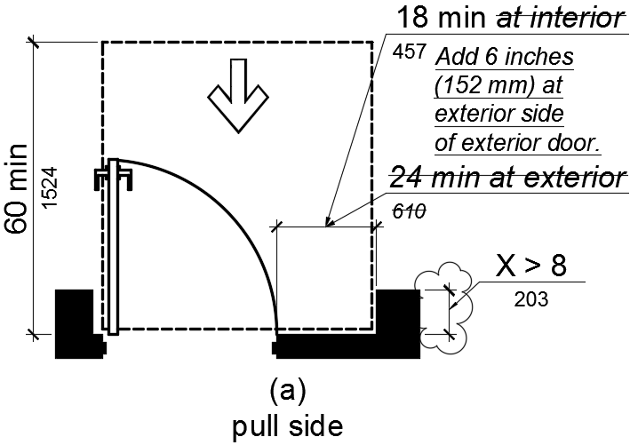
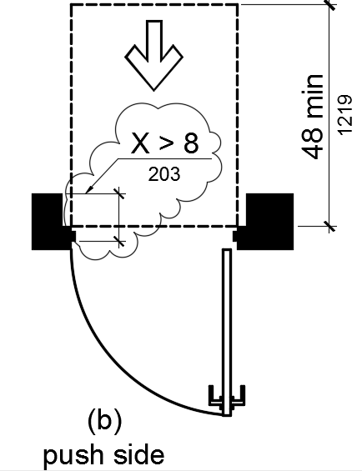
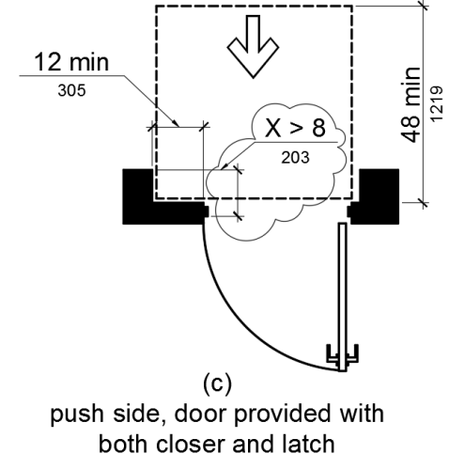

Figure 11B-404.2.4.3
Maneuvering Clearances at Recessed Doors and Gates

Code Text if Adopted
N/A

Rationale

CBC Section 11B-404.2.6 requires maneuvering clearance for forward approach when any obstruction within 24 inches of the latch side of an exterior doorway projects more than 8 inches beyond the face of the door; this requirement is illustrated in Figure 11B-404.2.4.3(a). However, the maneuvering clearance dimensions for the strike side clearance width are not consistent with Figure 11B-404.2.4.1(a) which illustrates the required maneuvering clearance for forward approach at an exterior door which is not recessed. DSA proposes to amend the latch side clearance width dimension in Figure 11B-404.2.4.3(a) to be consistent with Figure 11B-404.2.4.1(a); this dimension will read: “18 min” followed by “Add 6 inches (152 mm) at exterior side of exterior door.”
Amendments to vignettes (b) and (c) will correctly illustrate the code requirements that the alcove dimension is measured from the face of the door rather than the wall.

Comments

DSA Code Amendment development

Tracking
Date Received: -
DSA Tracking Number: N/A
Date Reviewed: 10/10/16
Status: Under consideration

Applicable Code
Applicable Code Section(s):
CBC Ch. 11B, Sect. 11B-502.6.4
Topic:
Accessible parking, identification, marking

Current Code Language

11B-502.6.4 Marking. Each accessible car and van space shall have surface identification complying with either Section 11B-502.6.4.1 or 11B-502.6.4.2.
11B-502.6.4.1 The parking space shall be marked with an International Symbol of Accessibility complying with Section 11B-703.7.2.1 in white on a blue background a minimum 36 inches wide by 36 inches high (914 mm by 914 mm). The centerline…
11B-502.6.4.2 The parking space shall be outlined or painted blue and shall be marked with an International Symbol of Accessibility complying with Section 11B-703.7.2.1 a minimum 36 inches wide by 36 inches high (914 mm by 914 mm) in white or a suitable contrasting color. The centerline…

Suggested Text of Proposed Amendment

11B-502.6.4 Marking. Each accessible car and van space shall have surface identification complying with either Section 11B-502.6.4.1 or 11B-502.6.4.2.
11B-502.6.4.1 The parking space shall be marked with an International Symbol of Accessibility complying with Section 11B-703.7.2.1 in white on a blue background a minimum 36 inches wide by 36 inches high (914 mm by 914 mm). (begin underline) A border may be provided inside, at, or outside of the minimum required ISA dimension. (end underline) The centerline…
11B-502.6.4.2 The parking space shall be outlined or painted blue and shall be marked with an International Symbol of Accessibility complying with Section 11B-703.7.2.1 a minimum 36 inches wide by 36 inches high (914 mm by 914 mm) in white or a suitable contrasting color. (begin underline) A border may be provided inside, at, or outside of the minimum required ISA dimension. (end underline) The centerline…

Code Text if Adopted
11B-502.6.4 Marking. Each accessible car and van space shall have surface identification complying with either Section 11B-502.6.4.1 or 11B-502.6.4.2.
11B-502.6.4.1 The parking space shall be marked with an International Symbol of Accessibility complying with Section 11B-703.7.2.1 in white on a blue background a minimum 36 inches wide by 36 inches high (914 mm by 914 mm). A border may be provided inside, at, or outside of the minimum required ISA dimension. The centerline…
11B-502.6.4.2 The parking space shall be outlined or painted blue and shall be marked with an International Symbol of Accessibility complying with Section 11B-703.7.2.1 a minimum 36 inches wide by 36 inches high (914 mm by 914 mm) in white or a suitable contrasting color. A border may be provided inside, at, or outside of the minimum required ISA dimension. The centerline…

Rationale

CBC Section 11B-502.6.4 requires an International Symbol of Accessibility (ISA) on the ground surface of standard accessible and van accessible parking spaces. DSA has received a number of questions about whether a border is required around the ISA; in response, DSA notes the text of the building code does not require a border around the ISA.
DSA is proposing to add permissive language which allows a border to be provided at the accessible parking ISA – either inside, at, or outside of the minimum required ISA dimension of 36” x 36”.

Comments

- For reference – Figure 11B-703.7.2.1 with proposed amendment:
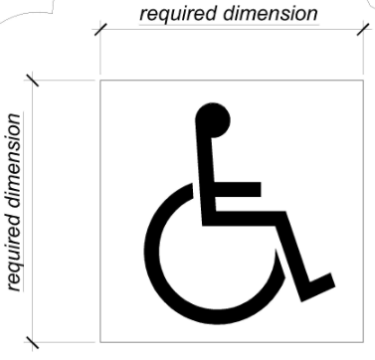

DSA Code Amendment development

Tracking
Date Received: -
DSA Tracking Number: N/A
Date Reviewed: 10/7/16
Status: Under consideration

Applicable Code
Applicable Code Section(s):
CBC Ch. 11B, Sect. 11B-604.7
Topic:
Feminine Hygiene Disposal Units

Current Code Language

11B-604.7 Dispensers. Toilet paper dispensers shall comply with Section 11B-309.4 and shall be 7 inches (178 mm) minimum and 9 inches (229 mm) maximum in front of the water closet measured to the centerline of the dispenser. The outlet of the dispenser shall be below the grab bar, 19 inches (483 mm) minimum above the finish floor and shall not be located behind grab bars. Dispensers shall not be of a type that controls delivery or that does not allow continuous paper flow.

Suggested Text of Proposed Amendment

11B-604.7 Dispensers (begin underline) and disposal units. Toilet paper dispensers and feminine hygiene disposal units shall comply with 11B-604.7. (end underline)

(begin underline) 11B-604.7.1 Dispensers. (end underline) Toilet paper dispensers shall comply with Section 11B-309.4 and shall be 7 inches (178 mm) minimum and 9 inches (229 mm) maximum in front of the water closet measured to the centerline of the dispenser. The outlet of the dispenser shall be below the grab bar, 19 inches (483 mm) minimum above the finish floor and shall not be located behind grab bars. Dispensers shall not be of a type that controls delivery or that does not allow continuous paper flow.

(begin underline) 11B-604.7.2 Disposal Units. (end underline) Feminine hygiene disposal unit, if provided, shall comply with 11B-309.4 and shall be wall mounted 18 inches (458 mm) minimum and 20 inches (508 mm) maximum in front of the water closet measured to the centerline of the disposal unit. The disposal unit shall be located below the grab bar, with the opening of the disposal unit 20" minimum (508 mm) and 22" (558 mm) maximum above the finish floor.

Code Text if Adopted

11B-604.7 Dispensers and disposal units. Toilet paper dispensers and feminine hygiene disposal units shall comply with 11B-604.7.

11B-604.7.1 Dispensers. Toilet paper dispensers shall comply with Section 11B-309.4 and shall be 7 inches (178 mm) minimum and 9 inches (229 mm) maximum in front of the water closet measured to the centerline of the dispenser. The outlet of the dispenser shall be below the grab bar, 19 inches (483 mm) minimum above the finish floor and shall not be located behind grab bars. Dispensers shall not be of a type that controls delivery or that does not allow continuous paper flow.

11B-604.7.2 Disposal Units. Feminine hygiene disposal unit, if provided, shall comply with 11B-309.4 and shall be wall mounted 18 inches (458 mm) minimum and 20 inches (508 mm) maximum in front of the water closet measured to the centerline of the disposal unit. The disposal unit shall be located below the grab bar, with the opening of the disposal unit 20" minimum (508 mm) and 22" maximum (558 mm) above the finish floor.

Rationale

A specific request to address placement of feminine hygiene disposal units, where provided in toilet rooms and toilet compartments, was made so that the disposal units would be in a location accessible to a user of the water closet.

Comments

- The title of Figure 11B-604.7 will be changed to Figure 11B-604.7.1. Figure 11B-604.7.2 will be added to the California Building Code.
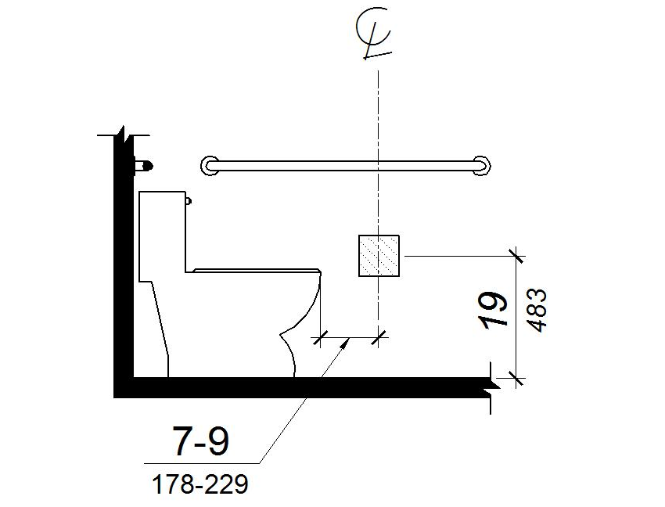

FIGURE 11B-604.7.1
DISPENSER OUTLET LOCATION
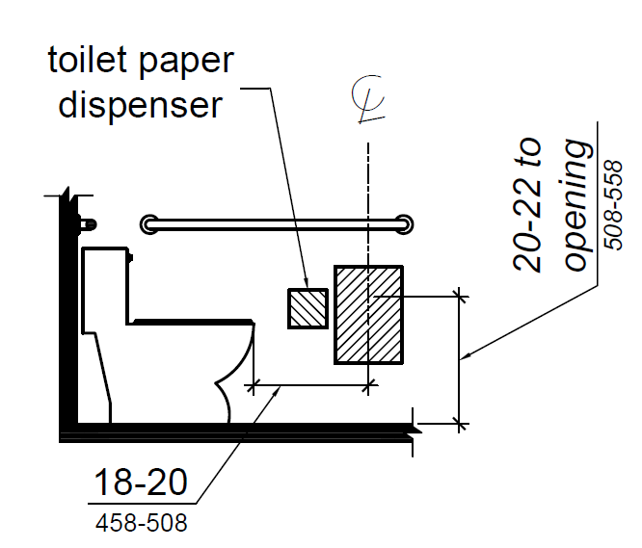
FIGURE 11B-604.7.2
DISPOSAL UNIT LOCATION

DSA Code Amendment development

Tracking
Date Received: -
DSA Tracking Number: N/A
Date Reviewed: 10/7/16
Status: Under consideration

Applicable Code
Applicable Code Section(s):
CBC Ch. 11B, Sect. 11B-703.7.2.1
Topic:
International Symbol of Accessibility dimension points

Current Code Language

11B-703.7.2.1 International Symbol of Accessibility. The International Symbol of Accessibility shall comply with Figure 11B-703.7.2.1. The symbol shall consist of a white figure on a blue background. The color blue shall approximate FS 15090 in Federal Standard 595C.

Suggested Text of Proposed Amendment

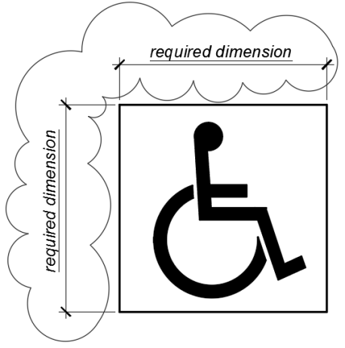

Figure 11B-703.7.2.1
International Symbol of Accessibility

Code Text if Adopted
N/A

Rationale

This amendment is proposed to provide code users with clarity for determining the dimension points when using the International Symbol of Accessibility.

Comments

DSA Code Amendment development

Tracking
Date Received: -
DSA Tracking Number: N/A
Date Reviewed: 10/7/16
Status: Under consideration

Applicable Code
Applicable Code Section(s):
CBC Ch. 11B, Sect. 11B-703.7.2.6
Topic: Toilet and bathing facilities geometric symbols

Current Code Language

11B-703.7.2.6 Toilet and bathing facilities geometric symbols. Geometric symbols at entrances to toilet and bathing rooms…

11B-703.7.2.6.1 Men’s toilet and bathing facilities. An equilateral triangle, 1/4 inch (6.4 mm) thick with edges 12 inches (305 mm) long and a vertex pointing upward, shall be located at entrances to men’s toilet and bathing facilities. The triangle symbol shall contrast with the door, either light on a dark background or dark on a light background.

Exception: Within secure perimeter…

11B-703.7.2.6.2 Women’s toilet and bathing facilities. A circle, 1/4 inch (6.4 mm) thick and 12 inches (305 mm) in diameter, shall be located at entrances to women’s toilet and bathing facilities. The circle symbol shall contrast with the door, either light on a dark background or dark on a light background.

Exception: Within secure perimeter…

11B-703.7.2.6.3 Unisex toilet and bathing facilities. A circle, 1/4 inch (6.4 mm) thick and 12 inches (305 mm) in diameter with a 1/4 inch (6.4 mm) thick triangle with a vertex pointing upward, superimposed on and geometrically inscribed within the circle and within the 12-inch (305 mm) diameter, shall be provided at entrances to unisex toilet and bathing facilities. The vertices of the triangle shall be located 1/4 inch (6.4 mm) maximum from the edge of the circle. The triangle symbol shall contrast with the circle symbol, either light on a dark background or dark on a light background. The circle symbol shall contrast with the door, either light on a dark background or dark on a light background.

Suggested Text of Proposed Amendment

11B-703.7.2.6 Toilet and bathing facilities geometric symbols. Geometric symbols at entrances to toilet and bathing rooms…

11B-703.7.2.6.1 Men’s toilet and bathing facilities. (begin strikeout) An equilateral triangle, (end strikeout) (begin underline) A triangle symbol shall be located at entrances to men’s toilet and bathing facilities. The triangle symbol shall be an equilateral triangle 1/4 inch (6.4 mm) thick with edges 12 inches (305 mm) long and a vertex pointing upward. (begin strikeout) shall be located at entrances to men’s toilet and bathing facilities. (end strikeout) The (begin underline) color of the (end underline) triangle symbol shall contrast with (begin underline) the color of (end underline) the door (begin underline) or surface on which the triangle symbol is mounted, (end underline) either light on a dark background or dark on a light background.

Exception: Within secure perimeter…

11B-703.7.2.6.2 Women’s toilet and bathing facilities. A circle (begin underline) symbol shall be located at the entrance to woman’s toilet and bathing facilities. The circle symbol shall be (end underline) 1/4 inch (6.4 mm) thick and 12 inches (305 mm) in diameter (begin strikeout) shall be located at entrances to women’s toilet and bathing facilities. (end strikeout) The (begin underline) color of the (end underline) circle symbol shall contrast with (begin underline) the color of (end underline) the door (begin underline) or surface on which it is mounted, (end underline) either light on a dark background or dark on a light background.

Exception: Within secure perimeter…

11B-703.7.2.6.3 Unisex toilet and bathing facilities. (begin strikeout) A circle, 1/4 inch (6.4 mm) thick and 12 inches (305 mm) in diameter with a 1/4 inch (6.4 mm) thick triangle with a vertex pointing upward, superimposed on and geometrically inscribed within the circle and within the 12-inch (305 mm) diameter, shall be provided at entrances to unisex toilet and bathing facilities. The vertices of the triangle shall be located 1/4 inch (6.4 mm) maximum from the edge of the circle. The triangle symbol shall contrast with the circle symbol, either light on a dark background or dark on a light background. The circle symbol shall contrast with the door, either light on a dark background or dark on a light background. (end strikeout) (begin underline) A combined circle and triangle symbol shall be located at entrances to unisex toilet and bathing facilities. The combined circle and triangle symbol shall consist of a circle symbol 1/4 inch (6.4 mm) thick and 12 inches (305 mm) in diameter with a 1/4 inch (6.4 mm) thick triangle symbol superimposed on and geometrically inscribed within the 12-inch (305 mm) diameter of the circle symbol. The vertices of the triangle symbol shall be located 1/4 inch (6.4 mm) maximum from the edge of the circle symbol with a vertex pointing upward. The color of the triangle symbol shall contrast with the color of the circle symbol, either light on a dark background or dark on a light background. The color of the circle symbol shall contrast with the color of the door or surface on which the combined circle and triangle symbol is mounted, either light on a dark background or dark on a light background. (end underline)

Code Text if Adopted

11B-703.7.2.6 Toilet and bathing facilities geometric symbols. Geometric symbols at entrances to toilet and bathing rooms…

11B-703.7.2.6.1 Men’s toilet and bathing facilities. A triangle symbol shall be located at entrances to men’s toilet and bathing facilities. The triangle symbol shall be an equilateral triangle 1/4 inch (6.4 mm) thick with edges 12 inches (305 mm) long and a vertex pointing upward. The color of the triangle symbol shall contrast with the color of the door or surface on which the triangle symbol is mounted, either light on a dark background or dark on a light background.

Exception: Within secure perimeter…

11B-703.7.2.6.2 Women’s toilet and bathing facilities. A circle symbol shall be located at the entrance to woman’s toilet and bathing facilities. The circle symbol shall be 1/4 inch (6.4 mm) thick and 12 inches (305 mm) in diameter. The color of the circle symbol shall contrast with the color of the door or surface on which it is mounted, either light on a dark background or dark on a light background.

Exception: Within secure perimeter…

11B-703.7.2.6.3 Unisex toilet and bathing facilities. A combined circle and triangle symbol shall be located at entrances to unisex toilet and bathing facilities. The combined circle and triangle symbol shall consist of a circle symbol 1/4 inch (6.4 mm) thick and 12 inches (305 mm) in diameter with a 1/4 inch (6.4 mm) thick triangle symbol superimposed on and geometrically inscribed within the 12-inch (305 mm) diameter of the circle symbol. The vertices of the triangle symbol shall be located 1/4 inch (6.4 mm) maximum from the edge of the circle symbol with a vertex pointing upward. The color of the triangle symbol shall contrast with the color of the circle symbol, either light on a dark background or dark on a light background. The color of the circle symbol shall contrast with the color of the door or surface on which the combined circle and triangle symbol is mounted, either light on a dark background or dark on a light background.

Rationale

During the 2015 Triennial Code Adoption cycle DSA received public comments from code users requesting clarification of the requirements of California’s enhanced provisions for the identification of toilet and bathing facilities.

The purpose of these code sections is to enable individuals who are blind or with low vision to locate the entrances to toilet and bathing facilities through the provision of geometric symbols. For individuals with low vision the current language requires the geometric symbols to contrast with the door on which they are mounted but is silent on any contrast requirements when the entrance to a toilet and bathing facility does not have a door. This situation is encountered at sports arenas, airports, concert halls and other facilities with a large number of occupants.

DSA also received comments indicating confusion on whether or not requirements for signs apply to the geometric symbols. The language of the provisions has been clarified to indicate the triangle, circle and combined circle and triangle are symbols; any signs provided to designate toilet and bathing facilities need to comply with distinct requirements in other parts of the code.

The proposed code amendments make specific the requirements for contrast between the geometric symbols and the surfaces on which they are mounted and clarify that they are symbols and not signs. There are no other substantive changes proposed beyond the clarifications noted above.

Comments

DSA Code Amendment development

Tracking
Date Received: -
DSA Tracking Number: N/A
Date Reviewed: 10/7/16
Status: Under consideration

Applicable Code
Applicable Code Section(s):
CBC Ch. 11B, Figure 11B-705.1(a)
Topic:
Truncated dome height

Current Code Language

11B-705.1.1.1 Dome size. Truncated domes in a detectable warning surface shall have a base diameter of 0.9 inch (22.9 mm) minimum and 0.92 inch (23.4 mm) maximum, a top diameter of 0.45 inch (11.4 mm) minimum and 0.47 inch (11.9 mm) maximum, and a height of 0.2 inch (5.1 mm).

Suggested Text of Proposed Amendment
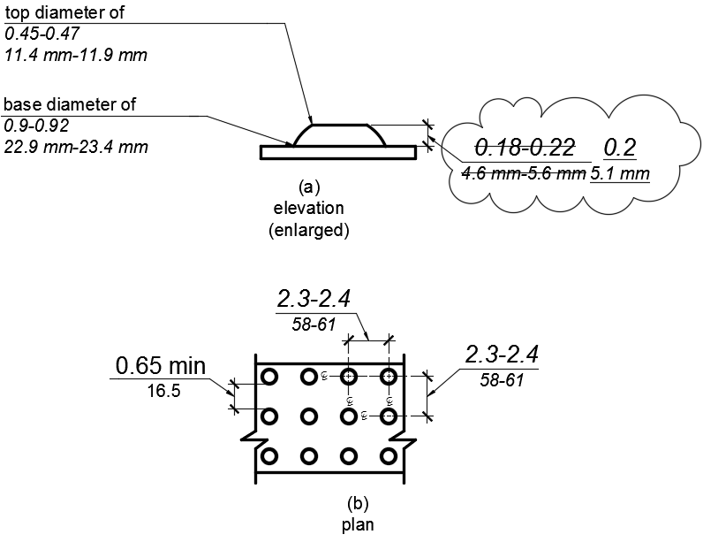

Figure 11B-705.1
Size and Spacing of Truncated Domes

Code Text if Adopted
N/A

Rationale

The revision occurs to the dimension in the figure for the height of the truncated domes. The proposed amendment will align the dimension in the figure to the code text that was amended during the rulemaking cycle for the 2016 triennial code.

Comments

- This revision is made in response to a comment from a code user who identified the discrepancy between the code text and the figure.

DSA Code Amendment development

Tracking
Date Received: -
DSA Tracking Number: N/A
Date Reviewed: 10/7/16
Status: Under consideration

Applicable Code
Applicable Code Section(s):
CBC Ch. 11B, Sect. 11B-812.5.2
Topic: Accessible route to EV charger

Current Code Language

11B-812.5.2 Accessible route to EV charger. An accessible route complying with Section 11B-402 shall be provided between the vehicle space and the EV charger which serves it.

Suggested Text of Proposed Amendment

11B-812.5.2 Accessible route to EV charger. An accessible route complying with Section 11B-402 shall (begin underline) connect (end underline) (begin strikeout) be provided between (end strikeout) the vehicle space and the EV charger which serves it.

Code Text if Adopted
11B-812.5.2 Accessible route to EV charger. An accessible route complying with Section 11B-402 shall connect the vehicle space and the EV charger which serves it.

Rationale

DSA received comments from code users that the current language was being misinterpreted to require an accessible route to be physically located so as to pass between the EV charger and the EVCS vehicle space which the EV charger serves.
This was not the intent of the original code provision; such a configuration would pose significant challenges to avoid conflicts with vehicle overhangs and blockage of the accessible route with deployed charging cables. The intent of the code requirement is to ensure there is an accessible route connecting the EVCS vehicle space with the EV charger that serves that space so that a user with mobility challenges may connect their vehicle with the EV charger.

Comments

DSA Code Amendment development

Tracking
Date Received: -
DSA Tracking Number: N/A
Date Reviewed: 10/7/16
Status: Under consideration

Applicable Code
Applicable Code Section(s):
CBC Ch. 11B, Sect. 11B-812.8.1
Topic:
Identification signs for EVCS

Current Code Language

11B-812.8 Identification signs. EVCS identification signs shall be provided in compliance with Section 11B-812.8.
11B-812.8.1 Four or fewer. Where four or fewer total EVCS are provided, identification with an International Symbol of Accessibility (ISA) shall not be required.

Suggested Text of Proposed Amendment

11B-812.8 Identification signs. EVCS identification signs shall be provided in compliance with Section 11B-812.8.
11B-812.8.1 Four or fewer. Where four or fewer total EVCS are provided, identification with an International Symbol of Accessibility (ISA) (begin underline) and signs identifying van accessible spaces (end underline) shall not be required.

Code Text if Adopted
11B-812.8 Identification signs. EVCS identification signs shall be provided in compliance with Section 11B-812.8.
11B-812.8.1 Four or fewer. Where four or fewer total EVCS are provided, identification with an International Symbol of Accessibility (ISA) and signs identifying van accessible spaces shall not be required.

Rationale

While original provisions did not require an ISA to be provided at the van accessible EVCS, this amendment clarifies that a "van accessible" sign is also not required when four or fewer EVCS are provided at a facility offering EV charging services.

Comments

