
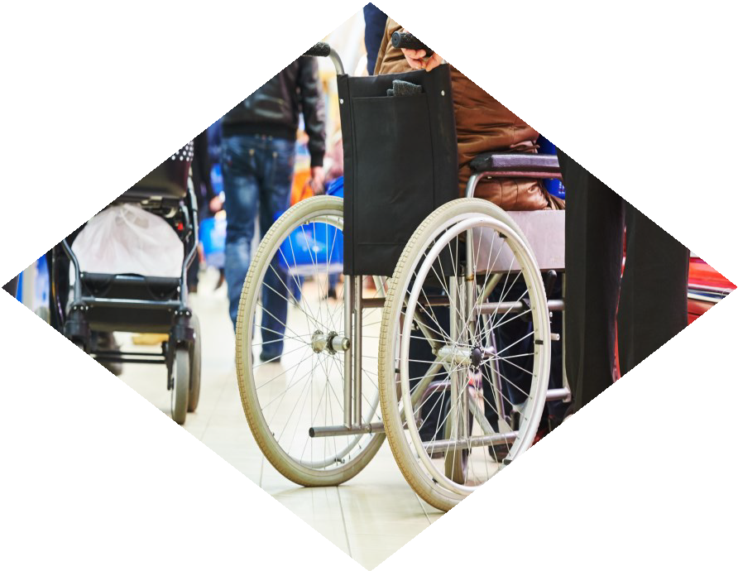

2024
ANNUAL REPORT TO THE LEGISLATURE

California Commission on Disability Access

March 31, 2025



This page was intentionally left blank.

Any questions regarding the following report can be directed to the California Commission on Disability Access (CCDA).



400 R Street, Suite 310
Sacramento, CA 95811
Phone: (916) 319-9974
Email: CCDA@dgs.ca.gov eFax: (916) 376-4216
Website: https://www.dgs.ca.gov/CCDA

Table of Contents

A Letter From CCDA Chair Commissioner Chris Downey | 1
A Letter From CCDA Executive Director April Dawson Rawlings | 2
Introduction | 3
Mission | 3
Vision | 3
History | 4
Reporting Requirements | 5
CCDA Staff | 5
Why This Report Matters | 6
Complaints and Prelitigation Letter Data Collection | 6
Data Overview - Complaints and Prelitigation Letters | 6
Table 1: Complaints and Prelitigation Letters Received by Year (2022-2024) | 6
Federal and State Court Filing Trends | 7
Table 2: 2022-2024 Filings Received by Commission (Federal vs. State) | 7
Alleged Construction-Related Physical Access Violations | 7
Table 3: Total Number of Alleged Construction-Related Physical Violations Received (2019-2024) | 7
Alleged Non-Construction-Related Physical Access Violations | 8
Table 4: Total Number of Alleged Non-Construction-Related Physical Violations Received (2024) | 8
Inaccessible Websites Violations Received | 9
Table 5: Top Website Barriers Submitted in 2024 | 9
Top Ten Alleged Construction-Related Physical Access Violations | 10
Top Frequent Businesses Featured in Complaints and Prelitigation Letters | 10
Table 6: Top Defendants’ Businesses (2024) | 11
Top Zip Codes | 12

Table 7: Top ZIP Codes (2024) | 12
Inset 1: Map of Top ZIP Codes by Number of Submissions to the CCDA Legal Portal - 2024 | 13
Inset 2: Map of Number of Submissions to the CCDA Legal Portal by ZIP Code - 2024 | 14
Volume Ranking of State and Federal Complaints Received from Law Firms | 15
Table 8: Volume of Submissions by Top 10 Law Firms (2024) | 15
Case Resolution Reports | 16
Data Overview - Case Resolution Reports (CRRs) | 16
Table 9: Case Resolution Reports Received by Type of Court Filing (2019-2024) | 16
Manner of Resolutions Reported for Cases | 17
Table 10: Percentage of Resolution Reported for Cases (2024) | 17
Construction-Related Access Barrier Remediation | 18
Supplemental Case Resolution Report Information | 18
Data Conclusions | 19
How the Data Shapes Our Work | 19
Commission and Subcommittee Breakdown | 20
Overview | 20
CCDA Commissioners | 21
CCDA Ex-officio Members | 25
CCDA Subcommittees | 27
Commission Tributes | 29
Commissioner Guy Leemhuis | 29
Pacific ADA Center Collaboration: Webinar Series | 29
25 Years of Olmstead v. L.C. Supreme Court Decision | 29

Commissioners Making An Impact — A Year in Review | 30
Overview | 30
Commissioner Ashley Leon-Vazquez | 30
Commissioner Ida Clair, FAIA | 31
Commissioner Jacqueline Jackson | 31
Projects in Progress and CCDA’s Path Forward | 32
Overview | 32
Legal Portal | 32
Accessible Parking Campaign (APC) | 33
CCDA’s Listening Forums | 34
CCDA’s Social Media and Outreach | 35
Web Accessibility Toolkit | 36
2024 Pacific ADA Center Webinar Collaboration Series | 37
Disability Access and Education Revolving Fund (DAER Fund) | 38
CCDA Outreach Efforts | 39
Overview | 39
CCDA’s Social Media and YouTube | 39
CCDA and Statewide Independent Living Council of Georgia (SILCGA) Webinar – The ADA and the Evolution of Inclusion | 39
Events Attended by CCDA in 2024 | 40
County of Ventura’s First Annual Government and Disability Summit | 40
Pacific ADA Center Conference Presentation | 40
City of San José 16th Annual Disability Awareness Day | 40
Certified Access Specialist Institute (CASI) Conference | 40

Appendices | 41
Appendix A: 2019-2024 Case Files and Prelitigation Letters  Received by the Commission | 41
Appendix B: 2024 Top 10 Alleged Violations | 42
Appendix C: Place of Public Accommodation Categories | 43
Appendix D: Complaints and Prelitigation Letters Received by Places of Public Accommodation (2021-2024) | 45
Appendix E: Case Resolution Report Questions and Responses (2023-2024) | 47
2024 Case Resolution Report Responses | 47
2023 Case Resolution Report Responses | 48
Appendix F: Summary of Five-Year Strategic Goals | 49
Appendix G: Summary of 2022-2023 Two-Year Strategic Goals | 50
References | 51


Dear Legislators:

I am so proud of all that was achieved by CCDA in 2024. CCDA continued to live our mission of increasing access across California through deepening existing partnerships, convening stakeholder listening forums, and building new relationships with municipalities, and business and disability advocacy groups. Our most notable achievement this year was the release of our two Guides for Accessible Parking for business owners and operators as well as the construction industry. These guides are the result of two years of intense stakeholder engagement and are a valuable tool in the effort to put accessibility at the front end of projects, rather than as an afterthought. I look forward to building on the momentum of 2024 into the coming years.

Sincerely,

Chris Downey
Chris Downey CCDA Chair

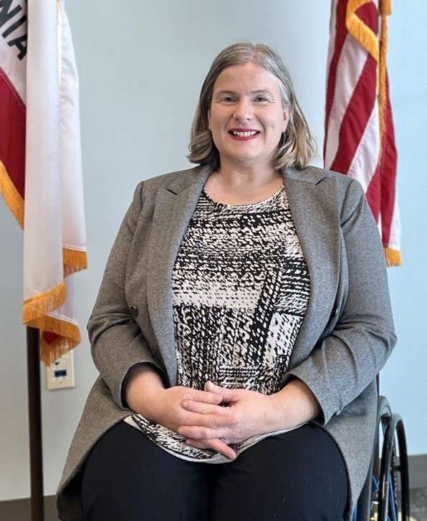
Dear Legislators:

I am pleased to present our 2024 Annual Report. Our data analysis of the top trends in business accessibility litigation continues to inform conversations across stakeholder groups and provides the basis for examining solutions around high frequency litigation and
maintaining accessibility to businesses for people with disabilities. This year, to increase transparency, CCDA is listing the names of the law firms associated with the top ten highest volume submissions to our portal, rather than simply referring to the law firm by their numbered rank on the list. We hope this change will offer a more complete data set to aid the dialogue around business accessibility issues.
CCDA is proud to be a connector between the business and disability communities, as well as all levels of government. This year, CCDA continued to engage with local communities through our listening forums in Monterey and Orange County, where we heard from local leaders in government, disability advocates and business. We also partnered across state lines with the Georgia State Independent Living Council to host a screening of a film about the history of the Americans with Disabilities Act. Our webinar series with the Pacific ADA Center covered topics such as maintaining accessibility during the holiday shopping season for retail stores and service animal etiquette. We look forward to growing our community connections and empowering those on the front lines of business accessibility with the information and resources to be successful.

Sincerely,

April Dawson Rawlings
April Dawson Rawlings CCDA Executive Director

Introduction
Mission
The mission of the California Commission on Disability Access (CCDA) is to promote disability access in California through dialogue and collaboration with stakeholders including, but not limited to, the disability and business community and all levels of government.
In order to achieve this mission, the CCDA is authorized by California Government Code Sections 14985-14985.11 to act as an information resource; to research and prepare advisory reports of findings to the Legislature on issues related to disability access, compliance inspections and continuing education; to increase coordination between stakeholders; to make recommendations to promote compliance with federal, and state laws and regulations; and, to provide uniform information about programmatic and architectural disability access requirements to the stakeholders.



Vision
The Commission, together with key partners, adopted a vision statement to reflect the ideal future state when the Commission’s mission is accomplished:

An Accessible, Barrier-Free California
=
Inclusive and Equal Opportunities and Participation for All Californians!

History
In 2008, the California State Legislature concluded that in many instances, persons with disabilities continued to be denied full and equal access to public facilities even though that right was provided under state and federal law. The Legislature further concluded that businesses in California have the responsibility to provide full and equal access to public facilities as required in
laws and regulations, but that compliance may be impeded, in some instances, by conflicting state and federal regulations, resulting in unnecessary litigation.
Senate Bill 1608 (Corbett, Chapter 549, Statutes of 2008) established the California Commission on Disability Access (Commission) with a vision toward developing recommendations to the Legislature. These recommendations would help enable persons with disabilities to exercise their right to full and equal access to public facilities while facilitating business compliance with applicable laws, building standards and regulations to avoid unnecessary litigation.
In September 2012, Senate Bill 1186 (Steinberg, Chapter 383, Statutes of 2012) revised and recast the Commission’s duties by making it a priority to develop and disseminate educational materials and information to promote and facilitate disability access compliance. Senate Bill 1186 also established annual reporting of prelitigation letters and complaints to the Legislature by the Commission.
In October 2015, Assembly Bill 1521 (Committee on Judiciary, Chapter 755, Statutes of 2015) was signed into law as an urgency measure and required the Commission to collect, study, and report on case outcomes.
In September 2016, Senate Bill 1406 (Mendoza, Chapter 892, Statutes of 2016) added review and reporting on prelitigation letters and complaints served on educational entities to the Commission’s existing obligation to review those served on public accommodations. Also, Assembly Bill 54 (Olsen, Chapter 872, Statutes of 2016) was enacted, giving the Commission the authority to establish a standard report format for receiving complaints and prelitigation letters.
On July 1, 2017, the Commission became incorporated with the Department of General Services (DGS), resulting in the Commission’s initial governing statutes, Government Code Sections 8299 – 8299.11, being replaced by Government Code Sections 14985 – 14985.11 (Assembly Bill 111, Committee on Budget, Chapter 19, Statutes of 2017).
In 2022, Assembly Bill 2917 (Fong, Chapter 897, Statutes of 2022) expanded the Commission's existing requirement for reviewing and reporting construction-related physical access violations served on places of public accommodations to include prelitigation letters and complaints about website accessibility violations. Furthermore, Assembly Bill 2917 expanded the Commission's priority to develop and disseminate educational materials and information relating to a business's obligations for website accessibility compliance, such as their obligations and how to facilitate compliance from a business perspective.

Reporting Requirements

This report outlines the Commission’s ongoing efforts to implement Government Code Sections 14985.5 and 14985.6. In general, these sections mandate the Commission to provide information to businesses on compliance with disability access requirements; recommend programs to enable persons with disabilities to obtain full and equal access to public facilities; provide information to the Legislature on access issues and compliance; develop and disseminate educational materials and information to promote and facilitate disability access compliance.

This report also provides tabulated data, including:

- The various types of construction-related physical access violations alleged in prelitigation letters and complaints
- The number of complaints alleged for each type of violation
- A list of the 10 most frequent types of accessibility violations alleged
- The numbers of alleged violations for each listed type
- The number of complaints received that were filed in state or federal court
- Filing frequencies and location frequencies
- The ZIP codes of complaints received
- The percentage of attorney, plaintiff, and defendant filings
- The resolution reached on complaints submitted

CCDA Staff

Executive Director – April Dawson Rawlings Operations Manager – Phil McPhaul
Administrative and Legislative Analyst – Abigail Ridge Marketing and Outreach Analyst – Presley Strother
Data and Research Analyst – Stephanie Groce

Why This Report Matters

The purpose of this report is to illustrate trends in alleged disability access violation court filings, so that CCDA can better target our education and outreach efforts. The Top 10 Alleged Disability Access Violations published in this report provides a valuable resource for businesses as they assess how to achieve and maintain disability access compliance.

Complaints and Prelitigation Letter Data Collection

Data Overview - Complaints and Prelitigation Letters
California Civil Code Section 55.32 requires attorneys to submit construction-related disability access complaints and prelitigation letters received by entities in California to the CCDA within five business days of a court filing. While complaints are the plaintiff’s attorney’s plea to the court, prelitigation letters are sent with demands to resolve the dispute prior to litigation.
In 2024, CCDA received approximately 3,513 state and federal complaints. This represented a decrease in submissions of state and federal complaints to the CCDA Legal Portal from 4,066 submissions in 2023.
On the other hand, CCDA received 806 prelitigation submissions in 2024. This continued the
trend of increased submissions of prelitigation letters seen 2023.
Table 1 outlines the total number of complaints and prelitigation letters submitted to CCDA over the past three years. See Appendix A for further information on complaints and prelitigation
letters received by CCDA from 2019 to 2024.

Table 1: Complaints and Prelitigation Letters Received by Year (2022-2024)

Year | Complaints (State & Federal) | Prelitigation Letters | Total
2024 | 3,513 | 806 | 4,319
2023 | 4,066 | 555 | 4,621
2022 | 2,957 | 10 | 2,967
Total: | 10,536 | 1,371 | 11,907

Federal and State Court Filing Trends
In 2024, CCDA received 422 federal court case filings and 3,091 state court case filings. Despite the number of federal court case filings increasing since 2023, the trend seen in 2023 of state court case filings making up most of the complaints submitted to the CCDA Legal Portal continued. Prior to 2022, federal court case filings made up most of the submissions, as seen in the graph and table for Appendix A.

Table 2 outlines the number of federal and state court filings submitted from 2022 to 2024. For more information on the outcome of these filings, refer to the Case Resolution Reports section.

Table 2: 2022-2024 Filings Received by Commission (Federal vs. State)

Type of Filing  Received | 2022  Total | 2022  Percent | 2023  Total | 2023  Percent | 2024  Total | 2024  Percent
Federal | 788 | 27% | 362 | 9% | 422 | 12%
State | 2,170 | 73% | 3,704 | 91% | 3,091 | 88%
Total: | 2,958 | 100% | 4,066 | 100% | 3,513 | 100%

Alleged Construction-Related Physical Access Violations
CCDA received 10,994 alleged construction-related access violations from 4,319 complaints and prelitigation letters in 2024. The number of alleged construction-related violations represented a slight increase compared to the 10,591 received in 2023. In 2024, there was on average 2.5 alleged barrier related dropdowns selected per complaint and pre-litigation letter submitted.

Table 3 outlines the total number of alleged construction-related access violations received by CCDA between 2019-2024.

Table 3: Total Number of Alleged Construction-Related Physical Violations Received (2019-2024)

Year | Number of Alleged Construction-Related Physical Violations
2024 | 10,994
2023 | 10,591
2022 | 6,981
2021 | 8,596
2020 | 9,533
2019 | 7,507
Total: | 43,208

Alleged Non-Construction-Related Physical Access Violations
Assembly Bill (AB) 2917 was chaptered in September 2022 and required complaints and prelitigation letters alleging website inaccessibility be submitted to the CCDA Legal Portal. As a result, CCDA saw a sharp uptick in submissions regarding alleged inaccessible websites in 2023. For more information, see the section titled Inaccessible Websites Violations Received.

For other non-construction-related violations, CCDA received one submission in which the plaintiff was refused service due to their service dog. There were also 22 instances in which staff or policy created a barrier. A common theme with many of these 22 submissions is the allegations that staff did not interact appropriately with the plaintiff or were not trained in the use or maintenance of accessible features of the business.

Combined with the number of submissions referencing inaccessible websites, there were 4,512 submissions for non-construction-related barriers received in 2024.

This is a sharp increase of non-construction related barriers as there were only 464 in 2023. This increase is directly related to the rise in the number of submissions related to website barriers. In 2024, there were 1,045 submissions that had website related barriers listed resulting in 4,489 website violations being alleged.

Table 4 outlines the total number of alleged non-construction-related violations received in 2024.

Table 4: Total Number of Alleged Non-Construction-Related Physical Violations Received (2024)

Non-Construction-Related Physical Violation | Number of Instances
Website Violation | 4,489
Mobile Application Violation | 0
Service Animal Violation | 1
Program Access (Rideshare, Hand-control, Rental Bike Service) | 0
Program Access (Company Policy) | 22
Total: | 4,512

Inaccessible Website Violations Received
Table 5 illustrates the top alleged website barriers submitted to CCDA in 2024.

The top five website barrier selections numbered 3,811 and make up 84.90% of alleged website barriers selected in complaint and prelitigation letter submissions made to the CCDA Legal Portal in 2024. Multiple barriers can be alleged in one complaint or prelitigation letter, which is why the total number of website barriers is greater than the 1,045 submissions where Website was marked as the location. On average, there were 3.6 alleged website barrier dropdowns selected for submissions related to websites.

Table 5: Top Website Barriers Submitted in 2024

Website Barrier | Number of Instances
Text alternatives were not provided for non-text content on website.  (e.g., alt text for images and form buttons were not provided, text labels for form inputs were not provided, etc.) | 960
Content not appropriately/logically marked on website. (e.g., semantic markups not used, tables not used for tabular data, only visual/auditory cues, content restricted to portrait/landscape, etc.) | 826
Navigation order is not logical on website. (e.g., navigation order of links, form elements, etc. is not logical and intuitive, etc.) | 823
Hyperlinks not meaningful on website. (e.g., link's purpose can't be inferred by link text, not clear links with same text go different places,  external hyperlink doesn't say it leaves page, etc.) | 821
Alternatives not provided for time-based media on website. (e.g., descriptive text transcripts, text/audio descriptions, synchronized captions not provided for non-live, web-based content, etc.) | 381
Total: | 3,811

Top Ten Alleged Construction-Related Physical Access Violations
In 2024, the total number of reported alleged construction-related access violations was approximately 10,994. The ten most reported alleged construction-related access violations totaled 8,303, or 75.52% of all alleged construction-related access violations reported in the CCDA Legal Portal in 2024.

The highest reported alleged violation was “Parking: Existing spaces are non-compliant (e.g., excessive slopes/cross-slopes, improper dimensions, striping, etc.).,” with 1,755 reports. It also made up 15.96% of all alleged physical access barriers selected. This alleged violation moved to first place from 2023 annual report where it was in second place.

In second place, “Path of Travel- Exterior: Routes to and from parking lot or public right of way are not accessible (e.g., non-compliant surfaces, excessive slope/cross-slope, lack of detectable warnings, not protected from traffic, etc.).” had 1,197 reports and it made up 10.89% of all barrier codes selected. This alleged construction-related access violation moved up to second place in 2024 from fourth place in 2023.

Of the top alleged construction-related access violations, three were in the “Parking” category, one was in the “Access to Goods, Support, Services, and Equipment” category, three were in the “Path of Travel – Exterior” category, two were in the “Path of Travel – Interior” category, and one was in the “Toilet, Lavatory, and Bathing Facilities” category.

A trend that has continued from 2023 is the growth of alleged barriers selected in the “Toilet, Lavatory, and Bathing Facilities” category. CCDA noted that barrier code “Toilet, Lavatory and Bathing Facilities: Main entry doors are not accessible or not on accessible route (e.g., thresholds, handles, pulls, latches, locks, clearances, etc. are non-compliant).” was in ninth place in 2024. This is an upward trend from when in 2023 this barrier was 11th place. Furthermore, the alleged barrier code, “Toilet, Lavatory, and Bathing Facilities- Access height/clearance of counters is non-compliant, plumbing not sufficiently covered or not located properly.”, was tenth in 2023, it dropped to 11th with 251 selections in 2024. Additionally, had this been a top 15 list, the 11th, 12th, 13th, and 15th spots would have all been from the “Toilet, Lavatory, and Bathing Facilities” category.

For more information on the top alleged construction-related access violations in 2024, refer to
Appendix B.

Top Frequent Businesses Featured in Complaints and Prelitigation Letters

From the submissions received in 2024, the top five businesses included were either gas stations or establishments serving food or drink. Establishments serving food and drink were the next most frequent location type, with three fast food franchises and one café franchise. The throughline for all these businesses is that they were places that the public can patronize to receive goods and/or services. Ten businesses were included in Table 6.
For more information on the number of each type of public accommodation in complaints and prelitigation letters submitted to the CCDA in 2024, please refer to Appendix D.

Table 6: Top Defendants’ Businesses (2024)

General Description of Business and Place of Public Accommodation Category | Number of Filings Received
Subway: A Franchise Fast Food Restaurant (Establishments Serving Food or Drink) | 32
Shell: A Franchise Gas Station (Service Establishment) | 30
Starbucks: A Franchise Coffee Shop (Establishments Serving Food or Drink) | 29
ARCO: A Franchise Gas Station (Service Establishment) | 29
Chevron: A Franchise Gas Station (Service Establishment) | 20
Walgreens: A Franchise Pharmacy and Retail Establishment (Sales or Rental Establishment) | 16
McDonalds: A Franchise Fast Food Restaurant (Establishments Serving Food or Drink) | 16
Target: A Franchise Retail Establishment (Sales or Rental Establishment) | 15
Dollar Tree: A Franchise Retail Establishment (Sales or Rental Establishment) | 12
Burger King: A Franchise Fast Food Establishment (Establishments Serving Food or Drink) | 12
Total: | 211

Top ZIP Codes
In 2024, CCDA reviewed the most frequent ZIP codes in which alleged access violations occurred in complaints and prelitigation letters submitted to the CCDA Legal Portal. The most received ZIP code in complaint and prelitigation letter submissions was 90028 in the Hollywood area of Los Angeles.

Table 7 outlines these ZIP codes as well as their corresponding neighborhoods, if applicable.

Table 7: Top ZIP Codes (2024)

Ranking | ZIP  Code | City (Region) | Corresponding Local  Neighborhoods (Districts) | County
1 | 90028 | Los Angeles | Hollywood | Los Angeles County
2 | 91732 | El Monte | El Monte | Los Angeles County
3 | 91776 | San Gabriel | San Gabriel | Los Angeles County
4 | 90210 | Beverly Hills | Beverly Crest | Los Angeles County
5 | 92101 | San Diego | San Diego | San Diego County
6 | 92868 | Orange | Orange | Orange County
7 | 94533 | Fairfield | Fairfield | Solano County
8 | 90660 | Pico Rivera | Pico Rivera | Los Angeles County
9 | 93003 | Ventura | Ventura | Ventura County
10 | 90012 | Los Angeles | Chinatown | Los Angeles County
11 | 90803 | Long Beach | Long Beach | Los Angeles County

The map located below, Inset 1, depicts the top ZIP codes by number of submissions received in 2024 as seen in Table 7. The submissions, in this instance refer to complaints and prelitigation
letters.

Inset 1: Map of Top ZIP Code by Number of Submissions to the CCDA Legal Portal - 2024
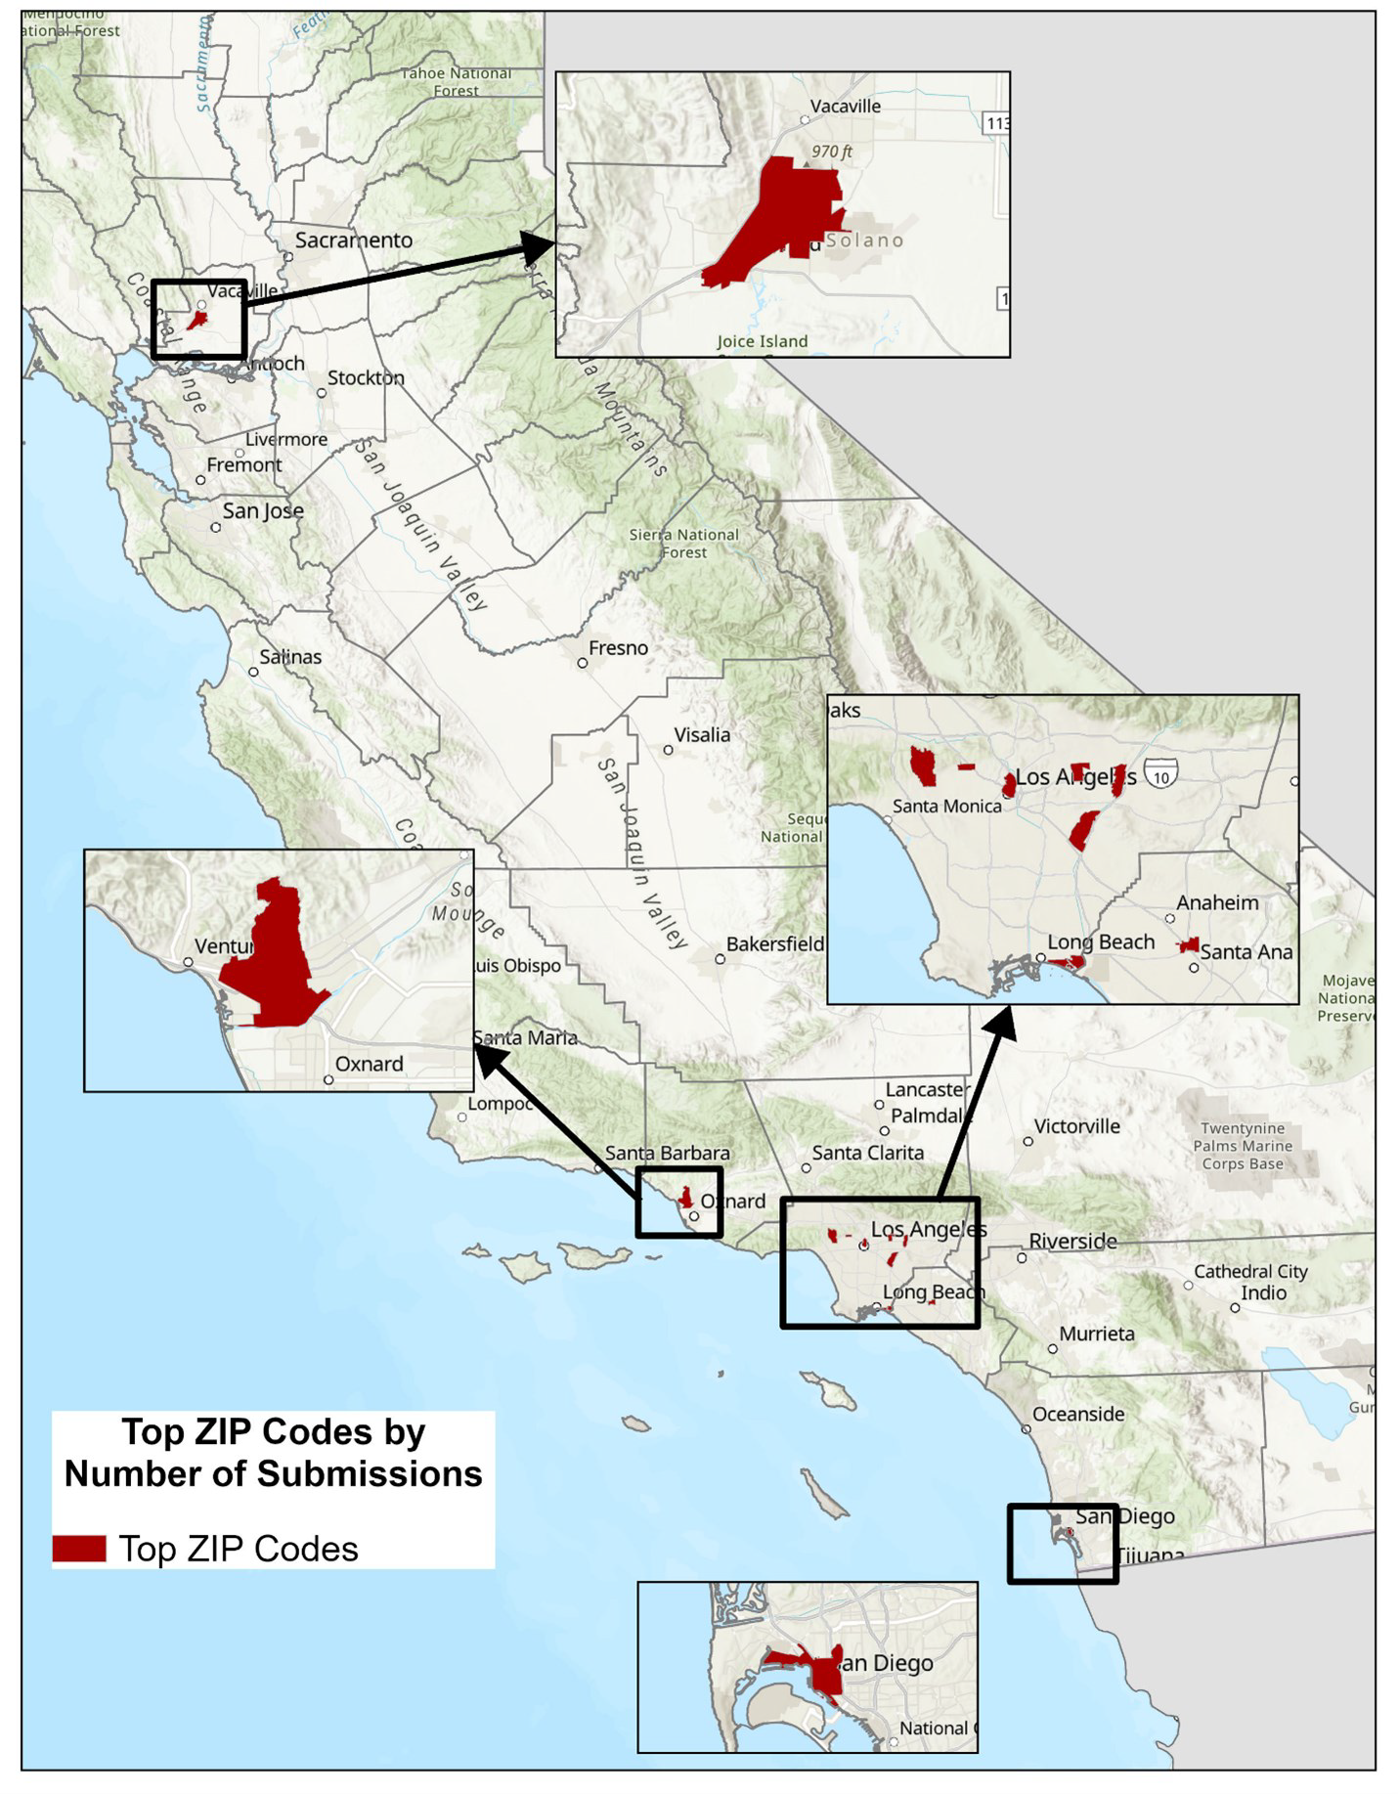

Inset 2: Map of Number of Submissions to the CCDA Legal Portal by ZIP Code - 2024
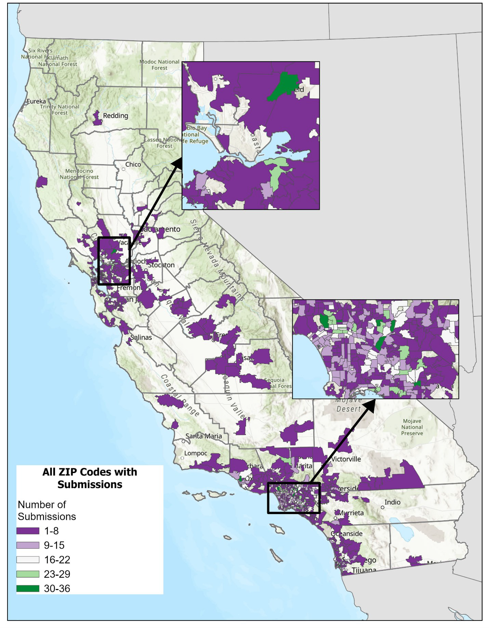
The map for Inset 2 has highlighted areas where at least one complaint or prelitigation letter submitted to the CCDA Legal Portal listed that ZIP code in the business address. The ZIP code 90028 in Hollywood was the most-referenced ZIP code in submissions received in 2024. Seven of the most frequent ZIP codes in 2024 were in Los Angeles County: 90028, 91732, 91776, 90210, 96610, 90012, and 90803. The other four most frequent ZIP codes were in San Diego County (92101), Orange County (92868), Solano County (94533), and Ventura County (93003).
Inset 1 and Inset 2 also reflects the ZIP codes listed for businesses in complaints and prelitigation letters where “Website” was listed as a location where barriers were encountered.

Volume of State and Federal Complaints Received from Law Firms
There were approximately 4,319 state and federal complaints and prelitigation letters submitted in 2024. The law firm that submitted the most complaints and prelitigation letters
submitted 41.1% of these submissions. Altogether, the ten highest submitting law firms were responsible for 95.8% of all complaints and prelitigation letters received in 2024.

Three of these top-submitting law firms were located in Northern California while six were located in in Southern California. One of most submitting law firms is located out of state.

For a breakdown of the percentage of complaints and prelitigation letters submitted by law firms in 2024, refer to Table 8.

Table 8: Volume of Submissions by Top 10 Law Firms (2024)

Name of Law Firm | Complaints and Prelitigation Letters Count | Percentage of Count
Manning Law, APC | 1,775 | 41.1%
The Law Office of Hakimi &  Shahriari | 802 | 18.6%
Law Office of Morse Mehrban | 418 | 9.7%
Seabock Price APC | 299 | 6.9%
The Reddy Law Firm | 279 | 6.5%
Pacific Trial Attorneys | 182 | 4.2%
The Strojnik Firm LLC | 168 | 3.9%
Valenti Law APC | 90 | 2.1%
Law Office of Richard A Mac  Bride | 70 | 1.6%
Moore Law Firm, P.C. | 55 | 1.3%
Other Law Firms | 181 | 4.2%
Total: | 4,319 | 100.0%

Case Resolution Reports

Data Overview - Case Resolution Reports (CRRs)
As part of California Civil Code Section 55.32, attorneys are required to submit a report of the resolution of the construction-related disability access complaints and prelitigation letters they filed in CCDA’s Legal Portal. These Case Resolution Reports (CRRs) allow CCDA to collect data on the outcome of the construction-related disability access complaints and prelitigation letters previously submitted to the CCDA Legal Portal by attorneys.
In 2024, CCDA received approximately 4,623 CRRs, representing a decrease of 687 from the CRRs in 2023. The majority of CRRs received were for complaints filed in the State Superior Court, which correlates with the rise of complaints filed in state courts that CCDA received since 2022.
Finally, there was a rise in CRRs that did not state the name of the corresponding court which are for prelitigation letters (prelitigation letters are not filed in a state or federal court). The number of CRRs for prelitigation letters rose from 91 in 2023 to 219 in 2024. This corresponds to the trend of increased submissions of prelitigation letters. As seen in Table 9, CRRs for prelitigation letters were not over 15 between the years of 2022 to 2019.
Table 9 provides further information on CRRs received from 2019 to 2024.

Table 9: Case Resolution Reports Received by Type of Court Filing (2019-2024)

Type of Complaint | 2024 | 2023 | 2022 | 2021 | 2020 | 2019
Federal | 422 | 2,559 | 2,917 | 1,979 | 954 | 1,397
State | 3,982 | 2,660 | 1,587 | 275 | 341 | 276
Prelitigation Letters | 219 | 91 | 4 | 7 | 15 | 12
Not Processed | N/A | N/A | 74 | 63 | N/A | 10
Total: | 4,623 | 5,310 | 4,582 | 2,324 | 1,310 | 1,695

Manner of Resolutions Reported for Cases

The CCDA routinely examines three types of case resolution categories: settlements, judgments, and dismissals.

In 2024, CCDA received 2,570 CRRs stating they were settled, including settlements, settlement/ dismissals, and judgment/settlement. The majority of CRR submissions featured settlements as part of the process of resolving cases either as “only settlements” with 1,725 or “settlement/ dismissals” with 842.

Additionally, there were 2,349 dismissals reported to the CCDA in 2024, including CRRs reporting dismissal, settlement/dismissal, and judgment/dismissal. About half of the CRR submissions listed dismissals in the process of resolving cases with 1,505 listing their manner of resolution as “only dismissal” and 842 were “settlements/dismissals.”

Lastly, CRRs reporting 551 judgments were received by the CCDA in 2024. This includes judgments, settlement/judgments, and judgment/dismissals. Overall, judgment was the least submitted manner of resolution.

Table 10 illustrates the total number of settlements, dismissals, and judgments.

Table 10: Percentage of Resolutions Reported for Cases (2024)

Manner of Resolution | Instances | Percentage
Only Settlement | 1,725 | 37.3%
Only Dismissal | 1,505 | 32.6%
Only Judgement | 546 | 11.8%
Settlement, Dismissal | 842 | 18.2%
Judgement, Dismissal | 2 | 0.0%
Judgement, Settlement | 3 | 0.1%
Totals: | 4,623 | 100.0%

Construction-Related Access Barrier Remediation
In 2024, CCDA identified 1,828 CRRs reporting that the plaintiff received injunctive relief. This is a drop from the 3,212 reported in 2023. In 2023, most CRRs listed that the plaintiff received injunctive relief at 61% as opposed to the trend in 2024, in which only 40% of plaintiffs received injunctive relief. Information on the data from remediations from 2023 and 2024 can be found in Appendix E.

Supplemental Case Resolution Report Information

In 2024, 34 defendants requested an early evaluation conference. This is similar to the
amount reported in 2023 with 31.

Also, 42 defendants requested a site inspection by a Certified Access Specialist (CASp) in 2024 which is a small decrease from the 62 that did in 2023. This continues the trend seen in 2023 where 99% of defendants did not utilize early evaluation conferences or requesting a site inspection by a CASp.

For further comparisons between CRRs received in 2023 and 2024, refer to Appendix E.

Data Conclusions
Through analysis of data submitted to the CCDA Legal Portal, some notable trends could be observed.

First, state court filed complaints continue to make up the majority of submissions. This is a trend that started in 2022 after federal court filed complaints were the majority of submissions from 2016 through 2021.

Furthermore, there has been a continued trend of increased submissions of prelitigation letters being submitted to the CCDA Legal Portal. From 2018 to 2022, the number of prelitigation letters submitted to the CCDA had never been above 50. In 2024 the number of prelitigation letters rose to 806 from the 555 submitted in 2023. This is also tied to the rise in CRRs listing “Not Stated” for the court due to more CRRs being submitted for prelitigation letters. As it takes time for cases to be resolved, it is probable that the number of CRRs tied to prelitigation letters will continue to rise in the following years.

Finally, with Assembly Bill 2917 chaptered in 2022, CCDA prepared for an increase in complaints and prelitigation letters involving website barriers being submitted to the CCDA Legal Portal. That increase was seen in 2023 but rose sharply in 2024 with 1,045 website related submissions. There was also an increase in alleged website related barriers with 4,489 alleged website barriers selected in those submissions.

How the Data Shapes Our Work
CCDA is committed to applying a data driven approach to fulfilling our mission. The data received through our Legal Portal produces information about trends in alleged construction and website related disability access violation claims. CCDA gathers data with the goal of assisting businesses in achieving access compliance for people with disabilities by analyzing the nature of the alleged violations, the types of businesses where the complaints are alleged, and the region where the complaints allegedly occurred. By analyzing the Legal Portal data, CCDA can deploy access education to the communities in California that need it most.

Commission and Subcommittee Breakdown

Overview
The CCDA delegated a specific scope to subcommittees to accomplish its mandates and to help determine how the Commission will use data for projects.
Each committee member brings their unique voice and background to the table while keeping Title III of the Americans with Disabilities Act (ADA), architectural barrier removal, and the built environment at the forefront of their minds and discussions.
Members of the CCDA were selected as specified by the provision of Government Code section 14985.1. The CCDA membership is as follows:
- Two (2) public members were appointed by the Senate Committee on Rules, with one appointee from the business community and one from the disability community.
- Two (2) public members were appointed by the Speaker of the Assembly, with one appointee from the business community and one from the disability community.
- Seven (7) public members were appointed by the Governor, with the consent of the Senate. Four (4) of the appointees must be from the disability community, and three (3) of the appointees must be from the business community.
- The State Architect, or their representative, as a nonvoting ex officio member.
- The Attorney General, or their representative, as a nonvoting ex officio
member.
- Two members of the Senate, appointed by the Senate Committee on Rules as nonvoting ex officio members. One member shall be from the majority party, and one member shall be from the minority party.
- Two members of the Assembly, appointed by the Speaker of the Assembly, as nonvoting ex officio members. One member shall be from the majority party, and one member shall be from the minority party.
The goal of the CCDA is to select public members who shall participate in and contribute to the activities of the CCDA commission committees and subcommittees to ensure the timely delivery of committee deliverables.
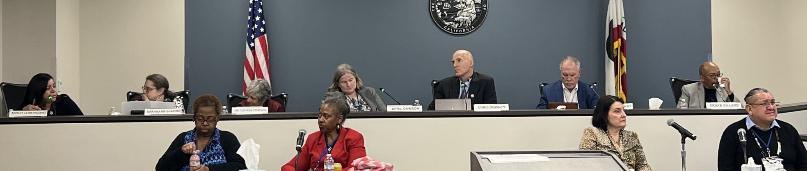

CCDA Commissioners

Name & Photo | Appointment Type (Governor, Speaker of the Assembly, Senate Committee on Rules) | Commission Role | Term Dates (Start – End)
Drake Dillard  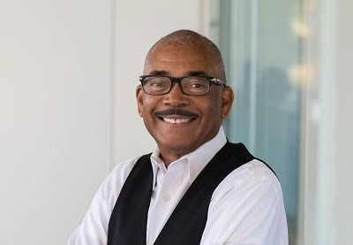 | Governor  Business Community | Chair of Checklist Committee  Committee Member of Executive Committee | 2022 - 2025
Chris Downey   | Governor  Disability Community | Chair of Commission  Chair of Executive  Committee | 2021 - 2024
Dr. Souraya Sue ElHessen  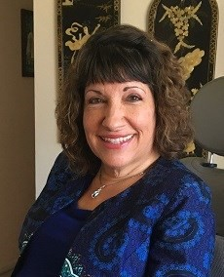 | Governor  Disability Community | Chair of Education and Outreach Committee  Committee Member of Executive Committee | 2022 - 2025

Name & Photo | Appointment Type (Governor, Speaker of  the Assembly, Senate Committee on Rules) | Commission Role | Term Dates (Start – End)
Brian Holloway  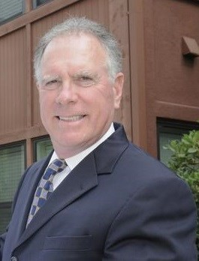 | Senate Committee on Rules  Business Community | Vice Chair of CCDA  Committee Member of Executive Committee | 2023 - 2026
Jacqueline Jackson  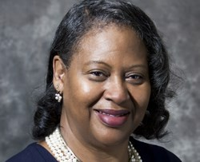 | Governor Disability Community | Committee Member of Legislative Committee | 2022 - 2025
Guy Leemhuis   | Senate Committee on Rules  Disability Community | Immediate Past Chair  Committee Member of Executive Committee | 2021 - 2024

CCDA Commissioners (Continued)

Name & Photo | Appointment Type (Governor, Speaker of the Assembly, Senate Committee on Rules) | Commission Role | Term Dates (Start – End)
Ashley Leon-Vazquez   | Speaker of the Assembly  Business Community | Committee Member of Education and Outreach Committee | 2021 - 2024
Scott Lillibridge  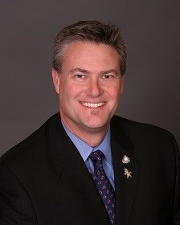 | Governor  Business Community | Chair of Legislative  Committee  Committee Member of Executive Committee | 2021 - 2024
Dr. Luciana Profaca   | Governor  Disability Community | Committee Member of Education and Outreach Committee | 2023 - 2026

Name & Photo | Appointment Type (Governor, Speaker of the Assembly, Senate Committee on Rules) | Commission Role | Term Dates (Start – End)
Héctor Ramírez  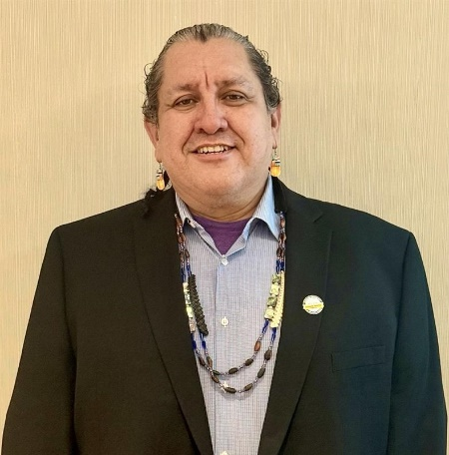 | Speaker of the Assembly  Disability Community | Committee Member of Education and Outreach Committee | 2023 – 2026
Sarahann Shapiro   | Governor Business Community CBPA Representative | Committee Member of Legislative Committee | 2023 - 2026

CCDA Ex-officio Members

Name & Photo | Office
Ida Clair, FAIA   | State Architect  The Division of the State Architect
Ben Conway   | Deputy Attorney General  Commissioner Representing California Attorney General Rob Bonta
Assembly Member Juan Alanis  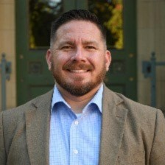 | Assembly District 22  Republican Party

Name & Photo | Office
Assembly Member Matt Haney   | Assembly District 17  Democratic Party
Senator Melissa Hurtado  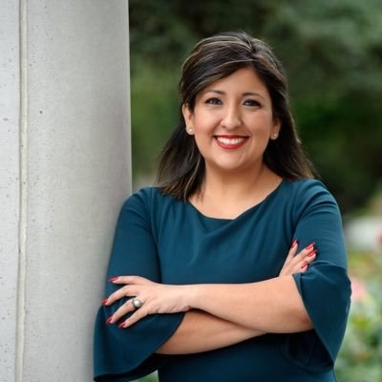 | Senate District 16  Democratic Party
Senator Rosilicie Ochoa Bogh   | Senate District 19  Republican Party

CCDA Subcommittees
Executive Committee

Purpose
The Executive Committee was created to discuss and act on operational and management level topics regarding the Commission. The Executive Committee is composed of the CCDA Chair, Vice Chair, Immediate-Past Chair, and the current Chair from each subcommittee.

Members
Commissioner Chris Downey – Chair
Commissioner Brian Holloway – Vice-Chair
Commissioner Drake Dillard – Chair of Checklist Committee
Commissioner Dr. Souraya Sue EIHessen – Chair of Education and Outreach Committee Commissioner Scott Lillibridge – Chair of Legislative Committee
Checklist Committee

Purpose
The Checklist Committee was created to work on technical documents and special projects related to the Commission.

Members
Commissioner Drake Dillard – Chair of Checklist Committee Commissioner Brian Holloway
Michelle Davis – Division of the State Architect
Richard Halloran – City of San Francisco
Beth Maynard – California Building Standards Commission
Ike Nnaji – Certified Access Specialist (CASp)
Mehdi Shadyab – City of San Diego, Certified Access Specialist (CASp) Bill Zellmer – Sutter Health, Certified Access Specialist (CASp)

Legislative Committee

Purpose
The Legislative Committee was created to discuss disability-related legislation and policy matters.

Members
Commissioner Scott Lillibridge – Chair of Legislative Committee Commissioner Jacqueline Jackson
Commissioner Sarahann Shapiro Commissioner Ben Conway
Dan Okenfuss – California Foundation for Independent Living Centers
Education and Outreach Committee

Purpose
The Education and Outreach Committee was created to discuss and advise on education and outreach topics for the business and disability communities.

Members
Commissioner Dr. Souraya Sue EIHessen – Chair of Education and Outreach Committee Commissioner Ashley Leon-Vazquez
Commissioner Dr. Luciana Profaca Commissioner Héctor Ramírez
Michelle Davis – Division of the State Architect
Zeenat Hassan – Disability Rights California
Arnie Lerner – FAIA, CASp
Stephen Simon – City of Los Angeles, Department on Disability

Commission Tributes
Overview

CCDA would like to hold tribute to significant events and people to commemorate and celebrate their contributions to the organization's mission. These tributes allow CCDA to show appreciation, preserve history, and recognize achievements.

Commissioner Guy Leemhuis

CCDA honors Commissioner Guy Leemhuis for his exceptional leadership and years of dedicated service. As 2024 marked the conclusion of his tenure with the Commission, CCDA wishes to recognize his invaluable contributions. Commissioner Leemhuis served as Chair of the CCDA, guiding the organization through a critical period of transition as it became part of DGS. Even after his time as Chair, Commissioner Leemhuis continued to play an influential role within the Commission, serving as the CCDA Immediate Past Chair. In this capacity, he provided a wealth of historical perspective and mentorship, helping to guide new members and ensure the Commission remained focused on its mission. Throughout his career as an attorney, Commissioner Leemhuis represented hundreds of individuals with disabilities, advocating tirelessly for their rights. His commitment to promoting better access for people with disabilities in California remained unwavering throughout his time with the Commission. A passionate advocate, Commissioner Leemhuis educated his colleagues and the public on ways to enhance accessibility and support for the disability community across the state. CCDA Commissioners have expressed their profound gratitude for Commissioner Leemhuis’ leadership, dedication, and service. His contributions have left an indelible mark on the Commission and the broader disability community.

Pacific ADA Center Collaboration: Webinar Series

Throughout 2024, CCDA collaborated with the Pacific ADA Center for a three-part 2024 Webinar Series hosted by Executive Director April Dawson Rawlings and Pacific ADA Center Deputy Director of ADA Programs Jan Garrett. Each webinar served as a venue to provide resources and information for businesses to enhance ADA compliance and learn more about why the ADA is important. The 2024 Webinar Series covered a range of topics from employment to effective business customer service during the holiday season. The webinars will be part of the CCDA's 2025 programming to increase technical assistance throughout California. CCDA is thrilled to continue our collaborative efforts and commitment to ensuring access for all.

25 Years of Olmstead v. L.C. Supreme Court Decision

The 25th anniversary of the Olmstead v. L.C. Supreme Court decision was in June 2024, which
affirmed that unjustified segregation of individuals with disabilities is unlawful discrimination under the ADA and Section 504 of the Rehabilitation Act. To commemorate this milestone, CCDA Executive
Director April Dawson Rawlings and Pacific ADA Center Deputy Director Jan Garrett hosted a special webinar in July 2024. The event also honored the 34th anniversary of the ADA, bringing together a panel to discuss the evolution of the law and key court cases that have advanced accessibility and inclusion. The conversation underscored how far we have come in fostering equity and independence, while also reminding us of the work still to be done. The webinar was both a celebration of progress and a tribute to the countless advocates whose efforts have shaped a more inclusive society for all.

Overview
Throughout the year, CCDA Commissioners make an impact in their communities. CCDA is having an impact across California, whether it is through Commissioners developing relationships with community partners or bringing their expertise and experiences to the table in projects.

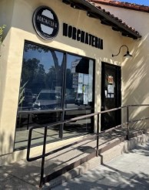
Commissioner Ashley Leon-Vazquez

Commissioner Ashley Leon-Vazquez is a small business owner of Horchateria Rio Luna, a coffee shop offering items rooted in Latino and Mexican culture. Starting in 2018, she and her family had a goal of bringing a taste of their heritage to their local community.
Horchateria Rio Luna has two stores in southern California, and they demonstrate the importance of ADA compliance and community engagement within the stores’ local communities. Her storefront businesses incorporate features such as wheelchair ramps and accessible seating arrangements, ensuring accessibility for customers with disabilities.

Commissioner Leon-Vazquez’s commitment to accessibility in her California businesses shows how inclusive practices can be beneficial in business operations. Horchateria Rio Luna hosts events that feature local talent,
which encourages local engagement and support from the community. These events provide a platform for local artists and create an accessible, welcoming space for all members of the community.

Commissioner Leon-Vazquez’s dedication to access compliance creates spaces where everyone
feels welcomed and included. Her businesses show the positive impact that inclusive, community
-focused business practices can have. By ensuring disability access and promoting inclusivity, small business owners like Commissioner Leon-Vazquez can make a positive impact on their community and provide equal opportunities for all.

Commissioner Ida Clair, FAIA
The American Institute of Architects (AIA) is a leading professional organization dedicated to supporting architects and architectural professionals through resources, education, and advocacy to promote excellence in design and the built environment. Among its most
prestigious honors is the designation of Fellow of the American Institute of Architects (FAIA), an accolade that fewer than three percent of architectural professionals achieve. AIA Fellowship is the highest membership honor bestowed by the organization, recognizing individuals who have made significant and lasting contributions to the field of architecture, including through public service, education, and leadership.

In 2024, a select group of AIA California members received this esteemed recognition for their outstanding work and contributions to architecture and society. One such honoree is Commissioner Ida Clair, who, as California’s State Architect and the first woman to hold this role, has made profound impacts on the state’s built environment. Commissioner Clair’s exceptional leadership and dedication to advancing the profession, coupled with her commitment to creating an inclusive and sustainable built environment, have earned her the well-deserved distinction of FAIA in 2024. Her impact continues to inspire both the architecture community and the broader public.

Commissioner Jacqueline Jackson

Commissioner Jacqueline Jackson is a disability rights advocate that is actively involved in her community. She holds a spot as a committee member for the CCDA Legislative Committee and is the chair of the Political Action Committee for the NAACP San Diego.
Commissioner Jackson works with a variety of local organizations who aim to ensure public spaces and services are accessible for individuals with disabilities.

Commissioner Jackson is actively engaged with Access for Independence INC, the City of San Diego Accessibility Advisory Board, and a member of the San Diego Registrar of Voters Accessibility Advisory Committee. This year, she has been recognized for her dedication to accessibility in her community by receiving awards from the Fourth District Senior Resource Center and the Mayor of San Diego, Todd Gloria. She was recently appointed to Assemblywoman Akilah Weber's Senior Advisory Council.

The Golden Pyramids Scholars program in San Diego, was founded by Commissioner Jackson while she was the Director of Education, Health, and Family Services for the San Diego Urban League. This program supports high-achieving students by offering mentorships, scholarship opportunities, educational activities, and community service opportunities. Commissioner Jackson's commitment to accessibility for all and her focus on helping students succeed shows how much she cares about making her community better for all.

Overview
CCDA is focused on strengthening its outreach and engagement efforts to help businesses achieve access compliance for individuals with disabilities. By analyzing data from the CCDA Legal Portal and fulfilling legislative mandates, CCDA identifies trends in alleged violations, highlighting the types of businesses and regions that would benefit most from additional support and resources. This data-driven approach allows the Commission to target communities across California with tailored access education and resources. A key priority is to increase collaboration and technical assistance, ensuring all stakeholders are equipped with the tools and knowledge needed for access compliance. Through these efforts, CCDA strives to create a more inclusive and accessible environment for people with disabilities throughout the state.

Legal Portal
Per California Civil Code Section 55.32, California law firms are required to submit complaints, prelitigation letters and CRRs associated with alleged construction-related physical access violations to CCDA. The CCDA Legal Portal was created as a vehicle for attorneys to submit this information to CCDA in lieu of emailed or mailed submissions. By the start of 2023, all data migration projects of past physical and emailed submissions had been completed.
In 2022, Assembly Bill 2917 was enacted and mandated CCDA to include attorney-submitted website accessibility violations data along with construction-related physical access violations. In response, CCDA added a new website category to the portal allowing law firms to specify how a website was inaccessible in 2023. In 2024 alone, CCDA was able to see the response to the passage of this law as there were 226 submission of website accessibility violations. In comparison, only 1 website accessibility case was received in 2022.
For more information on CCDA’s response to Assembly Bill 2917, refer to Inaccessible Websites Violations Received in the Complaints and Prelitigation Letters Data Collection section.

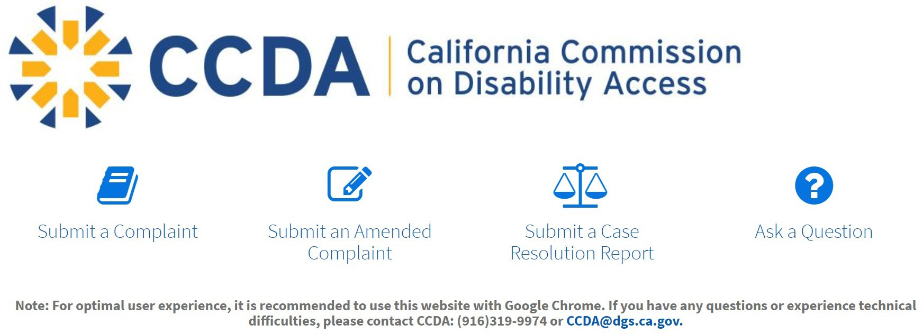
Path Forward:
CCDA is continuing to update our Legal Portal with more detailed drop downs that
attorneys can choose to describe the nature of the alleged construction-related physical access violations and physical website accessibility violations in each complaint reported to us. This will greatly assist CCDA with tailoring our approach to website accessibility education.

Accessible Parking Campaign (APC)
APC is CCDA’s statewide initiative aimed at creating educational toolkits to guide California businesses and contractors on accessibility standards related to accessible parking and external paths of travel (accessible routes). This effort supports the Commission's legislative mandate under Assembly Bill 2917, which directs the development and distribution of educational materials in line with the CCDA's DGS 2022-2023 Two-Year Strategic Goals. To develop the toolkits, CCDA established two stakeholder work groups led by CCDA commissioners.

The Business Owners & Operators work group, included ADA Coordinators and business professionals from across California. The Construction Industry Work Group, consisting of contractor experts and individuals involved in the construction industry, provided specialized insights.
In 2023, the Division of the State Architect (DSA) reviewed the toolkits for technical guidance and provided revisions, which were then incorporated by the CCDA in collaboration with DGS Real Estate Services Division (RESD). After incorporating these adjustments, both toolkits were finalized and approved by the Commission in 2024.
The distribution phase for the finalized toolkits began in 2024. The toolkits are now available for digital access on the CCDA website, and printed copies are also available. As part of the outreach efforts, CCDA partnered with the Contractors State License Board (CSLB), where Executive Director April Dawson Rawlings attended a monthly board meeting to promote the toolkits. CCDA continues to expand its outreach to ensure wide access to these valuable resources.
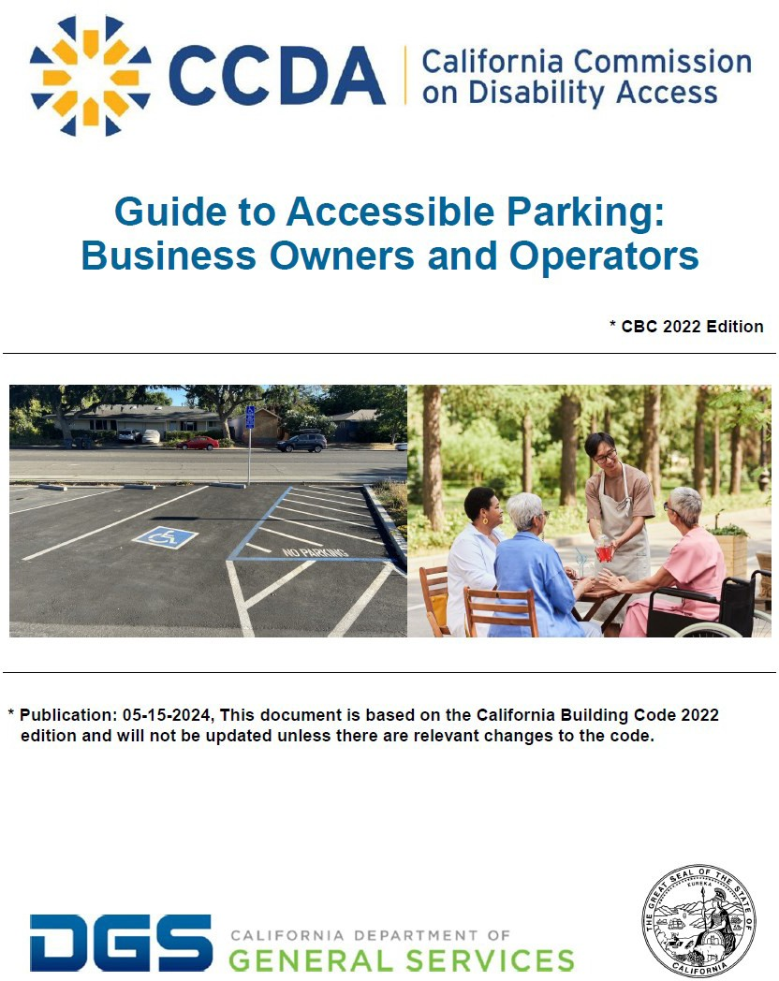
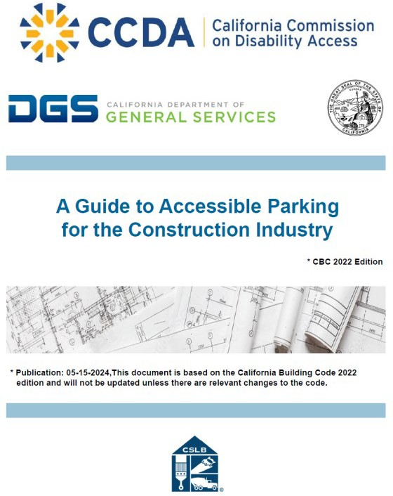
Path Forward:
2024 marked the beginning of the distribution logistics, marketing plan, and outreach for the two toolkits. Both toolkits are being translated into multiple languages to ensure they are accessible to individuals and communities from all backgrounds. This inclusive approach aims to make the toolkits available to a wide range of users, regardless of language or location. Additionally, CCDA has plans to update the toolkits with the latest information, including the current California Building Code (CBC). These updates are essential for ensuring that the toolkits reflect the most accurate and relevant standards for the industries they serve.

CCDA’s Listening Forums
In 2024, CCDA organized three Listening Forums aimed at fostering meaningful dialogue between the business, disability, and government communities at various levels. These forums were held in key locations across California, including Salinas, Sunnyvale, and Irvine, and were conducted in different formats to ensure maximum accessibility—either in-person, virtually, or as hybrid events.
In April, CCDA partnered with the County of Monterey Office of Civil Rights to host a hybrid Listening Forum in Salinas, which allowed small businesses and members of the disability community to participate both in person and virtually. This forum provided an opportunity for stakeholders to discuss accessibility challenges and solutions in the local business environment. Later that month, CCDA worked with the Pacific ADA Center and the City of Sunnyvale to conduct a virtual forum focused on ADA Title II and Title III training for city staff and area businesses. This training aimed to enhance understanding of the ADA and its implications for local businesses and government services.
In July, CCDA hosted an in-person Listening Forum in Irvine, where business leaders and members of the disability community came together to share insights and concerns.
Representatives from the local center for independent living and chambers of commerce were also present, fostering a collaborative environment where actionable solutions could be discussed.
The overarching goal for 2024-2025 is to trial different formats and assess the outcomes of each Listening Forum. By gathering feedback and reflecting on the takeaways from these events, CCDA intends to refine its approach and develop a more effective engagement strategy for 2026-2027. This ongoing process of evaluation and adaptation will ensure that CCDA remains responsive to the needs of both the business and disability communities, fostering greater inclusion and accessibility across California.
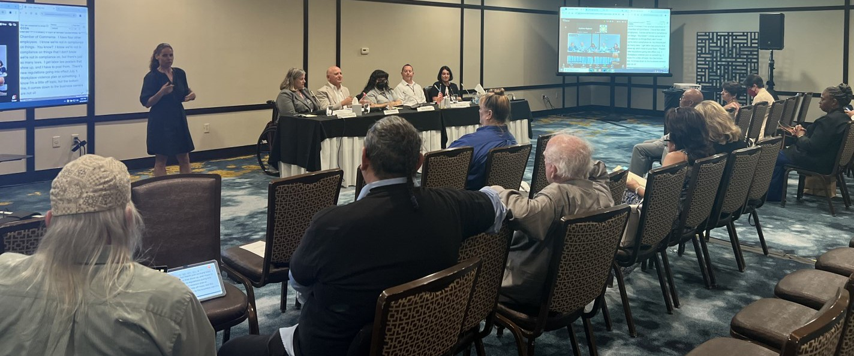
Path Forward:
Building on the success and lessons learned from the 2024 Listening Forums, CCDA intends to continue its outreach efforts across California in 2025. These forums will be a vital aspect of the ongoing dialogue between the business and disability communities, as well as government
affiliates, ensuring that each group has a venue to share their experiences, difficulties, and solutions to accessibility and inclusion. As the forums continue, CCDA will actively solicit
feedback from attendees, stakeholders, and partners, carefully considering the outcomes of 2024 and 2025. CCDA will need to continuously analyze and modify its engagement strategy to ensure it is inclusive and effective.

CCDA’s Social Media and Outreach

CCDA has effectively built a strong social media presence, primarily through its Facebook and YouTube platforms, to enhance its outreach and keep the public informed. Through these channels, CCDA shares crucial updates on accessibility compliance and promotes a variety of educational materials. Facebook is utilized to share announcements, engage with followers through interactive content, and highlight key events, while YouTube focuses on providing video resources, including past meetings and webinars, with closed captioning for accessibility. The strategic use of social media allows CCDA to strengthen connections with businesses, government entities, and the general public, advancing its mission to improve disability access throughout California.
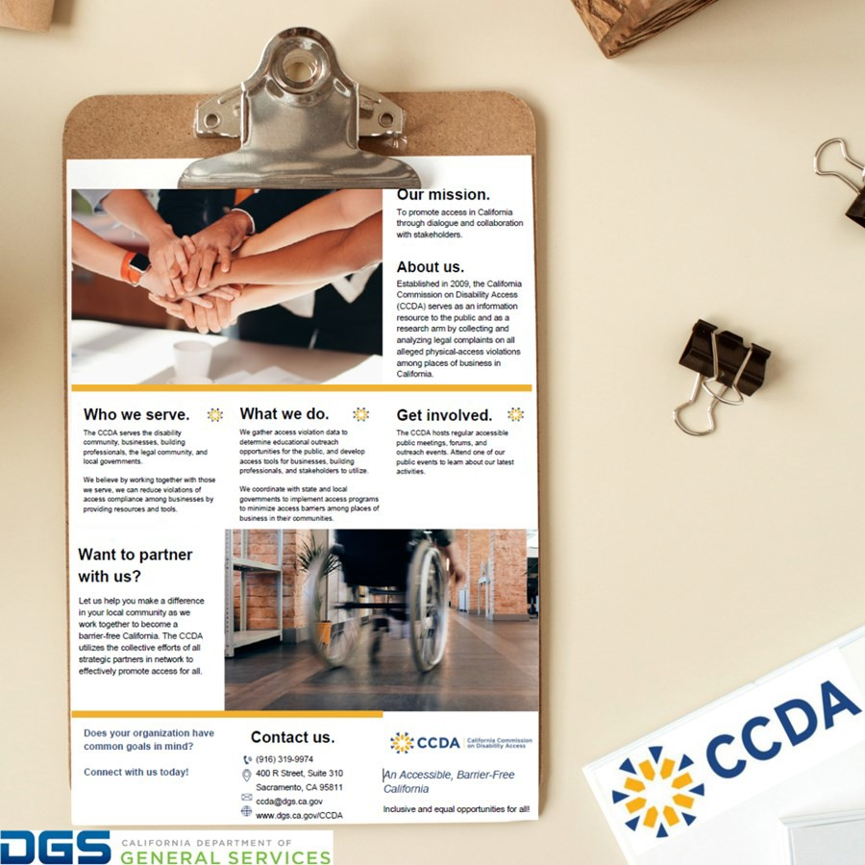

Path Forward:
CCDA plans to enhance our social media presence by diversifying our content with educational posts, meeting information, upcoming events, and infographics based on CCDA’s resources. Community engagement will be prioritized through interactive Facebook campaigns Q&A session posts, while YouTube will feature previously recorded meetings,
listening forums, webinars, and our new YouTube mini-series “Busting Barriers – Fact or Fiction” beginning in 2025. Accessibility features will remain a focus, ensuring content includes captions, alt text, and plain language.

Web Accessibility Toolkit
In response to Assembly Bill 2917 enacted in 2022, CCDA is developing a comprehensive Web Accessibility Toolkit aimed at educating businesses about the accessibility requirements for internet websites. This initiative was mandated by Assembly Bill 2917, which also addresses other accessibility concerns, such as parking lots and exterior paths of travel.

While places of public accommodation are governed by Title III of the ADA, the Department of Justice (DOJ) has yet to issue regulations for website accessibility for places of public accommodation. To fill this gap, the Web Content Accessibility Guidelines (WCAG) have been widely adopted as the standard for making web content accessible. WCAG provides detailed recommendations on how to make websites accessible to individuals with disabilities, addressing aspects such as making websites navigable with screen readers and providing images with text alternatives for non- text material.

The purpose of CCDA’s Web Accessibility Toolkit is to provide awareness, describe the items that commonly apply to web accessibility using WCAG guidelines, and provide information about available resources and best practices. The Web Accessibility Toolkit is currently in the review and development stage.

Path Forward:
Throughout 2025, CCDA will continue to develop its Web Accessibility Toolkit and provide resources on accessibility standards for internet websites, and to facilitate compliance with those requirements. Once CCDA’s Web Accessibility Toolkit is finalized, it will serve as a critical resource for businesses in California.

2024 Pacific ADA Center Webinar Collaboration Series
The 2024 Webinar Collaboration Series hosted by CCDA and Pacific ADA Center offered information for businesses to enhance access compliance and learn more about why the
ADA is important for business owners or operators. CCDA Executive Director April Dawson Rawlings and Pacific ADA Center Deputy Director of ADA Programs Jan Garrett were the presenters for the 3-Part 2024 Webinar Collaboration Series.
Part 1: ADA Opportunities for Small Businesses Webinar provided an overview of the ADA
Titles, focusing on Title I (Employment) and Title III (Public Accommodations). The presenters covered effective communication, physical accessibility, the role of service animals, and the
interactive process between employers and employees with disabilities.

Part 2: Disability Rights in Today’s World - Celebrating 34 Years of ADA and 25 Years of Olmstead celebrated the evolution of the ADA and several landmark court cases that have help create a path to a more accessible, barrier-free society for all. This part featured a live moderated panel that provided views of how the ADA impacts society.

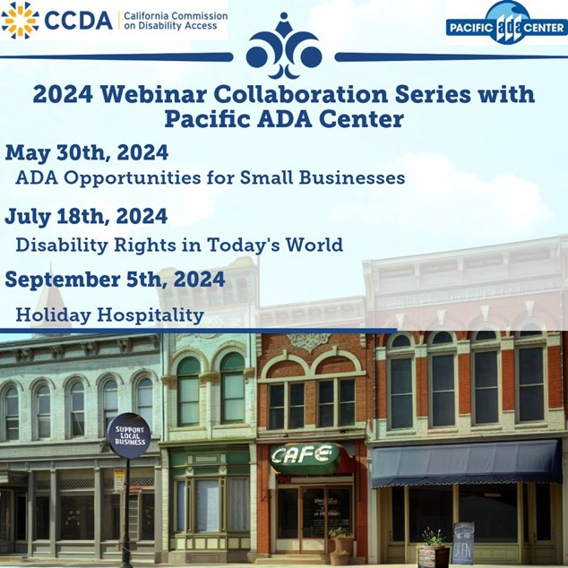
Part 3: Holiday Hospitality- Effective Customer Service for Customers with Disabilities covered customer service, focusing on accessibility for customers with disabilities during the busy holiday season. The collaboration series with the Pacific ADA Center has provided educational videos and resources that can help businesses improve their understanding and implementation of the ADA within their place of business.

Path Forward:
CCDA is excited to continue our partnership with the Pacific ADA Center to bring additional accessibility training to enhance ADA compliance in employment practices and public accommodations. Building on the success of the 2024 3-Part Webinar Collaboration Series, CCDA is developing new content to help businesses better understand and implement accessibility best practices. Recordings and webinar materials from the 2024 series, which covered topics like customer service accessibility tips, service animals, and the evolution of the ADA, are available on CCDA’s website and YouTube Channel. Each webinar is captioned and American Sign Language interpreted. Our goal remains to provide a suite of training
materials that businesses can use to educate managers and employees on serving customers with disabilities.

Disability Access and Education Revolving Fund (DAER Fund)
The Disability Access and Education Revolving Fund (DAER Fund) is aimed at promoting compliance with state and federal accessibility requirements. The DAER Fund is primarily funded through an additional fee imposed on applicants for local business licenses or building permits. Fees collected are directed towards the "Accessibility Compliance Fund,"
established by the city or county. The fund seeks to improve disability access and ensure compliance with construction-related accessibility standards in public spaces through locally tailored programs. This fund also supports local jurisdictions by facilitating the hiring or
retention of Certified Access Specialist (CASps) to enhance the availability of qualified professionals who can assist businesses in accessibility and compliance. Lastly, the fund supports education and outreach to help promote awareness and understanding of accessibility standards.
CCDA expanded outreach efforts for the DAER Fund. To assess awareness of the fund, CCDA distributed a statewide survey created with the Division of State Architect that received 76 responses from local California cities and counties, providing valuable insights into their knowledge of the Accessibility Compliance Fund and how it applies in their local jurisdictions. Findings from the survey are shaping CCDA’s targeted educational and outreach strategies. Executive Director Dawson Rawlings highlighted the DAER Fund through presentations at key events, including both CCDA listening forums with Monterey County and Orange County, engaging directly with local stakeholders. She also presented the DAER Fund’s impact to participants at the Pacific ADA Center Conference, Certified Access Specialist Institute Conference, and the Triple-A Council of California administrated by the California Commission on Aging. Through these efforts, CCDA continues to advance accessibility compliance across California.
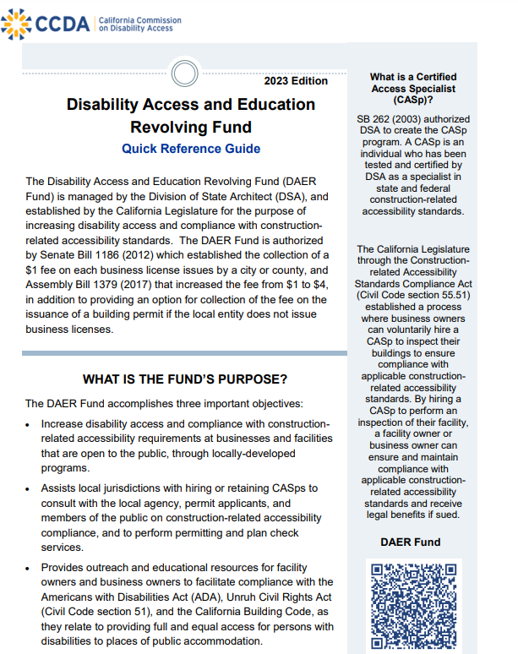
Path Forward:
CCDA will host a webinar designed to educate stakeholders on the DAER Fund’s objectives, eligibility criteria, and benefits. The webinar will provide a platform to address challenges and offer guidance on leveraging the fund effectively. CCDA will also continue to promote the Quick Reference Guide (QRG) to help jurisdictions and business owners or operators better understand the DAER Fund. The DAER Fund creates a culture of accessibility and encourages efforts in complying with accessibility regulations.

CCDA Outreach Efforts
CCDA and Website Accessibility
Overview
In 2024, CCDA achieved major milestones in its outreach efforts, expanding its impact both in the community and online. By establishing a strong social media presence, CCDA was able to connect with a wider audience, while also making meaningful in-person connection across
California. Through attending conferences and setting up resource tables, CCDA brought its mission directly to people, promoting engagement and raising awareness on a local level. This combination of physical and digital outreach has laid the foundation for even greater stakeholder involvement in the future.

CCDA’s Social Media and YouTube

CCDA actively utilizes its official Facebook and YouTube channels to engage with a wide audience, including businesses, the disability community, and various levels of government. These social media platforms are key to raising awareness about accessibility issues and fostering collaborations to improve compliance. The Facebook page serves as a hub for sharing educational content, practical toolkits, and essential resources related to accessibility. Meanwhile, the YouTube channel is dedicated to hosting videos from commission meetings, webinars, and other important events. By using social media to expand access to these resources, CCDA ensures its outreach efforts are far-reaching, ultimately helping to promote better compliance with disability access standards.

CCDA and Statewide Independent Living Council of Georgia (SILCGA) Webinar – The ADA and the Evolution of Inclusion

On October 29, CCDA and the Statewide Independent Living Council of Georgia (SILCGA) co- hosted a webinar featuring a screening of “Inclusion: The Story of the Americans with Disabilities Act (ADA).” The documentary explored the journey behind the ADA and the advocacy efforts that led to securing equal rights and opportunities for millions of Americans with disabilities. Throughout the screening, CCDA’s Education and Outreach Committee Chair, Commissioner Dr. ElHessen, moderated a discussion, asking panelists insightful questions about the ADA’s impact in their lives. The panel featured a group of disability rights leaders and advocates: Executive Director of SILCGA Shelly Simmons, Executive Director of the National Federation of the Blind Anil Lewis, SILCGA Mobility Policy Coordinator Jordan Hall, and Executive Director of CCDA April Dawson Rawlings. The panel of disability rights leaders and advocates shared their insights on the ADA and the impact it has made to pave the way to a more accessible, barrier free society for all.

CCDA looks forward to collaborating with new local governments and organizations to produce additional webinars focused on ADA education and advocacy. These webinars will help to provide more educational resources for small businesses in California, addressing key topics such as creating accessible storefronts, understanding accessible parking requirements, and implementing inclusive customer service practices. The success of this event with SILCGA highlights the potential of working with other government agencies or organizations to create a more accessible California for all.

Events Attended by CCDA in 2024

- County of Ventura’s First Annual Government and Disability Summit
  - In September 2024, CCDA staff attended the County of Ventura’s First Annual Government and Disability Summit and had a resource table for attendees at the event. The County of Ventura’s First Annual Government and Disability Summit was organized to bring together government agencies, disability advocates, and community leaders to discuss policies, services, and initiatives affecting individuals with disabilities. The summit featured panel discussion, presentations and resources aimed at promoting accessibility and inclusion within local government operations.

Pacific ADA Center Conference Presentation
  - In October 2024, CCDA Executive Director April Dawson Rawlings attended the Pacific ADA Conference and gave a presentation. The Pacific ADA Center Conference is a regional event that brings together ADA and accessibility experts. The conference covers best practices, legal updates, and strategies for ensuring ADA compliance and inclusion in public and private spaces. It serves as a platform for networking and knowledge-sharing among professionals, government representatives, and advocates.

City of San José 16th Annual Disability Awareness Day
  - In October 2024, CCDA staff attended the City of San José’s 16th Annual Disability Awareness Day event and had a resource table at the event. The City of San José’s 16th Annual Disability Awareness Day is an event held by the City of San José in collaboration with local disability organizations to raise awareness about the rights and needs of individuals with disabilities. The event includes informational booths, disability-related resources, and activities that highlight accessibility issues, promote inclusion, and celebrate the achievements of individuals with disabilities in the community.

Certified Access Specialist Institute (CASI) Conference
  - In October 2024, CCDA Executive Director April Dawson Rawlings attended the CASI conference and had a table at the event. The CASI conference is a specialized event for Certified Access Specialists, professionals trained in ensuring compliance with accessibility laws and regulations. The conference offers educational sessions, networking opportunities, and updates on the latest developments in the field of building accessibility and the enforcement of California's disability access laws. The event is a key gathering for those working to improve physical access to public and private buildings for individuals with disabilities.

Appendices

Appendix A: 2019-2024 Case Files and Prelitigation Letters Received by the Commission

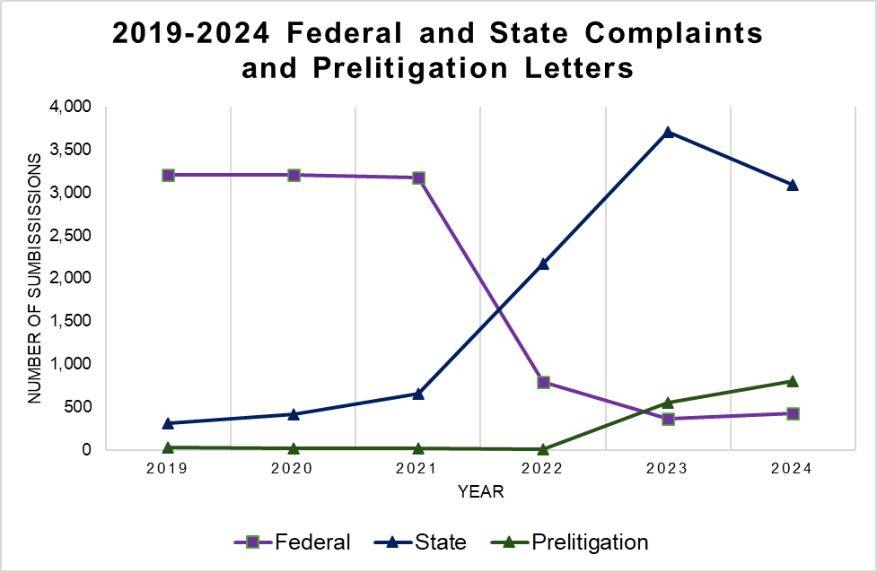

Type of Filing | Year of  2019 | Year of  2020 | Year of  2021 | Year of  2022 | Year of  2023 | Year of  2024
Federal | 3,211 | 3,210 | 3,176 | 788 | 363 | 422
State | 311 | 411 | 659 | 2,170 | 3,706 | 3,091
Prelitigation Letters | 30 | 12 | 15 | 10 | 555 | 806

Appendix B: 2024 Top 10 Alleged Physical Access Barriers
In 2024, there were 10,994 physical access barriers referenced in submissions of complaints and prelitigation letters to the CCDA Legal Portal. The top ten most selected barriers represent 75.52% of all physical access barriers alleged at 8,303 selections.

Rank | Violation Description | Total Number of Violations | Percent of All Alleged  Violations Received
1 | Parking: Existing spaces are non-compliant (e.g., ex- cessive slopes/cross-slopes, improper dimensions, striping, etc.). | 1,755 | 15.96%
2 | Path of Travel- Exterior: Routes to and from parking lot or public right of way are not accessible (e.g., non- compliant surfaces, excessive slope/cross-slope, lack of detectable warnings, not protected from traffic,  etc.). | 1,197 | 10.89%
3 | Parking: Designated accessible directional and/or parking signage is missing or non-compliant. | 1,074 | 9.77%
4 | Access to Goods, Support, Services and Equip- ment: Surface heights and space requirements for counters, tables, bars, or seating are not compliant. | 1,035 | 9.41%
5 | Path of Travel – Exterior: Vertical transitions (ramps and/or stairs) are not compliant (e.g., excessive slope/ cross-slope; landings are non-compliant, lack of guardrails and/or wheel guard, etc.). | 894 | 8.13%
6 | Path of Travel – Interior: Objects projecting into ac- cessible path of travel (e.g., a rack, display, or boxes placed in the aisle). | 644 | 5.86%
7 | Parking: Van-accessible and/or loading zones are non-compliant or non-existent. | 498 | 4.53%
8 | Path of Travel- Exterior: Doors are not accessible (e.g. the thresholds, handles, pulls, latches, locks, or clearances are non-compliant). | 441 | 4.01%
9 | Toilet, Lavatory and Bathing Facilities: Main entry doors are not accessible or not on accessible route (e.g., thresholds, handles, pulls, latches, locks, clear- ances, etc. are non-compliant). | 394 | 3.58%
10 | Path of Travel- Interior: Path of travel is not accessi- ble (e.g., non-compliant surfaces, excessive slope/ cross-slope, circulation aisles are too narrow, etc.). | 371 | 3.37%
Total: |  | 8,303 | 75.52%

Appendix C: Place of Public Accommodation Categories
“Place of Public Accommodation.”
According to the 2019 California Building Code, Title 24, Part 2, Volume 1 of 2, Chapter 2 (Section 202; Definitions), a place of public accommodation is a facility operated by a private entity whose operations affect commerce and fall within at least one of the following categories:
- Places of Lodging: Except for an establishment located within a facility that contains not more than five rooms for rent or hire and that is occupied by the proprietor of the establishment as the residence of the proprietor. For purposes of this code, a facility is a “place of lodging” if it is
  - An inn, hotel or motel; or
  - A facility that
    - Provides guest rooms for sleeping for stays that primarily are short-term in nature (generally 30 days or less) where the occupant does not have the right to return to a specific room or unit after the conclusion of his or her stay; and
    - Provides guest rooms under conditions and with amenities similar to a hotel, motel, or inn, including the following:
      - On- or off-site management and reservations service.
      - Rooms available on a walk-up or call-in basis.
      - Availability of housekeeping or linen service; and
      - Acceptance of reservations for a guest room type without guaranteeing a particular unit or room until check-in, and without a prior lease or security deposit.
- Establishments Serving Food or Drink: A restaurant, bar, or other establishment serving food or drink.
- Places of Exhibition or Entertainment: A motion picture house, theater, concert hall, stadium, or other place of exhibition or entertainment.
- Places of Public Gathering: An auditorium, convention center, lecture hall, or other place of public gathering.
- Sales or Rental Establishments: A bakery, grocery store, clothing store, hardware store, shopping center, or other sales or rental establishment.
- Service Establishments: A laundromat, dry cleaner, bank, barber shop, beauty shop, travel service, shoe repair service, funeral parlor, gas station, office of an accountant or lawyer, pharmacy, insurance office, professional office of a health care provider, hospital, or other service establishment.
- Public Transportation: A terminal, depot, or other station used for specified public transportation.
- Places of Public Display or Collection: A museum, library, gallery, or other place of public display or collection.
- Places of Recreation: A park, zoo, amusement park, or other place of recreation.

Appendix C: Place of Public Accommodation Categories (Continued)

- Places of Education: A nursery, elementary, secondary, undergraduate, or postgraduate private school, or other place of education.
- Social Service Center Establishments: A day care center, senior citizen center, homeless shelter, food bank, adoption agency, or other social service center
establishment.
- Places of Exercise or Recreation: A gymnasium, health spa, bowling alley, golf course, or other place of exercise or recreation.

Facility associated with the Regents of the University of California, the Trustees of the California State University and the California State University, the Office of the Chancellor of the California Community Colleges, a K–12 School District, or any Local Education Agency;
- Other (please specify): cannabis dispensaries (not recognized federally) and any businesses that do not fall under the other categories provided.
- A Religious Facility
- An Office Building
- A Public Curb or Sidewalk
- Website: Covers websites that are not accessible (i.e., lack of screen reader support or image alt-text, no large print, unmodifiable websites for non-readable text, etc.)

Appendix D: Complaints and Prelitigation Letters Received by Places of Public
Accommodation (2021-2024)

Place of Public Accommodation Category | 2024  Total | 2024  Percent | 2023  Total | 2023  Percent | 2022  Total | 2022  Percent | 2021  Total | 2021  Percent
Sales or Rental Establishments | 1,134 | 21.98% | 1,412 | 30.21% | 970 | 32.3% | 1,042 | 26.5%
Establishments Serving Food or Drink | 2,340 | 45.36% | 2,011 | 43.03% | 1,282 | 42.7% | 1,899 | 48.3%
Service  Establishments | 365 | 7.08% | 552 | 11.81% | 530 | 17.6% | 746 | 19%
Places of Lodging | 194 | 3.76% | 205 | 4.39% | 188 | 6.3% | 208 | 5.3%
Other ^{[1]} | 47 | 0.91% | 8 | 0.17% | 3 | .1% | 5 | 0.1%
Public Transportation Terminals, Depots or Stations | 1 | 0.02% | 0 | 0.00% | 2 | .1% | 1 | 0.0%
Place of Exhibition or Entertainment | 7 | 0.14% | 14 | 0.30% | 6 | .2% | 7 | 0.2%
Places of Exercise or Recreation | 12 | 0.23% | 10 | 0.21% | 8 | .3% | 7 | 0.2%
Places of Recreation | 3 | 0.06% | 1 | 0.02% | 2 | .1% | 5 | 0.1%
An Office Building | 1 | 0.02% | 3 | 0.06% | 2 | .1% | 7 | 0.2%

^{[1]} This category includes business categories not listed under Title 24 of the California Building Standards such as marijuana or Cannabis dispensaries.

Appendix D: Complaints and Prelitigation Letters Received by Places of Public Accommodation (2021-2024) (Continued)

Place of Public Accommodation Category | 2024  Total | 2024  Percent | 2023  Total | 2023  Percent | 2022  Total | 2022  Percent | 2021  Total | 2021  Percent
Places of Education (Non- Title II) | 1 | 0.02% | 0 | 0.00% | 1 | 0.0% | 1 | 0.0%
Places of Education (Title II) | 1 | 0.02% | 1 | 0.02% | 0 | 0.0% | 0 | 0.0%
Social Service Center Establishments | 1 | 0.02% | 3 | 0.06% | 0 | 0.0% | 0 | 0.0%
Places of Public Gathering | 2 | 0.04% | 1 | 0.02% | 2 | 0.1% | 3 | 0.1%
Places of Public  Display or  Collection | 0 | 0.00% | 0 | 0.00% | 1 | 0.0% | 0 | 0.0%
Public Curb or Sidewalk | 5 | 0.10% | 7 | 0.15% | 6 | 0.2% | 3 | 0.1%
Religious Facility | 0 | 0.00% | 0 | 0.00% | 0 | 0.0% | 0 | 0.0%
Websites ^{[2]} | 1,045 | 20.26% | 446 | 9.54% | 1 | 0.0% | N/A | N/A
Total: | 5,159 | 100% | 4,674 | 100% | 3,004 | 100% | 3,935 | 100%

^{[2]} In the past, websites were included as part of the “Other” category as they were not recognized as a Place of Public Accommodation, but this category was added due to growing interest in inaccessible websites. In 2022, Assembly Bill 2917 was signed into law, requiring attorneys to send a copy of their complaint alleging inaccessible websites to the CCDA.

Appendix E: Case Resolution Report Questions and Responses (2023-2024)

2024 Case Resolution Report Responses

Questions | Yes | Percent Yes | No | Percent No
Defendant requested an early evaluation conference | 34 | 1% | 4,589 | 99%
Defendant requested a site inspection by a Certified Access Specialist | 42 | 1% | 4,581 | 99%
Plaintiff received injunctive relief | 1,828 | 40% | 2,795 | 60%
Another favorable result was achieved | 571 | 12% | 4,052 | 88%
Plaintiff received damages or monetary settlement | 4,394 | 95% | 229 | 5%

Appendix E: Case Resolution Report Questions and Responses (2023-2024) (Continued)

2023 Case Resolution Report Responses

Questions | Yes | Percent Yes | No | Percent No
Defendant requested an early evaluation conference | 31 | 1% | 5,278 | 99%
Defendant requested a site inspection by a Certified Access Specialist | 62 | 1% | 5,247 | 99%
Plaintiff received injunctive relief | 3,212 | 61% | 2,097 | 39%
Another favorable result was achieved | 637 | 12% | 4,670 | 88%
Plaintiff received damages or monetary settlement | 3,929 | 74% | 1,378 | 26%

Appendix F: Summary of Five-Year Strategic Goals
2020-2024 Goals

Goal | Purpose
1. Increase disability access awareness. | Many members of the disability community are not readily identifiable and disability types come in all forms—visible and nonvisible. As California’s diverse population continues to grow and change, a greater percentage of  society will need built environments that are barrier-free. Accessibility compliance is sometimes viewed as unnecessary and applicable to a very small minority of entities. Business owners, nonprofits, and other organizations are often unaware of applicable state and federal compliance requirements— or if they are aware, they may be unsure of what compliance looks like. This goal seeks to raise awareness of access issues and the availability of tools to support accessibility in the built environment.
2. Continue to provide training programs and toolkits for targeted stakeholders. | This goal seeks to address the need for providers of places of public accommodation to learn about access issues, including available resources and support to make disability access modifications.
3. Identify and promote revenue streams to fund physical access compliance. | There are limited resources available to offset the financial cost of access compliance issues. This goal speaks to the need to identify available programs that support efforts to mitigate accommodation costs and incentivize access compliance.
4. Maintain data on status of access compliance. | Information on the status of access compliance will help stakeholders be more aware of ADA requirements and what compliance looks like. There are questions as to what information exists on compliance successes and where opportunities exist to create greater access, not to mention outcomes from state and federal accessibility lawsuits. The purpose of this goal is to provide relevant information and data on the status of access compliance throughout California.

Appendix G: Summary of 2024-2025 Two-Year Strategic Goals

Goal | Purpose
Create a new five-year strategic plan. | CCDA will embark on a yearlong planning process that will result in the development of a new five-year strategic plan.
Enhance regional outreach to small businesses. | Plans are underway to conduct listening forums, online trainings, and outreach  activities to small businesses in different  regions of the state.
Increase our business community engagement. | Utilizing census data, CCDA will develop a strategy to improve outreach to businesses that are minority owned and who represent non-English speaking communities, with the goal of reaching numerous business owners that more closely match the diversity of the communities in each region of California.

References

Table 7: Top ZIP Codes (2024)
ZIP Code: 90028 (Los Angeles) Los Angeles, CA – United States ZIP Codes.org ZIP Code: 91732 (El Monte) El Monte, CA – United States ZIP Codes.org
ZIP Code: 91776(San Gabriel) San Gabriel, CA – United States ZIP Codes.org ZIP Code: 90210 (Beverly Hills) Beverly Hills, CA – United States ZIP Codes.org ZIP Code: 92101 (San Diego) San Diego, CA – United States ZIP Codes.org
ZIP Code: 92868 (Orange) Orange, CA – United States ZIP Codes.org
ZIP Code: 94533 (Fairfield) Fairfield, CA – United States ZIP Codes.org
ZIP Code: 90660 (Pico Rivera) Pico Rivera, CA – United States ZIP Codes.org ZIP Code: 93003 (Ventura) Ventura, CA – United States ZIP Codes.org
ZIP Code: 90012 (Los Angeles) Los Angeles, CA – United States ZIP Codes.org ZIP Code: 90803 (Long Beach) Long Beach, CA – United States ZIP Codes.org

Inset 1: Map of Top ZIP Codes by Number of Submissions to the CCDA Legal Portal – 2024
Designed by Department of General Services – Enterprise Technology Solutions

Inset 2: Map of Number of Submissions to the CCDA Legal Portal by ZIP Code – 2024
Designed by Department of General Services – Enterprise Technology Solutions

This page was intentionally left blank.

This page was intentionally left blank.

This page was intentionally left blank.



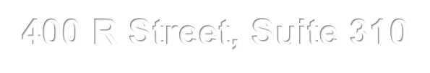
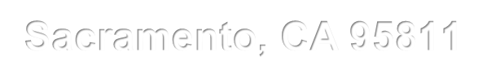


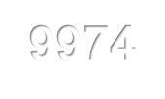

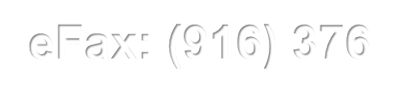
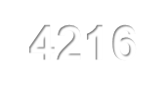

400 R Street, Suite 310
Sacramento, CA 95811
Phone: (916) 319-9974
Email: CCDA@dgs.ca.gov eFax: (916) 376-4216
Website: https://www.dgs.ca.gov/CCDA

