Document Owner: The OBAS Team
OBASHelpline@dgs.ca.gov
Abstract
The purpose of this document is to help answer questions that Contractors might have about OBAS’ eSignature process
Office of Business Acquisition Services’ (OBAS) eSignature Process
Contractor Information Sheet

Contents
1. Overview: 2
2. Scope: 2
3. Requirements: 2
4. Steps to eSign: 3
4.1. Standard procedure 4
4.2. When you access a DocuSign envelope, but are not ready to eSign 5
4.3. When you access a DocuSign envelope and cannot sign the contract, as written 6
5. Additional Authentication 6
6. Voided envelopes 6
7. Q&A: 7
7.1. How do I know the document being eSigned has been signed by all parties? 7
7.2. When can the I commence work? 9
7.3. How do I save and/or print an eSigned document for my own records? 9
7.4. Who do I contact about DGS-OBAS’ eSignature process, if I have questions? 9

Overview:
In August 2018, the Office of Business Acquisition Services (OBAS), under the Department of General Services (DGS), started using DocuSign to secure electronic Signatures on the STD 213 contracts it issues. Over time, the goal is to expand DGS’ use of eSignatures. Before this happens, you will be notified of DGS’ intention to include new document(s) in its eSignature process.

Scope:
All STD 213 contracts that are under OBAS’ delegated authority, for which the Contractor has agreed to eSign.

Requirements:
- Contractor’s agreement to eSign, which will be requested in OBAS’ standard Award Notification Email:
  - When the email will be sent in the overall contracting process:
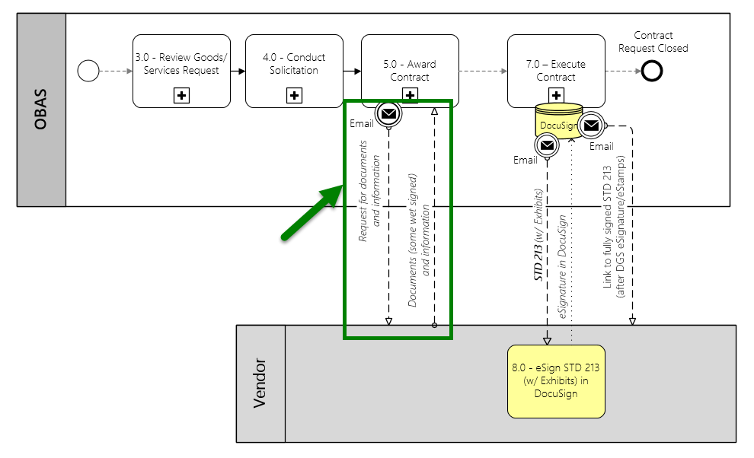

  - Example of the Award Notification Email:
Yellow = Key points in existing Award Notification Email.
Green = New key points for electronic signature
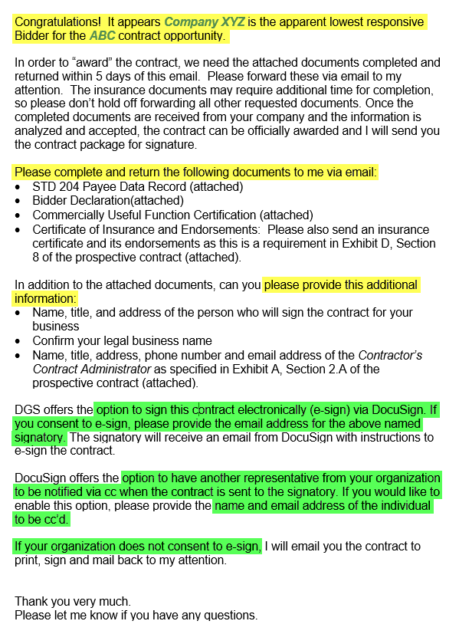
- Contractors do not need a DocuSign account to eSign
- Minimum system requirements needed to enjoy the DocuSign experience (after navigating to a document from the link provided in DGS’ “eSignature trigger email”).
  - https://support.docusign.com/en/guides/ndse-user-guide-system-requirements

Steps to eSign:
Note: all information listed in this documentation below (names, email addresses, and other information) is for illustrative purposes only.

Standard procedure
- After receiving DGS’ “eSignature trigger email”, click Review Document:
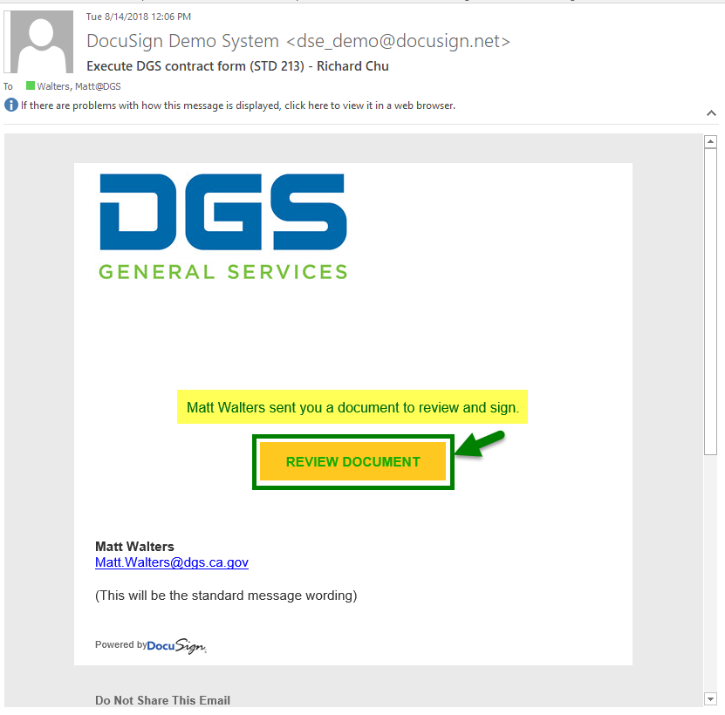
- In the browser window that appears, click Continue:
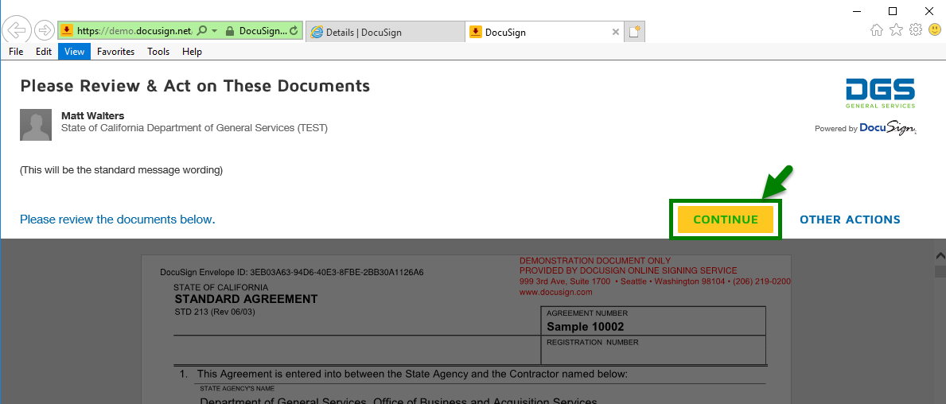
- Read through the document and navigate to the eSignature tag. When done, as a shortcut, you can navigate back to the tag by clicking Start:
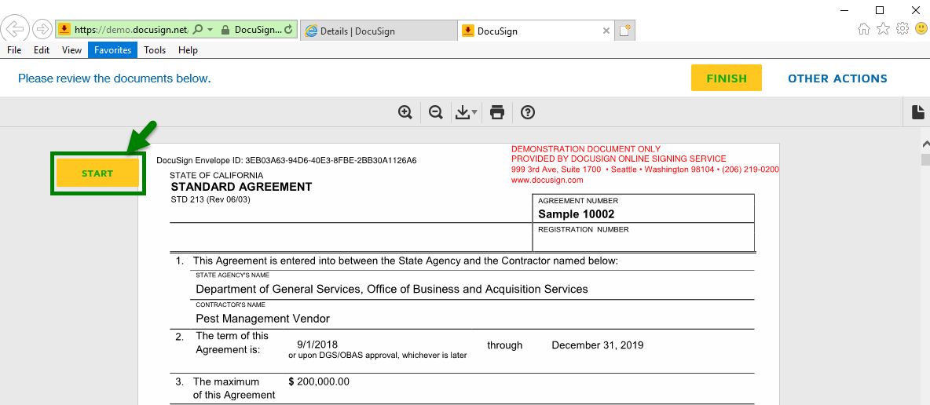
- After you have navigated to the eSignature tag (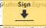), click on the tag to apply your eSignature (which may require you select a signature style), then click Finish:
Note: The following is how the will look after clicking the eSignature tag and applying the eSignature (Step 1, below).
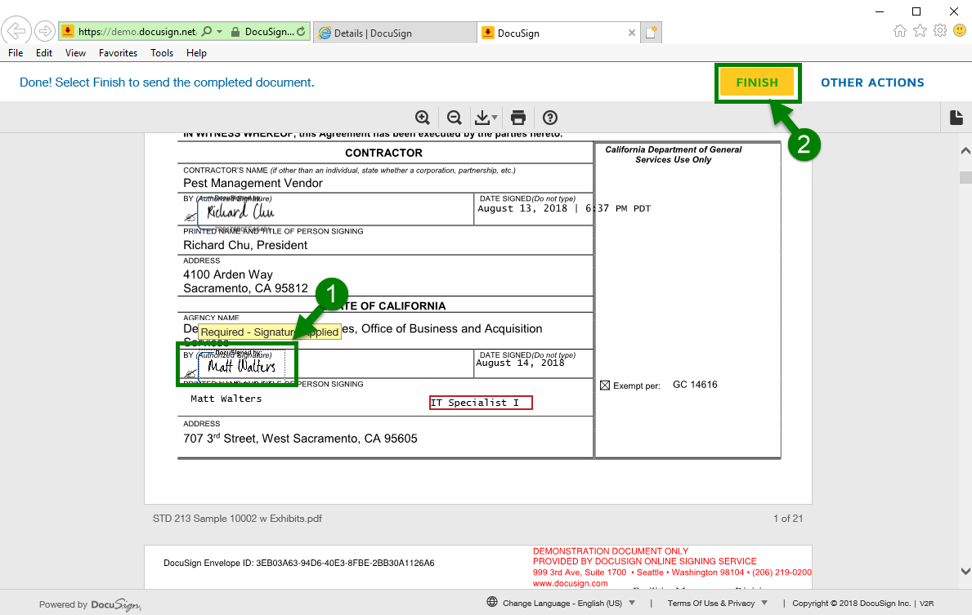
- The next screen will ask if you want to sign in to DocuSign (if you have an account, which is not required). If you don’t have an account, or don’t want to sign in, click No Thanks:
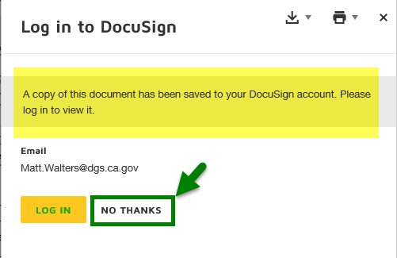

When you access a DocuSign envelope, but are not ready to eSign
Sometimes you might click on the link in DGS’ “eSignature trigger email” to review the document, but are not yet ready to eSign it. In this case, click Finish Later:
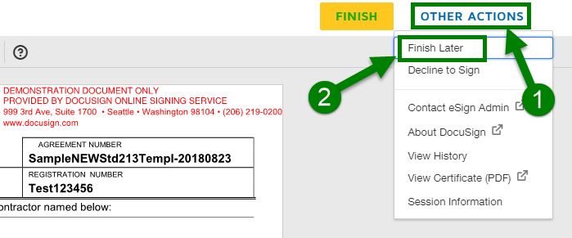

When you access a DocuSign envelope and cannot sign the contract, as written
If you have read through the document and determined that there is some reason that you simply cannot sign it, you have the option to Decline to Sign the document:
Important: Before declining to sign, please reach out to OBAS’ Acquisition Analyst to discuss your concerns, as they might be able to be addressed, without having to issue an updated DocuSign envelope.
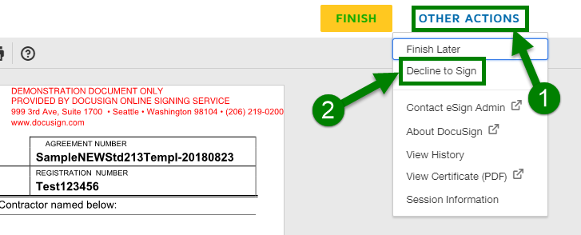

Additional Authentication
For some documents requiring an eSignature, OBAS may require additional authentication, before the signatory can access the document to eSign. When additional authentication is necessary, you will receive SMS text on your cell phone with access code that you will need to enter, before being able to access the document you are being asked to eSign.
Important: In order to be able to receive your access code via SMS text message, you must have responded to OBAS’ Award Notification Email with the cell phone number of the signatory.

Voided envelopes
In some cases, it will be necessary for the OBAS Acquisition Analyst to void a DocuSign envelope. Typically, this will occur when one or more signatories will not eSign a document, because there are required changes to the underlying document. When this happens, the current envelope will be voided and a new, replacement envelope will subsequently be sent.
After the Acquisition Analyst has voided an envelope, all recipients who have received the envelope will receive an email indicating that the envelope has been voided, and a large VOID watermark will be displayed on every page of the voided document:

Email:  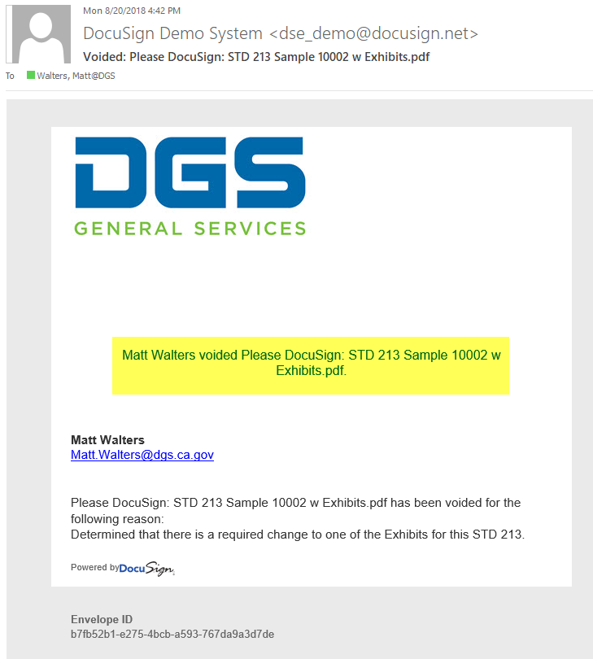 |  | Document:  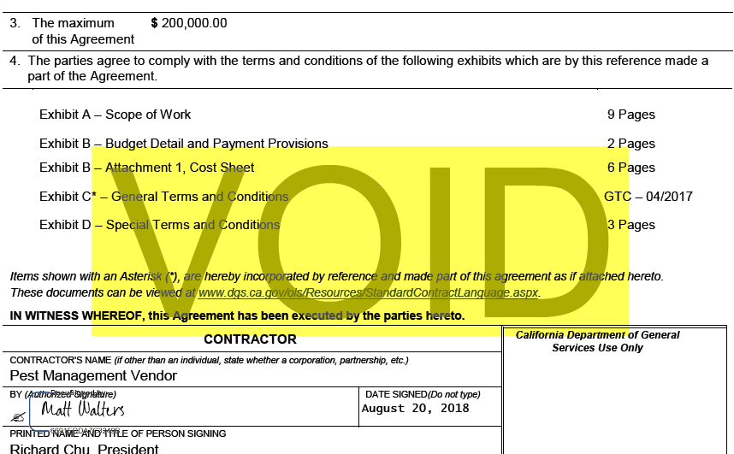  Note: ‘VOID’ is repeated on each subsequent page…

Q&A:

How do I know the document being eSigned has been signed by all parties?
- DocuSign automatically emails all parties (including the CC’s) that the document has been completed:
Email:  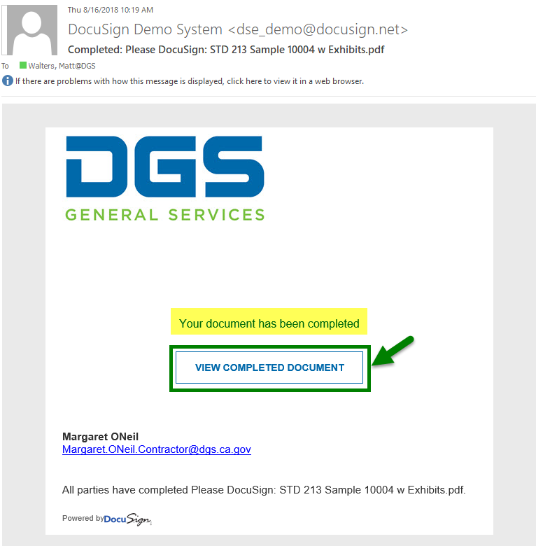 |  | Document:  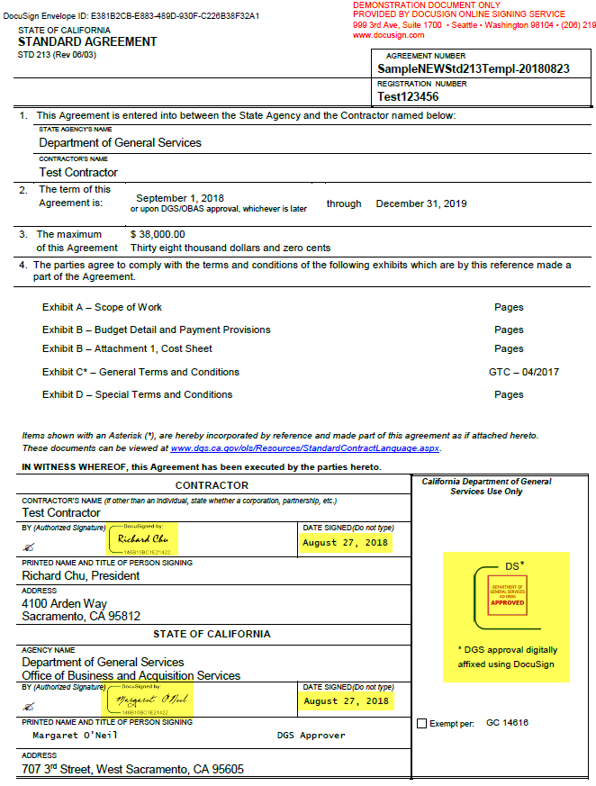

- After clicking on View Completed Document in the accompanying email, you can also access the DocuSign certificate, which should say Completed. There are two ways you can accomplish this:
  - Other Actions > View Certificate
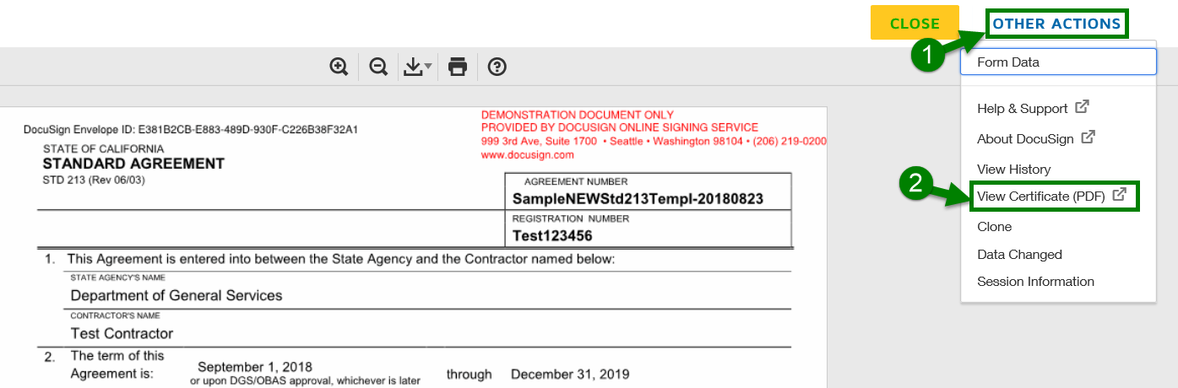
Note: your browser settings may prevent this approach, in which case you should follow the second approach outlined below. For example, your browser might give you the following error:
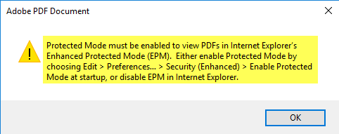
  - Or, you can download the certificate to view it:
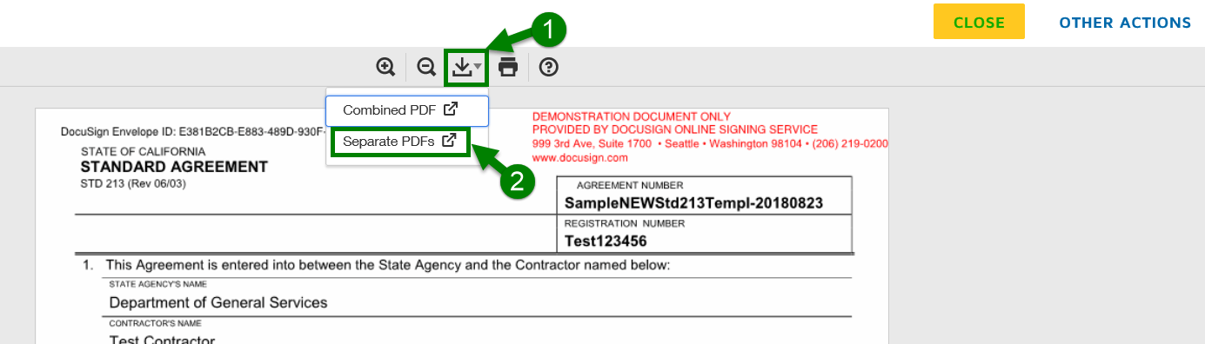
…after working through the various browser/system prompts you might receive, you will see files for each of the eSigned document, as well as the certificate (which you can, then, view and print):
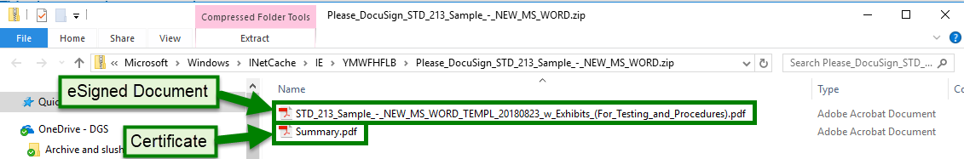

  - DocuSign certificate, showing the status as Completed:
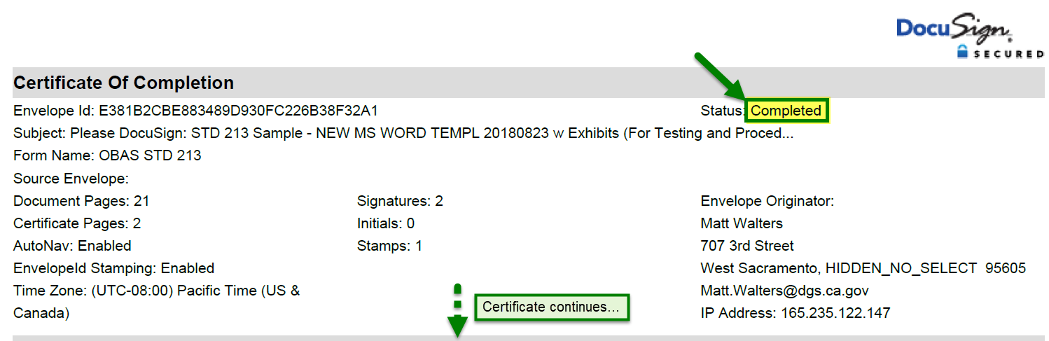

When can the I commence work?
Once you have been contacted by the DGS Contract Administrator.

How do I save and/or print an eSigned document for my own records?
- To only print the eSigned document:
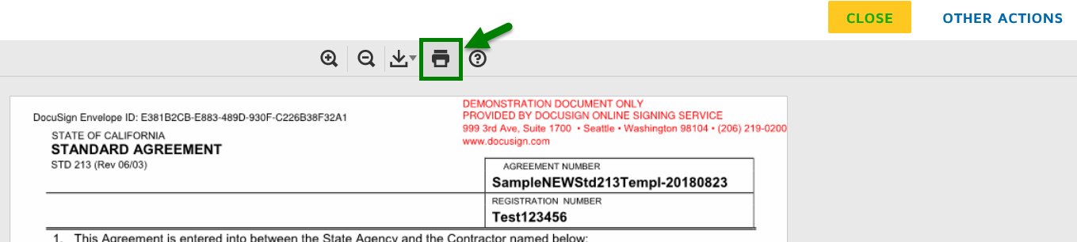
Note: your browser settings may prevent this approach, in which case you should follow the second approach outlined below. For example, your browser might give you the following error:
- Otherwise, follow the steps outlined above for downloading and viewing the certificate, in order to save and/or print the eSigned document (as well as the certificate, if you want):

Who do I contact about OBAS’ eSignature process, if I have questions?
All questions regarding the given procurement should be directed back to the OBAS Acquisition Analyst handing the procurement (via the From: email address on the original Award Notification Email).
Questions specific to OBAS’ eSignature process should be sent to OBASHelpline@dgs.ca.gov.

