Service Request

Jennifer Baker Jennifer.baker@docusign.com
Enterprise Account Executive | DocuSign – Public Sector | Cell: 650-561-5033

7/13/2018 DocuSign account executive provided Carasoft's Purchase Order for Enterprise Pro (20,000 envelopes/yr)

7/13/2018 ETS submit a service request via CDT's Remedy system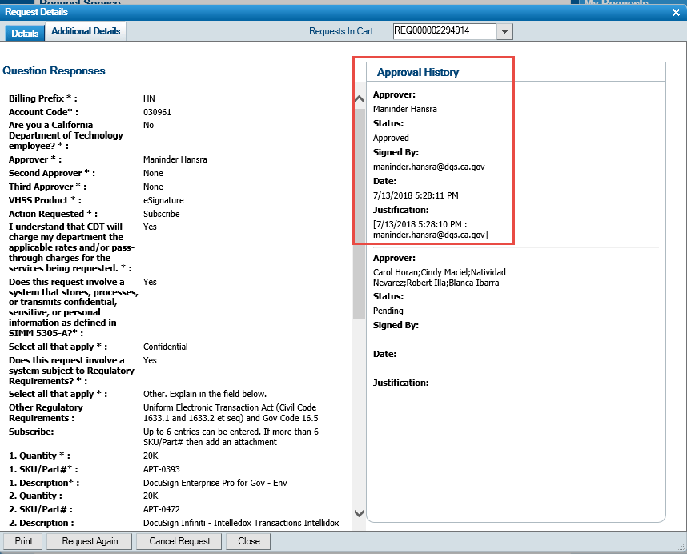

7/23/2018 DocuSign activated DGS' accounts in Sandbox and Production

Single Sign On Implementation

Joel A Savage Joel.Savage@docusign.com
Technical Specialist | Professional Services | DocuSign

During the kick off call the following items are typically covered.
- Kick off call between myself and the resources on your side, typically your DocuSign product owner and the IT resource that will handle the configuration of your Identity Provider.
- This is to discuss the technical aspect as well as the business take-aways of how you want to implement provisioning as well as dealing with any pre existing users outside of your corporate account.
- By the end of the kick off call we have at least enabled the SSO/org feature for your production account and setup a Demo environment with SSO features enable for this as well.

Beyond the kick off call
Overview of steps for implementing successful SSO (If assistance is required at any point I can make myself available to answer any questions via email or WebEX )
- From this point your team will perform configurations for SSO on your Identity Provider and DocuSign configuration within demo and production. (If assistance is needed I can be available for this)
  - Claiming your domain (We recommend you enable the setting “prevent unmanaged signups” on your domain once all of your corporate accounts are added to your organization)
  - Performing Identity Provider config with the DocuSign Endpoints
  - Performing Identity provider config within DocuSign for your Identity Provider URLs (issuser URL, login url etc.)
- Begin testing SSO Identity Provider initiated login and Service Provider initiated login
- You will want to generate a list of External Account users (Production only effort, no need to perform in demo)
- Email external account user to have them close the external account or if thye only have personal documents within this account you could allow them to change their email address within the external account to a personal one. (I can provide a sample email to send to your users) (Production only effort, no need to perform in demo)
- Review Just in Time Provisioning rules within Identity Provider tile in org admin (Choose desired default account and default permission set for newly provisioned users)
  - If you intend to use Advanced Just in Time provisioning please refer to the SSO implmentation guide for details on the Saml Attributes AccountID and permissionprofileID beginning on page 20 of the SSO guide just below.
  - https://support.docusign.com/en/guides/single-sign-on-implementation-guide
- Identify users that are service users for integrations (e.g salesforce, ariba, workday, etc)
  - Exclude integration users from SSO via steps below
- Test SSO Identity Provider initiated login
- Test SSO service provider initiated login
- Decide if you are going to use role based access with your Identity Provider to allow users into DocuSign or if you are going to allow all users within your company into DocuSign.
- Once all use cases are tested for SSO you will want to enforce SSO for all of your users and go live with SSO by clicking the checkbox “Require all users to authenticate via Identity Provider”
- 1 week after go live we will remove your SSOv1 config since you will be fully on SSOv2 at this point.

To change a user login policy to exclude them from SSO perform the following steps
- In the DocuSign Admin application, click Users.
- Find the user that will bypass federation. Click the user name or click ACTIONS adjacent to the name and select Edit.
- Select the Logon Policy option for the user.
- The available settings are:
- Default: This setting uses the policies set for the user’s email domain.
- Identity Provider or Username/Password: This setting allows a user to maintain a username and password within DocuSign, even when SSO is required for all users in the domain.
- Identity Provider only: This setting requires a user to log on with an Identity Provider when SSO is optional for users in the domain.
- Click SAVE to save the change.

This can also be accomplished in org admin by following the steps below
- Click Users
- Account Users
- Browse for desired user
- Click Security Tab
- Change login Policy to “Identity Provider or username/password”
- Click Update

Upload OBAS Senders (CSV) file to DocuSign Admin Portal

Account Manager Training

Lauren Griessel
Adoption Consultant | DocuSign | o: 2069573551 | m: 4256232940
Support: 1-866-219-4318

Lauren provided 1-on-1 help via WebEx and emails. All changes are tested in SandBox first. Production changes get applied after validation.

8/7/2018 - 1st Session
- How to create a template: https://support.docusign.com/en/guides/ndse-user-guide-create-templates
- Autoplace: https://support.docusign.com/en/guides/AutoPlace-New-DocuSign-Experience
- Branding: https://support.docusign.com/en/guides/ndse-admin-guide-advanced-branding-configuration
- Payments: https://support.docusign.com/en/guides/managing-payment-gateways
8/9/2018 - 2nd Session
- Stamps: https://support.docusign.com/en/guides/ndse-user-guide-manage-your-stamps
- Conditional logic: https://support.docusign.com/en/guides/ndse-user-guide-conditional-fields
- Approve and decline tags: https://support.docusign.com/en/guides/ndse-user-guide-field-types
- Power form settings: https://support.docusign.com/en/guides/ndse-user-guide-create-a-powerform
8/20/2018 - DocuSign account executive suggest using shared Inbox setup for OBAS
- SHARED INBOXES: Access to others inboxes on her team (https://support.docusign.com/en/guides/ndse-admin-guide-share-envelopes )
- REPORTING - Custom report: Ability to have report that shows total docs that are out for sig / completed etc for entire team
9/4/2018 - Delegated Admin Permission Set
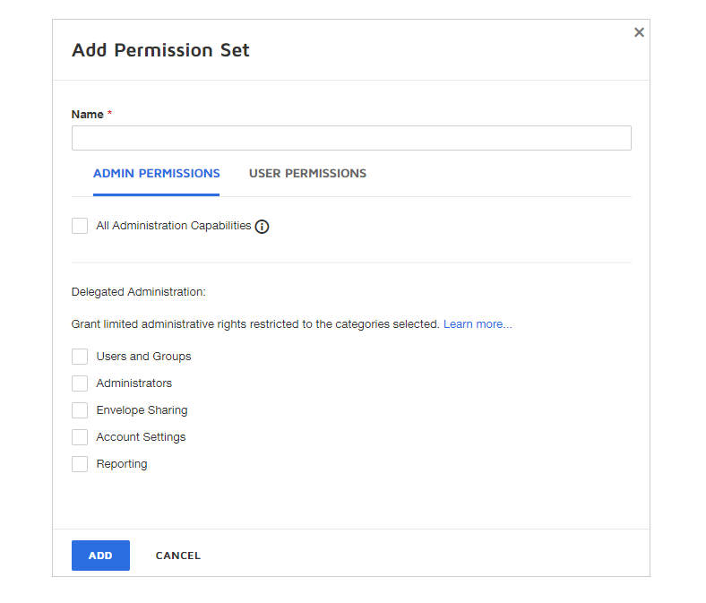
9/14/2018 - DocuSign Graduation to Account Manager

DocuSign Moving Forward

Geoff Gastwirth | Strategic Account Manager | (940) 453-4335

Introduced to Geoff Gastwirth, your Account Manager and main point of contact at DocuSign moving forward.

Directed any future questions to Geoff

Below are links to support resources available moving forward:
- DocuSign Knowledge Market
- DocuSign Support Center
- DocuSign Community

DocuSign University has also created a course specifically designed to enable the expansion of future use cases. The course is available on DocuSign University using the course code listed below.

Course Name: DocuSign Digital Transformation Project Manager Fundamentals
Course Code: DTPMFUND

