ACCOUNT
Account Profile: DGS address added
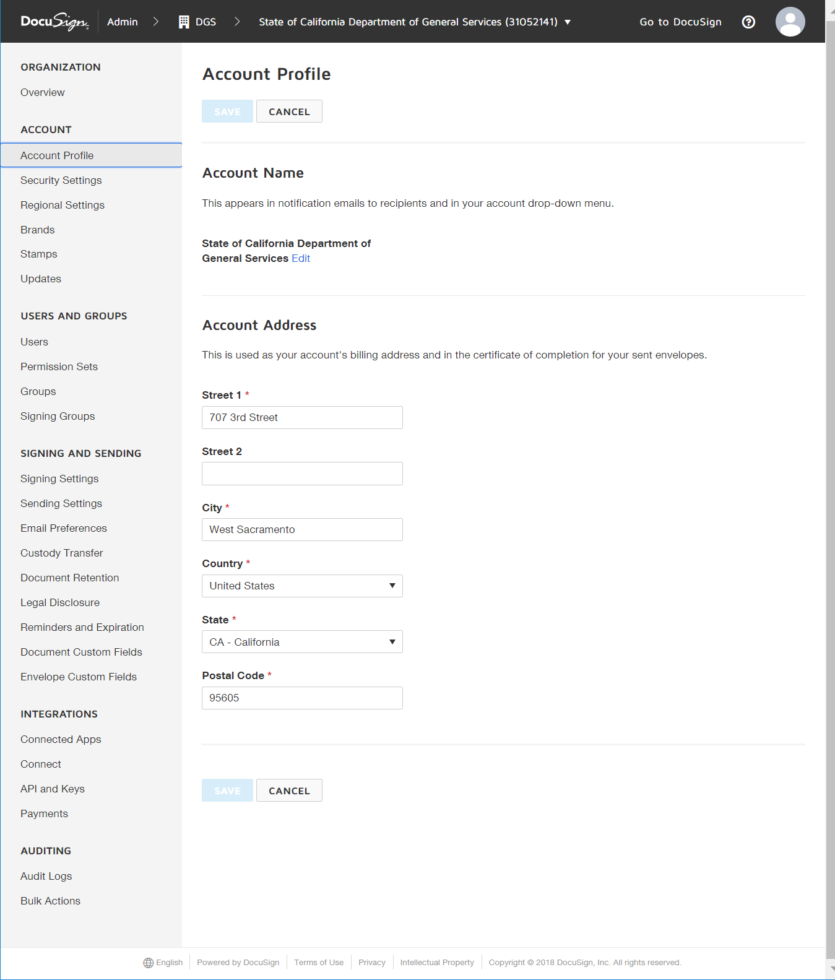
Security Settings
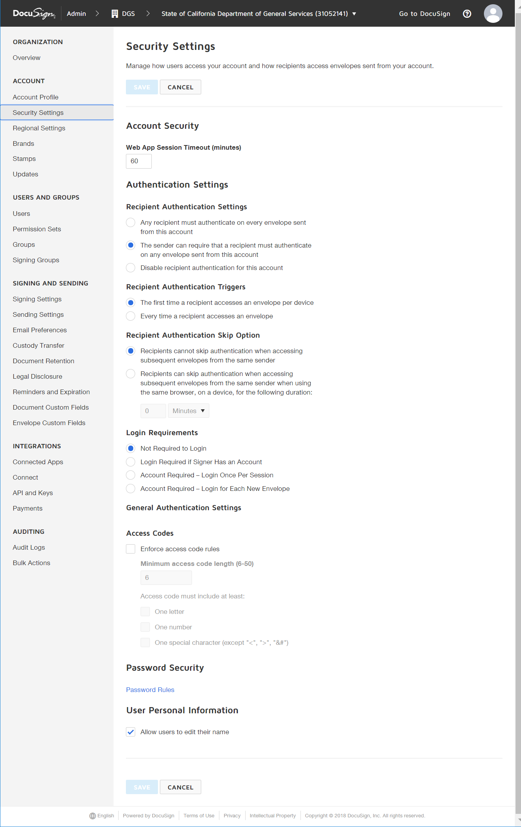
Regional Settings
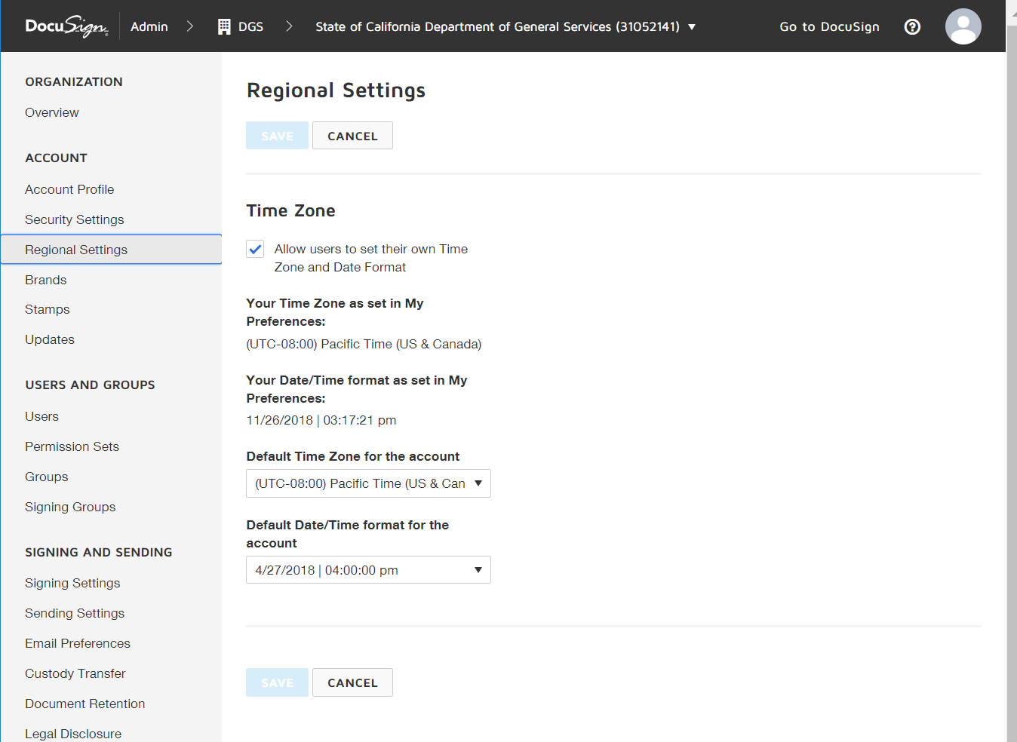
Brands
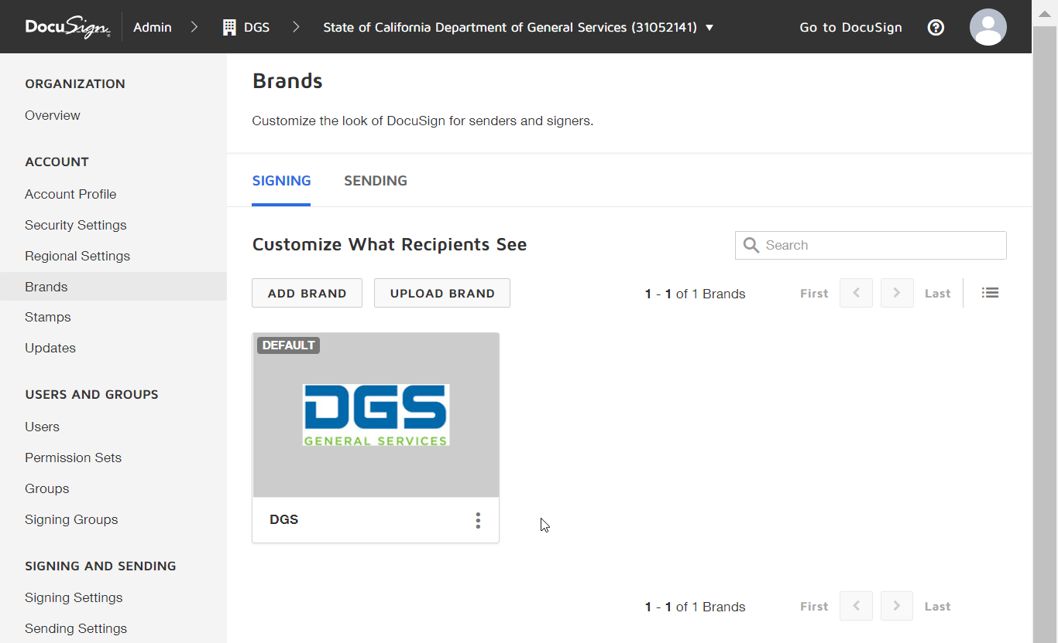
Stamps: No Stamp was created
Updates
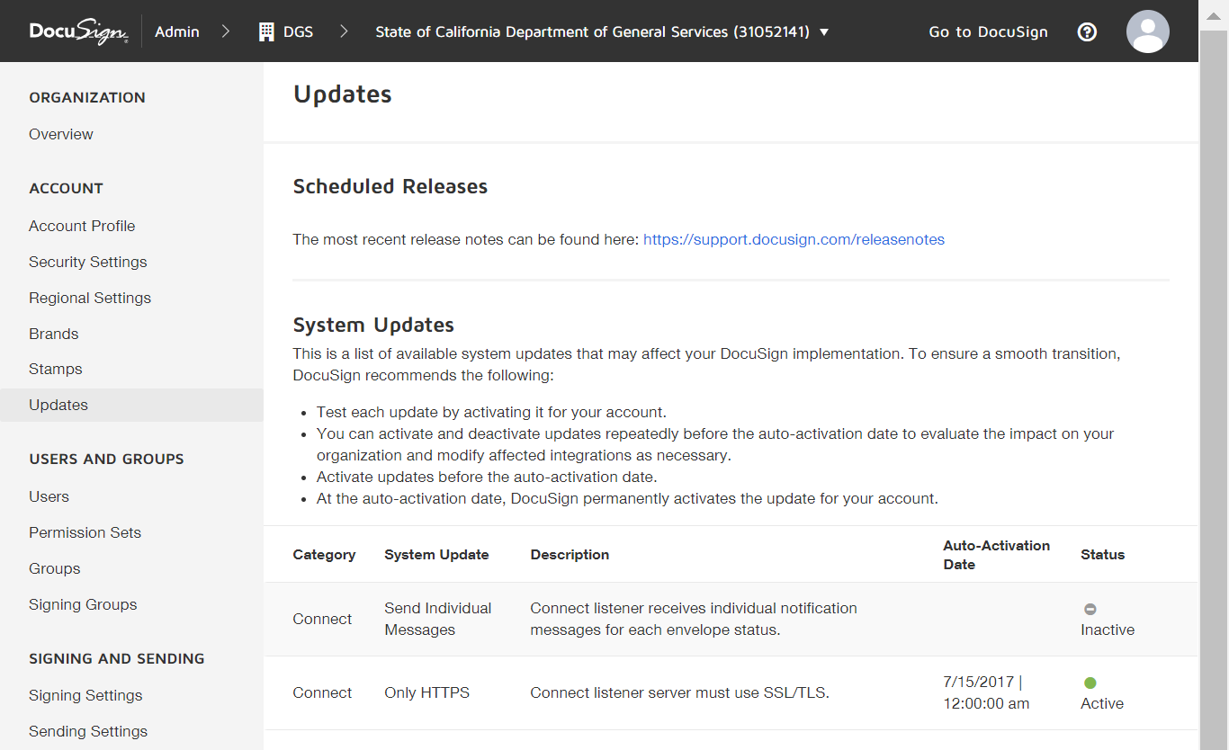
USERS AND GROUPS
Users: OBAS and ETS users were uploaded via CSV
Permission Sets
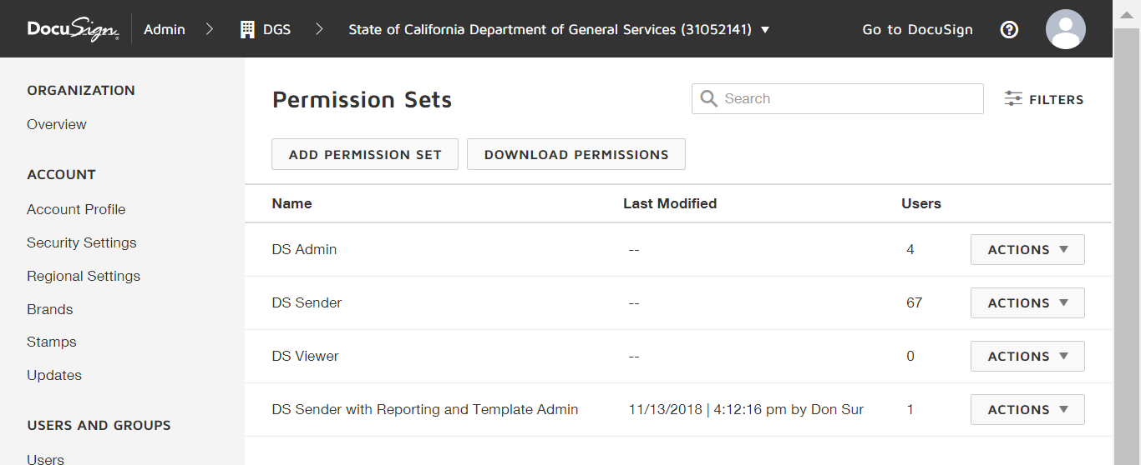
DS Admin: Don Sur; Liep Huynh; Richard Chu; Jones Ribinson
DS Sender with Reporting and Template Admin: Matt Walters
Groups
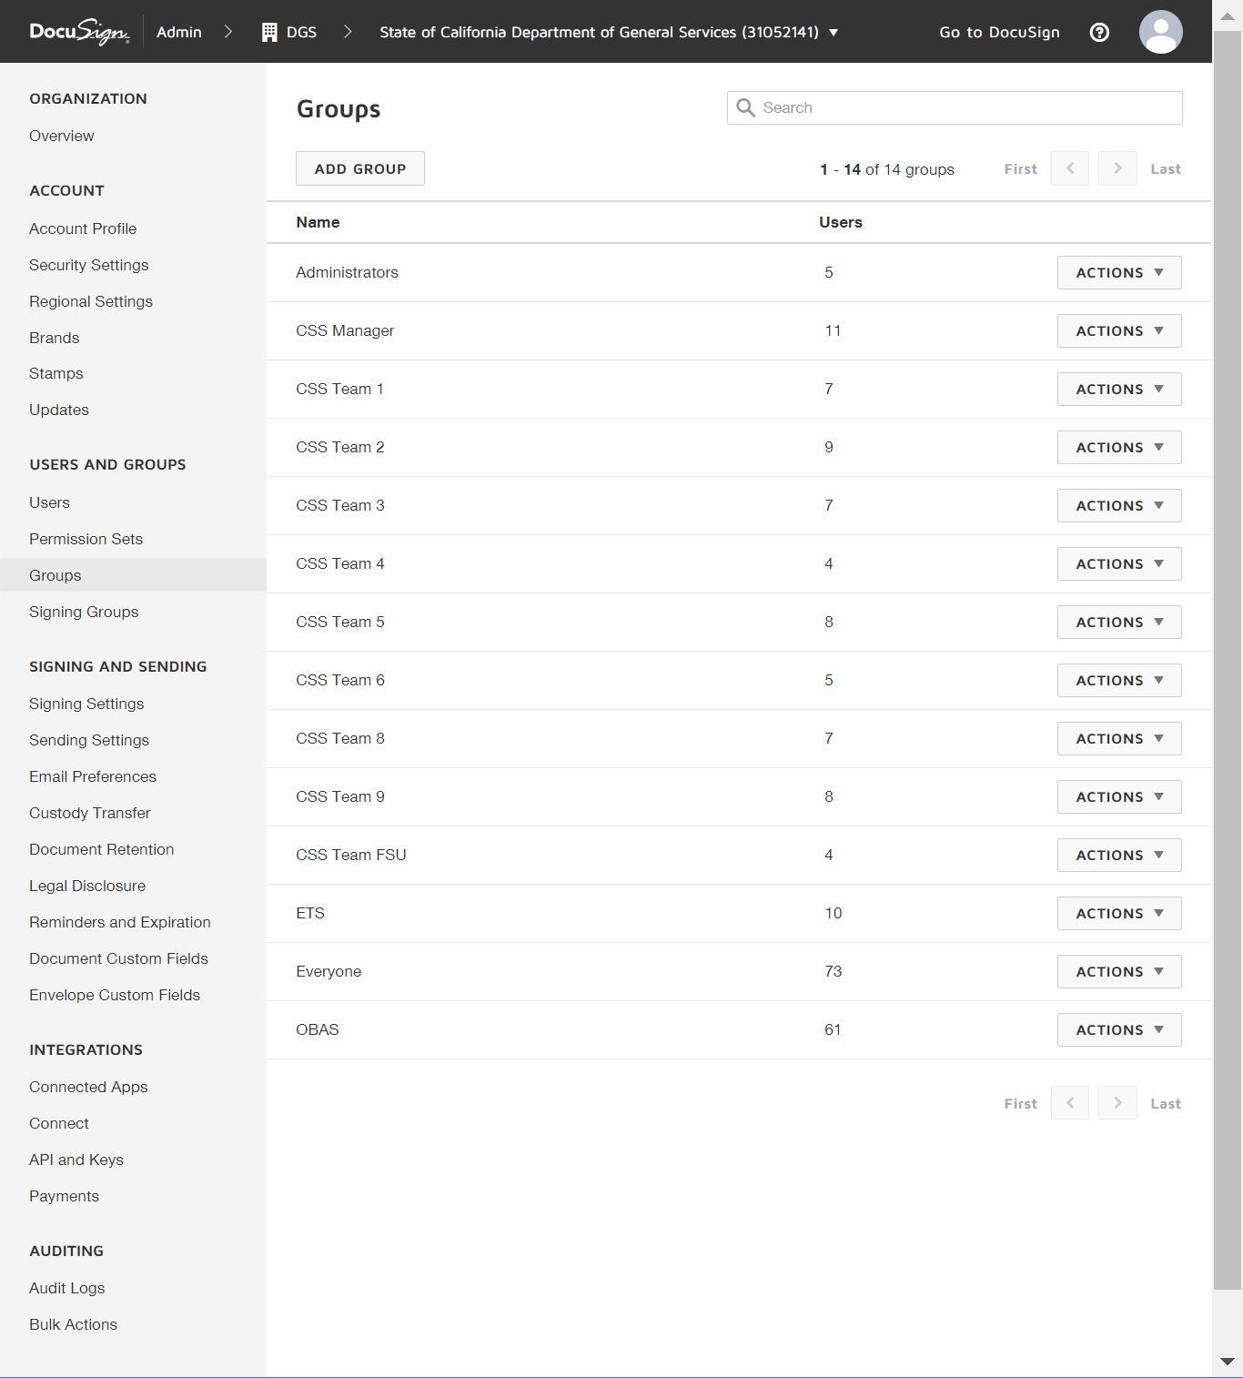
Signing Groups (Not used yet)

SIGNING AND SENDING
Signing Settings
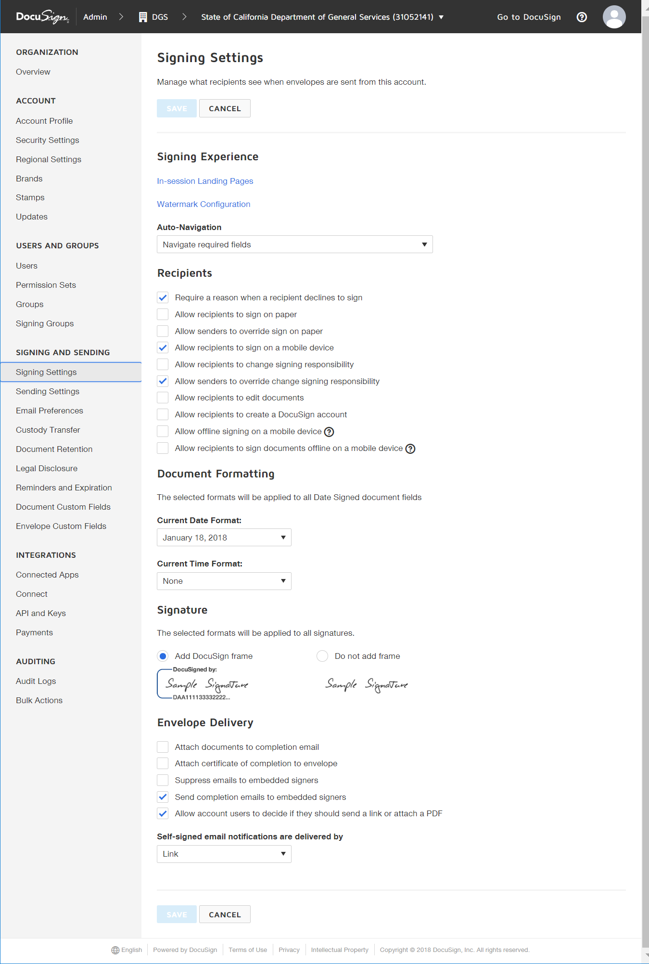
Sending Settings
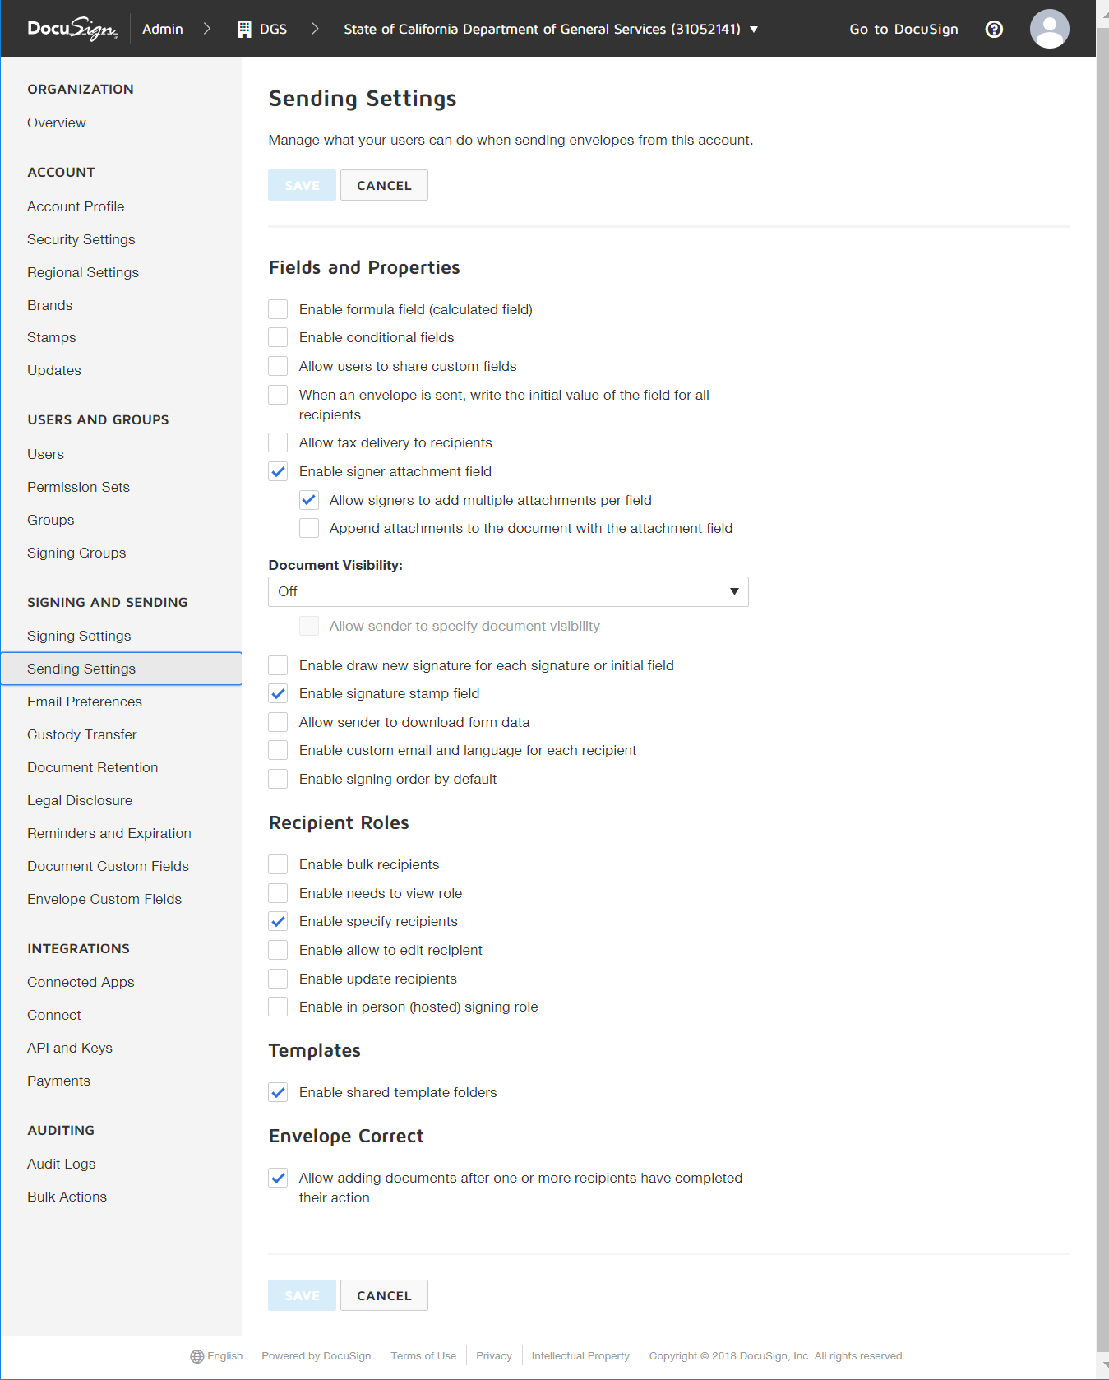
Email Preferences
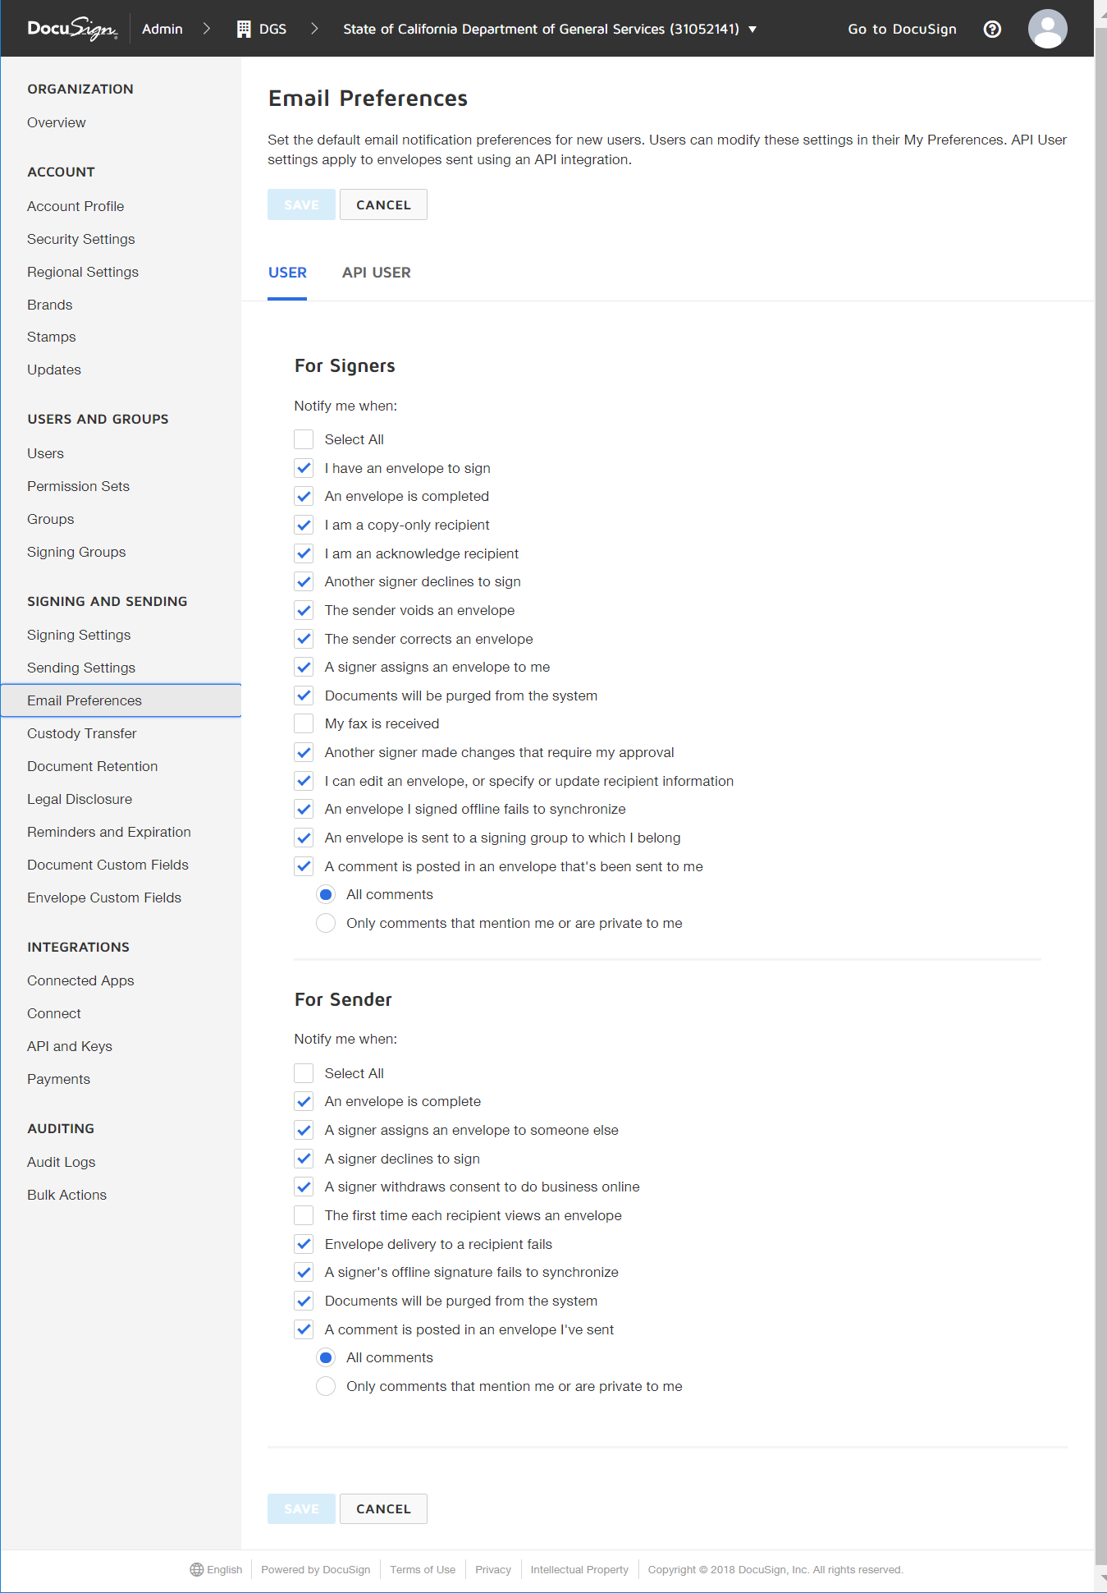
Custody Transfer: No rule added.
Document Retention: Not enabled.
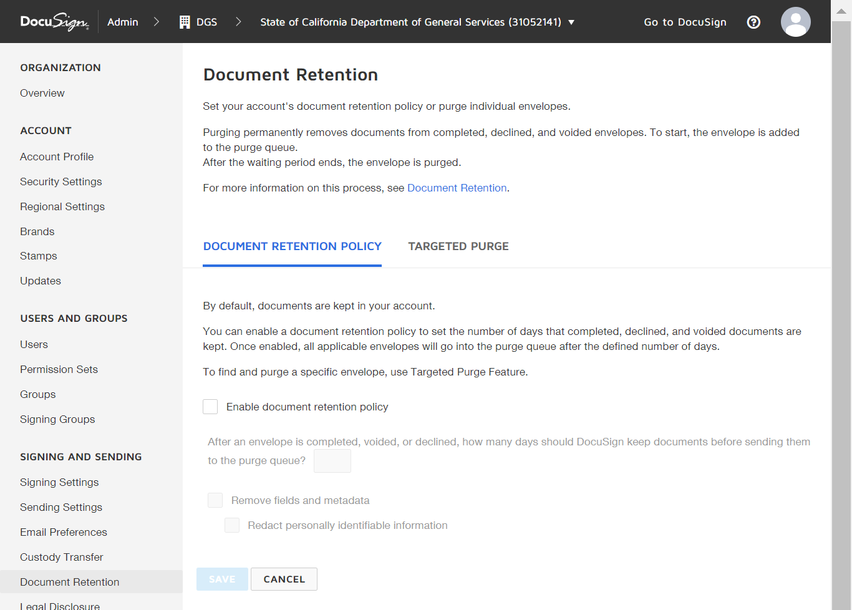
Legal Disclosure: Choose not to use.
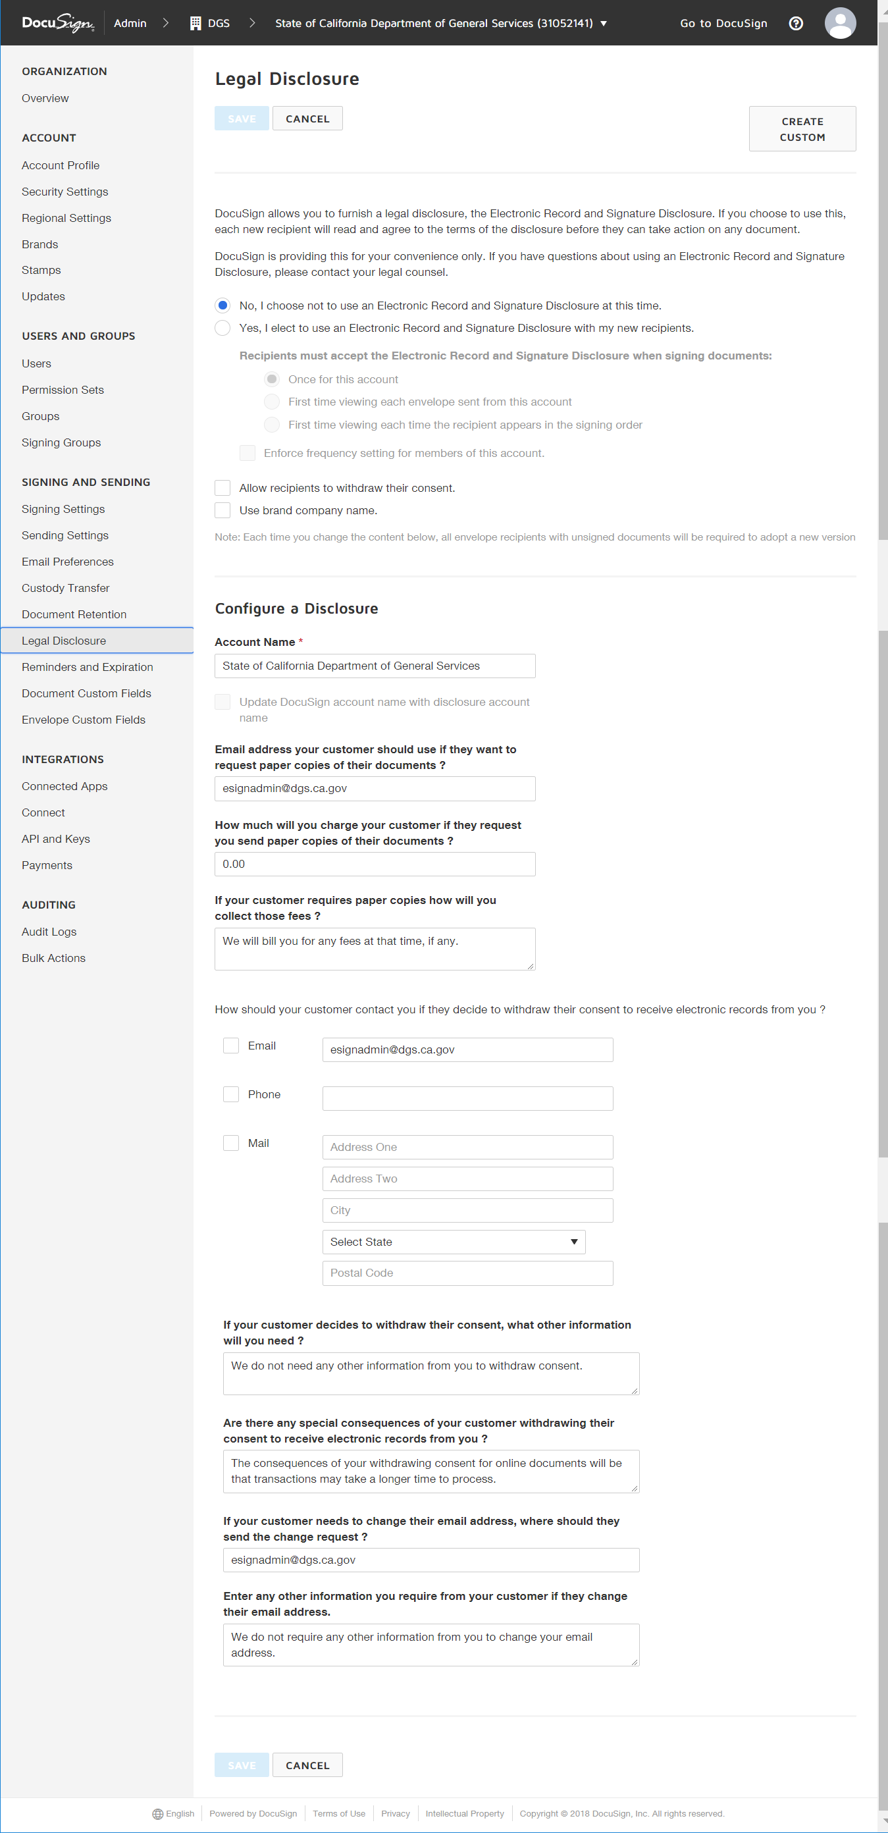
Reminders and Expiration
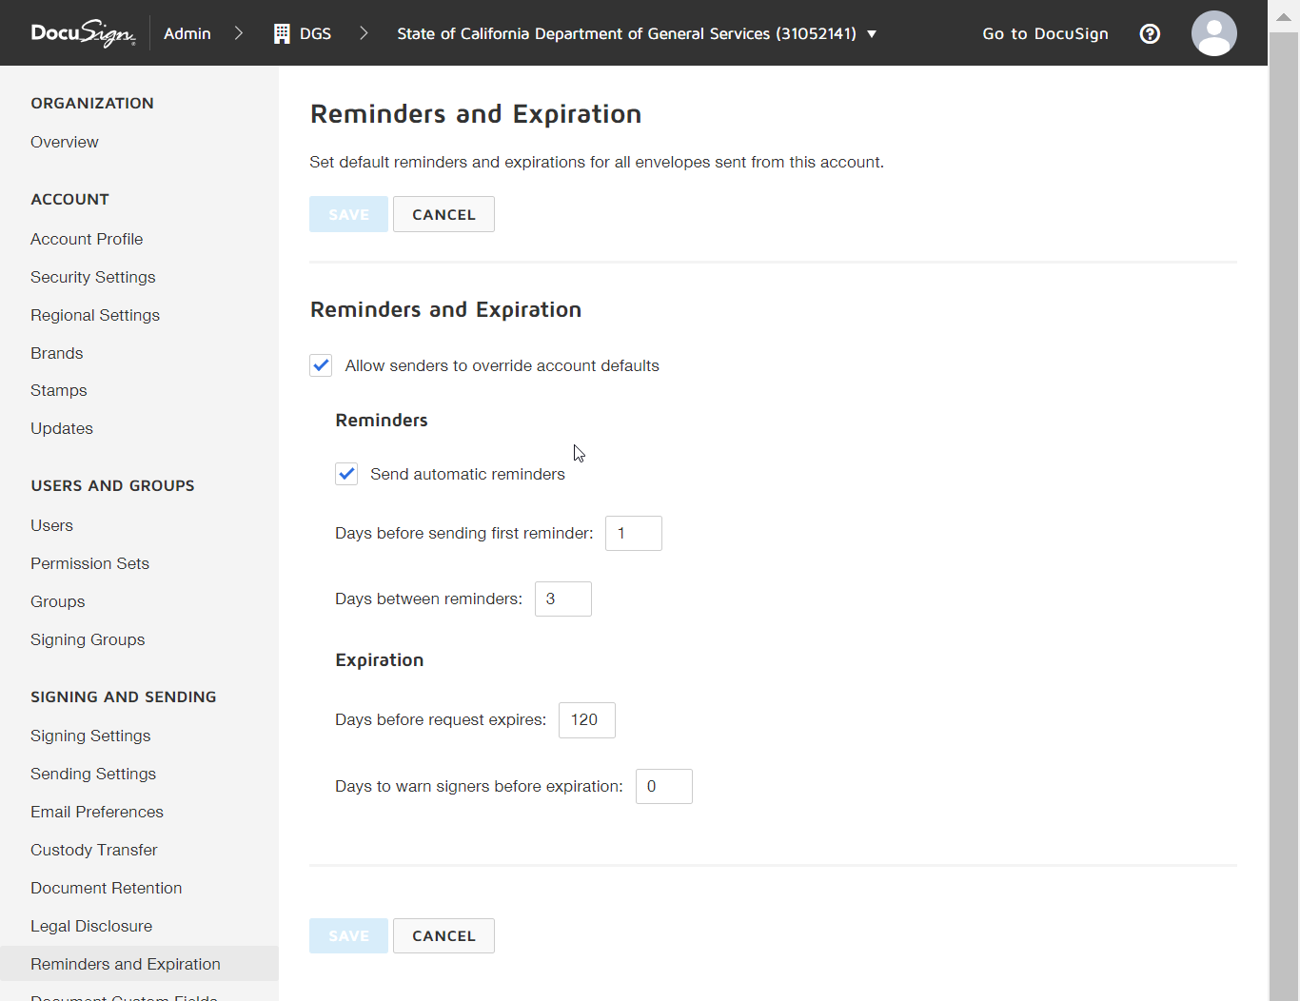
Document Custom Fields: Not configured
Envelope Custom Fields
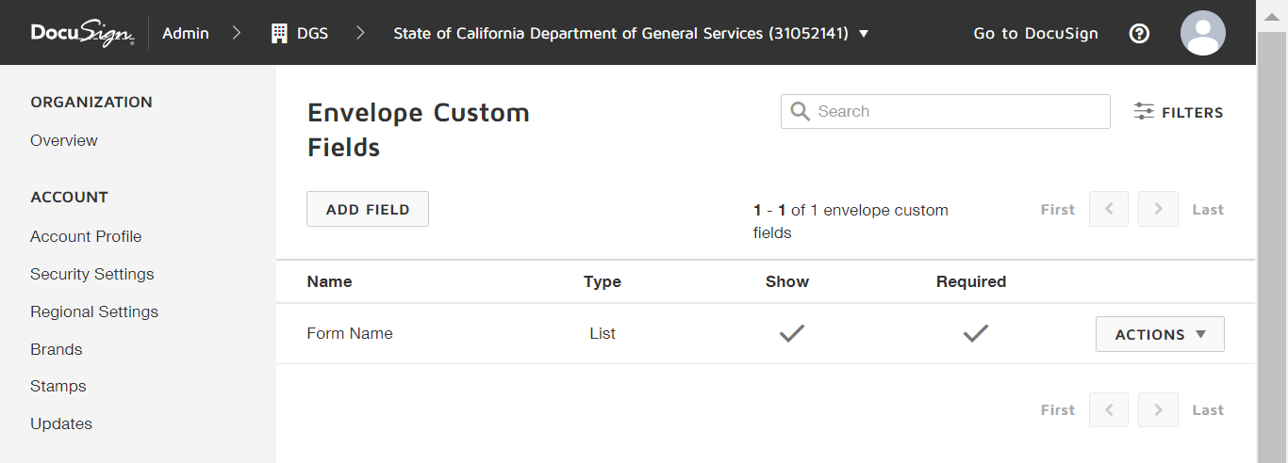
INTEGRATIONS
Connected Apps: Default (Box/DropBox/Google Drive/OneDrive)
Connect: None added.
API and Keys: Development purpose only. Not to be shared.
Payments: No payment gateway enabled
AUDITING
Audit Logs: No configuration needed.
Bulk Actions: No configuration needed.

