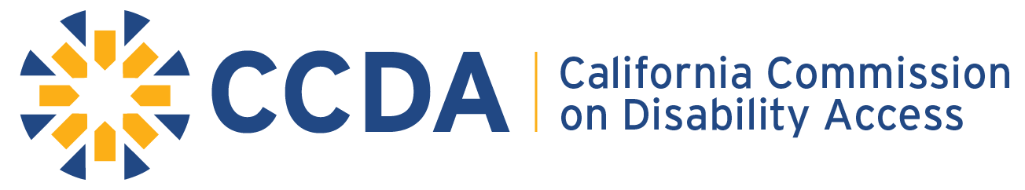

400 R Street, Suite 310 | Sacramento, CA 95811
Office: (916) 319-9974 | eFax:(916) 376-4216 | TDD/TTY: (800) 735-2929
https://www.dgs.ca.gov/ccda

MEMBERS of the COMMISSION
Guy Leemhuis – Chair Douglas Wiele – Vice-Chair
Tiffany Allen
Chris Downey
Souraya Sue ElHessen
Brian Holloway
Scott Lillibridge
Michael Paravagna
Karla Prieto
MEMBERS of the COMMISSION
Jim Frazier – Assembly Member
Tom Lackey – Assembly Member
Melissa Hurtado – Senator
Brian Jones – Senator
Ida Clair, Acting State Architect
Attorney General Xavier Becerra by Deputy Attorney General Anthony Seferian

Commission Executive Staff
Angela Jemmott – Executive Director

MEETING NOTICE AND AGENDA
Full Commission Meeting

July 15, 2020
10:00 AM – 4:00 PM
(The end time is an estimate; the meeting may conclude earlier)

The July Commission meeting is going to be on Zoom and via teleconference only. There is no physical location being made available to the public. Per Executive Order N-29-20, teleconferencing restrictions are waived during the COVID-19 pandemic. Therefore, committee members are not required to list their remote locations and members of the public may participate either by Zoom or teleconference from any location.

ZOOM WEBINAR - Virtual Meeting https://zoom.us/j/98484769746
TELECONFERENCE:
+1 408 638 0968
+1 669 900 6833
Webinar ID: 984 8476 9746

Live Captioning: https://www.streamtext.net/player?event=CCDA
CCDA wants to provide the highest level of accessibility for all meetings. We encourage you to look at the detailed information starting on page 3.

Notice is hereby given that the California Commission on Disability Access (CCDA) Committee will hear, discuss, deliberate and/or take an action upon the following items listed in this notice. The public is invited to attend and provide their input or comments.

ITEMS:

- Call to Order / Roll Call / Pledge of Allegiance / Housekeeping

- Introduction/Swearing-In/ Pinning Ceremony of Newly Appointed and Reappointed Commissioners

- Approval of Meeting Minutes (January 22, 2020) – Action

- Comments from the Public on Issues not on this Agenda – The Commission will receive comments from the public at this time on matters not on the agenda. Matters raised at this time may be briefly discussed by the Commission and/or placed on a subsequent agenda.

- Legislative Bill Tracking – Update and Discussion
- AB 2028 (Aguiar-Curry) – State agencies: meetings.
- AB 2123 (Chau) – Accessibility: internet website.
- AB 2504 (Nazarian) – The Capital Access Loan Program.
- AB 2664 (Diep) – Disability access: statutory damages: small businesses: certified access specialist’s report: violations.
- AB 3364 (Committee on Judiciary) – Judiciary omnibus.
- SB (Wiener) – Planning and zoning: housing development: streamlined approval: incentives.

- CCDA Executive Director Report – Update and Discussion
- Administrative, Operational, and Staffing
- Customer Service Inquiries
- Strategic Goal for 2020
- Outreach Efforts & Partnering Opportunities

- Data Base Automation Activities- Presentation – Bob Summers, CSM ServiceNow Manager, Department of General Services
- Current status of the project
- Future reporting features

- Committee Subcommittee Reporting – Update, Discussion, and Action
- Education and Outreach
- Checklist
- Legislative

Lunch Break

- CCDA Strategic Plan Stakeholder Involvement – Update and Discussion
  - Strategic Plan Stakeholder Survey Highlights
  - Focus Group discussion clusters with Commissioners
    - (Technical/Business Groups)
    - (Disability and Government Groups)
    - (Legal/Other Groups)

- Future Agenda Items – The Full Commission may be discussed and set items for action on future agendas.

- Adjourn

- The CCDA meeting is operating under the requirements of the Bagley-Keene Open Meeting Act set forth in Government Code Section §11120-11132. The Act generally requires the CCDA to publicly notice their meetings, prepare agendas, accept public testimony, and conduct their meeting in public unless specifically authorized by the Act to meet in closed session.
- Meetings are subject to cancellation; agenda items are subject to removal or items may be taken out of order.
- The Commission meets under the authority of Government Code §14985.
- The Commission may hold a closed session on pending or proposed litigation involving the Commission [Govt. Code §11126(e)] and personnel matters and performance review relating to the Commission [Govt. Code §11126(a)].
- Technical difficulties with equipment experienced prior to or during the meeting preventing or inhibiting accessibility accommodation is not cause for not holding or for terminating the scheduled meeting.
- Each Commission meeting will provide a teleconference line, alternative document formats, and captioning.
- Requests for accommodations for individuals with disabilities (sign-language interpreter, assistive listening device, Braille, or any other accommodation needed by an individual) should be made to the Commission no later than five (5) working days prior to the day of the meeting.
- For the latest information on meeting status, check the California Commission on Disability Access website: https://www.dgs.ca.gov/ccda.
- Questions regarding this notice and agenda may be directed to CCDA at ccda@dgs.ca.gov or (916) 319-9974 or mail to: 400 R Street, Suite 310, Sacramento, CA 95811.

