Central Valley Community Gathering:
ADA Access in the Restaurant Industry

The Falls Event Center
Fresno, CA
November 14, 2018


CCDA COMMISSIONERS
Guy Leemhuis, Chairperson
Doug Wiele, Vice Chairperson
Christopher Downey
Scott Lillibridge
Brian Holloway
Celia McGuinness
Michael Paravagna
Karla Prieto
Tiffany Allen-Potter
Betty Wilson
Laurie Cohen Yoo
Assemblymember Jim Frazier
Assemblymember Tom Lackey
Attorney General Xavier Becerra by Anthony Seferian
Chester “Chet” Widom, State Architect

EXECUTIVE STAFF
Angela Jemmott
Participant Workbook
For Remote Attendees:

To participate in the event remotely, please use information below:
- Link to Join Live Stream: https://zoom.us/j/449486812.
- Link to Access Captioning: https://www.streamtext.net/player?event=CCDA.

- Please feel free to email comments or questions for the panel to CCDA: ccda@dgs.ca.gov.

Desired Outcomes:
- Increase Certified Access Specialist (CASp) awareness
- Increase awareness of funding sources for compliance work
- Share information about federal, state, and local access laws that govern compliance
- Increase disability awareness
- Receive feedback on restaurant industry toolkit
- Introduction of the Americans with Disabilities Act (ADA) Business Mentorship Program

Program/Agenda

Wednesday, November 14, 2018 | 8:00 am – 2:00 pm
 | TIME | ITEM | PRESENTER(S)
 | 8:00 – 8:15 AM | Registration | CCDA Staff
 | 8:15 – 8:30 AM | Welcome, Introductions and  Purpose of the Day | Cris Vaughn  Moderator  Angela Jemmott  CCDA Executive Director
 | 8:30 – 8:35 AM | Overview of the Day and Agenda Review | Cris Vaughn  Moderator
 | 8:35 – 9:45 AM | Moderated Panel Q&A Session  - Representative from ADA funding  - Representative from legal community  - Local building official  - Representative from disability community  - Representative from the Division of the State Architect, Department of General Services | Cris Vaughn  Moderator
 | 9:45 – 9:50 AM | Break
 | 9:50 – 11:50 AM | Interactive Roundtable Discussions: Restaurant Industry Toolkit  - Glance at the legal landscape  - Solutions for your business  - Making your operations accessible  - Voices of the customers  Full Group Review of Table Discussions | Cris Vaughn  Moderator  Angela Jemmott  CCDA Executive Director
 | 11:50 AM –  12:00 PM | Wrap-Up, Next Steps and Closing  Remarks | Cris Vaughn  Moderator  Angela Jemmott  CCDA Executive Director
 | 12:00 – 12:30 PM | Awarding of ADA Mentor Program Participants  Mentors  - Hatmaker Law Group  - Xperience of Service  Business Mentee  - Ovidio Italian Restaurant | Angela Jemmott  CCDA Executive Director  Shannon Mulhall  City of Fresno
 | 12:30 – 1:30 PM | Networking Luncheon sponsored by the California Restaurant Association  Catering provided by: Love and Garlic Artisan Foods and Catering
 | 1:30 – 2:00 PM | Clean-up

Group Agreements
There will be opportunities for everyone to share and develop ideas. Everyone is asked to adhere to a few key guidelines to allow for productive outcomes:
ALL IDEAS AND POINTS OF VIEW HAVE VALUE
During this meeting you may hear something you do not agree with or you think is "silly" or "wrong." Please remember that the purpose of the meeting is to share ideas and achieve understanding. Simply listen, you do not have to agree, defend or advocate.

THINK INNOVATIVELY AND WELCOME NEW IDEAS:

Creative thinking and problem solving are essential to success. “Climb out of the box” and attempt to think about the situation in a new way. ASK QUESTIONS WITH CURIOUSITY

USE COMMON CONVERSATIONAL COURTESY
Don't interrupt; use appropriate language; no side-conversations at the table, etc.
AVOID EDITORIALS
It will be tempting to analyze the motives or intentions of others or to judge things. Please talk about YOUR ideas and thoughts.

HUMOR IS WELCOME
Though never at someone else's expense.
HONOR TIME
We have an ambitious agenda, in order to meet our goals, it will be important to follow the time guidelines given by the facilitator. And please share the air so all may participate.

BE COMFORTABLE
Please feel help yourself to refreshments or take personal breaks. If you have other needs, please let the facilitator know.

CELL PHONE & COMPUTER COURTESY
Most of us have demanding responsibilities outside of the meeting room. We ask that these responsibilities be left at the door. Your attention is needed for the full meeting. Please turn cell phones, or any other communication item with an on/off switch to “silent.” We ask that you refrain from using your computer during the meeting as well. If you do not believe you will be able to participate fully, please discuss your situation with the facilitator.

Guidelines For Working in Groups
You will spend parts of the day working in groups at your table. You will be asked to share your thoughts and brainstorm ideas, keep track of the discussion, and then report to the larger group. We ask that you select one person to act as the Facilitator and one person to take notes (Note taker).

Facilitator: ____________________________________________________

Note taker: ___________________________________________________

Roundtable Discussion Worksheet
Please introduce yourselves and determine who will take the roles outlined in the Guidelines for Working in Groups on the previous page. At the end of these discussions we will meet as a full group and review the highlights from the small group conversation. Please use the last five minutes of your time in the small group to summarize and prepare your recap. Each group’s reporter will have one to two minutes to report out to the full group about the major themes that emerged.

Please use the space below to record your notes and highlights. Feel free to use the back of the pages if you need additional space.
Small Group Table Discussion Round One (30 minutes):
- Glance at The Legal Landscape

Small Group Table Discussion Round Two (30 minutes):
- Solutions for Your Business

Small Group Table Discussion Round Two (30 minutes):
- Making Your Operations Accessible

Small Group Table Discussion Round Two (30 minutes):
- Voices of The Customers

Moderator:
Cris Vaughn, Attorney, Vaughn & Associates
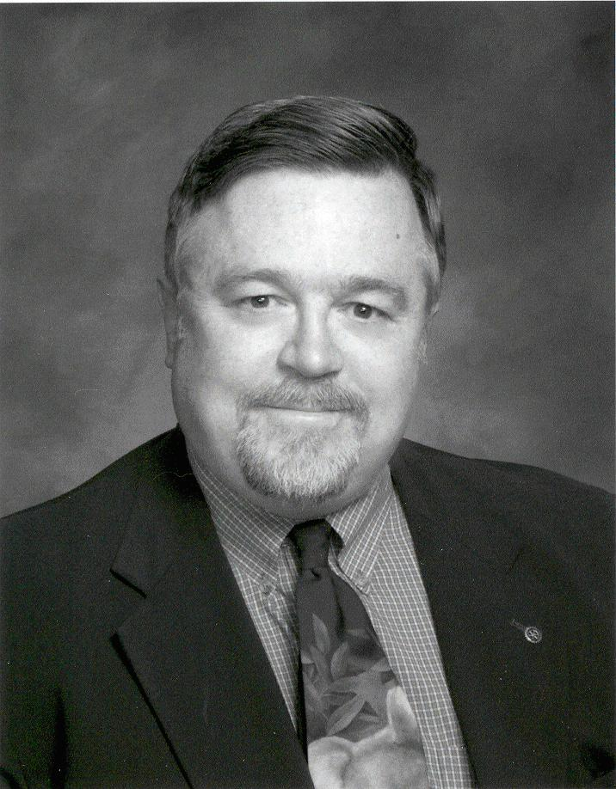
Mr. Vaughan was admitted to practice law in California in December 1981 and in Nevada in 1985. He is admitted to practice before a number of different United States District Courts in several states. He has represented hundreds of litigation clients in the United States District Court in all four federal court districts in California. Defending Americans with Disabilities Act access litigation and consultation for a variety of California businesses on accessibility issues has been his primary area of practice for more than 15 years. He has been retained as an accessibility expert in disability access litigation matters. Mr. Vaughan also owns and operates ADA Consultant Services which performs accessibility evaluations of both private and public facilities. He is a California Certified Access Specialist.
Over the course of his career, Mr. Vaughan has represented numerous public entity and private clients. His public entity experience includes representation of school districts, law enforcement agencies, counties and special districts in a variety of litigation matters involving both the entity as a defendant and employees as defendants. He was employed for over 6 years by the County of Placer and represented the County in a wide range of litigation matters including eminent domain, civil rights, personnel and all varieties of government tort claim cases. His appellate court experience includes successful representation of clients before the Third District Court of Appeal in Sacramento and the Ninth Circuit Court of Appeal in San Francisco.
Panelists:
Janae Davis, Program Manager, California Pollution Control Financing Authority
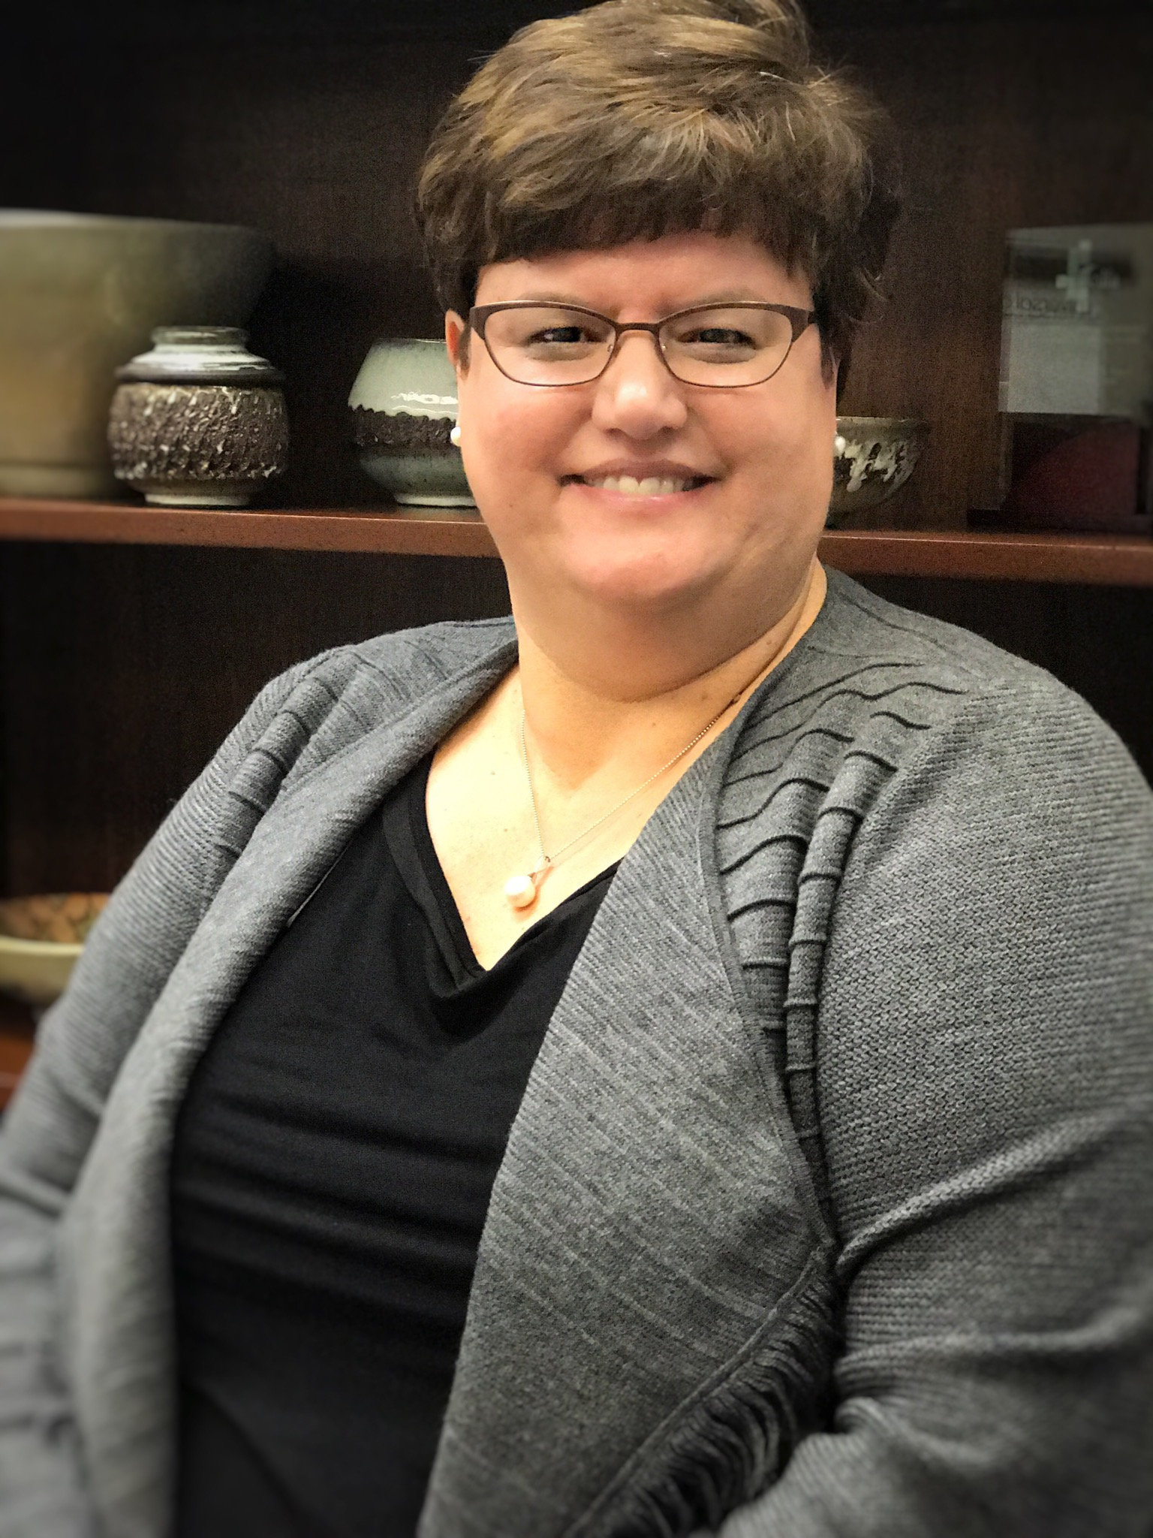Janae Davis has more than 17 years of work experience with the State Treasurer’s Office’s Commissions and Authorities. She is currently the California Pollution Control Financing Authority’s strategic outreach and development manager. In this capacity Janae helps develop, manage and coordinate stakeholder outreach and education and performance evaluation initiatives of each of the Authority’s financing programs including: the Bond Program, small business lending programs, brownfields grant and loan programs, and other financing programs in support of state energy and environmental goals. Prior to that Janae worked at the California Health Facilities Financing Authority, the California Debt and Investment Advisory Commission (CDIAC) and the California Tax Credit Allocation Committee. Janae holds a Master’s of Public Policy and Administration from California State University, Sacramento and a Bachelor’s of Arts in Political Science and Business Economics from University of California, Santa Barbara.

Rachelle Golden, Attorney, Hatmaker Law Group
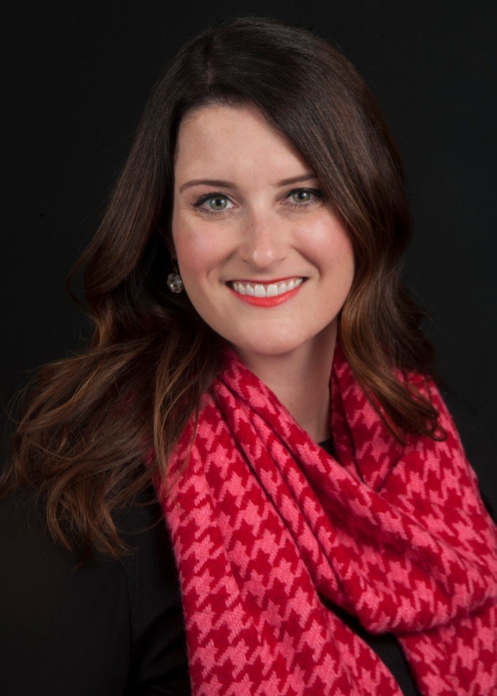
Rachelle handles labor and employment law and litigation. She defends employers before state, federal, and administrative agencies and provides counsel regarding all aspects of human resource issues and compliance to help clients avoid penalties and litigation. Rachelle also has extensive experience consulting with private and public entities in proactive ADA compliance, which includes creating policies and procedures that comply with Federal and State Laws. Rachelle has a successful track record defending clients against lawsuits relating to all aspects of the Americans with Disabilities Act.

Sarah Harris, Youth Empowerment Specialist for the BRIDGES Program, Resources for Independence Central Valley
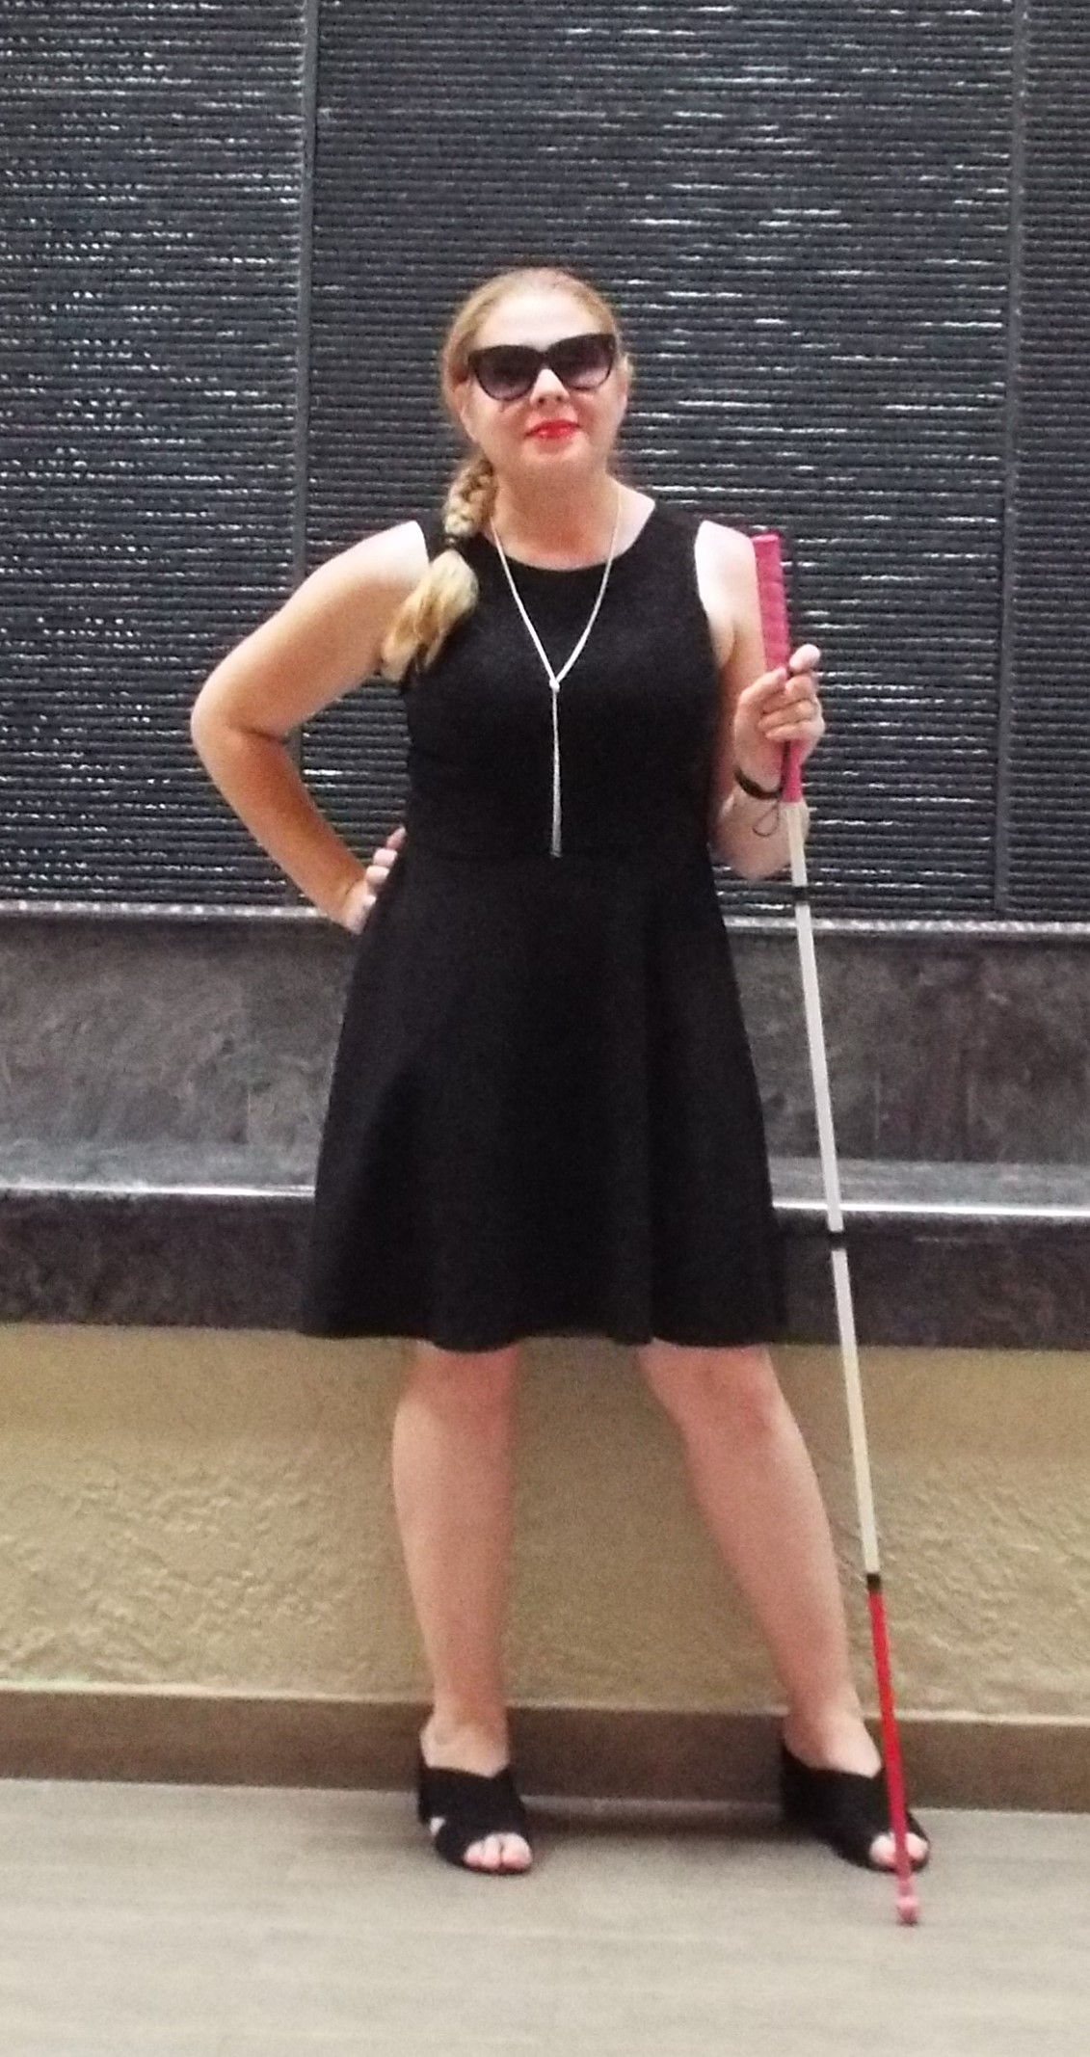
Sarah lost her sight in 2002, in a car accident that changed her life forever. She has taken this experience and turned it into something positive.
Sarah has experience in being in advocacy leadership roles over the past 5 years. She currently serves on the board of directors for California Council of the Blind and is the President of the local Fresno Chapter. In 2017, she was honored to win the JP Morgan Chase Leadership Fellows Scholarship from the American Council of the Blind. She is involved in local government issues including transportation, voting accessibility rights, and access. She was appointed to the Transportation Sub-Committee for the Disability Advisory Commission for the City of Fresno in 2016.
Recently, Sarah completed her second walking marathon in San Diego with Project Athena Foundation alongside her daughter and two best friends. Project Athena Foundation, PAF takes men and women who have experienced setbacks in life on amazing adventures to help with the recovery process of reclaiming your life. She became an Ambassador for PAF, after being an Athena in 2017, spreading the word every chance that she gets about the importance of finding your inner bad-ass! This experience has taught her that anything is possible.
In her spare time, Sarah enjoys spending time with her husband, Josh, and 14 year old daughter, Carson, reading, and exercising with friends. Sarah believes that educating the community about disabilities will encourage understanding, accessibility, and growth.

Daniel Mathers, Building Inspector, County of Fresno (invited)

Ana Medina, Senior Manager - Business Development, Access Capital Plus
Ana Medina currently serves as Senior Business Development Manager at Access Plus Capital, formerly known as Fresno CDFI assisting businesses in the Central San Joaquin Valley. Prior to joining Fresno CDFI, Ms. Medina worked in public relations, research & marketing, and business development at Community Services Employment Training (CSET), Sequoia Energy Service (SES), subsidiary of CSET, Fresno Area Hispanic Chamber of Commerce (FAHCC), former Assemblymember Juan Arambula, 31st District Office. Ms. Medina graduated from California State University, Fresno with a Bachelor’s in Mass Communications and Journalism. Ms. Medina has a track record of working with start-up and existing businesses in the Central Valley, having successfully assisted over 300 businesses with micro-loans and business planning through one-on-one technical support and business development workshops. Ms. Medina’s subsequent work with Sequoia Energy in Visalia laid the groundwork for partnerships and new financing products that Access Plus Capital has developed and was also instrumental in organizing the first ever SBA SCORE training in Spanish “Simple Steps En Español” a program that is now being replicated in other parts of the State.
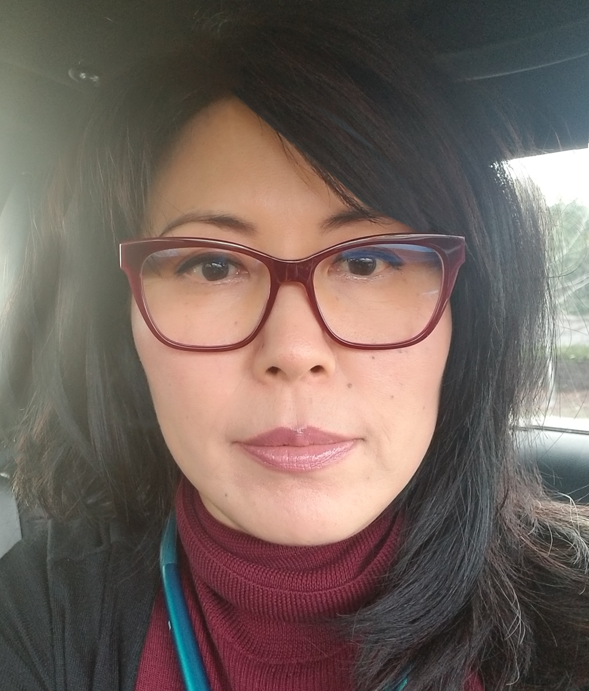
Debbie Wong, Senior Architect, Division of the State Architect, Codes & Standards
Debbie Wong is responsible for technical administration of the Certified Access Specialist (CASp) Program. She also provides technical oversight for the development and maintenance of CASp examinations and develops state building codes and accessibility regulations. Debbie has 15 years of experience as architect in private sector and has been a Certified Access Specialist since 2016.
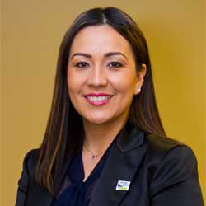
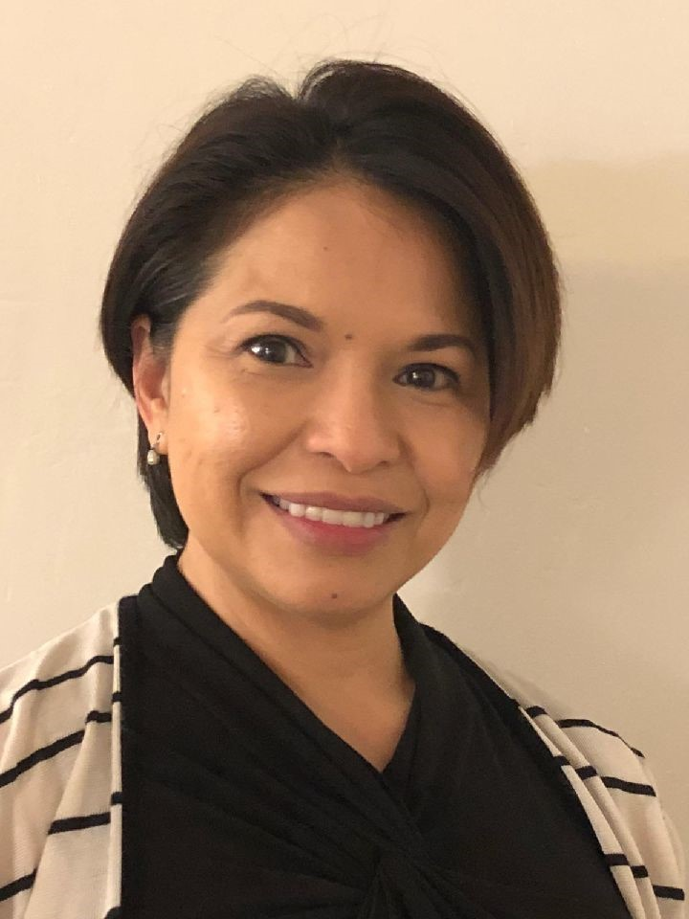
Robina Wright, Architect, CASp, LEED APO&M
For over 20 years, Robina Wright Architect develops Architectural design and Construction Documents in-line with client’s needs, building usage and environmental impact on commercial and residential facilities.
As a Certified Access Specialist (CASp), she provides CASp Survey and Report for business establishments across California. She provides Access compliance plan review services for Department of State Architect (DSA) for State projects and is also the Access Consultant for City of Selma and City of Kingsburg.
Currently, she is the Board of Director in Education for American Institute of Architects, San Joaquin Chapter, and the Board of Director - Secretary for San Joaquin Valley International Code Council (SJVC-ICC). She has served as a Board of Director for CASI (Certified Access Specialist) from 2014-2018.

This page intentionally left blank.
Thank You to Our
Event Partners and Sponsors!
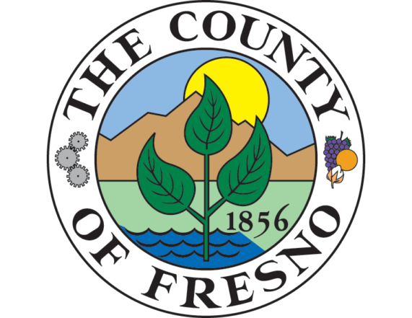

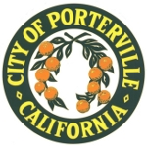
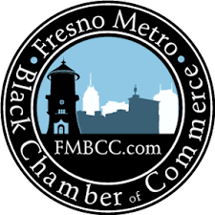

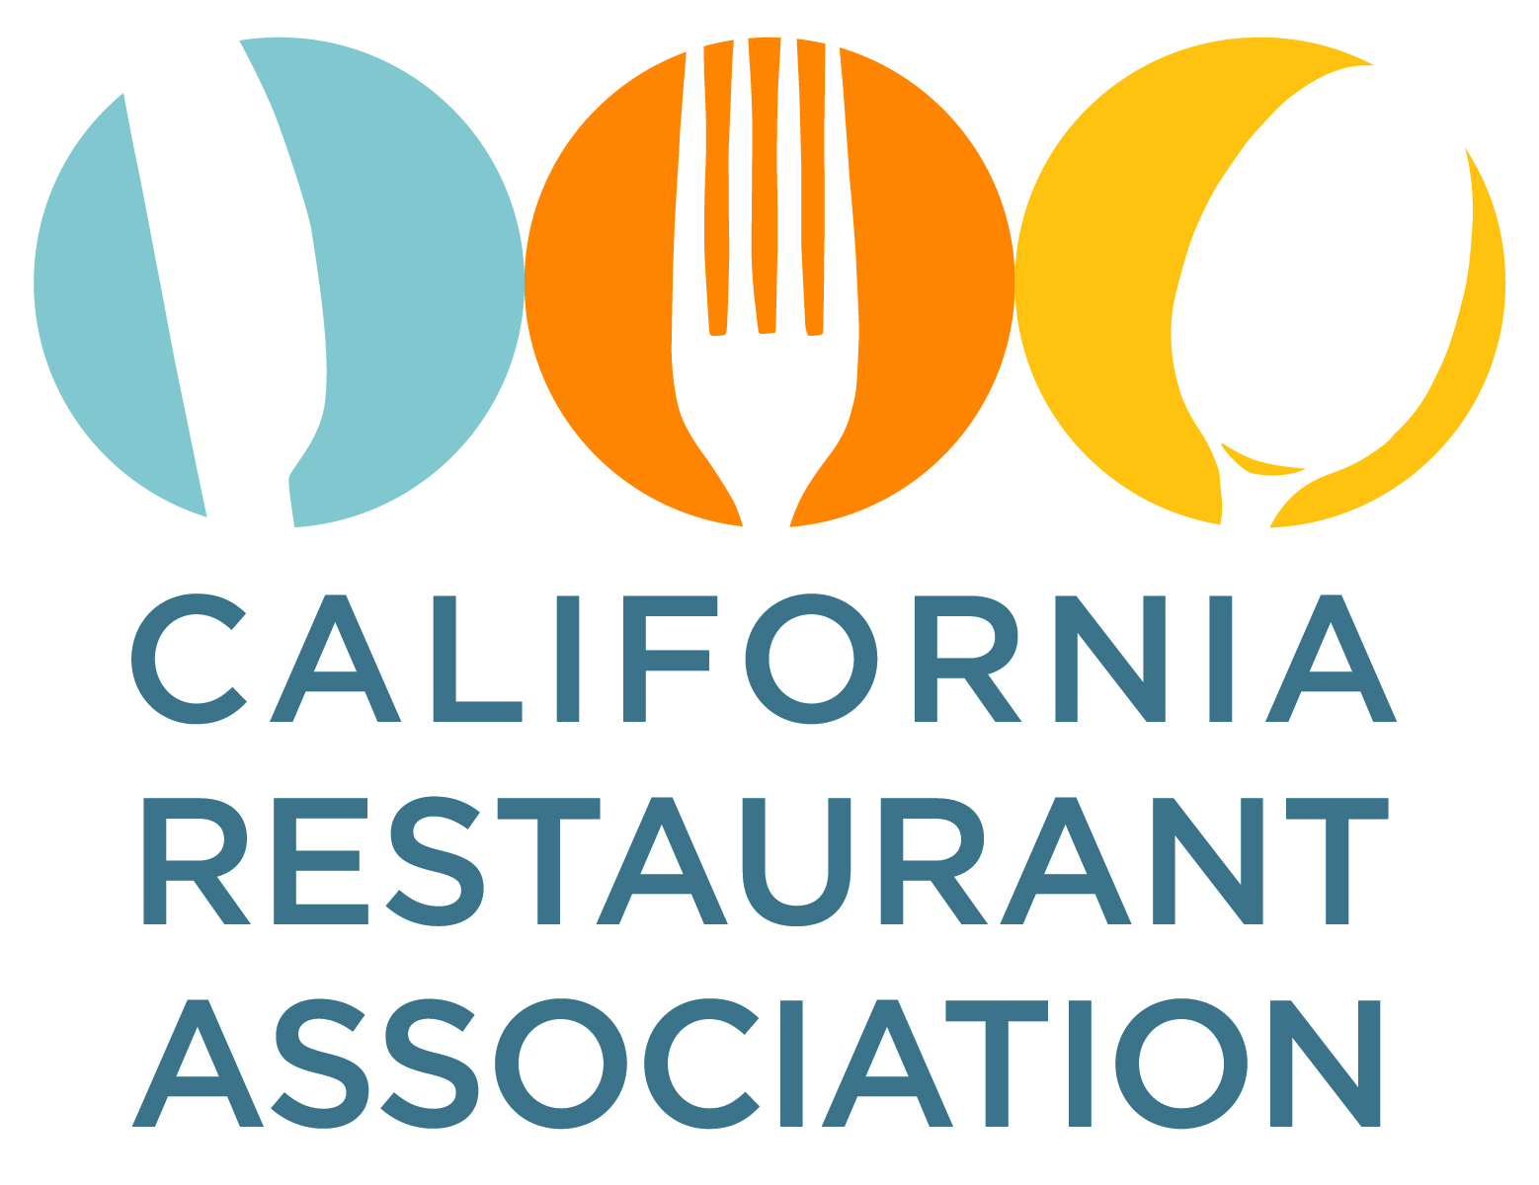

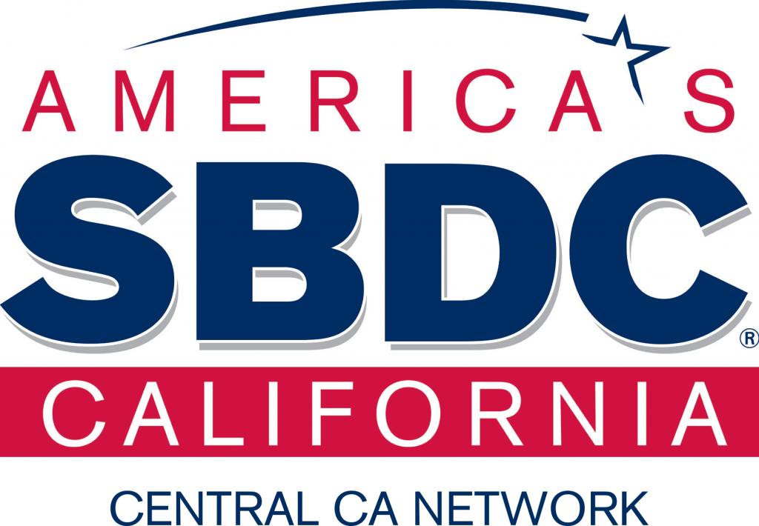



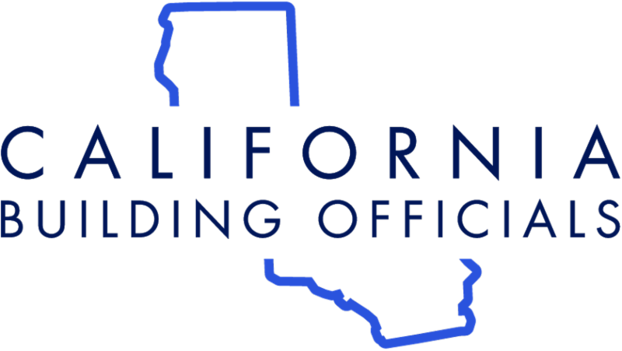
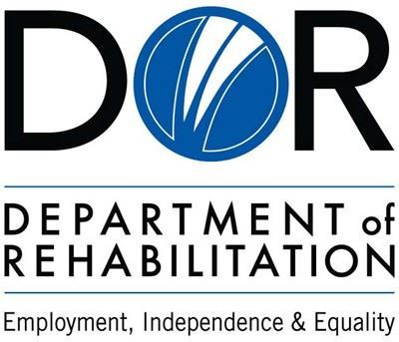



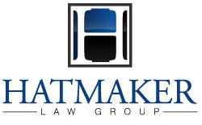
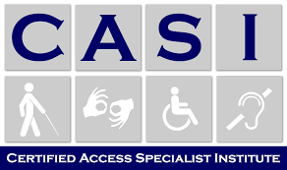



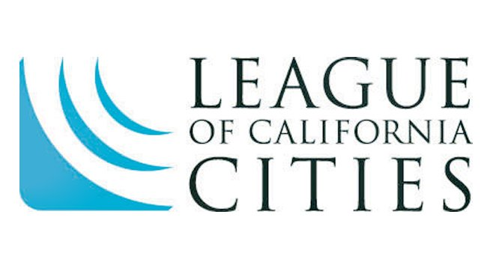

Contact Us!
California Commission on Disability Access (CCDA)
400 R Street, Suite 310
Sacramento, CA 95811
Phone: (916) 319-9974
Email: ccda@dgs.ca.gov
Website: https://ccda.ca.gov/

Feedback for CCDA: Please separate this page and give it to a CCDA staff member.
Rating Scale | Excellent  (5) | Good (4) | Average (3) | Poor (2) | Very Poor (1) | No Opinion (0)
- Rate the value of today’s overall program
  - Panel
  - Roundtable Discussions
- Rate the value of the registration process
- Rate the organization of today’s agenda
- Rate the instructions and facilitation
- Rate the length of today’s event
- Rate the event location and accessibility
- Rate the integration of remote access
Do you have any additional advice for improving future workshops and or improving accessibility? (Please feel free to write on the back if needed.)

How did you hear about the forum? (Check One)
Email Social Media Colleague/Word of Mouth Other:______________

