Virtual Meeting Instructions
  - Microsoft Teams

Tips
Please login to the meeting 15 minutes early to familiarize yourself with the platform and to allow California Commission on Disability Access (CCDA) staff to assist you if needed.
We recommend using the Google Chrome internet browser to begin.

Downloading Teams
- Select this hyperlink if you do not have the application already downloaded: https://www.microsoft.com/en-us/microsoft-365/microsoft-teams/download-app. This link will take you to the direct page to start the download process.
- Select the download button for either: “Download for Desktop” or
“Download to Mobile”
- When prompted select the “Run” button at the bottom of the screen. It could take a few min
- Follow remaining prompts.
Once completed the application will be installed.

Open Microsoft Teams Desktop App with Assistive Technology
- On your computer, press the Windows logo key, and type Microsoft Teams.
- You hear: "Microsoft Teams, app." To open the app, press Enter.
- When you hear the login window, type your work, school, or Microsoft account in the Sign-in address field.
- Press the Tab key to move to the Sign in button and press Enter to select.
- You're prompted to select the sign-in account and method you want to use. Press the Tab key until you hear the option you want, and then press Enter.
- Depending on the sign-in method, follow and act on the prompts as the screen reader announces them. For example, type your password or select your smart card certificate and type the PIN code, and then press Enter. If needed, press the Tab key to move to the Sign in button, and then press Enter.

Joining the Meeting
- Locate the email named “Link the join Invite” sent from CCDA staff. Or you may locate the link in the meeting agenda.
- Select the words “Join Microsoft Teams Meeting.”
This will automatically take you to the Microsoft Teams launch page.
Example: (Login reflected below is for demonstration purposes only)

- When prompted select the “Join on the Web Instead” button.
- Then, select the button on the middle of the screen that says, “Join Now”.

Audio and Visual Functions
After you have selected “Join Now,” you are then in the meeting. Be aware that if you are using a device with a front camera the camera will be automatically be turned on when you enter the meeting. Your built mic will be automatically turned on upon entrance as well.
Note: Your device does not need to have a camera, but is recommended for inclusivity. However, if your device does not have a built-in mic or if you are unsure, you will need to use a headset with a built-in mic.
User-Friendly Tool Bar:
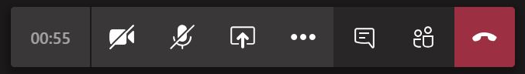

Keyboard Shortcuts for Microsoft Teams (Windows)
- The shortcuts in this topic refer to the US keyboard layout. Keys for other layouts might not correspond exactly to the keys on a US keyboard.
- If a shortcut requires pressing two or more keys at the same time, this topic separates the keys with a plus sign (+). If you must press one key immediately after another, the keys are separated by a comma (,).
- You can easily access the keyboard shortcuts list from within Microsoft Teams. Press Ctrl+E to go to the search field, type /keys, and then press Enter.
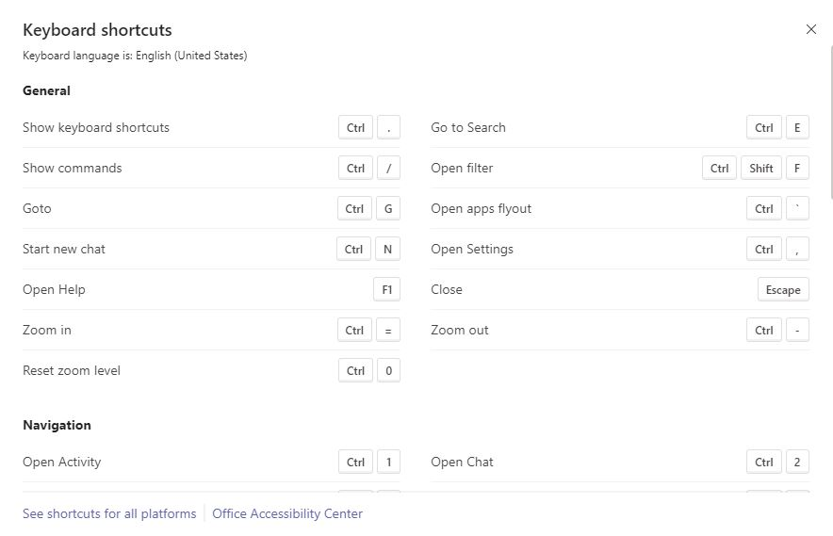
Shortcuts can be found on the Microsoft Teams Keyboard Shortcuts webpage.

Screen Reader Support for Microsoft Teams (NVDA & JAWS)
If you need additional assistance with screen readers, you may refer to the Office Support page.

Join via Teleconference
To attend the public meeting via teleconference, you may call in using the dial in number. You will be prompted to enter in the conference ID, followed by the pound sign. Once you have entered the code you will be admitted into the phone meeting.
The phone number and conference ID is located on the meeting agenda which can be found on the CCDA website.
Public attendees will be muted during the meeting except for minutes available for public comment in which the moderator will unmute the public.

