Review of CCDA 2018 One-Year Strategic Plan Goal Progress
- Goal 1: Create an Electronic Database. CCDA will create and maintain a secure database for data collection (Phase 2), with the objective of providing a web-based electronic form for the public to submit claims directly to CCDA.
  - This goal was not completed in 2018 and has become a carryover strategic goal for 2019.

- Goal 2: Establish an Electronic Document Management System. CCDA will implement an Electronic Document Management System (EDMS) solution for all past and future documents (Phase 1). This will allow for improved data collection and analysis.
  - This goal was completed in December 2018. CCDA staff will conduct ongoing maintenance of SharePoint site.
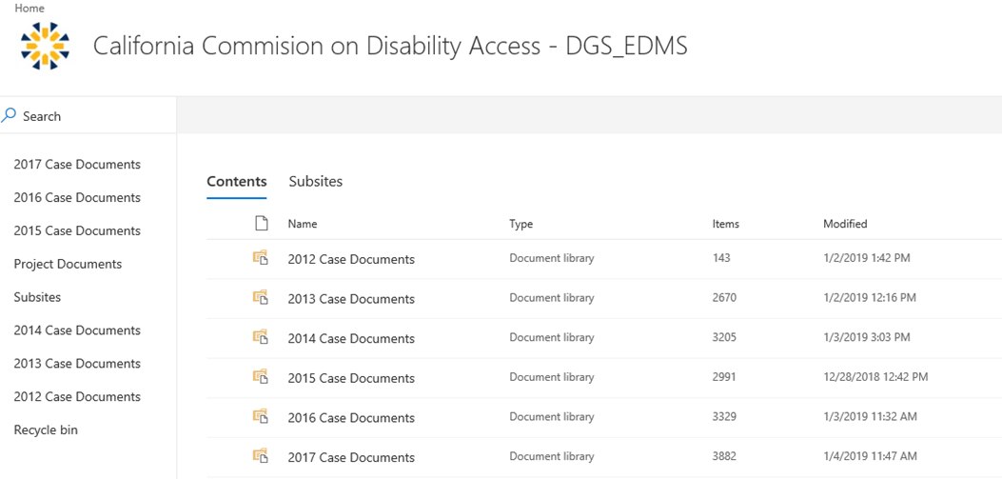
Screenshot of CCDA SharePoint site
- Goal 3: Conduct Regional Listening Forums. CCDA will conduct three regional listening forums with the small business community, improving compliance on issues of disability access.
  - Goal is on track to be completed in February 2019. CCDA has completed two out of three listening forums:
    - In March 2018, CCDA held second forum on the DMV Placard Program in Sacramento.
    - In November 2018, CCDA held the first forum for the restaurant industry in Fresno.

