  - Southern California Community Gathering
  - June 12, 2019 | 9:00 a.m. to Noon
  - Mission Valley Library Community Room
  - 2123 Fenton Parkway San Diego, CA 92108
  - 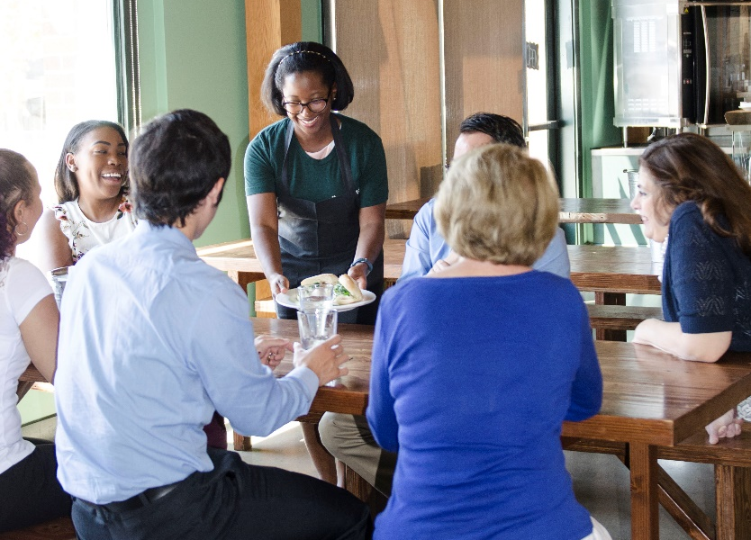
TOPIC:
Restaurant accessibility compliance information and resources.
The California Commission on Disability Access (CCDA) in collaboration with the City of San Diego, will be hosting a community gathering event for the Southern California region where members of the restaurant industry, state and local government, and consumers come together to dialogue and collaborate on issues related to disabled access. Refreshments will be provided, as well as resources to assist restaurant owners and operators in increasing access for all.
To RSVP, go to Eventbrite or call (916) 319-9974
For more information, visit CCDA's website.

  - 

