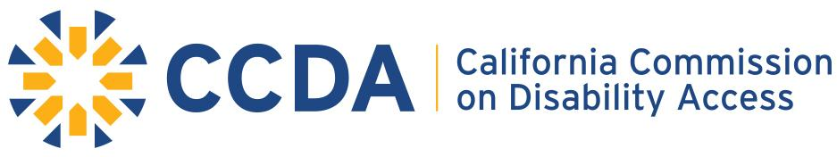

Item 8: 2021 Staff Recommendation for Subcommittee Projects

- Education within the Non-Compliant Legal Community
Summary:
Some law firms are still not in compliance with the use of the service portal. Our goal is to have all law firms who file complaints to use our service portal.
Goals:
- Assist the Research/Data Collection of CCDA to educate the legal community of the legal obligation of utilization of the Portal. CCDA’s desire to maintain a 90- 100% compliance rate.
- Secure CCDA goal of 90- 100% compliance rate of law firm utilization of the Portal
- Develop various strategies to market information to aid compliance.
  - Examples:
    - Training modules
    - Marketing eblast
    - State Bar Outreach
- Disability Access and Education Revolving Fund
Summary:
In preliminary research, it has been discovered the lack of usage, an awareness of the usage, and/ or the range of usage of the Disability Access and Education Revolving Funds from city to city across California.
Goals:
- Research the various City/County utilization of the Disability Access and Education Revolving Fund within each County Budget.
- To take this knowledge and create informational toolkit(s) for counties across the state to access and utilize. CCDA has informally begun this process within the model cities of San Francisco, San Diego and Fresno
Legislative Outreach
- Connect with the state legislator and local government to help educate them regarding access challenges and remedies.
- Providing more information that will help their districts and constituents in mitigating access issues
- Determine needs of legislator to communicate information to districts.

- Continuation of Accessible Parking Toolkit Project
Summary:
Parking infractions are the most common access issues to date. It is our responsibility to continue to develop toolkit(s) in this area.
Goals:
- Generate toolkit to illustrate/describe most common parking violations.
  - Highlight top 10 violations
- Create illustrative guide on problems and solutions to those most common violations within parking.
  - In a manner that will reach the greatest audience. (language)
- Continue marketing and distribution of the Open-air Dining/Curbside Pickup Access Considerations.

- Website Updates: CCDA Enhancements
Summary:
CCDA website is legislated to be a primary educational outreach tool, so 2021-22 we will be developing more strategies to fine tune this asset.
Goals:
  - Updated Communications with more relevant material
- Review and update easier navigation processes for stakeholders

- Increase Disability Access Awareness
Summary:
As California’s diverse population continues to grow and change, a greater percentage of society will need built environments that are barrier-free. This goal seeks to raise awareness of access issues and the availability of tools to support accessibility in the built environment.
. Goals:
- To continue to provide appropriate educational opportunities in our Full Commission Meetings and in Outreach events/opportunities
- Completion of our Public Announcement Project created by our graduate student programs.

