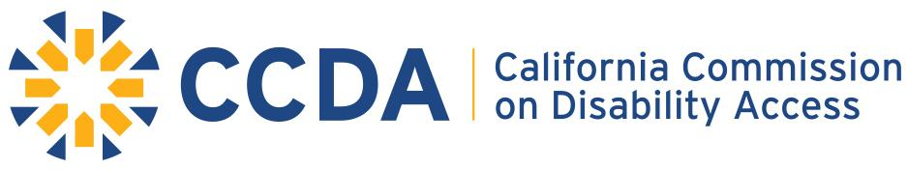

**400 R Street, Sacramento, CA 95811 ~ direct 916-319-9974 ~ www.ccda.ca.gov**

**Draft ADA Community Dialogue/Listening Forum Sessions**

In FY 18-19 CCDA will being the Outreach efforts within the Restaurant Industry.

**General Overview**

Focus Topics for the ADA Community Dialogue/Listening Forum Sessions

At all outreach events CCDA will provide attendees, through a facilitator lead panel presentation of SME and diverse businesses round table, engagement for an opportunity to interact on the listed topics:

* CASp Awareness
* ADA Funding Awareness
* Access Laws and Local Ordinances (Local ordinances of their region/city)
* Disability Awareness

**Sample Format of Outreach Event**

**Morning Session**: Listening Forum

**Afternoon Session**: Incubator Session and Interactive Activity of Reviewing the ADA Access Toolkit