DGS Website Redesign and Modernization Project Summary
In January, the Department of General Services (DGS) initiated a project to redesign its website for all divisions under the department, including CCDA; the overall goal of this project is to improve the customer experience of finding information about DGS’ services.
CCDA’s current task is transfer existing website content to the shared online file system (i.e. SharePoint) by the end April 2018. From late spring through summer, DGS will review and provided feedback on existing content. There will also be a period of time for CCDA to incorporate design features to improve the customer experience of accessing its webpages.
Once the content review and design phases are complete, DGS will train all divisions on how to upload finalized content to the new website. The entire, finished DGS website along with CCDA’s redesigned pages are scheduled to go live in Fall 2018. CCDA’s current website URL will be deactivated and redirected to the new DGS website. Screenshot examples of the DGS redesigned website pages are included on Page 2.
CCDA wants to obtain feedback from the Education and Outreach Committee on website content and accessibility considerations prior to end of April 2018 deadline.
Current CCDA Homepage View
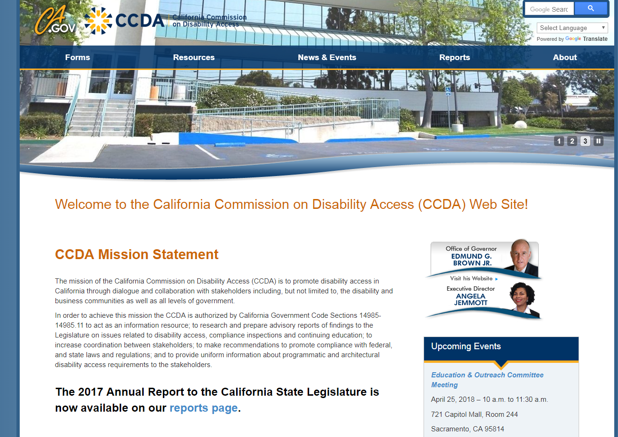

DGS Proposed Homepage Style

