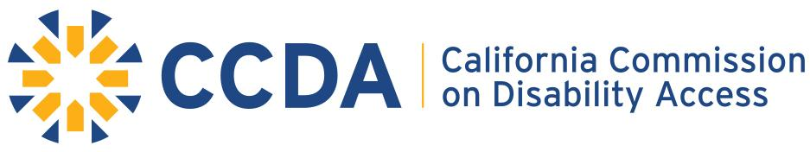
Item 6c: 2021 Staff Recommendation for Subcommittee Projects

Education within the Non-Compliant Legal Community
Summary:
Some law firms are still not in compliance with the use of the service portal. Our goal is to have all law firms who file complaints to use our service portal.
- Research into Law firm and attorney use of the service portal. Our request is all firms use service portal. Some still are out of compliance.
  - Goal is to find firms who are not in compliance and offer direction on how come into compliance.
- Develop strategies to market information to aid compliance.
  - Examples:
    - Training modules
    - Marketing eblast
    - State Bar Outreach
Disability Access and Education Revolving Fund
Summary:
In preliminary research, it has been discovered the lack of usage, an awareness of the usage, and/ or the range of usage of the Disability Access and Education Revolving Funds from city to city across California.
Goals:
- To locate County funds for Disability Access and Education Revolving Fund within each County Budget.
  - Educate cities and counties to ensure funds are being used correctly.
- To take this knowledge and help create toolkit for counties across the state. Much what was done with San Francisco, San Diego and Fresno, CCDA was used as vehicle and exhibitor of programs for other cities to use.
Legislative Outreach
- Connect with the state legislator and local government to help educate them regarding access challenges and remedies.
  - Providing more information that will help their districts and constituents in mitigating access issues
  - Determine needs of legislator to communicate information to districts.

Continuation of Accessible Parking Toolkit
Summary:
Parking infractions are the most common access issues to date. It is our responsibility to continue to develop toolkits in this area.
Goals:
- Generate toolkit to illustrate/describe most common parking violations.
  - Highlight top 10 violations
- Create illustrative guide on problems and solutions to those most common violations within parking.
  - In a manner that will reach the greatest audience. (language)
- Continue marketing and distribution of the Open-air Dining/Curbside Pickup Access Considerations.

Website Updates: CCDA Enhancements
Summary:
CCDA website is legislated to be a primary educational outreach tool, so 2021-22 we will be developing more strategies to fine tune this asset.
Goals:
- Updated Communications
  - More relevant material
- Effective Documents
  - Outreach ability
- Easier navigation for stakeholders
  - Adjusts technical language to standard language to increase understanding.
  - Ease of use-Survey

