

CCDA ADA 30 Campaign Plan
The California Commission on Disability Access (CCDA) is proud to celebrate the 30th anniversary of the Americans with Disabilities Act (ADA).

Signed into law on July 26, 1990, the civil rights law works to increase the inclusion of people with disabilities in all aspects of life and to prohibit discrimination. People with disabilities are protected by the ADA in areas such as employment, education, transportation, and all public and private places open to the general public.

Part 1: Highlight CA leaders and disability community on website (Commissioner’s Corner)

Since the ADA was signed, we have seen many advances in disability and accessibility awareness. Today we are asking commissioners, state and local leaders, businesses, and the disability community what the ADA means to them and how they would like to see California progress to become a barrier-free state.

*Questions we will ask:
- How has the ADA impacted your life, business, and/or community?
- What ADA improvements would you like to see in California?
CCDA Response Goal: 30 quotes from commissioners and other leaders

EXAMPLE:


Commissioner Michael Paravagna, Sacramento
ADA Coordinator, Former Chief California Department of Rehabilitation Disability Services
“The United States of America has been a noble experiment since 1776 in its attempt to realize equality for all Americans. The Americans with disabilities act of 1990 is a promise of inclusion to persons with disabilities. With every ramp built, every employment accommodation successfully put into place, every communication procedure implemented; we come closer to realizing the equality set is a great American goal in 1776. That goal will never be achieved until all Americans are included.”

Logistics:
All photos and responses will be uploaded on the CCDA website under the NEWS tab. The page will also be linked to the ADA30 logo image on CCDA’s splash page.

Email Communication:
Subject: ACTION REQUIRED: CCDA Celebrates ADA30
The California Commission on Disability Access (CCDA) is proud to celebrate the 30th anniversary of the Americans with Disabilities Act (ADA). Signed into law on July 26, 1990, the civil rights law works to increase the inclusion of people with disabilities in all aspects of life and to prohibit discrimination.

Since the ADA was signed, we have seen many advances in disability and accessibility awareness. Today we are asking commissioners, state and local leaders, businesses, and the disability community what the ADA means to them and how they would like to see California progress to become a barrier-free state. With your permission, we would like to feature your responses on CCDA’s website.

Please respond to this email answering the following questions:
- Full name, city, career/industry or job title
- How has the ADA impacted your life, business, and/or community?
- What ADA improvements would you like to see in California?

Please include your headshot photo, and sign/return the attached photo release form.

Part 2: Campaign Logo on CCDA Landing Page

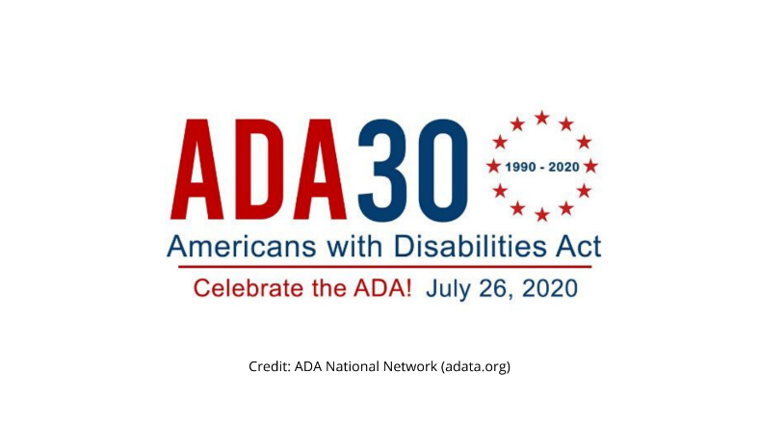ADA 30 – Celebrate, Learn, Share https://www.adaanniversary.org/

Credit/Use of Logos
When using any of the logos, please add credit to the source.
- Credit: ADA National Network (adata.org)
OR
- Credit: ADA National Network (adata.org) 1-800-949-4232

ADA 30 Logo With Stars in a Circle Formation Small https://www.adaanniversary.org/sites/default/files/ADA30-celebrate-logo.gif
ADA Logo With Stars in a Circle Formation Large https://www.adaanniversary.org/sites/default/files/ADA30-blog-post_0.jpg
ADA Logo Simplified https://www.adaanniversary.org/sites/default/files/ADA30-icon.jpg

Text with image:
[Title] California Commission on Disability Access is proud the celebrate the 30th anniversary of the Americans with Disabilities Act (ADA)!
[Subtitle] CCDA has asked commissioners, state and local leaders, and the disability community what the ADA means to them and how they would like to see California progress to become a barrier-free state. Learn more about what they have to say, and ADA resources.

Part 3: Resources

Events:
Abilities Expo – San Mateo Oct. 16, 2020 https://www.abilities.com/bayarea/

Easter Seals – Virutal Strides for Disability Walk Oct. 17, 2020 https://www.easterseals.com/southerncal/get-involved/events/
Disability Rights California – Webinars https://www.disabilityrightsca.org/events
ADA Anniversary National Events (some virtual) https://adata.org/ada-anniversary/events
UCP of Sacramento and Northern CA Accessible Outdoor Activities https://ucpsacto.org/resources/activities-outdoors/
San Diego Therapeutic Recreation Center (TRC) Summer Calendar Activities https://www.sandiego.gov/park-and-recreation/activities/trs

Articles and Editorials:
An Overlooked and Growing Market- People with Disabilities https://www.forbes.com/sites/brucelee/2016/11/02/an-overlooked-and-growing-market-people-with-disabilities/#61f1b4302ab0
The Next Big Consumer Segment: People with Disabilities https://blogs.perficient.com/2017/08/09/the-next-big-consumer-segment-people-with-disabilities/
How Accessibility Can Make or Break Your Small-Business Website https://www.entrepreneur.com/article/339555
Meeting the Needs of Adults with Disabilities in the Marketplace https://www.globenewswire.com/news-release/2018/04/17/1480293/0/en/Meeting-the-Needs-of-Adults-with-Disabilities-in-the-Marketplace.html
Business Tax Credits for Disability Access Updates https://www.thebalancesmb.com/business-tax-credits-for-disability-access-updates-397621

First Steps to Compliance:
ADA Resources https://www.adapacific.org/ada-resources
Great Lakes ADA Center: Webinars and Q&A by Topic https://www.accessibilityonline.org/ao/
ADA Basic Building Blocks Free Web Course https://www.adabasics.org/
Access Compliance Resources for Businesses and Consumers https://www.dgs.ca.gov/CCDA/Resources/Page-Content/California-Commission-on-Disability-Access-Resources-List-Folder/Government-Resources
World Wide Web Consortium (W3C) Web Content Accessibility Guidelines https://www.wuhcag.com/web-content-accessibility-guidelines/
Department of Rahabilitation Web Accessibility Resources https://www.dor.ca.gov/Home/Accessibility
Department of Justice: 2010 ADA Standards for Accessible Design https://www.ada.gov/regs2010/2010ADAStandards/2010ADAstandards.htm#c7

Model Release
I give the California Commission on Disability Access/ Department of General Services permission to use and publish photos in which I appear without incurring any debts or liabilities of any kind.

Name (print):

Address:

City/State/ZIP:
Signature____________________________________________________________

