
CCDA Website Analytics
February 28 - May 6, 2019

CCDA began tracking website analytics on February 28, 2019. Analytics currently being tracked include:

- Number of current active users on the site
- Number of users in the last 7 days, 30 days, 90 days, etc.
- Average duration of user visits
- Frequency users are returning to the site
- Frequency users are getting to the site
- Time of day users visit site
- Most visited web pages
- Devices users access the site from

Summary: CCDA’s website has had 4,556 users visit since we began tracking at the end of February. The average user stays on the site for 1 minute and 24 seconds. 3,788 (83%) of these users were first time visitors. The majority of users access our site through a search engine, as opposed to a social media link or a link from an email. Mondays at 11am, Thursdays at 10am, and Fridays at 3pm have the most active users on the site. User most often access the site from a desktop computer. Aside from the homepage, users visit the ‘Resources’ and ‘About’ pages most often. Figures 1 – 4 below demonstrate an overview of the amount of users that visit the site and the length of time they visit for, the most visited web pages, geographic locations users access the site from and the top devices they use to access the site.

Figure 1: User Overview (The declines occur on Saturdays and Sundays.)
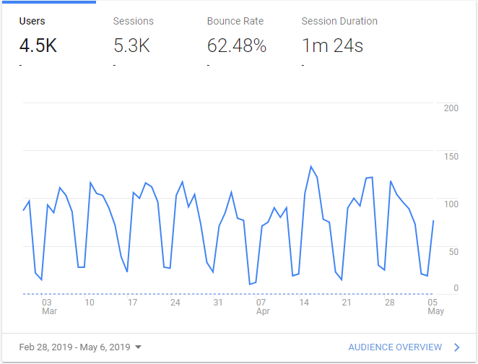
Figure 2: User Page Visits
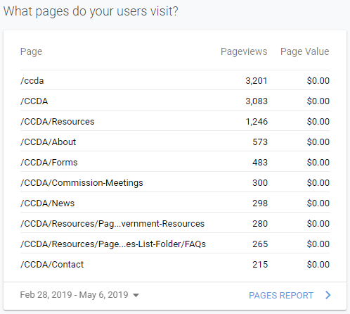

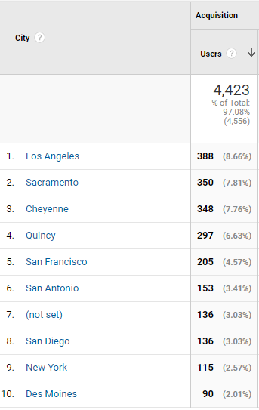Figure 3: Top 10 Cities Users
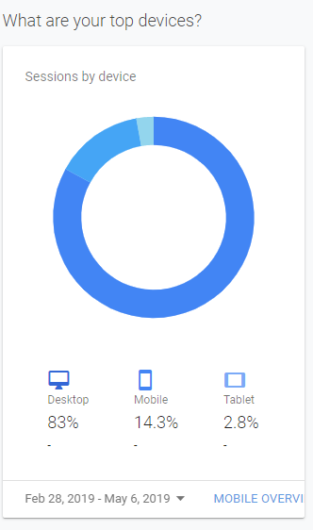
Figure 4: Devices Users Access From

