APPENDIX a: federal/state Complaints and
prelitigation letters received

In 2017, federal complaints accounted for 73 percent of the case filings (complaints received excluding prelitigation letters), in comparison to 67 percent in 2016; 47 percent in 2015; 52 percent in 2014; and 24 percent in 2013. At this time, CCDA is unable to ascertain the factors that are contributing to the growth in federal complaints.

Prelitigation letters continue to grow substantially for reasons unknown. They accounted for 38 percent of the 3,826 letters received in 2017 and grew by 87 percent over 2016.

2017
Category Total Percent
Federal complaint 1,722 45%
State complaint 643 17%
Prelitigation letter* 1,461 38%
Total 3,826
2016
Category Total Percent
Federal complaint 1,730 52%
State complaint 839 25%
Prelitigation letter* 781 23%
Total 3,340
2015
Category Total Percent
Federal complaint 1,083 37%
State complaint 1,240 42%
Prelitigation letter* 623 21%
Total 2,946
2014
Category Total Percent
Federal complaint 1,532 48%
State complaint 1,412 44%
Prelitigation letter* 234 8%
Total 3,178
2013
Category | Total | Percent
Federal complaint | 605 | 21%
State complaint | 1,950 | 68%
Prelitigation letter* | 327 | 11%
Total | 2,882

*CCDA is unable to ascertain whether prelitigation letters resulted in an actual case being filed in federal or state court.

APPENDIX a: federal/state Complaints and
prelitigation letters received

APPENDIX b: Federal/State complaints and prelitigation letters receiveD by CATEGORY
CCDA organizes alleged constructed-related access violations into six categories. As indicated by the table below, parking-related violations are the largest category and represented 37 percent of the 10,608 alleged violations in 2017; 44 percent of the 11,468 alleged violations in 2016; and 42 percent of the 9,643 alleged violations in 2015.

2017
Category Total Percent
Toilet Rooms and Bathrooms 1,497 14%
Parking 3,888 37%
Accessible Route and Entry 2,705 26%
Access within Public Facility 1,304 12%
Equipment within Public Facility 573 5%
General Alleged Violations 641 6%
Total 10,608
2016
Category Total Percent
Toilet Rooms and Bathrooms 1,756 15%
Parking 5,047 44%
Accessible Route and Entry 2,801 24%
Access within Public Facility 1,214 11%
Equipment within Public Facility 219 2%
General Alleged Violations 431 4%
Total 11,468
2015
Category Total Percent
Toilet Rooms and Bathrooms 1,681 17%
Parking 4,037 42%
Accessible Route and Entry 2,210 23%
Access within Public Facility 1,256 13%
Equipment within Public Facility 147 2%
General Alleged Violations 312 3%
Total 9,643

APPENDIX b: Federal/State complaints and
prelitigation letters RECEIVED by CATEGORY

2014
Category Total Percent
Toilet Rooms and Bathrooms 2,212 21%
Parking 3,926 38%
Accessible Route and Entry 2,206 21%
Access within Public Facility 1,276 12%
Equipment within Public Facility 245 2%
General Alleged Violations 542 5%
Total 10,407
2013
Category Total Percent
Toilet Rooms and Bathrooms 1,905 22%
Parking 3,552 41%
Accessible Route and Entry 1,730 20%
Access within Public Facility 999 12%
Equipment within Public Facility 296 3%
General Alleged Violations 167 2%
Total 8,649

APPENDIX C: ADA VIOLATION CODES LIST
CCDA categorizes the types of construction-related alleged ADA violations using 51 key codes consistent with Title 24 of the California Code of Regulations.
CATEGORY | KEY  CODE | DESCRIPTION
Toilet Rooms And Bathrooms | 1 | Entry doors are not accessible or not on an accessible route.
Toilet Rooms And Bathrooms | 2 | Clear Floor Space. Non-accessible fixtures and controls or insufficient turn around space.
Toilet Rooms And Bathrooms | 3 | Doors [Toilet stalls]. Non-accessible doors to toilet stalls.
Toilet Rooms And Bathrooms | 4 | Door space is not compliant.
Toilet Rooms And Bathrooms | 5 | Lavatories and mirrors are not accessible.
Toilet Rooms And Bathrooms | 6 | The location/height of toilets, urinals, flush controls, or toilet paper dispensers is not compliant.
Toilet Rooms And Bathrooms | 7 | Grab Bars. Grab bars in bathroom are non-existent, or existing grab bars are not compliant.
Toilet Rooms And Bathrooms | 8 | Insufficiently covered, coat racks too high, light switch too high.
Toilet Rooms And Bathrooms | 9 | Faucets. Non-accessible lever-operated, push-type, or electronically controlled mechanisms.
Toilet Rooms And Bathrooms | 10 | Bathtubs or showers are not accessible.
Toilet Rooms And Bathrooms | 39 | Toilet seat cover dispenser not accessible.
Toilet Rooms And Bathrooms | 40 | Hand sanitizer, liquid soap or paper towel dispenser not accessible.
Toilet Rooms And Bathrooms | 46 | Lack of unisex ADA bathrooms or any accessible bathrooms.
Parking | 11 | Number of spaces. Parking lot does not contain minimum number of accessible parking spaces.
Parking | 12 | Parking Spaces. Existing parking spaces are not compliant.
Parking | 13 | No sign showing the symbol of accessibility.
Parking | 14 | Loading zones/van access aisles are not compliant or non-existent.
Accessible Route and Entry To Public Facility | 15 | Routes to and from parking lot or public right of way are not accessible. May include uneven surfaces.
Accessible Route and Entry To Public Facility | 16 | Ramps. Curb ramps or entrance ramps are not compliant or non-existing.
Accessible Route and Entry To Public Facility | 17 | General. Entry doors are not accessible or missing sign/symbol of accessibility.
Accessible Route and Entry To Public Facility | 18 | Door Hardware. Thresholds, handles, pulls, latches, locks, or other operating devices are not accessible.
Accessible Route and Entry To Public Facility | 45 | Accessible path is too far away or path is not clear for the accessible route.
Access Within Public Facility | 20 | Access aisles within building are not accessible, e.g., dining or work surfaces are not on an accessible route.
Access Within Public Facility | 21 | Maneuvering Clearances at Doors. Required clearances are not compliant.
Access Within Public Facility | 22 | Stairs or Guardrails. Stairs are not compliant or lack guardrails.
Access Within Public Facility | 23 | Handrails non-existent or not accessible.
Access Within Public Facility | 24 | Route with inadequate signage.
Access Within Public Facility | 25 | Wheelchair spaces in assembly areas are non-existent or not compliant.
Access Within Public Facility | 26 | Access Height. Heights of surfaces such as counters, bars, or tables are not compliant.
Equipment Within Public Facility | 27 | Audible signals.
Equipment Within Public Facility | 28 | Public telephones are not wheelchair accessible.
Equipment Within Public Facility | 29 | Public telephones do not have accessible volume control.
Equipment Within Public Facility | 30 | General Public Equipment. Gas pumps, automatic teller machines, or fare machines are not compliant.
Equipment Within Public Facility | 37 | General Pool. Pool lifts, sloped entries, transfer walls, transfer systems, and pool stairs are not accessible.
Equipment Within Public Facility | 38 | Drinking Fountains and water coolers are not accessible.
General Violations | 31 | Dressing, fitting, or locker rooms are not compliant.
General Violations | 32 | Sleeping rooms, units or suites are not accessible or insufficient number of accessible guest rooms.
General Violations | 33 | Patient bedrooms or baths are not accessible.
General Violations | 34 | Audible and visual alarms and notification appliances are not compliant.
General Violations | 35 | Amusement rides are not accessible.
General Violations | 36 | Bus stop, bus stop pad, station, terminal, building or other transportation facility is not accessible.
General Violations | 41 | Service dog not allowed in building.
General Violations | 42 | Lamp not accessible.
General Violations | 43 | Shuttle van/bus not accessible.
General Violations | 44 | Accessible features not maintained.
General Violations | 47 | Website does not offer ADA options or is not accessible.
General Violations | 48 | Lack of separate call button.
General Violations | 49 | Insufficient documentation/lack of ADA access issue.
General Violations | 50 | Lack of temporary hand controls to test drive vehicles.
General Violations | 51 | Staff provided barrier to access.

APPENDIX d: Attorneys and plaintiffs SUBMISSIONS

In 2017, 23 percent of plaintiffs named on complaints received by CCDA filed 10 or more complaints in court. Those plaintiffs collectively filed 81 percent of the 2,365 complaints received (excludes prelitigation letters).

 | 2017 | 2018
Plaintiffs Involved in 10 or More State and Federal Complaints  (Excludes Prelitigation Letters) | 81% | 75%

The chart below shows the percentage of complaints (excludes prelitigation letters) reported to CCDA by the top four law firms in 2017. For example, 33 percent of the 2,365 complaints received were filed by one law firm. Of the 2,365 complaints received, 74 percent were filed by four law firms.
Complaints Filed by Law Firms in Order of Reporting Frequency (Excludes Prelitigation Letters) | 2017 | 2016
1 | 33% | 27%
2 | 16% | 21%
3 | 13% | 10%
4 | 12% | 7%
Total | 74%* | 65%*

*The percentage calculation will not total 100 percent because it only references the top four law firms.
APPENDIX E: 2017 TOP 10 VIOLATIONS
Rank # | Key Code | Violation Description | Total Number of Violations | Percent of Total
1 | 11 | Parking: parking lot does not contain the minimum number of accessible parking spaces | 1,792 | 17%
2 | 16 | Accessible Route and Entry: curb ramps or entrance ramps are non-compliant or non-existent | 1,091 | 10%
3 | 12 | Parking: the existing parking spaces are not compliant | 947 | 9%
4 | 15 | Accessible Route and Entry: routes to and from the parking lot or public right-of-way are not accessible | 830 | 8%
5 | 14 | Parking: van-accessible parking, van access aisles and/or loading zones are non-compliant or non-existent | 645 | 6%
6 | 26 | Access within Public Facility: heights of surfaces such as counters, bars, and tables, for example, are non-compliant | 608 | 6%
7 | 13 | Parking: signage in parking lot is non-compliant. For example, spaces need to be designated as reserved by a sign showing the symbol of accessibility | 504 | 5%
8 | 44 | General Violations: accessible features are not maintained | 434 | 4%
9 | 18 | Accessible Route and Entry: handles, pulls, latches, locks, or other operating devices are not accessible | 405 | 4%
10 | 20 | Access within Public Facility: access aisles or path of travel within building are not accessible | 367 | 3%
Total | 7,623 | 72%

APPENDIX F: COMPLAINTS/prelitigation letters

by place of public accommodation

The below chart demonstrates the frequency by which various types of businesses were alleged to be in violation. In 2017 the top three places of public accommodation, as defined in ADA Title III, Technical Assistance Manual, where violations occurred included: Sales/Rental Establishments (e.g. bakeries, grocery stores, hardware stores, shopping centers) (38%); Service Establishments(e.g. laundromats, dry-cleaners, banks, funeral homes, gas stations, professional offices, beauty shops) ( 35%); and Food or Drinks Establishments (e.g. restaurants and bars) (19%). These location categories are consistent with the 2016 reported violations.
 |  | 2017 |  | 2016 |  | 2015
*Public Location Category | Total | % | Total | % | Total | %
- Places of Lodging | 250 | 6.5% | 135 | 4.0% | 113 | 3.8%
2. Establishments Serving Food or Drink | 727 | 19.0% | 888 | 26.6% | 810 | 27.5%
3. Places of Exhibition or Entertainment | 12 | 0.3% | 13 | 0.4% | 3 | 0.1%
4. Places of Public Gathering | 1 | 0.0% | 3 | 0.0% | 1 | 0.0%
5. Sales or Rental Establishments | 1,453 | 38.0% | 1,355 | 40.6% | 1,240 | 42.1%
6. Service Establishments | 1,343 | 35.1% | 853 | 25.5% | 657 | 22.3%
7. Public transportation terminals, depots, or stations | 2 | 0.1% | 26 | 25.5% | 50 | 1.7%
8. Places of Public Display or Collection | 2 | 0.1% | 3 | 0.1% | 4 | 0.1%
9. Places of Recreation | 2 | 0.1% | 22 | 0.7% | 34 | 1.2%
10. Places of Education | 2 | 0.1% | 4 | 0.1% | 10 | 0.3%
11. Social Service Center Establishments | 1 | 0.0% | 6 | 0.2% | 4 | 0.1%
12. Places of Exercise or Recreation | 31 | 0.8% | 32 | 1.0% | 20 | 0.7%
Total | 3,826 | 100% | 3,340 | 100% | 2,946 | 100%

appendix g: zip code location

of complaints letters filed

The below maps depict the various zip codes where alleged violations have occurred. In 2017, the number of complaints filed remains heavily concentrated in urban areas. Southern California had the highest number of filings, followed by Northern California (Bay Area). Central Valley region ranked third, followed by the Sacramento region. This is consistent with 2016 filings.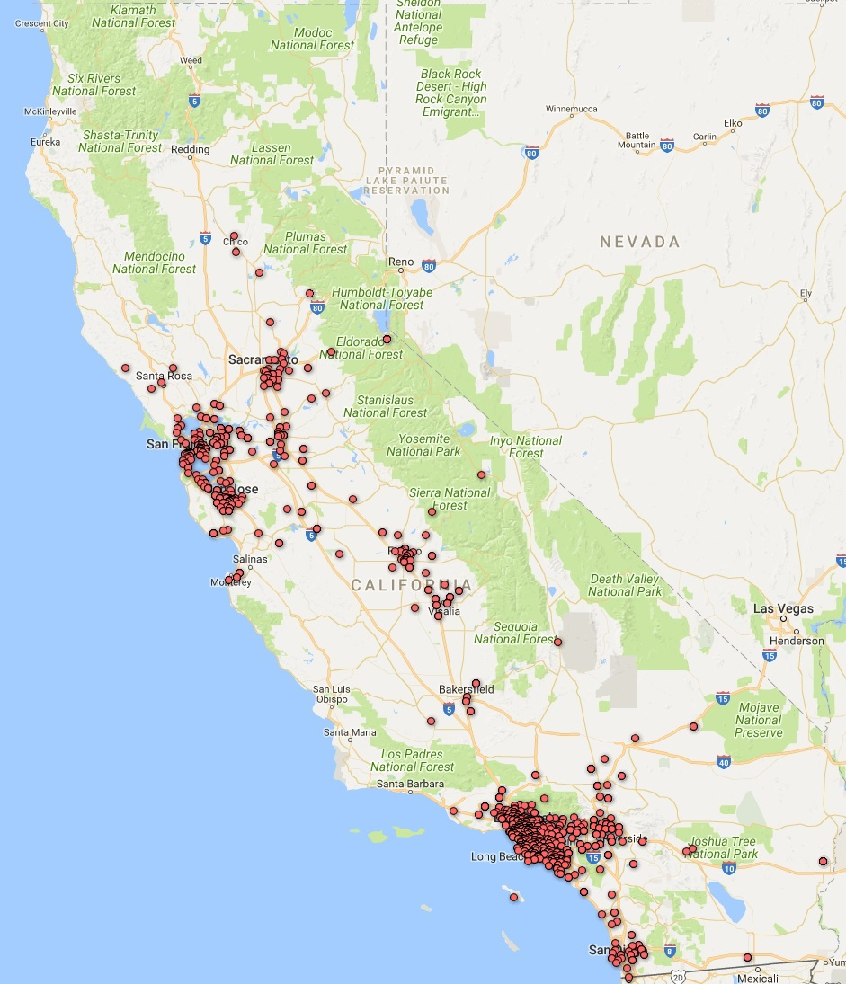
Figure 1: 2017
2015

appendix h: case resoLutions

2017 Case Resolution Report Questions
Questions | Yes | Percent  Yes | No | Percent  No
Defendant requested an early evaluation conference | 39 | 2% | 1799 | 98%
Defendant requested a site inspection | 45 | 2% | 1791 | 98%
Plaintiff received injunctive relief | 1370 | 75% | 460 | 25%
Another favorable result was achieved | 952 | 52% | 874 | 48%
Plaintiff received damages or monetary settlement | 744 | 93% | 57 | 7%

2016 Case Resolution Report Questions
Question | Yes | Percent  Yes | No | Percent  No
Defendant requested an early evaluation conference | 42 | 2% | 1,997 | 98%
Defendant requested a site inspection | 33 | 2% | 2,011 | 98%
Plaintiff received injunctive relief | 1,222 | 73% | 447 | 27%
Another favorable result achieved | 766 | 47% | 869 | 53%
Plaintiff received damages or a monetary settlement | 734 | 58% | 522 | 42%

2015 Case Resolution Report Questions*
Question | Yes | Percent  Yes | No | Percent  No
Defendant requested an early evaluation conference | 0 | 0% | 516 | 100%
Defendant requested a site inspection | 0 | 0% | 520 | 100%
Plaintiff received injunctive relief**
Another favorable result achieved**
Plaintiff received damages or a monetary settlement | 143 | 30% | 330 | 70%

